Date of preparing:
Date of teaching:
UNIT 5: FOOD AND DRINK
Period 39: Lesson 5: SKILLS 1

I. OBJECTIVES
By the end of this lesson, Ss will be able to:
1. Knowledge
- Develop their reading skill for specific information about food and drink
- Talk about the popular food and drink
2. Competences
- Develop communication skills and creativity
- Be collaborative and supportive in pair work and team work
- Develop presentation skills
- Actively join in class activities
3. Educational aim:
- Promote pride in the values ​​of Vietnamese culture
- Develop love for family and traditional food and drink
II. MATERIALS
1. Teacher: - Grade 7 textbook, Planning (Unit 5, skills 1)
- Smart TV/Pictures, sets of word cards
- Sachmem.vn
2. Students: Text books, notebooks, posters, ….
3. Method: Ask and answer; group works; individual ……
III. PROCEDURES:
Activity 1: Warm-up (5’)
* Aim: To create an active atmosphere in the class before the lesson; To introduce the topic of reading.
* Content: List some common dishes that your family often eats in daily meals.
* Products: Students’ answers on the board.
* Organization of implementation:
Teacher’s and Ss’ activities | Content
- T- Ss  * Teacher asks Ss write names dishes that their family often eats in daily meals.  ** Students discuss in groups and write the answers on the group board.  *** The teacher asks Ss to hang the group board on the board  **** Teacher gives feedback. | Game: List some common dishes that your family often eats in daily meals.  - Breakfast:  - Lunch:  - Dinner
Activity 2: Presentation (10’)
Pre teach vocabulary
* Aim: To provide students with some lexical items before reading the text.
* Content: Learn some vocab related the topic.
* Products: Read and understand the meaning of words.
* Organization of implementation:
Teacher’s and Ss’ activities | Content
T –Ss:  * Teacher uses different techniques to teach vocab (pictures, situation, explaination)  ** Ss repeat in chorus and individually  *** SS copy all the words  **** T checks the vocab by playing game “ call in English” | * Vocabulary  1. snack /snæk/: đồ ăn vặt  2. taste /teɪst/: nếm  3. broth /brɒθ/: nước dùng, canh  4. stew /stju:/: hầm  5. boneless /ˈbəʊnləs/: không xương
Activity 3: Reading
* Pre -reading
Task 1:
* Aims: To activate Ss' knowledge of the topic in the reading text.
* Content: Work in pairs. Discuss the following questions about “ pho”
* Products: Ss say the answers aloud in front of the class.
* Organization of implementation:
Teacher’s and Ss’ activities |  | Content
Task 1: T –Ss, Ss- Ss  *Teacher pairs Ss, gives them some time to discuss about “Phở”, using suggested questions.  ** Ss discuss as guided.  *** After discussing, Ss talk about pho in front of the class.  **** T listens and may ask some other questions about how to make Phở. |  | Task1: Work in pairs. Discuss the following questions  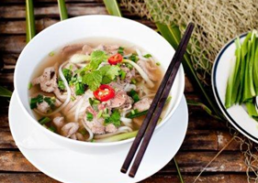  1. Is pho popular in your neighborhood?  2. When can we have pho?  3. What are the main ingredients of pho?  * Keys:  1. Yes, it is.  2. We have it in the morning.  3. The main ingredients of pho are noodles and beef or chicken,
While-Reading (10’)
Task 2
* Aims: To check students understanding of using correct lexical items about the topic.
* Content: - Read Phong’s blog. Match the underlined words in the text with their meanings.
- Circle the correct answer A, B or C.
* Products: Students swap their answers with their partner and say the correct answers.
* Organization of implementation:
Teacher’s and Ss’ activities |  | Content
Task 2: T –Ss, Ss- Ss  *Teacher asks Ss to scan the passage to find and work out the meanings of the words (1-5) in the passage and match with their meanings (a-e), using the context.  **Ss quickly locate the words, read with full concentration and complete focus, predict and match them with the provided meanings.  ***Ss swap their answers with each other.  ****Teacher checks the answers as a class, confirms the correct answers.  Or for weak classes, Teacher may ask for translation to check understanding  Task 3: T –Ss, Ss- Ss  *Teacher gives instructions.  ** Ss work individually to carefully read and underline key words in the given part of the sentences and three options of the other part that fit in.  - Teacher tells them to underline parts of the passage that help them with the answers and set a strict time limit to ensure Ss read the text quickly for information.  *** Ss share their answers with others to compare their choices in pairs before showing them in the class and to Teacher. Teacher also asks them to give evidence when giving the answers.  ****Teacher nominates some Ss to read the completed sentences aloud, listens and then gives them correct answers. |  | Task 2. Read Phong’s blog. Match the underlined words in the text with their meanings.  * Key:  1. d 2. b 3. c 4. a 5. e  Task 3: Read Phong’s blog again and circle the correct answer A, B or C.  1. The text is mainly about _______.  A. pho, a popular dish in Viet Nam  B. popular dishes in Viet Nam  C. different ways to cook pho  2. Pho is made mainly with ______.  A. rice noodles and beef or chicken  B. rice, pork, and vegetables  C. fish, shrimp, and noodles  3. We enjoy pho ______.  A. only for breakfast  B. for lunch and dinner  C. at any time of the day  4. To make noodles for pho, we use _____.  A. a variety of sticky rice  B. the best kind of rice  C. eggs and rice flour  5. The broth for pho is made by _____.  A. slowly cooking beef or chicken bones  B. cooking beef or chicken with fish sauce  C. boiling potatoes and chicken bones for a long time  * Key:  1. A 2. A 3. C 4. B 5. A
Activity 4: Speaking (15’)

* Pre- speaking
Task 4
* Aims: To help Ss generate ideas for the speaking activity
* Content: Make notes about a popular food and drink in your area. Think about its main ingredients, how often and when you have it.
* Products: Ss’ results on the group board clearly.
* Organization of implementation:
Teacher’s and Ss’ activities |  | Content
Task 4: T - Ss, Ss – Ss  *Teacher asks Ss to brainstorm or use a mind map/ web to make notes about a popular food and drink in their area in groups of 4 or 5 Ss. (Teacher can show them a mind map as a sample)  ** Ss think about a popular food or drink in their area, its ingredients and how often and when people in their neighborhood have it and note down quickly these ideas as instructed during the time limit set by the teacher.  *** Ss share their ideas with other groups.  **** Teacher asks them some extra questions to help Ss if they lack ideas or if they have had too many ones to choose from |  | Task 4: Make notes about a popular food and drink in your area. Think about its main ingredients, how often and when you have it.  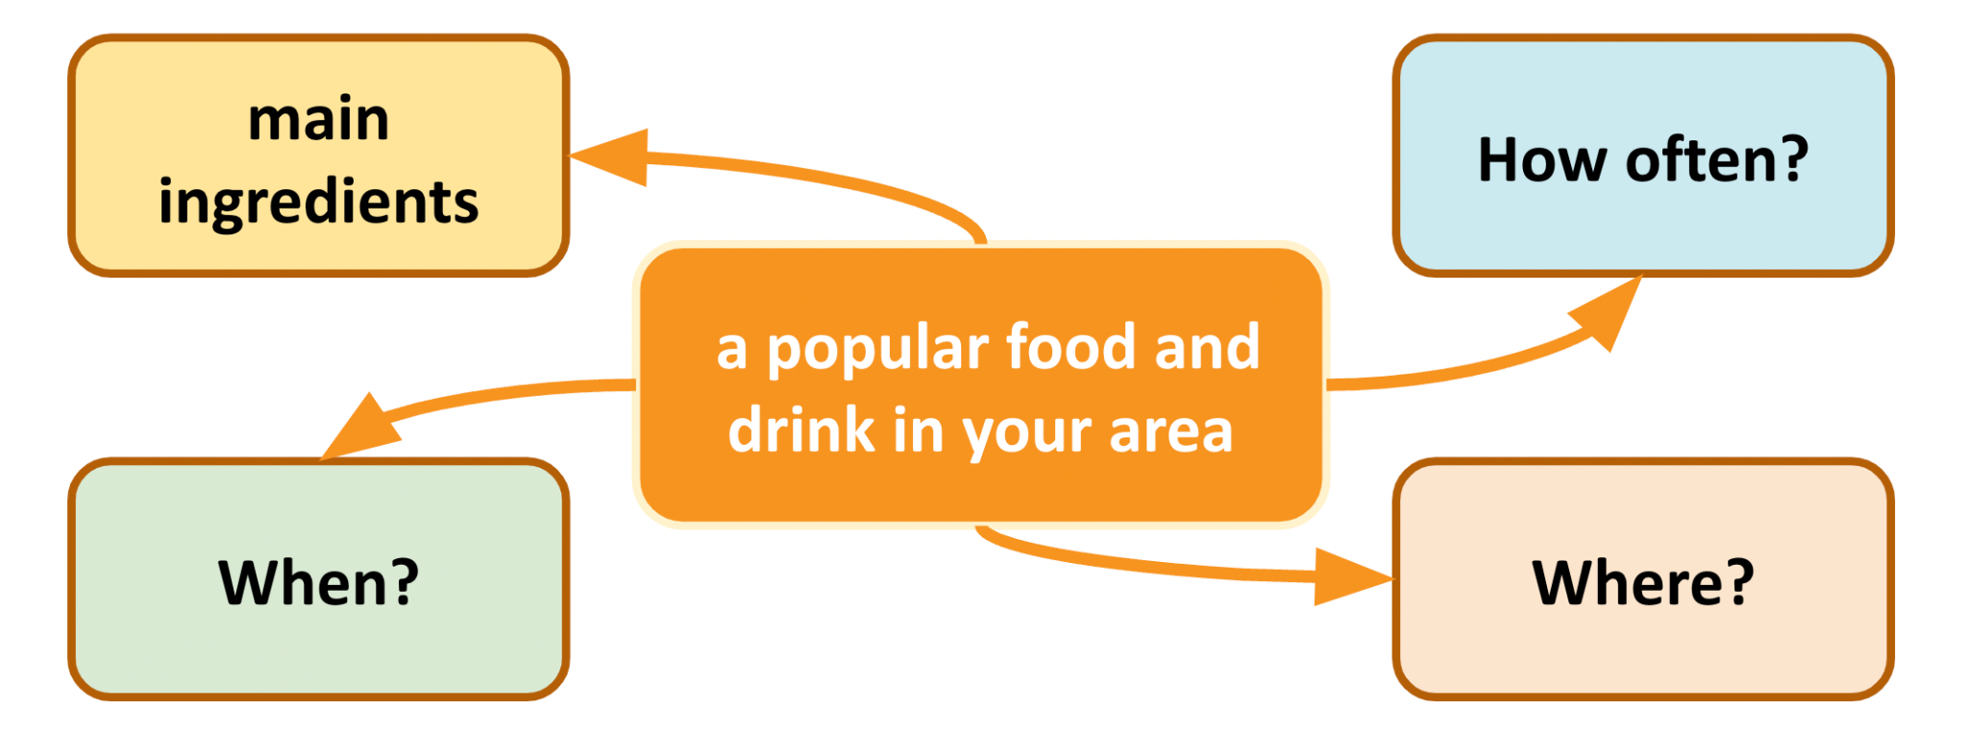  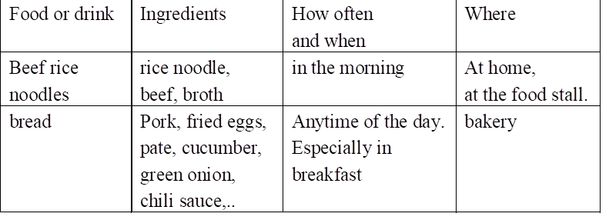
* While and post Speaking
* Aims: To provide an opportunity for Ss to practice talking about a popular food or drink.
* Content: Work in groups of 3 or 4. Take turns to talk about a popular food or drink in your area.
* Products: Some students share their preparation with the whole class.
* Organization of implementation:
Teacher’s and Ss’ activities |  | Content
Task 5: T - Ss, Ss – Ss  * T asks Ss to talk using the notes/ maps/ webs that they have prepared in their own group and then nominates some of them (maybe, strong students) to model this activity in front of the class.  ** Ss present in front of the class  *** Then, Ss listen to their classmates presenting and give positive comments to the others'.  **** Teacher gives feedbacks. |  | Task 5: Work in groups of 3 or 4. Take turns to talk about a popular food or drink in your area.  There are many delicious dishes in Vietnam, but one of the popular dishes in my area is Banh Mi. Banh Mi called “Sandwich or hamburgers” is the most popular street food in Vietnam because of its convenience, and deliciousness. Its ingredients such as pork, fried eggs, pate, cucumber, green onion, butter, and chili sauce. Vietnamese Sandwich is served as an ideal breakfast and light snack. People can buy this dish very easily on the Vietnamese streets.
Activity 5: Consolidation (3’)
* Aims: To consolidate what students have learnt in the lesson.
* Content: Ss summarize what they have learnt with the two skills.
* Products: Students say what they have learnt with the two skills in front of the class.
* Organization of implementation:
Teacher’s and Ss’ activities |  | Content
- Teacher asks students to talk about what they have learnt in the lesson. |  | - 2 skills  + Listen about a traditional Vietnamese dish.  + talk about popular food or drink in your area.)
* Homework (2’)
* Aim: To revise the knowledge that students have gained in this lesson.
* Content: Review the lesson and prepare for the next lesson
* Products: Students’ textbook and workbook
* Organization of implementation:
- Teacher asks students to prepare the new lesson |  | - Do Ex in WB  - Prepare: Skills 2
Complement.
…………………………………………………………………………………………………………………………………………………………………………………

