Date of preparing:
Date of teaching:
UNIT 5: FOOD AND DRINK
Period 38: Lesson 4: COMMUNICATION

I. OBJECTIVES:
By the end of this lesson, Ss will be able to:
1. Knowledge
- Use lexical items related to the favorite food and drink in everyday life
- Understand and use ways to ask and answer about prices and favorite food and drink in English
2. Competence
- Develop communication skills
- Be collaborative and supportive in pair work and team work
- Actively join in class activities
3. Educational aim:
- Promote pride in the values ​​of Vietnamese culture
- Develop love for family
II. MATERIALS
1. Teacher: - Grade 7 textbook, Planning (Unit 5- communication)
- Smart TV/Pictures, sets of word cards
- Sachmem.vn
2. Students: Text books, notebooks, posters, ….
3. Method: Ask and answer; group works; individual ……
III. PROCEDURES:
Activity 1: Warm-up (5’)
* Aim: - To activate students’ knowledge
- To get students interested in the topic
* Content: Answer some questions related the restaurant.
* Products: Ss give the answers in front of the class.
* Organization of implementation:
Teacher’s and Ss’ activities |  |  | Content
* Warm up  T – Ss  * Teacher elicits and asks students some questions about the restaurant.  ** Some students are invited to answer.  *** Teacher and students discuss the answers.  **** Teacher introduces the lesson. |  |  | * Warm up:Chatting  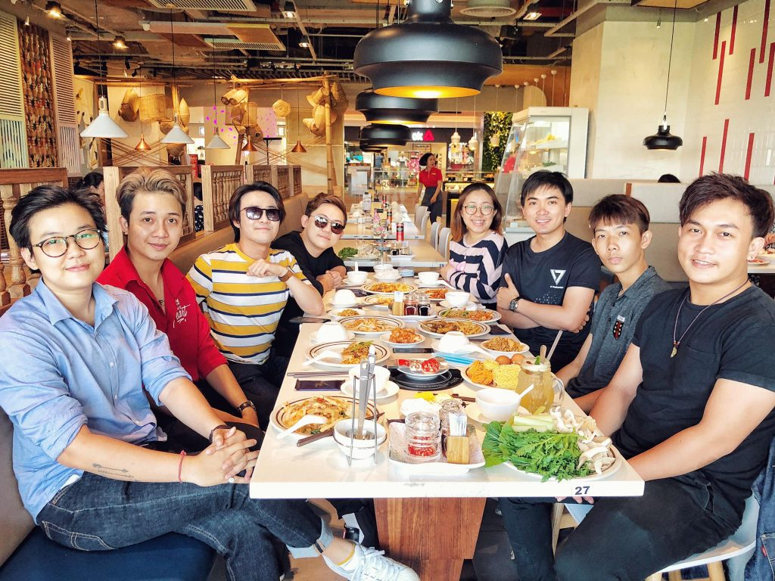  - Have you been to the restaurant?  - Who did you go with?  - What is your favorite food?  - Do you think the dishes and drinks at the restaurant are cheap or expensive?
Activity 2: Presentation (10’)
* Vocabulary
* Aim: To help students use key language more appropriately
* Content: Listen and read the short conversation, paying attention how to make and accept appointments
* Products: Understand and know how to make and accept appointments;
* Organization of implementation:
Teacher’s and Ss’ activities | Content
T – Ss  * T asks Ss to look at the photo and answer the question.  What is this?  ** Ss say the word.  *** Other Ss correct if the previous answer is incorrect.  **** Teacher shows and says the word aloud and asks Ss to repeat it.  * Teacher gives some words in Vietnamese and asks Ss to translate into English  ** Ss says the word  **** Teacher gives the correct answers | * Vocabulary  1. eel /iːl/: con lươn  2. foreign /ˈfɒrən/: ngoại quốc  3. favourite /ˈfeɪvərɪt/: ưa thích  4. interview /ˈɪntəvjuː/: cuộc phỏng vấn  5. try /traɪ/: thử làm gì đó
* Everyday English
Asking and answering about prices
Task 1:
* Aims: To introduce ways to ask and answer about prices in English.
* Content: Listen and repeat the conversation. Pay attention to the questions and answers
* Products: Some pairs to role play in front of the class.
* Organization of implementation:
Teacher’s and Ss’ activities |  | Content
Task 1: T –Ss; Ss- Ss  * Teacher gives Ss instructions.  ** Ss listen carefully, watch closely and repeat as a whole class. They pay attention to the questions whenever Teacher pauses and corrects their mistakes.  *** Ss work in pairs to repeat the conversation.  **** Teacher shows the conversation on the screen to make sure they ask the correct questions. |  | Task 1: Listen and repeat the conversation. Pay attention to the questions and answers.  * Audio script – Track 34:  Mark: How much is a bottle of mineral water?  Mrs Thu Ba: It’s 5,000 dong.  Mark: And how much are two kilos of apples?  Mrs Thu Ba: They’re 50,000 dong.
Activity 3: Practice (15’)
* Aims: To help Ss practice asking and answering about prices.
* Content: Ask and answer about the prices of the food and drink on the menu.
* Products: Ss role play in front of the class.
* Organization of implementation:
Teacher’s and Ss’ activities |  | Content
Task 2: T - Ss, Ss-Ss  * Teacher shows the menu on the screen, shows the sample of the conversation, pairs Ss and asks them to play the roles of a waiter and a customer to ask and answer about the prices of the food and drink on the menu.  ** Ss practice for about 3 minutes.  *** Ss work with another partner and change their roles, asking and answering questions about the prices.  ****Teacher goes around observes, corrects their mistakes and notes some of their typical errors if necessary. |  | Task 2: Works in pairs. Ask and answer about the prices of the food and drink on the menu.  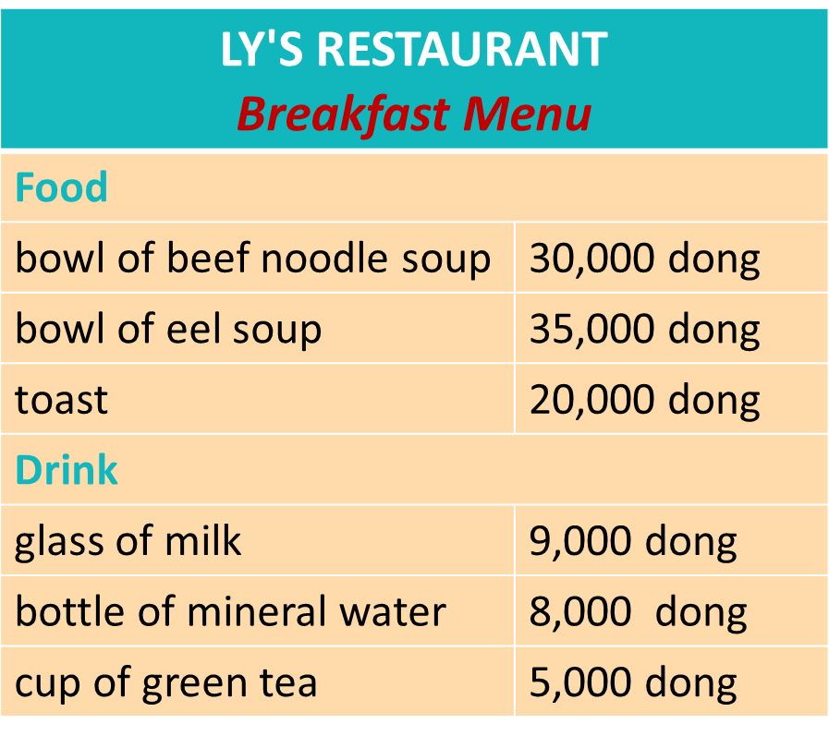  Ex: A: How much is a bowl of beef noodles soup?  B: It's 30,000 dong.
YOUR FAVOURITE FOOD AND DRINK
Task 3
* Aims: - To teach Ss the questions they can ask to interview someone about their favourite food and drink;
- To help Ss revise the vocabulary related to the topic.
* Content: Listen to the conversation and answer the questions.
* Product: Ss gives the correct answers.
* Organization of implementation:
Teacher’s and Ss’ activities |  | Content
Task 3: T – Ss.  * Teacher gives Ss some time to read the questions in Exercise 3, asks them to pay attention to the key words and predict the answers.  ** Ss do the exercise step by step.  - Ss read and underline key words.  - Ss listen twice, find synonyms and paraphrases of the key words and answer the question.  ***Teacher asks Ss to swap their notebooks with each other, listen to the recording once again and peer check.  ****Teacher gives Ss the correct answers and then asks them to repeat the conversation. |  | Task 3: Listen to the conversation and answer the questions.  * Key:  1. Spring rolls. 2. Lemonade.  3. Apple pie and pancakes.  4. Hu tieu (in Ho Chi Minh City).  5. Omelettes, rice, and spring rolls.  * Audio script – Track 35:  Peter: Nam, can you help me with my school project? I need to interview some people about what they like to eat and drink.  Nam: Sure. What questions do you have?  Peter: What’s your favorite food, Nam?  Nam: It’s spring rolls.  Peter: What’s your favorite drink?  Nam: I like lemonade.  Peter: Interesting. What foreign food do you like?  Nam: Mmm, I like apple pie and pancakes.  Peter: How about new food? Is there anything that you’ve never had, but would like to try?  Nam: Certainly. I’d love to try hu tieu in Ho Chi Minh City.  Peter: I’d like to give it a try too. What can you cook?  Nam: Let me think... I cook omelettes, rice, and spring rolls.
Task 4
* Aims: To help Ss practice asking and answering about their friends’ favorite food and drink;
- To help Ss get information to report on their friends’ favorite food and drink;
* Content: Interview two of you friends about their favorite food and drink. Write their answers in the table.
* Products: asking and answering the questions to get information about the others in their groups to complete the table exactly
* Organization of implementation:
Teacher’s and Ss’ activities |  | Content
Task 5: T - Ss, Ss – Ss  * Teach lets Ss randomly pick the cards to choose their teams. Then, teacher gives the instruction.  **Ss work in groups, practice asking and answering the questions to get information about the others in their groups to complete the table.  ***Ss share the collected information in the class.  ****Teacher listens to them, gives them comments and correct when necessary. |  | Task 4: Work in groups. Interview two of you friends about their favorite food and drink. Write their answers in the table.
Activity 4: Production (10’)
* Aims: To help Ss practice reporting the results of their interviews about favorite food and drink.
* Content: report your results to the class.
* Products: Some Ss report the results of their interviews in front of the whole class fluently.
* Organization of implementation:
Teacher’s and Ss’ activities |  | Content
* When Ss have finished the interview, T may have Ss practice reporting the results of their interviews in pairs or in groups.  ** Choose some Ss to report the results of their interviews in front of the whole class.  *** After each student has finished his / her report, invite some comments from other Ss. ****Then comment and correct any common errors. |  | Task 4  * Now report your results to the class.
Activity 5: Consolidation (3’)
* Aims: To consolidate what students have learnt in the lesson.
* Content: Summarize the content of the lesson.
* Products: Ss say aloud what they have just learnt
* Organization of implementation:
Teacher’s and Ss’ activities |  | Content
-Teacher asks students to talk about what they have learnt in the lesson. |  | - Vocabulary of the favorite food and drink in everyday life  - Ways to ask and answer about prices, and favorite food & drink in English
* Homework (2’)
* Aim: To revise the knowledge that students have gained in this lesson. And prepare for the next lesson: Skills 1.
* Content: Review the lesson and prepare for the next lesson and do exercise in the workbook
* Products: Students’ textbook and workbook
* Organization of implementation:
Teacher’s and Ss’ activities |  | Content
- T reminds Ss to do homework and prepare the new lesson. |  | - Create a menu and include starters, main courses, side dishes, desserts and drinks. Don't forget the prices.  - To prepare for the next lesson: Unit 4 (Skills 1)
Complement.
………………………………………………………………………………………………………………………………………………………………………………………………………

