Date of preparing:
Date of teaching:
UNIT 5: FOOD AND DRINK
Period 35: Lesson 1: GETTING STARTED – At a Vietnamese restaurant
I. OBJECTIVES:
By the end of this lesson, Ss will be able to gain:
1. Knowledge
- An overview about the topic Food and Drink
- Vocabulary to talk about food and drink
2. Competence
- Develop communication skills and cultural awareness
- Be collaborative and supportive in pair work and teamwork
- Actively join in class activities
3. Educational aims:
- Develop healthy eating habits and awareness of balanced diets
- Be proud of the homeland
II. TEACHING AIDS:
1. Teacher: - Grade 7 textbook, Planning (Unit 5- Getting started)
- Smart TV/Pictures, sets of word cards
- Sachmem.vn
2. Students: Text books, notebooks, posters, ….
3. Method: Ask and answer; group works; individual ……
III. PROCEDURES:
Activity 1: Warm-up (5’)
* Aim: To revise the old lesson and introduce the new lesson; To lead in the lesson.
* Content: Game: GAME: PELMANISM (words and pictures about music and arts)
* Products: Ss find out words and pictures exactly.
* Organization of implementation:
Teacher’s and Ss’ activities |  |  | Content
* Warm up: T – SS  * Teacher divides the class into 2 teams and asks them to choose the pair of number.  ** In 2 minutes, each member from each team has to take turns to turn over one card and try to find a card that matches it.  *** If the two cards match each other, the team gets one point.  - If the two cards are different, put them back in the same places, facing down.  **** The team with more points will win the game.  → Lead in: Teacher leads students into the new lesson |  |  | Game: 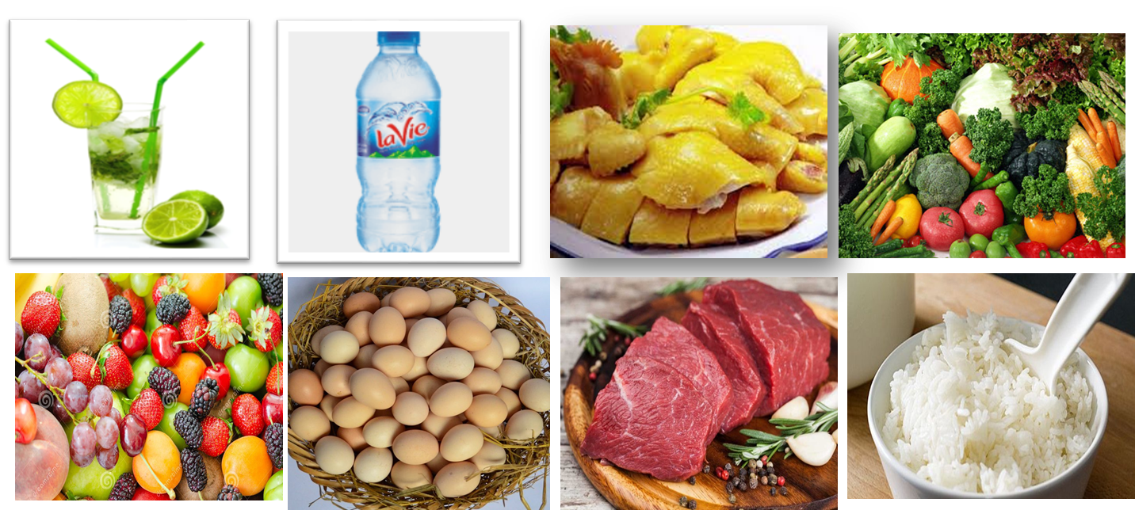
  lemonade | Mineral  water | chicken | Vegetables
  Fruit | Eggs | Beef | rice
Activity 2: Presentation (15’)
* Pre - teach vocabulary
* Aim: to introduce new vocabulary, to help students use key language more appropriately before they read and listen
* Content: Learn some vocabularies related to the topic.
* Products: Students read and understand the meaning of vocab.
* Organization of implementation:
Teacher’s and Ss’ activities |  | Content
- T - Ss.  *Teacher uses different techniques to teach vocab (pictures, situation, realia)  ** Follow the seven steps of teaching vocab.  *** Repeat in chorus and individually  - Copy all the words  **** T checks the words by game: “What and where”  * Checking vocab: < what and where> |  | * Vocabulary  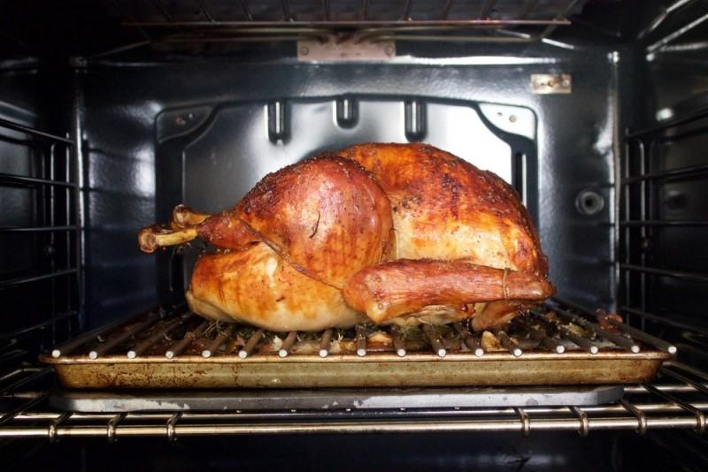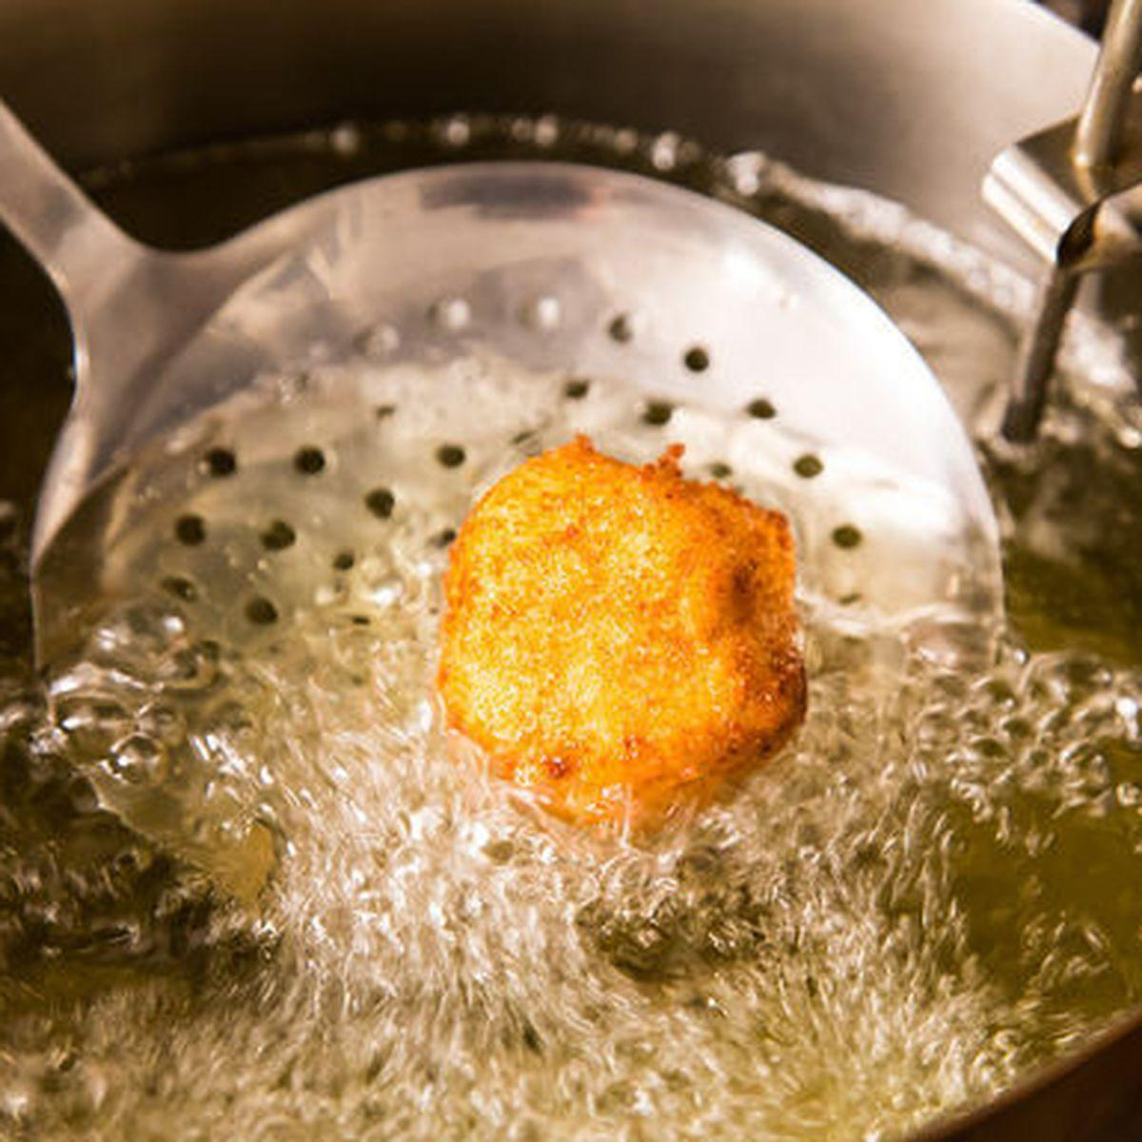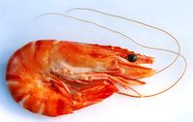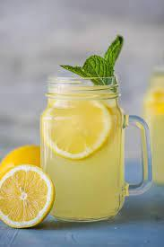  roast (v) /rəʊst/: quay, nướng (thịt…)  fry (v) /fraɪ/: rán  shrimp (n) /ʃrɪmp/: con tôm  lemonade (n) /ˌleməˈneɪd/: nước chanh  mineral water (adj) /ˈmɪnərəl/: nước khoáng
* Pre – reading and listening
* Aims: To get students interested in the topic; To set the context; To help Ss understand the main idea of the text
* Content: Answer some Qs related picture and the text; Role play
* Products: Students read and understand the meaning of the conversation
Students know how to role play
* Organization of implementation:
Teacher’s and Ss’ activities | Content
- T - Ss.  * Set the context for the listening and reading text. + Have Ss look at the picture and answer some questions,  + Encourage Ss to answer, but do not confirm whether their answers are right or wrong.  + Ask them to talk a bit about types of food and drink they know.  + T can also ask Ss to share any recent experiences of eating at a restaurant  **Play the recording twice for Ss to listen and read along. Have Ss underline the words that are related to the topic of the unit while they are listening and reading.  *** T invites some pairs of Ss to read the conversation aloud and gives feedbacks  **** Ask Ss what exactly Jack's family is doing. Now confirm the correct answer | Task 1. Listen and read  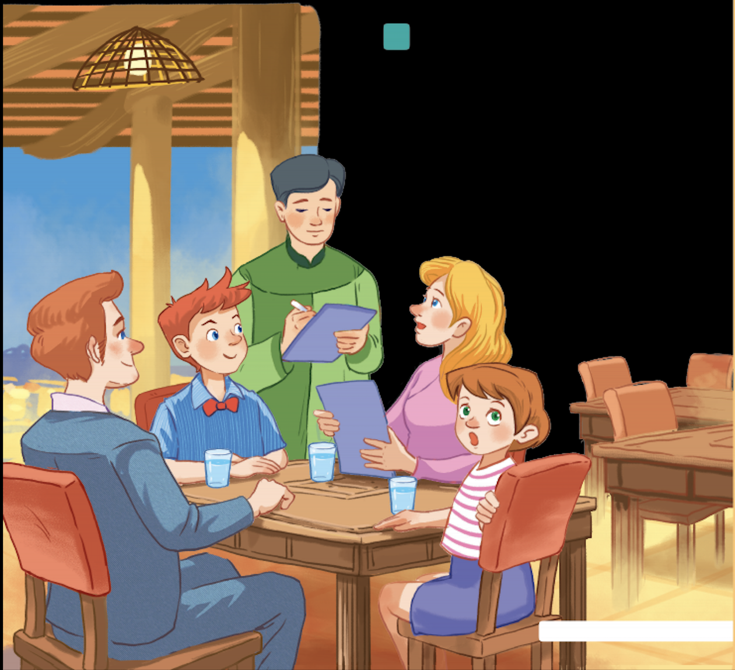  e.g  - Where is Mark's family?  - What are they doing?  _ Have you ever been to a restaurant?  _Where and when?  - What food and drink did you have there?  Task 2: Answer the question:  * What is Mark's family doing?  A. Ordering food for dinner.  B. Preparing for their dinner.  C. Talking about their favourite food.  Keys : A. Ordering food for dinner
Activity 3: Practice: (15’)

Task 3
* Aims: - To practice reading and listening for specific information; To practice scanning
- To develop Ss' vocabulary for food and drink
* Content: Find the words and phrases about food and drink in the conversation and write them in the correct columns
* Products: Ss say the correct answers and write all words/ phrases down on the notebooks exactly.
* Organization of implementation:
Teacher’s and Ss’ activities | Content
T-Ss, Ss-Ss  * Teacher asks Ss to work individually to read and listen to the conversation and find the words and phrases and then share their answers with their partners who sit next to them.  ** Ss do exercise 3 individually  *** Ss share and discuss with their partners to write all words/ phrases down on the notebooks.  **** Teacher corrects their answers as a class. | Task 3: Find the words and phrases about food and drink in the conversation and write them in the correct columns.  Key:
  Food | Drink
  rice, pork, fish sauce, roast chicken, fried vegetables, fried tofu, spring rolls, canh (soup), shrimp, fish, | juice, lemonade, green tea, mineral water, winter melon juice,
Task 4
* Aims: To help Ss deeply understand the text; To practice scanning and intensive reading
* Content: Read the conversation again and tick (✓) T (True) or F (False).
* Products: Students gives the correct answers and explains exactly.
* Organization of implementation:
Teacher’s and Ss’ activities | Content
T-Ss, Ss-Ss  * Teacher gives clear instructions.  ** Ss work individually step by step:  - Read the statements carefully and underline key words  - Scan the conversation to locate the underlined key words  - Read intensively to tick True or False  *** Teacher nominates Ss to read the statements aloud and say which ones are True and False, the others attentively listen to and correct their answers if necessary.  **** Teacher checks and gives the correct answers. | Task 4: Read the conversation again and tick (✓) T (True) or F (False).  * Suggested keywords in the statements:  1. Mark's family is at a Vietnamese restaurant.  2. Mark wants fried tofu and beef for dinner.  3. They don't order canh.  4. Mark's mum wants mineral water.  5. His mum doesn't allow her children to drink juice during dinner.  * Answer key:  1. T  2. F (Mark wants some fried tofu and spring rolls.)  3. F (Mark's dad thinks they will try some canh)  4. T  5. F (Mineral water for me, green tea for my husband, and juice for my children)
Activity 4: Production:(5’)
Task 5
* Aims: - To help Ss be able to talk about favorite food and drink; To develop teamwork skills
- To give students authentic practice in using target language
* Content: Think about your favorite food and drink. Then ask your partner about his or her favourite food and drink.
* Products: Some pairs perform in front of the class.
* Organization of implementation:
Teacher’s and Ss’ activities | Content
T-Ss, Ss-Ss  * Teacher gives Ss clear instructions in order to make sure Ss can role-play effectively.  ** Teacher asks each student to think of the questions he / she may use to ask about his / her partner's favorite food and drink.  *** Demonstrate the activity to the class first. Ask a strong student to help you. Then ask Ss to work in pairs. T goes round to help weaker Ss. Call on some pairs to perform in front of the class.  **** Teacher gives Ss feedback. | Task 5: Work in pairs. Think about your favorite food and drink. Then ask your partner about his or her favorite food and drink.  What kinds of food are the most popular? What ingredients are there? What is the food like  * Example:  A: What's your favorite food?  B: It's pho bo - beef noodle soup.  A: When do you usually have it?  B: In the morning.
Activity 5: Consolidation (3’)
* Aim: To consolidate what students have learnt in the lesson.
* Content: Summarize the main content what students have learnt in the lesson.
* Products: Some Ss say aloud in front of the class
* Organization of implementation:
Teacher’s and Ss’ activities | Content
- Teacher asks students to talk about what they have learnt in the lesson.  - Ss work independent | - Some new words  - Read and understand content of the conversation
* Homework (2’)
* Aim: To revise the lesson and prepare for the next lesson.
* Content: Review the lesson and prepare for the next lesson (A closer look 1)
* Products: Students’ textbook and workbook
* Organization of implementation
Teacher’s and Ss’ activities | Content
- T reminds Ss to do homework and prepare the new lesson. | - Learn by heart all the new words.  - Read the dialogue again.  - Prepare lesson 2 ( A closer look 1).
Complement.
………………………………………………………………………………………………………………………………………………………………………………………………………………………………..

