Date of preparing:
Date of teaching:
UNIT 5: FOOD AND DRINK
Period 37: Lesson 3: A CLOSER LOOK 2

I. OBJECTIVES:
By the end of this lesson, Ss will be able to:
1. Knowledge
- Know how to use the measurement words and phrases such as some and a lot of / lots of with countable and uncountable nouns
- Understand and use the How many/ How much to ask and answer about quantities
2. Competence
- Develop communication skills
- Be collaborative and supportive in pair work and team work
- Actively join in class activities
3. Educational aim:
- Promote pride in the values ​​of Vietnamese culture
- Develop love for family
II. MATERIALS
1. Teacher: - Grade 7 textbook, Planning (Unit 5- A closer look 2)
- Smart TV/Pictures, sets of word cards
- Sachmem.vn
2. Students: Text books, notebooks, posters, ….
3. Method: Ask and answer; group works; individual ……
III. PROCEDURES:
Activity 1: Warm-up (5’)
* Aim: To activate students’ knowledge using some and a lot of / lots of
- To get students interested in the topic
* Content: Mini game: Are these countable and uncountable?
* Products: Ss play in groups and say the word correctly.
* Organization of implementation:
Teacher’s and Ss’ activities | Content
* Warm up (group work)  - T - Ss  * Teacher divides the class into big groups (named Mango & Orange) and gives instruction.  ** Teacher say aloud the words (apple, carrot, chicken, salt, meal, sugar, star, cucumber, pepper, meat…)  *** Ss of Mango team stand up and shout out if the word is countable.  - Ss of Orange team stand up and shout out if the word is uncountable.  **** Teacher checks and tells Ss the noun is countable or uncountable when they have already reacted; The team with more correct words will win the game.  →Lead in: Today we are going to learn more about countable and uncountable nouns. | * Mini game: Are these countable and uncountable?  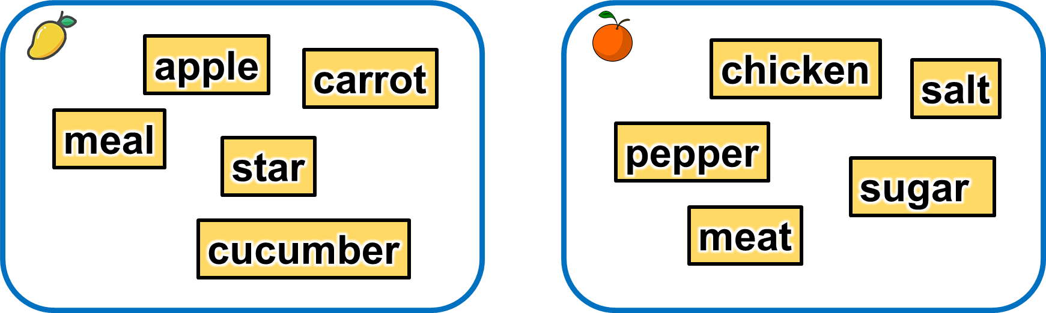
Activity 2: Presentation (5’)
* GRAMMAR
Measurement words/phrases: some, a lot of / lots of
* Aim: To help Ss understand and know how to use some, a lot of / lots of
* Content: Grammar: Countable and Uncountable nouns:
* Products: Understand and know how to use Countable and Uncountable nouns.
* Organization of implementation:
Teacher’s and Ss’ activities |  |  | Content
T –Ss:  * Teacher shows meanings of the new words in Vietnamese and asks Ss to translate them into English before starting the lesson  ** Teacher asks Ss to look at some countable nouns and uncountable nouns she has said and shared on the screen in the mini game, then asks them to tell the difference between countable nouns and uncountable nouns  ***After that, teacher has Ss look at the Remember! box about the use of some, a lot of / lots of and explain how to use some and a lot of / lots of, then show them the examples in the Remember! box.  ****Teacher briefly explains that some and a lot of / lots of are all used with both countable nouns and uncountable nouns to talk about quantities. Teacher also explains that SS can use some with plural countable nouns or uncountable nouns to talk about a number or amount of something / somebody when the exact number or amount is not given; Ss can use lot of / lots of with plural countable nouns or uncountable nouns to talk about a large number or amount of something / people. |  |  | * Vocabulary  1. đếm được: countable /ˈkaʊntəbəl/  2. số lượng: quantity /ˈkwɒntəti/  3. miêu tả: describe /dɪˈskraɪb/  4. nhiều người biết đến: popular /ˈpɒpjələr/  GRAMMAR  Measurement words/phrases: some, a lot of / lots of  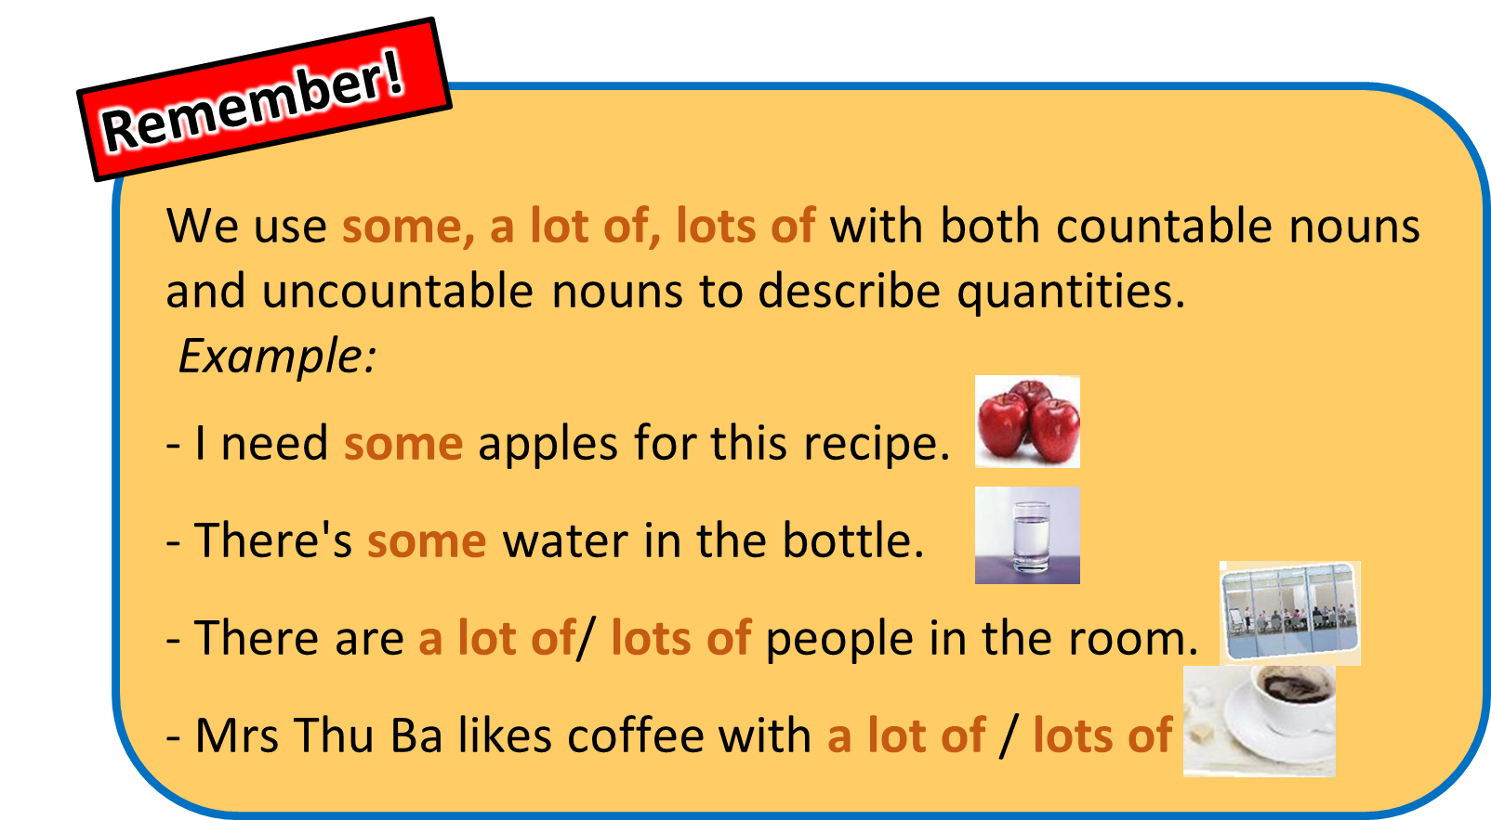
Activity 3: Practice ( 25 ’)
Task 1
* Aims: - To help Ss practice using some and a lot of / lots of in sentences and in context.
* Content: Choose the correct option for each sentence.
* Products: Students say the correct keys aloud.
* Organization of implementation:
Teacher’s and Ss’ activities |  | Content
* T –Ss, Ss- Ss  * Teacher asks Ss to read the sentences carefully and choose the best answers on their own, then then swap with their partners.  ** Ss do the exercise as instructed.  *** Ss share their answers and discuss the reasons why they have chosen them.  **** Teacher nominates some Ss to read their answers in front of the whole class, check and correct their answers. |  | Task 1: Circle the correct words or phrases to complete the following sentences.  Key:
  1. a lot of
  2. lots of
  3. some
  4. a lot of
  5. some
* Aims: To give Ss further practice on using some and a lot of / lots of in sentences and in context
- T help Ss revise the use of any.
* Content:
* Products: Understand and know how to use Some, many, much, a few, a little:
* Organization of implementation:
Teacher’s and Ss’ activities |  | Content
* T –Ss, Ss- Ss  * Teacher divides the class into 4 groups, asks them to look at the photos on the screen, write down the words/ phrases to complete the sentences as quickly as they can on their mini boards/ paper sheets and raise the board above their heads, saying "Bingo!"  ** The groups having more members who write correct answers the most quickly will get a star.  **** Teacher observes them closely and has one student assist in writing the number of stars each group achieves. |  | Task 2: Look at the pictures and complete each sentence. Write some, any or a lot of/lots of in the blanks.  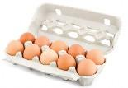  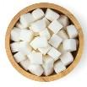  * Keys:  1. a lot of/lots of  2. any  3. some  4. a lot of/lots of  5. a lot of/lots of
Task 3
* Aims: To help Ss revise the use of How many and How much to ask about quantities.
* Content: Fill in each blank with How many or How much. Answer the questions, using the pictures
* Products: Understand and know how to use How many or How much.
* Organization of implementation:
Teacher’s and Ss’ activities |  | Content
T - Ss  * Teacher asks Ss to read the sentences carefully and choose the best answers on their own, then then swap with their partners.  ** Ss do the exercise as instructed.  *** Ss share their answers and discuss the reasons why they have chosen them.  **** Teacher nominates some Ss to read their answers in front of the whole class, check and correct their answers. |  | Task 3: Fill in each blank with How many or How much. Answer the questions, using the pictures.
Task 4
* Aims: To get Ss to use How much/ How many to ask questions about quantities
* Content: Work in pairs. Ask and answer, using How much/ How many.
* Products: Ss role play to ask and answer in front of the class.
* Organization of implementation:
Teacher’s and Ss’ activities |  | Content
* T-Ss, Ss-Ss  * - Teacher gives Ss two minutes to think of and write down as many questions using How much and How many as they can.  - Teacher pairs them to take turns asking and answering the questions in Task 3 and the questions they have prepared.  ** Ss work in pairs to practice.  *** Teacher nominates some pairs of Ss to model this activity in front of the class. The others vote the pairs they like best.  **** Teacher gives feedback to help students improve their talk later. |  | Task 4: Work in pairs. Ask and answer, using the questions in 3.  Eg. A: How much water do you drink every day?  B: Two litres.  A: How many bananas do you eat every week?  B: I eat two bananas every week.
Activity 4: Production (5’)
* Aims: -To get Ss to practice using measurement words and phrases, words of dishes and ingredients, How many and How much in context.
* Content: Work in pairs. Take turns to ask and answer about the recipes of pancakes and an omelette
* Products: Ss ask and answer in front of the class fluently.
* Organization of implementation:
Teacher’s and Ss’ activities |  | Content
* T-Ss, Ss-Ss  * - Teacher chooses some strong Ss in the class and assign the role of culinary teachers to them. The others will be culinary learners.  - Teacher asks them to sit in their groups to discuss and list all the questions and answers to make conversations in a culinary class.  - Teacher then mixes them in groups of a teacher and 3 to 4 students and asks them to make conversations asking and answering how to make pancakes and an omelette in a culinary class.  **/*** Every S in the group needs motivation to take part in the conversations while teacher goes around and observes them talking.  **** Teacher notes all useful measurement expressions and some students' grammatical errors for later comments. |  | Task 5: Work in pairs. Take turns to ask and answer about the recipes.  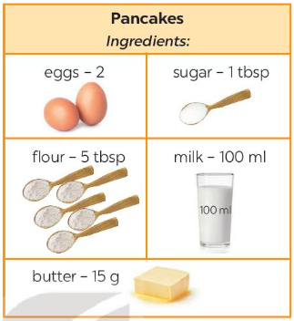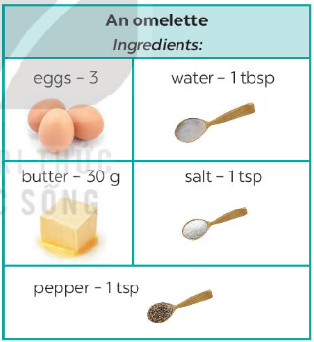  A: What do we need to make pancakes?  B: We need eggs, sugar, flour, milk, and butter.  A: How many eggs do we need?  B: Two.
Activity 5: Consolidation (3’)
* Aim: To help students to recall information they’ve learned during class and reflect on gaps in their knowledge
* Content: summarize the main content in the lesson.
* Products: Ss say what they have learnt in the lesson.
* Organization of implementation:
Teacher’s and Ss’ activities |  | Content
Teacher asks students to talk about what they have learnt in the lesson. |  | - How to use some, a lot of/ lots of  - How to ask and answer about food, drinks and cooking recipes using some, a lot of/ lots of, How many, How much
* Homework (2’)
* Aim: To revise the knowledge that students have gained in this lesson and prepare the new lesson
* Content: Review the lesson and prepare for the next lesson and do exercise in the workbook
* Products: Students’ textbook and workbook
* Organization of implementation:
Teacher’s and Ss’ activities |  | Content
- T reminds Ss to do homework and prepare the new lesson. |  | - Do exercises in the workbook.  - Prepare lesson 4 (communication)
Complement.
…………………………………………………………………………………………………………………………………………………………………………………………………………….

