Date of planning:……  Date of teaching: ….  WEEK: ….. | Period 22: UNIT 3: HEALTHY LIVING FOR TEENS  Lesson 7: LOOKING BACK & PROJECT
I. OBJECTIVES: * By the end of this lesson, Ss will be able to gain the following items:
1. Knowledge:
- Revise vocabulary items related to the topic students' life and schoolwork;
- Use modal verbs in first conditional sentences;
- Apply what they have learnt (vocabulary and grammar) into practice through a project.
+ Integrated skills: Listening, speaking, reading, writing.
* Vocabulary:
- Use words related to students’ life and school work.
+ Ask for repetition and respond;
* Grammar:
- Use modal verbs in the first conditional sentences.
2. Competence:
- Develop communication skills and and creativity;
- Be co-operative and supportive in pair work and teamwork.
3. Personal qualities:
- Be encouraged to attend school activities;
- Actively join in class activities.
- Develop self-study skills.
II. TEACHING AIDS:
- Teacher: Grade 9 text book ; Projector / TV.....
- Students : Text books, workbook…
- Computer connected to the Internet.
- Hoclieu.vn
III. PROCEDURE:

1. WARM UP & INTRODUCTION ( 3’- 5’)
* Objectives:
- To create an active atmosphere in the class before the lesson;
- To lead into the new lesson.
* Content: Kim’s game
To have some warm-up activities to create a friendly and relaxed atmosphere to inspire Ss to warm up to the subject and new lesson.
* Expected outcomes: Having a chance to speak English.
* Organisation : Teacher’s instructions …

Teacher’s & Student’s activities | Content
+ Greeting  + Kim’s game  - T asks Ss to work in groups of three or four Ss.  - Get them to look at the pictures about Ss’ life and schoolwork on the screen.  - Tell Ss that the pictures will disappear after 2 seconds, so they should try to remember all the pictures without writing them down.  - After all the pictures disappear, Ss have 1 minute to write down the words (2 points for each correct answer).  - T gets Ss to swap the answers among groups and give corrections after T shows the answers.  - Ss give marks to their friends’ answers.  - T leads in the lesson. | + Greeting  + Kim’s game  + Students (Ss) listen and learn how to do the tasks.  * 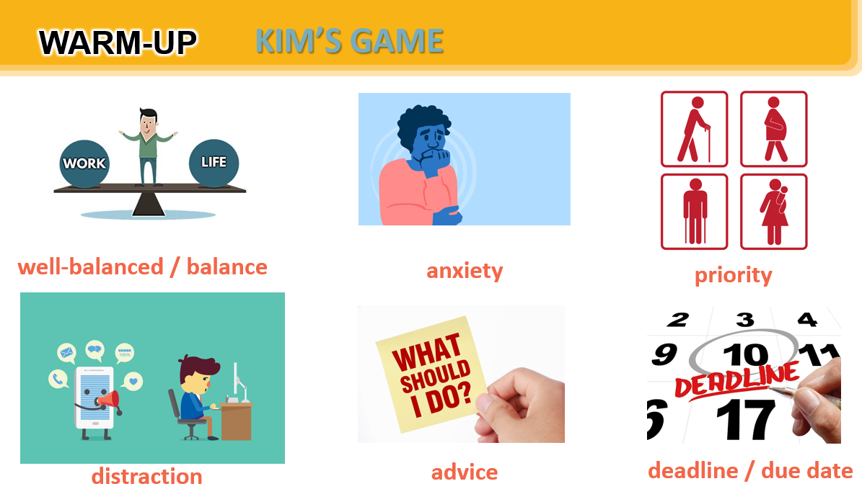  - Open the book and write the tittle of the lesson.
ACTIVITY 1. PRESENTATION/ NEW LESSON ( 12’- 15’)

I. VOCABULARY
* Objectives:
1 +2 To help Ss revise the vocabulary items they have learnt in the unit.
* Content:
- Task 1: Complete the sentences with the correct words and phrases in the box.
- Task 2: Choose the correct answer A, B, C, or D.
* Expected outcomes:
- Students can use the knowledge they have learnt in this unit to complete the tasks successfully.
* Organisation : Teacher’s instructions.

Teacher’s & Student’s activities | Content
TASK 1: Complete the sentences with the correct words and phrases in the box.

- Ask Ss to do these activities individually then compare their answers with their partners. Ask for Ss' answers or ask some Ss to read out their answers in front of the class.  - Check and confirm the correct answers. | - T_Ss  *Answer key:  1. well-balanced 2. due date  3. stressed out 4. priority  5. delay
TASK 2: Choose the correct answer A, B, C, or D.

- T encourages Ss to complete the task individually.  - Ss exchange their textbooks with their partners.  - T gives feedback as a class discussion. | - T_Ss  * Answer key:  1. A 2. C  3. A 4. B 5. C
ACTIVITY 2: GRAMMAR

* Objectives:
3 + 4. To help Ss revise the forms and uses of modal verbs in first conditional sentences.
* Content:
- Task 3: Complete the sentences with the correct modal verbs in the box. A modal verb can be used twice.
- Task 4: Circle the most suitable modal verbs to complete the sentences.
* Expected outcomes:
- Recall the uses of modal verbs in first conditional sentences.
* Organasation: Teacher’s instructions.

Teacher’s & Student’s activities | Content
TASK 3: Complete the sentences with the correct modal verbs in the box. A modal verb can be used twice.
+ Ask Ss to do the exercises individually first.  Then they can check their answers with a partner before discussing the answers as a class.  - Confirm the correct answers. | - T_ Ss  * Answer key:  1. must 2. might  3. can 4. should  5. can
TASK 4: Circle the most suitable modal verbs to complete the sentences.

- T asks Ss to work in pairs to read the sentences carefully and give the answers.  - T gives feedback as a class discussion. | - T_ Ss.  * Answer key:  1. shouldn’t 2. might  3. can 4. must  5. can
ACTIVITY 3. PRODUCTION/ PROJECT ( 8’)

* Objectives:
+ To provide an opportunity for Ss to develop their research and collaboration skills and to practise giving an oral presentation
* Content:
- Survey: How good are your classmates at time management?
+ Ss’ presentations.
* Expected outcomes: Students are able to give an oral presentation of survey results.

* Organization:
Teacher’s & Student’s activities | Content
- As Ss have prepared for the project throughout the unit, the focus of this lesson should be on the final product, which is an oral presentation of survey results.
- Have Ss work in their groups. Give them a few minutes to prepare for the presentation.
- Give Ss checklists for peer and self-assessment. \
- Explain that they will have to tick appropriate items while listening to their classmates' presentations and write comments if they have any. The presenters should complete their self-assessment checklists after completing their presentations.
- If necessary, go through the criteria for assessing their talk to make sure Ss are familiar with them.
- Invite two or three groups to give their presentations. Encourage the rest of the class to ask questions at the end.
- Give praise and feedback after each presentation.
- T can summarise the feedback given by other Ss and add any other comments.
- T can also give Ss marks for their presentation as part of their continuous assessment
** FEEDBACK FORM FOR SURVEY.(See teacher’s book)
Suggested answer:
Our group has interviewed 10 classmates about how good they are at time management. Only one of them is excellent at time management. He creates and follows a schedule or to-do list to manage his time efficiently. He prioritises his tasks effectively to ensure timely completion. He consistently completes tasks and projects within the given deadlines. He usually avoids delaying and stays focused on his tasks. He often uses productivity tools or techniques to enhance his time management skills. Five of the classmates we have interviewed are good at time management. They create and follow a schedule or to-do list to manage their time efficiently. They also prioritise their tasks effectively to ensure timely completion.They consistently complete tasks and projects within the given deadlines. They usually avoid delaying and stay focused on their tasks. However, they never use productivity tools or techniques to enhance their time management skills. Four of the classmates we have interviewed are poor at time management. They always try to complete tasks and projects within the given deadlines. However, they never create and follow a schedule or to-do list to manage their time efficiently. They don't prioritise their tasks effectively to ensure timely completion. They rarely try to avoid delaying or stay focused on their tasks. And they never use productivity tools or techniques to enhance their time management skills.

4. WRAP-UP & HOME WORK (2’)
* Ask one or two Ss to tell the class what they have learnt.
- Summarise the main points of the lesson.
* HOME WORK:
- Do more exercises in workbook.
- Prepare new lesson: Unit 2: LIFE IN THE CITY.
========================================

