Date of planning: 03.10.2024  Date of teaching: 04.10.2024  WEEK: | Period 11: UNIT 2: CITY LIFE  Lesson 2: A CLOSER LOOK 2
I. OBJECTIVES: * By the end of this lesson, Ss will be able to gain the following items:
1. Knowledge:
- To teach “double comparatives”. Comparisons of adjectives (review).
- Learn how to form and use double comparatives and some phrasal verbs.
* Integrated skills: Listening, speaking, reading, writing.
* Vocabulary:
+ Gain vocabulary to talk about life in the city
+ offering help and responding;
* Grammar:
- Recognise and use double comparatives and some phrasal verbs;
2. Competence:
- Be co-operative and supportive in pair work and teamwork.
- Access and consolidate information from a variety of sources.
3. Personal qualities:
- Be friendlier and willing to help the local community;
- Actively participate in class activities.
- Develop self-study skills.
II. TEACHING AIDS:
- Teacher: Grade 9 text book ;Projector / TV.....
- Students : Text books, workbook…
- Computer connected to the Internet.
- Hoclieu.vn
III. PROCEDURE: A. Double comparatives
Language notes
Double comparatives
Form | Example
The comparative + S + V, the comparative + S + V.
Short adj: adj + er | The nearer we got to the suburb, the less busy the road was.
Long adj: more/less + adj | The more developed the city is, the more crowded it becomes.
B. PHRASAL VERBS (See below)
Eg: + When I was in town, I chose to get around by bus.
- I’m coming down with a cold. I have a runny nose and a sore throat.
- Modal verbs: get around, carryout, come down with, hang out with, cut down on…

III. PROCEDURE:

1. WARM UP & INTRODUCTION ( 3’- 5’)
* Objectives:
- To create an active atmosphere in the class before the lesson;
- To lead into the new lesson.
* Content: To have some warm-up activities to create a friendly and relaxed atmosphere to inspire Ss to warm up to the subject and new lesson.
* Expected outcomes: Having a chance to speak English.
* Organisation : Teacher’s instructions …

Teacher’s & Student’s activities | Content
+ Greeting  + Chatting.  + Teacher (T) asks Ss some questions about the previous lessons,  - T may introduce some warm-up activities to create a friendly and relaxed atmosphere to inspire Ss to warm up to the subject and new class…  - T encourages Ss to talk in English as much as possible  Option 1: Think!  - Show Ss a picture of two bowls of spicy noodles. The second bowl of noodles has more chillis than the first one.  - Ask Ss which bowl of noodles they prefer.  - Put a tick below the first bowl and two ticks below the second bowl and tell them that the number of ticks shows T’s preference. Elicit from Ss a sentence with comparative structure (I like the second bowl more than the first bowl).  - Tell Ss that today they are learning another structure of comparison of adjectives.  - Introduce the objectives of the lesson. Write the objectives in the left corner of the board. | + Greeting  - T_Ss.      - Open the book and write the tittle of the lesson.
ACTIVITY 1. PRESENTATION/ NEW LESSON ( 12’- 15’)
* Objectives:
+ To present the new structure of double comparatives.
+ To help Ss use the grammar point correctly with attention to form and meaning.
* Content: To teach grammar. DOUBLE COMPARATIVE
- Task 1: Choose the correct option to complete each sentence.
- Task 2: Find a mistake in the underlined parts in each sentence below and correct it.
* Expected outcomes: Students know how to use double comparatives.
* Organisation : Teacher’s instructions.
Teacher’s & Student’s activities | Content
TASK 1: Choose the correct option to complete each sentence.
+ Show another picture of a bowl of spicy noodles which has even more chillies than the second bowl. - Put three ticks below this picture.  + Write the sentence "The hotter the noodles are, the more delicious they get." Underline "the hotter" and "the more delicious". Check if they understand the sentence.  + Tell Ss that they can use "the" with comparative adjectives to emphasise that one thing depends on another.  - Draw their attention to the form: The + comparative adjective 1 + clause 1, the + comparative adjective 2 + clause 2.  + Remind them that there must be “the” before the comparative form of adjective.  - Go through the Remember! box with Ss. Use the given examples to reinforce the grammar point.  - Ask Ss to look at Task 1. Do the first sentence with the class as an example.  - Tell Ss to complete Task 1 individually, then check their answers with another pair.  - Invite some Ss to share their answers. Confirm the correct answers. Explain or elicit explanations from Ss. | - T_Ss  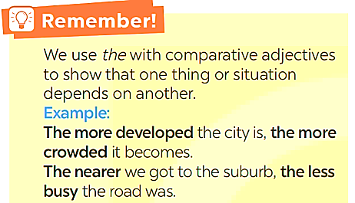  * Suggested answers:  1. later  2. more comfortable  3. the higher  4. more famous  5. the more difficult
TASK 2: Find a mistake in the underlined parts in each sentence below and correct it.

- Tell Ss to find a mistake in each sentence and correct it. Tell them to read the sentence carefully and pay attention to the meaning of each sentence.  - Ask Ss to do this exercise in pairs.  - Invite one or two Ss to write the mistakes and their corrections on the board.  - Check answers. Ask Ss to explain the meaning of each sentence after correcting the mistake.  - Reinforce the structure once more by reminding Ss of common mistakes: missing "the", incorrect use of comparatives, wrong order of subject and verb in the clause, etc. | - T_Ss  * Key:  1. B (The hotter)  2. C (more tired)  3. A (more modern)  4. D (the more polluted)  5. B (uglier)  *  ( 1. B (The hottest => The hotter)  2. C (tired => more tired)  3. A (modern more modern)  4. D (more polluted => the more polluted)  5. B (more ugly => uglier )
ACTIVITY 2: PHRASAL VERBS (2)
Objectives:
+ To present five phrasal verbs.
+ To help Ss practise using phrasal verbs learnt in 3 in sentences.
* Contents:
- Task 3: Match a phrasal verb in column A with a suitable word / phrase in column B.
- Task 4: Complete each sentence with a phrasal verb in 3. You can change the form of the
* Expected outcomes : Students understand and learn how to use some phrasal verbs.
* Organisation:
TASK 3: Match a phrasal verb in column A with a suitable word / phrase in column B.
Teacher’s & Student’s activities | Content
- Ask Ss to recall the phrasal verbs in Unit 1. Tell them that they will learn five more phrasal verbs in this lesson.  - Ask Ss to do Activity 3 individually. Tell them that they can guess if they are not sure.  - Check the answers as a class. Write the correct matches on the board.  - Elicit the meaning of each phrasal verb (get around ~ move from place to place / go to a lot of different places; carry out ~ conduct; come down with ~ catch (a disease); hang out with ~ spend time a lot of time with sb; cut down on ~ reduce).  - Check Ss’ comprehension by asking them some questions, tell them to translate the phrases into Vietnamese, or play Slap the board game. | - T_ Ss  * Answer key:  1. d 2. c  3. e 4. b 5. a
TASK 4: Complete each sentence with a phrasal verb in 3. You can change the form of the verb when necessary

- Tell Ss that they will work in pairs and complete Task 4.  - Set a time limit for them. Then call on one or two Ss to write the answers on the board.  - Check the answers. Elicit explanations from Ss.  * Teacher corrects for students as a whole class. | - T_ Ss.  *Answer key:  1. coming down with  2. cut down on  3. get around  4. hang out with  5. carrying out
EXTRA ACTIVITY:
- Have Ss play a quick game such as “Find someone who…”. Ask them to copy the following table into their notebooks. Then, tell them to ask their classmates to find at least one person who says “Yes” to each statement. The person who finishes their table first will say Bingo and become the winner of the game. (See Teacher’s book)
Find someone who... | Name | More information
1. likes getting around by public transport.
2. carried out a project last week.
3. came down with a flu or a cold last year.
4. often hangs out with friends in their free time.
5. wants to cut down on the amount of water they use daily.

ACTIVITY 3. PRODUCTION/ FURTHER PRACTICE ( 8’)
* Objectives:
+ To give Ss speaking practice with double comparatives.
* Content:
- Task 5: Work in pairs. Tell each other whether you agree or disagree with the following ideas.
* Expected outcome: Students can apply the grammar they have learnt in practical situations.

* Organisation :
Teacher’s & Student’s activities | Content
TASK 5: Work in pairs. Tell each other whether you agree or disagree with the following ideas.
- Go through the three sentences in 5 to make sure Ss understand them.  - Ask Ss to work in pairs. Each person chooses a sentence and says whether they agree or disagree with it. Encourage them to provide an example, a reason and / or an explanation for their viewpoint.  - Invite some Ss to share their opinions in front of class. Others listen and give feedback  * Teacher gives corrections and feedbacks. | * Suggested outcomes:  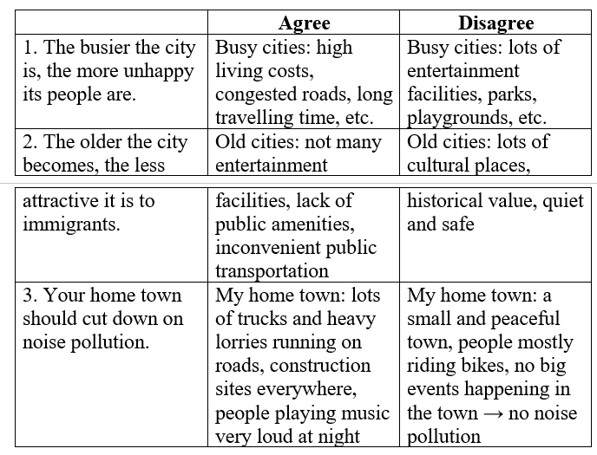
5. WRAP-UP & HOME WORK (2’)
+ Ask Ss to summarise what they have learnt in the lesson. Have Ss look at the objectives written on the board at the beginning of the lesson and tick the objectives they have learnt.
* HOME WORK:
- Do more exercises in workbook.
- Prepare new lesson: Lesson : COMMUNICATION.

==============================================

