Date of preparing:
Date of teaching:
UNIT 4: MUSIC AND ARTS
Period 30 Lesson 2: A CLOSER LOOK 2

I. OBJECTIVES
By the end of this lesson, students will be able to:
1. Knowledge:
* Vocabulary: + use the lexical items related to the topic Music and arts;
* Grammar: Comparisons
1. like → To show that sth is similar to sth else.
2. different from → To show that two or more things are not similar.
3. as + adj + as → To show that two things are similar.
4. not as + adj + as → To show that sth is “more” or “less” than sth else.
2. Competence:
- Develop communication skills
- Be collaborative and supportive in pair work and team work
- Actively join in class activities
3. Educational aim:
- Be responsible and hard-working
II. TEACHING AIDS:
1. Teacher: - Grade 7 textbook, Planning (Unit 4- A closer look 2)
- Smart TV/Pictures, sets of word cards
- Sachmem.vn
2. Students: Text books, notebooks, posters, ….
3. Method: Ask and answer; group works; individual ……
III. PROCEDURES:

Activity 1: Warm-up (5’)
* Aim: To activate students’ prior knowledge and vocabulary related to the targeted grammar of comparisons; To introduce the targeted grammar of the lesson.
* Content: GAME: BRAINSTORMING (Adjectives)
* Products: Ss play game in groups and write adjectives in the group board exactly.
* Organization of implementation:
Teacher’s and Ss’ activities |  |  | Content
* Warm up (group work)  - T - Ss  * Teacher asks students to work in 2 teams to think of as many adjectives to describe as possible.  ** Students work in 2 teams.  *** In 1 minute, students from each team, turn by turn, run to the board and write down one adjective.  **** Teacher comments and counts how many correct answers for each team.  - The team which has more correct answers will be the winner.  * Teacher shows the picture and asks students to use one adjective they have found to make comparisons  ** Students work individually.  *** Students give teacher a sentence:  **** Teacher gives feedback, then lead to the new lesson.  →Lead in  Teacher says: “This lesson today is going to tell you more about comparisons using like, different from, (not) as … as” |  |  | GAME: BRAINSTORMING  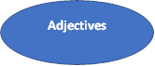  * Suggested answers:  big, small, heavy, light, cheap, expensive, boring, interesting, special, fun, thin, fat, tall, short, handsome, ugly, etc.  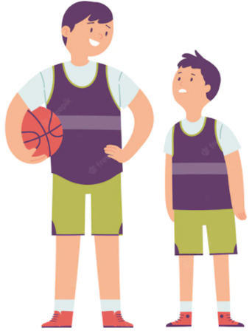  “The boy on the left is taller than the boy on the right.”
Activity 2: Presentation (10’)
* Aim: To introduce the form of comparisons to students.
* Content: Comparative adjectives
* Products: understand and how to use comparative adjectives
* Organization of implementation:
Teacher’s and Ss’ activities |  | Content
* Pre – grammar.  * Teacher prepares some pictures and asks students to make comparisons.  ** Students make comparison, using the pictures teacher shows on the screen.  Elicit the model sentences:  1. Teacher points to the yellow pencil and the orange pencil.  2. Teacher points to the yellow pencil and the pen and asks students to focus on the length of the two things.  3. Teacher points to the yellow pencil and the pen again and has students focus on their shape  4. Teacher says: “This is Robert’s pencil case and this is Mary’s pencil case” and asks them make comparison with “like”.  *** Students find out the form and the usage of comparisons using “like, different from, (not) as … as”  **** Teacher gives comments and writes on the board the form and the usage. |  | * Grammar: Comparative adjectives    Students: The yellow pencil is shorter than the orange one  Teacher: Right! Or I can say: “The yellow pencil is not as long as the orange one.”    → The pen is as long as the yellow pencil..  → The pen is different from the yellow pencil.  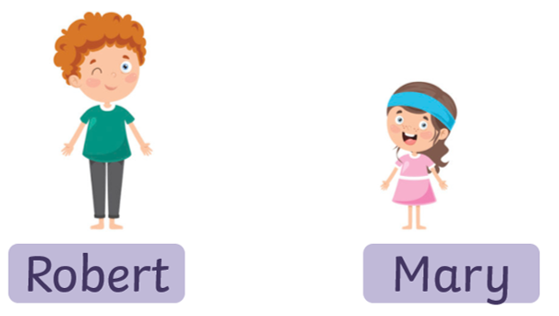  → Robert’s pencil case is like Mary’s pencil case.  * Concept checking:  + Form:  1. (not) as + adj + as  2. as + adj + as  3. to be different from  4. like  + Use: ask students to read “Remember box”, then teacher asks students some questions to check understanding.
Activity 3: Practice (20’)
Task 1
* Aims: To help students identify the correct form of comparisons, using like, different from, (not) as … as.
* Content: Write like, as, or different in the gaps
* Products: Students write correct the answers on the board.
* Organization of implementation:
Teacher’s and Ss’ activities | Content
Task 1: T –Ss  * Teacher asks students to do the exercise individually and then compare their answers with a classmate.  ** Students do the task individually.  *** Some students explain their choices.  **** Teacher confirms the correct answers. | TASK 1: WRITE LIKE, AS, OR DIFFERENT IN THE BLANKS. (Ex 1, p. 43)  * Answer key:  1. as  2. like  3. different  4. as  5. different
Task 2
* Aims: To help students use the correct comparisons using like, different from, (not) as … as.
* Content: Finish the second sentence in each pair using like, different from, (not) as … as.
* Products: Students’ correct sentences on the board.
* Organization of implementation:
Teacher’s and Ss’ activities | Content
Task 2: T - Ss  * Teacher has students do this exercise individually.  ** Students do the task individually.  *** Students give and explain their answers.  ****Teacher confirms the correct answers. | TASK 2: FINISH THE SECOND SENTENCE IN EACH PAIR, USING LIKE, AS … AS, OR DIFFERENT FROM. (Ex 2, p. 43)  * Answer key:  1. different from  2. like  3. as … as  4. different from  5. as … as
Task 3
* Aims: To help student practice using like, different from, (not) as … as.
* Content: Compare the two museums, using like, different from, (not) as … as.
* Products: Ss read aloud the complete sentences in front of the class.
* Organization of implementation:
Teacher’s and Ss’ activities | Content
Task 3: T - Ss, Ss - Ss  * Teacher asks students to work in pairs and helps them interpret the table first.  ** Students work in pairs to do the task and teacher encourages students to talk as much as possible.  *** Teacher calls on students to read aloud the complete sentences.  **** Teacher confirms the correct answers and helps them to correct mistakes if needed. | TASK 3: COMPARE THE TWO MUSEUMS: HISTORY AND SCIENCE, USING LIKE, AS … AS, OR DIFFERENT FROM. (Ex 3, p. 43)  * Suggested answers:  1. The History Museum is not as modern as the Science Museum.  2. The staff in History Museum is as friendly as ones in Science Museum.  3. Things in History Museum are more interesting than things in Science Museum.  4. The price in History Museum is like in Science Museum.
Task 4
* Aims: To help students revise to write comparisons using like, different from, (not) as … as.
* Content: Rewrite the sentences, using the words given at the beginning.
* Products: Ss write their correct answers on the board.
* Organization of implementation:
Teacher’s and Ss’ activities | Content
Task 4: T - Ss, Ss - Ss  * Teacher asks students to do the task individually to write down the sentences in their notebooks.  ** Students do the task individually and compare with their partners.  *** Some students write their answers on the board.  **** Teacher confirms the correct answers. | TASK 4: REWRITE THE SENTENCES, USING THE WORDS GIVEN AT THE BEGINNING. (Ex 4, p. 43)  * Suggested answers:  1. I think comedies are not as interesting as action films.  2. Our history homework is not as difficult as our math homework.  3. This year’s music contest is not like last year’s.  4. The characters in the film are different from the ones in the play.  5. That picture is not as bright as this one.
Activity 4: Production (5’)
* Aim: To help students practice speaking, using like, different from, (not) as … as through pictures.
* Content: Discuss and write a simple sentence from the two given sentences from 2 pictures)
* Products: Ss’ correct sentences on the group boards
* Organization of implementation:
Teacher’s and Ss’ activities | Content
Task 5: T - Ss, Ss - Ss  * Teacher asks students to work in groups to find out the similarities and differences between the two pictures and the things in them.  ** Students work in groups to do the task.  *** Students give as many sentences as possible.  **** Teacher listens to students to correct common errors after finishing speaking. | TASK 5: LOOK AT THE TWO PICTURES AND COMPARE THEM. (Ex 5, p. 43)  * Suggested answers:  - Picture A is not as big as picture B.  - The cat in picture A is different from the cat in picture B.  - The cat in the house in picture A is like the cat in the house in picture B.  - The fish in picture A is not as big as the fish in picture B.  - The flower in picture A is not as small as the flower in picture B.
Activity 5: Consolidation (3’)
* Aim: To consolidate what students have learnt in the lesson.
* Content: summarize the main content in the lesson.
* Products: Ss say what students have learnt in the lesson.
* Organization of implementation:
Teacher’s and Ss’ activities | Content
Teacher asks students to talk about what they have learnt in the lesson. | - Grammar: Comparative adjectives  - form and usage.
* Homework (2’)
* Aim: To revise the knowledge that students have gained in this lesson and prepare the new lesson
* Content: Review the lesson and prepare for the next lesson and do exercise in the workbook
* Products: Students’ textbook and workbook
* Organization of implementation:
Teacher’s and Ss’ activities | Content
- T reminds Ss to do homework and prepare the new lesson. | - Do exercises in the workbook.  - Prepare lesson 4 (communication)
Complement.
………………………………………………………………………………………………………………………………………………………………………………………………………………………………………..

