Date of preparing:
Date of teaching:
REVIEW 1 (UNIT 1,2,3)
Period 23: Lesson 1: LANGUAGE
(Pronunciation- Vocabulary- Grammar)

I. OBJECTIVES: By the end of this review, Ss will have revised the language they have learnt and the skills they have practiced in Units 1 -3.
1. Knowledge:
- To revise the language and skills they have learnt in Unit 1-2-3.
- Revise the words related to hobbies and verbs of liking and disliking; healthy activities and health problems; and words related to community activities;
- Pronounce the sounds /ə/, /ɜ:/, /f/, /v/, /t/, /d/, /ɪd/ correctly in isolation and in context;
- Revise the present simple tense, past simple to talk about past activities;
- Revise how to ask for and give health tips; how to give compliments.
* Vocabulary:
Ss revise the words related to hobbies and verbs of liking and disliking; healthy activities and health problems; and words related to community activities;
* Grammar:
Revise the present simple tense, past simple to talk about past activities; Simple sentences.
* Writing:
- Writing a paragraph about your hobby; Writing a passage to give advice on how to avoid viruses; Writing an email about school activities last summer.
2. Competence: Develop communication skills and cultural awareness
- Develop communication skills and creativity.
- Be cooperative and supportive in pair work and teamwork.
- Actively join in class activities
3. Qualities:
- Raise students’ awareness of the need to keep their neighborhood green.
- Develop self-study skills.
II. TEACHING AIDS:
- Teacher: Grade 7 text book, laptop, projector / TV/ pictures and cards....
- Students: Text books, studying equipment….
- Computer connected to the Internet.
- Sach mem.vn
III. PROCEDURES:
Activity1: WARM UP - (5’)
* Aim: To create an active atmosphere in the class before the lesson.

Teacher’s and Ss’ activities | Content
T- Ss  * Teacher shows 3 sets of pictures (taken from Project lessons of Unit 1-2-3) and asks students to find a keyword for each set of pictures.  ** Students raise hands to answer.  *** Teacher and students discuss the answers.  **** Teacher checks the answers as a class. | * Game: FINDING KEYWORDS    Set 1: HOBBIES  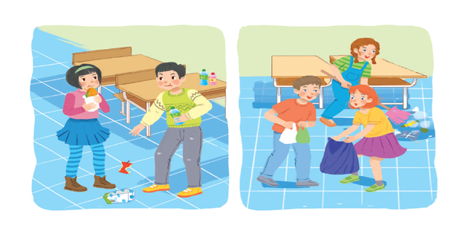  Set 2: HABITS (bad habits, good habits, healthy habits)  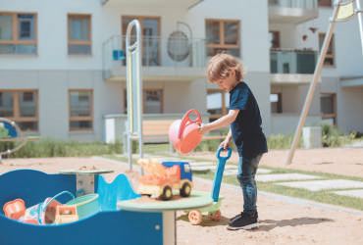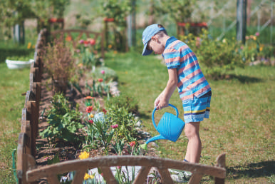  Set 3: COMMUNITY SERVICE
Activity 2: Practice (5’)
PRONUNCIATION
* Aim: To help Ss review the pronunciation of the sounds learnt in Units 1 - 3.

Teacher’s and Ss’ activities |  | Content
TASK 1:  * Teacher writes the sounds /ə/ and /ɜː/; /t/, /d/ and /ɪd/; /f/ and /v/ on the board.  - Teacher writes one word containing the sound below each of them.  - Teacher asks students to read the words aloud.  ** Students do the task by reading aloud each group and circling the odd one out.  *** Teacher can invite some pairs of students to read aloud.  **** Teacher check students’ pronunciation ad give feedback. |  | TASK 1: Circle the word in which the underlined part is pronounced differently  * Answer key:  1. A 2. C 3. B 4. A 5. B
Activity 3: VOCABULARY(15’)
* Aim: To help Ss revise the phrases showing activities and identify if they benefit oneself or the community.

Teacher’s and Ss’ activities | Content
TASK 2:  * Teacher tells students to read the phrases carefully and make sure they remember their meanings.  ** Students do this exercise individually by categorising the activities as they do them for their own sake or for the benefit of the community.  *** Teacher allows students to share their answers before discussing as a class and encourages them to pronounce the words / phrases correctly.  **** Teacher checks the answers as a class and gives feedback. | TASK 2: PUT THE PHRASES BELOW IN THE CORRECT COLUMNS  * Answer key:  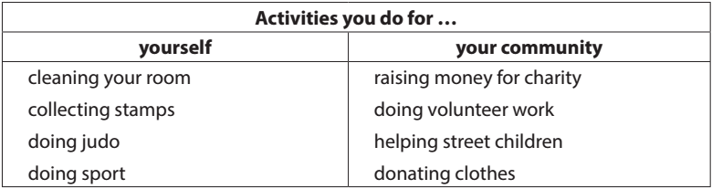
Activity 4:
* Aim: To help Ss revise more words from Units 1 - 3 and use them in context.

Teacher’s and Ss’ activities |  | Content
TASK 3  * Teacher asks students to work individually to complete the sentences with the given words and phrases.  ** Students work individually to complete the task.  *** Teacher allows students to share answers before discussing as a class.  **** Teacher asks students to say the sentences aloud and makes sure they pronounce the words and phrases correctly. Teacher can ask for translation to check their understanding. |  | TASK 3: COMPLETE THE SENTENCES WITH THE WORDS AND PHRASES BELOW. (Ex 3, p. 38)  * Answer key:  1. coloured vegetables  2. mountainous areas  3. hobby  4. chapped lips  5. community  6. taking photos
Activity 5: GRAMMAR(15’)
* Aims: To help students revise the use of the present or past simple.

Teacher’s and Ss’ activities |  | Content
TASK 4  * Teacher asks students to work independently to fill in the blanks with the correct tense of the verbs in brackets.  ** Students read the sentences first and underline the clues that help them decide if the verbs are used in the present or past simple tense.  *** Teacher reminds students to use the correct forms of the verbs (positive/ negative statements, or questions) as requested in each sentence then allows them to share answers before discussing as a class.  **** Teacher can ask students to read aloud the full sentences and correct their pronunciation if necessary. |  | TASK 4: FILL IN THE BLANKS WITH THE CORRECT TENSE OF THE VERBS IN BRACKETS. (Ex 4, p. 38)  * Answer key:  1. reads  2. Do … do  3. need  4. could not / couldn’t  5. did not / didn’t volunteer  6. joined
TASK 5:
* Aim: To consolidate what students have learnt in the lesson.

Teacher’s and Ss’ activities |  | Content
* Teacher asks students to read the sentences first and underline the verb in each sentence, then look at each verb and note if it is used in the present simple or past simple tense.  ** Students do the task individually.  *** Teacher reminds students to pay attention to the request of each sentence (change it into a negative statement or a question) then allows them to share answers before discussing as a class.  **** Teacher can ask students to read aloud the full sentences and correct their pronunciation if necessary. |  | TASK 5: TURN THE SENTENCES INTO NEGATIVE STATEMENTS OR QUESTIONS. (  * Answer key:  1. She didn’t like exercising.  2. My family doesn’t always spend time doing housework together on Sundays.  3. I didn’t use a lot of suncream during my holiday.  4. Did your community organise a fair to raise money for the homeless last week?  5. Does Tim make beautiful pieces of art from dry leaves and sticks?
Activity 6: Consolidation (3’)
* Aim: To consolidate what students have learnt in the lesson.

Teacher’s and Ss’ activities |  | Content
- Teacher asks students to talk about what they have learnt in the lesson. |  | - vocabulary and grammar in the lesson
* HOME WORK (2’)
- Do exercise in workbook.
- Prepare for the next lesson: Review (SKILLS).

