Date of preparing:
Date of teaching:
UNIT 3: COMMUNITY SERVICE
Period 22: Lesson 7: LOOKING BACK and PROJECT

I. OBJECTIVES:
By the end of this lesson, Ss will be able to:
1. Knowledge.
- Review the vocabulary and grammar of Unit 3.
- Apply what they have learnt (vocabulary and grammar) into practice through a project.
2. Competence.
- Develop communication skills and creativity
- Develop presentation skill.
- Develop critical thinking skill.
- Be collaborative and supportive in pair work and team work.
- Actively join in class activities.
3. Educational aim:
- Be more creative when doing the project.
- Develop self-study skills.
- Raise students’ awareness of the need to keep their neighbourhood green.
II. TEACHING AIDS:
1. Teacher: - Grade 7 textbook, Planning (Unit 3 - Looking back and project)
- Smart TV/Pictures, sets of word cards.
- sachmem.vn
2. Students: Text books, notebooks, posters, ….
3. Method: Ask and answer; group works; individual ……
III. PROCEDURES:
* WARM -UP (5’)
* Aim: - To revise the vocabulary related to the topic and lead in the next part of the lesson.
- To enhance students’ skills of cooperating with teammates.
Teacher’s and Ss’ activities | Content
* Warm up  - T -Ss  - Teacher shows the pictures and asks students to give descriptions to them. Teacher can divide the class into 2 teams and runs the game- Who’s faster.  - Members of each team take turns to raise hands to give description for each picture.  - Students discuss their friends’ answers.  -Teacher confirms the answers and gives feedback. The group having more correct answers is the winner. | *Warm-up - Game: Who’s faster  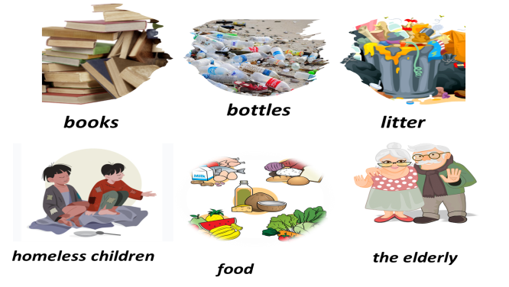
* LOOKING BACK
* VOCABULARY (10’)
Task 1+ Task 2
* Aim: To help students revise the vocabulary learnt.
- To help students match the correct verbs with the appropriate nouns / noun phrases to make phrases about community activities.
- To help students use the correct phrases about community activities in the correct contexts.
Teacher’s and Ss’ activities |  | Content
- T –Ss:  - Teacher encourages students to complete the task individually.  - Students do the task individually.  - Students exchange their textbooks with their partners.  - Teacher gives feedback as a class discussion.  - T –Ss  - Teacher asks students to complete the task individually.  - Students do the task individually to put the correct phrases in the blanks.  - Students exchange their textbooks with their partners.  - Teacher gives feedback as a class discussion. |  | Task 1: Complete the table with the words and phrases from the box.  * Answer key:  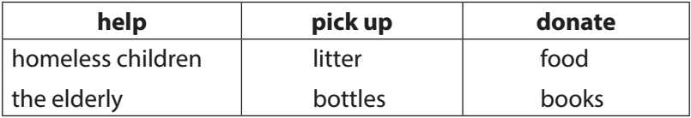  Task 2: Complete each sentence with one phrase from Task 1. Remember to use the correct forms of the verbs.  * Answer key:  1. donated food  2. picked up bottles  3. helped the elderly  4. donated books  5. helped homeless children
* GRAMMAR (13’)
Task 3 + Task 4
* Aims: To help students revise the past simple form of some verbs.
To help students improve their writing about community activities.
Teacher’s and Ss’ activities |  | Content
- T –Ss; Ss – Ss  - Teacher encourages students to complete the task individually.  - Students complete the passage using the correct forms of the verbs in the box.  - Students exchange their textbooks with their partners.  Teacher gives feedback as a class discussion.  - T –Ss; Ss – Ss  - Teacher asks students to do individually first.  - Students complete the task individually.  - Teacher then asks them to check their answers with a partner before discussing the answers as a class.  - Teacher confirms the answers and corrects students’ pronunciation if necessary. |  | Task 3: Use the correct form of the verbs from the box to complete the passage.  * Answer key:  1. had  2. collected  3. sold  4. donated  5. went  Task 4: Write full sentences about the activities the students did to help their community last year  * Answer key:  1. Mi sang and danced for the elderly at a nursing home.  2. Mark and his friends collected books and set up a community library.  3. Lan and Mai grew and donated vegetables to a primary school.  4. Minh and his friends gave food to young patients in a hospital.  5. Tom made and sent postcards to the elderly at Christmas.
* PROJECT (12’)
* Aims: - To help students identify problems that their neighbourhood is facing and brainstorm possible solutions to deal with those problems.
- To raise students’ awareness of the need to keep their neighbourhood green
- To improve students’ teamwork and public speaking skills.
Teacher’s and Ss’ activities |  | Content
- T –Ss; Ss – Ss  - Teacher has students work in groups and gives instructions to students as follow:  - discuss some environmental problems their neighbourhood is facing and how you are going to solve the problems.  - look at the pictures as clues to brainstorm ideas.  - Students discuss in groups then present the environmental problem to the class.  - Students vote for the best performance.  - Teacher gives feedback. |  | * PROJECT  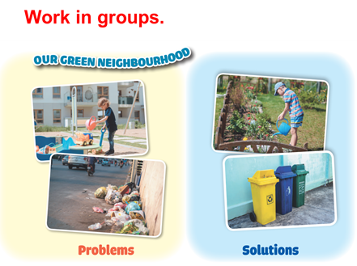  1. Think about some environmental problems in your neighborhood  2. Discuss and find the answers to the questions  . What problems can you find?  . What do you want to do to solve the problems?  . How are you going to do them?  3. Present them to your class
* CONSOLIDATION (3’)
* Aim: To consolidate what students have learnt in the lesson.
Teacher’s and Ss’ activities |  | Content
- Teacher asks students to talk about what they have learnt in the lesson. |  | - revise vocabulary and grammar in unit 3  - Make project about some environmental problems.
* HOMEWORK (2’)
Aim: To revise the knowledge that students have gained in Unit 3 and To prepare for the next lesson
Teacher’s and Ss’ activities |  | Content
- Teacher asks students to revise old lesson and to do exercise in workbook.  - Teacher asks students to complete the project and prepare the new lesson. |  | - Complete the project  - Prepare for the next lesson: Review 1.

