Date of preparing:
Date of teaching:
UNIT 3: COMMUNITY SERVICE
Period 18: Lesson 3: A CLOSER LOOK 2

I. OBJECTIVES:
By the end of this lesson, Ss will be able to gain:
1. Knowledge:
* Vocabulary: Some words related community activities.
* Grammar: - Understand the use of the past simple tense
- Practice using the past simple to talk about past activities
2. Competence:
- Develop communication skills and creativity
- Be collaborative and supportive in pair work and teamwork
- Actively join in class activities
3. Educational aim:
- Develop self-study skills
- Raise students’ awareness of the need to keep their neighbourhood green.
II. TEACHING AIDS:
1. Teacher: - Grade 7 textbook, Planning (Unit 3, A closer look 2)
- Smart TV/Pictures, sets of word cards
- sachmem.vn
2. Students: Text books, notebooks, posters, ….
3. Method: Ask and answer; group works; individual ……
IV. PROCEDURES:
* WARM- UP (5’)
* Aim: To activate students’ prior knowledge related to the targeted grammar: the past simple.
Teacher’s and Ss’ activities |  |  | Content
* Warm up  - T - Ss  -Teacher asks students some questions:  - Students answer the questions, using the past simple.  - Teacher and students discuss the answers.  - Teacher corrects students answers if needed and confirms the use of the past simple (to talk about completed actions in the past).  →Lead in  - Teacher says: “This lesson today we are going to revise the past simple”  ” |  |  | * Warm-up: Chatting  What did you do last weekend?  What did you watch yesterday?  Who did you meet two days ago?  * Students’ answer.
* PRESENTATION (10’)
* Aim: To review students’ knowledge of the past simple tense.
Teacher’s and Ss’ activities |  | Content
T -- Ss  - Teacher asks students to study the Grammar box.  - Teacher draws students’ attention to the meaning and use of the past simple.  - Teacher asks SS to remind the form of the past simple.  -Teacher then asks some more able students to give some more examples.  - Teacher confirms the answers and gives feedback. |  | UNIT 3:  Lesson 3: A closer look 2  * Grammar: Review the past simple.  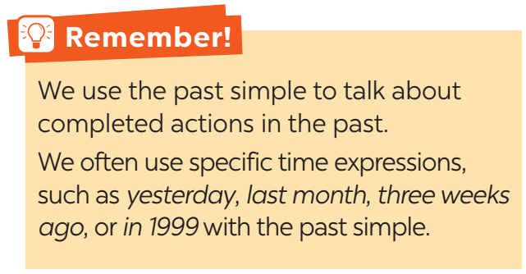
  Positive | S + V-ed / V ( cột 2)
  Negative | S + did not / didn’t + V
  Questions and short answers | Did + S + V ?  - Yes, S + did.  - No, S + didn’t.
* PRACTICE (20’)
Task 1
* Aims: To review students’ knowledge of the past simple tense.
Teacher’s and Ss’ activities | Content
Task 1: T –Ss, Ss- Ss  - Teacher has students work individually.  - Students work individually to complete the sentences with the past simple form of the given verbs.  - Teacher lets students work in pairs and exchange the answers before checking with the whole class (explain each sentence if necessary).  -Teacher confirms the answers and gives feedback. | Task 1: Circle the correct answer A, B, or C to complete each sentence.  * Answer key:  1. B  2. C  3. B  4. A  5. C
Task 2:
* Aims: To raise students’ awareness of the past simple tense and past forms of some verbs
Teacher’s and Ss’ activities | Content
Task 2: T - Ss, Ss - Ss  - Teacher has students work individually.  - Students work individually to complete the sentences.  - Teacher lets students work in pairs and exchange the answers before checking with the whole class (explain each sentence if necessary).  - Teacher confirms the answers and gives feedback. | Task 2: Complete the sentences with the past simple form of the given verbs.  * Answer key:  1. took  2. Did … join  3. helped  4. sent  5. volunteered
Task 3
* Aims: To help students distinguish between the present simple, present continuous and past simple in specific contexts.
Teacher’s and Ss’ activities | Content
- T-Ss, Ss-Ss  - Teacher asks the whole class to read aloud the verbs in the box then has students work individually to complete the sentences with the correct forms of the verbs from the box.  - Students work individually to complete the task.  - Teacher then has them work in pairs, comparing their sentences. Teacher can go around to help students.  - Teacher confirms the answers and gives feedback. | Task 3: Complete the sentences with the correct forms of the verbs from the box.  * Answer key:  1. cook  2. Did … plant  3. are picking up  4. recycled  5. read
Task 4*
Aims: To help students write full sentences using the correct forms of the verbs.
Teacher’s and Ss’ activities | Content
- T-Ss, Ss-Ss  -Teacher has students work independently.  - Teacher asks students to do the exercise individually.  - Teacher lets students work in pairs and exchange the answers before checking with the whole class (explain each sentence if necessary).  - Teacher confirms the answers and gives feedback.  . | Task 4: Write complete sentences from the prompts.  * Answer key:  1. Last year, our club donated books to children in rural areas.  2. Children sent thank-you cards to us a week ago.  3. I taught two children in grade 2 last summer.  4. Last spring, we helped the elderly in a nursing home.  5. We helped people in flooded areas last year.
* PRODUCTION (5’)
* Aims: - To enable students to ask and answer questions related to past activities.
- To help students be aware of some community activities that students in other countries do.
Teacher’s and Ss’ activities | Content
T - Ss, Ss – Ss  -Teacher introduces the Red Cross projects and activities in 2016 and 2020 and has students work in pairs for 5 minutes to practise asking and answering questions based on the fact sheet.  - Students use the past simple when they ask and answer questions about the past activities.  - Teacher invites some pairs to make short conversations as an example.  - Teacher corrects any grammar and pronunciation mistakes if necessary. | Task 5: Work in groups. Tom is from the Red Cross. Look at the fact sheet and ask Tom about his projects in 2016 and 2020.  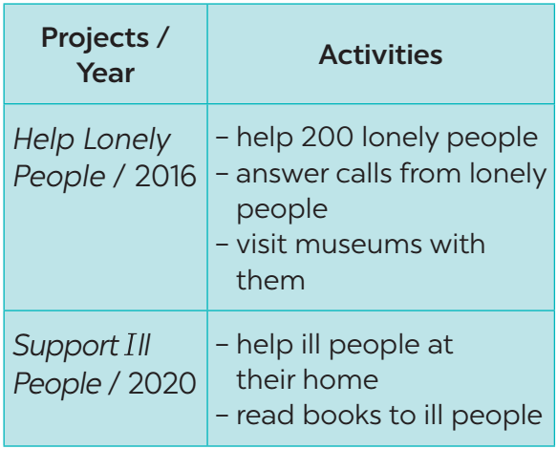  * Example:  Tom: I’m from the Red Cross. I worked on the Help Lonely People project in 2016.  Lan: What did you do?  Tom: We helped 200 lonely people…
* CONSOLIDATION (3’)
* Aim: To consolidate what students have learnt in the lesson.
Teacher’s and Ss’ activities | Content
Teacher asks students to talk about what they have learnt in the lesson. | - Grammar: revise the past simple.
* HOMEWORK (2’)
* Aim: To revise the knowledge that students have gained in this lesson and prepare the new lesson
Teacher’s and Ss’ activities | Content
- T reminds Ss to do homework and prepare the new lesson. | - Do exercises in the workbook.  - Prepare lesson 4 ( communication)
Complement.
………………………………………………………………………………………………………………………………………………………………………………………………………………………………………………………………………………………………………………………………………………………………………………………………………………………………

