Date of preparing:
Date of teaching:
UNIT 3: COMMUNITY SERVICE
Period 17: Lesson 2: A CLOSER LOOK 1

I. OBJECTIVES:
By the end of this lesson, students will be able to gain:
1. Knowledge:
- Vocabulary: Use words related to community activities.
- Pronunciation: Correctly pronounce the sounds: /t/, /d/, /ɪd/ in isolation and in context
2. Competence
- Develop communication skills and creativity
- Be collaborative and supportive in pair work and teamwork
- Actively join in class activities
3. Educational aim:
- Develop self-study skills
- Raise students’ awareness of the need to keep their neighbourhood green.
II. TEACHING AIDS:
1. Teacher: - Grade 7 textbook, Planning (Unit 3, A closer look 1)
- Smart TV/Pictures, sets of word cards
- sachmem.vn
2. Students: Text books, notebooks, posters, ….
3. Method: Ask and answer; group works; individual ……
III. PROCEDURES:
* WARM-UP (5’)
* Aim: To recall students’ vocabulary on community activities.
Teacher’s and Ss’ activities |  |  | Content
- T – Ss, Ss - Ss  - Teacher has students play in two groups and explains the game rules.  - Each group will have a list of verbs and nouns. Students match the verbs they have with the correct nouns.  - Teacher and students discuss the answers. The group with the most correct answers wins.  - Teacher confirms the answers and gives feedback.  - Lead in: Today we are going to learn some words related to community activities. |  |  | MATCHING GAME: Set of word cards:
  recycle | help | plant
  trees | vegetables | small children | old people
  books | bottles | cans | homeless children
* PRESENTATION (5’)
* Pre teach vocabulary
* Aim: To introduce the new words.
Teacher’s and Ss’ activities | Content
- T – Ss,  * Pre teach vocabulary  - Teacher introduces the vocabulary.  - Teacher introduces the vocabulary by:  - providing the pictures  providing the definition of the words  - Teacher asks students to repeat.  - Teacher rubs out and checks  - Ss concept checking | * VOCABULARY:  1. exchange (v): trao đổi  2. pick up (phr. v): nhặt lên  3. tutor (v): dạy kèm  * Checking vocab: < Matching>
* PRACTICE (15’)
Task 1
* Aims: To introduce some verbs and verb phrases that are often used to describe community activities.
Teacher’s and Ss’ activities |  | Content
Task 1: T-Ss  - Teacher has read aloud the verbs in A and words / phrases in B.  - Students work in pairs to match the verbs in A with words / phrases in B.  - Teacher asks them to share their answers in pairs before checking the answers as a class.  - Teacher invites students to take turns to read out their answers and corrects their pronunciation if needed. |  | Task 1: MATCH A VERB IN A WITH A WORD OR PHRASE IN B. (Ex 1, p. 30)  * Answer key:  1. e  2. a  3. d  4. c  5. b
Task2
* Aims: To allow students to use the learnt words / phrases in contexts.
Teacher’s and Ss’ activities |  | Content
Task 2: T - Ss, Ss - Ss  - Teacher asks students to work individually to complete each of the sentences with a suitable word / phrase from the box. All of these words / phrases have been learnt in.  - Students do the task individually.  - Teacher allows students to swap their textbooks to peer check first.  - Teacher confirms the answers and gives feedback, if necessary. |  | Task 2: COMPLETE EACH OF THE SENTENCES WITH A SUITABLE WORD OR PHRASE FROM THE BOX.  * Answer key:  1. litter  2. used paper for notebooks  3. water  4. donate  5. tutor
Task 3
* Aims: To have students practice producing full sentences using the learnt words / phrases.
Teacher’s and Ss’ activities |  | Content
Task 3:T-Ss, Ss-Ss  -Teacher asks students to work individually to write full sentences, using the given phrases.  - Students read aloud the six phrases and match with the appropriate pictures.  - Teacher asks students to work in pairs to swap their answers and peer check.  - Teacher checks their answers as a class. |  | Task 3: USE THE PHRASES FROM THE BOX TO WRITE FULL SENTENCES UNDER THE CORRECT PICTURE. (Ex 3, p. 30)  Answer key:  1. She’s reading books to the elderly.  2. They’re giving gifts to old people.  3. They’re exchanging used paper for notebooks.  4. They’re donating clothes to poor children.  5. She’s planting trees in the park.
PRONUNCIATION (10’)
Task 4:
* Aims: - To help students identify how to pronounce the sounds /t/, /d/ and /ɪd/.
- To help students practice pronouncing the sounds in words
Teacher’s and Ss’ activities |  | Content
Task 4:T-Ss, Ss-Ss  - Teacher has students listen to the recording once first.  - Students listen to the recordings and read out the words.  - Teacher plays the recording for them to listen and repeat each word as a class, then as individuals.  - Teacher check students’ pronunciation if needed.  + Teacher shows students tips to pronounce with V-ed |  | PRONUNCIATION: /t/, /d/, and /id/  TASK 4: LISTEN AND REPEAT. PAY ATTENTION TO THE SOUNDS /t/, /d/ AND /ɪd/. (Ex 4, p. 30)  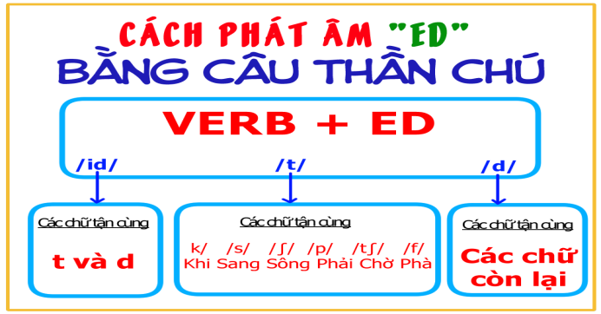
  /t/ | /d/ | /ɪd/
  cooked  passed  helped | watered  cleaned  volunteered | collected  donated  provided
Task 5:
* Aims: To help students practice pronouncing the sounds /t/, /d/ and /ɪd/ in sentences
Teacher’s and Ss’ activities |  | Content
Task 5 :T-Ss,  - Teacher has some students read the sentences first and asks them to pay attention to the underlined parts.  - Teacher plays the recording for Ss to listen then have them tick the appropriate sounds.  -Teacher invites some Ss to share their answers. Confirm the correct ones.  - Teacher plays the recording again and ask students to repeat each sentence after the recording. Teacher confirms the answers. |  | TASK 5: LISTEN TO THE SENTENCES AND PAY ATTENTION TO THE UNDERLINED PARTS. TICK THE APPROPRIATE SOUNDS. PRACTISE THE SENTENCES (Ex 5, p. 31).  * Answer key:  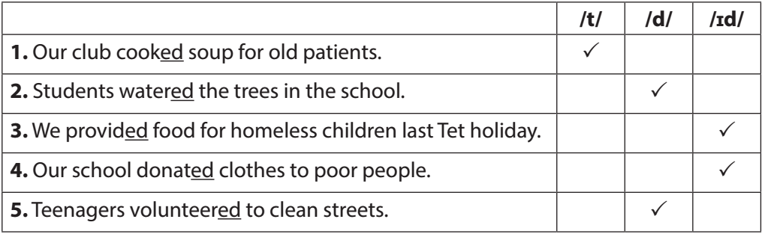
* PRODUCTION (5’)
* Aim: To test students' quick reaction to the targeted sounds.
Teacher’s and Ss’ activities |  | Content
- Teacher explains the rules:  Teacher divides the class into 2 teams and asks them to stand in 2 lines. The first student from each line will be told some words with the /t/, /d/ and /ɪd/ sounds. Team members have to whisper one by one till the last. The last student from each line runs to the board and write down the words in the correct columns. The faster one with correct answers will be the winner.  - Students play the game.  - Teacher helps students in the game.  - Teacher gives feedback. |  | * GAME: BROKEN TELEPHONE  * Suggested key:
  /t/ | /d/ | /ɪd/
  picked, booked, helped | tutored, watered, exchanged | donated, planted
* CONSOLIDATION (3’)
* Aim: To consolidate what students have learnt in the lesson.
Teacher’s and Ss’ activities |  | Content
- Teacher asks students to talk about what they have learnt in the lesson |  | - Vocabulary about community activities  pronounce the sounds /t/, /d/ and /ɪd/
* HOMEWORK (2’)
* Aim: To review the lesson and prepare for the next lesson.
Teacher’s and Ss’ activities |  | Content
- T reminds Ss to do homework and prepare the new lesson. |  | - Learn by heart all the new words.  - What can you do to make your neighborhood to be a greener place? Write at least 3 activities.  - Prepare lesson 3 ( A closer look 2)..
Complement.
………………………………………………………………………………………………………………………………………………………………………………………………………………………………………………………………………………………………………………………………………………………

