Date of preparing:
Date of teaching:
UNIT 3: COMMUNITY SERVICE
Period 16 Lesson 1: GETTING STARTED – Sounds like great work!

I. OBJECTIVES:
By the end of this lesson, Ss will be able to gain:
1. Knowledge:
- An overview about the topic “Community service”.
- lexical items related to community activities.
2. Competence:
- Develop communication skills and enhance awareness of preserving the culture.
- Be collaborative and supportive in pair work and teamwork.
- Actively join in class activities.
3. Educational aim:
- Develop self-study skills.
- Raise students’ awareness of the need to keep their neighbourhood green.
II. TEACHING AIDS:
1. Teacher: - Grade 7 textbook, Planning (Unit 3- Getting started)
- Smart TV/Pictures, sets of word cards
- sachmem.vn
2. Students: Text books, notebooks, posters, ….
3. Method: Ask and answer; group works; individual ……
III. PROCEDURES:
* WARM- UP (5’)
* Aim: To revise old lesson and to introduce the new lesson.
Teacher’s and Ss’ activities |  |  | Content
* Warm up: T – SS  - Teacher shows the picture and asks students questions:  - Students raise hands to answer the questions.  - Teacher and students discuss the questions.  - Teacher accepts all students’ questions and explains the term “Community service”  →Lead in:  - T introduces the topic of the lesson.  Today we are going to learn about “Community service”  - Teacher draws students’ attention to the picture in the textbook and asks them about “community activities”.  - Students raise hands to answer the questions. |  |  | * Picture describing  - What can you infer from this picture?    → Community service  (The work that people do to help others without paying)  + pick up litter  + help homeless people  + clean the street  + donate clothes, books, money,  + plant trees, vegetables,..
* PRESENTATION (5’)
Pre teach vocabulary
* Aim: - To provide students with vocabulary.
- To help students well-prepared for the listening and reading tasks.

Teacher’s and Ss’ activities |  | Content
* Pre teach vocabulary  - Teacher use different techniques to teach vocab (pictures, situation, realia)  - Follow the seven steps of teaching vocab.  - Repeat in chorus and individually  - Copy all the words  -Checking vocab: < what and where> |  | * Vocabulary  - community activity (n.phr.): hoạt động cộng đồng  - donate (v): quyên góp, ủng hộ  - nursing home (n.phr.): viện dưỡng lão  - homeless (adj): vô gia cư  - Checking vocab: < what and where>
PRACTICE (20’)
Task 1
* Aims: To set the context for the introductory conversation;
- To introduce the topic of the unit.
Teacher’s and Ss’ activities | Content
- T-Ss  - Set the context:  Have Ss look at the conversation and the picture, and answer some questions,  - Encourage Ss to answer, but do not confirm whether their answers are right.  - Teacher can play the recording more than once.  - Students listen and read.  - Teacher can invite some pairs of students to read aloud.  - Teacher check students’ pronunciation and give feedback.  - To help Ss understand the main idea of the conversation, ask Ss to answer the question: | - Set the context:  e.g. What can you see in the pictures?  Where do you think the boys and the girls are? What do you think they are doing?  + In picture 1: I can see a boy with a box. He is arranging books and toys (and may be clothes).  + In picture 2: I can see a girl and some small children. They are in a classroom. The girl is teaching the small children.  + In picture 3: I can see two girls and a boy. They are in the garden. They are gardening.  Task 1. Listen and read  - What are Tom and Minh talking about?  (They are talking about community activities in their school.)
Task 2 (5’)
* Aims: - To help students read for specific information about Minh and Tom’s community activities
Teacher’s and Ss’ activities | Content
Task 2: T-Ss, Ss-Ss, T-Ss  -Teacher tells students to read the conversation again and work in pairs to find the answers.  - Students can underline the words and phrases about community activities then work together for one or two minutes to check the words / phrases they have underlined.  - Have pairs tick the appropriate boxes. Ask pairs to say the answers aloud: Mirth's club picks up litter; Tom's club donates books, etc.  Make sure they pronounce the words / phrases correctly.  - Check the answers as a class. | Task 2: Read the conversation again and tick the appropriate box.  * Answer key:  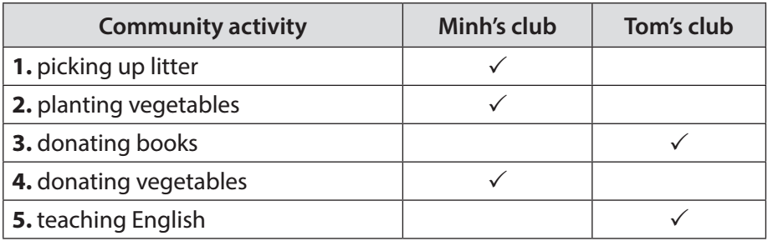
Task 3
* Aims: - To help students use phrases related to community activities.
- To help students further understand the text.
Teacher’s and Ss’ activities | Content
Task 3:T-Ss, Ss-Ss  - Teacher asks students to work individually to complete the phrases under the pictures with the given verbs.  - Students work individually to complete the task.  - Teacher allows students to share answers before discussing as a class.  - Teacher asks students to say the phrases aloud and makes sure they pronounce the words and phrases correctly. Teacher can ask for translation to check their understanding. | Task 3: Complete the phrases under the pictures with the verbs below.  * Answer key:  1. pick up  2. help  3. recycle  4. donate  5. clean
Task 4
* Aims: To help students use the vocabulary related to community activities in the right contexts.
Teacher’s and Ss’ activities | Content
Task4:T-Ss, Ss-Ss  - Teacher asks students to work independently to complete each sentence with a word or phrase from the box.  - Students fill in the blanks with the most suitable words / phrases.  - Teacher allows students to share answers before discussing as a class.  - Teacher can ask students to read aloud the full sentences and correct their pronunciation if needed. | Task 4 : Complete the sentences with the correct words or phrases below.  * Answer key:  1. homeless children  2. litter  3. old people  4. taught  5. planted
PRODUCTION (5’)
Task 5:
* Aims: - To help students review and reuse the learnt vocabulary.
- To create a fun atmosphere in the class.
Teacher’s and Ss’ activities | Content
Task 5:T-Ss, Ss-Ss  - Teacher instructs students to play the Vocabulary Ping-Pong game:  - Ask Ss to think of the topic Community Service.  - One student from team A shouts out a word or phrase related to the topic. Then one student from team B makes a sentence with that word or phrase. Then switch roles.  - The team that cannot give a phrase or make a correct sentence loses and the other team gets a point.  - Students play the game.  - Teacher can go around to help weaker students.  - Teacher stops the game when time is up. The team that makes the most correct sentences wins. | Task 5: Vocabulary Ping-pong game.  * Example:  Team A: Litter  Team B: We often pick up litter in the park. Trees.  Team A: We plan trees in our school every year. Book.  Team B: We donate books to poor children. Bottles  ………..
* CONSOLIDATION (3’)
* Aim: To consolidate what students have learnt in the lesson.
Teacher’s and Ss’ activities | Content
- Teacher asks students to talk about what they have learnt in the lesson.  - Ss work independently | - Some new words  - Read and understand content of the conversation
* HOMEWORK (2’)
* Aim: To review the lesson and prepare for the next lesson.
Teacher’s and Ss’ activities | Content
- T reminds Ss to do homework and prepare the new lesson. | - Learn by heart all the new words.  - Read the dialogue again.  - Prepare lesson 2 (A closer look 1).
Complement.
………………………………………………………………………………………………………………………………………………………………………………………………………………………………………………………………………………………………………………………………………………………………………………………………………………………………

