Date of preparing:
Date of teaching:
UNIT 2: HEALTHY LIVING
Period 12: Lesson 4: COMMUNICATION

I. OBJECTIVES:
By the end of this lesson, students will be able to:
1. Knowledge
- learn how to ask for and give health tips
- practice using some grammar points and vocabulary related to the topic.
2. Competence
- Develop communication skills
- Be collaborative and supportive in pair work and team work
- Actively join in class activities
3. Educational aim:
- Be benevolent (nhân từ) responsible
II. TEACHING AIDS:
1. Teacher: - Grade 7 textbook, Planning (Unit 2, Communication)
- Smart TV/Pictures, sets of word cards
- sachmem.vn
2. Students: Text books, notebooks, posters, ….
3. Method: Ask and answer; group works; individual ……
IV. PROCEDURES:
* WARM - UP (5’)
❖ Aims: To help students revise the vocabulary items they have learnt in the unit.
- To enhance students’ skills of cooperating with team mates.
Teacher’s and Ss’ activities |  | Content
ACTIVITY 1: * Warm up  T –Ss: Ss- Ss  - Teacher divides class into 2 teams and asks them to think of “health problems”.  - Ss have 1 min to think of the words related to the topic or they can discuss with their partners.  - Each member from each team turn by turn run to the board and write one word.  - Teacher corrects their answers.  - The team which has more correct words will be the winner  → Lead - in:  Teacher leads students into the lesson by telling what they are going to learn: “We are going to learn how to give tips for health problems”. |  | * Game: BRAINSTORMING  HEALTH PROBLEMS  * Suggested answers:  Asthma, a backache, a broken leg, a cold, a cough, an earache, a headache, a sore throat, a toothache, sunburn, etc.  ….
ACTIVITY 2: * PRESENTATION (5’)
* EVERYDAY ENGLISH
Giving tips for health problems
Task 1
* Aim: To introduce two ways to give tips on health problems and to allow Ss some practice.

Teacher’s and Ss’ activities | Content
Task 1: T –Ss: Ss- Ss  - Teacher plays the record for SS to listen and read the conversation about health problem.  - Ss listen and practice saying with their partners.  - Teacher calls some pairs to read aloud.  - Teacher corrects pronunciation if necessary.  - Teacher asks Ss to pay attention to the highlighted parts and asks them some questions to elicit the new structure:  - What do these sentences mean?  - When do we use these sentences?  - …  - Ss answer teacher’s questions to find out new structure to give tips for health problems.  - Some students give the new structure to the teacher.  - Teacher corrects and writes on the board: | TASK 1: LISTEN AND READ THE DIALOGUE. (Ex 1, p. 22)  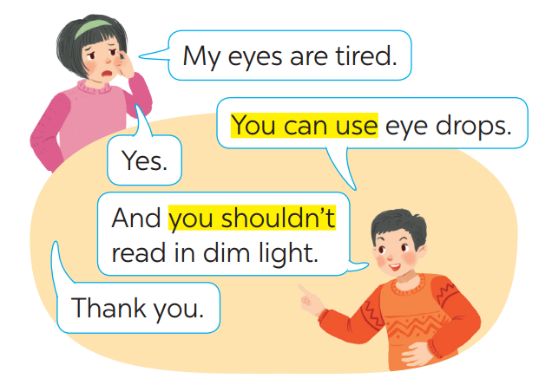  * Structure: to give advice:  - You should/ shouldn’t + V  - You can + V
ACTIVITY 3: * PRACTICE (25’)
Task 2:
❖ Aims: To help students practise giving tips on health problems.
. To provide students with more knowledge about healthy living and help them practice the skill of reading for the main idea
To help students identify the main points in a reading and talk about them.
Teacher’s and Ss’ activities | Content
Task 2: T –Ss: Ss- Ss  - Teacher has Ss look at the situation in Ex 2 to make similar dialogue:  - Ss work in pairs to make similar dialogue.  -Teacher calls some pairs to present it in front of the class.  -Teacher gives feedback and some comments. | TASK 2: MAKE SIMILAR CONVERSATION.  1. I’m tired.  2. I have acne.  3. My hands are chapped.  * Suggested answers:  A: I am tired.  B: You can drink some milk.  A: Yes.  B: And you should have a nap.  A: Thank you.
TIPS FOR A HEALTHY LIFE
Task 3:
* Aims: To provide students with more knowledge about healthy living and help them practice the skill of reading for the main idea
Teacher’s and Ss’ activities | Content
Task 3: T - Ss, Ss – Ss  - Teacher asks Ss to read the passage independently and choose the correct answer of the main idea.  -Ss so the task individually.  - Teacher calls some Ss to give their answer and explain it.  - Teacher confirms the correct answers. | TASK 3: READ THE PASSAGE AND CHOOSE THE CORRECT TITLE FOR IT. (Ex 3, p, 22)  * Answer key: A  In this passage, the author mentions to the way to live long including diet and outdoor activities.
Task 4
* Aims: To help students identify the main points in a reading and talk about them.
Teacher’s and Ss’ activities | Content
Task 4: T - Ss, Ss – Ss  -Teacher has students work in groups to discuss and takes notes of the tips for a long life that they find in the text.  - Ss work in groups.  - 2-3 groups share their lists.  - Teacher confirms and corrects if necessary. | TASK 4: DISCUSS AND MAKE A LIST FOR THE TIPS WHICH HELP THE JAPANESE LIVE LONG LIVES. (Ex 4, p. 22)  * Suggested answers:  + List of tips:  (1) They eat a lot of fish and vegetable.  (2) They cook fish with little cooking oil.  (3) They also eat a lot of tofu.  (4) The Japanese work hard and do a lot of outdoor activities.
ACTIVITY 4: * PRODUCTION (5’)
* Aims: To help students practice giving health tips on their own context.

Teacher’s and Ss’ activities | Content
Task 5: T - Ss, Ss - Ss  - Teacher asks students to work in groups of 4- 5.  - Ss work in group of 4- 5 to discuss and come up with some tips for how the Vietnamese can live longer.  - Some groups share ideas with the whole class and other groups listen and add more their ideas.  - Teacher listens and corrects if necessary. | TASK 5: DISCUSS AND MAKE A LIST FOR THE TIPS THAT THE VIETNAMESE CAN DO TO LIVE LONGER. (  * Suggested answers:  1. avoid overeating  2. do more outdoor activities.  3. drink enough water  4. sleep before 10 p.m  5. eat more nuts.  6. do more exercises.  7. …

* CONSOLIDATION (3’)
* Aims: To consolidate what students have learnt in the lesson.
Teacher’s and Ss’ activities | Content
Teacher asks students to talk about what they have learnt in the lesson. | - learn how to ask for and give health tips  - practice using some grammar points and vocabulary related to the topic.
* HOMEWORK (2’)
* Aim: To revise the knowledge that students have gained in this lesson. And prepare for the next lesson: Skills 1.
Teacher’s and Ss’ activities | Content
- T reminds Ss to do homework and prepare the new lesson. | - Do exercises in the workbook  - Prepare lesson 5 skills 1)
Complements.
………………………………………………………………………………………………………………………………………………………………………………………………………………………………………………………………………………………………………………………………………………………………………………………………………………………………

