Week : 30 Date of planning:13/4/2025
Period : 88 Date of teaching: 15/4/2025
UNIT 11: SCIENCE AND TECHNOLOGY
Lesson 2: A closer look 1
I. OBJECTIVES
By the end of this lesson, Ss will be able to:
1. Knowledge
- Identify some nouns related to the topic of science and technology and some new technologies.
- Identify some new verb phrases that used to talk about inventions, discoveries, creations and development
- Identify sentence stress.
2. Competences
- Develop competencies of communication, cooperation, and self-management.
- Be collaborative and supportive in pair work and teamwork
- Actively join in class activities
3. Personal qualities
- Love to research more about the benefits of science and technology in learning
- Have positive attitude in applying science and technology in learning and daily life
II. MATERIALS
- Grade 8 textbook, Unit 11, A closer look 1.
- Computer connected to the Internet
- Projector / TV
- hoclieu.vn
Language analysis
Form | Pronunciation | Meaning | Vietnamese equivalent
1. face recognition (n) | /feɪsˌrekəɡˈnɪʃn/ | technology that allows a computer to identify a person by their face | công nghệ nhận diện gương mặt
2. experiment (n) | /ɪkˈsperɪmənt/ | a scientific test that is done in order to study what happens and to gain new knowledge | thí nghiệm
3. eye-tracking (n) | /ˈai ˌtrækɪŋ/ | technology that follows the movements of eyes, especially by using special electronic equipment | theo dõi (cử động) mắt
4. fingerprint scanner(n) | /ˈfɪŋɡəprɪnt ˈskænə/ | a type of technology that identifies and authenticates the fingerprints of an individual in order to grant or deny access to a computer system or a physical facility | máy quét vân tay
5. digital communication (n) | /ˈdɪdʒɪtl kəˌmjuːnɪˈkeɪʃn/ | the use of online tools like email, social media messaging and texting to reach other individuals or a specific audience in order to share a message | giao tiếp kỹ thuật số
Assumption
Anticipated difficulties | Solutions
Ss may lack vocabulary related to the topic of science technology, new technologies, and verb phrases that used to talk about inventions, discoveries, creations and development, so they may have difficulty completing the tasks | T is willing to provide them with enough vocabulary related to the topic
III. PROCEDURES
1. WARM-UP (5 mins)
a. Objectives:
- To create an active atmosphere in the class before the lesson;
b. Content:
- Have some warm-up activities to create a friendly and relaxed atmosphere to inspire Ss to warm up to the new class.
c. Expected outcomes:
- Having a chance to speak English and focus on the topic of the lesson.
d. Organisation
TEACHER’S AND STUDENTS’ ACTIVITIES | CONTENTS
Game: Labelling the pictures  - Give Ss a few minutes to play a game. Have Ss play in two groups.  - Give Ss pictures of things and strips of paper with phrases including computer screen, breakout rooms, robot teacher, online class, 3D contact lenses, connection.  - Ask teams to stick the phrases to the right pictures.  - The team with the most correct answers wins.  - Ask Ss to open their books to page 116. | Key:  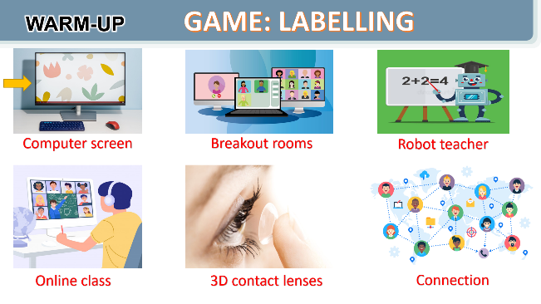
e. Assessment
- T checks ss’ vocabulary and gives feedback
2. ACTIVITY 1: VOCABULARY (25 mins)
a. Objectives:
- To introduce visually some nouns related to the topic of science and technology
- To introduce some new verb phrases that are used to talk about inventions, discoveries, creation and development
- To allow Ss to use the learnt words / phrases in different contexts.
b. Content:
- Task 1: Write the words and phrases under each picture.
- Vocabulary teaching
c. Expected outcomes:
- Students know more new nouns related to new technologies.
- Students know how to use the target vocabulary.
d. Organisation
TEACHER’S AND STUDENTS’ ACTIVITIES | CONTENTS
Task 1: Write the words and phrases under each picture. (6 mins)
- Have Ss read aloud the words / phrases in the box.  - Ask Ss to work in pairs to look at the pictures and describe the pictures.  - Have pairs write the correct words / phrases under the pictures. Explain the meaning of the new words / phrases in Vietnamese, if needed.  - Invite Ss to take turns to read out their answers.  - Correct their pronunciation if needed.  - Check the answers as a class. | Answer key:  1. digital communication  2. face recognition  3. eye-tracking  4. experiment  5. fingerprint scanner  6. video conferencing
Vocabulary teaching (6 mins)
- Teacher asks students to try explaining the meaning of the words in Task 1.  - Teacher explains the vocabulary.  - Teacher checks students’ understanding by the follow-up tasks in the student's book. | New words:  1. face recognition (n)  2. eye-tracking (n)  3. experiment (n)  4. fingerprint scanner (n)  5. digital communication (n)
Task 2: Choose the option that best completes each phrase. (6 mins)
- Ask Ss to read aloud the given verbs and nouns.  - Explain the verbs and if possible, give some examples. Also explain the verbs in Vietnamese.  - Ask Ss to work in pairs to choose the correct options to complete the phrases.  - Check the answers as a class.  - Have some Ss read aloud the phrases.  - Correct Ss’ pronunciation if necessary.  - Also ask Ss to add more words / phrases to the verbs to make up other phrases. This way, T can broaden Ss’ vocabulary if they are ready. | - To create something = To bring into existence out of nothing.  E.g.: She created a new robot.  - To invent = to design a new process or mechanism.  E.g.: He invented a new electric cooker.  - To develop = grow gradually or become bigger, stronger, etc.  E.g.: They developed a relationship / a method to work better / a computer programme.  - To discover = to find somebody/something that was hidden or that you did not expect to find.  E.g.: Galileo discovered that Jupiter had moons.  Answer key:  1. A  2. A  3. B  4. B
Task 3: Complete the sentences with the words and phrases from the box. (7 mins)
- Ask Ss to work individually to choose the correct answer for each sentence.  - Have Ss swap their answers with partners. Then check the answers as a class.  - Also ask some Ss to read out their answers. Then have some Ss read the sentences aloud as a class.  - Correct Ss’ pronunciation if necessary. | Answer key:  1. discovered  2. invented  3. created  4. experiments  5. fingerprint scanner
e. Assessment
- Teacher checks students’ pronunciation and gives feedback.
3. ACTIVITY 2: PRONUNCIATION (12 mins)
a. Objectives:
- To help Ss be aware of the words to stress in a sentence;
- To help Ss practise saying sentences with the correct stress.
b. Contents:
- Task 4: Listen and repeat the sentences. Pay attention to the bold syllables.
- Task 5: Listen and repeat the sentences. How many stressed words are there in each sentence?
c. Expected outcomes:
- Say sentences with the correct stress.
d. Organisation
TEACHER’S AND STUDENTS’ ACTIVITIES | CONTENTS
Task 4: Listen and repeat the sentences. Pay attention to the bold syllables. (6 mins)
- Have Ss listen to the recording once first. Ask them to pay attention to the stressed syllables.  - Play the recording again for them to listen and repeat each word as a class, then as individuals. Play the recording as many times as possible.  - Then ask Ss to read out the sentences. Correct their pronunciation and stress if needed.  - Introduce the rules in the Remember! Box: stress sentences, which words in a sentence should be stressed, and which are not.  - Remind Ss of the words that receive stress in a sentence, which they leant in Unit 11 Tiếng Anh 7. | 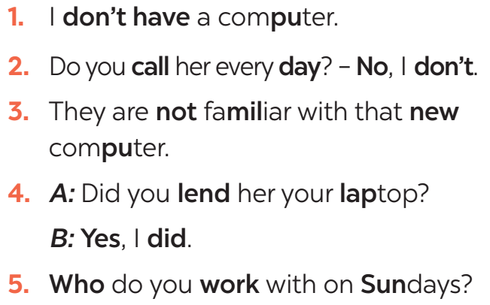
Task 5: Listen and repeat the sentences. How many stressed words are there in each sentence? (6 mins)
- Play the recording for Ss to listen and repeat each sentence after the recording. Correct Ss’ pronunciation if necessary.  - Ask Ss to count the number of stressed words in each sentence. Check if Ss have counted enough stressed words in each of the sentences.  - Call on some Ss to read the sentences. Play the recording multiple times if necessary. | Answer key:  1. He is an inventor.  → 1 stressed word  2. We won’t have a robot teacher next year.  → 6 stressed words  3. She likes learning online.  → 3 stressed words  4. Was she checking attendance when you came? – No, she wasn’t.  → 6 stressed words  5. What did he invent?  → 2 stressed words
e. Assessment
- Teacher checks students’ answers and their pronunciation and gives feedback.
4. ACTIVITY 3: PRODUCTION (5 mins)
a. Objectives:
- To test students' imitation and memorising ability of stress sentences.
b. Content:
- Game: Broken telephone
c. Expected outcomes:
- Remember the sentences and repeat it correctly in stress and content.
d. Organisation
TEACHER’S AND STUDENTS’ ACTIVITIES | CONTENTS
GAME: BROKEN TELEPHONE
- Teacher explains the rule:  RULE:  - Gather 3 or more players.  - The person starting the game thinks of SENTENCE and whispers it into the next player’s ear only once, with no repeats allowed.  - That listener tries to correctly repeat that SENTENCE into the next player’s ear (Paying attention to the sentence’s stress). The last person in the line or at the end of the circle repeats the SENTENCE  - Allow a moment for giggles if the message is “broken” or changed. The player who started announces the correct SENTENCE  - Players take turns thinking of the next SENTENCE to pass through a whisper. | 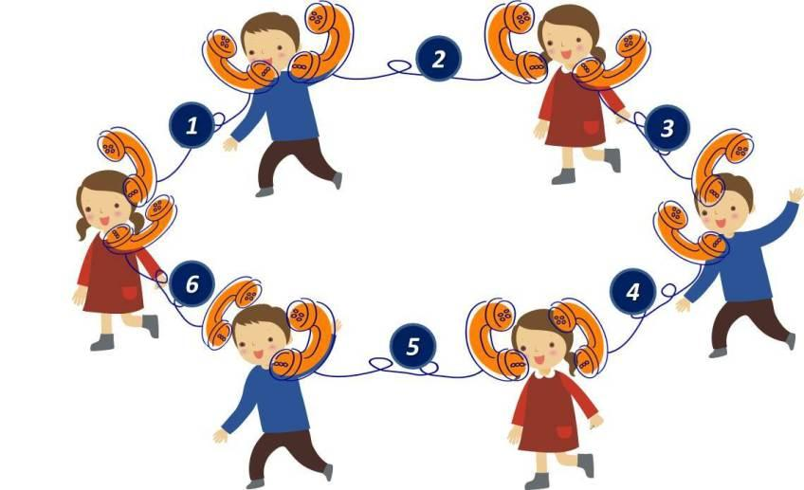
e. Assessment
- T and other Ss listen and give corrections to others’ pronunciation
4. CONSOLIDATION (4 mins)
a. Wrap-up
- Ask Ss to summarise what they have learned in the lesson.
- Ask them to list words and phrases related to new technologies.
- Ask them to list new verb phrases that are used to talk about inventions, discoveries, creation, and development.
- Ask them to retell the knowledge of sentences stress
b. Homework
- Learn by heart words and phrases related to new technologies and new verb phrases that are used to talk about inventions, discoveries, creation, and development.
- Do Exercises in the Workbook

Week : 30 Date of planning:14/4/2025
Period : 89 Date of teaching: 20/4/2025

UNIT 11: SCIENCE AND TECHNOLOGY
Lesson 3: A closer look 2
I. OBJECTIVES
By the end of this lesson, Ss will be able to:
1. Knowledge
- identify what direct speech and reported speech are.
- realise some differences between a direct speech and a reported speech (statements).
- be aware of changes in tenses, pronouns, time, and place expressions.
2. Competences
- Develop competencies of communication, cooperation, and self-management.
- Be collaborative and supportive in pair work and teamwork
- Develop self-study skills
- Actively join in class activities
3. Personal qualities
- Love to research more about the benefits of science and technology in learning
- Have positive attitude in applying science and technology in learning and daily life
II. MATERIALS
- Grade 8 textbook, Unit 11, A closer look 2.
- Computer connected to the Internet
- Projector / TV
- hoclieu.vn
Language analysis
 | Direct speech | Reported speech
1. Definition | - a report of the exact words used by a speaker or writer  - usually placed inside quotation marks and accompanied by a reporting verb, signal phrase, or quotative frame. | - the form of speech used to convey what was said by someone at some point of time.
2. Changes in tenses | 1. Present simple  2. Present continuous  3. Present perfect  4. Past simple  5. Past continuous  6. Past perfect  7. will  8. can  9. may  10. must | 1. Past simple  2. Past continuous  3. Past perfect  4. Past perfect  5. Past perfect continuous  6. Past perfect  7. would  8. could  9. might  10. had to
3. Changes in pronouns  (according to situations) | 1. I/ me  2. We/ us  3. You  4. He/ she/ it/ they…  5. this  6. these | 1. He/ She/ him/ her  2. They/ them  3. I/ me  4. He/ she/ it/ they…  5. that  6. those
4. Changes in time and place expressions | 1. now  2. today  3. ago  4. tomorrow  5. this week  6. yesterday  7. last week  8. here | 1. then  2. that day  3. before  4. the following day/ the next day  5. that week  6. the day before/ the previous day  7. the week before/ the previous week  8. there
5. Structures | S1 said: “S2 + V2,”  “S2 + V2,” S1 said | S1 + said/ told sb + (that) + S2 + V2 (back-form tenses)

Assumption
Anticipated difficulties | Solutions
Ss may get confused about the changes from direct speech to reported speech. | T should be ready to find examples and give clear explanations to the students.
III. PROCEDURES
1. WARM-UP (5 mins)
a. Objectives:
- To create an active atmosphere in the class before the lesson
b. Content:
- Game: Memorising
c. Expected outcomes:
- Having a chance to speak English and focus on the topic of the lesson.
d. Organisation

TEACHER’S AND STUDENTS’ ACTIVITIES | CONTENTS
Game: MEMORISING  RULE:  - Work in 4 groups  - Look at the pictures in 30 seconds and try to remember what each person said.  - Write down on the posters what each of the people in the picture said.  - The group with the most correct answers is the winner. | 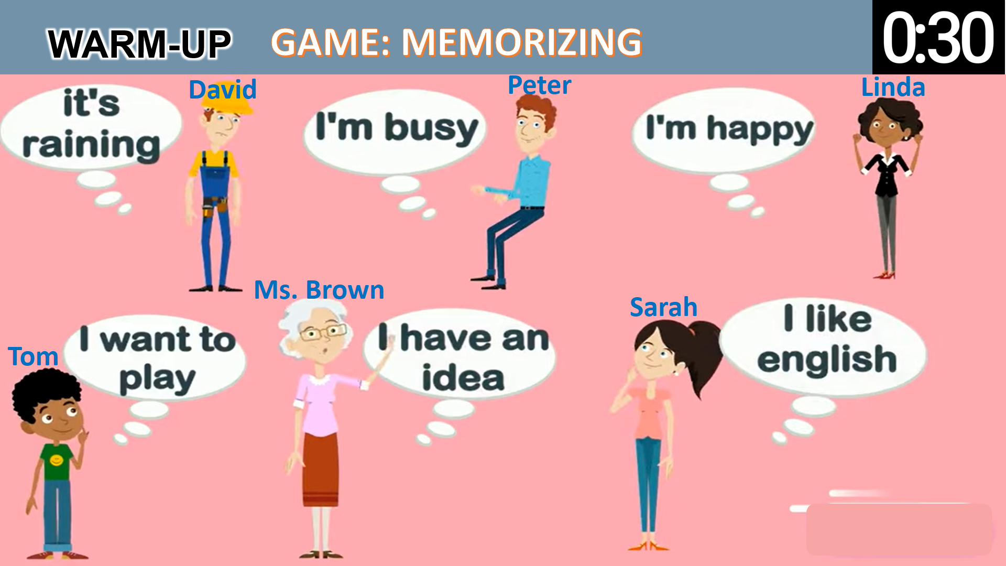
e. Assessment
- T checks ss’ answers and gives feedback.
2. ACTIVITY 1: PRESENTATION (12 mins)
a. Objectives:
- To realise some differences between direct speech and reported speech (Statements)
- To be aware of the changes in verb tenses, pronouns, time and place expressions.
b. Content:
- Task 1: Look at part of the conversation in GETTING STARTED again. Then match Minh’s uncle’s direct speech with his reported speech.
- Teaching point: Reported speech (statements)
c. Expected outcomes:
- Know what direct speech and reported speech are.
- Understand the changes in verb tenses, pronouns, time and place expressions.
d. Organisation
TEACHER’S AND STUDENTS’ ACTIVITIES | CONTENTS
Task 1: Look at part of the conversation in GETTING STARTED again. Then match Minh’s uncle’s direct speech with his reported speech.
- Ask Ss to work individually to look at the part of the conversation from GETTING STARTED  - Ask Ss to underline the sentences in GETTING STARTED  - Have Ss work in pairs to look at direct speech and reported speech boxes to match.  - Check the answers as a class.  - Ask some Ss to underline the differences in the pairs of sentences they have just matched.  - Emphasise will in direct speech is turned into would in the reported speech.  - Ask several Ss to read aloud full sentences. Correct their pronunciation if necessary. | Answer key:  1. B  2. A
Teaching point: Reported speech (statements)
- Have Ss work individually to read the Remember! box.  - Write examples of direct speech and reported speech on the board.  - Ask some Ss to point out the differences between pairs of sentences (direct and reported speech sentences)  - Remark on the differences in (1) verb form, (2) time expressions, (3) time and place expression, and (4) pronouns. | 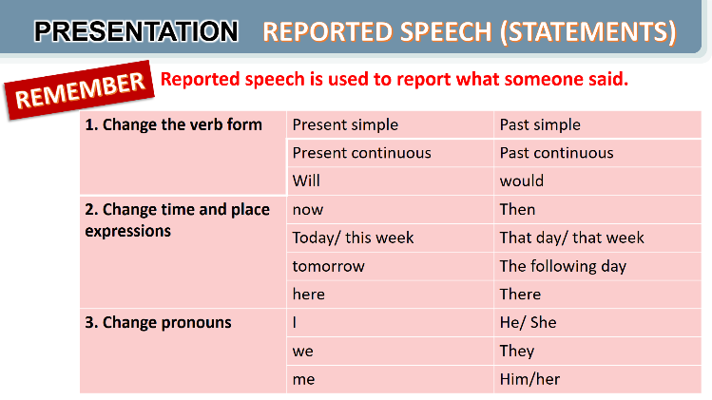
e. Assessment
- Teacher listens to students’ answers and gives feedback.

3. ACTIVITY 2: PRACTICE (28 mins)
a. Objectives:
- To be aware of how to change verb forms when they report information.
- To apply rules of changes in time and place expressions when they report information
- To practise changing direct sentences into reported sentences.
b. Content:
- Task 2: Complete the second sentences using the correct verb form.
- Task 3: Complete the second sentences with the words and phrases from the box.
- Task 4: Complete the second sentence in each pair so that it means the same as the first one.
c. Expected outcomes:
- Remember the rules of changes in verb tenses, time and place expressions, and pronouns when reporting information.
d. Organisation
TEACHER’S AND STUDENTS’ ACTIVITIES | CONTENTS
Task 2: Complete the second sentences using the correct verb form. (5 mins)
- Remind Ss that they should put the verb one tense back when they report something.  - Have Ss work in pairs to finish the sentences with the correct verb forms.  - Ask some Ss to write their answers on the board.  - Check Ss’ answers. Correct any mistakes and re-explain the rule if necessary.  - Have Ss read out loud sentences again and correct pronunciation if necessary. | Answer key:  1. was  2. would take  3. was talking  4. were going  5. didn’t have
Task 3: Complete the second sentences with the words and phrases from the box. (5 mins)
- Have Ss work individually to underline the expressions denoting time and place in the direct sentences.  - Ask Ss to choose the correct word / phrase from the box to fill each of the reported sentences. Remind them of the expressions they have just underlined in each of the direct speech sentences.  - Ask some Ss to read out the direct and reported speech sentences. Correct pronunciation if necessary.  - Check the answers as a class. | Answer key:  1. the next day  2. then  3. that day  4. that year  5. there
Task 4: Complete the second sentence in each pair so that it means the same as the first one.
(10 mins)
- Have Ss work individually for five minutes to complete the reported sentences. Then ask them to work in pairs to swap their answers.  - Ask some Ss to write their reported sentences on the board.  - Check the answers as a class.  - Have the class read out the sentences. Correct pronunciation when necessary. | Answer key:  1. The scientist said that we would live much longer in the future.  2. Our teacher said that our school was going to have a new laboratory there.  3. My dad said that they were developing technology to monitor students better.  4. Tom said that there were no classes the next day because their teacher was ill.  5. The teacher said that they wanted some students to join the science club the next semester.
e. Assessment
- Students do peer correction.
- Teacher checks students’ answers as a class and gives feedback.

4. ACTIVITY 3: PRODUCTION (4 mins)
a. Objectives:
- To enable Ss to practise reporting speech;
- To create an atmosphere of playing and learning.
b. Content:
- To report the information
c. Expected outcomes:
- Reporting direct sentences correctly.
d. Organisation
TEACHER’S AND STUDENTS’ ACTIVITIES | CONTENTS
Task 5: Work in pairs. One student says a sentence and the other changes that sentence into reported speech. Then swap roles. (4 mins)
GAME: He/ She said that…  - Divide the class into groups of 4.  - Instruct Ss to play the game in groups.  - Give groups two minutes to prepare. Tell them that groups can write down their group’s sentences.  - Invite one group to read out or say aloud a direct speech sentence and the other to say out the sentence in reported speech, starting with She / He said...  - Remind them that the group that has the correct reported speech sentence has the right to read out their direct sentence for the other to turn into a reported one.  - Correct any grammar and pronunciation mistakes if necessary.  - The group with the most correct reported sentences wins. | 
e. Assessment
- T corrects any grammar and pronunciation mistakes if necessary.
4. CONSOLIDATION (4 mins)
a. Wrap-up
- Ask Ss to summarise what they have learnt in the lesson.
- Retell what direct speech and reported speech are
- Retell the rules of changing direct speech to reported speech.
b. Homework
- Learn the rules of changing direct speech into reported speech by heart.
- Do exercise in the workbook

Week : 30 Date of planning:14/4/2025
Period : 90 Date of teaching: 20/4/2025

UNIT 11: SCIENCE AND TECHNOLOGY
Lesson 4: Communication
I. OBJECTIVES: By the end of this lesson, Ss will be able to:
1. Knowledge
- identify how to give and respond to good news.
- know about the benefits and problems of online learning.
2. Skills:
- Give and respond to good news.
- Read and talk about the benefits and problems of online learning.
3. Competences
- Develop competencies of communication, cooperation, and self-management.
- Be collaborative and supportive in pair work and group work.
4. Personal qualities
- Love to research more about the benefits of science and technology in learning
- Have positive attitude in applying science and technology in learning and daily life
II. MATERIALS
- Grade 8 textbook, Unit 11, Communication.
- Computer connected to the Internet
- Projector / TV
- hoclieu.vn
Language analysis
Giving good news | Responding to good news
- Great news for us.  - (Tell the news) | - Great!: if good news is general and good for everyone.  - Congratulations!: if the news is good for the speaker only
Assumption
Anticipated difficulties | Solutions
Some Ss may have difficulty getting enough information to talk about the benefits and problems of online learning. | T should give suggestions or let ss read more times to get enough information.
III. PROCEDURES
1. WARM-UP (3 mins)
a. Objectives:
- To create an active atmosphere in the class before the lesson;
b. Content:
- Video watching
c. Expected outcomes:
- Having a chance to speak English and focus on the topic of the lesson.
d. Organisation
TEACHER’S AND STUDENTS’ ACTIVITIES | CONTENTS
Video watching:  - T lets ss watch a clip and ask ss what the clip is about.  - T leads in the new lesson  - Ask Ss to look at COMMUNICATION on page 119. | Expected answers:  - Giving and responding to good news  Video link: Language Functions | Responding to Good and Bad News | Animated Lesson
e. Assessment
- T checks ss’ answers and give feedback
2. ACTIVITY 1: EVERYDAY ENGLISH (12 mins)
a. Objectives:
- To introduce how to give and respond to good news
- To help Ss practise giving and responding to good news
b. Content:
- Use everyday expressions to develop language skills (Giving and responding good news)
c. Expected outcomes:
- Learning how to give and respond to good news
d. Organisation
TEACHER’S AND STUDENTS’ ACTIVITIES | CONTENTS
Task 1: Listen and read the conversation. Pay attention to the highlighted sentences. (6 mins)
- Play the recording for Ss to listen and read the conversation between Nick and Mi. Ask Ss to pay attention to the highlighted parts. Emphasise the ways to give good news and respond to good news:  - Tell Ss that Great! and Congratulations! are different ways to respond to good news in different contexts. Tell them that if good news is general and good for everyone, we can say Great!; if the news is good for the speaker only, the responder may say Congratulations!  - Have Ss practise the conversation. | To give and respond to good news, you can use:  - Great news for us.  - Great!  - Congratulations!
Task 2: Work in pairs. Give news and respond to the news in the following situations.
- Ask Ss to work in pairs to make a similar conversation.  - Tell them to use the contexts given and the sample expressions.  - Give feedback on their conversation. | 1. You tell your classmate about the new vending machine at your school.  2. You tell your classmate about a new laptop that your dad gave you on your birthday.
e. Assessment
- Teacher listens to students’ pronunciation and gives feedback.
3. ACTIVITY 2: ONLINE LEARNING (25 mins)
a. Objectives:
- To help Ss learn the language to describe the benefits and problems of online learning;
- To help Ss practise reading for specific information.
- To help Ss practise reported speech
b. Content:
- Task 3: Work in pairs. Read the posts from some students about online learning and complete the table.
- Task 4: Work in groups. Talk about a platform you use for your online classes or one you know about. What are the benefits and problems of using it?
- Task 5: Report the answers of one of your group members to the class
c. Expected outcomes:
- Knowing the benefits and problems of online learning.
- Practising reading for specific information and practising speaking about a platform ss use for online classes or one ss know about.
- Can apply reported speech to report to the class.
d. Organisation

TEACHER’S AND STUDENTS’ ACTIVITIES | CONTENTS
Task 3: Work in pairs. Read the posts from some students about online learning and complete the table. (7 mins)
- Ask some Ss to read the posts aloud.  - Have Ss work in pairs to read the posts to get information from the post and to fill in the table below.  - Ask some pairs to read out their answers. Make corrections if necessary.  - Check the answers as a class.  - If time allows, ask some students to retell information from the posts or to role play the four friends to tell class about the platform their teacher uses for their classes. | Answer key:  Benefits:  1. It’s convenient.  2. Students don’t have to get up early.  3. It helps students become more independent.  4. It helps students avoid traffic jams.  Problems:  1. Some students don’t have computers or smartphones.  2. The Internet connection is poor.  3. It makes some students feel more stressed when learning online.  4. Students can’t meet their classmates.  5. Some students get tired eyes and can’t concentrate well.
Task 4: Work in groups. Talk about a platform you use for your online classes or one you know about. What are the benefits and problems of using it? (8 mins)
– Have Ss work in groups to talk about the benefits and problems of their online learning platform.
- Ask them to think of the platform they use and use the table in Activity 3 to make notes. Tell them to use adjectives or phrases as in Activity 3.
- Invite some Ss to talk about their online learning platforms. Correct any grammar or pronunciation mistakes if necessary.
Task 5: Report the answers of one of your group members to the class. (10 mins)
- Have Ss work in groups to discuss their online learning platforms.  - Tell them that they can make notes about what their friends like and dislike about the platform their classes/ teachers use.  - Ask them to use ideas from the posts and the table in Activity 3.  - Invite group representatives to report one of their group member’s answers. Give feedback on Ss’ reports. | You can conclude:  - The name of the platform you use for your online classes or one you know about.  - Its benefits  - Its problems  Example:  Lan said that her extra class used Microsoft Teams. She said that she and her classmates found it difficult to use. However, it is convenient to have online classes on Microsoft Teams when the weather is bad.
e. Assessment
- T listens to ss’ reports and gives feedback on their grammar, pronunciation and content.
- T gives feedback on their reports.
4. CONSOLIDATION (4 mins)
a. Wrap-up
- Ask Ss what they have learnt in the lesson.
- Ss retell ways of giving and responding to good news
- Ss retell some benefits and problems of online learning.
b. Homework
- Learn the ways of giving and responding to good news.
- Do exercise in the workbook.

TTCM
GVBM

Đinh Thị Dung

