Week : 28
Date of planning:31/3/2025
Period : 82 Date of teaching: 2/4/2025
UNIT 10: COMMUNICATION IN THE FUTURE
Lesson 4: Communication
I. OBJECTIVES:By the end of this lesson, Ss will be able to:
1. Knowledge
- interrupt politely
2. Competences
- Develop communication skills and creativity
- Be collaborative and supportive in pair work and teamwork
- Actively join in class activities
3. Personal qualities
- Be aware of the importance of technology in communication
- Love to learn more about technology and apply it in daily life
II. MATERIALS
- Grade 8 textbook, Unit 10, Communication
- Computer connected to the Internet
- Projector / TV
- hoclieu.vn
Language analysis
Structure | Examples
How to interrupt politely | Hold on.  Sorry for interrupting, but…
Assumption
Anticipated difficulties | Solutions
Ss may lack experience of group / team work. | - Encourage Ss to work in groups so that they can help one another.  - Give short, clear instructions, and help if necessary.
Ss may not have sufficient listening skills. | - Play the recording many times if necessary.  - Pick some Ss to ask and answer the questions.  - Have Ss practise the dialogue in pairs.
III. PROCEDURES
1. WARM-UP (5 mins)
a. Objectives:
- To create an active atmosphere in the class before the lesson;
- To lead into the new lesson.
b. Content:
- Ask and answer.
c. Expected outcomes:
- Students’ answers.
d. Organisation

TEACHER’S AND STUDENTS’ ACTIVITIES | CONTENTS
- Teacher asks students the question.  - Write on the board “I will _____ in 10 years.” Have Ss complete the sentence with their own ideas. Encourage them to provide more detail by adding one more sentence.  - Invite some Ss to share their sentences. Listen attentively and try interrupting one student by saying “Hold on. Can you repeat that, please?”.  - Have students repeat the information. Thank him/ her.  - Write “Hold on. Can you repeat that, please?” on the board. Explain to Ss that this structure is for interrupting the other speaker politely.  - Lead into the lesson. Introduce the objectives of the lesson. Write the objectives in the left corner of the board. | Question:  1. “How do you see yourself in 10 years?”  Suggested answers:  1. I will be working as a teacher.
e. Assessment
- Teacher corrects students’ answers (if needed).
2. ACTIVITY 1: EVERYDAY ENGLISH (15 mins)
a. Objectives:
- To introduce ways interrupting politely
- To help Ss practise interrupting politely
b. Content:
- Task 1: Listen and read the conversations below. Pay attention to the highlighted parts.
- Task 2: Work in pairs. Make similar conversations with the following situations.
c. Expected outcomes:
- Students know how to use the structures to interrupt politely.
d. Organisation
TEACHER’S AND STUDENTS’ ACTIVITIES | CONTENTS
Task 1: Listen and read the conversations below. Pay attention to the highlighted parts. (6 mins)
- Play the recording for Ss to listen and read the conversations between Mark and Trang, and between Nick and Lan. Ask Ss to pay attention to the highlighted language. Tell them that these are two ways to interrupt the other speaker politely.  - Have Ss practise the conversations in pairs. Call on some pairs to practise the dialogues in front of the class. | 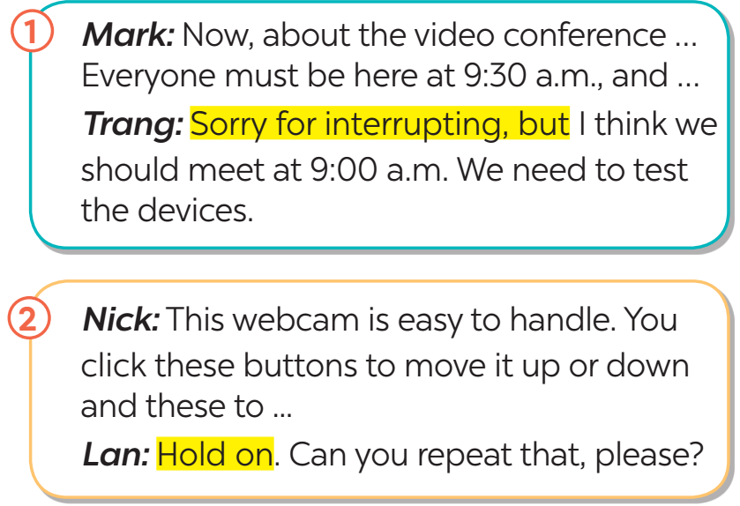
Task 2: Work in pairs. Make similar conversations with the following situations. (9 mins)
- Ask Ss to work in pairs to make similar dialogues, using the language they have learnt.  - Move around to observe and provide help. Call on some pairs to practise in front of the class.  - Comment on their performance. | 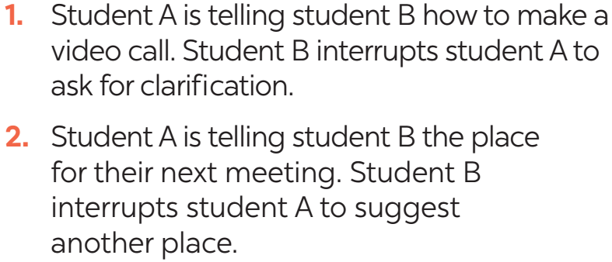
e. Assessment
- Teacher checks students’ understanding by asking some checking-questions.
3. ACTIVITY 2: THE FUTURE OF LANGUAGE (25 mins)
a. Objectives:
- To help Ss learn about the prediction about the future of communication.
- To provide Ss with practice in giving a presentation about their friends’ answers.
b. Content:
- Task 3,4 in Student book
c. Expected outcomes:
- Students know how to make questions and answer about the given topic.
- Students can report their friend’s answers.
d. Organisation
TEACHER’S AND STUDENTS’ ACTIVITIES | CONTENTS
Task 3: Work in pairs. Read Mark’s prediction about a popular means of communication in the near future. Then ask and answer the questions. (7 mins)
- Draw or show pictures of some emojis on the board. Have Ss call out the word “emoji”. Ask them if they use emojis a lot when chatting.  - Have Ss work in pairs, read Mark’s prediction about emojis and answer the questions that follow.  - Invite some pairs to share their answers. Confirm the correct answers. Accept all answers that are  logical and reasonable.  - Ask Ss if they think one day, they will receive an email or message that contains only emojis. | Suggested answers:  1. Jack is a cousin of hers.  2. Is this a tablet of his?  3. Can I borrow one of your pencils?  4. You look like Nick and Peter. Are you a relative of theirs?  5. Last year, two classmates of ours won scholarships to the US.
Task 4: Work in pairs. Choose one means of communication below. Ask and answer questions about it. (8 mins)
- Have Ss work in groups to ask and answer the two questions in the book. Have Ss in each group note down their friends’ answers.  - Ask some Ss to report their group’s answers to the class.  - Call on some Ss to give the presentation to the whole class. After each student finishes his or her presentation, invite comments on his or her clarity, language, and fluency from other Ss. | 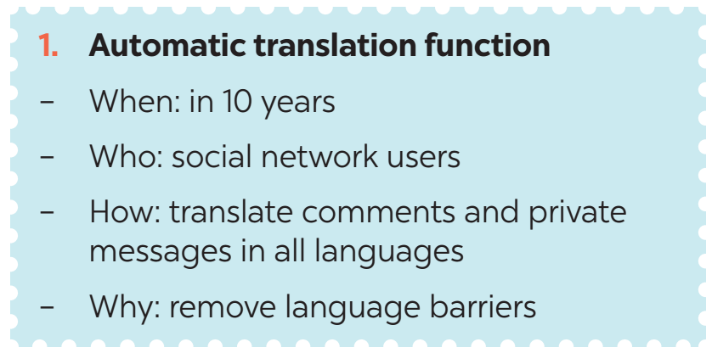  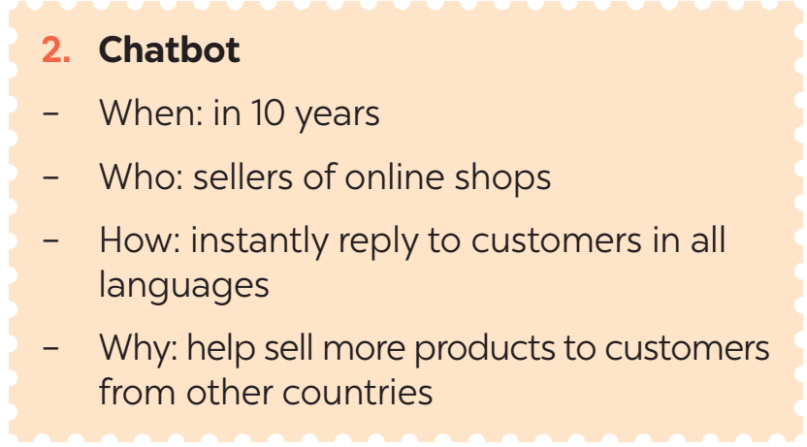
Task 5: Report your pair’s conversation to the class by making a similar talk to Mark’s prediction in 3. (10 mins)
- Have Ss work in groups to ask and answer the two questions in the book. Have Ss in each group note down their friends’ answers.
- Ask some Ss to report their group’s answers to the class.
- Call on some Ss to give the presentation to the whole class. After each student finishes his or her presentation, invite comments on his or her clarity, language, and fluency from other Ss.
e. Assessment
- Teacher corrects students’ pronunciation by going around while they’re practising.
5. CONSOLIDATION (5 mins)
a. Wrap-up
- Have Ss say what they have learnt in the lesson.
b. Homework
- Students’ workbook

Week : 28 Date of planning:31/2/2024
Period : 83 Date of teaching: 4/3/2024

UNIT 10: COMMUNICATION IN THE FUTURE
Lesson 5: Skills 1
I. OBJECTIVES: By the end of this lesson, Ss will be able to:
1. Knowledge
- read about ways of communication;
- talk about ways of communication;
2. Competences
- Develop communication skills and creativity
- Be collaborative and supportive in pair work and teamwork
- Actively join in class activities
3. Personal qualities
- Be aware of the importance of technology in communication
- Love to learn more about technology and apply it in daily life
II. MATERIALS
- Grade 8 textbook, Unit 10, Skills 1
- Computer connected to the Internet
- Projector / TV
- hoclieu.vn
Language analysis
New words | Pronunciation | Meaning | Meaning
1. telepathy (n) | /təˈlepəθi/ | the supposed ability to communicate mentally with another person without using the usual senses | thần giao cách cảm
2. keep in contact (v) | /kiːp ɪn kənˈtækt/ | to maintain communication or a relationship with someone | giữ liên lạc
3. thought (n) | /θɔːt/ | an idea, opinion, or belief, especially one that is considered to be formed as a result of mental activity | suy nghĩ
4. tiny (a) | /ˈtaɪni/ | very small in size or amount; little | nhỏ bé
Assumption

Anticipated difficulties | Solutions
1. Students may lack lexical items. | - Provide students with the meaning and pronunciation of words.
2. Students may not have sufficient reading, speaking and co-operating skills. | - Let students read the text again (if necessary).  - Create a comfortable and encouraging environment for students to speak.  - Encourage students to work in pairs, in groups so that they can help each other.  - Provide feedback and help if necessary.
3. Some students may excessively talk in the class. | - Define expectation in explicit detail.  - Have excessively talkative students practise.  - Continue to define expectations in small chunks (before every activity).
III. PROCEDURES
1. WARM-UP (5 mins)
a. Objectives:
- To help Ss understand and activate their knowledge of the topic;
- To help Ss remember some words related to telepathy
b. Content:
- Task 1: Work in pairs. List as many ways of communication as you can.
c. Expected outcomes:
- Students can say some ways of communication.
d. Organisation
TEACHER’S AND STUDENTS’ ACTIVITIES | CONTENTS
Task 1: Work in pairs. List as many ways of communication as you can. (5 mins)
- Have Ss work in pairs and list as many ways of communication as they can.  - Invite some Ss to share their lists. Write their ideas on a corner of the board and keep them there until the end of the lesson. | Suggested ideas: meeting face-to-face, sending letters, sending emails, texting, chatting online, sending voice messages, making phone calls, making group calls, having video calls, etc.
e. Assessment
- Teacher corrects for students (if needed)
2. ACTIVITY 1: READING (20 mins)
a. Objectives:
- To improve Ss’ knowledge of vocabulary related to telepathy
- To improve Ss’ skill of reading for general and specific information
b. Content:
- Vocabulary pre-teaching
- Task 2: Read an interview with two students, Minh and Tom. Then tick the speaker of each sentence.
- Task 3: Read the interview again. Choose the correct answer A, B, or C.
c. Expected outcomes:
- Ss understand new vocabulary
- Students can understand the text and choose the right answers.
d. Organisation
TEACHER’S AND STUDENTS’ ACTIVITIES | CONTENTS
Vocabulary pre-teaching
- Teacher explains the meaning of the new vocabulary by pictures.  - Teacher reveals that the words according to the pictures will appear in the reading text and asks students to open their textbook to find these words  - Teacher introduces the vocabulary.  - Teacher checks students’ understanding with follow up questions. | New words:  1. telepathy (n)  2. keep in contact (v)  3. thought (n)  4. tiny (a)
Task 2: Read an interview with two students, Minh and Tom. Then tick the speaker of each sentence. (5 mins)
- Draw Ss’ attention to the word “telepathy”. Tell them that this is a way of communication. Challenge Ss to quickly find the word telepathy in the conversation and guess its meaning. Confirm their answer.  - Ask Ss who are in the interview (the MC, Minh and Tom). Tell them that in this exercise, they need to find out what Tom is saying and what Minh is saying, so they should focus on Tom and Minh’s lines in the conversation.  - Briefly tell Ss the steps to complete the exercise: Read the statements, underline the keywords in each statement, locate the keywords in the text, find the information and decide if Minh or Tom is saying that information.  - Ask Ss to do the exercise individually and then check their answers in pairs.  - Invite some Ss to share their answers. Confirm the correct answers. | Answers key:  1. Minh  2. Tom  3. Minh  4. Minh  5. Tom
Task 3: Read the interview again. Choose the correct answer A, B, or C. (10 mins)
- Ask Ss what they are going to do.  - Have Ss share how to do this exercise.  - Briefly tell them the steps: Read the questions, underline the key words in each question, locate the  key words in the text and find the information to answer the question.  - Ask Ss to repeat the steps if necessary.  - Ask Ss to do the exercise individually and then check their answers in pairs.  - Invite some Ss to share their answers. Have them explain their answers. Confirm the correct answers.  - To connect the reading and the speaking parts, T can draw a table and ask Ss to fill in the table about the advantages and disadvantages of telepathy. | Answer key:  1. A  2. B  3. C  4. B  5. C  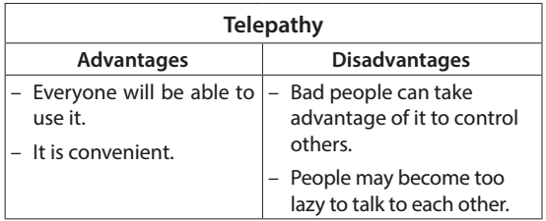
e. Assessment
- Teacher checks students’ answers as a whole class.
3. ACTIVITY 2: SPEAKING (15 mins)
a. Objectives:
- To help Ss prepare ideas for the next activity
- To provide an opportunity for Ss to practise talking about advantages and disadvantages of a way of communication
b. Content:
- Task 4: Work in pairs. Read the following ideas about online calls. Put the ideas in the correct column.
- Task 5: Work in groups. Choose a way of communication and discuss its advantages and disadvantages. Then report your answers to the class.
c. Expected outcomes:
- Students’ speaking
d. Organisation
TEACHER’S AND STUDENTS’ ACTIVITIES | CONTENTS
Task 4: Work in pairs. Read the following ideas about online calls. Put the ideas in the correct column. (5 mins)
- Ask Ss to work in pairs and complete the table about the advantages and disadvantages of online calls.  - Have Ss share their answers. Confirm the correct answers. | Answer key:  Advantages: a, c, e  Disadvantages: b, d, f
Task 5: Work in groups. Choose a way of communication and discuss its advantages and disadvantages. Then report your answers to the class. (10 mins)
- Elicit from Ss some useful structures to start a talk, and to introduce the advantages and disadvantages.  - Encourage Ss to try using the structures to make sentences about online calls.  - Have Ss work in groups. Tell them that they will choose from the list of ways of communication in the Warm up and discuss its advantages and disadvantages. They should make a table like the one in Activity 4 first, and then talk.  - Set a time limit for group work. Go around, monitor and support when necessary. Invite some Ss to share their group’s discussion to the class.  - Ask other groups to listen and give comments.  - Comment on Ss’ answers. | - To start a talk about advantages and disadvantages:  + I think there are both advantages and disadvantages of online calls.  - To introduce the advantages:  + In terms of the advantages / good points, ...  +... can be beneficial in many ways. First, ...  - To introduce the disadvantages:  + However, ... has some drawbacks. For example, ...  Suggested outcome:  I think there are both advantages and disadvantages of online calls. ...
e. Assessment- Teacher gives corrections and feedbacks
4. CONSOLIDATION (5 mins)
a. Wrap-up - Summarise the main points of the lesson.
b. Homework- Students’ workbook

Week : 28 Date of planning:31/3/2025
Period : 84 Date of teaching: 7/4/2025

THE MID- TERM TEST CORRECTION
* LISTENING (2,5pts)
I. Listen to a talk about online shopping and fill in each blank with a suitable word. (1,25pts)
1. You can buy a product or ____________ online.
A. shopping B. service C. shopping list
2. When shopping online, you visit a ____________.
A. shopping centre B. store online C. seller’s website
3. Online shopping helps you save time and _____________.
A. The trouble of travelling B. money C. A&B are correct
4. You can __________a product when you are not happy with it.
A. return B. see C. check
5. _____________can make you become a shopaholic.
A. Shopping online B. Shopping offline C. Surfing the net
II. Listen again. Answer T (True) or F (False). (1,25pts)
1.When you shop online, you can pay in three ways. … F……
2. The talk does NOT describe online shopping as interesting … T………..
3.The products you receive are sometimes not exactly what you expect. … T………
4. You may find shopping online easy to stop yourself from over-shopping… F……..
5. The talk is mainly about the advantages of online shopping. …F…….
* Tapescript( Skill 2- Unit 8- Track 51)

Online shopping is buying a product or service over the internet.
Online shopping is easy. You visit a seller's website, select the product you want to buy, and order it. You can pay online or when you get the product
Online shopping is convenient. With Internet access, you can purchase anything, at anytime from anywhere. It could be a meal, a gift for a friend, or even an English course. You can save the trouble of travelling, time, and money.
However, shopping online has disadvantages, too. Firstly, the products you receive are sometimes not exactly what you expect. Secondly, when you are not happy with a product, you can return it, but you have to pay for the shipping. Thirdly, you can easily become a shopaholic because it is easy and there are many products to choose from. You may find it hard to stop yourself from over-shopping. You may even buy things you don't really need.

* LANGUAGE FOCUS ( 3pts)
I. Find the word which has different sound in the part underlined. ( 0,5 pt)
1. A. erupted  2. A. discount | B. destroyed  B. victim | C. collected  C. habitat | D. decided  D. landslide
III. Choose the best answer. (1,5pts)
1. What do you think ________ the global warning ?
A. with | B. of | C. for | D. from
2. My sister enjoys ________when she goes shopping at the market.
A. bargaining | B. erupting | C. protecting | D. doing DIY
3. My sister ______sports because she is really busy.
A. doesn’t often play | B.doesn’t often plays | C often doesn’t play | D. isn’t often plays
4. We ______the film on T.V when the earthquake happened.
A. are watching | B. watches | C. watched | D. were watching
5. They lost all their ________because the flood happened.
A. property | B. discount | C. speciality | D.disaster
6. Nam: “How about going shopping offline?” - Peter: “_______”
A. Not bad | B. good idea | C. You’re welcome | D. No, thanks
III. Put the verbs in brackets in the correct form (0,5 pt)
1. Today __scientists___ can predict when a tidal wave will hit land. (Science)
2.Both online and offline supermarkets offer a wide range of__products_. (Produce)
IV. Find a mistake in each sentence and correct it. (0,5 pt)
1.What about using buses public instead of motorbikes to reduce exhaust fume?
A B C D
→ Public buses……………..
2. It often takes me about 20 minutes getting to school by electric bike. →…to get….
A B C D
* READING ( 2,5pts)
I. Read the passage and mark A , B , C or D to indicate the correct word or phrase that the best fits.
( 1,25pts)
Today, supermarkets are found in almost every large city in the world. But the first supermarket (1)_____opened only fifty years ago. It was opened in New York by a man named Michael Cullen. A supermarket is different (2)_______other types of stores in several ways. In supermarkets, goods are placed on open shelves. The (3)_____ choose what they want and take them to the checkout counter. This means that fewer shop assistants are needed than in other stores. The way products are displayed is another difference between supermarkets and many other types of stores; (4)_____ example, in supermarkets, there is usually a display of small inexpensive items just in front of the checkout counter: candies, chocolates, magazines, cheap foods and so on. Most customers (5)____go to a supermarket buy goods from a shopping list. They know exactly what they need to buy. They do the shopping according to a plan.
1. A. is  2. A. in  3 A. customers  4. A. in  5. A. who | B. has been  B. from  B. managers  B. for  B. what | C. was  C. of  C. assistants  C. of  C. which | D. were  D. with  D. sellers  D. by  D. Whom
II. Read the passage and mark the letter A, B, C or D to indicate the correct answer to each of the questions. ( 1,25pts)
I am sure you have heard about global warming. Global warming may make the sea level become higher. Do you know why? It is because global wanning causes the earth to be warmer and this in turn makes glaciers melt.
What is a glacier? It is a large sheet of ice that moves very, very slowly. Some melting glaciers add more water to the ocean. Higher temperatures also make water expand. When water expands in the ocean, it takes up more space and the level of the sea rises. Coastal flooding could cause salt water to flow into areas where salt is harmful, threatening plants and animals in those areas. Leaders of all nations around the world are in the fight against global warming but "change only happens when individuals take action”.
* Note: - glacier (n) : tảng băng
1. Global warming may make the level of the sea become _________.
A. warmer | B. hotter | C. lower | D. higher
2. How fast does a glacier move?
A. very quickly | B. very slowly | C. very fast | D. very rapidly
3. What does water expand, according to the passage?
A. Because of higher temperatures.  B.Because of leaders of all nations around the world | C.Because of individuals.  D.Because of plants and animals.
4. What will be threatened if salt water flows into areas where salt is harmful?
A. Rivers in those cars  B. Trees and animals in those areas. | C. Glaciers in those areas.  D. Buildings in those areas.
5. Which of the following statements is NOT TRUE, according to the passage?
A. Leaders of many countries in the world are fighting against global warming.
B. Global warming may make the sea level become higher.
C. A glacier is a large sheet of ice that moves very fast.
D.Water expands because of higher temperatures.
* WRITING (2pts)
I. Complete the second sentence so that it means the same as the first. (1pt )
1. The guidelines for evacuation will be useless if people don’t read and follow them.
Unless people read and follow the guidelines for evacuation, they will be useless.
2.They predict the hurricane won’t hit the city, but the residents still get prepared for the worst.
Although they predict the hurricane won’t hit the city, the residents still get prepared for the worst
3.It’s nescessary to keep our life in a safe place.
→ We should keep our life in a safe place./ We need to keep our life in a safe place.
4. Mrs.Lan is still fond of going shopping in spite of her old age. (Though)
→ Mrs. Lan is still fond of going shopping though she is old.
II. Write the full sentences using given words. (1 pt).
1. 8 p.m / last night, / I / watch / the tsunami / Malaysia / T.V.
→At 8 p.m last night, I was watching the tsunami in Malaysia on T.V.
2. When / my mother / go / shopping / the market, / not often / bargain.
When my mother goes shopping at / in the market, she doesn’t often bargain.

TTCM Teacher

Đinh Thị Dung

