Week : 25 Date of planning:10/2/2025
Period : 73 Date of teaching: 11/3/2025
UNIT 9: NATURAL DISASTERS
Lesson 5: Skills 1

I. OBJECTIVES:By the end of this lesson, students will be able to:
1. Knowledge:
- Read for specific information about natural disasters
- Talk about a natural disaster.
2. Core competence:
- Develop communication skills and creativity.
- Be collaborative and supportive in pair work and teamwork.
- Actively join in class activities.
3. Personal qualities:
- Develop awareness of Natural disasters.
- Be concerned and know what to prepare when natural disasters happen.

II. MATERIALS
- Grade 8 textbook, Unit 9- Skills 1.
- Computer connected to the Internet.
- Projector / TV
- hoclieu.vn
Language analysis
Form | Pronunciation | Meaning | Vietnamese equivalent
1. ash (n) | /æʃ/ | the soft, grey or black, powdery substance left after something has burned. | tro
2. tsunami (n) | /tsuːˈnɑːmi/ | an extremely large wave caused by a violent movement of the  earth under the sea | trận sóng thần
3. tremble (v) | /ˈtrembl/ | to shake slightly in a way that you cannot control | rung lắc
Assumption
Anticipated difficulties | Solutions
1. Students may lack knowledge about some lexical items. | Provide students with the meaning and pronunciation of words.
2. Students may not have sufficient reading, speaking and co-operating skills. | - Let students read the text again (if necessary).  - Create a comfortable and encouraging environment for students to speak.  - Encourage students to work in pairs, in groups so that they can help each other.  - Provide feedback and help if necessary.
III. PROCEDURES
1. WARM-UP (5 mins)
a. Objectives:
- To create an active atmosphere in the class before the lesson.
- To lead into the new lesson.
b. Content:
- Who’s faster?
c. Expected outcomes:
- Ss review words related to natural disasters.
d. Organisation
TEACHER AND STUDENTS’ ACTIVITIES | CONTENTS
- Teacher divides Ss into groups.  - Teacher gives each group a piece of paper.  - Teacher asks them to list all the words about natural disasters they have learnt.  - Ss work in their group and list all the words about natural disasters in 2 minutes.  - Teacher asks 4 groups to tick their posters on the board.  - Teacher checks and gives comments.  - The group with most correct words is the winner. | erupt  Natural disasters
e. Assessment
- Teacher’s feedback.
2. ACTIVITY 1: READING (24 mins)
a. Objectives:
- To introduce some vocabulary
- To activate Ss’ knowledge of the topic of the reading text.
- To help Ss develop the skill of reading for the main idea (skimming), specific information (scanning) and guessing word meaning in context.
b. Content:
- Vocabulary pre-teach
- Task 1: Match the headlines with the natural disasters.
- Task 2: Read the two news articles. Match the highlighted words with their meanings.
- Task 3: Read the articles again and answer the questions.
c. Expected outcomes:
- Ss understand new vocabulary
- Students can understand the text and choose the right answers.
d. Organisation
TEACHER AND STUDENTS’ ACTIVITIES | CONTENTS
Vocabulary:  - Teacher introduces the vocabulary.  - Teacher explains the meaning of the new vocabulary, using pictures and translation.  - Teacher checks students’ understanding with the “Matching” technique. | New words:  1. ash (n)  2. tsunami (n)  3. tremble (v)
Task 1: Match the headlines (1 – 2) with the natural disasters (A – B). (5 mins)
- Teacher asks Ss to read the headlines carefully and match them with the disasters.  - Ss work individually and do the task.  - Teacher elicits and confirms the correct answers.  - Teacher tell Ss something about Tonga which is a country in the South-western Pacific Ocean. It consists of about 170 islands.  - Teacher tells them that they are going to read news articles about two natural disasters. | Answer key:  1. B  2. A
Task 2: Read the two news articles. Match the highlighted words with their meanings.
(7 mins)
- Teacher asks Ss to read through the two articles individually.  - Ss read the articles carefully and match the words with their meanings.  - Teacher asks Ss to compare answers in pairs.  - Teacher confirms the answers as a class and explains if needed. | Answer key:  1. d  2. e  3. a  4. b  5. c
Task 3: Read the articles again and answer the questions. (7 mins)
- Teacher asks Ss to work individually.  - Ss read the articles again and answer 5 questions.  - Teacher asks Ss to compare their answers with a partner.  - Teacher confirms the correct answer as a class. | Answer key:  1. In the South Pacific last Saturday.  2. A tsunami.  3. It destroyed hundreds of homes on some small islands, and more than twenty people on these islands are missing.  4. For about 30 seconds.  5. A strong earthquake in China.
e. Assessment
- Teacher’s observation and feedback.
3. ACTIVITY 2: SPEAKING (13 mins)
a. Objectives:
- To help Ss generate ideas for talking about a natural disaster.
- To give Ss a chance to give a short piece of news about a natural disaster.
b. Content:
- Task 4: Work in pairs. Match the questions with the answers.
- Task 5: Work in groups. Prepare a short piece of news about the natural disaster in 4 or one you know of. Report the news to the class.
c. Expected outcomes:
- Ss can talk and prepare a short piece of news about natural disasters.
d. Organisation
TEACHER AND STUDENTS’ ACTIVITIES | CONTENTS
Task 4: Work in pairs. Match the questions with the answers. (6 mins)
- Teacher asks Ss to work in pairs.  - Ss read all the sentences carefully then match the questions with suitable answers.  - Teacher moves around to observe and offer help if needed.  - Teacher invites some pairs to practise in front of the class. |  | Answer key:  1. c  2. e  3. a  4. b  5. d
Task 5: Work in groups. Prepare a short piece of news about the natural disaster in 4 or one you know of. Report the news to the class. (7 mins)
- Teacher divides Ss into groups.  - Ss prepare a short piece of news about natural disasters.  - Teacher asks them to read the news in the reading part again to imitate the way it is written.  - Teacher asks them to read the example. Teacher tells them that they only need to organise the answers to the questions in 4 in a logical order to create a piece of news.  - Teacher moves around to give support if needed.  - Teacher invites some groups to report the news to the class.  - Teacher asks other groups to listen and give comments.  - Teacher comments on Ss’ answers. |  | Example:  Five days of heavy rain caused a serious flood in a village in Phu Yen. The flood happened last week. …
e. Assessment
- Teacher’s observation and feedback.
4. CONSOLIDATION (3 mins)
a. Wrap-up:
- Teacher asks Ss to summarise the main points of the lesson.
b. Homework:
- Learn by heart all the words that they have just learnt.
- Do exercises in the workbook.
- Prepare for Lesson 6 – Skills 2.

Week : 25 Date of planning:10/2/2025
Period : 74 Date of teaching: 14/3/2025
UNIT 9: NATURAL DISASTERS
Lesson 6: Skills 2
I. OBJECTIVES: By the end of this lesson, students will be able to:
1. Knowledge:
- Listen and get general and specific about things to do before, during, and after a natural disaster;
- Write instructions about things to do before, during, and after a natural disaster.
2. Core competence:
- Develop communication skills and creativity.
- Be collaborative and supportive in pairwork.
- Actively join in class activities.
3. Personal qualities
- Develop awareness of Natural disasters.
- Be concerned and know what to prepare when natural disasters happen.
II. MATERIALS
- Grade 8 textbook, Unit 9 Skills 2.
- Computer connected to the Internet.
- Projector / TV
- hoclieu.vn
Language analysis
Form | Pronunciation | Meaning | Vietnamese equivalent
1. authority (n) | /ɔːˈθɒrəti/ | a group of people with official responsibility for a particular  area of activity | chính quyền
2. warn (v) | /wɔːn/ | to make someone realise a  possible danger or problem | cảnh báo
3. avoid (v) | /əˈvɔɪd/ | to stay away from someone or something | tránh, tránh xa
Assumption
Anticipated difficulties | Solutions
Students may not have sufficient listening, writing and co-operating skills. | - Play the recording, replay depends on students’ needs.  - Encourage students to work in pairs, in groups so that they can help each other.  - Provide feedback and help if necessary.

III. PROCEDURES
1. WARM-UP (5 mins)
a. Objectives:
- To create an active atmosphere in the class before the lesson.
- To lead into the new lesson.
b. Content:
- Chatting
c. Expected outcomes:
- Ss can talk about what people should do before, during and after a storm.
d. Organisation
TEACHER AND STUDENTS’ ACTIVITIES | CONTENTS
- Teacher shows a picture of a storm and asks Ss what people should do before, during and after a storm.  - Teacher asks Ss to work individually and think of the answers.  - Teacher invites some Ss to share their ideas.  - Teacher gives comments and leads to the new lesson. | 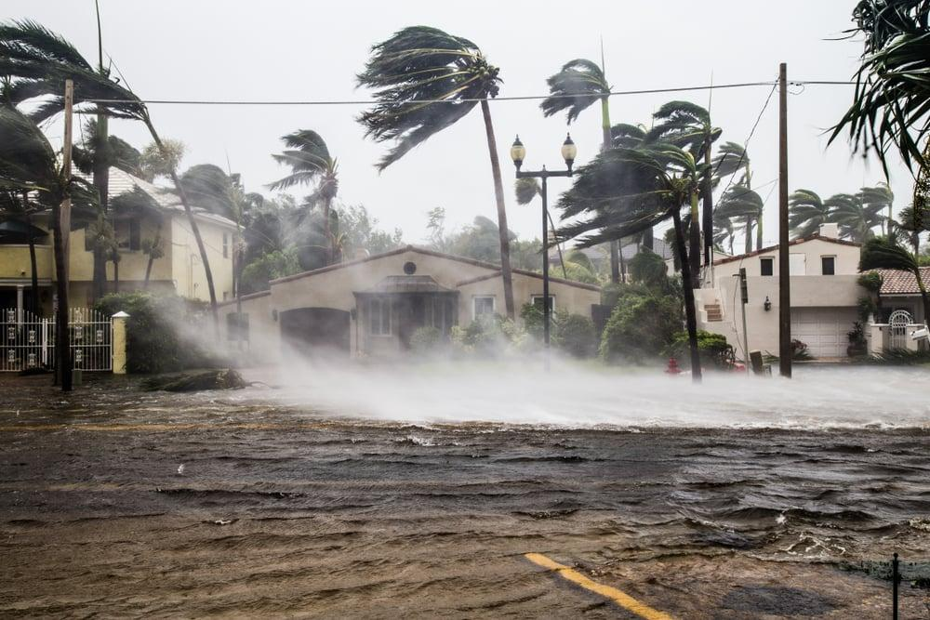
e. Assessment
- Teacher’s feedback.
2. ACTIVITY 1: VOCABULARY (4 mins)
a. Objectives:
- To introduce new words related to natural disasters.
- To help Ss develop the skill of listening for specific information.
- To help Ss further develop the skill of listening for specific information.
b. Content:
- Vocabulary pre-teach
- Task 1: Work in pairs. Look at the picture and answer the questions.
- Task 2: Listen to a broadcast. Put the activities in the correct column.
- Task 3: Listen again and tick T (True) or F (False) for each sentence.
c. Expected outcomes:
- Ss can answer the questions correctly.
- Ss can listen for specific information and do the learning tasks
d. Organisation
TEACHER AND STUDENTS’ ACTIVITIES | CONTENTS
Vocabulary pre-teaching
- Teacher introduces the vocabulary.  - Teacher explains the meaning of the new vocabulary, using pictures and translation.  - Teacher checks students’ understanding with the “Matching” technique. | New words:  1. authority (n)  2. warn (v)  3. avoid (v)
Task 1: Work in pairs. Look at the picture and answer the questions. (4 mins)
- Teacher asks Ss to work in pairs and look at the pictures carefully.  - Ss look at the pictures and answer the two questions.  - Teacher elicits the answers from Ss.  - Teacher invites some Ss to answer in front of the class. | Suggested answer:  A torch, a mask, a lamp, a whistle, a bottle of water, some medicine, matches, a radio, some plasters, a candle, a multi-purpose knife, some batteries, a blanket.
Task 2: Listen to a broadcast. Put the activities (1 – 6) in the correct column. (7 mins)
- Teacher tells Ss that they are going to listen to a broadcast in which instructions to prepare for a natural disaster are given.  - Teacher has them read the activities 1-6 and try to guess which activities go into which column.  - Teacher invites some Ss to share their answers and write them on the board.  - Teacher has Ss read the activities again and underline the key words.  - Teacher plays the recording and asks Ss to listen and put the activities in the correct columns.  - Ss work in pairs to compare their answers.  - Teacher asks Ss to compare their answers with the ones on the board.  - Teacher confirms whether they are right or wrong, playing the audio again if necessary. | Answer key:  - Before a storm: 2,6  - During a storm: 3,5  - After a storm: 1,4
Task 3. Listen again and tick T (True) or F (False) for each sentence. (7 mins)
- Teacher tells Ss that they are going to listen to the broadcast again and decide if the statements are true or false.  - Without playing the recording again, teacher has Ss read the statements and decide if they are true or false.  - Teacher plays the recording and asks Ss to listen again to check their answers.  - Teacher asks Ss to work in pairs to compare their answers.  - Teacher asks for Ss’ answers and confirms the correct ones. | Answer key:  1. F  2. T  3. F  4. T
e. Assessment
- Teacher’s observation and feedback
3. ACTIVITY 2: WRITING (15 mins)
a. Objectives:
- To brainstorm ideas and make an outline for Ss’ writing.
- To help Ss practise writing instructions about things to do before, during and after a flood.
b. Content:
- Task 4: Work in pairs. Discuss what you should do before, during, and after a flood. Write your ideas in the columns.
- Write instructions (80 - 100 words) about things to do before, during, and after a flood.
c. Expected outcomes:
- Ss can write instructions about things to do before, during, and after a flood.
d. Organisation
TEACHER AND STUDENTS’ ACTIVITIES | CONTENTS
Task 4: Work in pairs. Discuss what you should do before, during, and after a flood. Write your ideas in the columns. (5 mins)
- Teacher asks Ss to work in pairs.  - Ss discuss what they should do before, during and after a flood.  - Ss write their ideas in the columns.  - Teacher has some Ss present their ideas.  - Teacher comments on their answers. | 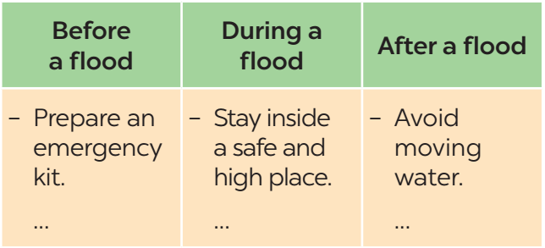
Task 5: Write instructions (80 - 100 words) about things to do before, during, and after a flood. (10 mins)
- Teacher asks Ss to work individually and write their instructions based on their answers in task 4.  - Teacher asks one student to write his/ her answer on the board. Other Ss and teacher comment on the writing on the board. | Suggested answer:  Here are the things you should do before, during, and after a ﬂood.  Before:  – Prepare an emergency kit with necessary things.  – Build barriers to stop ﬂoodwater from entering the house.  – Move to a higher place if necessary.  During:  – Listen to the radio or television for warnings and information.  – Be careful with ﬂash ﬂooding.  After:  – Avoid moving water.  – Stay away from damaged areas unless the local authority needs your help.  – Listen for local warnings of ﬂash ﬂoods.
e. Assessment
- Teacher’s observation and feedback.

4. CONSOLIDATION (3 mins)
a. Wrap-up
- Teacher asks Ss to summarise the main points of the lesson.
b. Homework
- Learn by heart all the words that they have just learnt.
- Rewrite the instructions.
- Do exercises in the workbook.
- Prepare for Lesson 7 – Looking back + Project.

Week : 25 Date of planning:10/2/2024
Period : 75 Date of teaching: 16/3/2024
UNIT 9: NATURAL DISASTERS
Lesson 7: Looking back & Project
I. OBJECTIVES: By the end of this lesson, students will be able to:
1. Knowledge:
- Revise more vocabulary items they have learnt in the unit.
- Revise the differences between the past simple and past continuous.
- Revise the past continuous.
- Have an opportunity to research more deeply into a natural disaster.
2. Core competence:
- Develop communication skills and creativity.
- Be collaborative and supportive in pair work.
- Actively join in class activities
3. Personal qualities
- Develop awareness of Natural disasters.
- Be concerned and know what to prepare when natural disasters happen.
II. MATERIALS
- Grade 8 textbook, Unit 9- Looking back & Project
- Computer connected to the Internet
- Projector / TV
- hoclieu.vn
Assumption
Anticipated difficulties | Solutions
Students may not have sufficient speaking, writing and co-operating skills when doing project. | - Encourage students to work in pairs, in groups so that they can help each other.  - Provide feedback and help if necessary.
III. PROCEDURES
1. WARM-UP (5 mins)
a. Objectives:
- To create an active atmosphere in the class before the lesson.
- To lead into the new lesson.
b. Content:
- Mind map
c. Expected outcomes:
- Ss can tell the teacher what they have learnt in unit 9.
d. Organisation
TEACHER AND STUDENTS’ ACTIVITIES | CONTENTS
- Teacher writes on the board “Unit 9” and asks students to think of what they have already learnt in this unit.  - Students work in groups to do the task.  - Teacher calls some students to retell.  - Teacher confirms and leads them to do all the exercises in books. | Suggested answer:  - Vocabulary: about the natural disasters  - Pronunciation: stress in words ending in -al and -ous  - Grammar: The past continuous
e. Assessment
- Teacher’s feedback.
2. ACTIVITY 1: VOCABULARY (10 mins)
a. Objectives:
- To help Ss revise the vocabulary they have learnt in the unit through pictures.
- To help Ss revise more vocabulary items they have learnt in the unit in different contexts.
b. Content:
- Task 1: Write the name of a natural disaster in each blank.
- Task 2: Fill in each blank with the correct form of the word in brackets.
c. Expected outcomes:
- Ss can use the words they have learnt in different contexts.
d. Organisation
TEACHER AND STUDENTS’ ACTIVITIES | CONTENTS
Task 1: Write the name of a natural disaster in each blank. (5 mins)
- Teacher asks Ss to work individually, read the sentences and look at the pictures.  - Ss write the name of a natural disaster in each blank.  - Teacher asks Ss to compare their answers with a partner.  - Teacher calls some Ss to share their answers.  - Teacher confirms the correct answers as a class. |  | Answer key:  1. flood  2. storm  3. earthquake  4. volcanic eruption  5. landslide
Task 2. Fill in each blank with the correct form of the word in brackets. (5 mins)
- Teacher asks Ss to work individually and read 5 sentences carefully.  - Ss complete the sentences using the correct form of the words given.  - Teacher asks Ss to share their answers with a partner.  - Teacher invites some Ss to write their answers on the board.  - Teacher confirms the correct answers. |  | Answer key:  1. destruction  2. predictions  3. victims  4. warned  5. workers
e. Assessment
- Teacher’s observation and feedback
3. ACTIVITY 2: GRAMMAR (10 mins)
a. Objectives:
- To help Ss revise the differences between the past simple and past continuous.
- To help Ss revise the past continuous by completing the sentences about them and their family members.
b. Content:
- Task 3: Put the verbs into the correct tense: the past simple or past continuous.
- Task 4: Complete the sentences about you and your family members.
c. Expected outcomes:
Students can differentiate between the past simple and past continuous.
d. Organisation
TEACHER AND STUDENTS’ ACTIVITIES | CONTENTS
Task 3: Put the verbs into the correct tense: the past simple or past continuous. (5 mins)
- Teacher asks Ss to work individually and read the sentences carefully.  - Ss give the correct form of the verbs (the simple past or past continuous).  - Teacher asks them to compare their answers with a partner.  - Teacher confirms the correct answers as a class. |  | Answer key:  1. were … doing  2. destroyed  3. was watering; came  4. were calling; appeared  5. Were … listening
Task 4: Complete the sentences about you and your family members. (5 mins)
- Teacher asks Ss to work individually and write sentences about their family members, using the past continuous.
- Teacher asks Ss to compare their sentences with a partner.
- Teacher invites some Ss to write their sentences on the board.
- Teacher comments on their answers.
e. Assessment
- Teacher’s observation and feedback
4. ACTIVITY 3: PROJECT (15 mins)
a. Objectives:
- To provide Ss with an opportunity to research more deeply into a natural disaster.
b. Content:
- Present the poster to the class.
c. Expected outcomes:
- Ss can research more deeply into a natural disaster.
d. Organisation
TEACHER AND STUDENTS’ ACTIVITIES | CONTENTS
What do we know about it?  - Ask Ss to read the instructions again (T has already assigned the project since the first lesson of the Unit and checked their progress after each lesson).  - Let students have some time to check their posters for the final time and make any adjustments if necessary.  - T has groups show their posters and present them to the class. | 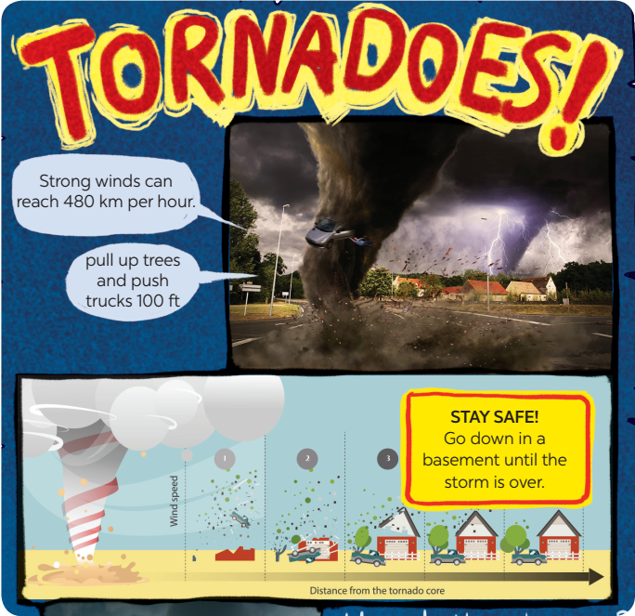
e. Assessment
- T checks ss’ grammatical and spelling mistakes on their poster, listens to their presentation, and gives feedback.
5. CONSOLIDATION (3 mins)
a. Wrap-up
- Teacher asks Ss to summarise the main points of the lesson.
b. Homework
- Do exercises in the workbook.
- Prepare Review 3
Teacher
TTCM

Đinh Thị Dung

