Week : 24 Date of planning:3/2/2025
Period : 70 Date of teaching: 4/3/2025
UNIT 9: NATURAL DISASTERS
Lesson 2: A closer look 1
I. OBJECTIVES
By the end of this lesson, students will be able to gain:
1. Knowledge:
- Vocabulary: The lexical items related to natural disasters.
- Pronunciation: Stress in words ending in -al and -ous
2. Core competence:
- Develop communication skills and creativity
- Be collaborative and supportive in pair work and teamwork
- Actively join in class activities
3. Personal qualities
- Develop awareness of Natural disasters.
- Be concerned and know what to prepare when natural disasters happen.
II. MATERIALS
- Grade 8 textbook, Unit 9 - A closer look 1
- Computer connected to the Internet
- Projector / TV
- hoclieu.vn
Language analysis
Form | Pronunciation | Meaning | Vietnamese equivalent
1. destroy (v) | /dɪˈstrɔɪ/ | to damage something so  badly that it cannot be used | phá hủy
2. erupt (v) | /ɪˈrʌpt/ | start to burn or burst into flames | phun trào
3. predict (v) | /prɪˈdɪkt/ | to say that an event or action  will happen in the future | dự đoán
4. emergency kit | /ɪˈmɜːdʒənsikit/ | a set of things used for a first-aid | bộ dụng cụ dùng trong trường hợp khẩn cấp
5. property (n) | /ˈprɒpəti/ | a building or area of land, or both together | của cải, nhà cửa
6. rescue worker | /ˈreskjuːˈwɜːkə/ | a person who helps  someone or something out of a dangerous, harmful, or unpleasant situation | nhân viên cứu hộ
7. victim (n) | /ˈvɪktɪm/ | a person who has suffered  the effects of violence or  illness or bad luck | nạn nhân
Assumption
Anticipated difficulties | Solutions
1. Students may lack experience of group/ teamwork. | - Encourage students to work in groups so that they can help each other.
2. Students may have underdeveloped co-operating skills. | - Encourage students to work in pairs, in groups so that they can help each other.
III. PROCEDURES
1. WARM-UP (5 mins)
a. Objectives:
- To create an active atmosphere in the class before the lesson.
- To lead into the new lesson.
b. Content:
- Kim’s game.
c. Expected outcomes:
- Ss review words about Natural disasters.
d. Organisation
TEACHER AND STUDENTS’ ACTIVITIES | CONTENTS
- Teacher asks Ss to work in 2 groups.  - Teacher shows some pictures related to Natural disasters in 2 minutes.  - Ss look at the pictures and remember (no writing).  - As soon as teacher stops showing the pictures, Ss work in groups and write the words for the pictures they have seen.  - The group with more correct words becomes the winner. | Kim’s game:  earthquake tornado  volcanic eruption tidal wave/ tsunami  flood drought
e. Assessment
- Teacher’s feedback.
2. ACTIVITY 1: VOCABULARY (22 mins)
a. Objectives:
- To present some words and phrases related to natural disasters.
- To give Ss further practice with words and phrases related to natural disasters.
b. Content:
- Vocabulary pre-teaching
- Task 1: In column B, write the noun forms of the verbs in column A.
- Task 2: Write a word or phrase from the box under the correct picture.
- Task 3: Fill in each blank with a word or phrase from the box.
c. Expected outcomes:
- Ss know how to pronounce the new words correctly and use them in appropriate situations.
d. Organisation

TEACHER AND STUDENTS’ ACTIVITIES | CONTENTS
Vocabulary pre-teaching (7 mins)
- Teacher introduces the words.  - Teacher explains the meaning of the new vocabulary, using pictures and translation.  - Teacher checks students’ understanding with the “Rub out and remember” technique. | New words:  1. destroy (v)  2. erupt (v)  3. predict (v)  4. emergency kit  5. property (n)  6. rescue worker  7. victim (n)
Task 1: In column B, write the noun forms of the verbs in column A. (5 mins)
- Teacher asks Ss to read the verbs in column A and try to give the noun forms of these verbs.  - Teacher asks Ss to work in pairs to compare their answers.  - Teacher has some Ss write their answers on the board.  - Teacher checks and confirms the correct answers. |  | Answer key:  1. destruction  2. eruption  3. warning  4. prediction  5. damage
Task 2: Write a word or phrase from the box under the correct picture. (5 mins)
- Teacher asks Ss to work individually.  - Ss look at the pictures and choose a suitable word/ phrase for each picture.  - Ss compare answers in pairs.  - Teacher invites some Ss to give their answers.  - Teacher confirms the correct answers. |  | Answer key:  1. whistle  2. property  3. emergency kit  4. victim  5. rescue worker
Task 3: Fill in each blank with a word or phrase from the box. (5 mins)
- Teacher asks Ss to work individually.  - Ss read all the sentences carefully to make sure they understand the sentences and fill in the blanks with the words and phrases in the box.  - Teacher lets Ss share their answers in pairs.  - Teacher invites some Ss to give the answers.  - Teacher confirms the correct answers. |  | Answer key:  1. damage  2. warning  3. emergency kit  4. predict  5. property
e. Assessment
- Teacher’s observation and feedback.
3. ACTIVITY 2: PRONUNCIATION (13 mins)
a. Objectives:
- To help students identify the stress in words ending in -al and -ous
- To help students stress the words ending in -al and -ous correctly and read the sentences including these words with correct stress.
b. Content:
- Listen and repeat the words. Pay attention to the word stress.
- Listen and repeat the sentences. Mark the stress in the underlined words.
c. Expected outcomes:
- Ss distinguish and pronounce the words ending -al and -ous with correct stress.
d. Organisation
TEACHER AND STUDENTS’ ACTIVITIES | CONTENTS
Task 4: Listen and repeat the words. Pay attention to the word stress. (6 mins)
- Teacher asks Ss to read out the words.  - Teacher plays the recording for them to listen and repeat the words they hear. Teacher plays the recording as many times as necessary.  - Teacher explains that these words have the stress on the first syllable and tells them that the endings –al and –ous do not change the stress pattern of the original words.  - Teacher asks Ss to work in pairs to practise saying the words.  - Teacher invites some Ss to say the words aloud. | 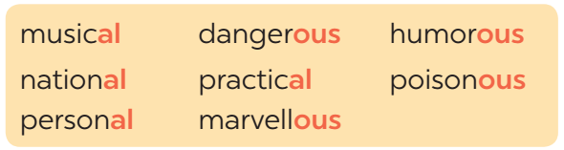
Task 5: Listen and repeat the sentences. Mark the stress in the underlined words. (7 mins)
- Teacher has Ss read the sentences quickly.  - Teacher plays the recording for Ss to listen to the sentences.  - Teacher asks Ss to pay attention to the underlined words and put stress on the correct syllable in each word.  - Teacher invites some Ss to share their answers, teacher confirms the correct ones.  - Teacher plays the recording again for Ss to repeat the sentences.  - Teacher has Ss practise the sentences in pairs and invites some pairs to read the sentences aloud. | Answer key:  1. The flood victims are collecting their ‘personal property.  2. Avoid ‘dangerous places, such as windows or bookcases, during an earthquake.  3. There are ‘numerous ‘tropical storms in this area every year.  4. Some ‘natural disasters, such as landslides, usually happen in ‘mountainous areas.  5. She gave us ‘practical tips about treating ‘poisonous wastes.
e. Assessment
- Teacher’s observation and feedback
4. CONSOLIDATION(5 mins)
a. Wrap-up
- Teacher asks Ss to retell the main points of the lesson.
b. Homework
- Learn by heart all the words that they have just learnt.
- Do exercises in the workbook.
- Prepare for Lesson 3 - A closer look 2

Week : 24 Date of planning:3/2/2025
Period : 71 Date of teaching: 7/3/2025
UNIT 9: NATURAL DISASTERS
Lesson 3: A closer look 2
I. OBJECTIVES: By the end of this lesson, students will be able to gain:
1. Knowledge:
- Grammar: How to use “The past continuous”
2. Core competence:
- Develop communication skills and creativity
- Be collaborative and supportive in pair work and teamwork
- Actively join in class activities
3. Personal qualities
- Develop awareness of Natural disasters.
- Be concerned and know what to prepare when natural disasters happen.
II. MATERIALS
- Grade 8 textbook, Unit 9 - A closer look 2
- Computer connected to the Internet
- Projector / TV/ pictures and cards
- Phần mềm tương tác hoclieu.vn
Language analysis
Structure | Examples
Affirmative sentences: S + was/ were + V_ing | She was doing her homework at 8 o’clock last night.
Negative sentences: S + was/ were not + V_ing | She was not doing her homework at 8 o’clock last night.
Questions: Was/ were + S + V_ing? | Was she doing her homework at 8 o’clock last night?
Assumption
Anticipated difficulties | Solutions
Students may not know how to work in teams or fully understand the exercises and tasks. | Give short, clear instructions and help if necessary.
III. PROCEDURES
1. WARM-UP (5 mins)
a. Objectives:
- To create an active atmosphere in the class before the lesson.
- To lead into the new lesson.
b. Content:
- Questions and answers.
c. Expected outcomes:
- Ss can use suitable answers to teacher’s questions.
d. Organisation

TEACHER AND STUDENTS’ ACTIVITIES | CONTENTS
- Teacher says one sentence about himself, using the past continuous.  - Teacher invites some Ss to answer the question.  (teacher writes the question and Ss’ answers on the board. If Ss don’t use the past continuous, still accept their answers).  - Teacher underlines the form of the past continuous in the sentence, and then corrects Ss’s answers if they don’t include the past continuous in their answers.  - Teacher tells them that they are going to learn the past continuous and leads to the lesson. | Question:  What were you doing?
e. Assessment
- Teacher’s feedback.
2. ACTIVITY 1: PRESENTATION (8 mins)
a. Objectives:
- To introduce the form and use of the past continuous.
b. Content:
- Introduce the past continuous.
c. Expected outcomes:
- Ss know the form and how to use the past continuous.
d. Organisation
TEACHER AND STUDENTS’ ACTIVITIES | CONTENTS
- Teacher draws Ss’s attention to the sentences on the board and asks “What is the form of the past continuous?”  - Teacher invites some Ss to answer the questions, then writes their answers on the board.  - Teacher confirms the correct answer. | - Form of the past continuous:  (+): S + was/ were + V_ing.  (-): S + was/ were not + V_ing.  (?): Was/ were + S + V_ing?  - The use of the past continuous:  We use the past continuous to describe:  + an action that was happening at a particular time in the past.  + a past action that was happening when another action interrupted it. We use the past simple for the action that interrupted it.  - Notes:  + We can use when or while before the past continuous.  + We can only use when before the past simple.
e. Assessment
- Teacher’s observation and feedback
3. ACTIVITY 2: PRACTICE (23 mins)
a. Objectives:
- To help Ss practise the form of the past continuous.
- To help Ss distinguish the past simple and the past continuous.
- To give further practice with the past continuous.
b. Content:
- Task 1: Complete the sentences by putting the verbs in brackets into the past continuous.
- Task 2: Circle the correct answer to complete each sentence.
- Task 3: Look at the picture and write what each person in Lan’s family was doing when the earthquake happened. Use the given word and phrases from the box.
- Task 4: Form questions using the past continuous. Then in pairs, ask and answer the questions.
c. Expected outcomes:
- Ss know how to use the past continuous.
- Ss can distinguish the past simple and the past continuous.
d. Organisation
TEACHER AND STUDENTS’ ACTIVITIES | CONTENTS
Task 1: Complete the sentences by putting the verbs in brackets into the past continuous. (6 mins)
- Teacher asks Ss to work in pairs and do the exercise.  - Ss do the exercise, then compare their answers with other pairs.  - Teacher invites some Ss to share their answers.  - Teacher confirms the correct answers. | Answer key:  1. were helping  2. was not / wasn’t snowing  3. was working  4. were … doing; was watching  5. Were … crying
Task 2: Circle the correct answer to complete each sentence. (5 mins)
- Teacher asks Ss to work individually and do the exercise.  - Teacher asks Ss to compare their answers with a partner.  - Ss discuss with their friends if there are any differences between their answers.  - Teacher checks students’ answers as a class.  - Teacher confirms the correct answers. | Answer key:  1. donated  2. were you doing; was sleeping  3. were camping; came  4. ran; moved  5. wasn’t reading; was watching
Task 3: Look at the picture and write what each person in Lan’s family was doing when the earthquake happened. Use the given word and phrases from the box. (6 mins)
- Teacher asks Ss who they can see in the picture and what they are doing.  - Teacher describes the situation to Ss and asks them to describe the actions of the people in the picture, using the past continuous and the words/ phrases given in the box.  - Teacher has Ss do this exercise individually and then compare their answers with another classmate’s.  - Teacher invites some Ss to write their answers on the board.  - Teacher checks the answers with the whole class and confirms the correct answers. | 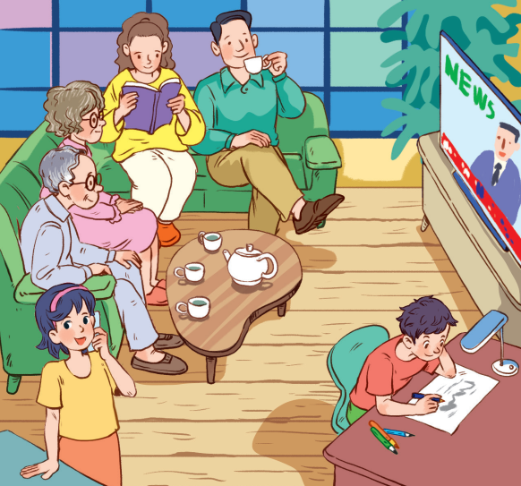  Answer key:  1. Lan’s grandparents were watching TV.  2. Lan’s/ Her mother was reading a book.  3. Lan’s/ Her father was drinking tea.  4. Lan was talking on the phone.  5. Lan’s/ Her brother was drawing.
Task 4: Form questions using the past continuous. Then in pairs, ask and answer the questions. (5 mins)
- Teacher asks Ss to read the example carefully and explains what they have to do.  - Teacher asks Ss to work in pairs to do this activity. They make questions and then practise asking and answering.  - Teacher invites some pairs to ask and answer the question in front of the class.  - Teacher comments on their answers and accepts different answers provided that they are correct and logical. | Answer key:  1. Were you having dinner at 7 o’clock yesterday evening?  2. Were you doing your homework at 8 o’clock yesterday evening?  3. Were you watching a film at 9 o’clock yesterday evening?
e. Assessment
- Teacher’s observation and feedback
4. ACTIVITY 3: PRODUCTION (7 mins)
a. Objectives:
- To help students practise the past continuous via a game.
b. Content:
- Task 5: Work in groups. Take turns to say a sentence that describes what each person in the picture was doing.
c. Expected outcomes:
- Ss can say sentences to describe what each person in the picture was doing.
d. Organisation

TEACHER AND STUDENTS’ ACTIVITIES | CONTENTS
Task 5: Work in groups. Take turns to say a sentence that describes what each person in the picture was doing. (7 mins)
- Teacher divides Ss into groups and assigns a group leader to keep watch of the game.  - Teacher explains the rule of the game:  The picture shows a class at break time. Now work in groups. Look at the picture for one minute. Take turns to say a sentence that describes what each person in the picture was doing. You score one point for every correct sentence. The student with the highest score in each group wins.  - Teacher has groups play the game in about 3-5 minutes.  - Teacher invites some groups to perform the game in front of the whole class and comments on their performance. |  | Suggested answers:  - Mai was reading.  - Phong and Nick were playing chess.  - Lan and Ann were singing.  - Nam was cleaning the board.  - Mi and Ha were talking.
e. Assessment
- Teacher’s observation and feedback.

4. CONSOLIDATION (3 mins)
a. Wrap-up
- Teacher asks Ss to summarise the main points of the lesson.
b. Homework
- Remember the form and use of the past continuous.
- Do exercises in the workbook.
- Prepare for Lesson 4 - Communication

Week : 24 Date of planning:3/2/2025
Period : 72 Date of teaching: 9/3/2025

UNIT 9: NATURAL DISASTERS
Lesson 4: Communication
I. OBJECTIVES:By the end of this lesson, students will be able to:
1. Knowledge:
- Use lexical items related to natural disasters.
- Practise giving and responding to bad news.
- Get some information about natural disasters.
2. Core competence:
- Develop communication skills and creativity
- Be collaborative and supportive in pair work and teamwork.
- Actively join in class activities
3. Personal qualities
- Develop awareness of Natural disasters.
- Be concerned and know what to prepare when natural disasters happen.
II. MATERIALS
- Grade 8 textbook, Unit 9 - Communication
- Computer connected to the Internet
- Projector / TV
- hoclieu.vn
Language analysis
Form | Pronunciation | Meaning | Vietnamese equivalent
1. shake (v) | /ʃeɪk/ | to move backwards and forwards or up and down in quick, short movements | rung, lắc
2. Fahrenheit (n) | /ˈfærənhaɪt/ | a measurement of temperature on a standard in which 32° is the temperature at which  water freezes and 212° that at which it boils | độ F (đo nhiệt độ)
3. Richter scale (n) | /ˈrɪktə skeɪl/ | a system used to measure the  strength of an earthquake | độ rích te (đo độ mạnh của động đất)
Assumption
Anticipated difficulties | Solutions
Ss may not have sufficient listening skills. | - Play the recording many times if necessary.  - Pick some Ss to ask and answer the questions.  - Have Ss practise the dialogue in pairs.
III. PROCEDURES
1. WARM-UP (5 mins)
a. Objectives:
- To create an active atmosphere in the class before the lesson.
- To lead into the new lesson.
b. Content:
- Ask and answer
c. Expected outcomes:
- Ss get some general ideas and get ready for the new lesson.
d. Organisation
TEACHER AND STUDENTS’ ACTIVITIES | CONTENTS
- Teacher shows a picture about one disaster.  - Teacher asks Ss to work individually and answer the questions.  - Teacher invites some Ss to talk in front of the class.  - Teacher comments on their answers and leads to the new lesson. | Answering the questions:  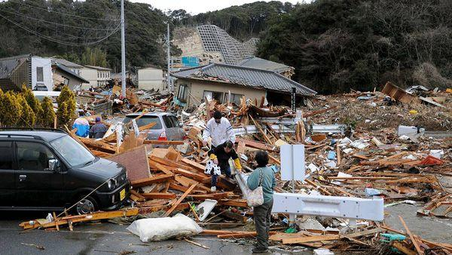  1. What do you see in the picture?  2. How do you feel?
e. Assessment
- Teacher’s feedback.
2. ACTIVITY 1: EVERYDAY ENGLISH (20 mins)
a. Objectives:
- To introduce ways of giving and responding to bad news.
- To help Ss practise giving and responding to bad news.
b. Content:
- Vocabulary pre-tech
- Task 1: Listen and read the dialogue below. Pay attention to the highlighted sentences.
- Task 2: Work in pairs. Practise giving and responding to bad news in the following situations.
c. Expected outcomes:
- Ss know how to give and respond to bad news.
- Students can make dialogue using the structures of giving and responding to bad news.
d. Organisation
TEACHER AND STUDENTS’ ACTIVITIES | CONTENTS
Vocabulary pre-teach (5 mins)
- Teacher introduces the vocabulary.  - Teacher explains the meaning of the new vocabulary, using pictures and translation.  - Teacher checks students’ understanding with the “What and where?” technique. | New words:  1. shake (v)  2. Fahrenheit (n)  3. Richter scale (n)
Task 1: Listen and read the dialogue below. Pay attention to the highlighted sentences.
(6 mins)
- Teacher plays the recording for Ss to listen and read the dialogue between Mark and Phong.  - Teacher asks Ss to pay attention to the highlighted sentences and tells them that these are two ways to give and respond to bad news.  - Teacher has Ss practise the dialogue in pairs.  - Teacher calls on some Ss to practise the dialogue in front of the class. | 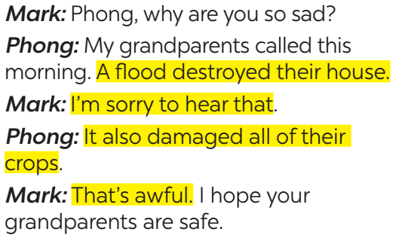
Task 2: Work in pairs. Practise giving and responding to bad news in the following situations. (9 mins)
- Teacher asks Ss to work in pairs to read the given situations and make similar dialogues, using the language they have learnt.  - Ss use the language and make similar dialogues.  - Teacher moves around to observe and provides help.  - Teacher calls on some pairs to practise in front of the class.  - Teacher comments on their performance. | Situations:  – You have a friend in a mountainous area. A landslide destroyed his family’s garden yesterday. You share this news with your classmate.  – You hear that a big earthquake hit a city. You share this news with your classmate.
e. Assessment
- Teacher’s observation and feedback.

3. ACTIVITY 2: KNOWLEDGE OF NATURAL DISASTERS (18 mins)
a. Objectives:
- To provide Ss with knowledge of different natural disasters.
- To provide Ss with a chance to communicate with each other and confirm their knowledge of natural disasters.
b. Content:
- Task 3: Read the short passages below. Decide which natural disaster each person below is talking about.
- Task 4: Choose the correct answer to each question to see how much you know about natural disasters.
- Task 5: Work in pairs. Compare your answers. Then check your answers with the key on page 101. How many points did each of you get?
c. Expected outcomes:
- Ss know more about natural disasters.
d. Organisation
TEACHER AND STUDENTS’ ACTIVITIES | CONTENTS
Task 3: Read the short passages below. Decide which natural disaster each person below is talking about. (6 mins)
- Teacher asks Ss to work in pairs to read the three short texts and decide what natural disaster each person is talking about.  - Teacher asks Ss to prepare an explanation for their answers.  - Teacher elicits answers from Ss.  - Teacher confirms the correct answers. |  | Answer key:  Nam: landslide  Ann: tornado  Tom: earthquake
Task 4: Choose the correct answer to each question to see how much you know about natural disasters. (7 mins)
- Teacher tells Ss that they are going to answer a questionnaire to see how much they know about natural disasters.  - Teacher has Ss read through the questionnaire quickly and explain any new words.  - Teacher asks Ss to answer the questions individually. |  | Answer key:  1. A  2. B  3. C  4. B  5. C  6. A
Task 5: Work in pairs. Compare your answers. Then check your answers with the key on page 101. How many points did each of you get? (5 mins)
- Teacher asks Ss to work in pairs to compare their answers.
- Teacher asks Ss to note down the answers and then check them with the key on page 101.
- Teacher has Ss calculate the points each of them earns.
- Teacher asks some Ss to report their answers and points to the class.
e. Assessment
- Teacher’s observation and feedback.
4. CONSOLIDATION (4 mins)
a. Wrap-up
- Teacher asks Ss to summarise the main points of the lesson.
b. Homework
- Learn by heart all the words that they have just learnt.
- Do exercises in the workbook.
- Prepare for Lesson 5 – Skills 1
Teacher
TTCM
Đinh Thị Dung

