Week : 22 Date of planning:18/2/2025
Period : 64 Date of teaching: 19/ 2/2025
UNIT 8: SHOPPING
Lesson 3: A closer look 2
I. OBJECTIVES: By the end of this lesson, Ss will be able to:
1. Knowledge
- revise and use some adverbs of frequency
- identify how to use the present simple for future actions.
- understand the difference in the use of present simple and future simple when talking about future activities.
2. Competences
- Develop competencies of communication, cooperation, and self-management.
- Be collaborative and supportive in pair work and teamwork
- Actively join in class activities
3. Personal qualities
- Be encouraged to know more about making plans, timetables, and schedules
- Develop self-study skills
II. MATERIALS
- Grade 8 textbook, Unit 8, A closer look 2.
- Computer connected to the Internet
- Projector / TV
- hoclieu.vn
Language analysis
Types of sentences | Definition | Examples
1. Adverbs of frequency | To say how often we do things and how often things happen.  There are six main adverbs of frequency that we use in English: always, usually (or normally), often, sometimes, rarely, and never | - They usually buy discount goods.
2. Present simple for future events | We use the present simple with a future meaning to talk about timetables or schedules. | - The train leaves at 4:30, so we still have a lot of time.
Assumption
Anticipated difficulties | Solutions
Ss may get confused about the use of present simple and future simple when talking about future activities. | T should be ready to find examples and give clear explanations to distinguish them.
III. PROCEDURES
1. WARM-UP (4 mins)
a. Objectives:
- To create an active atmosphere in the class before the lesson;
b. Content:
- Brainstorming
c. Expected outcomes:
- Having a chance to speak English and focus on the topic of the lesson.
d. Organisation

TEACHER’S AND STUDENTS’ ACTIVITIES | CONTENTS
Brainstorming
- Ss work in two teams.
- Give Ss 2 minutes to write as many adverbs of frequency as possible.
- The team with the most correct sentences wins.
- T leads in the lesson A CLOSER LOOK 2 on page 85.
e. Assessment:T checks ss’ answers and gives feedback
2. ACTIVITY 1: PRESENTATION (7 mins)
a. Objectives:
- To review ss’ knowledge of adverbs of frequency
- To revise ss’ knowledge of the simple sentences
b. Content:
- Review some adverbs of frequency and their use.
- Revise simple sentences
c. Expected outcomes:
- Recall the main adverbs of frequency and their use.
- Recall the form of the simple sentences
- Know the use of the present simple for future actions.
d. Organisation
TEACHER’S AND STUDENTS’ ACTIVITIES | CONTENTS
1. Adverbs of frequency
- T gets ss to list all the adverbs of frequency they can remember and the elicits the use of adverbs of adverbs of frequency from ss.  - T confirms the answer and gets ss to take notes | 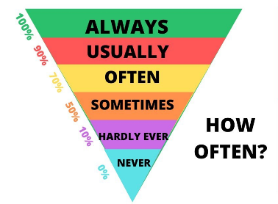
2. Present simple for future events
- T asks ss to recall the forms and uses of the present simple.  - T introduces the use of the present simple for future actions. | 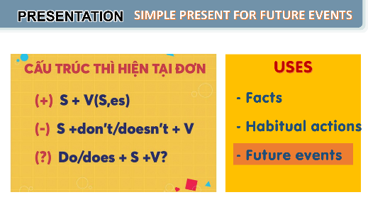
e. Assessment
- Teacher listens to students’ answers and gives feedback.
3. ACTIVITY 2: PRACTICE (24 mins)
a. Objectives:
- to revise and use some adverbs of frequency.
- to apply the use of present simple for future actions.
- to understand the difference in the use of present simple and future simple when talking about future activities.
b. Content:
- Task 1: Complete the sentences with the adverbs of frequency from the box.
- Task 2: Read the schedule of the field trip for the grade 8 students tomorrow and underline the verbs in the sentences. Then answer the questions.
- Task 3: Write A next to a sentence if it refers to a timetable, schedule, or plan, and B if it is an unplanned future action.
- Task 4: Choose the correct answer to complete each sentence.
c. Expected outcomes:
- Recall the main adverbs of frequency and their use.
- Recall the form and use of the simple sentences
- Can use the present simple for future actions.
d. Organisation
TEACHER’S AND STUDENTS’ ACTIVITIES | CONTENTS
Task 1: Complete the sentences with the adverbs of frequency from the box. (4 mins)
- Ask Ss to do the activity individually.  - Have Ss read the sentences and decide which adverb in the box best describes the frequency of the action.  - Call on some Ss to read aloud their answers.  - Check the answers as a class. Explain if needed. | Answer key:  1. always  2. rarely  3. never  4. often  5. sometimes
Task 2: Read the schedule of the field trip for the grade 8 students tomorrow and underline the verbs in the sentences. Then answer the questions. (5 mins)
- Have Ss do this activity individually or in pairs.  - Ask them to read the schedule and underline the verb in each sentence.  - Allow them some time to answer the questions.  - Call on some Ss to give their answers.  - Confirm the correct answers as a class.  - Have Ss read the Remember! box. Explain if needed. | Answer key:  Verbs: leaves, arrive, watch, starts, return  1. The present simple.  2. Future activities. (Refer to the word “tomorrow” in the task instructions.)
Task 3: Write A next to a sentence if it refers to a timetable, schedule, or plan, and B if it is an unplanned future action. (6 mins)
- Write scheduled future activity and unplanned future activity on the board. Say two sentences: The bus leaves at 11:00 and we have plenty of time. and Don’t move. I’ll answer the phone. Ask Ss which sentence is a scheduled future activity and which one is an unplanned future activity. Then write them underneath their correct categories.  - Ask Ss to work individually or in pairs.  - Call on 2 - 3 Ss to read aloud their answers.  - Confirm the correct answers as a class. Explain if needed. | Answer key:  1. B  2. A  3. A  4. A  5. B
Task 4: Choose the correct answer to complete each sentence. (5 mins)
- Have Ss do this activity individually.  - Ask Ss to read each sentence carefully and decide which option best completes the sentence.  - Call on some Ss to read out their answers.  - Confirm the correct answers as a class. | Answer key:  1. opens  2. will make  3. won’t buy  4. is  5. Does
e. Assessment
- Students do peer correction
- Teacher checks students’ answers as a class and gives feedback.
4. ACTIVITY 3: PRODUCTION (5 mins)
a. Objectives:
- To provide Ss with a real-life practice to use the present simple to talk about events.
b. Content:
- Task 5: Work in pairs. Ask and answer to check planned events for the community fair next month.
c. Expected outcomes:
- Ss can us the present simple to talk about the future the events.
d. Organisation
TEACHER’S AND STUDENTS’ ACTIVITIES | CONTENTS
Task 5: Work in pairs. Ask and answer to check planned events for the community fair next month. (5 mins)
- Have Ss work in pairs.  - Ask Ss to read the example so that they know what they have to do.  - Allow Ss some time to read the schedule and ask and answer about the time of different events.  - Call on some pairs to say aloud their questions and answers. Ask the whole class to follow and correct if they make a mistake. | 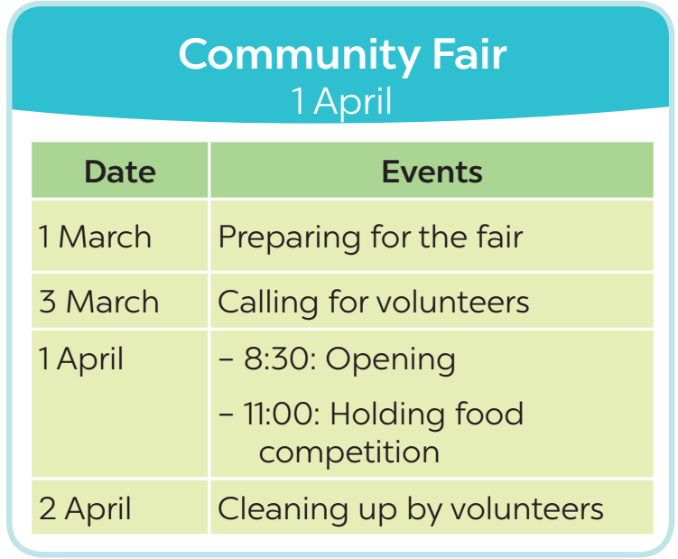
e. Assessment
- T corrects any grammar and pronunciation mistakes if necessary.
5. CONSOLIDATION (4 mins)
a. Wrap-up
- Ask Ss to summarise what they have learnt in the lesson.
- Have them say out loud the adverbs of frequency they learned in the lesson.
- Have them retell the form and uses of the present simple
b. Homework
- Learn the use of adverbs of frequency by heart.
- Make 5 sentences of the simple present for future meaning
- Do Exercise in the Workbook

Week : 22 Date of planning:18/2/2024
Period : 65 Date of teaching: 19/2/2024
UNIT 3: SHOPPING
Lesson 4: Communication
I. OBJECTIVES: By the end of this lesson, Ss will be able to:
1. Knowledge
- identify how to make complaints in English
- know about one’s favourite shopping place.
2. Skills
- Make complaints in English
- Listen and talk about one’s favourite shopping place.
3. Competences
- Develop competencies of communication, cooperation, and self-management.
- Be collaborative and supportive in pair work and group work.
4. Personal qualities
- Raise ss’ awareness of other’s favourite shopping places.
- Have good attitude to making polite complaints
II. MATERIALS
- Grade 8 textbook, Unit 8, Communication.
- Computer connected to the Internet
- Projector / TV
- hoclieu.vn
Language analysis
Making complaints | Examples
- I’m calling/ writing to make a complaint about…  - I’m not happy with … | - I’m calling to make a complaint about the backpack I ordered from you last week.  - I’m not happy with the colour.
Assumption
Anticipated difficulties | Solutions
Some Ss may have difficulty getting enough information to ask and answer what each person likes about their shopping | T should give suggestions or let ss listen more times to get enough information.
III. PROCEDURES
1. WARM-UP (3 mins)
a. Objectives:
- To create an active atmosphere in the class before the lesson;
b. Content:
- Chatting
c. Expected outcomes:
- Having a chance to speak English and focus on the topic of the lesson.
d. Organisation
TEACHER’S AND STUDENTS’ ACTIVITIES | CONTENTS
Chatting:  - T gives ss a situation:  Suppose that you ordered a hat online, but when you got it, it didn’t have the same colour as you ordered. What would you do in that case?  - T leads in the new lesson: If we aren’t satisfied with something you ordered, we can make complaints. There are two ways of making complaints that we will learn in Lesson 4. Communication.  - Ask Ss to look at COMMUNICATION on page 86. | Expected answers:  - Making complaints
e. Assessment
- T checks ss’ answers and give feedback
2. ACTIVITY 1: EVERYDAY ENGLISH (12 mins)
a. Objectives:
- To introduce how to make a complaint;
- To help Ss practise making a complaint.
b. Content:
- Use everyday expressions to develop language skills (Making a complaint)
c. Expected outcomes:
- Students can make complaints about specific situations
d. Organisation
TEACHER’S AND STUDENTS’ ACTIVITIES | CONTENTS
Task 1: Listen and read the dialogue. Pay attention to the highlighted parts. (5 mins)
- Play the recording for Ss to listen and read the conversation where Tom makes complaints about the SMART backpack he bought the previous week. Ask Ss to pay attention to the highlighted parts.  - Elicit the structures for making a complaint. Have Ss practise the conversation in pairs. | To make a complaint, you can use:  - I’m calling/ writing to make a complaint about….  - I’m not happy with ….
Task 2: Work in pairs. In turn, make complaints about the situations below. (7 mins)
- Ask Ss to work in pairs to make similar dialogues.  - Tell them to use the contexts given and the sample requests.  - Give feedback on their dialogues. | 1. The cans of fish you bought at the shop expired five days ago.  • I’m calling to make a complaint about the cans of fish I bought at your shop five days ago. It was expired.  2. An assistant at the shop was not very helpful.  I’m not happy with an assistant at the shop. She was not very helpful.
e. Assessment
- Teacher listens to students’ pronunciation and gives feedback.
3. ACTIVITY 2: MY FAVOURITE SHOPPING PLACE (25 mins)
a. Objectives:
- To help Ss practise listening for general and specific information.
- To provide Ss with some samples to help them talk about their favourite shopping places.
b. Content:
- Task 3: Listen to three people talking about their favourite shopping places and tick the place they mention.
- Task 4: Work in pairs. Take turns to ask and answer what each person in 3 likes about their shopping place.
c. Expected outcomes:
- Know some different favourite shopping places
- Students can apply what they have learnt to talk about their favourite places to shop.
d. Organisation
TEACHER’S AND STUDENTS’ ACTIVITIES | CONTENTS
Task 3: Listen to three people talking about their favourite shopping places and tick the place they mention. (7 mins)
- Have Ss read the instruction and the table so that they know what they have to do while listening to the recording.  - Play the recording and ask Ss to listen and tick the correct answers.  - Call on some Ss to read their answers.  - Confirm the correct answers as a class. | Answer key:  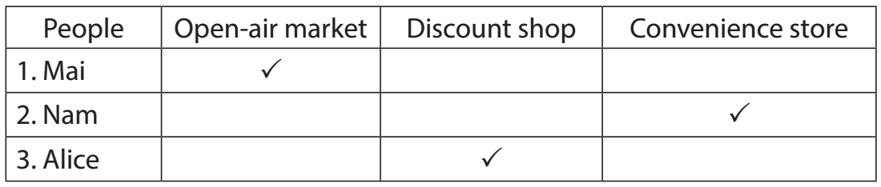
Task 4: Work in pairs. Take turns to ask and answer what each person in 3 likes about their shopping place. (8 mins)
- Have Ss work in pairs.  - Have Ss take turns to ask and answer about what each person in 3 likes about the place where they shop.  - Call on 2 - 3 pairs to share their lists. Make comments. | Model dialogue:  A: What does Nam like about shopping at a convenience store?  B: It saves him time.  Suggested answers:  Mai:  The products are home-grown and home-made. The market goers know one another.  They chat happily while selling and buying.  Nam:  They are convenient because they are everywhere. You can save time.  Alice:  There is a wide range of goods there. Everything is cheaper than at other places.
Task 5: Work in groups. Share your favourite shopping place with your group. (10 mins)
- Have Ss work in groups.  - T gets Ss to apply what they have learnt so far in this unit (ideas, vocabulary, grammar) to talk about their favourite places to shop.  - Allow Ss some time to talk in their groups. Go round and give support if needed.  - Ask some Ss to share their ideas with the class. | You can include:  - The name of the place  - The reason(s) why you like it
e. Assessment
- T listens to ss’ reports and gives feedback on their pronunciation and content.
3. CONSOLIDATION (4 mins)
a. Wrap-up
- Ask Ss what they have learnt in the lesson.
- Ss retell 2 ways of making complaints and list some favourite shopping places
b. Homework
- Learn the ways to make complaints by heart.
- Write a paragraph of 50 - 70 words about your favourite shopping place.
- Do exercise in the Workbook

Week : 22 Date of planning:18/2/2025
Period : 66 Date of teaching: 24/2/2025
UNIT 8: SHOPPING
Lesson 5: Skills 1
I. OBJECTIVES:By the end of this lesson, Ss will be able to:
1. Knowledge
- use the lexical items related to the reason(s) people go shopping.
- make a conversation to ask and answer about a new shopping centre and
2. Skills:
- develop their reading skill for specific information (scanning) through multiple-choice questions and gap-filling exercise
- practise asking and answering questions for information about a new shopping centre about a shopping place in their own area.
3. Competences
- develop communication skills and creativity
- be collaborative and supportive in pair work and teamwork
- develop presentation skill
- actively join in class activities
4. Personal qualities
- raise ss’ awareness of shopping places and the reason(s) people go shopping.
- have a good attitude towards going shopping to a shopping place.
II. MATERIALS
- Grade 8 textbook, Unit 8, Skills 1
- Computer connected to the Internet
- Projector / TV
- hoclieu.vn
Language analysis
Form | Pronunciation | Meaning | Vietnamese equivalent
1. customer (n) | /ˈkʌstəmə(r)/ | a person or an organisation that buys goods or services from a shop or business | Khách hàng
2. try on (v) | /traɪ ɒn/ | to put on a piece of clothing to see if it fits and how it looks | Thử (quần áo)
3. decoration (n) | /ˌdekəˈreɪʃn/ | a thing that makes something look more attractive on special occasions | Đồ trang trí
4. wander (v) | /ˈwɑːndər/ | to walk slowly around or to a place, often without any particular sense of purpose or direction | Đi lang thang, thả bộ
Assumption
Anticipated difficulties | Solutions
1. Ss may lack knowledge about some lexical items. | Provide Ss with the meaning and pronunciation of words.
2. Ss may not have sufficient reading, speaking and cooperating skills. | - Let Ss read the text again (if needed).  - Create a comfortable and encouraging environment for Ss to speak.  - Encourage Ss to work in pairs, and in groups so that they can help each other.  - Provide feedback and help if necessary.

III. PROCEDURES
1. WARM-UP (3 mins)
a. Objectives:
- To create an active atmosphere in the class before the lesson;
- To elicit from Ss some reasons why they go shopping
b. Content:
- Have Chatting activities to elicit some reasons why Ss go shopping
c. Expected outcomes:
- Having a chance to speak English and focus on the topic of the lesson.
d. Organisation
TEACHER’S AND STUDENTS’ ACTIVITIES | CONTENTS
Chatting:  - Ask ss questions to elicit from ss the reasons why they go shopping.  + Do you like shopping?  + How often do you go shopping?  + Why do you go to shopping centres?  - Ask Ss to discuss the reasons why they go shopping  - Ask Ss to look at SKILLS 1 on page 87-88. | Expected answers:  - Yes/ No  - I go shopping twice a week/ every day….  - I like shopping because….
e. Assessment
- T listens to ss’ answers and gives feedback
2. ACTIVITY 1: READING (26 mins)
a. Objectives:
- To help Ss develop their reading skill for general and specific information.
b. Content:
- Task 1: Read the list below and tick (v) the most common reason(s) why you go shopping.
- Vocabulary pre-teaching
- Task 2: Read the passage and choose the correct answer A, B, or C.
- Task 3: Fill in each blank with ONE word from the passage.
c. Expected outcomes:
- Know more new words and some reason(s) people go shopping.
d. Organisation
TEACHER’S AND STUDENTS’ ACTIVITIES | CONTENTS
Task 1: Read the list below and tick the most common reason(s) why you go shopping. (3 mins)
- Have Ss work individually.  - Ask Ss to read the words and phrases and tick the one(s) that is / are correct for them.  - Call on some Ss to share their answers with the class. | 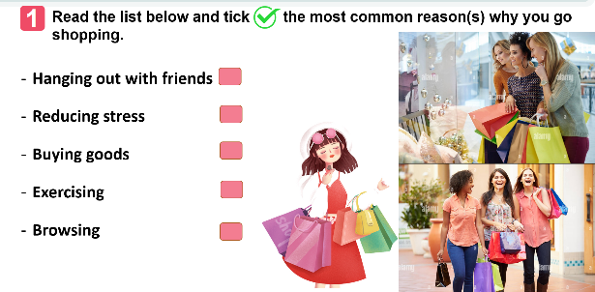
Vocabulary pre-teaching  - Teacher asks ss to look through the text.  - Teacher gets ss to guess the meaning of the new vocabulary through context  - Teacher confirms the answers then gets ss to read orally and take notes of all the four words in their notebooks. | * Vocabulary:  1. customer (n)  2. try on (v)  3. decoration (n)  4. wander (v)
Task 2: Read the passage and choose the correct answer A, B, or C. (10 mins)
- Have Ss read the text in detail first. Then ask them to read each question and choose the correct answer for it.  - Ask ss to find the information in the reading text.  - Call on some Ss to share their answers. Ask them where they find the information for their answers.  - Confirm the correct answers as a class. Explain if needed. | Answer key:  1. C  2. A  3. B  4. B  5. A
Task 3: Fill in each blank with ONE word from the passage. (10 mins)
- Ask Ss to read each sentence carefully, then refer to the text to look for the answer. Have them complete the task.  - Have Ss compare their answers in pairs and discuss if there are any differences in their answers.  - Call on some Ss to share their answers with the class. Ask them where they find the information for their answers.  - Confirm the correct answers as a class. | Answer key:  1. sales  2. try  3. entertainment  4. decorations  5. free
e. Assessment
- Teacher listens to students’ pronunciation and gives feedback.
- T checks the answers as a class and give feedback
3. ACTIVITY 2: SPEAKING (15 mins)
a. Objectives:
- To help Ss practise asking and answering questions for information about a new shopping centre
- To provide an open opportunity for Ss to talk about a shopping place in their own area
b. Content:
- Task 4: Work in pairs. Ask and answer about a new shopping centre.
- Task 5: Work in pairs. Ask and answer about a shopping centre, a supermarket, or an open-air market in your area. Take notes of your partner’s answers and report them to the class.
c. Expected outcomes:
- Students can speak about a new shopping centre and a shopping place in their own area.
d. Organisation
TEACHER’S AND STUDENTS’ ACTIVITIES | CONTENTS
Task 4: Work in pairs. Ask and answer about a new shopping centre. (9 mins)
- Ask Ss to work in pairs, each having their card (A or B). Make sure that they know how to work with the cards.  - Allow them some time to prepare the questions and to read the information for the answers. Then ask them to start asking and answering about the new shopping centre. Go around and monitor. Give help if needed.  - Call on some Ss to share their conversation with the class. Comment on their conversation.  - This activity helps prepare Ss for 5. | Suggested questions:  1. Where is the new shopping centre?  2. How many shops are there / does it have?  3. What kind of entertainment does it offer / have / can we find there?  4. What are its opening hours?  5.What date does the shopping centre open?
Task 5: Work in pairs. Ask and answer about a shopping centre, a supermarket, or an open-air market in your area. Take notes of your partner’s answers and report them to the class. (5 mins)
- Have Ss work in pairs.
- Ask Ss to reflect on the conversation in 4 and read the suggestions for 5.
- Allow Ss some time to carry out their conversation. Remind them to take notes of their partner’s answers. Go round and offer help if needed.
- Call on some Ss to report to the class what they find out about their partner’s shopping place. Comment on their presentation.
e. Assessment
- T asks the class to give feedback on their questions and answers, and pronunciation.
- T gives feedback on their reports in terms of language, reasoning skills, and pronunciation.
4. CONSOLIDATION (3 mins)
a. Wrap-up
- Ask Ss what they have learnt in the lesson.
- Ss retell the reasons why we go to shopping centres and information about new shopping centres.
b. Homework
- Learn the new words by heart.
- Make a speech introducing a new shopping centre in your city.
- Do exercise in the Workbook.

TTCM Teacher

Đinh Thị Dung

