Date of planning : 18/1 / 2025
Date of teaching : 23 /1 / 2025

Week : 20 UNIT 7: TELEVISION

Period : 60 Lesson 6: SKILLS 2
I. OBJECTIVES:
By the end of the lesson, students will be able to:
- listen to get specific information from a recommended TV schedule;
- write a short guided passage about one’s watching TV habits.
II. LANGUAGE ANALYSIS
1. Knowledge:
* Vocab: revise words related the topic “Television”
* Grammar: Use conjunctions (but, and, because …) and question words (where, who, why,… )
2. Competences: Talk about their favourite TV programme; work in group to talk about two things you like and don’t like about TV program.
3. Quality/ behavior: To teach SS to work hard, Ss will be more aware of spending time watching TV, and choose the best programme for yourself ; Ss have the good attitude to working in groups, individual work, pairwork, cooperative learning and working.
III. MATERIALS
1. Teacher:
- Text books , pictures, planning ( Unit 7, Skills 2)
- Smart TV/Pictures.
- sachmem.vn
2. Students: Text books, notebooks, posters, ….
3. Method: Ask and answer ; group works; individual ……
  - IV. PROCEDURES : (STAGES)
* Warm-up (5’)
* Aim: - To create a friendly and active atmosphere in the class before the lesson;
-To lead in the topic of the listening tasks.
* Content: Game: Kim’s game
* Products: Ss write the name of TV programs on the posters.
* Organization of implementation:
Teacher’s and Ss’activities |  |  | Content
* Warm up  T -Ss  - Teacher shows some pictures of TV programmes.  - Teacher asks students to look carefully at them for about thirty seconds. Then take the pictures away and ask them to call out what they can remember.  Lead in:  - Teacher asks students some questions to lead in the listening tasks: |  |  | * Play a game : Kim’s game      + What programme did you watch last night?  + What was it about?  + What did you like about it?  + What didn’t you like about it?  + Why did you like/dislike it?
* Pre-Listening (2’)
* Aim: - To draw students’ attention to the keyword of the listening task
* Content: Read the programmes in the table.
* Products: Read and understand the meaning of words.
* Organization of implementation:
Teacher’s and Ss’activities |  | Content
- T –Ss :  - Teacher allows students some time to read the programmes in the table.  - Teacher asks them to focus only on the information they need:  the channel.  “We are going to read a schedule of some programmes on TV.  First, I would like you to read it, underline the important key words (“the channel”), then listen to tick which channel it belongs to.” |  | * Read the programmes in the table.  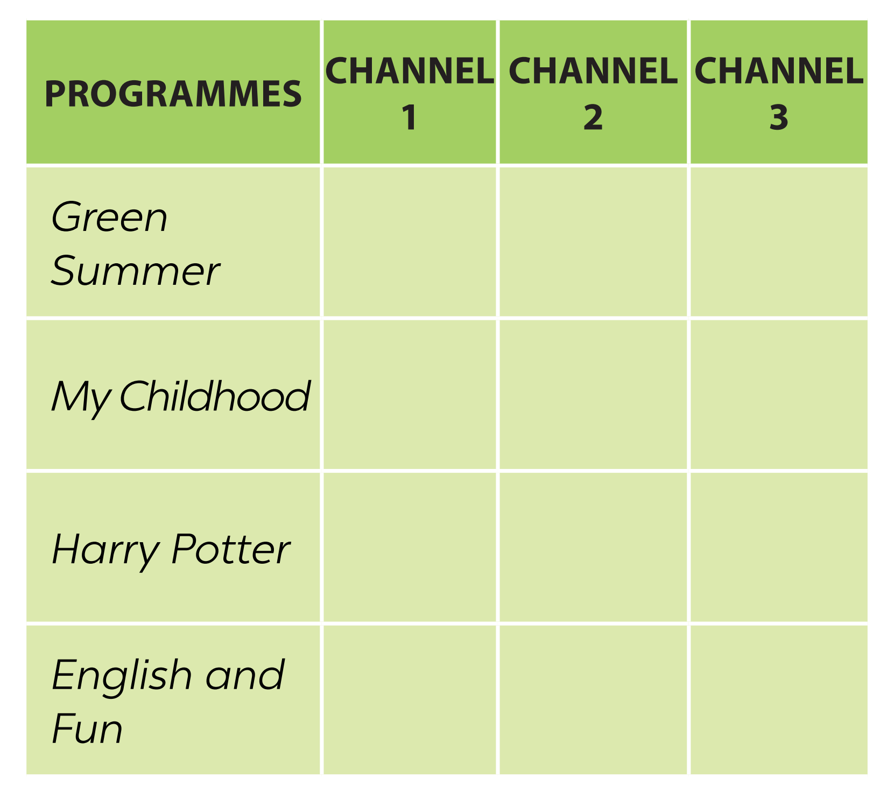
* While -listening (10’)

Task 1
* Aims: To help students develop their listening skill for specific information.
* Content: Listen and tick the correct channel for each programme.
* Products: Students say the correct answers aloud.
* Organization of implementation:
Teacher’s and Ss’activities | Content
Task 1:T –Ss : Ss- Ss  - Teacher plays the recording.  - Students listen and tick.  - Teacher checks their answers as a class. | Task 1 : Listen and tick the correct channel for each programme.  *Answer key:
  Programme | Channel 1 | Channel 2 | Channel 3
  Green Summer | 
  My Childhood |  | 
  Harry Potter |  |  | 
  English and Fun | 
Task 2

* Aims: To help students develop listening skill for specific information. (T/F)
* Content: Listen again and tick T (True) or F (False)..
* Products: Students say T or F exactly.
* Organization of implementation:
Teacher’s and Ss’activities | Content
Task 2: T - Ss, Ss - Ss  - This activity requires students to listen more carefully for details.  - Teacher allows students some time to read the statements first and see if they can answer any of them based on the previous listening.  - Teacher draws students’ attention to the fact that almost all the questions start with the names of the programmes. They are signals that the answers are coming.  - Teacher plays the recording.  - Students listen and tick.  - Teacher checks their answers as a class. If students have difficulty in catching the information, determine their answers, pause the recording after each sentence where the information appears. | Task 2: Listen again and tick T (True) or F (False).  => Answer: 1. T 2. F ( a boy and his dog)  3. T 4. F ( 9 o'clock)  *Audio script:  - Here are some interesting TV programmes for you. Green Summer, a music programme, is on Channel 1. It starts at eight o’clock. My Childhood is on Channel 2. It’s the story of a country boy and his dog Billy. On Channel 3, you will watch Harry Potter at 8.30. Children all over the world love this film. If you like to learn English, you can go to English and Fun on Channel 1. It’s at nine o’clock. We hope you can choose a programme for yourself. Enjoy and have a great time.
* Post- listening (5’)
* Aims: To summarize the key information in the listening tasks.
  - * Content: Summarize the information of the listening part.
* Products: Ss summarize the information in the listening part before the class.
* Organization of implementation:
Teacher’s and Ss’activities | Content
Task 3:T-Ss, Ss-Ss( work group)  - Students work in groups of four.  - Teacher asks students to summarize the information in the listening part and talk about it.  - Teacher helps if necessary. | - * Summarize the information of the listening part.  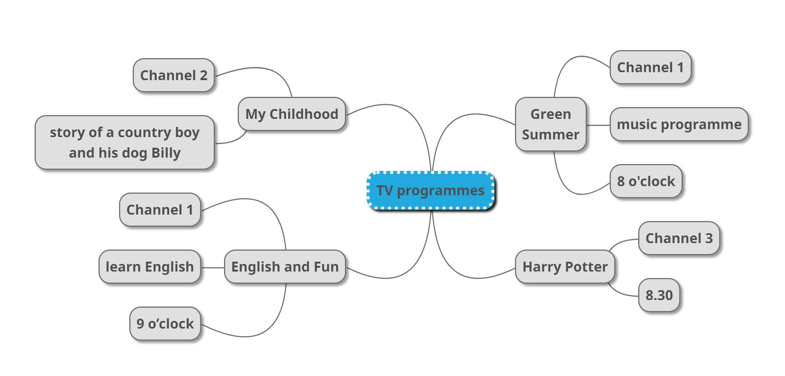
* Pre-Writing (5’)
* Aims: To guide and prepare students with information for their writing in Task 4.
* Content: Read the questions and circle the right answers for yourself
* Products: Students’ answers.
* Organization of implementation:
Teacher’s and Ss’activities | Content
Task 4: T - Ss, Ss – Ss  - Students have to answer a questionnaire about TV-watching habits.  - Teacher lets students read the questions and tick the most appropriate answers for themselves.  - - Teacher asks them to think of a TV programme they like and write the answer to Question 5.  - T can have Ss ask and answer in front of the class | Task 3: Read the questions and circle the right answers for yourself.  1. How much do you like watching TV?  A. A lot B. So so. C. Not much.  2. How many hours a day do you watch TV?  A. 1 hour. B. 2-3 hours. C. Less than one hour.  3. When do you watch TV the most?  A. In the morning B. In the afternoon.  C. Inthe evening.  4. Do you watch TV when you are eating?  A. Always. B. Sometimes. C. Never.  5. What TV programme do you watch the most?  A. cartoon B. Sports. C. cience
* While-Writing (5’)
* Aim: To guide students how to write a paragraph about TV-watching habits.
* Content: Write a paragraph of 40-50 words about your school.
* Products: Students’ perfect writing on the posters.
* Organization of implementation
Teacher’s and Ss’activities | Content
- Teacher lets students work individually.  - Teacher asks them to refer to the questions and their answers in 3 while they are writing. These questions are a very good guide of how to form a sentence and what information they need to complete the sentence.  - Teacher tells students that the information in the questions in Task 3 has been arranged in a logical order and they can organise their writing by referring to their answers one after another.  - Teacher goes round and oﬀer help if needed.  - If time allows, ask some students to share their writing with the class.  If not, collect some students’ writings to correct at home. | Task 4: Write a paragraph of about 50 words about your TV-viewing habits. Use your answers in Task 3.  * Sample answer:  - +I like watching TV, about one hour a day. I only watch TV in the evening. During the day, I go to school. On Saturday and Sunday, I watch more. Sometimes I watch TV when I’m eating, but I never watch TV when I’m studying. I watch Da Vinci most. It has interesting educational programmes for children.  + I like watching TV a lot. I usually spend 2-3 hours on watching TV. I often watch TV in the evening. I somtimes watch TV when I'm eating. I watch Cartoon the most because it’s funny and interesting.
* Post-Writing (3’)
* Aim: To peer check, cross check and final check students’ writing.
* Content: Cross check students’ writing
* Products: Students check the others’ writing carefully .
* Organization of implementation:

Teacher’s and Ss’ activities | Content
- Teacher asks students to exchange their textbooks to check their friends’ writing.  - Teacher then gives feedback as a class discussion. | + Exchange their textbooks to check their friends’ writing.
* Consolidation (2’)
* Aim: To consolidate what students have learnt in the lesson.
* Content: Summarize the main content in the lesson.
* Products: Say aloud what they have just learnt in front of the class.
* Organization of implementation:

Teacher’s and Ss’ activities | Content
- Teacher asks students to talk about what they have learnt in the lesson. | - Listen and tick the correct channel for each programme.  - Write a paragraph of about your TV-viewing habits.
* Homework (2)
* Aim: To revise the knowledge that students have gained in this lesson.
- To allow students finalize their versions after being checked by friends and teacher.
* Content: Review the lesson and prepare for the next lesson and do exersie in the workbbook
* Products: Students’ textbook and workbook
* Organization of implementation:

- Teacher asks students to write down the paragraph in their books.  - Teacher asks students to prepare the new lesson. | - Rewrite the paragraph in the notebooks.  - Prepare Looking back and project.

