Date of planning : 18 /1 / 2025
Date of teaching : 21/1 / 2025

Week :20 UNIT 7: TELEVISION

Period : 59 Lesson 5 : SKILLS 1
I. OBJECTIVES:
By the end of the lesson, students will be able to:
- use the lexical items related to the topic Television;
- read for specific information about television; talk about one’s favourite TV program, the reasons for that.
II. LANGUAGE ANALYSIS
1. Knowledge:
* Vocab: compete (v), plant (n), comedy, race (n),..
* Grammar: Use conjunctions (but, and, because …) and question words (where, who, why,… )
2. Competences: Talk about their favourite TV programme; work in group to talk about two things you like and don’t like about TV program.
3. Quality/ behavior: To teach SS to work hard, Ss will be more aware of spending time watching TV, and choose the best programme for yourself ; Ss have the good attitude to working in groups, individual work, pairwork, cooperative learning and working.
III. MATERIALS
1. Teacher:
- Grade 6 textbook, planning ( Unit 7, skills 1)
- Smart TV/Pictures, sets of word cards
- sachmem.vn
2. Students: Text books, notebooks, posters, ….
3. Method: Ask and answer ; group works; individual ……
  - IV. PROCEDURES : (STAGES)
* Warm-up (5’)
* Aim: To create a friendly and active atmosphere in the class before the lesson.
To lead in the topic of the reading text.
* Content:
* Products: Students say the correct answers aloud.
* Organization of implementation:
Teacher’s and Ss’activities | Content
- T- Ss  - Teacher shows some pictures which illustrate the logos of some famous TV channels. These logos are missing some parts or in the reversed position.  - Students have to guess the name of the TV channels.  - Teacher provides feedback and confirms the answers:  + Lead in:  -To lead in the text about TV guides.  - Teacher asks students questions to lead in the reading text: | * Play a game : * Guessing game: TV channels      * Discovery Channel; Disney Channel; Cartoon Network, football channel, Quang Ngai television,  -1/Among these five channels, which one do you like best?  I like …… best because I………………  2/ What about you? Do you often read the TV guide before watching TV?  ……………………………………….
* Pre- reading (7’)
* Aim: - To prepare students with vocabulary related to the lesson ; To lead in the reading skills.
* Content: Some vocabularies related the lesson.
* Products: Read and understand the meaning of the words.
* Organization of implementation:
Teacher’s and Ss’activities | Content
T –Ss :  - Pre teach vocabulary  - Teacher use different techniques to teach vocab (pictures, situation, realia)  - Repeat in chorus and individually  - Copy all the words  * Checking vocab: < Rub out and remember | - * vocabulary:  - compete (v) : tranh tài cạnh tranh  - plant (n): cây cảnh, thực vật  - comedy (n): phim hài  - race (n): Cuộc đua  * Checking vocab: <R &R>
* While reading (15’)
Task 1
* Aims: To teach students how to read a TV guide.
* Content: Read the first two columns of the TV guide and answer the questions.
* Products: Read and answer the questions exactly.
* Organization of implementation:
Teacher’s and Ss’activities | Content
Task 2:T –Ss : Ss- Ss  - Teacher asks students to have a quick look at the TV guide and answer questions like:  - This task should be done carefully as it helps do Task 2.  - Teacher explains to students so that they can distinguish the name of the programme (e.g. Sports) and the name of the specific event / show/ film, etc. on that programme (e.g. The Pig Race).  - Teacher allows students some time to read the TV guide and answer the questions.  - Teacher checks their answers as a class. | Task 1: Read the first two columns of the TV guide and answer the questions.  1. What information do you see? (the time, the name of the programme and its content)  2. What information comes first? What comes next?  - 3. What do you look at when you are choosing a  programme to watch?  * Answer key:  1. (It’s) Cuc Phuong Forest.  2. Yes, it is.  3. It’s on at 10.30.  4. No, we can’t.  5. (It’s about) dolphins.
Task 2
* Aims: To show students how to find a suitable TV programme for a person.
* Content: Write the programmes that these people may choose to watch.
* Products: Stusents’ correct answers on the board.
* Organization of implementation:
Teacher’s and Ss’activities | Content
Task 2: T - Ss, Ss – Ss  Teacher asks students to read the information about each person carefully, underline the key word(s) showing what each person likes in order to help them find the answer.  Teacher allows students some time to do the task individually.  Teacher asks some students to share their answers before checking as a class. | Task 2: Read the TV guide in Task 1 and write the programmes that these people may choose to watch.  * Answer key:  1. Phong: Children are Always Right  2. Bob: The Fox Teacher  3. Nga: Cuc Phuong Forest  4. Minh: The Pig Race  5. Linh: The Dolphins
* Pre- speaking (5’)
Task 3
* Aims: To allow students to talk about what they have done in Reading Task 2.
* Content: Work in groups. Share your table in Task 2 with your group and see if they agree with you.
* Products: Some students demonstrate fluently it in front of the class.
* Organization of implementation:
Teacher’s and Ss’activities | Content
Task 3: T - Ss, Ss – Ss  - Teacher lets students work in groups and share their answers in Task 2 to the groups.  - Teacher encourages other students to say if they agree or disagree with the answers and explain their partners’ choice.  - Teacher calls some students to demonstrate it in front of the class. | Task 3: Work in groups. Share your table in Task 2 with your group and see if they agree with you.  * Example:  A: I think the best programme for Phong is the game show "Children are always right".  B: I agree. He wants to know more about pets.
* While-Speaking (6’)
* Aims: To teach students how to talk about their favourite TV programmes.
* Content: Tell your group about your favourite TV programme.
* Products: Some students present their answers to the class.
* Organization of implementation:
Teacher’s and Ss’activities | Content
Task 4: T - Ss, Ss – Ss  - Teacher asks students to read the instructions carefully and allow them some time to prepare their answers.  - Teacher tells students the suggested structure can help them arrange their ideas.  - Teacher lets students share their answers in groups before calling some students to present their answers to the class.  - - Teacher corrects later if they make any mistakes. | Task 4: Work in groups. Tell your group about your favourite TV programme.  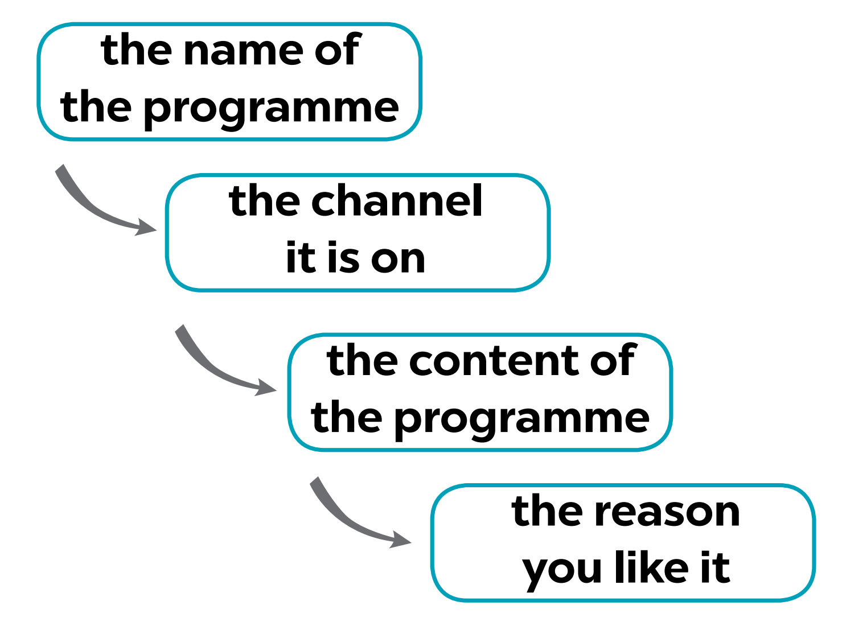  * Suggestions:  - My favourite programme is...  - It’s on ...  - It’s about ...  - I like it because it ...
* Post-Reading and Speaking (5’)
* Aim: To help students improve next time.
  - * Content: Discuss your choice with your friends.
* Products: Some students present in front of fluently.
* Organization of implementation:

Teacher’s and Ss’activities | Content
Task 5: T - Ss, Ss – Ss  - Teacher allows students to give comments for their friends and vote for the most interesting and informative presentation.  - Teacher gives feedback and comments. | - Task 5: Discuss your choice with your friends.  * Students ’ presentation
* Consolidation (2’)
* Aims: To consolidate what students have learnt in the lesson.
* Content: summarize the main content in the lesson.
* Products: Students say what they have learnt in the lesson.
* Organization of implementation:

Teacher’s and Ss’ activities | Content
- Teacher asks students to talk about what they have learnt in the lesson. | + words/phrases/ sentences describing television  + talk about a TV programme you like.
*Homework (2’)
* Aim: To revise the knowledge that students have gained in this lesson.
* Content: Review the lesson and prepare for the next lesson and do exersie in the workbbook
* Products: Students’ textbook and workbook
* Organization of implementation:

Teacher’s and Ss’ activities | Content
- Teacher asks students to revise old lesson and to do exercise in workbook. | - Do exercise in workbook.  - Prepare for the next lesson: Skills 2.

