Date of planning : 24/12 / 2024
Date of teaching :26 /12 / 2024

Week :16 UNIT 6: OUR TET HOLIDAY.

Period : 48 Lesson 7: Looking back and project
I. OBJECTIVES:
By the end of the lesson, students will be able to:
- review the vocabulary and grammar of Unit 6;
- apply what they have learnt (vocabulary and grammar) into practice through a project.
II. LANGUAGE ANALYSIS
1. Knowledge:
* Vocabulary: revise vocabulary related to Tet
* Grammar: should/ shouldn't + V
2. Competences:Ss review the vocabulary and grammar of Unit 6 and apply what they have learnt in the unit; Ss will be developed speaking, writing and co-operating skills when doing project.
3. Quality/behavior: To teach SS to work hard , love our Tet holiday; undestand something should /shouldn’t do at Tet holiday.
III. MATERIALS
1. Teacher: - Grade 6 textbook, Planning (Unit 6 -Looking back and project)
- Smart TV/Pictures, sets of word cards
- sachmem.vn
2. Students: Text books, notebooks, posters, ….
3. Method: Ask and answer ; group works; individual ……
IV. PROCEDURES : (STAGES)
* Check- up (5’)
* Aim: To revise the vocabulary related to the topic and lead in the next part of the lesson.
* Content: Look at the pictures and Write Activities you should do/ shouldn’t do at Tet
* Products: Students’ perfect sentences on the board.
* Organization of implementation:
Teacher’s and Ss’activities |  |  | Content
* Warm up  - T –Ss ; Ss - Ss  - Teacher divides the class into 2 big groups.  Teacher asks students to ook at the pictures and Write Activities you should do/ shouldn’t do at Tet  The group having the most suitable and correct answers is the winner. |  |  | * Warm up : Look at the pictures and Write Activities you should do/ shouldn’t do at Tet  * Suggested answers:  -You should cook Chung cake.  - You shouldn’t eat a lot of sweets.  - You should watch fireworks.  ………………..
* VOCABULARY
Task 1,2 (10’)
* Aim: Task 1: To help students revise the vocabulary about things and activities at Tet.
Task 2: To help students revise the vocabulary about Tet in context.
* Content: Match the verbs on the left with the nouns on the right.
* Products: Ss say the correct answers key aloud.
* Organization of implementation:
Teacher’s and Ss’activities | Content
Task 1:  - T –Ss :  - Teacher encourages students to complete the task individually.  - Students exchange their textbooks to compare their answers together.  - Teacher gives feedback to the whole class.  Task 2:  - T –Ss :  - Teacher encourages students to complete the task individually.  - Student exchange their textbooks to discuss the reasons why they are choosing the appropriate words/phrases.  - Teacher gives feedback as a class discussion. | Task 1: Match the verbs on the left with the nouns on the right.  * Answer key:  1. D 2. C 3. E  4. A 5. B 6. F  Task 2: Complete the sentences with the words/phrases in the box. (p. 66)  * Answer key:  1. lucky money  2. cleaning  3. Banh Chung  4. peach  5. gathering
* GRAMMAR (10’)

Task 3+ Task 4
* Aims: Task 3- To help students revise the use of should/ shouldn’t in context; to let students learn how to behave well at other people’s houses.
Task 4 - To help students revise the use of some/ any in context.
* Content: Tick () the things a child should do and cross (x) the things he/ she shouldn’t when visiting someone’s house at Tet
* Products: students write the perfect sentences on the board.
* Organization of implementation:
Teacher’s and Ss’activities |  | Content
- Task 3: T - Ss  - Teacher highlights the new situation of visiting someone else’s house, a popular activity for children at Tet.  - Teacher has students read the phrases first, tick or crosses each one as they wish.  - Teacher lets students write the sentences individually.  - Teacher calls on some students to say the sentences aloud and sees if others agree.  - Teacher checks their answers as a class.  - Teacher asks if students can suggest any other behaviours with should/shouldn’t.  Task4 :  T - Ss, Ss – Ss  - Students work individually.  - Teacher asks students to look for clues in each sentence to decide which word to fill the blank.  - Teacher asks students to swap their answers and check.  - Teacher checks their answers as a class. |  | Task 3: Tick () the things a child should do and cross (x) the things he/ she shouldn’t when visiting someone’s house at Tet. Then write sentences using should/ shouldn’t. (p. 66)  * Suggested answers:  1. He/she shouldn’t enter a room without asking for permission.  2. He/she should ask to use the toilet.  3. He/she should ask to take things for a shelf.  4. He/she shouldn’t make a lot of noise.  5. He/she should ask for some water if he/she feels thirsty.  Task 4: Read the passage and fill the blanks with some or any. (p. 66)  * Answer key:  1. some 2. Some 3. any  4. any 5. Some 6. any
3 . Production(3’):
* Aims: To give Ss further practice on using should/ shouldn’t ; any /some…
* Content: Rewrite the sentences using the words in brackets.
* Products: Ss play game in groups and complete the correct sentences on the board.
* Organization of implementation:
- T - Ss, Ss – Ss  - T divides the class into 2 teams.  - SS sewrite the sentences using the words in brackets.  - Ss has Ss play a game : Lucky number  - Teacher prepares 6 numbers which includes 4 questions about their school, and 2 lucky numbers.  - Each team takes turns and chooses a number and Rewrite the sentences.  - If the team writes correctly, they will get 1 point. If the team chooses the lucky number, they get 1 point without answering the question and may choose another number.  - T comments and give marks. |  | * Rewrite the sentences using the words in brackets.  1. It’s good if children help their parents with the housework.  → Children should…………………………  2. It’s not a good idea when you eat a lot of sweets and candies.  → You shouldn’t………………………  3. I’m not happy when children lie to their parents.  → Children shouldn’t………………  4. She doesn’t have any new books in the bag  → There ………………………………………….................  .
4. Project (5’)
* Aims: To allow students to apply what they have learnt (vocabulary and grammar) into practice through a project.
* Content: Make * PROJECT “I WISH”
* Products: Students’ project on the posters.
* Organization of implementation:
Teacher’s and Ss’activities |  | Content
T - Ss, Ss – Ss  - Teacher sets the context that Tet is coming, and encourages students to think about their wishes.  - Teacher asks students to get a small piece of paper. (Paper in different colours can give the tree a bright atmosphere.)  - Teacher reminds students not to write their names on the paper.  - Teacher draws students’ attention to some wishes on the trees as examples.  - Teacher allows students  3-5 minutes to write their wishes.  - Teacher let students come up and hang their wishes on the tree.  - - When everybody is ready, call on some students to come and pick a random piece of paper, and read the wish aloud. The class can guess whose wish it is.  In the end, ask students to make a list of wishes they are most interested in so that they can share with their family when they return home. |  | * PROJECT  I WISH  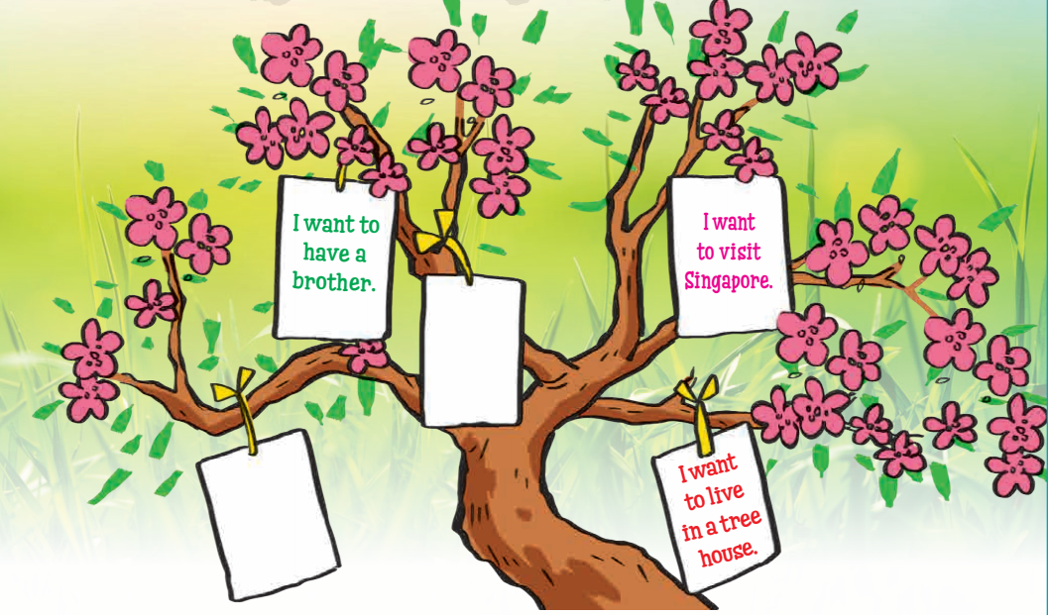  * Example:  - I want to pass all of my exams.  - I want to have a new bike  - I want to make a lot of good friends.
* Consolidation (2’)
* Aim: To consolidate what students have learnt in the lesson.
* Content: summarize the content of the lesson.
* Products: A student says the lesson’s content aloud.
* Organization of implementation:

Teacher’s and Ss’activities |  | Content
- Teacher asks students to talk about what they have learnt in the lesson. |  | - revise vocabulary related to Tet  - Grammar: should/ shouldn't + V
* Homework (2’)
Aim: To revise the knowledge that students have gained in Unit 6 and To prepare for the next lesson
* Content: Review the lesson and prepare for the next lesson and do exersie in the workbbook
* Products: Students’ textbook and workbook.
* Organization of implementation:

Teacher’s and Ss’ activities |  | Content
- Teacher asks students to revise old lesson and to do exercise in workbook.  - Teacher asks students to complete the project and prepare the new lesson. |  | - Complete the project  - Write 5 sentences to tell about the most useful things on Tet holiday  - Prepare UNIT 7

