Date of planning : 2/12 / 2024

Date of teaching :5 /12 / 2024

Week : 13 UNIT 5: NATURAL WONDERS OF VIET NAM

Period : 39 Lesson 5 : Skills 1
I. OBJECTIVES:
By the end of the lesson, students will be able to:
- develop reading skill for general and specific information about the topic;
- use the lexical items related to the topic ‘things in nature’ and ‘travel items’;
- use what they have learnt to talk about a famous place, and what people must/ mustn’t do there.
II. LANGUAGE ANALYSIS
1. Knowledge:
* Vocabulary: lexical items related to the lesson.
* Grammar: Modal Verb: must in advice
2. Competences: develop reading, speaking and co-operating skills; Talk and give travel advice
3. Quality/behavior: To teach SS to work hard and love travelling; Educate Ss to love and conserve the natural wonders in Viet Nam ; Educate Ss what people must/ mustn’t famous place.
III. MATERIALS
1. Teacher: - Grade 6 textbook, Planning (Unit 5, skills 1)
- Smart TV/Pictures, sets of word cards
- sachmem.vn
2. Students: Text books, notebooks, posters, ….
3. Method: Ask and answer ; group works; individual ……
IV. PROCEDURES : (STAGES)
1. Warm-up (5’)
* Aim: To introduce the topic of reading.
* Content: Game: Hidden picture.
* Products: Students’ answers.
* Organization of implementation:
Teacher’s and Ss’activities |  | Content
- T- Ss  * Set the scene.  - Teacher sets the scene: “Next month, I am going travelling. Guess where I will visit.”  - Let’s students guess the places by opening the boxes one by one. The pictures are hidden behind the boxes.  - Teacher shows the pictures on the screen.  - Teacher leads in the lesson by asking questions: |  | Game: Hidden picture.    - Have you ever been to these places?”  “Today, let’s see what do they have.”
2. Presentation (7’)
* Aim:. To provide students with some lexical items before reading the text.
* Content: Learn some vocab related the topic.
* Products: Read and understand the meaning of words.
* Organization of implementation:
Teacher’s and Ss’activities |  | Content
T –Ss :  - Pre teach vocabulary  - Teacher use different techniques to teach vocab (pictures, situation, explaination…..)  - Repeat in chorus and individually  - Copy all the words  * Checking vocab: |  | * Vocabulary  - tourist attraction (n) : điểm thu hút khách du lịch  - popular (adj): phổ biến  - landscape (n) : phong cảnh  - slope (n) : dôc, sườn  - sand dune (n) : cồn cát  *Checking: Matching
3. Pre -reading (5’)
* Discussing:
Task 1:
* Aims: To activate Ss' knowledge of the topic in the reading text.
* Content: Look at the pictures and answer some questions.
* Products: Ss say the answers aloud.
* Organization of implementation:
Teacher’s and Ss’activities | Content
Task 1:T –Ss  - Teacher asks students to close the book.  - Teacher shows the pictures of the places and asks students to answer the questions:  - Teacher invites some students to share their discussion in front of the class.  - Teacher asks students to open the book. Read the text and check their ideas. | . * Discussing:  Task 1: Look at the pictures and make predictions about the reading. (p. 54)  1. What are the places?  2. What do you know about these places?    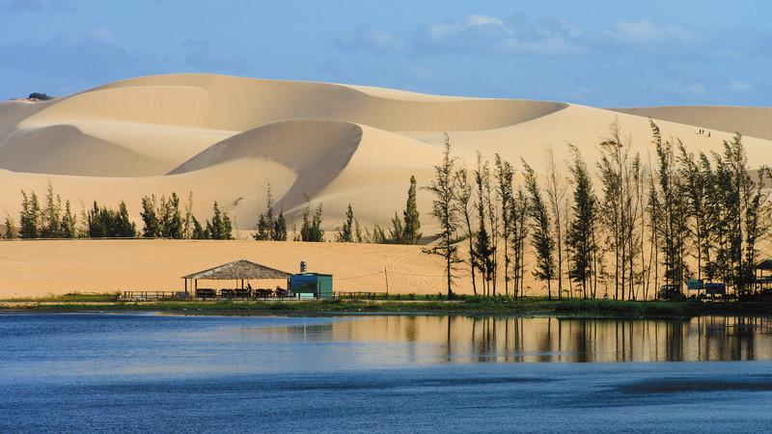
4. While-Reading (5’)
Task 2
* Aims: To check students understanding of using correct lexical items about the topic.
* Content: Complete the sentences, using the words from the box.
* Products: students swap their answers with their partner and say the correct answers.

* Organization of implementation :
Teacher’s and Ss’activities | Content
- Teacher askes students to do Exercise 2 individually, in 3 minutes.  After 3 minutes, teacher lets students swap their answers with their partner.  Check the answers. | Task 2. Complete the sentences, using the words from the box. (p. 54)  * Answer key:  1. islands  2. wonder  3. desert  4. Remember  5. visit
5. While-Reading (5’)
Task 3:
* Aims: To develop reading skill for general and specific information.
* Content: Read the text and answer the questions.
* Products: Students play game by answering the questions correctly.
* Organization of implementation :
Teacher’s and Ss’activities | Content
Task 3: T - Ss, Ss – Ss  - T has Ss anser the questions by playing game : Lucky number. Class is divided into 2 groups.  - Teacher prepares 7 numbers which includes 5 questions about their school, and 2 lucky numbers.  - Each team takes turns and chooses a number and answers the question behind the number. If the team answers the question correctly, they will get 1 point. If the team chooses the lucky number, they get 1 point without answering the question and may choose another number. | Task 3: Read the text and answer the following questions. (p. 54)  * Answer key:  - Ha Long Bay is in Quang Ninh.  - You can enjoy great seafood and join in exciting activities.  - No, there isn’t. It’s like a desert, not a real desert.  - You can have a picnic in Mui Ne by the beach.  5. The best time to visit the Mui Ne Sand Dunes is early morning or late afternoon.
5. Post reading (5’) + Pre -speaking
Task 4
* Aims: To check students’ reading comprehension and prepare for the next part.
* Content: Make notes about one of the places in the reading
* Products: Students’ answers on the posters.
* Organization of implementation:
Teacher’s and Ss’activities | Content
Task 4: T - Ss, Ss – Ss  -Teacher asks students to work in groups of 3 and make notes about one place in the reading.  - Compare the notes with other groups.  Teacher asks students to tell their partner about the place by looking at the notes.  - Teacher goes around and offers help if needed.  - Students share their ideas with the whole class. | Task 4: Work in pairs. Make notes about one of the places in the reading. You can add your own ideas. (p. 54)  Ha Long Bay Mui Ne  - interesting islands - many islands and caves - beautiful beaches - great seafood - exciting activities - a beautiful places - amazing landscapes - different colour - like a desert - many activities  * Example:  Ha Long Bay has a lot of interesting islands. It also has many caves and beautiful beaches. You can enjoy great seafood here and take part in exciting activities.
6. While –Speaking (5’)
Task 5:
* Aims: To help students form the ideas for their speaking.
* Content: Some foreign visitors are visiting your city/ town/ area. You are their tour guide. Tell them some interesting things about the place as well as what they must and mustn’t do there.
* Products: Students’ idea in groups and share with the class.
* Organization of implementation:

Teacher’s and Ss’activities | Content
T - Ss, Ss – Ss  Teacher askes students to work in groups of 5.  + Leader?  + Idea thinkers?  + Presenters?  + Drawers?  - Teacher asks students to choose a famous place in their city or area.  - Teacher asks students to discuss and make notes of the information they want to share with the class.  - Teacher asks students to refer to the questions as suggestions for their notes or they can do it in their own way.  - Teacher goes around and offers help if needed. | Task 5: Some foreign visitors are visiting your city/ town/ area. You are their tour guide. Tell them some interesting things about the place as well as what they must and mustn’t do there.  + Where is it?  + What does it have?  + Are there any interesting things here?  + What must they do or mustn’t do there?  * Example:  - You must wear sun scream when you're in My Khe beach  - You must go to the My Khe beach in late afternoon  - You mustn't litter on the beach.  - You mustn't swim alone
7. Post-Speaking (3’)
* Aims: To help students use what they have learnt so far to talk about a famous place
To help students improve next time.
* Content: Students Tell some interesting things about the place as well as what they must and mustn’t do there.
* Products: Some students share their preparation with the whole class.
* Organization of implementation:

Teacher’s and Ss’activities | Content
- Teacher asks students to practice presenting in their groups.  - Teacher makes sure that students speak in full sentences.  - Then, teacher invites some groups to go to the board and share their preparation with the whole class.  - - Teacher allows students to give comments for their friends and vote for the most interesting and informative presentation.  - Teacher gives feedback and comments. | * Students’ presentation
7. Consolidation (2’)
* Aims: To consolidate what students have learnt in the lesson.
* Content: Ss summarise what they have learnt with the two skills.
* Products: Students say what they have learnt with the two skills in font of the class.
* Organization of implementation:
Teacher’s and Ss’activities | Content
- Teacher asks students to talk about what they have learnt in the lesson. | - 2 skills ( talk about some famous places )
8. Homework (2’)
* Aim: To revise the knowledge that students have gained in this lesson.
* Content: Review the lesson and prepare for the next lesson .
* Products: Students’ textbook and workbook
* Organization of implementation:

- Teacher asks students to prepare the new lesson | - Do Ex inWB  - Practice speaking a place you like.  - Prepare: Skills 2

