Date of planning : 1/12 / 2024
Date of teaching :3 /12 / 2024

Week :13 UNIT 5: NATURAL WONDERS OF VIET NAM

Period :38 Lesson 4 : Communication
I. OBJECTIVES:
By the end of the lesson, students will be able to:
- make and accept appointments;
- have knowledge about a travel guide;
- use must and mustn’t to talk about what to prepare for a trip.
II. LANGUAGE ANALYSIS
1. Knowledge:
* Vocab: lexical items related to the lesson.
* Grammar: Making and accepting appointments.
2. Competences: Ss learn how to make and accept appointment. To practice making and accepting an appointment. To know about a travel guide.
3. Quality/behavior: Educate the love of the natural wonders in Viet Nam , the love of the hometown and the country. Having a good attitude to protect and conserve the natural wonders.
III. MATERIALS
1. Teacher: - Grade 6 textbook, Planning (Unit 5- communication)
- Smart TV/Pictures, sets of word cards
- sachmem.vn
2. Students: Text books, notebooks, posters, ….
3. Method: Ask and answer ; group works; individual ……
  - IV. PROCEDURES : (STAGES)
1.Warm-up (5’)
* Aim: To review must and mustn’t.
To lead in the lesson about vocabulary and pronunciation.
* Content: * GAME: Pass the ball (make a sentence with must/ mustn’t)
* Products: Ss play in group and say a sentence with must/ mustn’t aloud
* Organization of implementation:
Teacher’s and Ss’activities |  |  | Content
* Warm up  - T – Ss  - Teacher plays the music. When music’s on, students pass the ball as fast as they can.  - When music’s off, the student taking the ball has to make a sentence with must/ mustn’t.  - Lead in:  - Teacher sets the scene.  - They are Duong and Steven. Steven wants Duong to go picnic with him this Sunday. What structures can he use? If Duong agrees, what does he say?  - Students give their answers.  Teacher leads students into the lesson by telling about what they are going to learn: “We are going to learn how to make and accept appointments |  |  | * GAME: Pass the ball  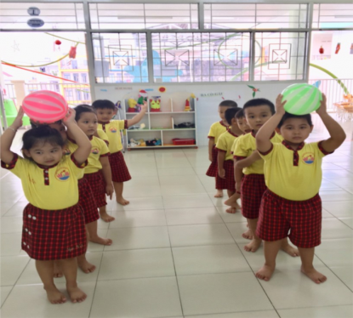
2. Presentation ( 5’)
* EVERYDAY ENGLISH
* Making and accepting appointments

Task 1: (5’)
* Aim: To introduce how to make and accept appointmen
* Content: Listen and read the short conversation, paying attention how to make and accept appointments
* Products: Understand and know how to make and accept appointments;

* Organization of implementation:
Teacher’s and Ss’activities |  | Content
Task 1:T –Ss  - Teacher asks students listen and read the short conversation, paying attention to the highlighted parts.  - Teacher writes down highlighted parts on the board and asks students what they are used to, which is used to make appointments and which is used to accepting appointments.  - Teacher calls some students to share their opinions.  - Teacher gives more explanations and elicit the form. |  | Task 1: Listen and read the short conversation, paying attention to the highlighted parts.  - Making appointments:  Let’s + V.  How about …?  - Accepting appointments:  That’s fine.  Sure.
3. Practice (20’)

Task 2: (5’)
* Aims: To practice making and accepting appointments.
* Content: Make a short conversation, following the example in Task 1.
* Products: Some pairs to make a conversation in front of the class.
* Organization of implementation:
Teacher’s and Ss’activities | Content
Task 2:T –Ss : Ss- Ss  - Teacher asks students to work in pairs and make a short conversation, following the example.  - Teacher models with a volunteer.  - Students do the task in pairs.  - Teacher calls some pairs to make a conversation in front of the class.  - Teacher gives feedback and corrections (if necessary). | Task 2: Work in pairs. Make a short conversation, following the example in Task 1.  - Example:  Huy: Nam, let's go to the supermarket this Sunday morning.  Nam: That's great. What time can we meet?  Huy: How about 8 o'clock?  Nam: Sure, I'll meet you at that time.
Pre-Reading
* A TOUR GUIDE
* Aims: To help students set the scene.
* Content: * Chatting: Look at the picture and answer the question.
* Products: Ss say the answers aloud.
* Organization of implementation:
Teacher’s and Ss’activities | Content
Task 3: T - Ss,  - Teacher shows the picture and ask students some questions:  Next week, I am going mountain climbing. Can you guess where I am going to? (Himalayas)  Before we go, what should we read? A tour guide  What information can you read in a tour guide? | * Chatting: Look at the picture and answer the question.  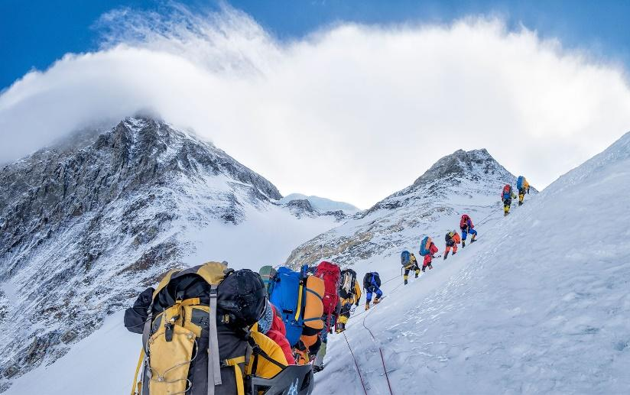  -Can you guess where I am going to? (Himalayas)
While-Reading (8’)

Task 3:(5’)
* Aims: To help students have knowledge about a travel guide.
* Content: Read the travel guide entry, Make a list of the things you must bring to the Himalayas.
* Product: Read and understand the text; calls some groups to give their correct answers
* Organization of implementation:
Teacher’s and Ss’activities | Content
Task 3: T – Ss.  Teacher asks students to read the travel guide entry to check their guess and sets the time limit for reading task for 2 minutes.  Task 4: T - Ss, Ss – Ss  - In group of 3, students write as many things they must and mustn’t bring to the Himalayas as they can in 2 minutes.  Teacher calls some groups to give their answers and checks. | Task 3: Read the travel guide entry. (p. 53)  Task 4: Make a list of the things you must bring to the Himalayas. Then add things you mustn’t bring. (p. 53)  MUST MUSTN’T  - compass - sleeping bag - plaster - packback - waterproof coat - bicycle - shorts - T-shirt
Post-Reading
Task(5’)
* Aims: To help students talk about what to prepare for a trip
* Content: Role-play being a tour guide and a tourist.
Tell your partner what to prepare for their trip to the Himalayas, and give reasons
* Products: Role –play in front of the class.
* Organization of implementation:
Teacher’s and Ss’activities | Content
Task 5: T - Ss, Ss – Ss  - Teacher divide the class into 2 main group. One is a tour guide and one is a tourist.  - The tourist prepares the questions and the tour guide prepare the information in 2 minutes.  - Students work in pair. Make a conversation.  - Teacher calls some pairs to talk in front of the class.  - Peer check and then teacher gives feedback | Task 5: Role-play being a tour guide and a tourist.  Tell your partner what to prepare for their trip to the Himalayas, and give reasons.  Example:  A: I'd like to go to the Himalayas next month.  B: OK. I think you must bring a waterproof coat. It's cold and rainy there!  A: Yes. Anything else?  B: You must bring a sleeping bag so that you can stay here overnight. You must also bring a compass in case you are lost.  A: Is there anything I mustn’t bring?  B: Well, you mustn’t bring bicycle because you can’t ride it here and it’s very cold, so you mustn’t bring shorts or T- shirt.  A: Thanks a lot.
5. Consolidation (3’)
* Aims: To consolidate what students have learnt in the lesson.
* Content: Summarize the content of the lesson.
* Products: Ss say aloud what they have just learnt .
* Organization of implementation:
Teacher’s and Ss’activities | Content
Teacher asks students to talk about what they have learnt in the lesson. | - Making and accepting appointments  - Read the travel guide  - Make a list of the things you must or mustn’t when traveling.
6. Homework (2’)
* Aim: To revise the knowledge that students have gained in this lesson. And prepare for the next lesson: Skills 1.
* Content: Review the lesson and prepare for the next lesson and do exersie in the workbbook
* Products: Students’ textbook and workbook
* Organization of implementation:
Teacher’s and Ss’ activities | Content
- T reminds Ss to do homework and prepare the new lesson. | - Learn by heart the structures about making and accepting appointments.  - To prepare for the next lesson: Unit 4 My neighbourhood / Skills 1.
*- Evaluation:

