Date of planning : 16/11 / 2024
Date of teaching : 18 /11 / 2024

Week :11 UNIT 4: MY NEIGHBOURHOOD

Period : 31 Lesson 4 : Communication
I. OBJECTIVES:
By the end of the lesson, students will be able to:
- ask for and giving directions in a neighbourhood;
- listen for sequence and for details;
- create an audio guide for Ho Chi Minh City.
II. LANGUAGE ANALYSIS
1. Knowledge:
* Vocab: lexical items related to city fact file of some cities.
* Grammar: Comparative, giving instructions.
2. Competences : . To practice asking for direction and creating audio guide to places;
develop their language skills, as well as communication, summarizing
3. Quality/behavior: To teach Ss to work hard, love their neighbourhood, the hometown, the country, Having the serious attitude to asking and giving the directions; cooperative learning; sharing.
III. MATERIALS:
1. Teacher: - Grade 6 textbook, Planning Unit 4, communication
- Smart TV/Pictures, sets of word cards
- sachmem.vn
2. Students: Text books, notebooks, posters, ….
3. Method: Ask and answer ; group works; individual ……
  - IV. PROCEDURES : (STAGES)
1.Warm-up (5’)
* Aim: To introduce the topic; To lead in the lesson about vocabulary and pronunciation
* Content:
* Products:
* Organization of implementation:
Teacher’s and Ss’activities |  |  | Content
* Warm up  - T - Ss  - Teacher divides the class into 2 groups and let them play a small game: Guessing game  - Teacher gives 3 pictures related to Hoi An (one by one) and asks “Which city is this?”, students guess the name of the place and explain their guess.  - Lead in:  - Teacher leads students into the lesson by asking students some questions:  Today we are going to listen to a guide to Hoi An. |  |  | * Game: Guessing game  => Hoi An, HCM city.  - Have you ever been to Hoi An?  - What do you know about this place?  * Suggested answers:  Yes, I have.  I think Hoi An is an ancient town, it has Ong pagoda, Hoa Nhap workshop,…
2. Presentation ( 5’)
* EVERYDAY ENGLISH
Asking for and giving diredions

Task 1: (5’)
* Aim: To introduce ways to ask for and give directions in English.
* Content: Listening and expressing the strutures of giving directions
* Products: Role play and practice in front of the class.
* Organization of implementation:
Teacher’s and Ss’activities |  | Content
Task 1:T –Ss  - Teacher plays the recording for students to listen and read the dialogue between A and B at the same time.  - Ask students to pay attention to the sentences and phrases used to ask for and give directions.  -Teacher elicits the structures for directions  - Teachers elicit the phrases to give directions from student. |  | Task 1: Listening and expressing the strutures of giving directions.  1. Could you tell me the way to …?  2. Where’s the nearest …?  1. go along  2. on your left/ right  3. take the first turning  Audio script:  A: Excuse me. Could you tell me the way to the cinema, please?  B: Go along this street. It’s on your left.  A: Excuse me. Where’s the nearest post office, please?  B: Go out of the station. Take the first turning on the right.
3. Practice (20’)

Task 2: (5’)
* Aims: To practice asking for and giving directions.
* Content: practice the phrases and structures of asking for and giving directions.
* Products: Some pairs to practise in front of the class.
* Organization of implementation:
Teacher’s and Ss’activities | Content
Task 2:T –Ss : Ss- Ss  - Teacher asks students to work in pairs and take turns to practice the dialogue.  - Students do the task in pairs.  - Teacher calls some pairs to practise in front of the class.  - Teacher gives feedback and corrections (if necessary). | Task 2: Work in pairs. Have students practice the phrases and structures of asking for and giving directions. (p. 61)
Task 3: (5’)
* Aims: To apply the knowledge about asking and giving directions in a neighbourhood
* Content: Make similar conversations to ask for and give directions to places near your school.
* Products: Some pairs to practice in front of the class.
* Organization of implementation:
Teacher’s and Ss’activities | Content
Task 3: T - Ss, Ss – Ss  .  - Teacher asks students to work in pairs to make similar conversations, using the structures and phrases for asking for and giving directions.  - Encourage them to practice asking for and giving directions to some places near their school.  - Move around to observe and provide help.  - Call some pairs to practice in front of the class.  - Comment on their performance. | Task 3: Work in pairs. Make similar conversations to ask for and give directions to places near your school.  Example:  A: Excuse me. Could you tell me the way to Song Ve market please?  (B: Go straight and then take the second turning on the right.
4. Production (8’)
* An audio guide to a place
Task 4:(5’)
* Aims: To help students get used to some famous landmarks in big cities.
* Content: listening to an audio guide to Hoi An. Listen and fill in the blanks
* Product: Write the correct name under the pictures of the pictures.(individual work)
* Organization of implementation:
Teacher’s and Ss’activities | Content
Task 4: T - Ss, Ss – Ss  - Teacher shows 4 pictures of 4 places mentioned in the recording. Students give the order of their names (individually).  - The whole class share their ideas.  - Teacher writes some students’ ideas on the board to check later.  -Teacher asks students to work in pairs, read the names in the boxes (make sure that they pronounce the names correctly) and write the correct name under the pictures of the pictures.  -Students share the answer with the whole class.  - Teacher checks and elicits from students any information they know about the pictures.  - Ss run through the passage of Ex3 / P43  - T play Track 37, students fill in the gaps (individually).  - Students compare with a partner, then check together. | Task 4: Nick is listening to an audio guide to Hoi An. Listen and fill in the blanks. (p. 43)  a) Café 96    b) Hoa Nhap Workshop  c) Museum of Sa Huynh Culture    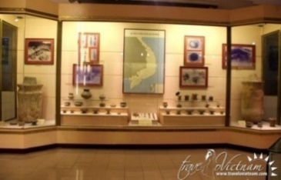  d) Quan Cong Temple  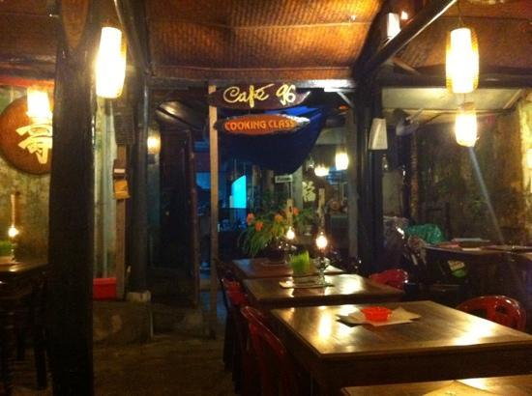  * Fill in the gaps  Answer key:  1. straight  2. second  3. next to  4. near
Task(5’)
* Aims: To help students practice creating an audio guide for Ho Chi Minh City.
* Content: Look at the map below and create an audio guide for District 1 of Ho Chi Minh City.
* Products: Ss give directions to places on the map (group work)
* Organization of implementation:
Teacher’s and Ss’activities | Content
Task 5: T - Ss, Ss - Ss  - Ask students to read the instructions carefully  - Remind them of the expressions they can use to give directions.  - Ss work in groups  - Group 1: Thong Nhat Palace  - Group 2: Sai Gon Notre Dame Cathedral  - Group 3: Ho Chi Minh city Museum  - Group 4: Ton Duc Thang mMuseum | Task 5: Look at the map below and create an audio guide for District 1 of Ho Chi Minh City. (p. 43)  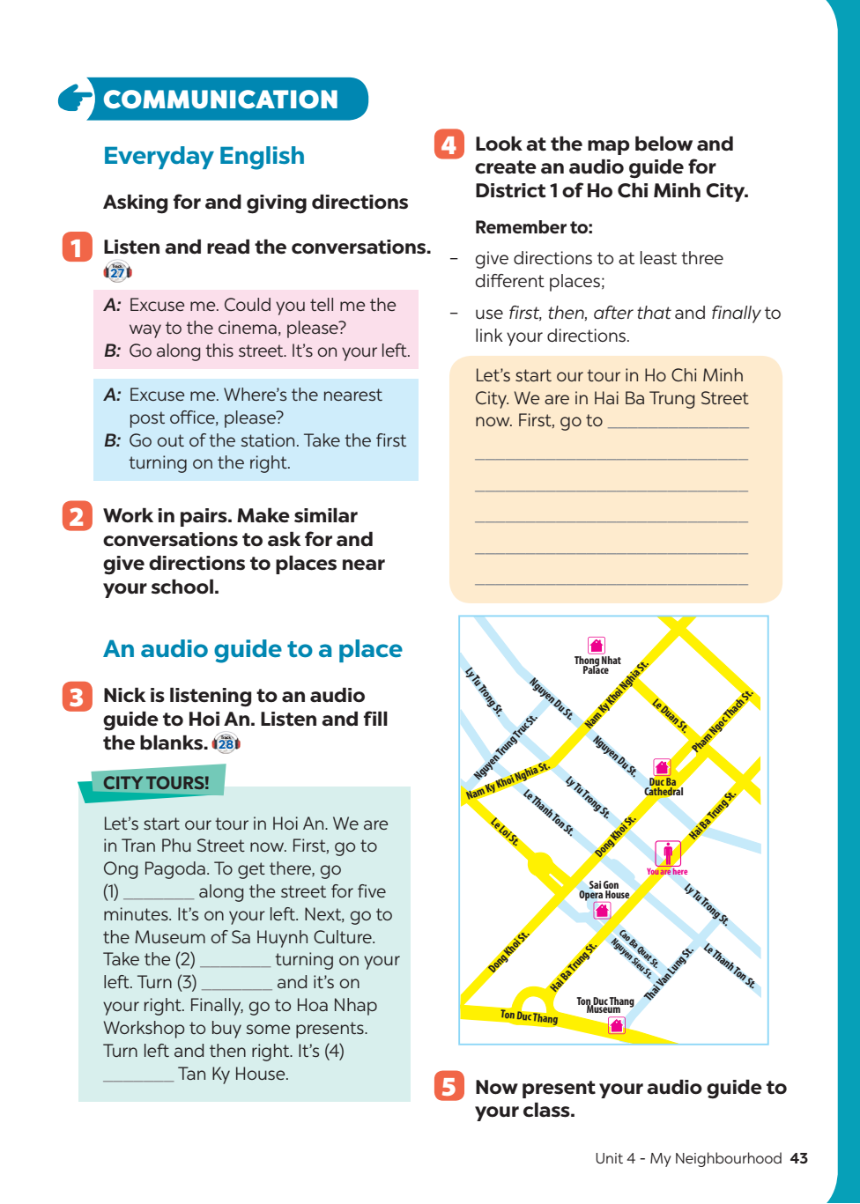  Use “first, after that, and finally” to link the direction  Example:  Let’s start our tour in Ho Chi Min City. We are in Hai Ba Trung now.  First, go to…………
5. Consolidation (3’)
* Aims: To consolidate what students have learnt in the lesson.
* Content: Summarize the content of the lesson
* Products: Say aloud what they have learnt in front of the class.
* Organization of implementation:
Teacher’s and Ss’activities | Content
Teacher asks students to talk about what they have learnt in the lesson. | - Asking for and giving diredions  - Listen to an audio guide to a place and create an audio guide for District 1 of Ho Chi Minh City
6. Homework (2’)
* Aim: To revise the knowledge that students have gained in this lesson. And prepare for the next lesson: Skills 1.
* Content: Review the lesson and prepare for the next lesson and do exersie in the workbbook
* Products: Students’ textbook and workbook
* Organization of implementation:
Teacher’s and Ss’ activities | Content
- T reminds Ss to do homework and prepare the new lesson. | - Learn by heart the structures about asking and giving directions  -Do exercise C, D / P29,30,31,32-WB  - To prepare for the next lesson: Unit 4 My neighbourhood / Skills 1.

