UNITS | VOCABULARY | GRAMMAR
Unit 1  FREE TIME | - Hobbies  - Make future plans  - Pronunciation: /eɪ/ sound | - Present simple for habits  - Present continuous for future plans  - Prepositions of place
Unit 2  HEALTH | - Healthy lifestyle  - Health problems | - Indefinite quantifiers  - Should and Shouldn’t
Unit 3  MUSIC AND ARTS | - Types of music | - Present simple for facts
Tiếng Anh 7 – i-LEARN SMART WORLD

MIDTERM TEST – SEMESTER 1
Note: Each correct answer earns 0.2 points.

I. PRONUNCIATION (0.8 points)
A. Choose the word whose underlined part is pronounced differently.
1. A. market B. skating C. headache D. game
2. A. bowling B. soda C. rock D. only
B. Choose the word that has a different stressed syllable from the rest.
3. A. model B. lifestyle C. Fever D. enjoy
4. A. medicine B. exciting C. Classical D. vitamin

II. VOCABULARY AND GRAMMAR (2.4 points)
Choose the best option (A, B, C or D) to complete each of the following questions.
5. Student A: Are you going to the music club tonight?
Student B: No, they are playing jazz tonight and I __________ it.
A. like B. love C. don’t like D. enjoy
6. Harry loves ________ about the nature. He carries his camera everywhere.
A. writing blogs B. making vlogs C. reading books D. watching films
7. There is __________ orange juice in the fridge. Would you like a glass?
A. no B. many C. a lot D. some
8. My favorite hobby is __________ and I think I’m good at it. My friends say my cookies taste amazing.
A. baking B. building models C. eating fast food D. watching cookery shows
9. You __________ take the stairs, not the elevator. Walking is good for your health.
A. shouldn’t B. should C. need D. don’t
10. I’m sorry I can’t go with you because I __________ badminton with Julie this afternoon.
A. play B. played C. am playing D. playing
11. Andy drank a lot of iced soda yesterday, so he has a ______ today. It hurts when he swallows.
A. sore throat B. fever C. stomachache D. headache
12. My sister always __________ comics after she finishes her homework.
A. is reading B. has C. is having D. reads
13. You shouldn’t __________. If you don’t get enough sleep, you will feel tired the next morning.
A. get some rest B. stay up late C. go to bed D. take a nap
14. Student A: How much takeaway food do you eat every week?
Student B: _________
A. Always. B. Lots of. C. Not many D. Just a little.

15. What does that sign mean?
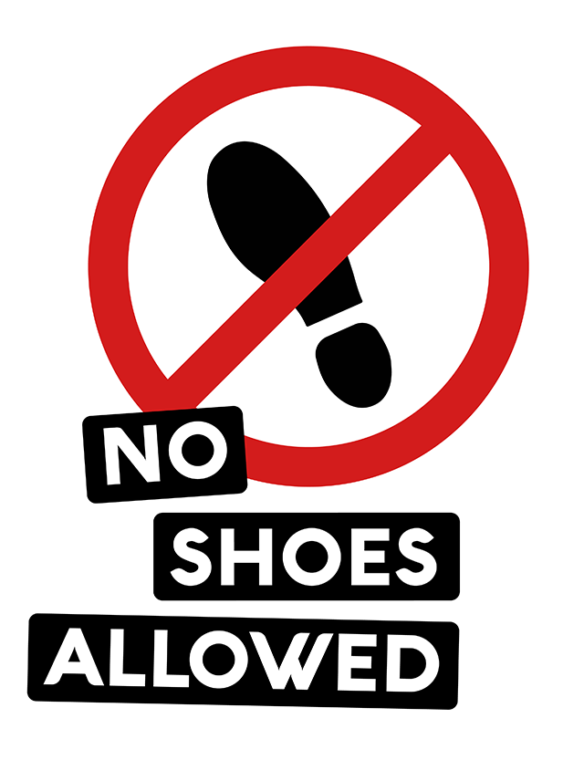 | A. You have to take off your shoes when you enter this place.  B. You can’t buy any shoes in this area.  C. You shouldn’t wear sneakers in this place.  D. You need to allow shoes in this place.

16. What does this sign mean?
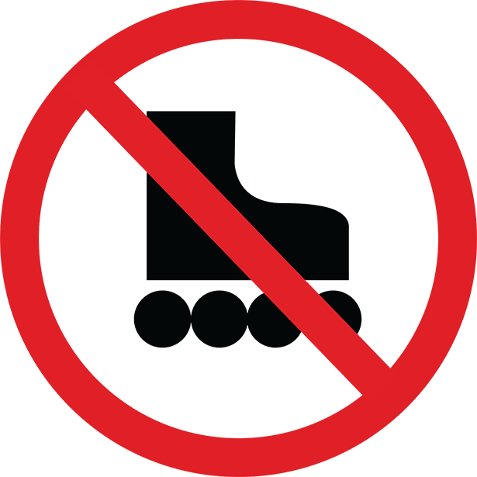 | A. You can’t go ice skating here.  B. You can’t go skateboarding here.  C. You can’t go skiing here.  D. You can’t go roller skating here.

III. WORD FORMATION (1.2 points)
Write the correct form of the words in brackets.
17. Fizzy drinks such as soda or Coke are very __________. They contain a large amount of sugar. (HEALTH)
18. You should eat a lot of fruit. It helps to keep you ___________. (HEALTH)
19. Joey’s hobby is building models. He has a big __________ of wooden model boats. (COLLECT)
20. You need to pay 50 dollars to hire the safety __________ for rock climbing. (EQUIP)
21. Anna is afraid of height. She thinks the roller coasters at the fair are __________. (DANGER)
22. The first time I went zorbing, I felt really __________, but now I’m totally into it. (SCARE)
V. READING (2 points)
A. Read the following passage. For each question from 33 to 37, complete the summary with NO MORE THAN TWO WORDS.

Two years ago, my dad had a new job, so my family moved to this city. When I came to this school, I didn’t know anyone. I decided to join some sports clubs to meet new friends, but I did badly in all of them. Then, one of my classmates invited me to go on a walk in the mountain with her family. I didn’t say yes immediately because it didn’t sound very interesting. However, I decided to give it a try, and this was the beginning of my love for hiking. At first, I walked slowly because I wasn’t very fit. Then, I improved quickly and now I can walk quite fast. I began to feel so much better. Now, I go hiking with my friends once or twice a month and we really enjoy it. Hiking is a great way to get outside, move your body and explore new places. Hiking makes my lungs, bones and muscles stronger. You don’t need any special equipment to go hiking. All you need is comfortable clothes and a good pair of sneakers so that you don’t hurt your feet. Don’t forget to bring lots of water and some snacks, such as fruit, nuts or seeds to eat while hiking.

33. The boy went to the new school _________ ago.
34. He wanted to make new friends, so he joined some _________.
35. At first, he didn’t accept the invitation to go hiking because he thought it wasn’t _________.
36. It’s important to have good _________ to protect our feet when we go hiking.
37. He says we should bring water and _________ while we go hiking.

B. Read the passage. For questions from 38 to 42, choose the correct option A, B, C or D that best suits each blank.

SMALL CHANGES FOR A HEALTHY LIFESTYLE
Do you eat healthy food? No? It’s time to start! You should have three to five meals a day, including (38) __________ fruit and vegetables, and drink eight glasses of water a day – that’s about two liters a day. You can even make a delicious drink with the fruit you like. It’s (39) __________vitamins. You should start exercising, and you will feel great. It can be expensive to work out at the (40) __________, and sometimes you don’t have much free time to go, but there are other types of exercise you can do easily. On weekdays, you can ride a bike or walk to school. After school, don’t sit (41) __________ the TV. You should do physical jobs around the house or in the garden, such as sweeping the floor or watering the plants. Or you can listen to your favorite music and dance to it. That’s exercising, too. Moreover, it’s good to hang out with your friends (42) __________ the weekends and have fun. Spending time with people you love gives you more energy.

38. A. Much B. little C. lots of D. any
39. A. important B. full of C. Containing D. giving
40. A. gym B. swimming pool C. Park D. ice rink
41. A. behind B. next to C. opposite to D. in front of
42. A. on B. in C. For D. along
VI. WRITING (1.6 points)
A. Rewrite the following sentences without changing their meaning. Use the given word(s) if any.
43. Peter finds skateboarding interesting. (IN)
→ Peter .
44. There are no vegetables in the kitchen.
→ We don’t .
45. It’s important to sleep seven to eight hours a night.
→ You should .
46. It’s not a good idea to eat too much sugar because it’s bad for your teeth.
→ You .
B. Use the given words or phrases to make complete sentences.
47. Sophia/ usually/ play/ tennis/ sports center/ Tuesdays.
→
48. brother/ and/ I/ enjoy/ play/ computer games.
→
49. Let’s/ go/ bowling alley/ next/ theater tonight.
→
50. Tommy/ go zorbing/ Mike/ 4 p.m./ this Friday.
→

IV. LISTENING (2 points)
A. You will hear a doctor talking to a group of students about staying healthy. For questions 23-27, listen and decide whether the statements are True (T) or False (F).

23. Doctor Brown gives the students some advice on how to sleep well at night.
24. It’s difficult for many teenagers to go to bed before 11 o’clock.
25. According to one study, 50 percent of teenagers get enough sleep.
26. It’s a good idea to do some exercise before you go to bed.
27. Reading a book before bed helps you to sleep better.

B. You will listen to a boy talking about hobbies. For each question from 28 to 32, listen and choose the correct option A, B, C or D

28. Why does Mark like reading comics?
A. Because he can understand the stories easily.
B. Because he doesn’t have much free time.
C. Because he has a collection of comics.
D. Because his sister buys him comics.
29. Mark buys comics at the bookstore _______.
A. near his house B. opposite the house
C. behind his garden D. in the town square
30. Katy enjoys taking photos of ________.
A. people B. the garden C. the park D. birds and animals
31. Who won a competition last year?
A. Mark B. Katy C. Luis D. Mark’s friend
32. Mark thinks roller skating _______.
A. interesting B. entertaining C. dangerous D. fun

V. READING (2 points)
A. Read the following passage. For each question from 33 to 37, complete the summary with NO MORE THAN TWO WORDS.

Two years ago, my dad had a new job, so my family moved to this city. When I came to this school, I didn’t know anyone. I decided to join some sports clubs to meet new friends, but I did badly in all of them. Then, one of my classmates invited me to go on a walk in the mountain with her family. I didn’t say yes immediately because it didn’t sound very interesting. However, I decided to give it a try, and this was the beginning of my love for hiking. At first, I walked slowly because I wasn’t very fit. Then, I improved quickly and now I can walk quite fast. I began to feel so much better. Now, I go hiking with my friends once or twice a month and we really enjoy it. Hiking is a great way to get outside, move your body and explore new places. Hiking makes my lungs, bones and muscles stronger. You don’t need any special equipment to go hiking. All you need is comfortable clothes and a good pair of sneakers so that you don’t hurt your feet. Don’t forget to bring lots of water and some snacks, such as fruit, nuts or seeds to eat while hiking.

33. The boy went to the new school _________ ago.
34. He wanted to make new friends, so he joined some _________.
35. At first, he didn’t accept the invitation to go hiking because he thought it wasn’t _________.
36. It’s important to have good _________ to protect our feet when we go hiking.
37. He says we should bring water and _________ while we go hiking.

B. Read the passage. For questions from 38 to 42, choose the correct option A, B, C or D that best suits each blank.

SMALL CHANGES FOR A HEALTHY LIFESTYLE
Do you eat healthy food? No? It’s time to start! You should have three to five meals a day, including (38) __________ fruit and vegetables, and drink eight glasses of water a day – that’s about two liters a day. You can even make a delicious drink with the fruit you like. It’s (39) __________vitamins. You should start exercising, and you will feel great. It can be expensive to work out at the (40) __________, and sometimes you don’t have much free time to go, but there are other types of exercise you can do easily. On weekdays, you can ride a bike or walk to school. After school, don’t sit (41) __________ the TV. You should do physical jobs around the house or in the garden, such as sweeping the floor or watering the plants. Or you can listen to your favorite music and dance to it. That’s exercising, too. Moreover, it’s good to hang out with your friends (42) __________ the weekends and have fun. Spending time with people you love gives you more energy.

38. A. Much B. little C. lots of D. any
39. A. important B. full of C. Containing D. giving
40. A. gym B. swimming pool C. Park D. ice rink
41. A. behind B. next to C. opposite to D. in front of
42. A. on B. in C. For D. along
VI. WRITING (1.6 points)
A. Rewrite the following sentences without changing their meaning. Use the given word(s) if any.
43. Peter finds skateboarding interesting. (IN)
→ Peter .
44. There are no vegetables in the kitchen.
→ We don’t .
45. It’s important to sleep seven to eight hours a night.
→ You should .
46. It’s not a good idea to eat too much sugar because it’s bad for your teeth.
→ You .
B. Use the given words or phrases to make complete sentences.
47. Sophia/ usually/ play/ tennis/ sports center/ Tuesdays.
→
48. brother/ and/ I/ enjoy/ play/ computer games.
→
49. Let’s/ go/ bowling alley/ next/ theater tonight.
→
50. Tommy/ go zorbing/ Mike/ 4 p.m./ this Friday.
→

