UNIT 10. ENERGY RESOURCES
A. VOCABULARY
1. New words
No | Word | Part of speech | Pronunciation | Meaning
1 | Abundant | adj | /ə'bʌndənt/ | Dư thừa
2 | Advantage | n | /əd’vɑ:ntɪdʒ/ | Lợi ích, ưu điểm
3 | Affect | V | /ə'fekt/ | Ảnh hưởng
4 | Alternative | adj | /ɔ:l'tɜ:nətɪv/ | Dùng để thay thế
5 | Appliance | n | /ə'plaiəns/ | Đồ dùng, thiết bị (điện)
6 | Available | adj | /ə'veiləbl/ | sẵn có
7 | Avoid | V | /ə'vɔid/ | Tránh làm gì
8 | Biogas | n | /'baiəʊgæs/ | Khí ga sinh học
9 | Carbon footprint | n | /,kɑ:rbən'fʊtpɪnt/ | Tổng khí thải được tạo ra bởi các hoạt động của con người
10 | Climate change | n | /'klaimət tʃeindʒ/ | Thay đổi khí hậu
11 | Coal | n | /kəʊl/ | Than đá
12 | Convert (into) | V | /kən'vɜ:rt/ | Chuyển hóa, biến đổi
13 | Crack | n | /kræk/ | Chỗ nứt
14 | Dam | n | /dæm/ | Cái đập nước
15 | Depend (on) | V | /dɪ'pend/ | Phụ thuộc(vào)
16 | Disadvantage | n | /,dɪsəd'vɑ:ntɪdʒ/ | Bất lợi
17 | Effect (on) | n | /ɪ'fekt/ | Sự ảnh hưởng
18 | Electric | adj | /ɪ’lektrɪk/ | Chạy bằng điện
19 | Electrical | adj | /ɪ’lektrɪkl/ | (Thuộc) điện
20 | Electricity | n | /ɪ.lek'trɪsətɪ/ | Điện
21 | Emission | n | /ɪ'mɪʃn/ | Sự thải ra
22 | Emit | V | /ɪ'mɪt/ | Thải ra
23 | Energy | n | /'enərdʒɪ/ | Nguồn năng lượng
24 | Exhaustible | adj | /ig'zɔ:stəbəl/ | Cạn kiệt
25 | Extreme weather event | n | /ɪk'stri:m 'weðər ɪ'vent/ | Hiện tượng thời tiết cực đoan
26 | Fossil fuel | n | /'fɒsl 'fju:əl/ | Nhiên liệu hóa thạch
27 | Generate | V | /'dʒenəreit/ | Tạo ra, phát ra
28 | Global warming | n | /.gləʊbl 'wɔ:rmɪŋ/ | Sự nóng lên toàn cầu
29 | Greenhouse effect | n | /'gri:n haʊs ɪ'fekt/ | Hiệu ứng nhà kính
30 | Harm | n,v | /hɑ:rm/ | Mối nguy hại, làm hại
31 | Harmful | adj | /'hɑ:rmfl/ | Có hại
32 | Harmless | adj | /'hɑ:rmləs/ | Vô hại
33 | Heat | n,v | /hi:t/ | Khí nóng, đốt nóng, sưởi ấm
34 | Hydro /  Hydrogen energy | n | /'haidrəʊ/  /'haidrədʒən 'enədʒɪ/ | Năng lượng nước
35 | Inconsiderate | adj | /.ɪnkən'sɪdərət/ | Thờ ơ, lãnh đạm
36 | Increase | V | /ɪn'kri:s/ | Tăng
37 | Increasingly | adv | /ɪn'kri:sɪŋlɪ/ | Một cách tăng dần
38 | Install | V | /ɪn'stɔ:l/ | Lắp đặt, cài đặt
39 | Invest (in) | V | /ɪn'vest/ | Đầu tư vào
40 | Investment | n | /ɪn'vestmənt/ | Sự đầu tư
41 | Last | V | /læst/ | Tồn tại, kéo dài
42 | Lead to | V | /li:d/ | Dần đến, gây ra
43 | Light bulb | n | /lait bʌlb/ | Bóng đèn
44 | Limited | adj | /'lɪmɪtɪd/ | Có hạn
45 | Low-energy | adj | /ləʊ-'enərdʒɪ/ | Tiêu thụ ít năng lượng
46 | Main | adj | /mein/ | Chính
47 | Mainly | adv | /'meinlɪ/ | Chủ yếu
48 | Natural gas | n | /,nætʃrəl 'gæs/ | Khí ga tự nhiên
49 | Natural resources | n | /.nætʃrəl rɪ'sɔ:sɪz/ | Nguồn tài nguyên thiên nhiên
50 | Negative | adj | /'negətɪv/ | Tiêu cực
51 | Non-renewable | adj | /,nɒn rɪ'nu:əbl/ | Không thể tái tạo được
52 | Nuclear | adj | /'nju:kliə/ | Thuộc về hạt nhân
53 | Overcool | V | /,əʊvə'ku:l/ | Làm cho quá lạnh
54 | Overheat | V | /,əʊvə'hi:t/ | Làm cho quá nóng
55 | Panel | n | /'pænl/ | Tấm ghép
56 | Plentiful | adj | /'plentɪfl/ | Dồi dào
57 | Pollutant | n | /pə'lu:tənt/ | Chất gây ô nhiễm
58 | Pollute | V | /pə'lu:t/ | Làm ô nhiễm
59 | Polluted | adj | /pə'lu:tɪd/ | Bị ô nhiễm
60 | Pollution | n | /pə'lu:ʃn/ | Sự ô nhiễm
61 | Positive | ad) | /'pɒzətɪv/ | Tích cực
62 | Power | n,v | /'paʊər/ | Năng lượng, cung cấp năng lượng để vận hành
63 | Produce | V | /prə'du:s/ | Tạo ra, sản xuất ra
64 | Reduce | V | /rɪ'dju:s/ | Giảm
65 | Release | V | /rɪ'li:s/ | Thải ra
66 | Rely (on) | V | /rɪ'lai/ | Tin vào, dựa vào
67 | Renewable | adj | /rɪ'nu:əbl/ | Có thể tái tạo được
68 | Replace | V | /rɪ’pleis/ | Thay thế
69 | Run out | vphr. | /rʌn aʊt/ | Hết, cạn kiệt
70 | Save | V | /seiv/ | Tiết kiệm
71 | Shortage | n | /ʃɔ:rtɪdʒ/ | Sự thiếu hụt
72 | Solar energy | n | /'səʊlər 'enədʒɪ/ | Năng lượng mặt trời
73 | Solar panel | n | /,səʊlar 'paenl/ | Tâm năng lượng mặt trời
74 | Solution | n | /sə'lu:ʃn/ | Giải pháp
75 | Solve | V | /sɒlv/ | Giải quyết
76 | Source of energy | n | /sɔ:rs əv 'enərdʒɪ/ | Nguồn năng lượng
77 | Syllable | n | /'sɪləbl/ | Âm tiết
78 | Tap | n | /tæp/ | Vòi
79 | Trap | V | /træp/ | Giữ lại, mắc kẹt
80 | Unlimited | adj | /ʌn'lɪmɪtɪd/ | Vô hạn
81 | Use | V | /ju:z/ | Sử dụng
82 | Waste | V | /weist/ | Lãng phí
83 | Wind energy | n | /wɪnd 'enədʒɪ/ | Năng lượng gió
84 | Wind turbine | n | /'wɪnd tɜ:rbain/ | Tua bin gió
2. Collocation
No. | Collocation | Meaning
1 | Come from | Bắt nguồn từ
2 | Instead of | Thay cho
3 | Look for | Tìm kiếm
4 | Provide sb with sth | Cung cấp
5 | Rely on | Phụ thuộc vào
6 | Replace sth with sth | Thay thế
7 | Run out | Hết, cạn kiệt
8 | Turn on | Bật
9 | Use up | Dùng hết
10 | Work on | Luyện tập, làm việc
3. Word formation
No. | Word | Part of speech | Meaning
1 | Environment | n | Môi trường
 | Environmentalist | n | Nhà môi trường học
 | Environmental | adj | Thuộc môi trường
 | Environmentally | adv | Liên quan đến môi trường
2 | Electricity | n | Điện
 | Electrician | n | Thợ điện
 | Electric | adj | Có điện
 | Electrical | adj | Liên quan đến điện
 | Electrically | adv | Liên quan đến điện
3 | Limit | n, v | Giới hạn
 | Limitation | n | Hạn chế
 | Limited | adj | Có hạn
 | Unlimited | adj | Vô hạn
4 | Pollute | v | Ô nhiễm
 | Pollution  Pollutant | n  n | Sự ô nhiễm  Chất gây ô nhiễm
 | Polluted | adj | Bị ô nhiễm
 | Pollute | V | Ô nhiễm
5 | Sun | n | Mặt trời
 | Solar | adj | Thuộc mặt trời
 | Sunny | adj | Có nắng

B. STRESS
❄ Stress on three-syllable words (Trọng âm của từ có 3 âm tiết)
🗶 Đối với các từ có âm tiết thứ 2, 3 chứa nguyên âm đơn ngắn là /ɪ/ và /ə/ | 🗶 Trọng âm rơi vào âm tiết số 1  family /’fæməlɪ/
🗶 Đối với các từ có âm tiết thứ 2 chứa nguyên âm đôi hoặc dài và âm tiết  thứ 3 là: -ian, -ic, -ience, -ient, -ial, -ual, -al, -eons, -ion, -iar | 🗶 trọng âm thường rơi vào âm tiết ngay phía trước chúng (âm tiết số 2)  phisician /fɪ'zɪʃn/
Đối với các từ có âm tiết thứ 3 là: -ee, -eer, -ese, -ier, -ette, -oo, -esque | 🗶 trọng âm thường rơi vào âm tiết chứa các đuôi này (âm tiết số 3)  volunteer /vɒlən’tɪər/
C. GRAMMAR
❄ PRESENT CONTINUOUS (Thì hiện tại tiếp diễn)
1. Forms (Cấu trúc)
Câu khẳng định | S + am/ is/ are + V-ing. | She is cooking.
Câu phủ định | S + am/ is/ are + not + V-ing. | She isn 't cooking.
Câu hỏi | Am / Is /Are + S + V-ing?  (+) Yes, S + is/am/are.  (-) No, S + isn’t/am not / aren’t. | Is she cooking?  (+) Yes, she is.  (-) No, she isn’t
 | (W-h) W-H + am/is/are + S + V-ing? | What is she doing?
2. Use (Cách dùng)
Hành động đang diễn ra vào lúc nói | Ex: She is sleeping now.
Diễn tả xu hướng | Ex: It’s getting hot.
Dự định trong tưomg lai gần | Ex: l am flying to Kyoto tomorrow.
Thói quen xấu gây khó chịu | Ex: He is always coining late.
3. Add -ing to the verbs (Quy tắc thêm đuôi -ing vào sau động từ)
- Tận cùng là e bỏ -e thêm -ing. Ex: ride - riding
- Từ tận cùng là -ee chỉ việc thêm -ing. Ex: see - seeing
- Từ kết thúc bằng ie - đổi ie thành y, thêm -ing. Ex: lie - lying
- Động từ 1 âm tiết kết thúc bằng 1 nguyên âm (u, e, o, a, i) và 1 phụ âm (trừ h, w, x, y, z) 🡪 nhân đôi phụ âm cuối, thêm -ing. Ex: put 🡪 putting
- Động từ có từ hai âm tiết trở lên 🡪 nhân đôi phụ âm khi trọng âm rơi vào âm tiết cuối cùng. Ex: per'mit -permitting
- Động từ có từ hai âm tiết trở lên, trọng âm rơi vào âm tiết thứ nhất - thêm -ing. Ex: ‘open -- opening
4. Time expressions (Dấu hiệu trạng ngũ’ thòi gian)
- At + giờ; It’s + giờ
- S + be + giới từ vị trí + danh từ địa điểm.
- Có các cụm từ hoặc trạng từ: At the moment, now, right now, at present
- Câu mệnh lệnh: Look!, Listen!, Be quiet!, Keep silent!
* Lưu ý: một số động từ CẢM GIÁC không dùng với thì tiếp diễn: like, dislike, hate, love, want, prefer, admire, believe, understand, remember, forget, know, belong, have, taste, smell, be... Nhưng nếu mang nghĩa chi hoạt động thì được chia thời tiếp diễn (be Ving).
D. PRACTICE
I. PRONUNCIATION
Exercise 1. Find the word which has a different sound in the part underlined.
1. A. hydroelectric X B. environment C. solar D. biogas
X 2. A. pleasure B. feed C. heat D. meat
3. A. plentiful B. electric X C. renewable D. energy
4. A. few B. knew C. new X D. sew
X 5. A. nuclear B. truck C. abundant D. dump
6. A. wants B. helps X C. plays D. looks
7. A. transport X B. power C. report D. short
8. A. listened B. enjoyed X C. decided D. played
9.X A. many B. carbon C. large D. hard
10.X A. blood B. spoon C. noon D. tool
Exercise 2. Find the word which has different stress pattern from the others.
1. A. Climate X B. Abundant C. Fossil D. Generate
2. A. Emit B. Event X C. Disadvantage D. Install
3.X A. Pollute B. Plentiful C. Panel D. Positive
4.X A. Unlimited B. Harmful C. Global D. Greenhouse
5. A. Produce B. Release C. Rely X D. Overheat
6. A. Replace X B. Shortage C. Renewable D. Increasingly
7. A. Fossil B. Harmless X C. Extreme D. Solar
8. A. Nuclear B. Hydro C. Generate X D. Appliance
9. X A. Inconsiderate B. Positive C. Energy D. Limited
10. A. Emission X B. weather C. Electrical D. Depend
II. VOCABULARY
Exercise 1. Look at the pictures and complete the words with the clues given.
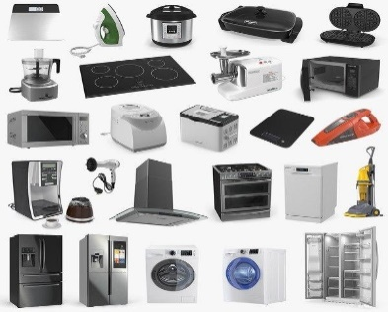 | 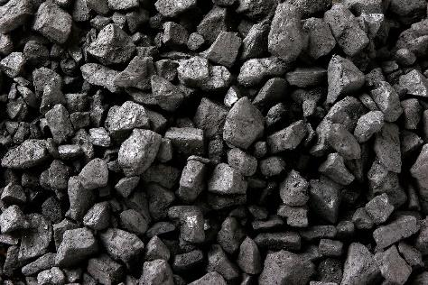 | 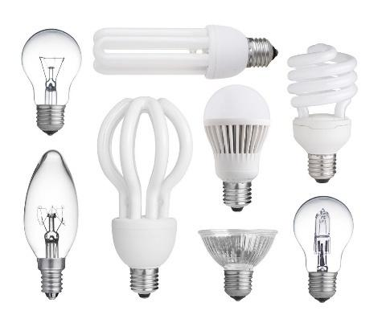
1. A_ _ _ _A_ _ _ | 2. C_ _L | 3. T_ _
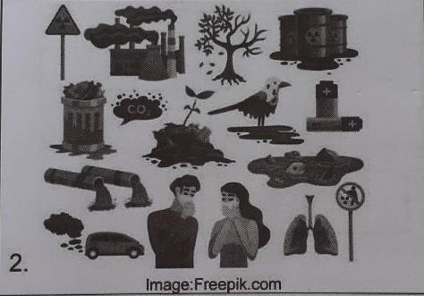 | 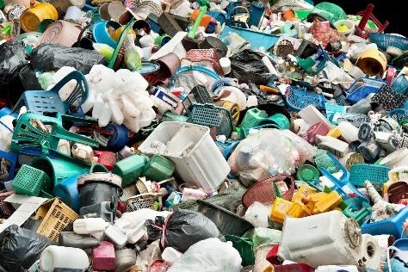 | 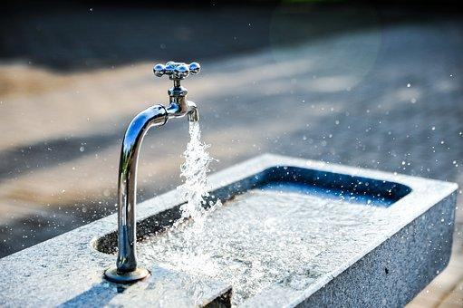
4. P_ _ _ _T_ _ _ | 5. W_ _ T_ | 6. E_ _ T_ _
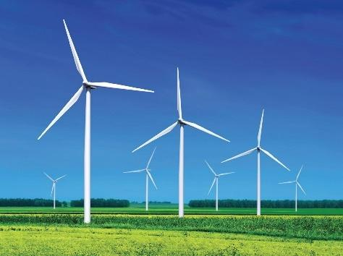 | 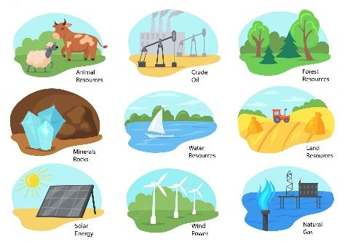 | 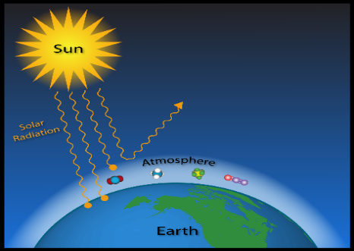
7. W_ _ _ T_ _B_ _ _ | 8. N_ _ _R_ _ _ R_ _ _ _R_ _ _ | 9. G_ _ _ _H_ _ _ _ E_ _E_ _
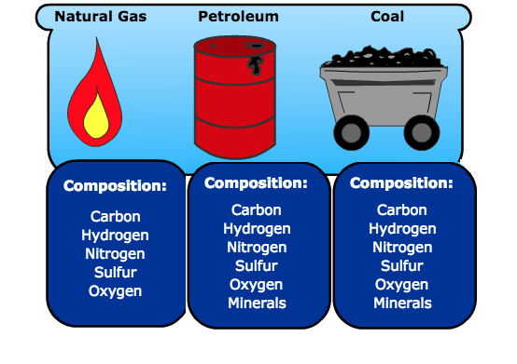 | 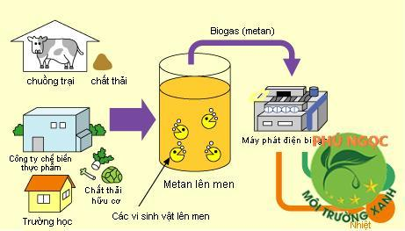 | 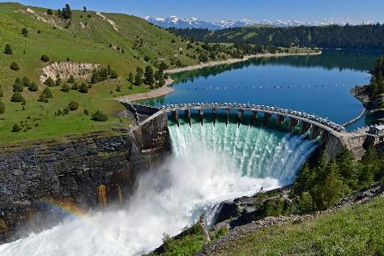
10. F_ _S_ _ F_E_ | 11. B_ _G_ _ | 12. D_ _
Exercise 2. Choose the word(s) that doesn’t belong to the group.
1. A. Crack B. Electricity X C. Abundant D. Dam
2X A. Electric B. Emit C. Last D. Overheat
3. X A. Polluted B. Produce C. Release D. Solution
4. A. Solve B. Trap C. Waste X D. Panel
5. A. Syllable B. Tap X C. Save D. Emission
6.X A. Annual B. Award C. Choose D. Chase
7. A. Opportunity XB. Fascinating C. Festival D. Feast
8. A. Own B. Organize C. Reach X D. Festive
9. A. Impressive B. Disappointing X C. Lantern D. Annual
10.X A. Decorate B. Turkey C. Symbol D. Easter
Exercise 3. Match the words or phrases on the left with their meaning on the right.
1. climate change C | A. available or existing in large amounts or numbers
2. advantage G | B. being the largest or most important of its kind
3.abundant E | C. changes in the Earth’s weather, including changes in temperature, wind patterns and rainfall, especially the increase in the temperature of the earth’s atmosphere that is caused by the increase of particular gases, especially carbon dioxide
4. available F | D. to fix equipment or furniture into position so that it can be used
5. disadvantage I | E. existing in large quantities; more than enough
6. investment H | F. that you can get, buy or find
7. generate J | G. a quality of something that makes it better or more useful
8. plentiful A | H. the act of investing money in something
9. install D | I. to cause problems and tend to stop somebody/something from succeeding or making progress
10. main B | J. to produce energy, especially electricity
Your answer:
1. | 2. | 3. | 4. | 5. | 6. | 7. | 8. | 9. | 10.
Exercise 4. Fill in the blanks with suitable words or phrases in the box to complete the sentences below.
avoid | dam | electric | harm | main
pollute | save | use | power | installing
1. The flood weakened the __ dam _______________.
2. I try to ___ avoid ______________ going shopping on Saturdays.
3. Smoking can cause serious ___ harm ______________ to the lungs.
4. This calculator is easy to ______ use ___________.
5. A lot of _____ electric ____________ lamps illuminated the stage.
6. The _______ main __________ crop of Japan is rice.
7. Bicycling doesn’t ____ pollute _____________ the air.
8. We all want to _____ save ____________ money.
9. Tommy is _____ installing ____________ new software.
10. Knowledge is _____ power ____________.

Exercise 5.
Task 1. Mark the letter A, B, c, or D to indicate the word or phrase that is CLOSEST in meaning to the underlined part in each sentence.
1. Scientists are developing new sources of energy to protect the environment.
A. use X B. preserve C. harm D. waste
2. Wind energy is abundant, isn’t it?
A. badly B. well X C. plentiful D. excellent
3. Are fossil fuels limitless?
A. lavish X B. unlimited C. dangerous D. exhausted
4. When we bum coal, it causes air pollution.
A. produces B. due to X C. leads to D. results from
5. Non-renewable sources will eventually run out.
X A. be used up B. be replaced C. be recycled D. generate
Task 2. Mark the letter A, B, C, or D to indicate the word or phrase that is OPPOSITE in meaning to the underlined part in each sentence.
1. They are reducing the use of nuclear energy because it’s not safe to produce.
A. lowering B. cutting C. decreasing X D. increasing
2. Do you turn off the lights when going to bed?
A. go on B. get off X C. turn on D. switch off
3. How many kinds of renewable sources of energy are there?
X A. non-renewable B. alternative C. polluting D. expensive
4. For many people living in rural areas, biogas is a cheap energy.
A. suburban B. remote X C. urban D. country
5. What are the advantages of hydro energy?
A. benefits X B. disadvantages C. values D. usages
Exercise 6. Give the correct word form of these words.
1 | We should use them _economically__________ and try to find alternative sources of power. | ECONOMY
2 | Solar energy is __renewable__________, plentiful and clean. | RENEW
3 | I think that solar energy can be an __alternative__________ source of energy in the near future. | ALTER
4 | We should reduce the use of ___electricity_________ at home. | ELECTRICAL
5 | It’s a clean source of energy. Sailboats couldn’t move without this ___power_________. | POWERFUL
6 | Waves will be used as an ____environmentally________ friendly source of energy. | ENVIRONMENT
7 | Limit car trips by relying on biking, walking, public ___transportation_________. | TRANSPORT
8 | Solar power can be used to __heat__________ or cool our houses. | HOT
9 | Energy is used to __produce__________ a lot of electrical things. | PRODUCT
10 | There will be a ___shortage_________ of energy in the near future. | SHORT
Exercise 7. Match the collocations on the left with their meaning on the right.
1. come from E | A. to finish a supply of something
2. instead of D | B. used to emphasise that something is very noticeable in the stated way
3. look for G | C. to need a particular thing or the help and support of someone or something in order to continue, to work correctly, or to succeed
4. provide F | D. in place of someone or something
5. rely on C | E. to be born, got from, or made in a particular place
6. replace B | F. to give someone something that they need
7. run out I | G. to try to notice someone or something
8. turn on H | H. to activate or cause to flow, operate, or function by or as if by turning a control
9. use up A | I. to finish, use, or sell all of something, so that there is none left
10. work on J | J. to spend time repairing or improving something
Your answer:
1. | 2. | 3. | 4. | 5. | 6. | 7. | 8. | 9. | 10.
Exercise 8. Fill in the blanks with suitable words/phrases in the box.
comes from | use up | instead of | run out | replace with
work on | look for | rely on | provide with | turn on
1. Don’t ___ use up _____________ all the milk. We need some for breakfast.
2. Cows ____ provide with us good milk.
3. Jane _____ comes from ____________ Canada.
4. Don’t climb a tree to ____ look for _____________ fish.
5. Jack and Jill don’t go to ___ work on ______________ Saturdays.
6. You can rely on me for help.
7. She has ____ run out _____________ of ideas.
8. The woman was pensioned off and _____ replace with ____________ a young girl.
9. My children want to ____ turn on _____________ the television.
10. We took a cross-country route _____ instead of ____________ the motorway.
Exercise 9. These pairs of words are easily confused. Choose the best word for each sentence.
1. We had ice cream and apple pie for (desert/dessert).
2. Wood is (one/want) of the primary renewable resources.
3. Reduce, reuse, and recycle (to/too) minimize waste and reduce carbon dioxide emissions.
4. The two basic types (off/of) solar energy components include passive and active solar energy systems.
5. (Wind/Will) energy is another alternative energy source that is entirely renewable.
6. Black and white complement each other (quite/quiet) well.
7. I used to have long (hair/hear) during my childhood.
8. (Its/It’s) your duty to inform the truth to your parents.
9. Jenny didn’t waste (time/times).
10. The (energy/engineer) from a solar panel can be used locally with solar lights or solar fans.
Exercise 10. Choose the correct answers.
1. Nuclear energy is _________________, but it is dangerous.
X A. renewable B. non-renewable C. natural resource D. fossil fuel
2. Fossil fuels are very common in our society, but they _________________ the environment.
A. waste X B. pollute C. renew D. provide
3. All the houses in our village will be _________________ by solar energy
X A. frozen B. widened C. heated D. heightened
4. Several governments try to _________________ the use of fossil fuels.
A. waste B. save X C. reduce D. increase
5. At this time next week, we _________________ a wind turbine in our garden.
A. will installed X B. will be installing C. install D. installed
6. Low energy light bulbs should be used to _________________ electricity
A. convert X B. save C. spend D. buy
7. It is a good idea to use _________________ when traveling long distances.
A. private cars X B. public transport C. cars D. taxis
8. “Why is it called a _________________ source?”
- “Because it can be replaced easily and quickly.”
X A. renewable B. non-renewable C. effective D. specific
9. We must _________________ the amount of water our family uses every day.
A. lessen B. narrow C. lower X D. reduce
10. Wave energy is a source of _________________ energy.
A. environmental friendly B. environmentally friendliness
C. environment friendly X D. environmentally friendly
11. Alternative sources of energy _________________ developed in the near future.
A. has been X B. will be C. is D. was
12. She _________________ cooking in the kitchen at 7 p.m tomorrow.
A. will B. is X C. will be D. be
13. Some new energy-saving bulbs _________________ in the dining room.
XA. will be put B. will put be C. will put D. will be putting
14. What should we do to _________________ electricity?
A. take X B. save C. cut D. waste
15. The wind, the sun, and the waves are some types of _________________ sources of energy.
A. cheap B. costly C. changeable X D. alternative
III. GRAMMAR
Exercise 1. Fill in the blanks.
V-inf | V-ing form  (Present continuous) | Vs/es form  (Present simple)
play | playing | plays
swim | swimming | swims
lie | lying | lies
use | using | uses
buy | buying | buys
get | getting | gets
study | studying | studies
watch | watching | watches
go | going | goes
sing | singing | sings
Exercise 2. Present simple or Present continuous?
A. Things which are always true
B. Things which are happening at the moment of speaking
C. Habits or things we do regularly
D. Definite future plans
E. Future events which are part of a timetable
Present simple  A – C - E | Present continuous  B - D
Exercise 3. Fill in the blanks with “do / does / is / am / are”.
1. Cindy _______is__________ not interested in music. She ______does___________ not play any musical instruments.
2. Ben, together with his mother, ____is____________ preparing dinner in the kitchen.
3. ___Do______________ you usually have an English lesson on Wednesdays?
4. Why _____is____________ James always late for school?
5. I ______am___________ not doing my homework now. I ______am___________ listening to music.
6. Helen ___does______________ not like strawberries, but I ______do___________.
7. There _____are____________ a lot of students playing in the schoolyard now.
8. We ____are_____________ not allowed to use mobile phones in class.
9. _____Does____________ Andy fancy making models?
10. Where _____do____________ they often go camping? - In the woods.
Exercise 4. Put the verbs into the correct tense (present simple or present continuous).
1. John (not talk) __isn’t talking__ on the phone right now, he (clean) ___is cleaning__the floor.
2. My brother (watch / usually) __ usually __ watches__the news in the evening.
3. Daniel (play / always) _is always playing__ drums in the afternoon. It’s too noisy for me to take a nap.
4. Jane’s sister (be) ___is__very hard-working. She (have) ____has__ a big flat now.
5. Look! Those children (sail) __are__sailing_a boat. It (be) ___is__too dangerous.
6. (it/ rain) _Does it rain_ heavily in summer in your country?
7. How often (Brian/ take) _does Brian take__the dog for a walk?
8. It (get) _is getting_ darker. I (have) _have__ to go home now.
9. Where (your mother/ be) _is _ your mother __? - She (do) _is doing_ the laundry.
10. My best friend (love) _loves__writing poems.
Exercise 5. Circle the best answers.
1. Does /Is your teacher American?
2. My dad washes/is washing his car at the moment.
3. I go to bed at 10 p.m every day, but today I go/am going to bed at 9 p.m.
4. Jack always leaves/is always leaving his clothes on the floor. It looks so messy.
5. Either my brother or Jack’s go/goes to the gym in the mornings.
6. She teaches/is teaching physics in a high school.
7. We stay/are staying in a resort at present.
8. Listen! Does Ann play/Is Ann playing the piano in her room?
9. Why don’t we go /aren’t we going to the cinema tonight?
10. They aren ’t/don’t be ready to go to the concert.
Exercise 6. Group the time expressions in the box for the correct tenses below.
It’s 9 o’clock | at the moment
sometimes | on Mondays
twice a week | every week
at present | now
three times a year | right now

Present simple | Present continuous
twice a week  sometimes  every week  on Mondays  three times a year | at the moment  now  right now  It’s 9 o’clock  at present

Exercise 7. Write one suitable word in each blank.
1 | I don’t think so. The solar panels are becoming __cheaper__and easy to install. | CHEAP
2 | Scientists are looking for clean and ___effective___sources of energy. | EFFECT
3 | I know it is also clean and safe for the environment. But does it cost a lot of money to install the ____solar___ panels on the roofs? | SUN
4 | More renewable energy sources will be used to solve the problem of. pollution | POLLUTE
5 | Because our major sources of energy are running out while solar energy is abundant and __unlimited__. | LIMIT
6 | _Unfortunately___, fossil fuels are harmful to the environment. | FORTUNATE
7 | Energy is used to produce a lot of _electrical__ things. | ELECTRICAL
8 | The __installation___ of wind turbines will be completed by next Friday. | INSTALL
9 | It can be found in only some places on the earth. It comes from ___depth__ inside the Earth. | DEEP
10 | __Energetic__ particles reach the Earth in just 8 minutes. | ENERGY
Exercise 8. Circle the correct answers.
1. Be quiet! Our grandparents _________________.
A. is sleeping X B. are sleeping C. are sleep D. is sleep
2. My mother _________________ the housework now.
A. isn’t do X B. isn’t doing C. doing D. not doing
3. _________________ Bill’s cousins _________________ trees in the garden?
X A. Are / planting B. Are / plant C. Do / planting D. X / planting
4. My friends and I _________________ to the café twice a month.
X A. go B. goes C. gos D. are go
5. She _________________ watching documentaries.
A. isn’t enjoy B. don’t enjoy X C. doesn’t enjoy D. doesn’t enjoys
6. What time _________________ Keith have lunch every afternoon?
X A. does B. do C. is D. be
7. I _________________ the dishes after meals.
A. am wash usually X B. usually wash C. usually washes D. wash usually
8. They _________________ really hard-working at school.
A. don’t be B. not be C. don’t are X D. aren’t
9. My brother _________________ playing golf now.
A. like B. is like C. is liking X D. likes
10. Is she baking cookies now? - Yes, she _________________.
X A. is B. does C. be D. isn’t
11. The students _________________ the project now.
X A. are doing B. is do C. do D. is doing
12. Nowadays, people in Iceland _________________ using energy from coal.
A. is B. isn’t C. was X D. aren’t
13. Renewable sources _________________ from the sun, wind or water.
X A. come B. comes C. coming D. is coming
14. Mrs. Van is teaching us about solar energy _________________.
X A. at the moment B. yesterday C. last night D. in 2000
15. They _________________ for a cheap, clean and effective source of energy now.
A. look X B. are looking C. looks D. looked
Exercise 9. Underline the mistakes and correct them.
1. She isn’t swim in the swimming pool right now.
______________swimming___________________________________________________________________
2. Mrs. Lien is teaching we about solar energy at the moment.
____________________________us_____________________________________________________
3. I are using more solar energy to save energy.
_____am____________________________________________________________________________
4. Nowadays, people in Iceland isn’t using energy from coal.
_____________________________________aren’t____________________________________________
5. What you usually do to save energy?
___What do you______________________________________________________________________________
6. Linh always turn off the lights when going out.
__________________turns_______________________________________________________________
7. Well, we uses low-energy light bulbs at my house.
______________use___________________________________________________________________
8. Normally they start school in eight o’clock in the morning.
___________________________________at______________________________________________
9. Turn the lights off when are you leave the classroom.
__________________________when you_______________________________________________________
10. Normally they start school in eight o’clock in the morning.
____________________________________at_____________________________________________
IV. READING
Exercise 1. Choose the word or phrase among A, B, C or D that best fits the blank space in the following passage.
In Western countries, electricity, gas, and water are not (1) ___________ but necessities. Companies now realize that consumers want (2) ___________ that will not only work effectively, (3) ___________ save money.
For most North American households, lighting (4) ___________ for 10 percent to 15 percent of the electricity (5) ___________. However, this amount can be (6) ___________ by replacing an ordinary 100-watt light bulb with an energy-saving bulb. These bulbs use a (7) ___________ of the electricity of standard bulbs and last eight times (8) ___________. Therefore, consumers can save about US$7 to US$21 per bulb. In Europe, there is a labeling scheme for refrigerators, freezers, washing machines and tumble dryers. The label tells the consumers how much energy efficiency each model has, compared (9) ___________ other appliances in the same category. Ultimately, these innovations will save money as well as (10) ___________ the Earth’s resources.
1. A. launching X B. luxuries C. coming D. peaking
2. A. tickets B. weapons C. spaceships X D. products
3.X A. but also B. towards C. with D. into
4. A. as good as B. like as X C. accounts D. such as
5. A. burnt X B. bill C. went off D. banged
6.X A. reduced B. audience C. observatories D. watcher
7. A. sent back B. returned to C. separated from X D. quarter
8. A. weightlessness X B. longer C. wavelengths D. length
9. A. space B. atmosphere X C. with D. universe
10.X A. conserve B. drivers C. tourists D. astronauts
Exercise 2. Fill in each blank with a suitable word.
Energy is very (1) _important__ in modem life. People use energy to (2) __run__machines, heat and cool their homes, cook, (3) _give___ light, transport people and products from place (4) __to__ place. Most energy nowadays (5) _comes___ from fossil fuels such as petroleum, coal, and (6) __natural__ gas. However, (7) __burning__fossil fuels causes pollution. In addition, if we don’t find new (8) _kinds__ of energy, we will (9) __use__up all the fossil fuels in the 21st century. Scientists are working to (10) _find__ other kinds of energy for the future. What might these sources of energy be?
V. WRITING
Exercise 1. Reorder the words to make correct sentences.
1. doing / She / energy / a / is / project / on / sources.
She is doping a project on energy sources.
2. Renewable/ of./ we/ mean/ the/ sources/ cannot/ run/ out/ sources
Renewable souces mean the sources we cannot run out of.
3. We / of / run / out / cannot / renewable / energy.
We can not run out of renewable energy.
4. we / energy / When / from / comes / hydro / water, / call / it / energy.
When energy comes from water, we call it hydro energy.
5. energy / Nuclear / dangerous / expensive. / is / and
Nuclear energy is dangerous and expensive.
6. for / Our / looking / new / replace / government / is / sources / energy / to / gas.
Our government is looking for new energy sorces to replace gas.
7. our / Burning / polluting / is / coal / environment.
Burning coal is polluting our environment.
8. are / solar / replace / energy / We / to / energy / using / from / coal / today.
We are using solar energy to replace energy from coal today.
9. Scientists / new / protect / energy / sources / are / to / the / environment. / developing
Scientists are developing new energy sources to protect the environment.
10. energy / We / are / the / use / reducing / of / nuclear / nowadays.
We are reducing of use the nuclear energy nowadays.
Exercise 2. Write the sentences using the given words.
1. Many countries / already using / solar energy.
Many countries are already using solar energy
2. Save / energy / one / best / way / conserve / natural / resources.
Saving energy is one of the best ways to conserve natural resources.
3. Currently / most / our electricity / come / coal, gas, oil, or nuclear power.
Currently, most of our electricity comes from coal, gas, oil, or nuclear power.
4. Plant / trees / create / shade / around / house / help / keep / cool.
Plant trees because trees create shade around your house and help keep it cool.
5. This power/could/provide/sun.
This power could be provided by the sun.
6. Not leave / fridge door / open / cold air / escape / use / lot / electricity.
Don’t leave the fridge door open because cold air escape and this use a lot of electricity.
7. One percent / solar energy / reach / Earth/ enough / provide power / the total population.
One percent of the solar energy that reaches the Earth is enough to provide power for the total population.
8. Turn / all / light / every / time / leave / room.
Turn off all the lights every time you leave the room.
9. Viet Nam/ advanced technology/ solar energy
Viet Nam has advanced technology in solar energy
10. Shut / computer / TV / other / electrical / stuff / when / not / use.
Shut down the computer, TV and other electrical stuff when you aren’t using them.

