Week: 13 Date of preparing: 02 /12 /2024
Period: 93 Date of teaching: 05/12 /2024

UNIT 11: OUR GREENER WORLD
Period 93: PROJECT

I.Aims: By the end of the lesson, Students will be able to: review some vocabulary and grammar they’ve learn in unit 11.
II.Objectives:
-Vocabulary: the lexical items related to the topic “ Our greener world”
-Structures: conditional sentences-type 1
III.Teaching aids:
- Teacher: Text book, laptop, loudspeaker, projector…
- Students: Text books, studying equipment….
- Method: T-WC; group works; individual ……
IV.Procedure:
V.Time: 20’
IDEAS ABOUT REUSING OLD THINGS

Teacher’s & Student’s activities | Content
P1:A pencil holder: People probably used old cans and ropes to make it.  P2,3,4:Plant pots: People probably used old containers, a broken bottle and old cans to make them.  -Group work  -Ss choose used objects: a bottle, a can, a sheet of paper…...  -Ss make something new from it and decorate it.  -Ss bring it to class.  -Ss do a “ show and tell” about it.  1.Picture 1: They use used bottles to make pencil box  2.Picture 2: They make the light bulbs from old bottles  3.Picture 3: They use an used glass bottle to make a flower vase  1.Soak bottles/jars in warm soap water to remove labels…  2.Rinse jars and let dry.  3.Apply tape around the bottles, leaving some of the glass exposed.  4.Stuff paper towels in to the opening of each jar to prevent paint getting inside.  5.Paint bottles in assorted colors.  -In the first picture, I can see a beautiful bookcase with many pens inside.  -In the second picture, I can see small trees inside coconut shells.  -In the third picture, I can see beautiful flower vases made from tins.  -These are beautiful flower vases made from old plastic bottles. We wash used water bottles and cut them into different shapes. We also cover them with old gift wraps. What do you think of our products? | + Greeting  + Chatting. T_Ss  1.What can you see in each picture? What did people use to make the things in the pictures?  2.Now work in pairs or in groups to complete the project.  3.How to make a flower vase fr om an used glass bottle.  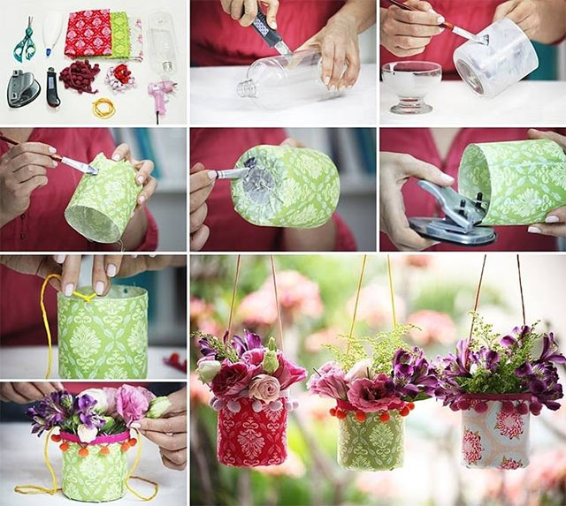  4.Listen to other presentations and decide which is the best.

* Homework:
- Do more exercises in workbook.
- Make more sentences using will/ might

