Date of planning:…………..  Date of teaching: ………..…  WEEK: | Peroid 74 : UNIT 9 : CITIES OF THE WORLD  Lesson 6 : SKILLS -2/ Listening & Writing
THIS UNIT INCLUDES:
Vocabulary  - Cities and landmarks  Pronunciation:  - Sounds: / әu / and / au /  Grammar  - Possessive adjectives.  - Possessive pronouns. | Skills:  - Reading about a holiday postcard.  - Talking about a city  - Listening to a description of a city.  - Writing a holiday postcard  Everyday English  Expressing exclaimations with What.
I. OBJECTIVES: By the end of this lesson, students will be able to gain the following things :
1. Knowledge:
- To teach listening and writing. To develop their listening skills for specific information about a description of a city. Also to write a holiday postcard
+ Vocabulary: - use the words related to cities and landmarks
- Expressing exclaimations with What.
+ Grammar: - use the past simple;
- use imperatives to tell someone to do something;
2. Competence: Students will be able to listen skills for specific information about a description of a city. Also to write a holiday postcard.
3. Quality/ behavior : The love of learning English. The love of the cities and beautiful spots. Having serious attitude to working in groups, individual work, pairwork, cooperative learning and working.
II. TEACHING AIDS:
- Teacher: Text book, laptop, louspeaker, projector…
- Students : Text books, studying equipments….
- Work Arrangements: T_Ss , group works; individual ……
III. PROCEDURE:
1. WARM UP & INTRODUCTION (3’-5’)

Aim:
- To develop student’s listening skills for specific information. It also provides input for the writing skills.
* Content: Review the previous leson or have some warm-up activities to creat a friendly and relaxed atmostphere to inspire Ss to warm up to the new lesson.
* Output: Having a chance to speak English and focus on the topic of the lesson..
* Organisation :Teacher’s instructions…

Teacher’s & Student’s activities | Content
+ Greeting  + Asking Ss some questions  - Teacher (T) asks Ss some questions about them and class.  - Ask Ss about the content of the previous lesson.  - Ask Ss to open their book and introduce what they are going to study….  - T leads in the lesson. | + Greeting  + T _ Ss  - Students (Ss) listen and answer the teacher’s or friend’s questions  - Listen and know what they are going to learn  - Open their book and write the tittle of the lesson
2. PRESENTATION/ NEW LESSON ( 12’)

ACTIVITY 1: Pre-listening
Aim: To help Ss brainstorm about Bangkok.
* Content: Discuss in groups and answer the questions.
* Output: Ss can answer the questions in groups.
* Organisation : ....…
Teacher’s & Student’s activities | Content
1. Work in groups . Discuss and answer the questions.  *) Pre- teach vocabulary:  - Teacher uses different techniques to teach vocabulary (situation, realia, translation .....) if have  - Repeat in chorus and individually  * Tell Ss they will listen to a talk about Bangkok, the capital of Thailand.  - Ask Ss the two questions and discuss with them to see what they know about Bangkok or Thailand.  - Allow Ss to speak in Vietnamese (sometimes) if they do not have enough vocabulary in English.  Ask Ss to look at the photos and say what they see, and if it's similar to Viet Nam.  - Play the recording again if needed, stopping at the place where Ss find it difficult to hear. | 1. Work in groups . Discuss and answer the questions.  - T _ Ss    - Do the tasks. Compare the answers.  - Give the answer.  Suggested answers:  1. Bangkok is in central Thailand.  2. It's famous for its temples, markets, shopping centres, silk, street food, friendly people, and many types of entertainments.
3. While-listening ( 18’)
ACTIVITY 2 : While-listening
Aim: To help Ss develop listening skill for specific information (T / F).
* Content: Listen and tick T/ F to get specific information a talk about Bangkok, the capital of Thailand.
* Output: Ss can tick T/F correctly while they are listening.
* Organisation : Teacher’s instructions…

Teacher’s & Student’s activities | Content
2. Listen and Tick (✓) T (True ) or F (False)  - Ask Ss to go through the statements (1 - 4) to make sure that they understand them and know what information they have to catch for the answers. (Ss may underline the key word(s) in each statement.)  - Play the recording. Ask Ss to listen and tick the answers.  - Call on some Ss to read aloud their answers and correct the false one(s).  - Check and confirm the correct answers.  *(Post-listening)  * T may give some clues  - Call on some Ss to speak freely.  - Correct pronunciations, grammar, vocab, intonation. | 2. Listen and Tick (✓) T (True ) or F (False)  - T _ Ss  - Listen to the teacher’s instructions carefully and learn how to do it.  - Fulfil the tasks  - Give the answers  * Key:  1. F (markets and street food)  2. F (cheap)  3. F (on the river)  4. T
ACTIVITY 3 :
Aim : To help Ss develop listening skill for specific information ( gap- filling)
* Content: Listen and fill the gaps.
* Output: Ss understand more information about Bangkok, the capital of Thailand.
* Organisation : Teacher’s instructions…

3. Listen again and fill each gap with One word/ number.  - Ask Ss to read the questions carefully and determine what information they need to fill the gaps (numbers, words).  - Play the recording for Ss to fill the gaps. Ask them to exchange answers in pairs before checking their answers as a class.  Audio script:  Bangkok is famous for its markets and street food.  Visit the Chatuchak, the largest weekend market in the world. There are over 15,000 stalls selling nearly everything, at cheap prices. It's only five minutes' walk from the station. When you visit this market, you can see part of Thai people's life. | 3. Listen again and fill each gap with One word/ number.  - T _ Ss  - Listen carefully to the instructions  - Work individually  * Ss learn how to do the tasks  - Ss’ answers  Key: 1. 15,000 2. 5 3. life 4. delicious  Audio script:  Another interesting type of market is the floating market on the river. Don't forget to try street food in Bangkok. It's easy to find food stalls all around Bangkok, serving different Thai dishes. They are really delicious.
ACTIVITY 4: Writing
Aim: To help Ss talk about a holiday city and collect information for their later writing.
* Content: Group work and talk about city intheir countryusing questions given.
* Output: Ss can talk about city they know.
* Organisation : ..…

Teacher’s & Student’s activities | Content
4. Work in groups. Talk about a city in your country, using the questions below as a guide  - Ask Ss to work in groups. Choose a city they know and discuss guided by the questions.  - Ask Ss to take short notes of the answers for later use.  - Go round and help if needed.  - Go around and give help If necessary.  - Call on some Ss to speak in front ofthe class.T and other Ss listen and make comments. | 4. Work in groups. Talk about a city in your country, using the questions below as a guide  - Listen carefullyand learn how to talk.  - Group works  - Write themselves  *Sample speaking:  Hue is a great city. The weather is fine, sunny all the time. The food is cheap and delicious. The people here are friendly and hospitable. The hotel where we’re staying is small but comfortable. Yesterday we visited the historic monuments. Tomorrow we’re going on a trip along Huong River. I bought a small present for you yesterday.  You must visit this place/ city someday.  You’ll love it.  Bye for now!
4. APPLLICATION (8’-10’)

ACTIVITY 5:
Aim: To teach Ss how to write a postcard.
* Content: Write a postcard about their holiday.
* Output: Ss can write a postcard completely.
Teacher’s & Student’s activities | Content
5. Listen again and fill each gap with One word/ number.  - Ask Ss to use their ideas in 4 to write a postcard to their family.  - Ask Ss to refer to Reading 2 if needed.  - If there is time, pair Ss and ask them to write postcards to each other. Have them swap and give feedback on each other's writing once they have finished.  - Go around and give help If necessary.  - Call on some Ss to read their notes in front ofthe class.T and other Ss listen and make comments.  * Post writing  - T may display all or some of the Ss' writings on the wall / notice board. T and other Ss give comments. Ss edit and revise their writing as homework.  - T may collect some Ss'writings and mark them, then give comments to the class. Remember to tell them how to improve their writings.  - If time is limited,T may ask Ss to write the final version at home.  - Other Ss and T comment on the writing. | 5. Listen again and fill each gap with One word/ number.  - Listen carefully and learn how to write  - Write themselves. Ss do it  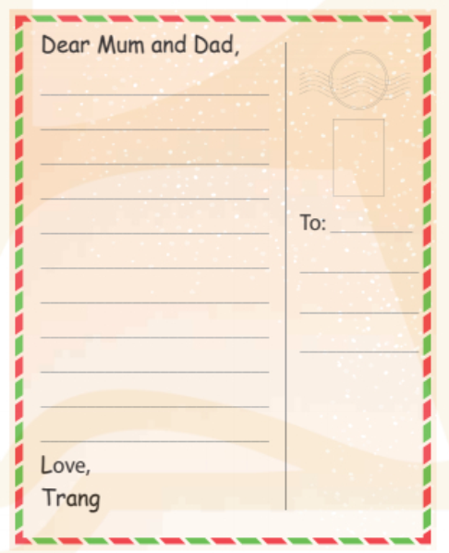  *Sample answer  Dear Mum and Dad,  Hue is a great city. The weather is fine, sunny all the time. The food is cheap and delicious. The people here are friendly and hospitable. The hotel where we’re staying is small but comfortable. Yesterday we visited the historic monuments. Tomorrow we’re going on a trip along Huong River. I bought a small present for you yesterday.  You must visit this place/ city someday.  You’ll love it.  Love  Trang
5. WRAP-UP & HOME WORK (2’)

*Have Ss summarise what they have learnt with the two skills.
* HOME WORK.
- Finish writing a diary entry. Copy in the note books.
- Do more exercises in workbook.
- Prepare new lesson.

=========================

