Giới từ chủ thời gian – Preposition of Time
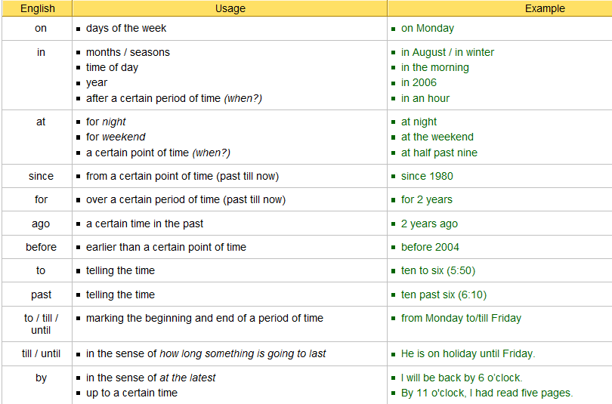
I. Bài tập điền giới từ in / on / at chỉ thời gian
1. Peter is playing tennis …………….. Sunday.
2. My brother’s birthday is ………….. the 5th of November.
3. My birthday is ……………. May.
4. We are going to see my parents ……………. the weekend.
5. ……………….. 1666, a great fire broke out in London.
6. I don’t like walking alone in the streets ……………….. night.
7. What are you doing ……………… the afternoon?
8. My friend has been living in Canada ……………….. two years.
9. I have been waiting for you ………………. seven o’clock.
10. I will have finished this essay ……………… Friday.
1. Let's meet ... six o'clock.
2. He was born ... July.
3. I went there ... 1978.
4. She'll be at work ... Friday.
5. We met ... Christmas day.
6. They drove to Rochester ... September 15th.
7. We arrived in this country ... October.
8. I love to go shopping ... Christmas time.
9. We get up early ... the morning.
10. Do you dream ... night?
11. What do you like doing ... weekends?
12. He's working on his homework ... the moment.
13. I lived in the US ... the 1980s.
14. I'll see you ... a few weeks.
15. We like going to the movies ... Fridays.

