UNIT 7: TRAFFIC (TEACHER’S FILE)
VOCABULARY
1. cycle (v) /saɪkl/: đạp xe
2. traffic jam (n) /'træfɪk dʒæm/: sự kẹt xe
3. park (v) /pɑ:k/: đỗ xe
4. pavement (n) /'peɪvmənt/: vỉa hè (cho người đi bộ)
5. railway station (n) /'reɪlwei ,steɪ∫n/: nhà ga xe lửa
6. safely (adv) /'seɪflɪ/: an toàn
7. safety (n) /'seɪftɪ/: sự an toàn
8. seatbelt (n) /'si:t'belt/: dây an toàn
9. traffic rule (n) /'træfIk ru:l/: luật giao thông
10. train (n) /treɪn/: tàu hỏa
11. roof (n) /ru:f/: nóc xe, mái nhà
12. illegal (adj) /ɪ'li:gl/: bất hợp pháp
13. reverse (n) /rɪˈvɜːs/: quay đầu xe
14. boat (n) /bəʊt/: con thuyền
15. ﬂy (v) /ﬂaɪ/: lái máy bay, đi trên máy bay
16. helicopter (n) /'helɪkɒptər/: máy bay trực thăng
17. triangle (n) /'traɪæŋɡl/: hình tam giác
18. vehicle (n) /'viɪkəl/: xe cộ, phương tiện giao thông
19. plane (n) /pleɪn/: máy bay
20. prohibitive (adj) /prə'hɪbɪtɪv/: cấm (không được làm)
21. road sign /rəʊd saɪn/: biển báo giao thông
22. ship (n) /ʃɪp/: tàu thủy
23. tricycle (n) /trɑɪsɪkəl/: xe đạp ba bánh
GRAMMAR
HỎI VÀ TRẢ LỜI VỀ KHOẢNG CÁCH ( ASK & ANSWER ABOUT DISTANCE)
Cách dùng | “How far” là câu hỏi thường được dùng để hỏi về khoảng cách, quãng đường giữa 2 địa điểm.  Ta đặt “It” làm chủ ngữ trong câu để nói về khoảng cách.
Cấu trúc | How far is it from A to B?  It is (about) + khoảng cách
Ví dụ | How far is it from your house to Tan Son Nhat airport?  (Khoảng cách từ nhà bạn tới sân bay Tân Sơn Nhất bao xa?)  It’s about 200 km (Khoảng 200 km)
Lưu ý | Trong câu trả lời về khoảng cách ta thường dùng “about” (khoảng chừng) khi không biết chính xác về khoảng cách đó.
PRACTICE 1
Bài 1: Khoanh tròn vào đáp án đúng.
- How far is it from your apartment (from/to) the city centre?
- It is (at/ about) 1 kilometre.
- It is not very (near/far) from my house to the post office. It is just 500 metres.
- How far (is it/ it is) from your country to Japan?
- How (far/ much) is it from your location to the train station?
- My house is 2 kilometers (near/ far) from my grandparents’ bungalow.
- How far (is it/ are they) from here to the local museum?
- I think it is about 200 ( metres/ metre) from here to the nearest bus stop.
- My school is not far (from/to) my house. I can walk to school every day.
- How far is it (from/ at) your office to the supermarket?
Bài 2: Điền một từ thích hợp vào chỗ trống.
- How_______ is it from your house to the city centre?
- How far is it from this restaurant to the nearest __________? It is about 1 kilometer from this restaurant to the nearest bank?
- How far__________it from Hanoi to Ho Chi Minh City?
- It is about 5 kilometres from my house__________yours.
- How far is_________from your company to your apartment?
- It is __________3 kilometres.
- How far is it from my school to yours? __________is about 8 kilometres
- How far is it __________where you live to your company?

Bài 3: Dựa vào những câu trả lời cho trước, hãy viết câu hỏi về khoảng cách.
- ______________________________________________________________?
It is about 300 metres from here to the nearest post office.
- ______________________________________________________________?
It is about 3,900 kilometers from New York to California.
- ______________________________________________________________?
It is about 200 metres from my house to my family store.
- ______________________________________________________________?
It is about 4576.89 miles from Beijing to Berlin.
- ______________________________________________________________?
It is about 1 kilometer from my hotel to the beach.
- ______________________________________________________________?
It is about 500 metres from here to the place where I live.
- ______________________________________________________________?
It is about 200 kilometers from his hometown to the place where he lives now.
- ______________________________________________________________?
It is just 200 metres from the park to the parking lot.
- ______________________________________________________________?
It is approximately 4 kilometers from here to the airport.
- ______________________________________________________________?
It is about 60 kilometers from my parent’s house to mine
Bài 4: Đánh dấu (√ ) trước những câu trả lời đúng. Đánh dấu (X) trước những câu có lỗi sai và sửa lại cho đúng.
_________ | - How far is from your house to the nearest restaurant?  __________________________________________________________
_________ | - It is at 2 kilometers from my house to La Villa French restaurant.  __________________________________________________________
_________ | - How far is it from your university and my university?  __________________________________________________________
_________ | - It is not far from my university to yours  __________________________________________________________
_________ | - How far is it from here to our destination?  __________________________________________________________
_________ | - How far it is from our school to the camp site?  __________________________________________________________
_________ | - Its not far from our school to the camp site.  __________________________________________________________
_________ | - How far is it at the train station to the nearest drugstore?  __________________________________________________________

Bài 5: Dựa vào gợi ý cho sẵn trong ngoặc, trả lời các câu hỏi về khoảng cách sau đây:
- How far is it from your house to the gym? (300 metres)
__________________________________________________________
- How far is it from where you live to where you work? (2 kilometres)
__________________________________________________________
- How far is it from Hanoi to Hoi An? (about 800 kilometres)
__________________________________________________________
- How far is it from from Earth to Mars? (about 34 miles)
__________________________________________________________
- How far is it from Earth to the nearest star? (4.2 light-years)
__________________________________________________________
- How far is it from North Pole to Equator? (about 100000 kilometres)
__________________________________________________________
GRAMMAR
1. Should (nên) và Shouldn't (không nên) dùng để đưa ra lời khuyên
Should là động từ khuyết thiếu, do đó nó không cần chia theo các ngôi và luôn cẩn một
động từ nguyên thể không "to" đi đằng sau
Thể | Thể khẳng định +Thể phủ định | Thể nghi vấn
Chức năng | Dùng để diễn tả lời khuyên, hay ý nghĩ điều gì là đúng, nên làm hoặc không nên làm. | Dùng để hỏi ý kiến hay yêu cẩu một lời khuyên.
Cấu trúc | s + should/ shouldn't + V + (các thành phần khác). | Should + s + V + (các thành phẩn khác)?  Yes, s + should.  No, s + shouldn't.
Vi dụ | We should brush our teeth twice a day. (Chúng ta nên đánh răng hai lẩn một ngày.)  We shouldn't waste water.  (Chúng ta không nên lãng phí nước.) | Should we buy a new car?  (Chúng ta có nên mua một chiếc ô tô mới không?)  Yes, we should.  (Có, chúng ta nên mua.)
BÀI TẬP VẬN DỤNG CƠ BẢN
Bài 1: Đọc câu và điền should/shouldn't vào chỗ trống sao cho hợp lý.
1.Tom.........................eat so many lollipops. It's bad for his teeth.
2. He's fifteen. He........................ drive a car.
3. Pregnant women..............smoke as it can damage the baby.
4.We...................go somewhere exciting for our holiday.
5. People ...................drive fast in the town centre.
6. You ...................ask the teacher to help you if you don't understand the lesson.
7. I ...................buy the dress or the skirt?
8. She ...................tell lies.
9.That's a fantastic book. You...................read it
10. The doctot said: you ...................eat healthy food. You...................eat fast food.You
................... watch so much TV. You ................... walk 1 hour a day. You...................
drink fruit juice and water. You...................drink wine or beer.
11. You ................... be so selfish.
12. I don’t think you ................... smoke so much.
13. You................... exercise more.
14. I think I you ................... try to speak to her.
15. You are overweight. You ................... go on a diet.
16. Where................... we park our car?
17. You ................... never speak to your mother like this.
18. The kid ................... spend so much time in front of the TV.
19. ................... I tell her the truth or should I say nothing?
20. I think we................... reserve our holiday in advance.
Bài 2: Nối câu ở cột A (tình huâng) v6i cột B (lời khuyên) sao cho hạp lý.
Cột A | Cột B
1. It's too far to walk. | a. You should learn the language before you go.
2. Someone doesn't know which way to go. | b. You should ask a policeman.
3. Someone is going to live overseas. | c. You should wear an overcoat.
4. It's going to be a cold day. | d. You should pay by cheque.
5. Someone is feeling hot and has a headache. | e. You should call the police.
6. Someone has seen somebody breaking into a shop window. | f. You should see a doctor.
7. Someone hasn't got any money with them. | g. You should take a rest.
8. It's raining. | h. You should take a taxi.
9. Someone has to get up early in the morning. | i. You should set your alarm clock.
10. Someone is tired out. | j. You should take an umbrella.
1........... 2........... 3........... 4........... 5...........
6........... 7........... 8........... 9........... 10...........
Bài 3: Sắp xếp các từ sau để tạo thành câu hoàn chinh.
1. up/I / smoking/./ should/ give
………………………………………………………………………………………
2. I/ not/?/ tell/ her/ or/ Should
………………………………………………………………………………………
3. think/should/I/take/you/easy/./ it
………………………………………………………………………………………
4.What/should/time/come/?/I
………………………………………………………………………………………
5.Jeff/ much/. /work/ so/ shouldn't
………………………………………………………………………………………
6.We/ our/ take/ should/ umbrellas/.
………………………………………………………………………………………
7.don't/ accept/ this/ Anita/ job/./ think /I /should
………………………………………………………………………………………
8.you/ should/ sure/ we/ Are/ it/?/ do
………………………………………………………………………………………
9.What /should/ is/ do/ home/, /go/ you
………………………………………………………………………………………
10.speak/ should/ think/ to/ Do/ police/?/ you/ the/I
………………………………………………………………………………………
Bài 4: Dựa vào các gợi ý dưới đây để đưa ra lời khuyên cho mỗi tình huống sau.
Take medicine / take up swimming/ worry about it/ eat so much sweets/ do little jobs or go
babysitting/ ask your teacher to explain it again/ study harder/ watch too much television/ i
practice a lot/ get up earlier
1. We are often late for school.
………………………………………………………………………………………
2. My friends laugh at me because I don't have expensive clothes.
………………………………………………………………………………………
3. My mother has a terrible headache.
………………………………………………………………………………………
4. don't understand how to give advice in English.
………………………………………………………………………………………
5.My brother gets very bad marks at school.
………………………………………………………………………………………
6.We're going to write a Maths test tomorrow.
………………………………………………………………………………………
7. My sister can’t swim and she wants to go to Greece next summer.
………………………………………………………………………………………
8. I always feel tired
………………………………………………………………………………………
9. My friends love eating and they're very fat.
………………………………………………………………………………………
10. I want to buy some new clothes but I don't have any money.
………………………………………………………………………………………
Bài 5: Chọn động từ thích hợp trong bảng dưới đây để điền vào chỗ trống.
clean eat fasten go stay study takex2 visit watch
1. If you have time you should............................ the National Museum.
2. When you are driving a car, you should. .........................your seatbelt.
3. When you play football, you should .........................the ball .
4. It's late and you are tired. You should...................... to bed.
5.You should .....................your teeth at least twice a day.
6. It's too far from here. You should....................a taxi to get there.
7. If you want to pass the exam, you should....................more.
8. He wants to lose weight, so he should.................... less
9. It's raining now. I think you should....................an umbrella.
10. He is ill. He should............................ at home.
Bài 6: Dựa vào các gợi ý sau, viết câu với cấu trúc should hoặc shouldn't.
1.(eat between meals) You ........................................................................................................
2.(go on a diet) You ........................................................................................................
3.(get exercise) You ........................................................................................................
4.(drink soda) You ........................................................................................................
5.(eat mmore vegetables) You ........................................................................................................
6.(eat apple) You ........................................................................................................
7.(eat too much bread) You ........................................................................................................
8.( only drink plain water) You ........................................................................................................
9. (eat too much chocolate) You ........................................................................................................
10. (change your health habits) You ........................................................................................................
PRACTICE
VOCABULARY AND PRONUNCIATION

1.1 Phát âm nguyên âm đôi /eɪ/
Bước 1: Bắt đầu từ âm /e/, sau đó di chuyển về phía âm /ɪ/.
Bước 2: Khi bắt đầu, miệng mở rộng thoải mái, đầu lưỡi chạm hàm răng dưới, hàm hạ. Sau đó, môi dần kéo sang hai bên về phía tai, hàm dưới nâng lên một chút.
Bước 3: Kết thúc âm, môi mở hờ.
Ví dụ:
- Later /ˈleɪtər/: sau đó
- Tasty /ˈteɪsti/: vị
- Danger /ˈdeɪndʒər/: nguy hiểm
- Explain /ɪkˈspleɪn/: giải thích
- Exchange/ ɪksˈtʃeɪndʒ/: trao đổi

1.2 Phát âm nguyên âm đôi /aɪ/
Bước 1: Bắt đầu từ âm /a/, sau đó di chuyển về phía âm /ɪ/.
Bước 2: Khi bắt đầu, miệng mở hình ovan, lưỡi hạ thấp chạm hàm răng dưới. Sau đó, môi dần kéo sang 2 bên về phía tai, hàm dưới nâng lên 1 chút.
Bước 3: Kết thúc âm, môi mở hờ.
Ví dụ:
- fine /faɪn/: tốt, nguyên chất
- behind /bɪˈhaɪnd/: đằng sau
- child /tʃaɪld/: đứa trẻ
- nice /naɪs/: đẹp
Practice
Means of transport:
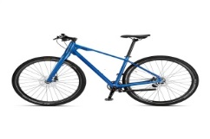 | 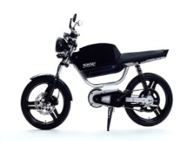 | 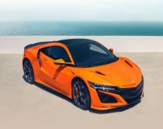 | 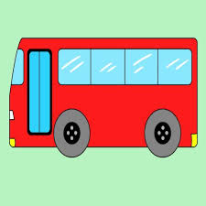
Bike/bicycle | Motorcycle | Car | Bus
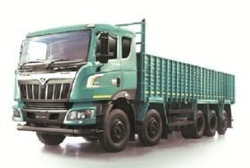 | 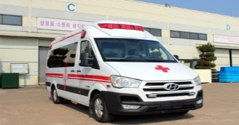 | 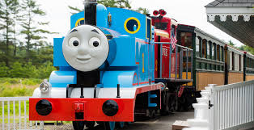 | 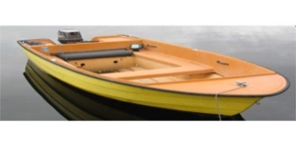
Truck | Ambulance | Train | Boat
 | 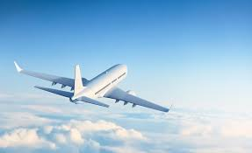 | 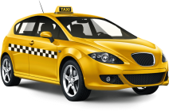 | 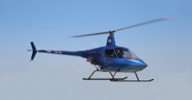
Ship | Plane | Taxi | Helicopter

1.accident (n) | Tai nạn | 2. population (n) | Dân số
3. rule (n) | Luật lệ | 4. vehicle (n) | Phương tiên
5. pedestrian (n) | Người đi bộ | 6. pavement (n) | Vỉa hè
7. footpath (n) | Lối đi bộ | 8. helmet (n) | Mũ bảo hiểm
9. obey (v) | Tuân lệnh | 10. increase (v) | Gia tăng
11. cross (v) | Sang đường | 12. narrow (a) | Hẹp
13. bumpy (a) | Nhấp nhô | 14. crowded (a) | Đông đúc
15. illegal (a) | Phạm pháp | 16. rush hour | Giờ cao điểm
17. traffic jams | Tắc nghẽn giao thông | 18. traffic sign | Biển báo giao thông
19. traffic light | Đèn giao thông | 20.cycle lane | Làn đường cho xe đạp
21. parking lot | Bãi đỗ xe | 22. safety belt | Dây an toàn
23. poor quality | Chất lượng kém | 24. means of transport | Phương tiện giao thông
Ex I: Choose the word that has different sound in the underlined part
- A. ship B. bicycle C. dish D. taxi
- A. hole B. cold C. motorbike D. bowl
- A. hand B. traffic C. cancel D. park
- A. subject B. truck C. ambulance D. luck
- A. illegal B. helicopte C. nest D. dentist
- A. railway B. law C. may D. today
- A. accident B. cookies C. traffic D. carry
- A. entered B. loved C. kicked D. discovered
- A. opened B. invented C. considered D. married
10.A. attacked B. stopped C. laughed D. surrounded
Ex II: Labe the picture
Traffic lights, cycle lane, Turn left ahead, Parking lot, No cycling, One way traffic, Turn right ahead, Road work

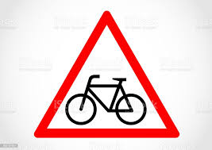 | 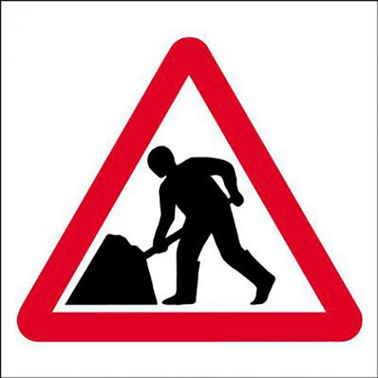 | 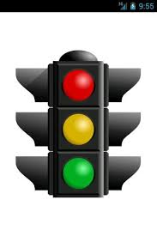 | 
1. | 2. | 3. | 4.
 | 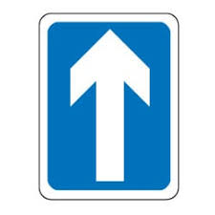 | 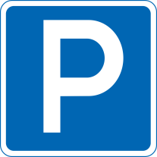 | 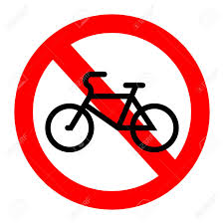
5. | 6. | 7. | 8.

Ex III: Write the words using the first letter given
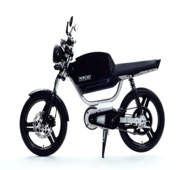
1.m……………….. | 2.t………………. | 3.t………………….. | 4.b…………………
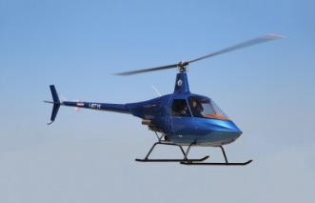 |  |  | 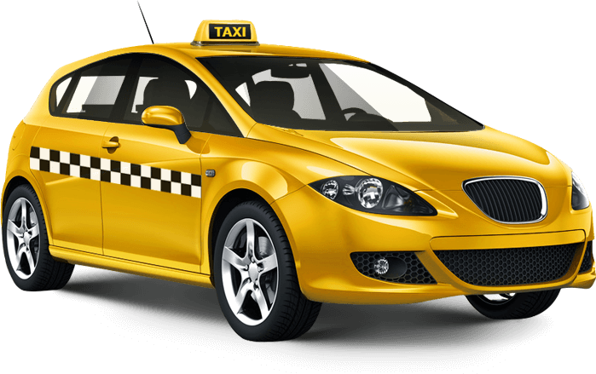
5.h……………….. | 6.s………………. | 7.p……………….. | 8.t………………..

Ex IV: Odd one out
- A. ambulance B. taxi C. sign D. plane
- A. bus B. driver C. motorbike D. bicycle
- A. train B. yesterday C. tomorrow D. today
- A. artist B. engineer C. painter D. transport
- A. pavement B. sheep C. pedestrian D. footpath
- A. crowded B. bumpy C. accident D. noisy
- A. increase B. supermarket C. restaurant D. cinema
- A. helmet B. vehicle C. accident D. narrow
- A. pizza B. spaghetti C. obey D. hamburger
10.A. secretary B. rule C. nurse D. dentist
Ex V: Add more word to each list
- Means of transport: bus,………………………………………………………………
………………………………………………………………………………………………………………
- Road signs: stop,……………………………………………………………………………
Ex VI: Circle the correct word
- You can/can’t park here. 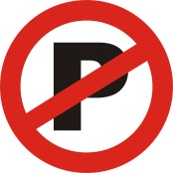
- You can/can’t turn right here.
- You can/can’t turn left. 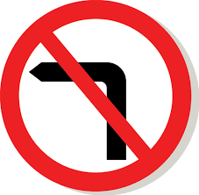
- You can/can’t make a U-turn here. 
- You can/can’t go home here. 
Ex VII: Put the words in the correct column
tradition, payment, train, lane, , today, May, whale, pain, taste, lake, main, rain, stay, die like why high night fighting / surprise childhood tour guide

/ ai / | /eɪ/
Ex VIII: Read and choose the best answer
1.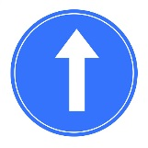 | a. You must turn right.  b. You must turn left.  c. You must go ahead. | 2.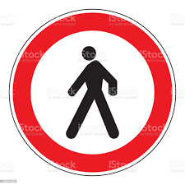 | a. Pedestrians can enter.  b. Pedestrians mustn’t enter.  c. Pedestrians must enter.
3.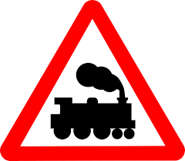 | a. Trains must stop.  b. Trains mustn’t enter.  c. You must be careful with the train. | 4. | a. You can park here.  b. You must park here.  c. You mustn’t park here.
5. | a. You can turn back.  b. You mustn’t turn back.  c. You must turn back. | 6.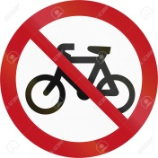 | a. Cyclists must enter.  b. Cyclists mustn’t enter.  c. Cyclists can park here.

Ex IX: Read and underline the words with the /e/ sound and /eɪ/ sound in the following passage
For many years, Betty has been driving to work and back every weekday. Every morning, on her way to work, especially during the rush hour, the highways are usually crowded causing massive traffic jams. The situation is even worse in the evening when she drives home. All the traffic comes to a halt whenever there is an accident or a car broken down and blocks an entire lane. In the winter, particularly when it snows, multi-car accidents with injuries can take vehicles removers a number of hours to clear the road. When Betty is stuck in a heavy traffic jam, she listens to music on the radio to calm her nerves. Her boss and her husband know that if she is late, she is probably stuck in traffic.
Ex X: Fill in the gap with a suitable word or phrase given in the box
pollution | suspension | traffic | environmental
factories | underground | busiest | cheapest

- In Dubai, the ……………..is so bad that it is quicker to walk than to go by car or bus.
- People suggest building flyovers, tunnels and ……………..car parking.
- There are lots of problems nowadays, mainly because of pollution.
- The emission of smoke from ……………….and cars is a big cause of air pollution.
- We all should act green and fight the ……………….by using the 3 R’s.
- One of the quickest and ………………..ways travelling around the city is to take a bus.
- Bangkok, the capital of Thailand, is one of the …………….city in the world.
- The Golden Gate Bridge, a…………………. bridge, is one of the most internationally recognized symbols of San Francisco.
Ex XI: Choose the best answer
- They often choose …………………cars with bigger engines to get higher speed.
- slower B. faster C. smaller D. worse
- The underground in Japan is much …………………than taxis or buses.
- slow B. quick C. quicker D. more quick
- What ………………did you use to play when you were six years old?
- toy B. card C. ball D. game
- There should be a ……………..limit in the playground to prevent accidents.
- speed B. time C. engine D. cost
- The traffic…………….tell people to do, warns people about possible dangers in the street.
- jams B. signs C. lights D. rules
- Always look…………………..when you cross the street.
- quickly B. well C. carefully D. safely
- What must you do before you turn left or right when ……………a motorbike?
- holding B. taking C. making D. riding
- He is driving his car too fast but he is not wearing his……………..
- seatbelt B. helmet C. hat D. coat
- The little boy is walking at the side of the road towards a zebra………………….
- passing B. crossing C. taking D. doing
10. Why should pedestrians wear light colored …………….in the dark?
A. gloves B. hats C. clothes D. jeans
11. Big cities often ………………..from traffic jams every day.
A. cross B. suffer C. start D. come
12. One problem in big cities is that too many people…………the road.
A. take B. do C. make D. use
Ex XII: Write the correct form of the word given
- A man in a silver sports car ……..……. into a lady in a big blue truck in the middle of the intersection yesterday. CRASH
- Traffic accidents can be ……………….if people obey the rules. PREVENT
- My father used to go ………………in the pond near our house. FISH
- Which drivers are the ………………….on the roads? SAFE
- Young and inexperienced ………………..are the most likely to have an accident. DRIVE
- When young male drivers have their friends in the car, their driving usually becomes…………………BAD
- It’s much more ………………………..for you to cross the street now. DANGER
- You should drive more ………………….and safely when it gets dark. SLOW
- Bells are designed to wake the ………………..motorists. SLEEP
10.There are many …………………who sell and buy things on the road every morning. VILLAGE

Ex XIII: Give the correct form of the words in brackets
There are over 700 million motor vehicles in the world and the number is (1.rise)……………….by more than 40 million each year. This dependence on motor vehicles has given rise to major problems including (2. environment)……………………..…pollution, traffic congestion and safety. Emissions from new cars are far more (3. harm) ………..……than they used to be. City streets and motorways are becoming more (4. crowd)………..………than ever, often with more older trucks, buses and taxis. This makes the air quality in urban areas unpleasant and sometimes (5. danger) …………………….to breathe

SKILLS
B. KỸ NĂNG
DO YOU KNOW?
STRANGE TRAFFIC LAWS FROM AROUND THE WORLD
• It’s illegal to eat or drink while driving in Cyprus.
• In South Africa, animals have the same right to the roads as motorists do. Drivers face heavy fines of up to $500 if they do not slow or stop for passing livestock.
• Road safety officials in Denmark have made it a legal requirement for drivers to check for children hiding beneath the vehicle before starting the engine.
• In Moscow, it’s all about cleanliness - police impose fines on anyone with a dirty car.
• In Jasper Gates, Canada, a dumb law forbids drivers from going faster than a horse or carriage
KỸ NĂNG ĐỌC (READING SKILLS)
I - Read the passage and choose the best option to answer each of the following questions.
In the UK, bus journeys are just boring and simply a necessity. This public means of transportation is often convenient when you live or work in the city centre, as you can avoid traffic jams by moving very quickly in the bus lanes, and do not have to pay to park the car. After all, though, taking the bus is just a necessary and tedious part of life: you board the bus, pay the driver and sit down or find a place to stand. Very boring.
In Latin America, however, bus trips can be very lively. For a start, long-distance buses put on films so that you have entertainment for at least some of the journey. Naturally, local transport does not show films but drivers usually switch on the radio and that can be a great way to hear new songs and new styles of music. Therefore, taking the bus doesn’t sound like fun but it is much more exciting than any UK bus journey.
(British Council)
1. What is the main idea of the passage?
A. Buses in the UK are very convenient.
B. Bus journeys are different in the UK and in Latin America.
C. Bus journeys in the UK are boring.
D. Films are shown on long-distance buses in Latin America.
2. Public transport in the UK is convenient because you can avoid_________.
A. traffic accidents B. policemen C. traffic jams D. bus lanes
3. The word “tedious” in line 3 means_________.
A. not interesting B. exciting C. wonderful D. important
4. The phrasal verb “put on” in the first sentence of the second paragraph can be replaced with “_________”.
A. close B. wear C. play D. open
5. Which of the following statements is NOT MENTIONED about bus journeys in Latin America?
A. Passengers can entertain during their trip by watching films.
B. Drivers play new styles of music on the radio.
C. They are more exciting than bus trips in the UK.
D. They are more expensive than bus trips in the UK.
II - Read the passage and do the tasks below.
Traffic jams in Viet Nam frequently take place in big cities, such as Ha Noi and Ho Chi Minh City.
There is no fixed rule for the time a traffic jam to happen. But It is worst during the rush hour when everyone is in a hurry to get to work or come back home. Apart from peak hours, the time between 9 a.m. to 10 a.m. and between 3 p.m. to 4 p.m. also witnesses long lines of vehicles, mainly motorbikes. When it rains, the traffic jam gets more terrible. Taxis are extremely hard to catch or wave during the downpour.
However, the most annoying thing about the traffic jam is the way people react to it. Most road users ride their motorbikes on the pavement rather than waiting calmly. Moreover, they constantly use their horns to hasten riders in the front, even shouting at them from time to time.
Part 1: Choose the best answer to each of the following questions.
1. What is the passage mainly about?
A. the causes of traffic jams in Viet Nam
B. the effects of traffic jams in Viet Nam
C. the reality of traffic jams in Viet Nam
D. the solutions to reduce traffic jams in Viet Nam
2. When is traffic congestion in Viet Nam the worst?
A. when everyone goes to work
B. between 9 a.m. to 10 a.m.
C. between 3 p.m. to 4 p.m.
D. at the weekend
3. It’s difficult to catch a_________during the downpour.
A. bus B. taxi C. train D. motorbike
Part 2: Decide whether the statements are TRUE (T) or FALSE (F).
1. There is a certain time for traffic congestion in Viet Nam.  2. The traffic jam becomes more serious when it rains.  3. To get through a traffic jam, road users usually break traffic rules. | ❑    
KỸ NĂNG NGHE (LISTENING SKILLS)
Exercise 1: Listen and complete the text about traffic. (Track 13)
TRAFFIC
There is too much traffic on our roads. In (1) ....................., it may take 20 minutes to go through a 02-kilometer road by (2) .....................
Everyone agrees that something has to be done to solve this problem. No one likes to spend much time going to school or the (3) ..................... Going home takes even more time.
It is not easy to build more or (4) ..................... the roads because it is expensive. So, the answer here is to reduce the number of vehicles.
(5) ..................... may be the solution to the traffic jam.
The problem is that time is golden, so not everyone agrees to wait for (6) ..................... of public transport such as buses or (7) ..................... Another problem is that they may not like to be (8) .................... in a (9) .................... bus. The last problem is that the buses cannot go in a small road, so some people who work in a small road will have to walk for a while.
The answer to (10) ..................... has not been found out.
Exercise 2: Listen and decide if each statement is true or false or not given. (Track 14)
No. | Statements | T/F/NG
1. | Garret A. Morgan lives in a rich family since he is born.
2. | When he is 14, he does not study at school any more.
3. | He is famous all over the world for his imagination.
4. | He works in a sewing machine shop and finds it interesting.
5. | In 1901, he sells the idea of a special belt at the price of $150.
6. | Three years later, he invents a helmet and wins a silver medal for this idea.
7. | When Morgan witnesses the car accident of his mother, he thinks of a traffic light.
8. | Morgan spends the amount of money from selling the idea of traffic light on an abroad trip.

KỸ NĂNG NÓI (SPEAKING SKILLS)
Talk about your favorite means of transportation
You can use the following questions as cues:
• What is your favourite means of transportation?
• How often do you use it?
• Where do you usually go?
• Why do you like it?
Useful languages:
Useful vocabulary | Useful structures
• bicycle  • car  • helicopter  • boat  • convenient  • cheap  • safe  • environmentally friendly  • healthy | • My favourite means of transportation is ...  • ... is my favourite means of transportation.  • I ride a bike/ sail on a boat/ fly every day/ every weekend ...  • I ride a bike/ sail on a boat/ fly to ...  • I really like this vehicle because ....  • I love this vehicle because of its + N
Complete the notes:
Structures of the talk | Your notes
What is your favourite means of transportation? | __________________________________________  __________________________________________  __________________________________________
How often do you use it? | __________________________________________  __________________________________________  __________________________________________
Where do you usually go? | __________________________________________  __________________________________________  __________________________________________
Why do you like it? | __________________________________________  __________________________________________  __________________________________________
Now you try!
Give your answer using the following cues. You should speak for 1-2 minutes.
1. My favourite means of transportation is ...
2. I ride a bike/ sail on a boat/ fly by plane ...
3. I ride a bike/ sail on a boat/ fly by plane to ...
4. I really like this vehicle because ....
Now you tick!
Did you ...
❑ answer all the questions in the task?
❑ give some details to each main point?
❑ speak slowly and fluently with only some hesitation?
❑ use vocabulary wide enough to talk about the topic?
❑ use various sentence structures (simple, compound, complex) accurately?
❑ pronounce correctly (vowels, consonants, stress, intonation)?
Let’s compare!
Finally, compare with the sample answer on page 138.
KỸ NĂNG VIẾT (WRITING SKILLS)
I- Complete each of the following sentences using the cues given. You can change the cues and use other words in addition to the cues to complete the sentences.
1. have/ trip/ hometown/ brother/ two days ago.
→ ________________________________________________________
2. 15 kilometres/ my place/ my hometown.
→ ________________________________________________________
3. go/ there/ train/ and/ it/ comfortable.
→ ________________________________________________________
4. there/ a lot of/ vehicles/ road.
→ ________________________________________________________
5. trip/ exciting/ meaningful.
→ ________________________________________________________
II - Write a short paragraph (60-80 words) describing a trip to your hometown.
You can answer some of the following questions:
• Where is your hometown?
• How did you get there?
• Who did you go with?
• How was the traffic?
• Did you enjoy the trip?
__________________________________________________________________
__________________________________________________________________
__________________________________________________________________
__________________________________________________________________
__________________________________________________________________
__________________________________________________________________
__________________________________________________________________
__________________________________________________________________
__________________________________________________________________

