School: Tran Phu high school | Week: 17  Date: 23/12/24
Class: 12a6 | Period: 47

UNIT 5: Lifelong Learning
Lesson 3.2: Speaking and Writing (Pages 59 & 60)

1. Objectives
By the end of this lesson, students will be able to…
1.1. Language knowledge/ skills
- Practice softening meaning and showing uncertainty.
- Write a blog post about possible challenges lifelong learners face and their solutions.
- Talk about common challenges of lifelong learning and solutions
1.2. Competences
- Improve Ss’ communication, collaboration, analytical, and critical thinking skills.
1.3. Attributes
- Cultivate a heightened curiosity for diverse learning methodologies.

2. Teaching aids and materials
- Teacher’s aids: Student’s book and Teacher’s book, class CDs, DCR– Phần mềm tương tác trực quan, DHA – Ứng dụng trò chơi tương tác, projector / interactive whiteboard /TV (if any), PowerPoint slides.
- Students’ aids: Student’s book, Workbook, Notebook.

3. Assessment Evidence
Performance Tasks | Performance Products | Assessment Tools
- Read the blog post and underline examples of this. | - Ss’ answers. | - Observation/feedback.
- Rewrite sentences by softening meaning and showing uncertainty. | - Ss’ answers. | - Observation/feedback.
- Talk about some possible challenges lifelong learners might face and what they can do to overcome the challenges | - Ss’ answers. | - Observation/feedback.
- Read the phrases and the blog post, circle the phrases that the writer used | - Ss’ answers. | - Observation/feedback.
- Fill in the blanks (A–D) with the verbs | - Ss’ answers. | - Observation/feedback.
- Write a blog post about possible challenges of lifelong learning and solution | - Ss’ answers. | - Observation/feedback.

4. Procedures
A. Warm-up: 5 minutes
a. Objectives: to introduce the topic about challenges of lifelong learning
b. Content: Share the ideas with the class.
c. Expected outcomes: Ss can talk about the challenges of lifelong learning
d. Organization
Teacher’s activities | Students’ activities
Warm-up activities: Work in pairs and answer these questions.  - Divide Ss into pairs.  - Give Ss instructions and one example.  - Show questions for Ss to discuss.  - Call some pairs to give their answers.  - Give feedback.  Questions:  1. What time management challenges do lifelong learners face when balancing learning with other responsibilities?  2. How can technological barriers affect access to online learning for lifelong learners?  3. How might a lack of support from family or peers slow down lifelong learners' progress? | - Work in pairs.  - Follow the instructions.  - Discuss the questions.  - Read the sentences out loud.  - Listen to some answers.  Suggested answers  1. What time management challenges do lifelong learners face when balancing learning with other responsibilities?  Lifelong learners often find it hard to make time for studying because of work and family duties.  2. How can technological barriers affect access to online learning for lifelong learners?  If lifelong learners don't have good internet or know how to use computers well, they can't easily use online courses.  3. How might a lack of support from family or peers slow down lifelong learners' progress?  Without support from family or friends, lifelong learners might feel lonely and less motivated to keep learning.

B. New Lesson (35’)
1. Pre-writing (25’)
1.1.Writing: (10’)
a. Objectives: To help Ss learn how to use some words to soften meaning and show uncertainty
b. Content: tasks a and b
c. Expected outcomes: Ss can learn how to use some words to soften meaning and show uncertainty.
d. Organization
Teacher’s activities |  | Students’ activities
Task a. Read about softening meaning and showing uncertainty, then read the blog post again and underline examples of this.
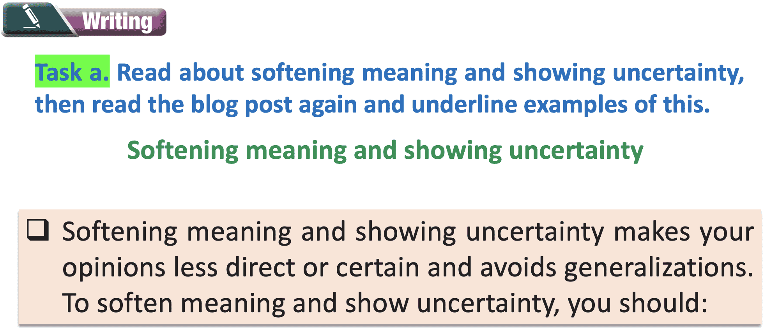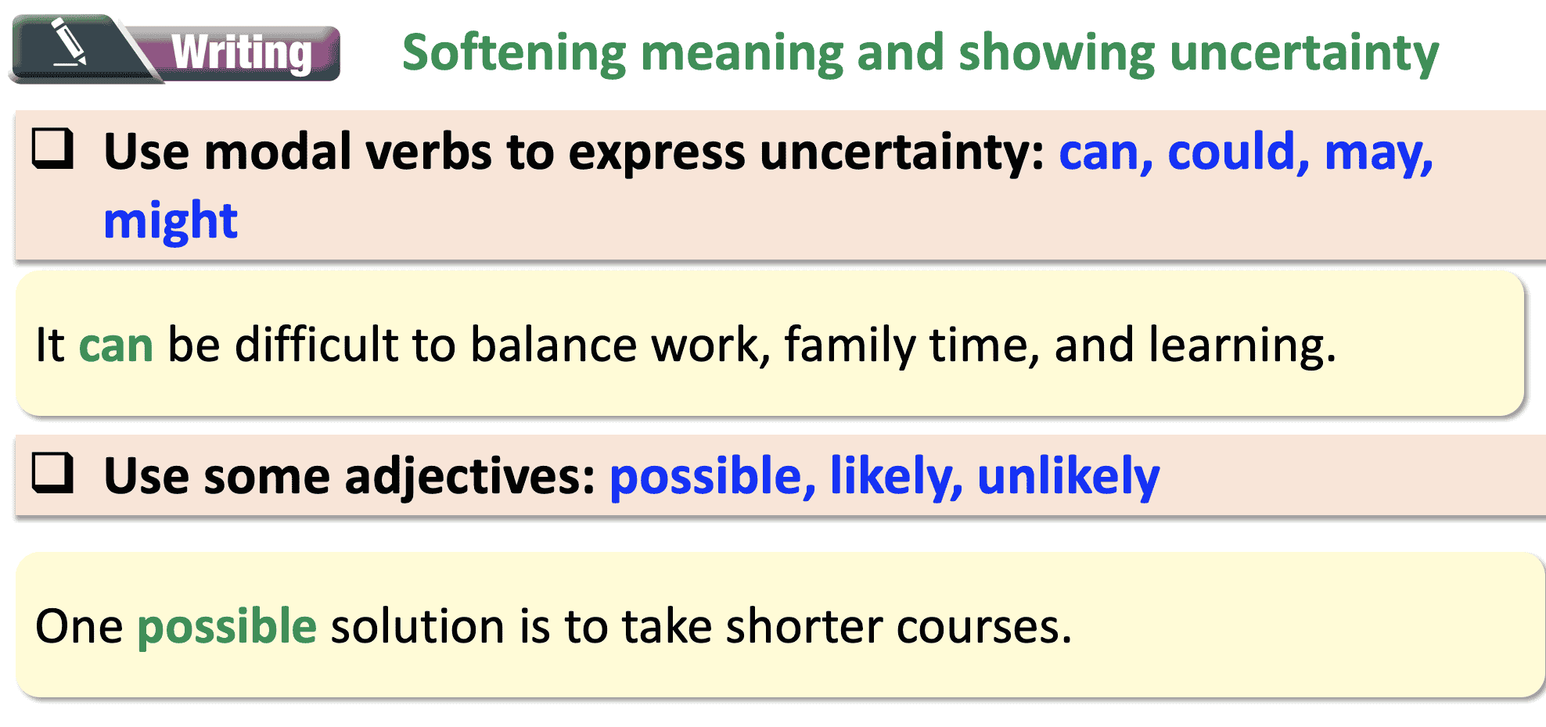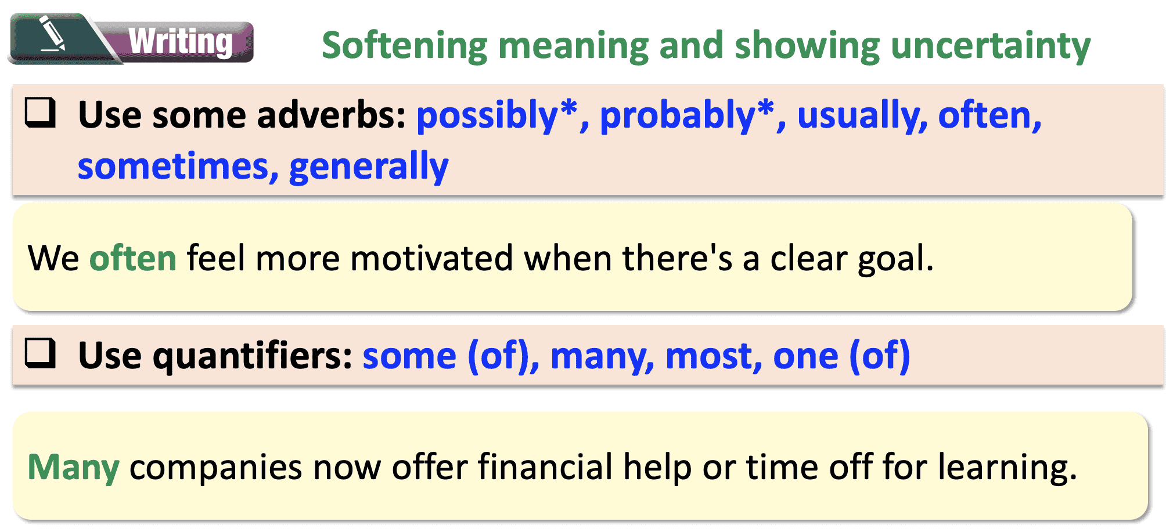
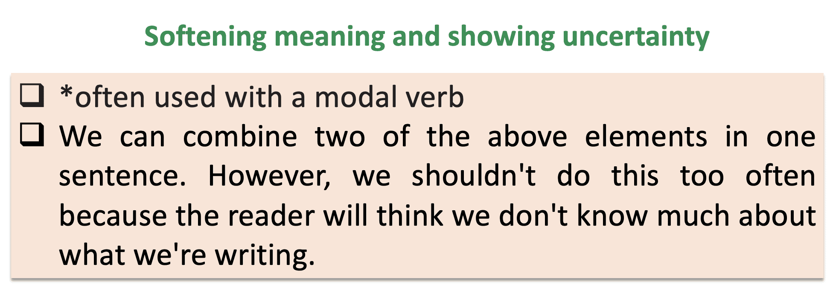
- Ask students to read the Writing Skill and the blog post again, then underline examples of softening meaning and showing uncertainty. | - Read the Writing Skill and the blog post again, then underline examples of softening meaning and showing uncertainty.
- Ask students to check their answers with a partner. | - Check their answers with a partner.
- Check answers as a whole class. | - Correct the answers.
Answer key:
Do you find learning after graduation difficult? If the answer is yes, you're not alone. Below are some of the most common difficulties people might have when trying to pursue lifelong learning.
Lifelong learning can be time-consuming. Besides the time for classes, you'll have to complete assignments and take tests. Also, you may lose out on time for family and friends. While it isn't easy to deal with this problem, one possible solution is to find online classes that allow you to learn at your own pace.
Another challenge is the cost of learning. Taking courses and buying materials can be pretty expensive. However, there are great free online resources that you can use as a start. You can also consider asking for financial help from your employer if you're looking to take more expensive courses for your job.
You might also lose your motivation. Learning can sometimes be difficult or boring. However, if you choose courses that you're truly interested in or that can lead to a job promotion, you may find it easier to pursue learning. You could also find support from a study partner. Having someone to share your progress with can make learning more fun.
In addition, you might not have access to learning resources. Thankfully, there are websites that have courses on lots of different topics. If you still can't find what you want, many experts now offer their own online courses. You can find out about these by following people on social media.
To sum up, lifelong learning may be challenging, but there are ways to make it easier. Choose a suitable course and use any support you can find. And remember, it's never too late to learn and grow

Task b. Rewrite these sentences by softening meaning and showing uncertainty.
- Ask students to rewrite the sentences by softening meaning and showing uncertainty. | - Rewrite the sentences by softening meaning and showing uncertainty.
- Ask students to check their answers with a partner. | - Check their answers with a partner.
- Check answers as a whole class. | - Correct answers.
Answer key:
1. A lack of self-discipline can/could/may/might make it hard to learn on your own.
2. Learning usually/often/sometimes/generally requires financial investment in classes, materials, and tools.
3. Finding the right learning resources can/could/may/might be challenging.
4. Some/Many people think that they're bad learners and are afraid of learning.
5. One possible/likely way to overcome this is to set aside time to learn every day.

1.2.Speaking: (10’)
a. Objectives: To help Ss generate and discuss ideas they can use later in their own writings
b. Content: Tasks a and b
c. Expected outcomes: Ss can generate and discuss ideas they can use later in their own writings.
d. Organization
Teacher’s activities | Students’ activities
Task a. In pairs: What are some possible challenges lifelong learners might face? What can they do to overcome the challenges?
- Demonstrate the activity by practicing with a student. | - Watch the demonstration.
- Divide the class into pairs. | - Work in pairs.
- Ask students to discuss what some possible challenges of lifelong learning might be and what can be done to overcome them. | - Practice speaking with partners.
- Have some students share their ideas with the class. | - Listen to other students’ ideas.
Suggested answer:
1. Time:
A: They might not have enough time to study.
B: I think making a schedule could help with that.

2. Finance:
A: They might not have enough money for courses.
B: I think looking for free or low-cost resources online could help with that.

3. Motivation:
A: They might lack motivation to keep learning. B: I think setting small goals and rewarding themselves could help with that.

4. Lack of Access:
A: They might not have access to good learning materials.
B: I think using public libraries or community centers could help with that.

5. Lack of Support:
A: They might not have support from family or friends.
B: I think joining a study group or online community could help with that.

6. Lack of Confidence:
A: They might lack confidence in their abilities. B: I think starting with easier tasks and gradually increasing difficulty could help with that.
Task b. Choose three possible challenges and complete the table with your ideas.
-Ask students to choose three possible challenges. | - Choose three possible challenges.
- Ask students to complete the table with their ideas. | - Complete the table.
- Ask students to share their ideas with the class. | - Listen to other students’ ideas.
Suggested answer:

Challenges | Solutions
1: They might not have enough time to study. | I think making a schedule could help with that.
2: They might not have access to good learning materials. | I think using public libraries or community centers could help with that.
3: They might not have support from family or friends | I think joining a study group or online community could help with that.

1.3. Useful Language: (5’)
a. Objectives: To help Ss understand and use some useful phrases related to lifelong learning.
b. Content: Tasks a and b
c. Expected outcomes: Ss can understand and use some useful phrases related to lifelong learning.
d. Organization

Teacher’s activities | Students’ activities
Task a. Read the phrases (1– 4) below and the blog post again. Circle the phrases below that the writer used.
-Ask students to read the phrases in the box. | - Read the phrases in the box.
- Ask students to read the blog post again and circle the phrases they can see. | - Read the blog post again and circle the  phrases they can see.
- Check answers as a whole class. | - Listen to other students’ ideas.
Answer key:
1. take a course
2. lose motivation
3. deal with a problem
Evidence:
…. While it isn't easy to deal with this problem, one possible solution is to find online classes that allow you to learn at your own pace….
Taking courses and buying materials can be pretty expensive. ….
You might also lose your motivation. Learning can sometimes be difficult or boring….

Task b. Fill in the blanks (A–D) with the verbs below.
-Ask students to add the verbs to the box in Task a. | - Add the verbs to the box in Task a.
- Check answers as a whole class. | - Listen to other students’ ideas.
Answer key:
A. I want to attend/sign up for a course.
B. l can provide/maintain motivation.
C. I need to overcome a problem.
D. I want to pick up a new skill.

2. While-writing (8’)
a. Objectives: To help Ss write a blog post about possible challenges of lifelong learning and solutions.
b. Content: Let’s write
c. Expected outcomes: Ss can write a blog post about possible challenges of lifelong learning and solutions.
d. Organization:
Let’s write:
Now, write a blog post about possible challenges of lifelong learning and solutions. Use the Writing Skill box, the reading model, and your speaking notes to help you. Write 180–200 words.
- Ask Ss to brainstorm the ideas in pairs. | - Brainstorm the ideas in pairs.
- Ask Ss to make an outline and make notes. | - Make an outline and make notes.
- Ask Ss to use their notes to write an essay about the importance of lifelong learning. | - Use their notes to write an essay about the importance of lifelong learning.
Sample answer:
Lifelong learning is very important in today's world, but it isn't easy. Here are some of the most common challenges lifelong learners might have and how to overcome them.
Lifelong learning can be time-consuming. You'll probably have to attend classes, do homework, and take tests. If you have a job, it's pretty difficult to find time for all of that. One way to overcome this is to find online courses that you can complete at your own pace.
Learning can sometimes be expensive. Courses and materials can cost a lot of money. But there are lots of free online resources you can use. And if you take courses for your job, you should ask your company for financial aid.
You might not have the motivation to learn. Learning can be boring or difficult, especially if you're learning alone. One possible solution is to learn with your friends. They'll keep you motivated and help you with difficult problems.
Lifelong learning doesn't have to be challenging. If you follow the advice above, you'll be able to pursue lifelong learning and benefit from it.
181 words
3. Post-writing (2’)
a. Objectives: To help Ss check the writing text and correct mistakes.
b. Content: Edit the writing text
c. Expected outcomes: Ss can check the writing text and correct mistakes.
d. Organization

Teacher’s activities | Students’ activities
Finalize and student-check the writing task
- Draw students' attention to the Feedback form. | - Look at the Feedback form.
- Ask Ss to count the number of words in the writing text. | - Count the number of words in the writing text.
- Ask Ss to check the paragraph. | - Check the paragraph.
- Ask Ss to swap the writing texts in pairs and check each other’s work. | - Swap the writing texts in pairs and check each other’s work.
-Choose some students’ paragraphs and correct them in front of the class. | - Listen to feedback.
Feedback form:
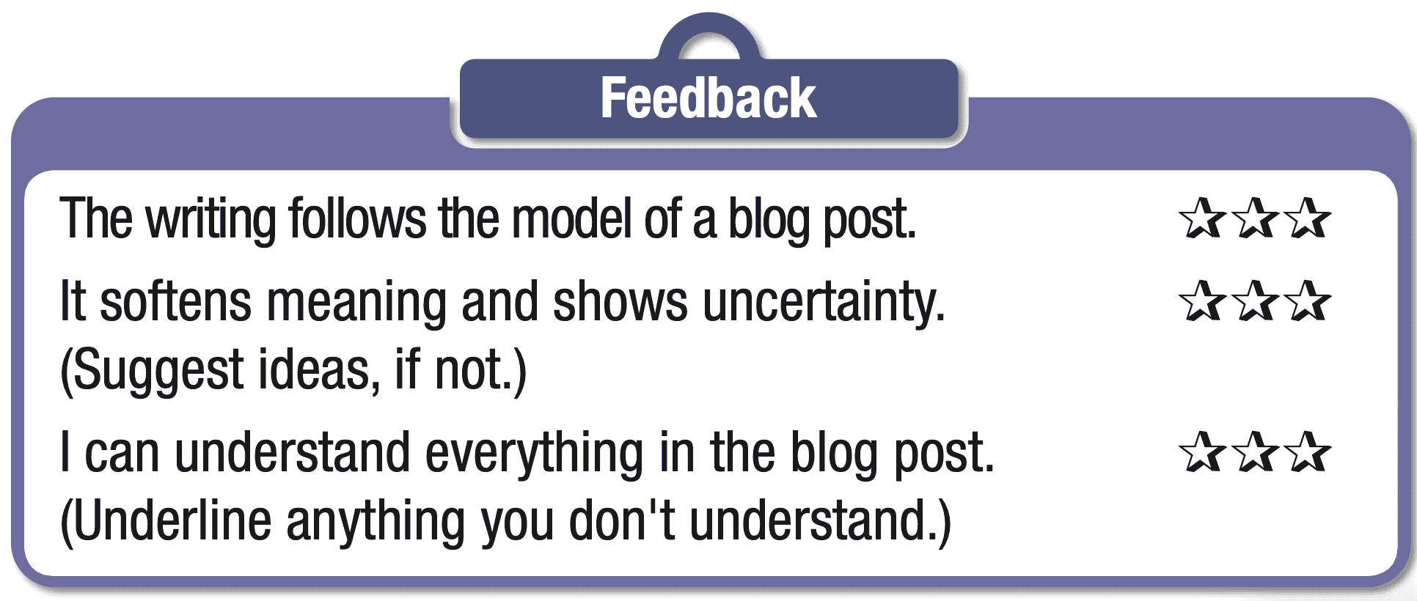

C. Consolidation and homework assignments (5’)
- Speaking: Ask and answer the question below with your partner about lifelong learners:
What are some ways for lifelong learners to balance work, life, and learning?
Suggested answers: Lifelong learners can balance work, life, and learning by making a schedule, setting priorities, and taking short breaks to relax. They can also ask for support from family and friends.
HOMEWORK:
- Learn vocabulary related to life in the past.
- Make sentences using vocabularies in SB.
- Prepare for the next lesson (Review 2 – Page 61- SB).
- Play the consolidation games on www.eduhome.com.vn
5. Reflection
a. What I liked most about this lesson today:
…………………………………………………………………………………………
b. What I learned from this lesson today:
…………………………………………………………………………………………
c. What I should improve for this lesson next time:
…………………………………………………………………………………………

