School: Tran Phu high school | Week: 16  Date: 16/12/24
Class: 12a6 | Period: 44

UNIT 5: Lifelong Learning
Lesson 2.2: Grammar (Pages 55 & 56)

1. Objectives
By the end of this lesson, students will be able to…
1.1. Language knowledge/ skills
- learn and use “reported speech”
- produce sentences using “reported speech”
- improve Grammar and Speaking.
1.2. Competences
- improve Ss’ communication, collaboration, analytical, and critical thinking skills.
1.3. Attributes
- cultivate a heightened curiosity for diverse learning methodologies.

2. Teaching aids and materials
- Teacher’s aids: Student’s book and Teacher’s book, class CDs, DCR– Phần mềm tương tác trực quan, DHA – Ứng dụng trò chơi tương tác, projector / interactive whiteboard /TV (if any), PowerPoint slides.
- Students’ aids: Student’s book, Workbook, Notebook.
3. Assessment Evidence
Performance Tasks | Performance Products | Assessment Tools
- Read about reported speech, and fill in the blanks. | - Ss’ answers. | - Observation.
- Listen, check, and repeat. | - Ss’ answers. | - Observation/feedback.
- Fill in the blanks to report what these people said. | - Ss’ answers. | - Observation/feedback.
- Choose the best sentence for the direct speech. | - Ss’ answers. | - Observation/feedback.
- Take turns giving instructions, orders, and advice, making requests, and making offers, then report them to the other group member. | - Ss’ answers/ presentations. | - Observation/feedback.
- Share the ideas with the class. | - Ss’ answers. | - Observation/feedback

4. Procedures
A. Warm-up: 5 minutes
a. Objectives: To introduce the grammar point: “reported speech”.
b. Content: Sentence completion game “reported speech”.
c. Expected outcomes: Ss can unscramble the sentences with “reported speech”.
d. Organization

Teacher’s activities | Students’ activities
Warm-up activities: Competition time:
- Create groups/teams of 5 students. | - Form groups/teams of 5 students.
- Give Ss instructions and one example. | - Follow the instructions.
- Give Ss incomplete sentences. | - Work in groups
- Ask students to complete the sentences with their ideas. The team(s) with the most correct answers win(s). | - Complete the sentences.
- Check the answers. | - Check the answers.
Sentences:  My dad asked me if I...  Suggested answer: My dad asked me if I was going to be home for dinner.  1. The teacher asked me if I...  2. My friend asked me if I...  3. The waiter asked me if I...  4. The police officer asked me if I...  5. The librarian asked me if I...  6. My coach asked me if I… | Suggested answers  1. The teacher asked me if I had completed my assignment.  2. My friend asked me if I wanted to go to the movies.  3. The waiter asked me if I was ready to order.  4. The police officer asked me if I had seen anything suspicious.  5. The librarian asked me if I had returned the book.  6. My coach asked me if I was prepared for the game.

B. New Lesson (35’)
1. Presentation (15’)
a. Objectives: To help Ss understand how to use “reported speech”.
b. Content: Tasks a and b.
c. Expected outcomes: Ss can understand how to use the grammar point
d. Organization

Teacher’s activities | Students’ activities
Task a: Read about the reported speech, then fill in the blanks.
- Ask Ss to work individually and complete the task (using the DCR/ PPTs slides). | - Fill in the blanks.
- Ask Ss to compare the answers with a partner. | - Compare the answers with a partner.
- Check Ss’ answers around the class. | - Check the answers
- Explain the use of “reported speech” (using the DCR/ PPTs slides. | - Listen to the teacher’s instructions and take notes.
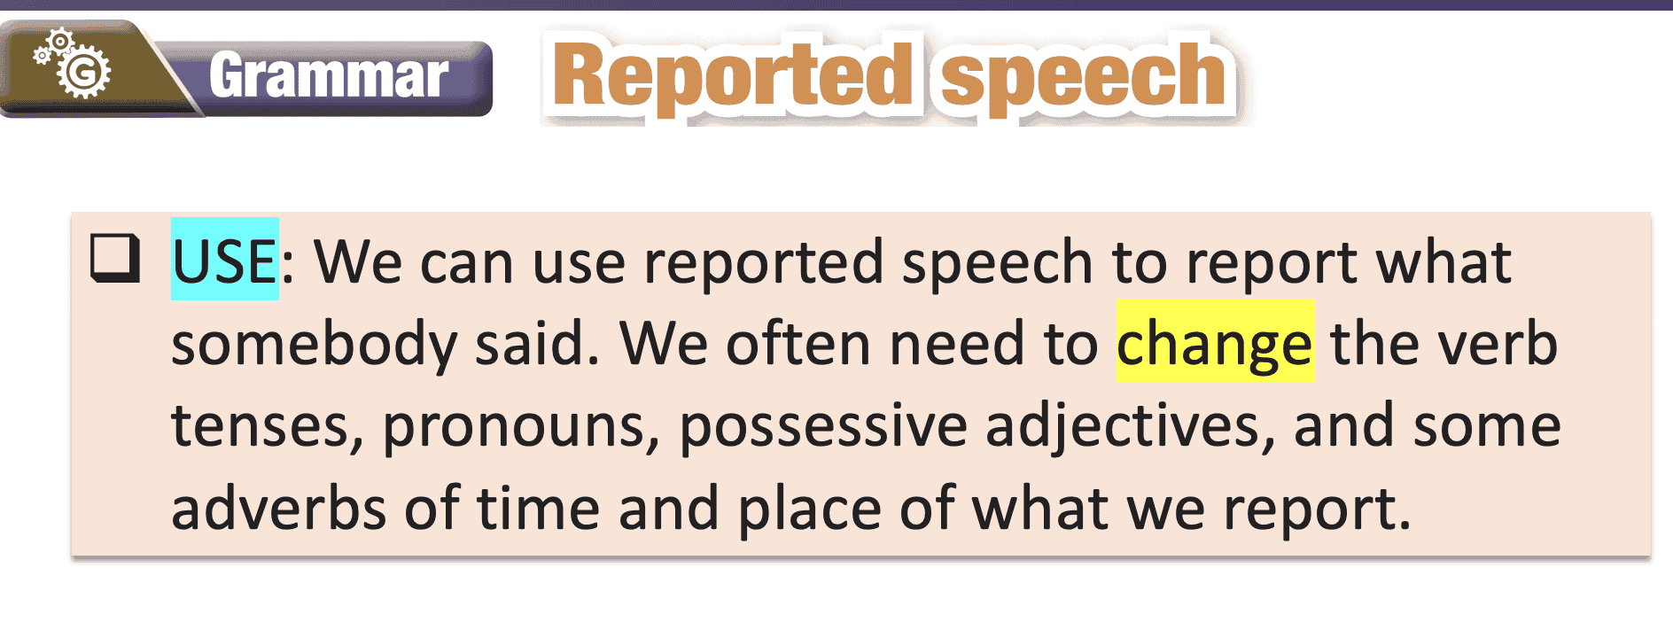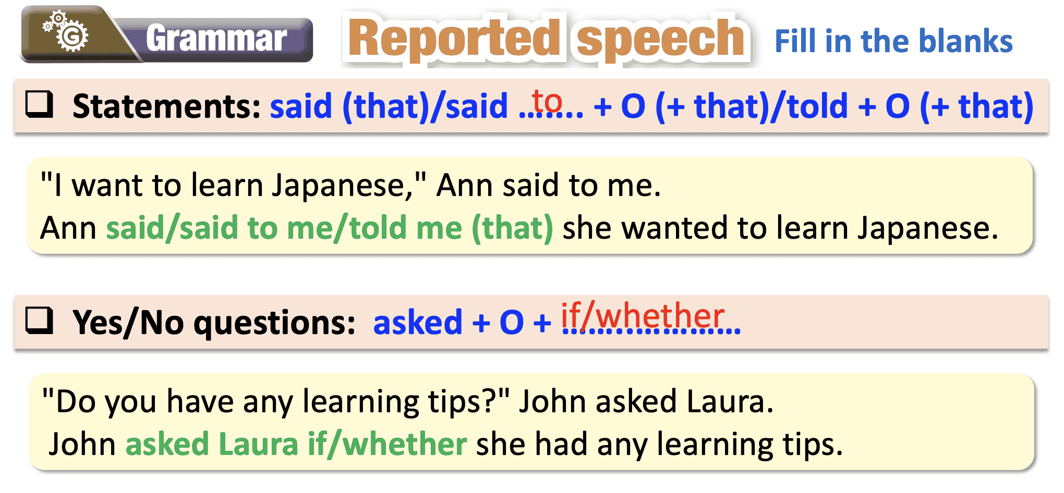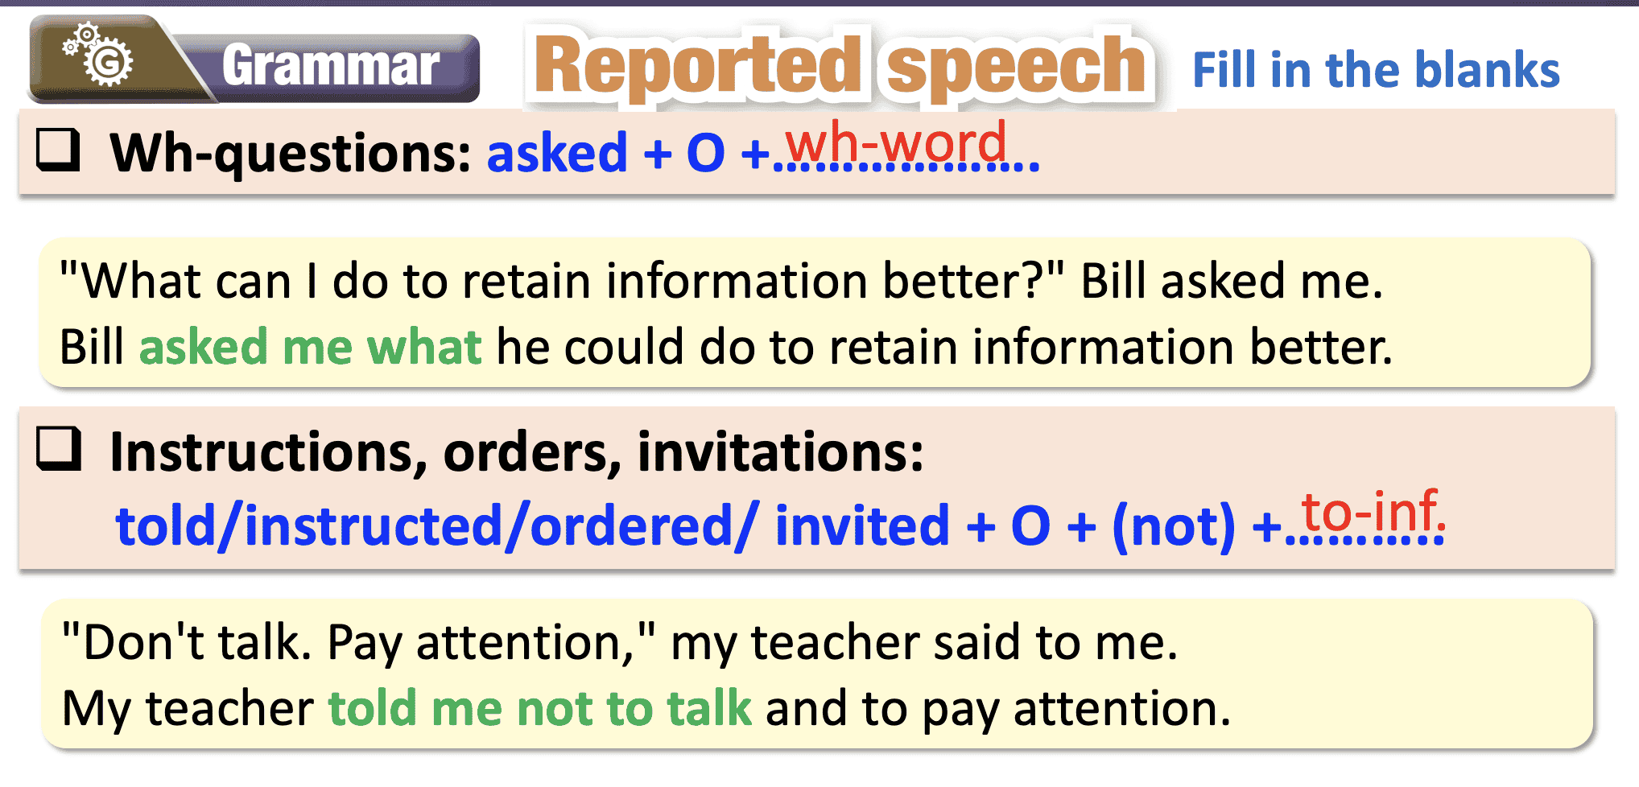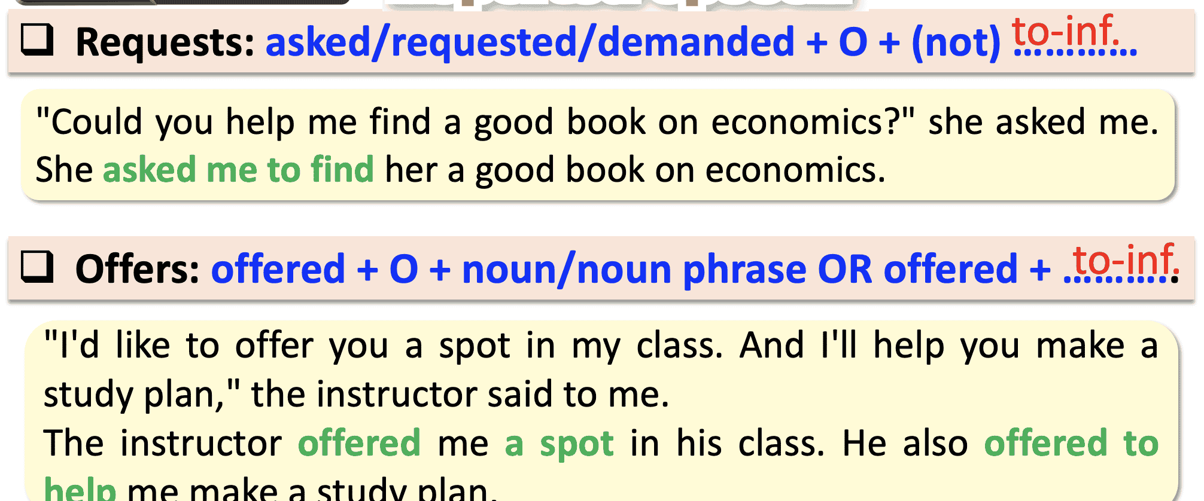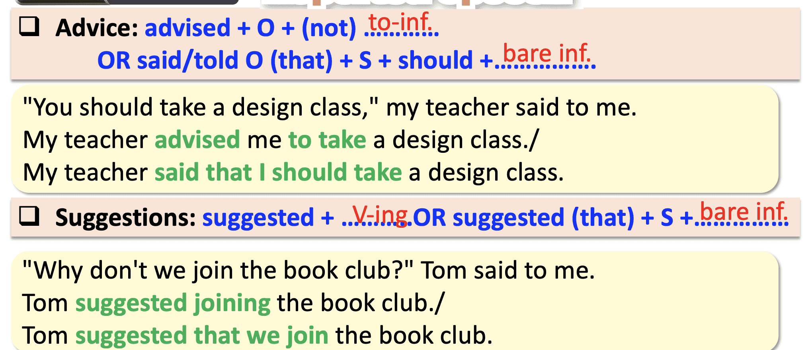

Task b: Listen and check. Listen again and repeat.
- Play audio. Ask students to listen and check their answers. | - Listen and check.
- Play audio again. Ask students to listen again and repeat. | - Listen and repeat.
SCRIPT: CD1-Track 72  M: Experiment with new ways of learning and don't be afraid to make mistakes.  G: He told me to experiment with new ways of learning and not to be afraid to make mistakes | Answer Keys:  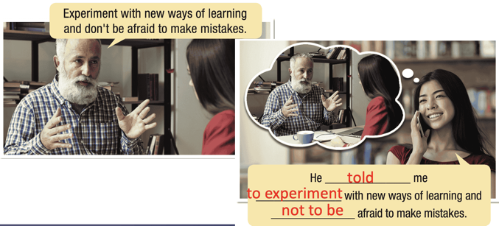

2. Practice (15’)
a. Objectives: To help Ss practice the use of “reported speech”.
b. Content: Tasks c and d.
c. Expected outcomes: Ss can understand and apply the formula to the exercises.
d. Organization:
Teacher’s activities | Students’ activities
Task c: Fill in the blanks to report what these people said.
- Demonstrate the activity using the example. | - Listen to the instructions.
- Ask Ss to read the sentences. | - Read the sentences.
- Ask Ss to fill in the blanks to report what the people said. | - Complete the task.
- Have pairs check each other's work. | - Compare the answers with a partner.
- Pick some Ss to share their answers with the class. | - Share the answers.
- Check and correct Ss’ answers. | - Correct the answers.
Answer Keys:
1. advised Sarah to watch/said (that) Sarah should watch 2. told/ordered/instructed him to run
3. offered me the role
4. asked Harry and Jessica to practice
5. told/ordered/instructed me to read – myself
Task d: Choose the best sentence for the direct speech.
- Demonstrate the activity using the example. | - Listen to the instructions.
- Ask Ss to read the sentences. | - Read the sentences
- Ask Ss to choose the best sentence for the direct speech. | - Choose the best sentence for the direct speech.
- Have pairs check each other's work. | - Check the answers with a partner.
- Ask some Ss to share their answers with the class. | - Share the answers.
- Check Ss’ answers. | - Correct the answers.
Answer Keys:
1. C
2. B
3. A
4. B
3. Production (5’)
a. Objectives: To help Ss produce sentences using “reported speech”.
b. Content: Different methods to study English.
c. Expected outcomes: Ss can give instructions, orders, and advice, make requests, and make offers, then report them to the other group members.
d. Organization

Teacher’s activities | Students’ activities
Task e. In groups of three: Take turns giving instructions, orders, and advice, making requests, and making offers, then report them to the other group members.
- Divide the class into groups of three. | - Work in groups.
- Ask students to take turns giving instructions, orders, and advice, making requests, and making offers. | - Complete the task.
- Ask Ss to report the direct speech to the other group members. | - Report the direct speech to the other group members.
- Have some groups demonstrate the activity in front of the class. | - Share the ideas with the class.
Suggested answers:
1. A: You should practice writing more often.
B: OK.
B: He advised me to practice writing more often. C: OK.
2. A: Run ten kilometers!
B: OK.
B: He told me to run ten kilometers.
C: Oh, no.

C. Consolidation and homework assignments (5’)
- Change the “Direct Speech” to “Reported speech”
1. I want to learn how to manage my time better,” Ann said to me.
=>Ann………………
2.“Do you have any learning tips?” Dan asked Laura.
=>Dan………………
3. I think you should take a class,” Jane said to Tom.
=>Jane………………
Suggested answers:
1. I want to learn how to manage my time better,” Ann said to me.
=>Ann said/said to me/told me (that) she wanted to learn how to manage her time better.
2.“Do you have any learning tips?” Dan asked Laura.
=> Dan asked Laura if/whether she had any learning tips.
3. I think you should take a class,” Jane said to Tom.
=> Jane advised Tom to take a class./Jane said that Tom should take a class.

- Review “reported speech”
- Make sentences using “reported speech” in SB.
- Prepare for the next lesson (Pronunciation & Speaking - pages 56 & 57 - SB).
- Play the consolidation games on www.eduhome.com.vn

5. Reflection
a. What I liked most about this lesson today:
…………………………………………………………………………………………
b. What I learned from this lesson today:
…………………………………………………………………………………………
c. What I should improve for this lesson next time:
…………………………………………………………………………………………

