School: Tran Phu high school | Week: 15  Date: 13/12/24
Class: 12a6 | Period: 43

UNIT 5: Lifelong Learning
Lesson 2.1: Vocabulary and Listening (Pages 54 & 55)

1. Objectives
By the end of this lesson, students will be able to…
1.1. Language knowledge/ skills
- Practice and learn vocabulary related to lifelong learning
- Practice listening for gist and specific information
- Practice functional English (Summarizing what you’ve heard)
1.2. Competences
- improve Ss’ communication, collaboration, analytical, and critical thinking skills.
1.3. Attributes
- cultivate a heightened curiosity for diverse learning methodologies.

2. Teaching aids and materials
- Teacher’s aids: Student’s book and Teacher’s book, class CDs, DCR– Phần mềm tương tác trực quan, DHA – Ứng dụng trò chơi tương tác, projector / interactive whiteboard /TV (if any), PowerPoint slides.
- Students’ aids: Student’s book, Workbook, Notebook.
3. Assessment Evidence
Performance Tasks | Performance Products | Assessment Tools
- Match the words with the pictures | - Ss’ answers. | - Observation/feedback.
- Talk about common learning aids and resources | - Ss’ answers. | - Observation/feedback.
- Use the new words to talk about your learning habits. | - Ss’ answers. | - Observation/feedback.
- Draw lines to predict which piece of information (1–5) will be (A) instructed, (B) advised, (C) offered, (D) ordered, or (E) requested. | - Ss’ answers. | - Observation/feedback.
- Listen and number the boxes to match the reported verbs with the information. | - Ss’ answers. | - Observation/feedback.
- Read the Conversation Skill box, then listen and repeat. | - Ss’ answers. | - Observation/feedback
- Listen to the conversation again and number the phrases in the correct order. | - Ss’ answers. | - Observation/feedback.
- Talk about whether you are using any of the strategies the teacher mentioned and what tips you will use in the future.

4. Procedures
A. Warm-up: 5 minutes
a. Objectives: to introduce the topic.
b. Content: Let’s talk.
c. Expected outcomes: Ss can talk about tools that these people often use to learn.
d. Organization

Teacher’s activities | Students’ activities
Let’s talk: Look at the title of the unit and the picture. Answer these questions:
1. What tools are these people using to learn? 2. What other tools can help people learn?
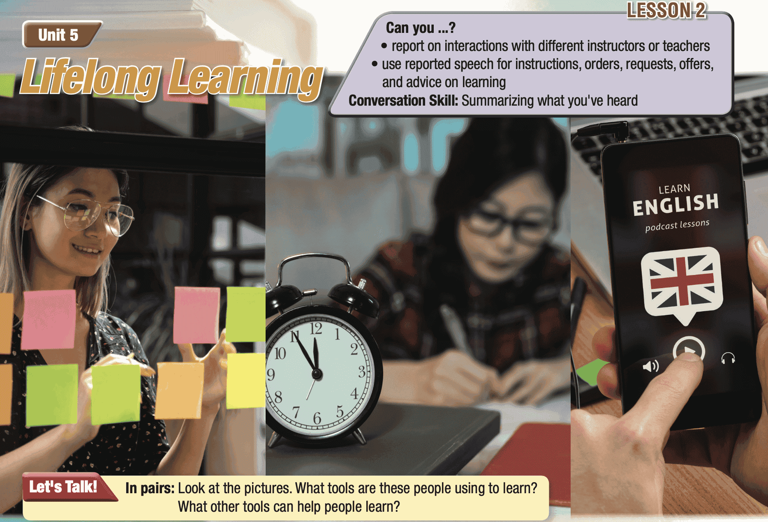
- Ask Ss to work in pairs, look at the title and the picture, and answer the questions (using the DCR/ PPTs slides). | - Work in pairs, look at the title and the picture and answer the questions
- Call some pairs to give their answers. | - Read the answers out loud.
- Give feedback. | - Share/exchange the answers with the class.
Suggested answers
1. Tools the people are using: sticky notes, using a timer/ taking breaks, (language) apps 2. Other learning tools: videos/movies, flashcards, games, online classes

B. New Lesson (35’)
1. Pre-listening (Vocabulary - 15’)
a. Objectives: To help Ss improve their collocations/ new words related to lifelong learning.
b. Content: tasks a, b and c
c. Expected outcomes: Ss can learn some new collocations/ new words related to lifelong learning
d. Organization

Teacher’s activities | Students’ activities
Task a: Read the words and definitions, then fill in the blanks. Listen and repeat
CD1- Track 69
- Demonstrate the activity using the example. | - Watch the demonstration.
- Ask Ss to read the words and definitions, then fill in the blanks. | - Read the words and definitions, then fill in the blanks.
- Divide the class into pairs and have them check their answers with their partners. | - Check the answers with a partner.
- Check Ss’ answers around the class. | - Listen to feedback.
- Play audio. Ask Ss to listen and repeat. | - Listen and repeat.
SCRIPT  CD1-Track 69  1. M: reward  2. M: growth mindset  3. M: reinforce  4. M: aid  5. M: audio  6. M: visual  7. M: retain  8. M: discouraged  9. M: tutorial | Answer Keys:  1. reward  2. growth mindset  3. reinforce  4. aid  5. audio  6. visual  7. retain  8. discouraged  9. tutorial
Task b. What are some common learning aids and resources? Add words to the box.
- Demonstrate the activity. | - Listen to the instructions.
- Ask students to add other common learning aids and resources to the box. | - Add other common learning aids and resources to the box.
- Divide the class into pairs and have them check their answers with their partners. | - Check their answers with partners.
- Give feedback | - Listen to feedback
Suggested answers:
tutorials, tests, books, CDs, presentations, videos, games, maps
Task c: In pairs: Use the new words to talk about your learning habits.
- Explain and model the activity. | - Listen to the instructions.
- Ask Ss to work in pairs to talk about their learning habits using the new words. | - Work in pairs to share the ideas.
- Check Ss’ answers around the class. | - Listen to feedback.
- Pick some Ss to share their ideas. | - Share the ideas with the whole class.
New words:  1. reward  2. growth mindset  3. reinforce  4. aid  5. audio  6. visual  7. retain  8. discouraged  9. tutorial | Suggested answers:  - I reward myself with a treat after studying.  - With a growth mindset, students can regard mistakes as valuable learning experiences.  - I reinforce my learning by practicing daily.  - Flashcards aid in memorizing new words.  - I use audio lessons to improve my listening skills.  - I watch visual tutorials to understand better.  - Reviewing notes helps me retain information.  - I feel discouraged when I don’t understand, but I keep trying.  - I follow an online tutorial to learn new skills

2. While - listening (Listening- 15’)
a. Objectives: To help Ss listen for gist and details.
b. Content: Tasks a, b, c, d and e
c. Expected outcomes: Ss can listen to different people who talk about their days.
d. Organization:
Teacher’s activities | Students’ activities
Task a: You will hear different people talking about their days. Draw lines to predict which piece of information (1–5) will be (A) instructed, (B) advised, (C) offered, (D) ordered, or (E) requested.
- Divide the class into pairs. | - Work in pairs
- Have pairs read the question. | - Work in pairs
- Have pairs discuss and predict which piece of information will be instructed, advised, offered, requested, or ordered and draw lines. | - listen and circle the correct answer.
- Ask Ss to compare the answer with a partner. | - Compare the answer with a partner
- Check the answers. | -Correct the answers.
Suggested answer:
A: instructed 5: how to retain information
Task b: Now, listen and number the boxes to match the reported verbs with the information. How many did you guess correctly?
A: instructed
B: advised
C: offered
D: ordered
E: requested

1: teach outdoor skills
2: how to improve cooking
4: do exercise
3: prepare a training course
5: how to retain information
CD1- Track 70
- Ask Ss to read the questions, underline the key words | - Read the questions, underline the key words
- Play audio. Have students listen and number the boxes. | - Listen and number the boxes.
- Ask Ss to compare the answer with a partner and show the evidence to justify the answer. | - Compare the answer with a partner and show the evidence to justify the answer.
- Check the answers. | -Correct the answers.
Answer key:
A.5
B.2
C.1
D.4
E.3
ANSWERS | EVIDENCE
A: instructed.5: how to retain information | 1.  Ashley: It was nice. Mr. Smith gave me some instructions about how to retain information better.  Mom: Great. What did he say?  Ashley: He told me to write things down on paper.  Mom: That's always a good idea.  Ashley: Yeah. He also instructed me to create visual and audio aids to help me.  Mom: You mean making recordings of yourself  speaking or making mind maps?  Ashley: Yeah, exactly.
B: advised .2: how to improve cooking | 2.Mary: Yeah, I'm learning more every single day. Yesterday, my instructor advised me to use more salt and to let things cook for longer.  Peter: So, you're saying that you didn't use to use much salt?  Mary: No. I wasn’t using enough. I'm getting much better at cooking now, though.
E: requested.3: prepare a training course | 3. Narrator: You will hear a girl talking to her dad about his work.  Sarah: Hey, Dad. How was work?  Dad: It was alright. Today my boss requested me to prepare a training course for new employees. It’ll be a lot of work.  Sarah: But it means he thinks you’re good, right? That’s why he asked you to teach new employees.  Dad: Maybe you’re right.
D: ordered.4: do exercise | 4.  Mark: No. But today, my army instructor told us to run fifteen kilometers.  Sophie: Wow.  Mark: Yeah. He also told me to wear a heavy backpack for complaining.  Sophie: You mean you were the only one that had to wear one?  Mark: Yeah!  Sophie: Haha. That’s pretty funny.  Mark: I didn't feel funny. Anyway, I need to shower!
C: offered .1: teach outdoor skills | 5. Deborah: What did you do?  Kevin: Well, we talked about going camping. He’s interested in that now. So I offered to teach him some outdoor skills.  Deborah: Oh, that's great. You love the outdoors.  Kevin: Yeah. I offered to take him camping next week. I’ll teach him how to make a fire and put up a tent.  Deborah: Lovely.
Task c: Listen again and answer the questions
CD1- Track 70
- Ask Ss to read the questions, underline the key words | - Read the questions, underline the key words
- Play audio. Have students listen and answer the questions. | - Listen and answer the questions.
- Ask Ss to compare the answer with a partner and show the evidence to justify the answer. | - Compare the answer with a partner and show the evidence to justify the answer.
- Check the answers. | -Correct the answers.
Answer key:
1. visual and audio aids
2. use more salt
3. teach them
4. a heavy backpack
5. go camping
ANSWERS | EVIDENCE
1. What did Mr. Smith instruct Ashley to make?  1. visual and audio aids | 1. Ashley: It was nice. Mr. Smith gave me some instructions about how to retain information better.  Mom: Great. What did he say?  Ashley: He told me to write things down on paper.  Mom: That's always a good idea.  Ashley: Yeah. He also instructed me to create visual and audio aids to help me.  Mom: You mean making recordings of yourself  speaking or making mind maps?  Ashley: Yeah, exactly.
2. What was Mary advised to do?  2. use more salt | 2. Mary: Yeah, I'm learning more every single day. Yesterday, my instructor advised me to use more salt and to let things cook for longer.  Peter: So, you're saying that you didn't use to use much salt?  Mary: No. I wasn’t using enough. I'm getting much better at cooking now, though.
3. What will Sarah's dad do with new employees?  3. teach them | 3. Narrator: You will hear a girl talking to her dad about his work.  Sarah: Hey, Dad. How was work?  Dad: It was alright. Today my boss requested me to prepare a training course for new employees. It’ll be a lot of work.  Sarah: But it means he thinks you’re good, right? That’s why he asked you to teach new employees.  Dad: Maybe you’re right
4. What did Mark have to wear earlier in the day?  4. a heavy backpack | 4. Mark: No. But today, my army instructor told us to run fifteen kilometers.  Sophie: Wow.  Mark: Yeah. He also told me to wear a heavy backpack for complaining.  Sophie: You mean you were the only one that had to wear one?  Mark: Yeah!  Sophie: Haha. That’s pretty funny.  Mark: I didn't feel funny. Anyway, I need to shower!
5. What did Kevin say he'd do with his grandson next week  5. go camping | 5. Deborah: What did you do?  Kevin: Well, we talked about going camping. He’s interested in that now. So I offered to teach him some outdoor skills.  Deborah: Oh, that's great. You love the outdoors.  Kevin: Yeah. I offered to take him camping next week. I’ll teach him how to make a fire and put up a tent.  Deborah: Lovely.
SCRIPT:
CD1-Track 70
1. Narrator: You will hear a girl talking to her mother about ways of learning.
Ashley: Hi, Mom. I'm home.
Mom: Welcome home, Ashley. How was your day at school?
Ashley: It was nice. Mr. Smith gave me some instructions about how to retain information better.
Mom: Great. What did he say?
Ashley: He told me to write things down on paper.
Mom: That's always a good idea.
Ashley: Yeah. He also instructed me to create visual and audio aids to help me.
Mom: You mean making recordings of yourself
speaking or making mind maps?
Ashley: Yeah, exactly.
2. Narrator: You will hear a girl talking to her friend about what she's learning.
Peter: Hi, Mary. I haven't seen you in a while.
Mary: Hi, Peter. I've been really busy.
Peter: Nice. What are you busy doing?
Mary: I’m taking an online cooking course.
Peter: Great. Are you learning a lot?
Mary: Yeah, I'm learning more every single day. Yesterday, my instructor advised me to use more salt and to let things cook for longer.
Peter: So, you're saying that you didn't use to use much salt?
Mary: No. I wasn’t using enough. I'm getting much better at cooking now, though.
3. Narrator: You will hear a girl talking to her dad about his work.
Sarah: Hey, Dad. How was work?
Dad: It was alright. Today my boss requested me to
prepare a training course for new employees. It’ll be a lot of work.
Sarah: But it means he thinks you’re good, right? That’s why he asked you to teach new employees.
Dad: Maybe you’re right.
4. Narrator: You will hear a brother talking to his sister about his day.
Mark: That was the hardest day!
Sophie: What happened, Mark? Are you OK?
Mark: I'm just tired. I had army training at university today.
Sophie: It's not usually that difficult, is it?
Mark: No. But today, my army instructor told us to run fifteen kilometers.
Sophie: Wow.
Mark: Yeah. He also told me to wear a heavy backpack for complaining.
Sophie: You mean you were the only one that had to wear one?
Mark: Yeah!
Sophie: Haha. That’s pretty funny.
Mark: I didn't feel funny. Anyway, I need to shower!
5. Narrator: You will hear two neighbors talking outside their homes.
Deborah: Hi, Kevin. How are you?
Kevin: I'm great.
Deborah: Oh. That’s nice.
Kevin: Yeah. I spent the day with my grandson. We had a lot of fun.
Deborah: What did you do?
Kevin: Well, we talked about going camping. He’s interested in that now. So I offered to teach him some outdoor skills.
Deborah: Oh, that's great. You love the outdoors.
Kevin: Yeah. I offered to take him camping next week. I’ll teach him how to make a fire and put up a tent.
Deborah: Lovely.

Teacher’s activities | Students’ activities
Task d. Read the Conversation Skill box, then listen and repeat.
CD1- Track 71
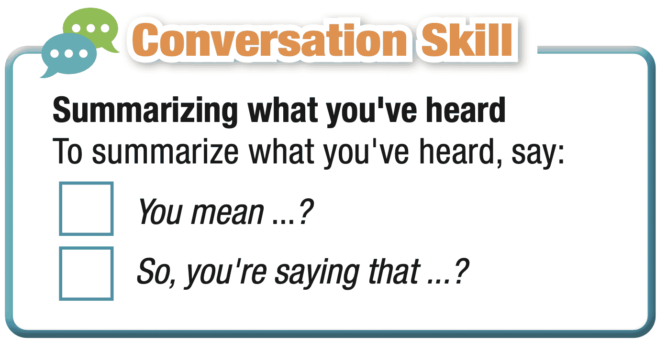
- Have students read the Conversation Skill box. | - Read the Conversation Skill box
- Clarify the use of the conversation skill. | - Listen to instructions.
- Play audio. Have students listen and repeat. | - Listen and repeat.
Script CD1- Track 71
M: You mean ...?
M: So, you're saying that ...?
Task e. Now, listen to the conversation again and number the phrases in the correct order
CD1- Track 70
-Play audio. Have students listen and number the phrases in the correct order. | - Listen and number the phrases in the correct order.
- Check answers as a whole class. | - Correct answers.
Answer key:
1. You mean ...?
2. So, you're saying that ...?
Evidence:
1.
Ashley: Yeah. He also instructed me to create visual and audio aids to help me.
Mom: You mean making recordings of yourself speaking or making mind maps?
2. Mary: Yeah, I'm learning more every single day. Yesterday, my instructor advised me to use more salt and to let things cook for longer.
Peter: So, you're saying that you didn't use to use much salt?
Mary: No. I wasn’t using enough. I'm getting much better at cooking now, though.

3. Post - listening (5’)
a. Objectives: To help Ss practice talking about whether you are using any of the strategies the teacher mentioned. And what tips you will use in the future
b. Content: Task f
c. Expected outcomes: Ss can talk about whether you are using any of the strategies the teacher mentioned. And what tips you will use in the future
d. Organization

Teacher’s activities | Students’ activities
Task f: In pairs: Are you using any of the strategies the teacher mentioned? What tips will you use in the future?
- Divide the class into pairs. | - Work in pairs.
- Ask Ss to discuss the questions. | - Discuss the questions.
- Check Ss’ answers and give feedback. | - Listen to feedback.
Suggested answer:
1. Are you using any of the strategies the teacher mentioned?
Yes, I write things down on paper and create visual and audio aids.
2. What tips will you use in the future?
I will use the tip on how to cook food. I will use more salt and let things cook for longer.

C. Consolidation and homework assignments (5’)
- Speaking: Ask and answer the question below with your partner
What are your favorite learning aids and resources?
Suggested answers:
My favorite learning aids and resources are online courses like Coursera and Khan Academy and educational apps such as Duolingo and Quizlet.
- Vocabulary:
- aid (n)
- audio (adj)
- discouraged (adj)
- growth mindset (n)
- reinforce (v)
- resource (n)
- retain (v)
- reward (v)
- tutorial (n)
- visual (adj)

HOMEWORK:
- Learn vocabulary related to lifelong learning.
- Make sentences using vocabularies in SB.
- Prepare for the next lesson (Grammar - pages 55 & 56 - SB)
- Play the consolidation games on www.eduhome.com.vn
5. Reflection
a. What I liked most about this lesson today:
…………………………………………………………………………………………
b. What I learned from this lesson today:
…………………………………………………………………………………………
c. What I should improve for this lesson next time:
…………………………………………………………………………………………

