School: Tran Phu high school | Week: 15  Date: 9/12/24
Class: 12a6 | Period: 41

UNIT 5: Lifelong Learning
Lesson 1.2: Grammar (Pages 51 & 52)

1. Objectives
By the end of this lesson, students will be able to…
1.1. Language knowledge/ skills
- practice and use simple, compound, and complex sentences to talk about skills they want to learn.
- improve Grammar and Speaking.
1.2. Competences
- improve Ss’ communication, collaboration, analytical, and critical thinking skills.
1.3. Attributes
- cultivate a heightened curiosity for diverse learning methodologies.

2. Teaching aids and materials
- Teacher’s aids: Student’s book and Teacher’s book, class CDs, DCR– Phần mềm tương tác trực quan, DHA – Ứng dụng trò chơi tương tác, projector / interactive whiteboard /TV (if any), PowerPoint slides.
- Students’ aids: Student’s book, Workbook, Notebook.
3. Assessment Evidence
Performance Tasks | Performance Products | Assessment Tools
- Read about simple, compound, and complex sentences, and fill in the blanks. | - Ss’ answers. | - Observation.
- Listen, check, and repeat. | - Ss’ answers. | - Observation/feedback.
- Choose the correct conjunctions. | - Ss’ answers. | - Observation/feedback.
- Combine the sentences using the conjunctions in the box. | - Ss’ answers. | - Observation/feedback.
- Use the prompts to make compound or complex sentences about lifelong learning. | - Ss’ answers. | - Observation/feedback

4. Procedures
A. Warm-up: 5 minutes
a. Objectives: To introduce the grammar point: simple, compound, and complex sentences
b. Content: Matching sentence endings.
c. Expected outcomes: Ss can get to know simple, compound, and complex sentences
d. Organization

Teacher’s activities | Students’ activities
Competition time:
- Ask Ss to form groups of 5. | - Work in groups.
- Give Ss instructions and one example. | - Follow the instructions.
- Give Ss some time to match sentence beginnings and endings. | - Match sentence beginnings and endings in a team/group.
- Give feedback. | - Listen to feedback.
Questions:  Sentence beginnings Sentence endings  1. We wanted to go to the show, a. so we don’t get there late.  2. I often make omelettes b. or at the football match?  3. Shall we go to the cinema, c. because he laughs in his sleep.  4. Burgers are very tasty d. and watch that film you were talking about?  5. My neighbours are friendly, e. because they’re quick and easy.  6. Do you know if he’s at home, f. although they are not very healthy.  7. Pick me up early, please, g. but they’re noisy.  8. We know he has great dreams h. but there weren’t any seats left. | Suggested answers  1. h.We wanted to go to the show, but there weren’t any seats left.  2.e. I often make omelettes because they’re quick and easy.  3. d.Shall we go to the cinema, and watch that film you were talking about?  4. f. Burgers are very tasty although they are not very healthy.  5. g.My neighbours are friendly, but they’re noisy.  6. b.Do you know if he’s at home, or at the football match?  7. a.Pick me up early, please, so we don’t get there late.  8. c. We know he has great dreams because he laughs in his sleep.

B. New Lesson (35’)
1. Presentation (15’)
a. Objectives: To help Ss understand how to use simple, compound, and complex sentences
b. Content: Tasks a and b.
c. Expected outcomes: Ss can make sentences using simple, compound, and complex sentences
d. Organization

Teacher’s activities | Students’ activities
Task a: Read about simple, compound, and complex sentences, then fill in the blanks.
- Ask Ss to work individually and complete the task (using the DCR/ PPTs slides). | - Fill in the blanks.
- Ask Ss to compare the answers with a partner. | - Compare the answers with a partner.
- Check Ss’ answers around the class. | - Check the answers
- Explain the use of “simple, compound, and complex sentences” (using the DCR/ PPTs slides. | - Listen to the teacher’s instructions and take notes.
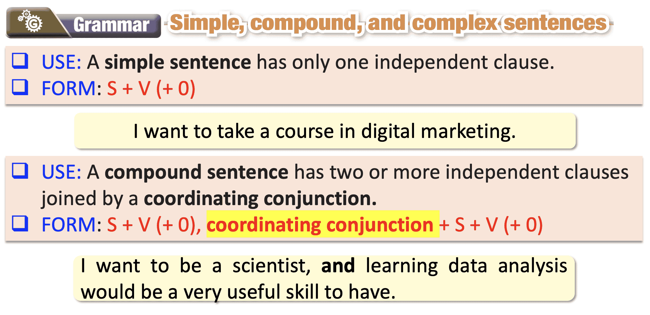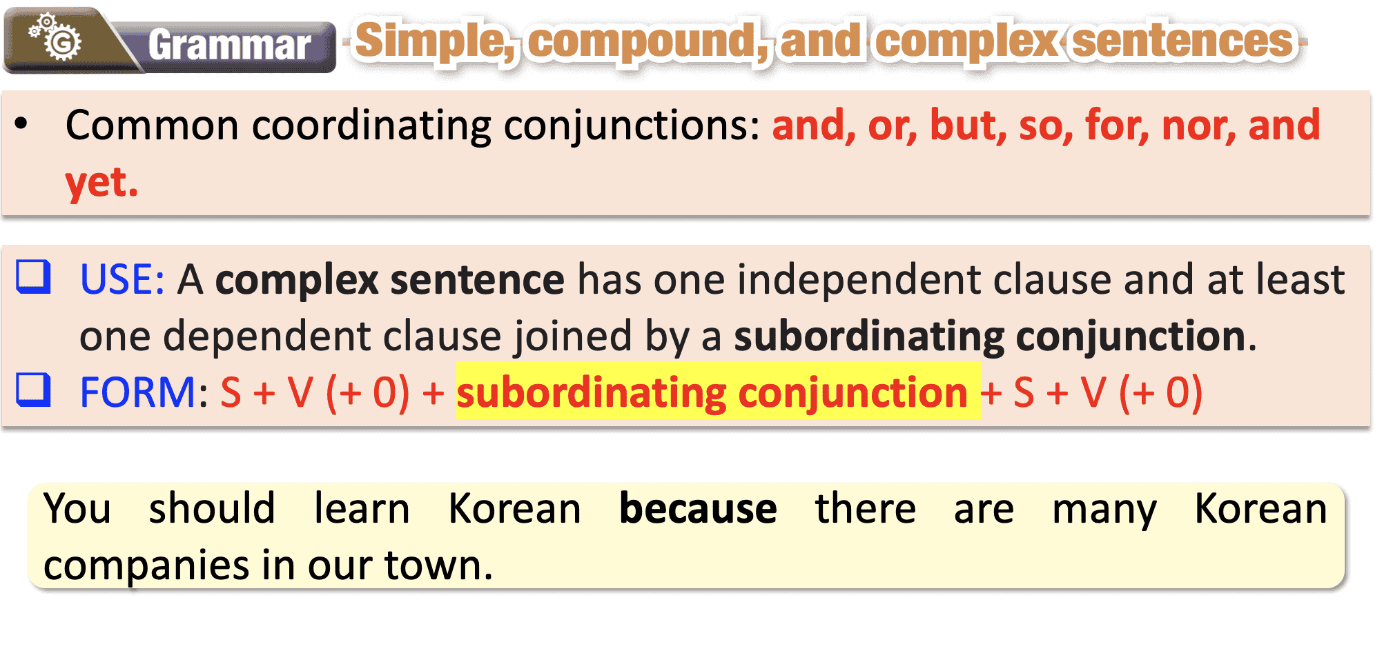
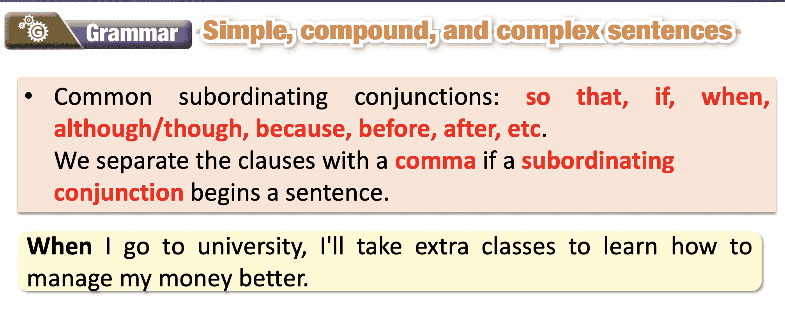
Task b: Listen and check. Listen again and repeat.
- Play audio. Ask students to listen and check their answers. | - Listen and check.
Answer Keys:
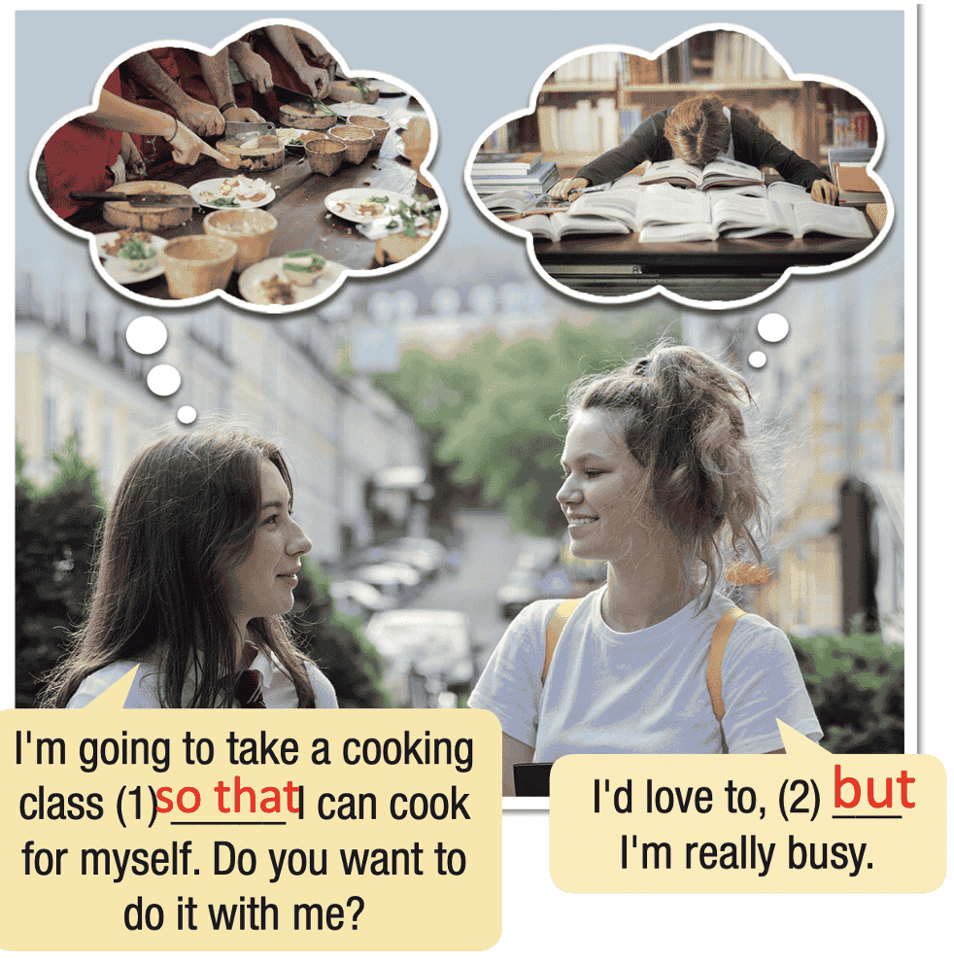

- Play audio again. Ask students to listen again and repeat. | - Listen and repeat.
Script-Track 65
G1: I'm going to take a cooking class so that I can cook for myself. Do you want to do it with me?
G2: I'd love to, but I'm really busy.

2. Practice (15’)
a. Objectives: To help Ss practice the use of “simple, compound, and complex sentences”
b. Content: Tasks c and d.
c. Expected outcomes: Ss can practice the use of “simple, compound, and complex sentences” and when to use them.
d. Organization:
Teacher’s activities | Students’ activities
Task c: Choose the correct conjunctions.
- Demonstrate the activity using the example. | - Listen to the instructions
- Ask students to read the sentences. | - Read the sentences.
- Ask students to choose the correct conjunctions. | - Choose the correct conjunctions.
- Have pairs check each other's work. | - Compare the answers with a partner.
- Pick some Ss to read the sentence(s) out loud. | - Read the sentences out loud.
- Check and correct Ss’ answers. | - Correct the answers
Answer Keys:
1. A
2. C
3. B
4. C
5. A
6. C
7. A
8. B
Task d: Combine the sentences using the conjunctions in the box.
- Demonstrate the activity using the example. | - Follow the instructions.
- Ask students to read the sentences. | - Read the sentences.
- Ask students to combine the sentences using the conjunctions in the box. | - Combine the sentences using the conjunctions in the box.
- Have pairs check each other's work. | - Check the answers with a partner.
- Ask some students to share their answers with the class. | - Read the sentences out loud.
- Check Ss’ answers. | - Correct the answers.
. | Answer Keys:  1. Tom wants to learn many skills, but he doesn't have enough self-discipline.  2. You'll get a lot of satisfaction from learning something you love, and you'll meet new friends.  3. We should try hard to acquire these in-demand skills because they'll be really useful.  4. I want to learn tennis so that I can keep fit.  5. If our company offers an online course in data analysis, I'll take it.  6. Before you sign up for any courses, it's always a good idea to read the reviews

3. Production (5’)
a. Objectives: To help Ss produce sentences using “simple, compound, and complex sentences”
b. Content: Lifelong learning.
c. Expected outcomes: Ss can make compound or complex sentences about lifelong learning.
d. Organization

Teacher’s activities | Students’ activities
Task e. In pairs: Use the prompts to make compound or complex sentences about lifelong learning.
- Divide the class into pairs. | - Work in pairs
- Ask students to use the prompts to make compound or complex sentences about lifelong learning. | - Use the prompts to make compound or complex sentences about lifelong learning.
- Have some students demonstrate the activity in front of the class. | - Watch the demonstration.
- Monitor the class and help them if necessary. | - Work in pairs to share the ideas/ sentences.
- Ask some Ss to share their ideas. | - Share the ideas with the class.
Suggested answers:
1. After high school, I want to learn how to cook.
2. Before going to university, I need to decide what I want to study.
3. Though I'm not good at it, I love dancing.
4. When I finish school, I will get a part-time job.
5. I want to study German, but I don't have a lot of free time.
6. I want to take extra math classes so that I can improve.
7. I'm taking a cooking class because it's my passion.
8. I'm going to learn French if I can find an instructor.

C. Consolidation and homework assignments (5’)
- Speaking: Use the prompts to make compound or complex sentences. Share your sentences with the class.
While I was riding my bike home, ……………
Although I feel sick, ……………………………..
Suggested answers:
While I was riding my bike home, I saw a beautiful garden.
Although I feel tired, I still have to attend an important meeting later this afternoon.
- Review simple, compound, and complex sentences to talk about skills they want to learn.
- Make sentences using simple, compound, and complex sentences in SB.
- Prepare for the next lesson (Pronunciation & Speaking - pages 52 & 53 - SB).
- Play the consolidation games on www.eduhome.com.vn

5. Reflection
a. What I liked most about this lesson today:
…………………………………………………………………………………………
b. What I learned from this lesson today:
…………………………………………………………………………………………
c. What I should improve for this lesson next time:
…………………………………………………………………………………………

