School: Tran Phu high school | Week: 14  Date:6/12/24
Class: 12a6 | Period: 40…………………………….

UNIT 5: Lifelong Learning
Lesson 1.1: Vocabulary and Reading (Pages 50 & 51)

1. Objectives
By the end of this lesson, students will be able to…
1.1. Language knowledge/ skills
- practice and learn vocabulary related to lifelong learning.
- practice reading for main ideas and specific information
1.2. Competences
- improve Ss’ communication, collaboration, analytical, and critical thinking skills.
1.3. Attributes
- cultivate a heightened curiosity for diverse learning methodologies.

2. Teaching aids and materials
- Teacher’s aids: Student’s book and Teacher’s book, class CDs, DCR– Phần mềm tương tác trực quan, DHA – Ứng dụng trò chơi tương tác, projector / interactive whiteboard /TV (if any), PowerPoint slides.
- Students’ aids: Student’s book, Workbook, Notebook.
3. Assessment Evidence
Performance Tasks | Performance Products | Assessment Tools
- Match words to the definitions. | - Ss’ answers. | - Observation/feedback.
-Talk about what skills/qualities people need to study/work effectively | - Ss’ answers. | - Observation/feedback.
- Read the article about lifelong learning and choose the best title for the article. | - Ss’ answers. | - Observation/feedback.
- Read and choose the correct answers. | - Ss’ answers. | - Observation/feedback.
- Listen and read. | - Ss’ answers. | - Observation/feedback
- Talk about lifelong learners and what people in your country usually do to learn after finishing school | - Ss’ answers. | - Observation/feedback.

4. Procedures
A. Warm-up: 5 minutes
a. Objectives: to introduce the topic.
b. Content: Let’s talk.
c. Expected outcomes: Ss can talk about lifelong learners and why some people continue to learn after finishing school
d. Organization

Teacher’s activities | Students’ activities
Let’s talk: Look at the title of the unit and the picture. Answer these questions:
1. What are these people learning?
2. Why do some people continue to learn after finishing school?
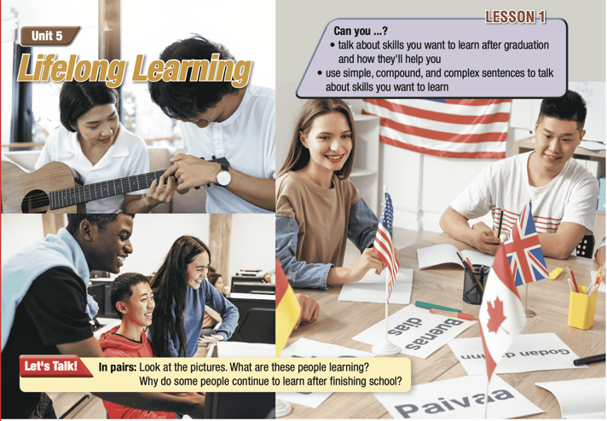
- Ask Ss to work in pairs, look at the title and the picture, and answer the questions (using the DCR/ PPTs slides). | - Work in pairs, look at the title and the picture and answer the questions.
- Call some pairs to give their answers. | - Read the answers out loud.
- Give feedback. | - Share/exchange the answers with the class.
Suggested answers
1. They're learning how to play the guitar, how to use a computer and languages.
2. Reasons people continue to learn: for a hobby, to help with their jobs, to keep up with technology, to move/travel to a new country.

B. New Lesson (35’)
1. Pre-reading (Vocabulary - 15’)
a. Objectives: To help Ss improve vocabulary related to lifelong learning.
b. Content: tasks a, b and c.
c. Expected outcomes: Ss can learn some new words related to lifelong learning.
d. Organization

Teacher’s activities | Students’ activities
Task a: Read the sentences and match the underlined words with the definitions.
Listen and repeat. CD1-Track 63
- Demonstrate the activity using the example. | -Watch the demonstration.
- Ask Ss to work by themselves and match the words (using the DCR/ PPTs slides). | - Match the words to the definitions.
- Ask Ss to compare the answers with a partner. | - Check the answers with a partner.
- Check Ss’ answers around the class. | - Listen to feedback.
- Play audio. Ask Ss to listen and repeat. | - Listen and repeat.
Answer Keys:
1. acquire
2. analysis
3. in-demand
4. satisfaction
5. self-discipline
6. passion
7. voluntary
8. competitive
Task b: What skills/qualities do people need to study/work effectively? Use words from Task a or your own ideas.
- Explain and model the activity. | - Listen to the instructions.
- Ask Ss to use words from Task a or their own ideas. | - Use words from Task a or their own ideas.
- Divide the class into pairs and have them check their answers with their partners. | - Check answers with partners.
-Pick some Ss to share their ideas and give feedback. | - Share the ideas with the whole class.
Suggested answers:
self-discipline, passion, research skills, flexibility, creativity, problem-solving, communication, time management
Task c: What is your passion? Use words from Task b to say what you will need to follow it.
- Explain and model the activity. | - Listen to the instructions.
- Divide the class into pairs. | - Work in pairs.
- Ask students to talk about their passion and what they need to follow it using words from Task b. | - Talk about their passion and what they need to follow it using words from Task b.
-Pick some Ss to share their ideas and give feedback. | - Share the ideas with the whole class.
Suggested answers:
-My passion is learning languages. I'll need good self-discipline to keep learning
-My passion is cooking. I will need self-discipline to practice every day, research skills to find new recipes, and creativity to make delicious dishes.

2. While - reading (Reading – 15’)
a. Objectives: To help Ss practice reading for details.
b. Content: Tasks a, b, and c.
c. Expected outcomes: Ss can read for specific information and know about lifelong learners.
d. Organization:

Teacher’s activities | Students’ activities
Task a: Read the article about lifelong learning and choose the best title for the article.
1. What's lifelong learning, and how do you benefit from it?
2. What's lifelong learning, and how to encourage it?
- Ask Ss to read the questions and underline the key words | - Read the questions and underline the key words.
- Ask Ss to read the article and choose the correct answer. | - Read the article, underline the evidence, and circle the correct answer.
- Ask Ss to compare the answer with a partner and show the evidence to justify the answer. | - Compare the answer with a partner and show the evidence to justify the answer.
-Check the answers. | -Correct the answers.
Answer Key: 1. What's lifelong learning, and how do you benefit from it?
Evidence:
"Lifelong learning" means continuing to acquire new knowledge and skills throughout your life. ……
First of all, lifelong learning can offer benefits for your professional development. ……
Another benefit is personal development, like taking a yoga class or learning how to cook a new dish you like. ……
Lifelong learning also helps your social life. ……
Task b: Now, read and choose the correct answers.
- Ask Ss to read the questions and underline the key words | - Read the questions and underline the key words.
-Ask students to read the article again and choose the correct answers. | - Read the article again and choose the  correct answers.
- Ask Ss to check the answers with a partner. | - Compare the answer with a partner and show the evidence to justify the answer.
- Check Ss’ answers | - Correct the answers.
Answer Keys
1. A
2. C
3. C
4. B
5. B
SENTENCES | EVIDENCE
1. Which of the following is NOT mentioned as a characteristic of lifelong learning?  A. It's the same as formal education.  B. It's voluntary.  C. It requires learners to be motivated | "Lifelong learning" means continuing to acquire new knowledge and skills throughout your life. It is voluntary but often requires lots of self-discipline and motivation to continue.
2. What is different about learning new skills today?  A. It's mostly online.  B. Learners prefer to have virtual classes.  C. Technology makes it easier. | It can occur in many ways, for example, by joining a local course, taking virtual lessons online, or reading books. These days, it has become easier than ever to learn new skills and improve your professional, personal, and social life thanks to new technology.
3. The word competitive in paragraph 2 is closest in meaning to ___.  A. aggressive  B. cheap  C. valuable | Learning new things, especially high-tech skills like computer programming or data analysis will also help you be more competitive in the job market because having a wide range of abilities will make you more attractive to employers.
4. How can lifelong learning help your social life?  A. You learn to be a better friend.  B. You can meet people with similar interests.  C. You can become more interesting. | Lifelong learning also helps your social life. If you join a class, you will likely meet people who share the same interests. As you learn and gain skills, and make new friends, you will likely become more confident in yourself, which can lead to greater satisfaction and happiness.
5. Which of the following can be inferred from the passage?  A. Online learning is better.  B. Learning helps your career and happiness.  C. Learning is very difficult. | Overall, lifelong learning is an important part of personal and professional development. It is an enjoyable process that can bring many opportunities to help you improve your work life, meet new friends, and achieve personal satisfaction.
Teacher’s activities | Students’ activities
Task c: Listen and read.
CD1- Track 64
- Play the CD and ask Ss to listen and read along. | - Listen and read along.
- Correct their pronunciation if necessary. | - Listen to the feedback

3. Post-reading (5’)
a. Objectives: To help Ss talk about lifelong learners and what people in their country usually do to learn after finishing school
b. Content: Tasks d
c. Expected outcomes: Ss can talk about lifelong learners and what people in their country usually do to learn after finishing school
d. Organization

Teacher’s activities | Students’ activities
Task d: In pairs: Do you know someone who's a lifelong learner? What do people in your country usually learn after finishing school?
- Divide the class into pairs. | - Work in pairs.
- Ask Ss to discuss the questions. | - Discuss the questions.
- Check Ss’ answers and give feedback. | - Listen to feedback.
Suggested answer:
1. Do you know someone who's a lifelong learner?
Yes, at the age of 45, my mother is a lifelong learner who continues to study English.

2. What do people in your country usually learn after finishing school?
Many people in my country continue learning after school, pursuing higher education, vocational training, or engaging in lifelong learning through various means such as workshops, online courses, and community education programs.

C. Consolidation and homework assignments (5’)
- Speaking: Ask and answer the question below with your partner about lifelong learning:
What are the benefits of lifelong learning?
Suggested answers:
Lifelong learning helps you stay competitive in your job, keeps your skills updated, and can lead to better job opportunities. It also makes you more knowledgeable and adaptable to changes in your career and personal life.
- Vocabulary:
- acquire (v)
- analysis (n)
- competitive (adj)
- in demand (idm)
- passion (n)
- satisfaction (n)
- self-discipline (n)
- voluntary (adj)
HOMEWORK:
- Learn vocabulary related to lifelong learning.
- Make sentences using vocabularies in SB.
- Prepare for the next lesson (Grammar - pages 51 & 52 - SB).
- Play the consolidation games on www.eduhome.com.vn
5. Reflection
a. What I liked most about this lesson today:
…………………………………………………………………………………………
b. What I learned from this lesson today:
…………………………………………………………………………………………
c. What I should improve for this lesson next time:
…………………………………………………………………………………………

