School: Tran Phu high school | Week: 13  Date: 25/11/24
Class: 12a6 | Period: 35

UNIT 4: GRADUATION AND CHOOSING A CAREER
Lesson 2.1: Vocabulary and Reading (Pages 43 & 44)

1. Objectives
By the end of this lesson, students will be able to give advice on different careers.
1.1. Language knowledge/ skills
- learn and use words related to different careers.
- practice reading for the specific information.
- learn how to write an email.
- improve reading skills.
1.2. Competences
- improve Ss’ communication, collaboration, analytical, and critical thinking skills.
1.3. Attributes
- express your opinions about different careers.
2. Teaching aids and materials
- Teacher’s aids: Student’s book and Teacher’s book, class CDs, DCR– Phần mềm tương tác trực quan, DHA – Ứng dụng trò chơi tương tác, projector / interactive whiteboard /TV (if any), PowerPoint slides.
- Students’ aids: Student’s book, Workbook, Notebook.
3. Assessment Evidence
Performance Tasks | Performance Products | Assessment Tools
- Match the bold words with the correct definitions.  - Talk about the careers or future careers of your family and friends.  - Read and answer the questions | - Ss’ answers.  - Ss’ answers/presentation.  - Ss’ answers. | - Observation.  - Observation.  - Observation.
4. Procedures
A. Warm-up: 5 mins
a. Objectives: to introduce the topic.
b. Content: Let’s talk.
c. Expected outcomes: Ss can express what they should do when choosing a job.
d. Organization
Teacher’s activities | Students’ activities
Let’s talk: Look at the pictures. What are some positive and negative things you can see about these jobs? What are some things people look for or avoid when choosing a job?    - Ask Ss to work in pairs, look at the picture and discuss the questions (using the DCR/ PPTs slides).  - Call some pairs to give their answers.  - Give feedback. | - Work in pairs, look at the picture and answer the questions.  Answer Keys  - Positive: making money, working doing something you love.  - Negative: Getting hurt, being dangerous, being stressed or bored.  - Look for: working with others, interesting or exciting jobs.  - Avoid: boring office and dangerous jobs.  Ss’ own answers

B. New Lesson: 35 mins
1. Vocabulary – 15 mins
a. Objectives: To help Ss learn and use the words or phrases to talk about the job.
b. Content: tasks a, b, c, and WB p.22 – task a, b
c. Expected outcomes: Ss can learn and use the words or phrases to talk about the job.
d. Organization
Teacher’s activities | Students’ activities
Task a: Read the sentences and match the words with the definitions. Listen and repeat.  - Ask Ss to work in pairs, read the bold words and definitions, and then match the words with the definitions.  - Check Ss’ answers around the class.  - Ask Ss to listen and repeat. | - Work with a partner and match the words with the definitions.  - Listen and repeat.  Answer Keys:  1. D; 2. A; 3. B; 4. C; 5. E; 6. H; 7. G; 8. F
Extra practice – WB – P.22:  Task a: Read and match to make sentences.  - Ask Ss to read the phrases and match them to make sentences.  - Check Ss’ answers around the class  Task b: Fill in the blanks with the words from Task a.  - Ask Ss to read the sentences and fill in the words from task a to complete the sentences.  - Check Ss’ answers around the class | Answer Keys:  1. C; 2. F; 3. E; 4. A; 5. B; 6. G; 7. H; 8. D  - Read the sentences and fill in the words to complete the sentences.  Answer Keys:  1. Entrepreneur; 2. Influencer ; 3. Editor; 4. Beautician; 5. Interior designer; 6. Instructor; 7. Banker; 8. Physical therapist
Task b: Write down where the people with the jobs above work. Add any other jobs and workplaces you know to the box.  - Demonstrate the activity.  - Have Ss write down where the people with the jobs in Task a work.  - Ask Ss to write other jobs and workplaces they know in the box.  - Have Ss share their ideas and check the answers with their partners  - Check Ss’ answers around the class. | - Work with their partners  Suggested answers:  1. banker - bank  2. instructor – classroom  3. beautician – spa  4. editor – office  5. entrepreneur – office / home  6. influence – home  7. physical therapist – clinic  8. interior designer – office / home
Task c: In pairs: Use the new words to talk about the careers or future careers of your family and friends.  - Ask Ss to work in pairs.  - Have Ss talk about the careers or future careers of their family and friends using the new words.  - Check Ss’ answers around the class.  - Pick some Ss to share their ideas with the class. | -Work with their partner, and share their ideas.

2. Pre & While-Reading – 12 mins
a. Objectives: To help Ss read for specific information.
b. Content: tasks a, b, and c.
c. Expected outcomes: Ss can read for specific information, and understand how to give advice.
d. Organization:
Teacher’s activities | Students’ activities
Task a: Read the email from Lizzy to Jess and choose the subject line of Jess's original email.  - Ask students to read the question and possible answers.  - Have students read the email and choose the correct answer.  - Pick some Ss to share their ideas and show the evidence to justify their answer.  - Check the answer as a whole class | - Read the email and choose the correct answer  Answer Keys: 2
Task b: Now, read and answer the questions.  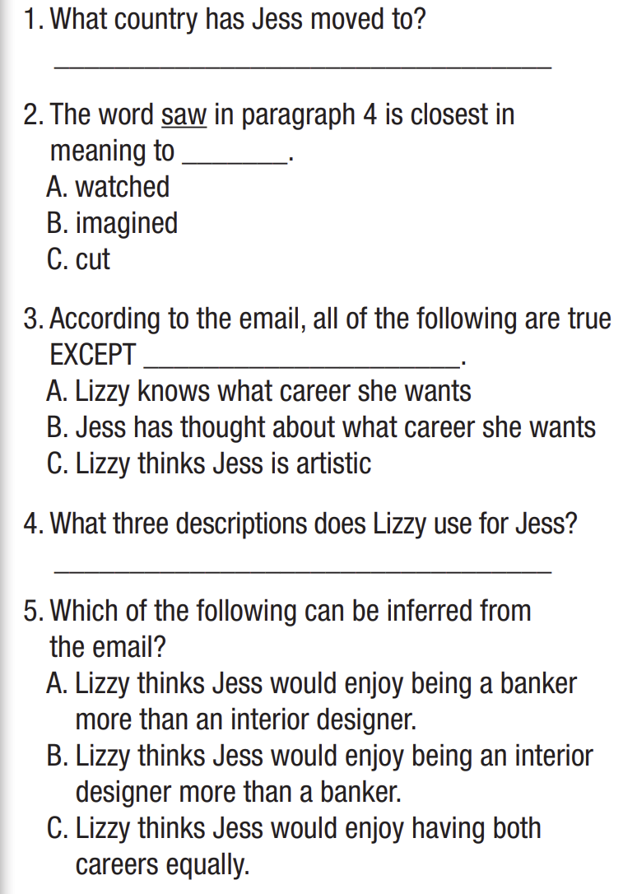  - Ask Ss to read the question  - Have students read the email again and answer the questions.  - Have students check their answers with a partner.  - Check answers as a whole class. | - Read the question and the choices  - Choose the correct answers  Answer Keys  1. Canada  2. B  3. A  4. creative – artistic – hard-working  5. B
Task c: Listen and read.  - Play audio. Have Ss listen and read. | -Listen and read
Extra practice – WB – P.22&23  Task a. Read Betty’s email. What was it mostly about?  - Divide the class into pairs  - Have Ss read the question  - Ask Ss to read the email and choose the correct answer.  - Check answers as a whole class  Task b. Now, read and circle True, False, or Doesn't say.  - Divide the class into pairs  - Have Ss read the sentences  - Ask Ss to read the email and decide if they are True, False or Doesn’t say.  - Check answers as a whole class | - Work in pairs.  - Read and choose the correct answer.  Answer Keys: 2  - Work in pairs.  - Read and decide if they are True, False or Doesn’t say.  Answer Keys:  1. True  2. True  3. Doesn’t say  4. False  5. False

3. Post-Reading – 8 mins
a. Objectives: to help Ss to give opinions about each career and choose the career they would prefer to have.
b. Content: tasks d
c. Expected outcomes: Ss can practice giving opinions about each career and choose the career they would prefer to have
d. Organization
Teacher’s activities | Students’ activities
Task d: In pairs: What other positives and negatives can you think of for each career? Which career would you prefer to have? Why?  - Divide the class into pairs.  - Have Ss discuss the questions.  - Elicit answers from some students. | - Work in pairs  - Discuss the questions

C. Consolidation and homework assignments – 5 mins
- Vocabulary: editor; banker; instructor; beautician; entrepreneur; interior designer; physical therapist; influencer.
- Do Vocabulary & Reading exercises in the workbook on pages 22&23.
- Prepare the next lesson: Lesson 2.2 – Grammar, pages 44 & 45.

5. Reflection

a. What I liked most about this lesson today:
…………………………………………………………………………………………
b. What I learned from this lesson today:
…………………………………………………………………………………………
c. What I should improve for this lesson next time:
…………………………………………………………………………………………

