School: Tran Phu high school | Week: 12  Date: 18/11/24
Class: 12a6 | Period: 32

UNIT 4: GRADUATION AND CHOOSING A CAREER
Lesson 1.1: Vocabulary and Listening (Pages 39 & 40)

1. Objectives
By the end of this lesson, students will be able to…
1.1. Language knowledge/ skills
- learn and use vocabulary for activities for college students.
- practice listening for specific information.
- talk about the importance of different college opportunities.
- improve listening skills.
1.2. Competences
- improve Ss’ communication, collaboration, analytical, and critical thinking skills.
1.3. Attributes
- give opinions about study experiences.
- talk about what universities should offer.
2. Teaching aids and materials
- Teacher’s aids: Student’s book and Teacher’s book, class CDs, DCR– Phần mềm tương tác trực quan, DHA – Ứng dụng trò chơi tương tác, projector / interactive whiteboard /TV (if any), PowerPoint slides.
- Students’ aids: Student’s book, Workbook, Notebook.
3. Assessment Evidence
Performance Tasks | Performance Products | Assessment Tools
- Fill in the blanks with the correct new words.  - Talk about yourself and your routine.  - Listen to the discussion and fill in the note | - Ss’ answers.  - Ss’ answers/presentation.  - Ss’ answers. | - Observation.  - Observation.  - Observation.
4. Procedures
A. Warm-up: 5 mins
a. Objectives: to introduce the topic.
b. Content: Let’s talk.
c. Expected outcomes: Ss can talk about activities at the college that might help them succeed and get good jobs based on the title and the picture.
d. Organization
Teacher’s activities | Students’ activities
Option 1: Mind map  - Divide the class into groups  - Talk about the activities of college students  - Check the answer and give feedback  - Give more information  Option 2:  Let’s talk: Look at the pictures. What are these people doing? What else can people do at university to help them succeed and get good jobs?    - Ask Ss to work in pairs, look at the pictures and answer the questions (using the DCR/ PPTs slides).  - Call some pairs to give their answers.  - Give feedback. | - Work in groups and discuss  Answer keys:  engaging in community service; working part-time jobs; participating sports teams; doing research; working with people; learning to work by themselves…..  - Work in pairs, look at pictures and answer the questions.  Answer Keys  - doing research/ experiments; studying; working in teams; meeting people.  - go to lectures; do assignments; do exercise; cook and clean; learn to work by themselves.  Ss’ own answers

B. New Lesson: 35 mins
1. Vocabulary – 15 mins
a. Objectives: To help Ss improve their vocabulary about phrasal verbs.
b. Content: tasks a, b and c.
c. Expected outcomes: Ss can learn some new vocabulary to show the activities of college students
d. Organization
Teacher’s activities | Students’ activities
Task a: Read the words and definitions, then fill in the blanks. Listen and repeat.  - Ask Ss to work in pairs  - Read the definitions and give some examples  - Fill in the blanks to complete the sentences  - Check Ss’ answers around the class.  - Ask Ss to listen and repeat. | - Work with a partner  - Read the definitions and give examples  - Fill in the blanks and check the answer with their partner.  - Listen and repeat.  Answer Keys:  1. figure out 2. carry out  3. fill out 4. put on  5. deal with 6. help out  7. catch up on 8. get together
Task b: Use the words in the boxes to make a phrase, then say what they mean. Add any other phrases like these that you know to the box  - Demonstrate the activity.  - Divide the class into pairs.  - Have Ss match the words to make phrases, then say what they mean.  - Have Ss write other phrases that they know in the box, and share the opinions with the others.  - Check answers as a whole class.  Task c: In pairs: Use the new words to talk about yourself and your routine.  - Ask Ss to work with their partner,  - Demonstrate the activity and ask Ss to read the example.  - Have pairs talk about themselves and their routines using the new words.  - Check Ss’ answers around the class.  - Pick some Ss to talk about their story. | - Work with their partner.  Answer Keys:  - hang out: spend time in a place (usually with someone)  - clean up: make yourself or something clean, usually by washing.  - look after: take care of someone/ something.  Answer Keys:  wake up; work out; carry on with; make up  -Work with their partner, and share their routines.

2. Pre & While-Listening – 15 mins
a. Objectives: To help Ss listen for details.
b. Content: tasks a, b, and c.
c. Expected outcomes: Ss can listen for specific information and discuss what they think universities should offer.
d. Organization:
Teacher’s activities | Students’ activities
Task a: You will hear two students discussing what they think universities should offer. For each question below, write your prediction on the line.  - Divide the class into pairs  - Ask pairs to read the task underline the key words and give possible answers.  - Have Ss read the questions in the box and give a prediction for each question.  - Have some pairs share their ideas with the class.  - Check the answer around the class. | - Read the task, and underline the key words.  - Ss give the answer  Suggested answers:  - doing the experiments/ researches.  - meeting people  - working in teams
Task b: Now, listen and circle the students who give more ideas about what universities should offer. Mary/ Peter  - Ask Ss to read the task and underline the key words.  - Get Ss to listen to the text.  - Ask Ss to give the correct answer.  - Check Ss’ answers (using the DCR). | - Read the task and underline the key words.  - Listen and circle the name.  - Correct the answers.  Answer Keys: Peter
Task c: Listen again and answer the questions. Write your answers on the answer line. How many answers did you guess correctly?  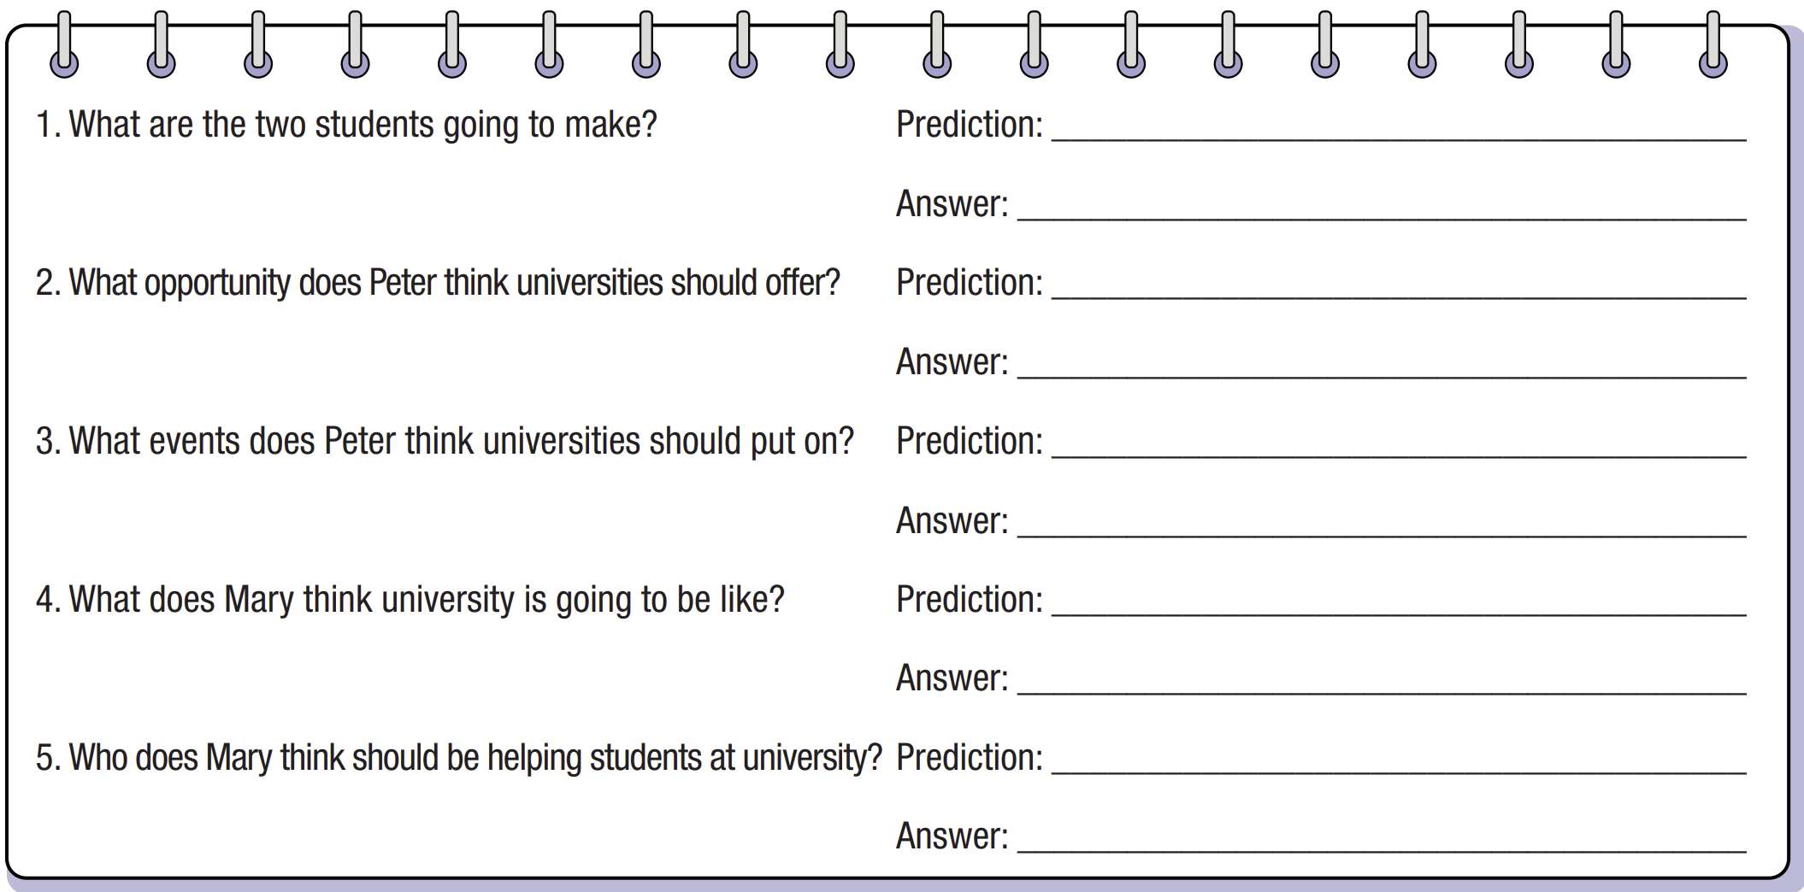  - Play the CD and ask Ss to listen and write the phrases or words they hear.  - Check answers as a whole class. | - Listen and write the answer.  - Correct the answer.  Answer keys:  1. a list of important things universities should offer.  2. research  3. performances, cultural fairs, job fairs.  4. really difficult and stressful  5. a counselor or teacher.

3. Post-Listening – 5 mins
a. Objectives: to help Ss to use the language and communicate in the real situation.
b. Content: task d, e, and f
c. Expected outcomes: Ss can use useful expressions to make conversation.
d. Organization
Teacher’s activities | Students’ activities
Task d: Read the conversation Skill box, then listen and repeat.  - Ask Ss to work in pairs,  - Have Ss read the sentences in the Conversation Skill box  - Clarify the use of the conversation skill.  - Play audio. Have students listen and repeat. | - Work in pairs to answer the questions.  - Share their stories.
Task e: Now, listen to the conversation again and circle the phrase(s) you hear.  - Play audio. Have students listen and circle the phrase(s) in the conversation skill box.  - Check the answer as a whole class. | - Listen to the conversation again and circle the phrase(s) they hear.  Answer key:  Well, thanks, (Mary). I’m going to….

C. Consolidation and homework assignments – 5 mins
- Vocabulary: figure out, carry out, fill out, put on, deal with, help out, catch up on, get together
- Do Vocabulary & Listening in the workbook on page 20.
- Prepare the next lesson: Lesson 1.2 – Grammar, pages 40 & 41.

5. Reflection

a. What I liked most about this lesson today:
…………………………………………………………………………………………
b. What I learned from this lesson today:
…………………………………………………………………………………………
c. What I should improve for this lesson next time:
…………………………………………………………………………………………

