School: Tran Phu high school | Week: 8  Date: 23/10/24
Class: 12a6 | Period: 21

UNIT 3: WORLD OF WORK
Lesson 2.1: Vocabulary and Listening (Pages 30 & 31)
1. Objectives
By the end of this lesson, students will be able to…
1.1. Language knowledge/ skills
- learn and use job vocabulary.
- practice listening for the main idea and specific information.
- learn and practice functional English
- improve listening skills.
1.2. Competences
- improve Ss’ communication, collaboration, analytical, and critical thinking skills.
1.3. Attributes
- express your feeling during different experiences
2. Teaching aids and materials
- Teacher’s aids: Student’s book and Teacher’s book, class CDs, DCR– Phần mềm tương tác trực quan, DHA – Ứng dụng trò chơi tương tác, projector / interactive whiteboard /TV (if any), PowerPoint slides.
- Students’ aids: Student’s book, Workbook, Notebook.
3. Assessment Evidence
Performance Tasks | Performance Products | Assessment Tools
- Fill in the blanks with the correct phrases.  - Talk about reasons for choosing a job.  - Listen and fill in the blanks | - Ss’ answers.  - Ss’ answers/presentation.  - Ss’ answers. | - Observation.  - Observation.  - Observation.
4. Procedures
A. Warm-up: 5 mins
a. Objectives: to introduce the topic.
b. Content: Let’s talk.
c. Expected outcomes: Ss can express how they feel during different situations.
d. Organization
Teacher’s activities | Students’ activities
Let’s talk: In pairs: Look at the pictures. What jobs are these people doing? Which job would you like to do most? Why?  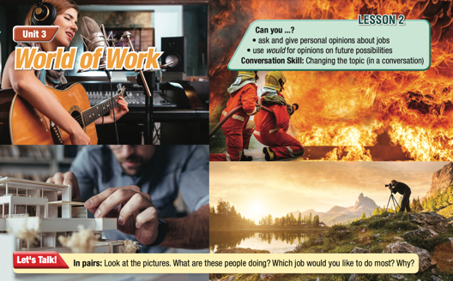  - Divide the class into pairs.  - Have Ss look at the picture and discuss the questions (using the DCR/ PPTs slides).  - Call on some pairs for their answers.  - Give feedback. | - Work in pairs.  - Look at the picture and answer the questions.  - Ss’s own answers  - Suggested Answer Keys  Jobs: singer/musician, firefighter, architect/designer, builder, photographer/wildlife photographer  I'd like to be a photographer because I like traveling an  taking photos.

B. New Lesson: 35 mins
1. Vocabulary – 15 mins
a. Objectives: To help Ss learn and use jobs vocabulary
b. Content: tasks a, b, c, and WB p.16 – task a
c. Expected outcomes: Ss can put the job's vocabulary into practice.
d. Organization
Teacher’s activities | Students’ activities
Task a: Read the sentences and match the underlined words with the definitions.  Listen and repeat. Listen and repeat.  - Show how to do the activity with an example.  - Students read the sentences and match underlined words with definitions.  - Pair up students to check answers.  - Play audio for students to listen and repeat. | - Work with a partner to match the words up with the definitions.  - Answer keys:  1. d  2. c  3. e  4. а  5. b  6. f  - Listen and repeat.
Extra practice – WB – P.16: Task a: Read the clues. Complete the crossword.  - Have Ss read the hints that help solve the crossword puzzle.  - Check Ss’ answers around the class | - Complete the crossword.  Answer Keys:  1. electrician  2. counselor  3. surgeon  4. lawyer  5. mechanic  6. software designer
Task b: Add more jobs you know to the box.  - Show how to do the activity with an example.  - Have students add more jobs they know to the box.  - Pair up students to check answers. | Suggested answers:  police officer, firefighter, teacher, engineer, accountant, cashier
Task c: In pairs: Use the new words to talk about which jobs sound most interesting to you and explain why.  - Have pairs take turns telling each other which jobs they think sound the most interesting and why.  - Have some students share their ideas with the class. | -Work with their partner and share ideas.

2. Pre & While-Listening – 12 mins
a. Objectives: To help Ss listen for the main idea and specific information.
b. Content: tasks a, b, and c.
c. Expected outcomes: Ss can listen for the main idea and specific information, and understand what feelings the girl mentions.
d. Organization:
Teacher’s activities | Students’ activities
Task a: You will hear two students talking about jobs in the future. What's one reason someone would want to be a lawyer or a software developer?  - Pair up students.  - Have pairs read the question.  - Have pairs write down one idea why the two students would want each job.  - Invite pairs to present the ideas to the class. | - Discuss in pairs  Answer Keys: Ss’ own ideas
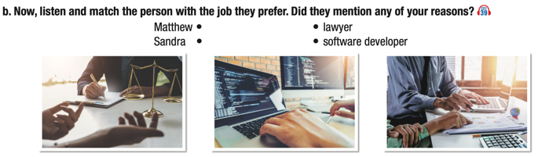  Task b: Now, listen and match the person with the job they prefer. Did they mention any of your reasons?  - Have Ss read the question.  - Play audio. Have students listen and match the person with the job they prefer.  - Check Ss’ answers (using the DCR). | - Read the question and the words.  - Listen for the key words.  Answer Keys  Matthew – software developer  Sandra – lawyer
Task c: Listen again and circle the correct answer.  - Have students read the questions.  - Play audio. Have students listen and circle the correct answer.  - Check Ss’ answers (using the DCR). | -Listen and choose the correct options.  Answer Keys:  1. B 2.A 3. C 4. C 5.A

3. Post-Listening – 8 mins
a. Objectives: to help Ss to use the language in the Conversation Skill box.
b. Content: tasks d, e, and f
c. Expected outcomes: Ss can practice using the phrases in the Conversation Skill box in a real situation
d. Organization
Teacher’s activities | Students’ activities
Task d: Read the Conversation Skill box, then listen and repeat  - Have Ss read the Conversation Skill box.  - Clarify the use of the conversation skill.  - Play audio. Have Ss listen and repeat. | - Listen and repeat phrases in the Conversation box.
Task e: Now, listen to the conversation again and tick the phrase(s) or sentence(s) you hear.  - Play audio. Have students listen and tick the phrase(s) or sentence(s) they hear.  - Check answers as a whole class. | - Listen for the phrase(s) or sentence(s) they hear.  Answer Key:  What’s the next (job)?
Task f: In pairs: Are you more similar to Matthew or Sandra? How are you similar? How are you different?
- Divide the class into pairs.
- Have Ss discuss the questions.
- Elicit answers from Ss.

C. Consolidation and homework assignments – 5 mins
- Vocabulary: electrician, counselor, surgeon, lawyer, mechanic, software designer
- Do Vocabulary & Listening exercises in the workbook on page 16.
- Prepare the next lesson: Lesson 2.2 – Grammar, pages 31 & 32.
5. Reflection
a. What I liked most about this lesson today:
…………………………………………………………………………………………
b. What I learned from this lesson today:
…………………………………………………………………………………………
c. What I should improve for this lesson next time:
…………………………………………………………………………………………

