School: Tran Phu high school | Week: 7  Date: 16/10/24
Class: 12a6 | Period: 17

UNIT 3: WORLD OF WORK
Lesson 3.1: Vocabulary and Reading (Pages 26 & 27)

1. Objectives
By the end of this lesson, students will be able to…
1.1. Language knowledge / skills
- learn and use vocabulary for different jobs.
- practice reading for specific information.
- talk about important skills and characteristics for different jobs.
- improve reading skills.
1.2. Competences
- improve Ss’ communication, collaboration, analytical, and critical thinking skills.
1.3. Attributes
- gain insight into characteristics needed for certain jobs.
- give opinions about jobs.
2. Teaching aids and materials
- Teacher’s aids: Student’s book and Teacher’s book, class CDs, DCR– Phần mềm tương tác trực quan, DHA – Ứng dụng trò chơi tương tác, projector / interactive whiteboard /TV (if any), PowerPoint slides.
- Students’ aids: Student’s book, Workbook, Notebook.
3. Assessment Evidence
Performance Tasks | Performance Products | Assessment Tools
- Fill in the blanks with the correct new words.  - the characteristics from the new words and any other characteristics  - Read the article and write the correct heading for each section. | - Ss’ answers.  - Ss’ answers/presentation.  - Ss’ answers. | - Observation.  - Observation.  - Observation.
4. Procedures
A. Warm-up: 5 mins
a. Objectives: to introduce the topic.
b. Content: Let’s talk.
c. Expected outcomes: Ss can talk about characteristics that people in different jobs need.
d. Organization
Teacher’s activities | Students’ activities
Let’s talk: Look at the title of the unit and the picture. What skills are these people using?  What jobs do you think these skills are most important for?  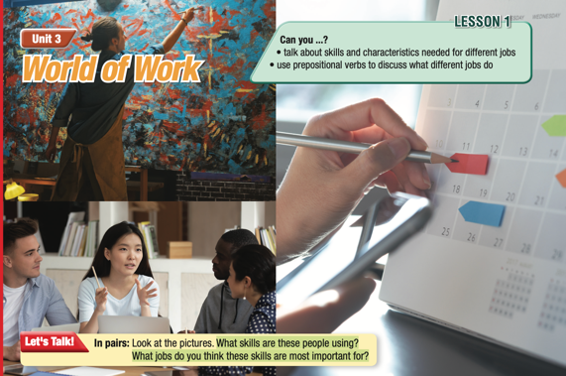  - Ask Ss to work in pairs, look at the title and the picture and answer the questions (using the DCR/ PPTs slides).  - Ask some pairs to give their answers.  - Give feedback. | - Work in pairs, reading the title, looking at the picture and answering the questions.  Suggested Answers  - First picture: creativity, painting. They're important for designers, and artists.  - Second picture: speaking, listening, communication. They're important for teachers, and sales assistants.  - Third picture: planning, organization. They're important for assistants, teachers, and managers.

B. New Lesson: 35 mins
1. Vocabulary – 15 mins
a. Objectives: To improve Ss’ vocabulary for characteristics that people in different jobs
b. Content: tasks a, b and c.
c. Expected outcomes: Ss can talk about characteristics that people in different jobs need.
d. Organization
Teacher’s activities | Students’ activities
Task a: Read the words and definitions, then fill in the blanks. Listen and repeat.  - Ask Ss to work in pairs, read the definitions and fill in the blanks.  - Check Ss’ answers around the class.  - Ask Ss to listen and repeat. | - Work with a partner and fill in the blanks.  - Listen and repeat.  Answer Keys:  1. confident 2. receptionist 3. architect  4. adaptable 5. patient  6. accountant 7. organized
Task b: Add the characteristics from the new words and any other characteristics you know to the box.  - Demonstrate the activity.  - Have students add the characteristics from the new words and any other characteristics that they know to the box.  - Divide the class into pairs and have them check their answers with their partners.  Task c: In pairs: Use the new words to talk about characteristics that people in different jobs need.  - Have pairs talk about characteristics that people in different jobs need.  - Have some students share their ideas with the class. | Suggested answers:  organized, adaptable, patient, confident, enthusiastic, positive, hardworking, honest  - Work with their partners, sharing and comparing the ideas

2. Pre & While-Reading – 15 mins
a. Objectives: To help Ss read for details.
b. Content: tasks a, b, and c.
c. Expected outcomes: Ss can identify the main idea or theme of each section and acquire knowledge of the qualities needed for a certain job.
d. Organization:
Teacher’s activities | Students’ activities
Task a: Read the article and write the correct heading for each section. Choose the correct answer.  - Ask Ss to read the questions and give possible answers.  - Ask Ss to read the article and write the correct heading for each section.  - Call on some Ss to give answers and provide explanations for the answers.  - Check Ss’ answers. | - Expected answers:  Multitasking, Stress Management, Leadership and Teamwork Skills, Problem-solving skills  - Read the article, underline the lines for evidence, and write the correct headings.  Answer keys  1. Multitasking  2. Stress Management  3. Leadership and Teamwork  Skills  4. Problem-solving Skills
Task b: Now, read and answer the questions.  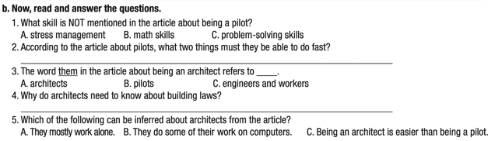  - Ask Ss to read the phrases and underline the key words.  - Get Ss to scan the text for key words.  - Ask Ss to find the correct answers using the key words.  - Set the time limit; observe the class.  - Check Ss’ answers (using the DCR). | - Read the phrases and underline the key words.  - Scan the text for the key words.  - Find the answers using the key words.  Answer Keys  1. C  2. making decisions and doing math  3. C  4. Because they must know about building regulations and what they are allowed to build.  5. B
Task c: Listen and read.  - Play audio. Have students listen and read.  - Call on 4 Ss to read the 4 sections aloud and correct their pronunciation if necessary. | -Listen and read along.

3. Post-Reading – 5 mins
a. Objectives: to help Ss to use the language and information in real situations.
b. Content: task d
c. Expected outcomes: Ss can talk about their trip experiences.
d. Organization
Teacher’s activities | Students’ activities
Task d: In pairs: Answer the questions: Which job sounds more interesting to you? Why?  - Ask Ss to work in pairs, talking about the jobs they want to have.  - Have students discuss the questions.  - Elicit answers from some students.  - Monitor the class and help them if necessary.  - Ask some Ss to share their thoughts | - Work in pairs to answer the questions.  - Present the ideas

C. Consolidation and homework assignments – 5 mins
- Vocabulary: accountant, receptionist, architect, organized, adaptable, patient, confident
- Do Vocabulary & Reading exercises in the workbook on pages 14 & 15.
- Prepare the next lesson: Lesson 3.2 – Grammar, pages 27 & 28.

5. Reflection

a. What I liked most about this lesson today:
…………………………………………………………………………………………
b. What I learned from this lesson today:
…………………………………………………………………………………………
c. What I should improve for this lesson next time:
…………………………………………………………………………………………

