School: Tran Phu high school | Week: 5  Date: 4/10/24
Class: 12a6 | Period: 13

UNIT 2: OUT INTO THE WORLD
Lesson 2.1: Vocabulary and Listening (Pages 19 & 20)

1. Objectives
By the end of this lesson, students will be able to…
1.1. Language knowledge/ skills
- learn and use words related to items and services in a hotel.
- practice listening for the main idea and specific information.
- learn and practice functional English (describing things)
- improve listening skills.
1.2. Competences
- improve Ss’ communication, collaboration, analytical, and critical thinking skills.
1.3. Attributes
- express your feeling during different experiences
2. Teaching aids and materials
- Teacher’s aids: Student’s book and Teacher’s book, class CDs, DCR– Phần mềm tương tác trực quan, DHA – Ứng dụng trò chơi tương tác, projector / interactive whiteboard / TV (if any), PowerPoint slides.
- Students’ aids: Student’s book, Workbook, Notebook.
3. Assessment Evidence
Performance Tasks | Performance Products | Assessment Tools
- Fill in the blanks with the correct words / phrases.  - Talk about the items or services you have used at a hotel.  - Listen and fill in the blanks | - Ss’ answers.  - Ss’ answers/presentation.  - Ss’ answers. | - Observation.  - Observation.  - Observation.
4. Procedures
A. Warm-up: 5 mins
a. Objectives: to introduce the topic.
b. Content: Let’s talk.
c. Expected outcomes: Ss can express how they feel during different situations.
d. Organization
Teacher’s activities | Students’ activities
Let’s talk: Look at the picture. Where do you think the man is? Why is he visiting there?  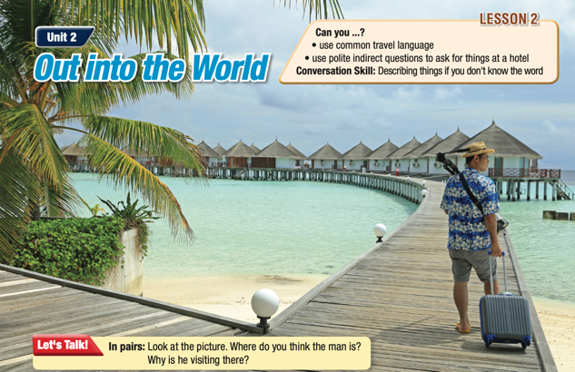  - Ask Ss to work in pairs, look at the picture and discuss the questions (using the DCR/ PPTs slides).  - Call some pairs to give their answers.  - Give feedback. | - Work in pairs, look at the picture and answer the questions.  Answer Keys  - The man is at a resort. He is probably a tourist or a visitor.  - He is visiting it to have a nice and relaxing vacation.  Ss’ own answers

B. New Lesson: 35 mins
1. Vocabulary – 15 mins
a. Objectives: To help Ss learn and use words related to items and services in a hotel.
b. Content: tasks a, b, c, and WB p.4 – task a
c. Expected outcomes: Ss can learn words related to items and services in a hotel to describe things.
d. Organization
Teacher’s activities | Students’ activities
Task a: Read the words and definitions, then fill in the blanks to complete the signs and notices. Listen and repeat.  - Ask Ss to work in pairs, read the words and definitions, and then fill in the blanks.  - Check Ss’ answers around the class.  - Ask Ss to listen and repeat. | - Work with a partner and fill in the blanks.  - Listen and repeat.  Answer Keys:  1. dry cleaning  2. complimentary  3. iron  4. swipe  5. uppercase  6. lowercase  7. operate  8. remote control
Extra practice – WB – P.10: Task a: Fill in the bank using the words from Task a.  - Ask Ss to read the words and match the phrases to the sentences.  - Check Ss’ answers around the class | Answer Keys:  - lowercase  - complimentary  - iron  - swipe  - dry cleaning  - operate  - remote control  - uppercase
Task b: Add the new words to the table and add other things or services you know hotels have or offer?  - Demonstrate the activity.  - Have Ss say which words they know and their meanings.  - Check Ss’ answers around the class. | Suggested answers:  Things hotels have iron, remote control, gym, pool, restaurant, tennis court  Services hotels offer dry cleaning, laundry services, spa, massage club
Task c: In pairs: Use the new words to talk about things and services you’ve used at a hotel.  - Ask Ss to work with their partner, talking about things and services you’ve used at a hotel.  - Check Ss’ answers around the class.  - Pick some Ss to talk about services they’ve used in a hotel. | -Work with their partner, and share their services used.

2. Pre & While-Listening – 12 mins
a. Objectives: To help Ss listen for the main idea and specific information.
b. Content: tasks a, b, and c.
c. Expected outcomes: Ss can listen for the main idea and specific information, and understand what feelings the girl mentions.
d. Organization:
Teacher’s activities | Students’ activities
Task a: You will hear a guest asking a hotel employee for some items and information. What do you think the guest will ask for? Add two more items.  - Ask Ss to work in pairs and read the suggested items.  - Have pairs of Ss predict the items.  - Pick some Ss to share their answer. | - Discuss in pairs  Answer Keys: Ss’ own ideas
Task b: Now, listen and circle the things above that the guests ask about. How many did you guest correctly.  - Ask Ss to read the question  - Play audio. Have Ss listen and circle the things they hear.  - Set the time and monitor the class.  - Have Ss share how many answers they guessed correctly  - Check Ss’ answers (using the DCR). | - Read the question and the words  - Listen to find the key words.  Answer Keys  1. Wi-Fi password
Task c: Listen again and circle the correct answer.  - Have Ss read the sentences  - Play audio. Have Ss listen and circle the correct answers.  - Check answers around the class | -Listen and circle correct answers  Answer Keys:  1.D 2.B 3.C 4.B 5.A

3. Post-Listening – 8 mins
a. Objectives: to help Ss to use the language in the Conversation Skill box.
b. Content: tasks d, e, and f
c. Expected outcomes: Ss can practice using the phrases in the Conversation Skill box in a real situation.
d. Organization
Teacher’s activities | Students’ activities
Task d: Read the Conversation Skill box, then listen and repeat  - Have Ss read the Conversation Skill box.  - Clarify the use of the conversation skill.  - Play audio. Have Ss listen and repeat. | - Listen and repeat phrases in the Conversation box.
Task e: Now, listen to the conversation again and circle the phrase you hear  - Play audio. Have Ss listen and tick the phrase they hear.  - Check the answer as a whole class | - Listen and circle the phrase they hear  Answer Key:  A thing for pressing the shirt
Task f: In pairs: What problems have you had on vacation? How did you solve them?  - Have Ss work in pairs  - Have Ss discuss the question  - Check answers around the class | - Discuss and share the idea with a partner.

C. Consolidation and homework assignments – 5 mins
- Vocabulary: iron, swipe, upper case, lower case, operate, remote control, dry cleaning, complimentary
- Do Vocabulary & Listening exercises in the workbook on pages 9 & 10.
- Prepare the next lesson: Lesson 2.2 – Grammar, pages 20 & 21.

5. Reflection

a. What I liked most about this lesson today:
…………………………………………………………………………………………
b. What I learned from this lesson today:
…………………………………………………………………………………………
c. What I should improve for this lesson next time:
…………………………………………………………………………………………

