School: Tran Phu high school | Week: 4  Date: 27/9/24
Class: 12a6 | Period: 10

UNIT 2: OUT INTO THE WORLD
Lesson 1.1: Vocabulary and Reading (Pages 15 & 16)

1. Objectives
By the end of this lesson, students will be able to…
1.1. Language knowledge/ skills
- learn and use vocabulary about travel.
- practice reading for specific information.
- talk about traveling tips.
- improve reading skills.
1.2. Competences
- improve Ss’ communication, collaboration, analytical, and critical thinking skills.
1.3. Attributes
- give advice on how to stay safe when traveling.
- spend a good time when traveling.
2. Teaching aids and materials
- Teacher’s aids: Student’s book and Teacher’s book, class CDs, DCR– Phần mềm tương tác trực quan, DHA – Ứng dụng trò chơi tương tác, projector / interactive whiteboard /TV (if any), PowerPoint slides.
- Students’ aids: Student’s book, Workbook, Notebook.
3. Assessment Evidence
Performance Tasks | Performance Products | Assessment Tools
- Fill in the blanks with the correct new words.  - Talk about safe travel.  - Read the text and choose the best title. | - Ss’ answers.  - Ss’ answers/presentation.  - Ss’ answers. | - Observation.  - Observation.  - Observation.
4. Procedures
A. Warm-up: 5 mins
a. Objectives: to introduce the topic.
b. Content: Let’s talk.
c. Expected outcomes: Ss can talk about problems that may happen when visiting a new country based on the title and the picture.
d. Organization
Teacher’s activities | Students’ activities
Let’s talk: Look at the picture. What problems might these people have when visiting a new country? How can people stay safe when they visit a new country?  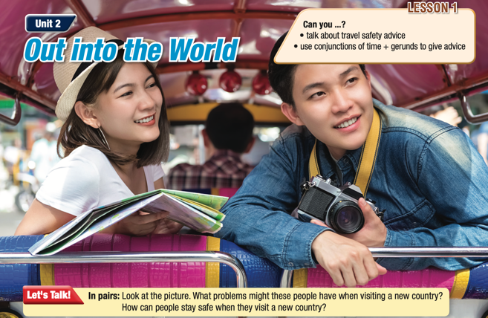  - Ask Ss to work in pairs, look at the title and the picture and answer the questions (using the DCR/ PPTs slides).  - Call some pairs to give their answers.  - Give feedback. | - Work in pairs, look at the title and the picture and answer the questions.  Answer Keys  They might get into an accident.  They have to think about taking care of their belongings.  Ss’ own answers

B. New Lesson: 35 mins
1. Vocabulary – 15 mins
a. Objectives: To help Ss improve their vocabulary about travel safety.
b. Content: tasks a, b and c.
c. Expected outcomes: Ss can learn some new vocabulary to advise on travel safety.
d. Organization
Teacher’s activities | Students’ activities
Task a: Read the words and definitions, then fill in the blanks. Listen and repeat.  - Ask Ss to work in pairs, read the definitions and fill in the blanks.  - Check Ss’ answers around the class.  - Ask Ss to listen and repeat. | - Work with a partner and fill in the blanks.  - Listen and repeat.  Answer Keys:  1. spot 2. safe  3. snatch 4. credit card  5. currency 6. pick up  7. discreet
Task b: Add the words in the box to the table.  - Demonstrate the activity.  - Have Ss read the presented categories in the table, then find words in the box and add them to the table.  - Check Ss’ answers around the class.  Task c: In pairs: Use the new words to talk about how to have a safe vacation.  - Ask Ss to work with their partner, giving advice on having a safe vacation.  - Check Ss’ answers around the class.  -Pick some Ss to talk about their advice. | Answer Keys:  - currency – credit card – safe – cash – exchange rate  - discreet – safe – snatch – travel insurance – emergency – embassy  - pick up a language – spot – itinerary – travel insurance – embassy  -Work with their partner, and share their advice.

2. Pre & While-Reading – 15 mins
a. Objectives: To help Ss read for details.
b. Content: tasks a, b, and c.
c. Expected outcomes: Ss can read for specific information and understand what they should do before and during traveling.
d. Organization:
Teacher’s activities | Students’ activities
Task a: Read the article from a travel insurance website. Choose the best title for the article.  - Ask Ss to read the questions and give possible answers.  - Ask Ss to read the article and choose the correct title.  - Pick some Ss to give the answer and show the evidence to justify their answer.  - Check Ss’ answers. | -Expected answers: Travel Insurance for a Safer Trip, Stay Safe on Your Travels, Leave Your Valuables in the Safe …  - Read the article, underline the evidence and circle the correct title.  Answer Keys: 2
Task b: Now, read and choose the correct answers.  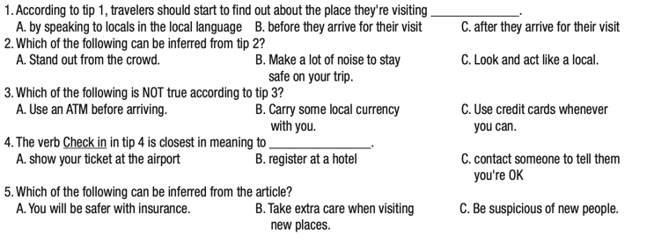  - Ask Ss to read the phrases and underline the key words.  - Get Ss to scan the text to find the key words.  - Ask Ss to find the correct answer based on the key words.  - Set the time and monitor the class.  - Check Ss’ answers (using the DCR). | - Read the phrases and underline the key words.  - Scan the text to find the key words.  - Find the answers based on key words.  Answer Keys  1. B. 2.C. 3. A 4. C 5. B
Task c: Listen and read.  - Play the CD and ask Ss to listen and read along.  - Pick 8 Ss to read the 8 paragraphs aloud and correct their pronunciation if necessary. | -Listen and read along.

3. Post-Reading – 5 mins
a. Objectives: to help Ss to use the language and information in a real situation.
b. Content: task d
c. Expected outcomes: Ss can talk about the best useful travel tip.
d. Organization
Teacher’s activities | Students’ activities
Task d: In pairs: Which tip do you think is the most useful? Why?  - Ask Ss to work in pairs, talking about the travel tip they think is the most useful one.  - Elicit Ss to talk about what might happen to their trip and how to stay safe.  - Monitor the class and help them if necessary.  - Ask some Ss to share their travel tips. | - Work in pairs to answer the questions.  - Share their travel tips.

C. Consolidation and homework assignments – 5 mins
- Vocabulary: spot, safe, snatch, credit card, currency, pick up a language, discreet
- Do Vocabulary & Reading exercises in the workbook on pages 8 & 9.
- Prepare the next lesson: Lesson 1.2 – Grammar, pages 17 & 18.

5. Reflection

a. What I liked most about this lesson today:
…………………………………………………………………………………………
b. What I learned from this lesson today:
…………………………………………………………………………………………
c. What I should improve for this lesson next time:
…………………………………………………………………………………………

