School: Tran Phu high school | Week: 3  Date: 16/9/24
Class: 12A6 | Period: 5

UNIT 1: LIFE STORIES
Lesson 2.1: Vocabulary and Listening (Pages 8 & 9)

1. Objectives
By the end of this lesson, students will be able to…
1.1. Language knowledge/ skills
- learn and use idioms related to life stories.
- practice listening for the main idea and specific information.
- learn and practice functional English (Introducing a story)
- improve listening skills.
1.2. Competences
- improve Ss’ communication, collaboration, analytical, and critical thinking skills.
1.3. Attributes
- express your feeling during different experiences
2. Teaching aids and materials
- Teacher’s aids: Student’s book and Teacher’s book, class CDs, DCR– Phần mềm tương tác trực quan, DHA – Ứng dụng trò chơi tương tác, projector / interactive whiteboard /TV (if any), PowerPoint slides.
- Students’ aids: Student’s book, Workbook, Notebook.
3. Assessment Evidence
Performance Tasks | Performance Products | Assessment Tools
- Fill in the blanks with the correct phrases.  - Talk about how they felt during different experiences.  - Listen and fill in the blanks | - Ss’ answers.  - Ss’ answers/presentation.  - Ss’ answers. | - Observation.  - Observation.  - Observation.
4. Procedures
A. Warm-up: 5 mins
a. Objectives: to introduce the topic.
b. Content: Let’s talk.
c. Expected outcomes: Ss can express how they feel during different situations.
d. Organization
Teacher’s activities | Students’ activities
Let’s talk: Look at the pictures. How do you think these people feel? Which life events do you think they’re experiencing? What situations or events would make you feel the same?  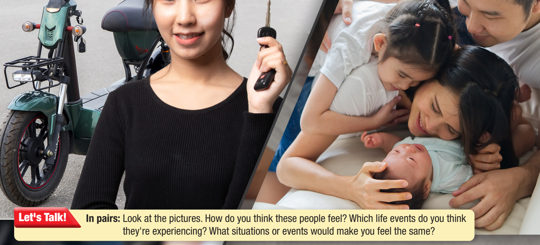  - Ask Ss to work in pairs, look at the picture and discuss the questions (using the DCR/ PPTs slides).  - Call some pairs to give their answers.  - Give feedback. | - Work in pairs, look at the picture and answer the questions.  Answer Keys  The woman is happy. She's holding the key of her new e-bike.  Ss’ own answers

B. New Lesson: 35 mins
1. Vocabulary – 15 mins
a. Objectives: To help Ss learn and use adverbial clauses of manner to describe your feelings
b. Content: tasks a, b, c, and WB p.4 – task a
c. Expected outcomes: Ss can learn adverbial clauses of manner to express their feelings for an event.
d. Organization
Teacher’s activities | Students’ activities
Task a: Read the idioms and definitions, then fill in the blanks with the correct idioms. Use the correct verb form and possessive adjectives. Listen and repeat.  - Ask Ss to work in pairs, read the idioms and definitions, and then fill in the blanks.  - Check Ss’ answers around the class.  - Ask Ss to listen and repeat. | - Work with a partner and fill in the blanks.  - Listen and repeat.  Answer Keys:  1. couldn't wrap my head around it  2. was on cloud nine  3. was/got bent out of shape  4. was beyond my wildest dreams  5. was a blessing in disguise  6. my life depended on it  7. had/got butterflies in my stomach  8. the end of the world
Extra practice – WB – P.4: Task a: Match the phrases to the definition  - Ask Ss to read the idioms and match the phrases to the definitions  - Check Ss’ answers around the class | Answer Keys:  A. 2 E. 4  B.6 F. 7  C.5 G. 1  D. 8 H. 3
Task b: Which of the idioms below do you know? What do they mean?  - Demonstrate the activity.  - Have Ss say which idioms they know and their meanings  - Check Ss’ answers around the class. | Suggested answers:  - look/feel like a million bucks: to look/feel extremely good  - cost an arm and a leg: to cost/pay a lot of money  - a piece of cake: easy  - go around in circles: to work hard at or discuss something without making any progress  - a fish out of water: a person who feels uncomfortable because they are in an environment that is not familiar
Task c: In pairs: Use the new idioms to talk about how you felt during different experiences.  - Ask Ss to work with their partner, talking about how they felt during different experiences.  - Check Ss’ answers around the class.  - Pick some Ss to talk about their story. | -Work with their partner, and share their stories.

2. Pre & While-Listening – 12 mins
a. Objectives: To help Ss listen for the main idea and specific information.
b. Content: tasks a, b, and c.
c. Expected outcomes: Ss can listen for the main idea and specific information, and understand what feelings the girl mentions.
d. Organization:
Teacher’s activities | Students’ activities
Task a: You will hear a girl talking about a presentation she did. What feelings do you think the girl will mention? Circle three  - Ask Ss to work in pairs and read the question.  - Have pairs of Ss predict the feelings the girl will mention  - Pick some Ss to share their ideas and show the evidence to justify their answer. | - Discuss in pairs  Answer Keys: Ss’ own ideas
Task b: Now, listen and put the feelings she mentions in the order you hear. Write a number on the line. How many feelings did you guess correctly?  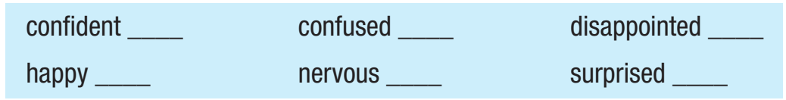  - Ask Ss to read the question  - Play audio. Have Ss listen and put the feelings in the order they hear.  - Set the time and monitor the class.  - Have Ss share how many answers they guessed correctly  - Check Ss’ answers (using the DCR). | - Read the question and the words  - Listen to find the key words.  Answer Keys  1. happy  2. nervous  3. confident
Task c: Listen again and fill in the blanks with no more than four words  - Have Ss read the sentences  - Play audio. Have Ss listen and fill in the blanks with no more than 4 words  - Check answers around the class | -Listen and fill in the blanks without more than 4 words.  Answer Keys:  1. practiced really hard  2. was on cloud nine  3. go first – go last  4. little things go wrong  5. choose her topic

3. Post-Listening – 8 mins
a. Objectives: to help Ss to use the language in the Conversation Skill box.
b. Content: tasks d, e, and f
c. Expected outcomes: Ss can practice using the phrases in the Conversation Skill box in a real situation
d. Organization
Teacher’s activities | Students’ activities
Task d: Read the Conversation Skill box, then listen and repeat  - Have Ss read the Conversation Skill box.  - Clarify the use of the conversation skill.  - Play audio. Have Ss listen and repeat. | - Listen and repeat phrases in the Conversation box.
Task e: Now, listen to the conversation again and circle the phrase you hear  - Play audio. Have Ss listen and circle the phrase they hear.  - Check the answer as a whole class | - Listen and circle the phrase they hear  Answer Key:  Hey, you’re not going to believe this, but …
Task e: In pairs: What would make you experience the feelings Alice had? Why?
- Have Ss work in pairs
- Have Ss discuss the question
- Check answers around the class

C. Consolidation and homework assignments – 5 mins
- Vocabulary: (be) on cloud nine, (be) beyond one’s wildest dreams, (have/get) butterflies in my stomach, (be) the end of the world, (be) a blessing in disguise, my life depended on it, (be) bent out of shape, (could/couldn’t) wrap one’s head around it
- Do Vocabulary & Listening exercises in the workbook on page 4.
- Prepare the next lesson: Lesson 2.2 – Grammar, pages 9 & 10.

5. Reflection

a. What I liked most about this lesson today:
…………………………………………………………………………………………
b. What I learned from this lesson today:
…………………………………………………………………………………………
c. What I should improve for this lesson next time:
…………………………………………………………………………………………

