School: Tran Phu high school | Week: 2  Date: 9/9/24
Class: 12A6 | Period: 2

UNIT 1: LIFE STORIES
Lesson 1.1: Vocabulary and Reading (Pages 4 & 5)

1. Objectives
By the end of this lesson, students will be able to…
1.1. Language knowledge/ skills
- learn and use vocabulary for life stories.
- practice reading for specific information.
- talk about trip experiences.
- improve reading skills.
1.2. Competences
- improve Ss’ communication, collaboration, analytical, and critical thinking skills.
1.3. Attributes
- give opinions about trip experiences.
- spend a good time when travelling.
2. Teaching aids and materials
- Teacher’s aids: Student’s book and Teacher’s book, class CDs, DCR– Phần mềm tương tác trực quan, DHA – Ứng dụng trò chơi tương tác, projector / interactive whiteboard /TV (if any), PowerPoint slides.
- Students’ aids: Student’s book, Workbook, Notebook.
3. Assessment Evidence
Performance Tasks | Performance Products | Assessment Tools
- Fill in the blanks with the correct new words.  - Talk about life stories.  - Read the text and choose the best answer. | - Ss’ answers.  - Ss’ answers/presentation.  - Ss’ answers. | - Observation.  - Observation.  - Observation.
4. Procedures
A. Warm-up: 5 mins
a. Objectives: to introduce the topic.
b. Content: Let’s talk.
c. Expected outcomes: Ss can talk about an event that may change their life based on the title and the picture.
d. Organization
Teacher’s activities | Students’ activities
Let’s talk: Look at the title of the unit and the picture. What's happening in each  picture? What events do you think could change your life?  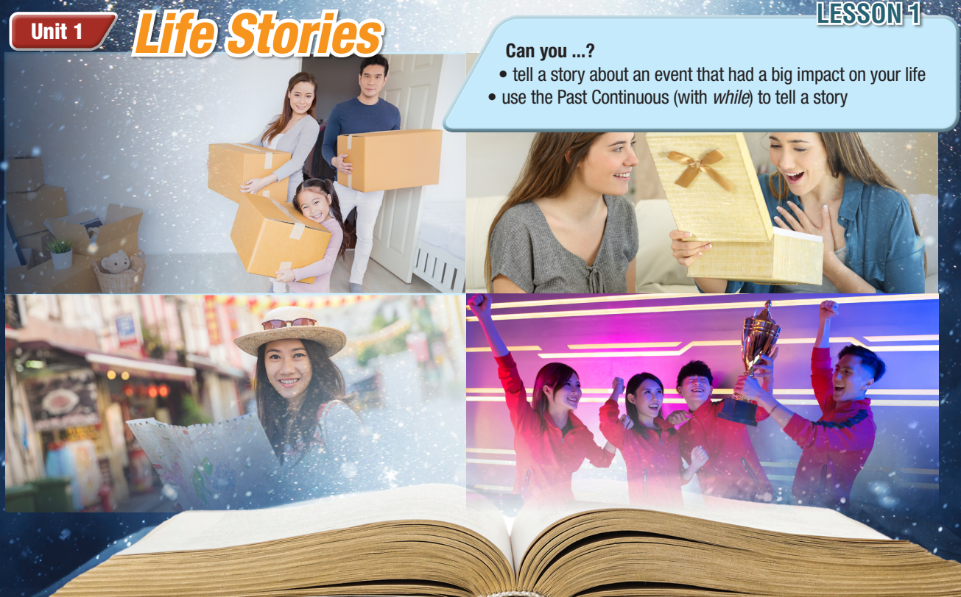  - Ask Ss to work in pairs, look at the title and the picture and answer the questions (using the DCR/ PPTs slides).  - Call some pairs to give their answers.  - Give feedback. | - Work in pairs, look at the title and the picture and answer the questions.  Answer Keys  They are moving to a new house.  Ss’ own answers

B. New Lesson: 35 mins
1. Vocabulary – 15 mins
a. Objectives: To help Ss improve their vocabulary about opinion adjectives.
b. Content: tasks a, b and c.
c. Expected outcomes: Ss can learn some new vocabulary to express their feelings for an event.
d. Organization
Teacher’s activities | Students’ activities
Task a: Read the words and definitions, then fill in the blanks. Listen and repeat.  - Ask Ss to work in pairs, read the definitions and fill in the blanks.  - Check Ss’ answers around the class.  - Ask Ss to listen and repeat. | - Work with a partner and fill in the blanks.  - Listen and repeat.  Answer Keys:  1. amazed 2. grateful  3. anxious 4. depressed  5. relieved 6. embarrassed  7. react
Task b: Find words in Task a. that have similar or opposite meanings to the words below.  - Demonstrate the activity.  - Have Ss read the words in the box and find words that have similar or opposite meanings to the words in Task a.  - Check Ss’ answers around the class.  Task c: In pairs: Use the new words to tell your partner about something that recently happened to you and how you felt.  - Ask Ss to work with their partner, talking about what recently happened to them and how they felt.  - Check Ss’ answers around the class.  -Pick some Ss to talk about their story. | Answer Keys:  - surprised – amazed  - happy – depressed  - uncomfortable – embarrassed  - thankful – grateful  - calm – anxious  -Work with their partner, and share their stories.

2. Pre & While-Reading – 15 mins
a. Objectives: To help Ss read for details.
b. Content: tasks a, b, and c.
c. Expected outcomes: Ss can read for specific information and understand what they should do when travelling.
d. Organization:
Teacher’s activities | Students’ activities
Task a: Read Lisa's blog about visiting Italy. What event impacted her the most? Choose the correct answer.  - Ask Ss to read the questions and give possible answers.  - Ask Ss to read the blog and choose the correct answer.  - Pick some Ss to give the answer and show the evidence to justify their answer.  - Check Ss’ answers. | -Expected answers: visiting attractions in Italy, Italian food, Italian history, using phone while travelling …  - Read the blog, underline the evidence and circle the correct name.  Answer Keys: 3
Task b: Now, read and answer the questions.  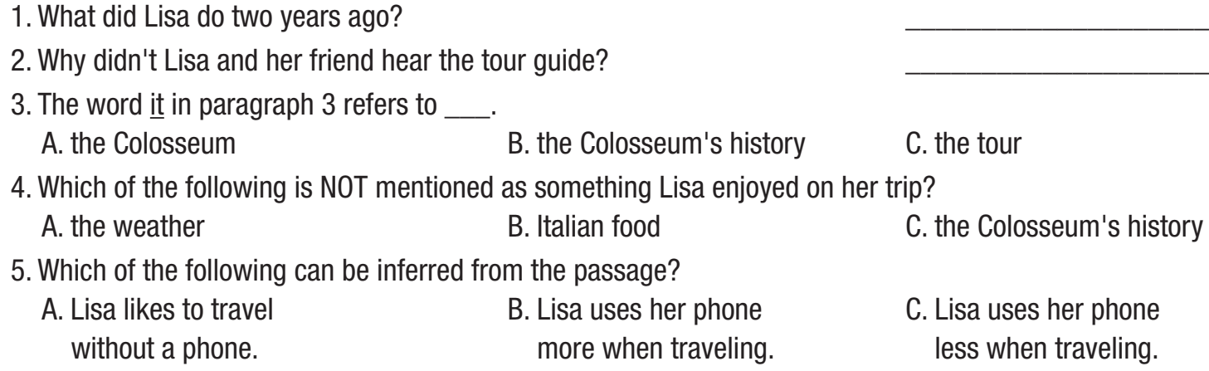  - Ask Ss to read the phrases and underline the key words.  - Get Ss to scan the text to find the key words.  - Ask Ss to find the correct answer based on the key words.  - Set the time and monitor the class.  - Check Ss’ answers (using the DCR). | - Read the phrases and underline the key words.  - Scan the text to find the key words.  - Find the answers based on key words.  Answer Keys  1. She took a trip to Rome, Italy.  2. They were taking selfies.  3. A 4. B 5. C
Task c: Listen and read.  - Play the CD and ask Ss to listen and read along.  - Pick 4 Ss to read the 4 paragraphs aloud and correct their pronunciation if necessary. | -Listen and read along.

3. Post-Reading – 5 mins
a. Objectives: to help Ss to use the language and information in the real situation.
b. Content: task d
c. Expected outcomes: Ss can talk about their trip experiences.
d. Organization
Teacher’s activities | Students’ activities
Task d: In pairs: Think of a trip you went on. What happened, and how did you feel?  - Ask Ss to work in pairs, talking about their trips.  - Elicit Ss to talk about what happened to their trip and how they felt.  - Monitor the class and help them if necessary.  - Ask some Ss to share their stories. | - Work in pairs to answer the questions.  - Share their stories.

C. Consolidation and homework assignments – 5 mins
- Vocabulary: amazed, anxious, depressed, embarrassed, relieved, grateful, react
- Do Vocabulary & Reading exercises in the workbook on pages 2 & 3.
- Prepare the next lesson: Lesson 1.2 – Grammar, pages 5 & 6.

5. Reflection

a. What I liked most about this lesson today:
…………………………………………………………………………………………
b. What I learned from this lesson today:
…………………………………………………………………………………………
c. What I should improve for this lesson next time:
…………………………………………………………………………………………

