School: ……………………………………….. | Date:……………………………………..
Class: ……………………………..................... | Period: ………………………………….

Review 2
Review 2.2: Page 62

1. Objectives
By the end of this lesson, students will be able to…
1.1. Language knowledge/ skills
- consolidate and practice vocab and grammar presented in units 4-5
- consolidate and practice pronunciation presented in units 4-5
- practice speaking
- check the writing of units 4-5
1.2. Competences
- improve Ss’ communication, collaboration, analytical, and critical thinking skills.
1.3. Attributes
- cultivate a heightened curiosity for diverse learning methodologies.
2. Teaching aids and materials
- Teacher’s aids: Student’s book and Teacher’s book, class CDs, DCR– Phần mềm tương tác trực quan, DHA – Ứng dụng trò chơi tương tác, projector / interactive whiteboard /TV (if any), PowerPoint slides.
- Students’ aids: Student’s book, Workbook, Notebook.
3. Assessment Evidence
Performance Tasks | Performance Products | Assessment Tools
- Fill in the blanks using the words in the box. | - Ss’ answers. | - Observation/feedback.
- Report the information | - Ss’ answers. | - Observation/feedback.
- Circle the correct answer. | - Ss’ answers. | - Observation/feedback.
- Circle the word that differs from the other three in the position of primary stress in each of the following questions. | - Ss’ answers. | - Observation/feedback.
- Circle the word that has the underlined part pronounced differently from the others. | - Ss’ answers. | - Observation/feedback.
- Talk about what you want to do after graduating from high school. | - Ss’ answers. | - Observation/feedback
-Discuss the advantages and disadvantages of doing what you want to do after high school. | - Ss’ answers. | - Observation/feedback
- Make a list of things you need to remember for your future writing. | - Ss’ answers. | - Observation/feedback

4. Procedures
A. Warm-up: 5 minutes
a. Objectives: To review the vocabularies related to lifelong learning
b. Content: Share the ideas with the class.
c. Expected outcomes: Ss can talk about lifelong learning
d. Organization
Teacher’s activities | Students’ activities
Competition time:
- Ask Ss to form groups of 5. | - Work in groups.
- Give Ss instructions and one example. | - Follow the instructions.
- Ask Ss to match the words with the correct definitions in 5 minutes. The team(s) with the most correct answers win (s). | - Match the words with the definitions in a team/group.
- Give feedback. | - Listen to feedback.
Match the words with the definitions  Words Definitions  1. entrepreneur a. done willingly, not because you are forced.  2. physical therapist b. a pleasant feeling that you get when you receive something you wanted  3. voluntary c. someone who starts their own business  4. reward d. a healthcare professional who treats muscle issues using massage  5. satisfaction e. to give something to somebody because they have done something good | Suggested answers  Words Definitions  1. entrepreneur c. someone who starts their own business  2. physical therapist d. a healthcare professional who treats muscle issues using massage  3. voluntary a. done willingly, not because you are forced.  4. reward e. to give something to somebody because they have done something good  5. satisfaction b. a pleasant feeling that you get when you receive something you wanted

B. New Lesson (35’)
1. Vocabulary (10’)
a. Objectives: Review the target language learned in the unit
b. Content: Vocabulary
c. Expected outcomes: Ss can practice test-taking skills.
d. Organization:
Teacher’s activities | Students’ activities
Task a. Fill in the blanks using the words in the box. There are two extra words which you do not need to use.
- Demonstrate the activity using the example. | - Listen to the instructions.
- Ask students to guess the type of missing words. | - Guess the type of missing words.
- Ask students to fill in the blanks using the words in the box | - Complete the task.
- Have pairs check each other's work. | - Compare the answers with a partner.
- Pick some Ss to read the sentence(s) out loud. | - Read the sentences out loud.
- Check and correct Ss’ answers. | - Correct the answers
Answers
1. voluntary
2. entrepreneurs
3. reward
Task b. Fill in the blanks with the words from Unit 5. The first letter is already there.
-Demonstrate the activity using the example. | - Listen to the instructions.
- Ask students to guess the type of missing words. | - Guess the type of missing words.
- Ask students to fill in the blanks using the words in the box | - Complete the task.
- Have pairs check each other's work. | - Compare the answers with a partner.
- Pick some Ss to read the sentence(s) out loud. | - Read the sentences out loud.
- Check and correct Ss’ answers. | - Correct the answers
Answers
1. discouraged
2. self-discipline
3. acquire

2. Grammar (5)
a. Objectives: Review the target language learned in the unit
b. Content: Grammar
c. Expected outcomes: Ss can practice test-taking skills.
d. Organization:
Teacher’s activities | Students’ activities
Task a. Report the information below.
-Demonstrate the activity using the example. | - Listen to the instructions.
- Ask Ss to report the information | - Complete the task.
- Have pairs check each other's work. | - Compare the answers with a partner.
- Pick some Ss to read the sentence(s) out loud. | - Read the sentences out loud.
- Check and correct Ss’ answers. | - Correct the answers
Answers
1. Mr. Lewis told me to set a goal and create a plan for achieving it.
2. Mrs. Thompson advised John not to be afraid to change his career.
3. Susan asked Ms. Miller to discuss her career options with her
Task b. Circle the correct answer.
-Demonstrate the activity using the example. | - Listen to the instructions.
- Ask Ss to circle the correct answer. | - Complete the task.
- Have pairs check each other's work. | - Compare the answers with a partner.
- Pick some Ss to read the sentence(s) out loud. | - Read the sentences out loud.
- Check and correct Ss’ answers. | - Correct the answers
Answers
1. A
2. B
3. C

3. Pronunciation (5’)
a. Objectives: Review the target language learned in the unit
b. Content: Pronunciation
c. Expected outcomes: Ss can practice test-taking skills.
d. Organization:
Teacher’s activities | Students’ activities
Task a. Circle the word that differs from the other three in the position of primary stress in each of the following questions.
- Ask Ss to notice the pronunciation feature. | - Notice the pronunciation feature
- Ask Ss to circle the word that differs from the other three in the position of primary stress | - Circle the correct answer
- Ask Ss to compare the answers with a partner. | - Compare the answers with a partner and show the evidence to justify the answer.
- Check the answers as a whole class. | - Correct the answers
Answer Key
1. B 2.D
Task b. Circle the word that has the underlined part pronounced differently from the others.
- Ask Ss to notice the pronunciation feature. | - Notice the pronunciation feature.
- Ask Ss to circle the word that has the underlined part pronounced differently from the others. | - Circle the correct answer.
- Ask Ss to compare the answers with a partner. | - Compare the answers with a partner and show the evidence to justify the answer.
- Check the answers as a whole class. | - Correct the answers.
Answer Key
1. B 2.D

Evidence:
Task a:
1.A. acquire | B. pressure | C. expand | D. pursue
/əˈkwaɪər/ | /ˈpreʃər/ | /ɪkˈspænd/ | /pərˈsuː/
2.A. analysis | B. tutorial | C. interior | D. satisfaction
/əˈnæləsɪs/ | /tuːˈtɔːriəl/ | /ɪnˈtɪriər/ | /ˌsætɪsˈfækʃn/
Task b:
1. A. passion | B. reward | C. activity | D. demand
/ˈpæʃən/ | /rɪˈwɔːrd/ | /ækˈtɪvəti/ | /dɪˈmænd/
2. A. register | B. editor | C. competitive | D. reinforce
/ˈredʒɪstər/ | /ˈedɪtər/ | /kəmˈpetətɪv/ | /ˌriːɪnˈfɔːrs/

4. Speaking (10’)
a. Objectives: Review the target language learned in the unit
b. Content: Speaking
c. Expected outcomes: Ss can practice test-taking skills.
d. Organization:

Teacher’s activities | Students’ activities
Task a. In groups of 2–4: Talk about what you want to do after graduating from high school.
- Ask Ss to work in pairs. | - Work in pairs.
- Ask Ss to discuss what they want to do after graduating from high school. | - Practice speaking
-Have some students demonstrate the activity in front of the class. | - Watch the demonstration.
-Monitor the class and help them if necessary. | - Work in pairs to share the ideas.
- Ask some Ss to share their ideas. | - Share the ideas with the class.
Suggested Answers
A: After graduating from high school, I plan to take a gap year to travel and volunteer internationally.
B: After graduating from high school, I want to pursue a degree in computer science.
Task b. Discuss the advantages and disadvantages of doing what you want to do after high school.
- Ask Ss to work in pairs. | - Work in pairs.
- Ask Ss to discuss the advantages and disadvantages of doing what you want to do after high school. | - Practice speaking
-Have some students demonstrate the activity in front of the class. | - Watch the demonstration.
-Monitor the class and help them if necessary. | - Work in pairs to share the ideas.
- Ask some Ss to share their ideas. | - Share the ideas with the class.
Suggested Answers
Advantages and disadvantages of taking a gap year.
Advantages: Traveling and volunteering can broaden my perspective, increase cultural awareness, and help me develop independence.
Disadvantages: Taking a year off means delaying my college education and entry into the workforce, which might affect my long-term career timeline.
Task c. Tell another group your ideas.
- Ask Ss to work in groups. | - Work in groups.
- Ask Ss to tell another group their ideas | - Practice speaking
-Have some students demonstrate the activity in front of the class. | - Watch the demonstration.
-Monitor the class and help them if necessary. | - Work in pairs to share the ideas.
- Ask some groups to share their ideas. | - Share the ideas with the class.
Suggested Answers
I want to take a gap year after graduating from high school because I can gain new experiences, learn about different cultures, and contribute to communities in need

5. Writing (5’)
a. Objectives: Review the target language learned in the unit
b. Content: Writing
c. Expected outcomes: Ss can practice test-taking skills.
d. Organization:
Teacher’s activities | Students’ activities
Task a. In pairs: Check one of your partner's final writing passages for Units 4–5 using Feedback forms from the lessons.
- Ask Ss to work in pairs. | - Work in pairs.
- Ask Ss to check one of your partner's final writing passages for Units 4–5 using Feedback forms from the lessons. | - Check writing passages
-Choose some students’ paragraphs and correct them in front of the class | - Listen to feedback.
Feedback form
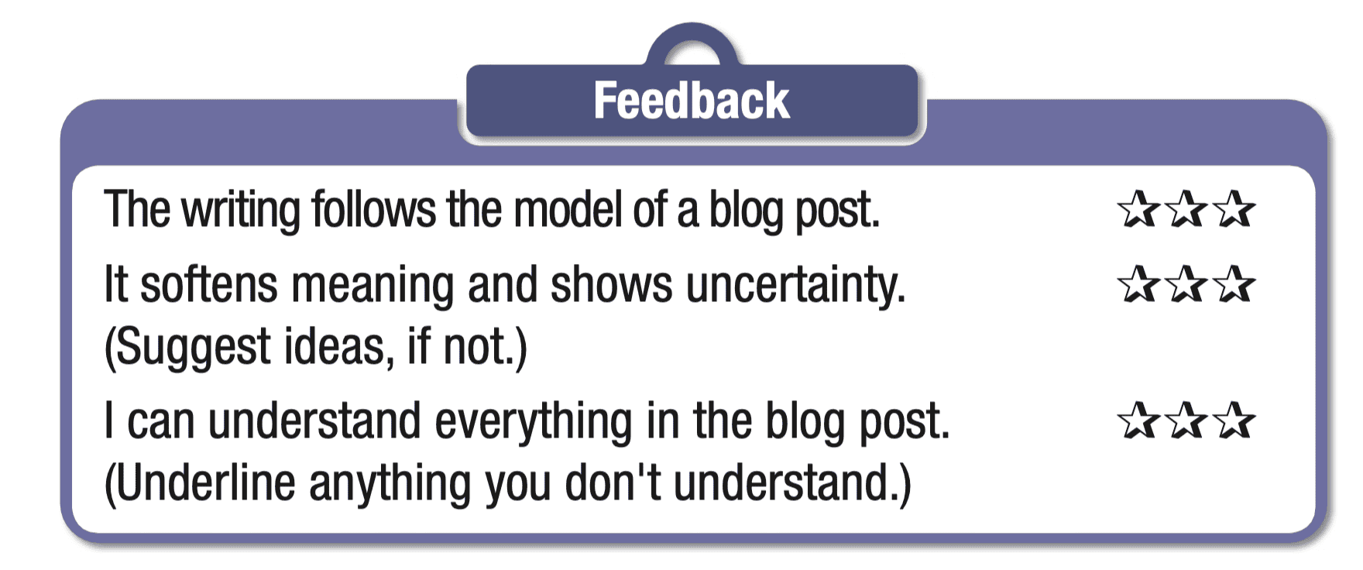
Task b. Make a list of things you need to remember for your future writing.
- Ask Ss to make a list of things you need to remember for their future writing | - Complete the task.
- Ask some students to share their ideas. | - Share the ideas with the class.
Suggested answer:
- Clarity and conciseness: Strive for clear and concise communication.
- Grammar and punctuation: Maintain proper grammar and punctuation.
- Organization and structure: Ensure logical organization and coherent structure.
- Proofreading and editing: Carefully proofread and edit your work for errors.
- Purpose and focus: Clearly define your purpose and stay focused on your topic.
- Revision and feedback: Take time to revise and seek feedback for improvement.

Task c. Compare your list with another group and add anything you think is useful.
- Ask Ss to compare their lists with another group and add anything they think is useful. | - Complete the task.
- Ask some students to share their ideas. | - Share the ideas with the class.

C. Consolidation and homework assignments (5’)
- Vocabulary:
1. entrepreneur
2. physical therapist
3. voluntary
4. reward
5. satisfaction
- Review the target language learned in the unit.
- Practice test-taking skills.
- Prepare for the next lesson (Revision).
- Play the consolidation games on www.eduhome.com.vn

5. Reflection
a. What I liked most about this lesson today:
…………………………………………………………………………………………
b. What I learned from this lesson today:
…………………………………………………………………………………………
c. What I should improve for this lesson next time:
…………………………………………………………………………………………

