School: Tran Phu high school | Week: 10  Date: 6/11/24
Class: 12a6 | Period:27
REVIEW 1
Review 1.2: Grammar, Pronunciation, Speaking & Writing (Page 38)
1. Objectives
By the end of this lesson, students will be able to…
1.1. Language knowledge/ skills
- use the past continuous, adverbial clauses of manner, conjunctions of time + gerunds.
- improve word stress and /s/ & /z/ sounds.
- talk about things tourists should know.
- check writing skills.
1.2. Competences
- improve Ss’ communication, collaboration, analytical, creativity, and critical thinking skills.
1.3. Attributes
- nurture Ss’ patience and attention to detail for consistent practice and repetition to reinforce learning and build fluency.
- understand Vietnam’s culture and give travel safety advice to tourists visiting Vietnam.
2. Teaching aids and materials
- Teacher’s aids: Student’s book and Teacher’s book, class CDs, DCR– Phần mềm tương tác trực quan, DHA – Ứng dụng trò chơi tương tác, projector / interactive whiteboard /TV (if any), PowerPoint slides.
- Students’ aids: Student’s book, Workbook, Notebook.
3. Assessment Evidence
Performance Tasks | Performance Products | Assessment Tools
- Fill in the blanks with the correct verb form.  - Fill in the blanks with the correct prepositions.  - Circle the word that differs from the other three in the position of primary stress in each of the following questions.  - Circle the word that has the underlined part pronounced differently from the others.  - Talk about things tourists should know.  - Check one of your partner's final writing passages for Units 1–3 using Feedback forms from the lessons.  - Make a list of things you need to remember for your future writing.  - Compare your list with another group and add anything you think is useful. | - Ss’ answers.  - Ss’ answers.  - Ss’ answers.  - Ss’ answers.  - Ss’ performance.  - Ss’ performance.  - Ss’ answers.  - Ss’ answers. | - Observation and feedback.  - Observation and feedback.  - Observation and feedback.  - Observation and feedback.  - Observation and feedback.  - Observation and feedback.  - Observation and feedback.  - Observation and feedback.
4. Procedures
A. Warm-up: 5 minutes
a. Objectives: To review phrasal verbs.
b. Content: ‘Word Search’ Game
c. Expected outcomes: Ss can find eight phrasal verbs.
d. Organization
Teacher’s activities | Students’ activities
Game: Word Search  - Instruct Ss to play the game.  + Work in groups of 4-5.  + Search 8 phrasal verbs.  + Which team finishes first wins.  + Time limit: 3 minutes.  - Check the answers as a whole class.  - Nominate the winner. | - Listen to the instructions.  - Work in groups and find eight phrasal verbs.  - Check the answers  - Congratulate the winner.

B. New Lesson (35’)
1. Grammar (10’)
a. Objectives: To review the past continuous, adverbial clauses manner, conjunctions of time + gerunds, and prepositions.
b. Content: Tasks a and b.
c. Expected outcomes: Ss can use grammar points in writing.
d. Organization
Teacher’s activities | Students’ activities
Review: The past continuous (Grammar Reference)  - Show the form of the past continuous.  - Have Ss read the sentences and underline the form of the past continuous.  1. Joe was swimming with dolphins this morning.  2. I was visiting Paris when I met your mom.  3. Ben was eating ice cream while Jen was taking photos.  4. While we were swimming, we saw a shark.  5. We were running home yesterday at 3:30 in the afternoon.  - Elicit Ss’ answers.  - Have Ss match the sentences with the uses of the past continuous.  - Have Ss check their answers with a partner.  _______ a. Two or more actions happening at the same time in the past.  _______ b. An action was in progress when another action interrupted it in the past.  _______ c. An action that was in progress at a specific time in the past.  _______ d. A past action that was in progress for a period of time.  - Check the answers as a whole class. | - Review the form of the past continuous.  - Read the sentences and underline the form of the past continuous  Answer Keys:  1. Joe was swimming with dolphins this morning.  2. I was visiting Paris when I met your mom.  3. Ben was eating ice cream while Jen was taking photos.  4. While we were swimming, we saw a shark.  5. We were running home yesterday at 3:30 in the afternoon.  - Match the sentences with the uses of the past continuous.  - Check the answers with a partner.  Answer Keys:  - 3  - 2, 4  - 5  - 1
Review: Adverbial clauses of manner (like, as if, as though). (Grammar Reference)  - Show the use of adverbial clauses of manner.  - Explain its function using the examples.  - Show the form.  S + past tense V + conjunction + clause  - Draw Ss’ attention to notes.  Note 1: When ‘like’ is used with a noun or noun phrase, it’s used as a preposition, not a conjunction.  Note 2: Using adverbial clauses of manner in different tenses can change the meaning.  - Provide additional explanations. | - Listen to the explanation and form of adverbial clauses of manner  - Take notes.
Review: Conjunctions of time (before, when, after, during) + gerunds. (Grammar Reference)  - Show the use of adverbial clauses of manner.  - Explain its function using the examples.  - Show the form.  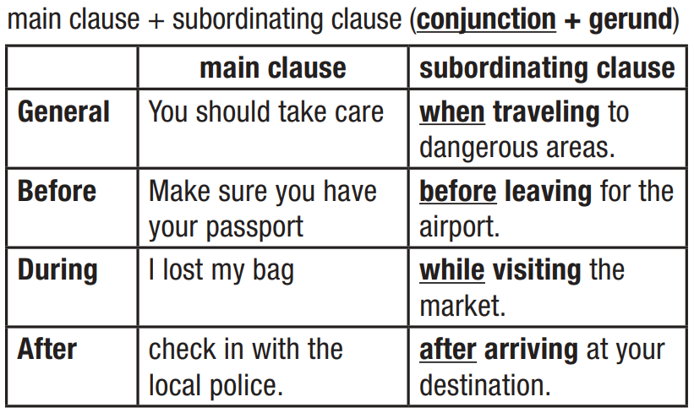  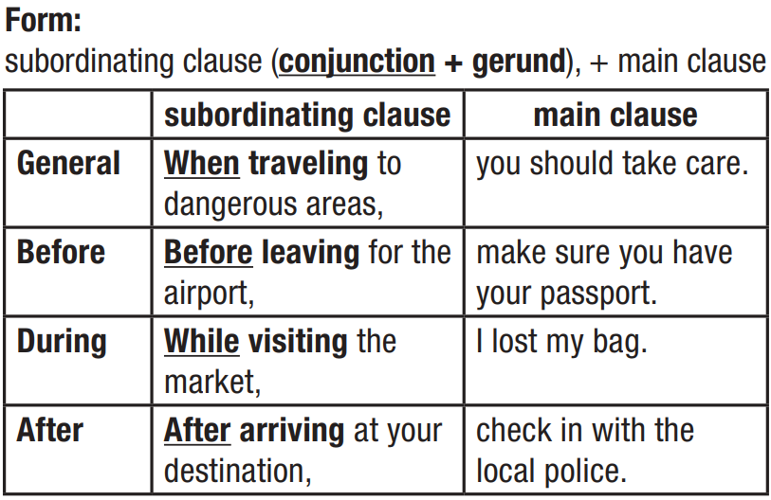  - Draw Ss’ attention to notes.  Note: We can put subordinating clauses before or after the main clause. When they come before the main clause, we use a comma,  - Provide additional explanations. | - Listen to the explanation and form of adverbial clauses of manner  - Take notes.
Task a: Fill in the blanks with the correct verb form.  - Have Ss fill in the blanks with the correct verb form.  - Have Ss check their answers with a partner.  - Invite Ss to give the answers and explain.  - Give feedback and provide additional explanations. | - Fill in the blanks with the correct verb form.  - Check their answers with a partner.  - Give the answers and explain.
Task b: Fill in the blanks with the correct prepositions.  - Have Ss fill in the blanks with the correct prepositions.  - Have Ss check their answers with a partner.  - Invite Ss to read the sentences aloud.  - Give feedback and provide additional explanations. | - Fill in the blanks with the correct verb prepositions.  - Check their answers with a partner.  - Read the sentences aloud.

2. Pronunciation (5’)
a. Objectives: To improve word stress and /s/ & /z/ sounds.
b. Content: Tasks a and b.
c. Expected outcomes: Ss can improve their word stress and /s/ & /z/ sounds.
d. Organization
Teacher’s activities | Students’ activities
Task a: Circle the word that differs from the other three in the position of primary stress in each of the following questions.  - Have Ss say the words and choose the correct answer.  - Have Ss check their answers with a partner.  - Check Ss’ answers around the class.  - Have Ss read the words aloud. | - Complete the task.  - Check the answers with a partner.  Answer Keys:  1.C 2.A  - Read the words aloud.
Task b: Circle the word that has the underlined part pronounced differently from the others.  - Have Ss say the words and choose the correct answer.  - Have Ss check their answers with their partner.  - Check Ss’ answers around the class.  - Have Ss read the words aloud as the whole class or individually. | - Complete the task.  - Check the answers with their partner.  Answer Keys:  1.D 2.C  - Read the words aloud.

3. Speaking (10’)
a. Objectives: To talk about things tourists should know.
b. Content: Tasks a, b, and c
c. Expected outcomes: Ss can talk about things tourists should know.
d. Organization
Teacher’s activities | Students’ activities
Task a: In groups of 2– 4: Choose a place in your country and talk about things tourists should know.  - Have Ss work in groups and talk about some things tourists should know:  • What tourists should know before visiting  • What they should or shouldn't do during their time there  • Places to visit and things to do  - Go around the class and support Ss if necessary.  - Invite Ss to perform in front of the class. | - Talk in groups of 2-4.  - Perform in front of the class.  Sample answers:  A: Let’s talk about Hoi An, a charming ancient town in Vietnam. What should tourists know before visiting Hoi An?  B: I think tourists should know about the climate in Hoi An. The best time to visit is from February to April when the weather is mild and beautiful with light sunshine and less rain.  A: How about transportation there?  B: Renting bicycles or motorbikes is a popular way to get around because Hoi An is a pedestrian-friendly town.  A: What should they do during their time there?  B: They should respect local customs such as dressing modestly when visiting temples and religious sites and removing shoes before entering sacred places.  A: What shouldn’t they do?  B: They shouldn’t litter. Dispose of your waste properly.  A: What activities do they do there?  B: They can visit the bustling night market to shop for local handicrafts, and souvenirs and enjoy street food.  A: That sounds interesting. Thank you!  Students’ answers.
Task b: Discuss and choose the five most important things tourists should know.  - Have Ss work in another group and discuss the five most important things tourists should know.  - Go around the class and support Ss if necessary.  - Invite Ss to perform in front of the class. | - Discuss in another group.  - Share/exchange their ideas.  - Share the ideas with the class.  Sample answers:  We think the five most important things tourists should know are:  - Best time to visit  - Local customs  - Bargaining  - Currency  - Language  Students’ answers.
Task c: Tell another group about your advice.  - Have Ss tell another group about their advice.  - Go around the class and support Ss if necessary.  - Invite Ss to perform in front of the class. | - Share/exchange their ideas.  - Share the ideas with the class.  Sample answers:  Students’ answers.

4. Writing (10’)
a. Objectives: To review writing skills presented in units 1-3.
b. Content: Tasks a, b, and c
c. Expected outcomes: Ss can consolidate writing skills.
d. Organization
Teacher’s activities | Students’ activities
Task a: In pairs: Check one of your partner's final writing passages for Units 1–3 using Feedback forms from the lessons.  - Show feedback forms from the lessons.  - Have Ss work in pairs to check their partner’s writing passage for units 1-3 and give feedback.  - Go around the class and support if necessary. | - Review feedback forms.  - Check a partner’s writing passage and give feedback.  Students’ answers.
Task b: Make a list of things you need to remember for your future writing.  - Demonstrate the activity using the example.  - Have Ss make a list of things they need to remember for their future writing.  - Go around the class and support if necessary.  - Have 1-2 Ss share their ideas with the class. | - Listen to the instructions.  - Make a list of things they need to remember for their future writing.  - Share the ideas with the class.  Sample answers:  Students’ answers.
Task c: Compare your list with another group and add anything you think is useful.  - Have Ss compare their list with another group and add anything they think is useful.  - Go around the class and support if necessary.  - Have 1-2 Ss share their ideas with the class. | - Complete their lists.  - Share the ideas with the class.  Students’ answers.

C. Consolidation and homework assignments (5’)
- Review Vocab, Grammar points, and Writing skills.
- Prepare for the next lesson (Unit 4: Vocabulary & Listening pages 39 & 40 - SB)
- Play the consolidation games on www.eduhome.com.vn
5. Reflection
a. What I liked most about this lesson today:
…………………………………………………………………………………………
b. What I learned from this lesson today:
…………………………………………………………………………………………
c. What I should improve for this lesson next time:
…………………………………………………………………………………………

