School: Tran Phu high school | Week:10  Date:4/11/24
Class: 12a6 | Period:26

REVIEW 1
Review 1.1: Listening, Reading, & Vocabulary (Pages 37 & 38)

1. Objectives
By the end of this lesson, students will be able to…
1.1. Language knowledge/ skills
- improve listening and reading for gist and specific information.
- practice test-taking skills.
- consolidate and practice vocabulary presented in units 1-3.
1.2. Competences
- improve Ss’ communication, collaboration, analytical, and critical thinking skills.
1.3. Attributes
- nurture Ss’ patience and attention to detail for consistent practice and repetition to reinforce learning and build fluency.
2. Teaching aids and materials
- Teacher’s aids: Student’s book and Teacher’s book, class CDs, DCR– Phần mềm tương tác trực quan, DHA – Ứng dụng trò chơi tương tác, projector / interactive whiteboard /TV (if any), PowerPoint slides.
- Students’ aids: Student’s book, Workbook, Notebook.
3. Assessment Evidence
Performance Tasks | Performance Products | Assessment Tools
- Listen and choose the correct answer (A, B, or C)  - Read and choose the best one (A-H) to fill in the blanks (1-5)  - Match the words with the descriptions.  - Fill in the blanks using the words in the box. | - Ss’ answers.  - Ss’ answers.  - Ss’ answers.  - Ss’ answers. | - Observation and feedback.  - Observation and feedback.  - Observation and feedback.  - Observation and feedback.
4. Procedures
A. Warm-up: 5 minutes
a. Objectives: To review vocabulary from unit 1 to unit 3.
b. Content: Competition Time: Word Voyage
c. Expected outcomes: Ss can list as many words related to topics in units 1-3 as possible.
d. Organization
Teacher’s activities | Students’ activities
COMPETITION TIME: Word Voyage  - Divide the class into groups of 5. Each group selects a captain.  - Instruct the game:  + Each round, a topic is chosen from the list provided: feelings, idioms, travel safety tips, jobs, skills for different jobs, etc.  + The captain of each team takes turns saying a word related to the chosen topic. For example, if the topic is ‘feelings’, the captain might start with ‘happy’. The next team captain must say ‘tired’.  + The game continues with each team taking turns until one team cannot think of a word within 10 seconds.  + Each correct word earns a point for the team. The team with the most points at the end of the game wins.  - Nominate the winner. | - Form groups of 5.  - Select the captain.  - Play the game.  - Count the points and congratulate the winner.

B. New Lesson (35’)
1. Listening (15’)
a. Objectives: To improve listening for the specific information.
b. Content: Listen twice and choose the correct answer.
c. Expected outcomes: Ss can listen and choose the correct answer.
d. Organization
Teacher’s activities | Students’ activities
Pre-Listening: Vocabulary Review  - Divide the class into 5 teams. Ss name their teams like Tiger, Lion, Batman, etc.  - Instruct the game rules:  + Have Ss look at each picture and say their team name quickly to have the right to answer. If the answer is wrong, other teams say their name before answering.  + The game continues with other pictures.  + Each correct answer earns a point for the team. The team with the most points at the end of the game wins.  - Nominate the winner. | - Form 5 teams and name each team.  - Listen to the instructions.  - Play the game.  Suggested answers:  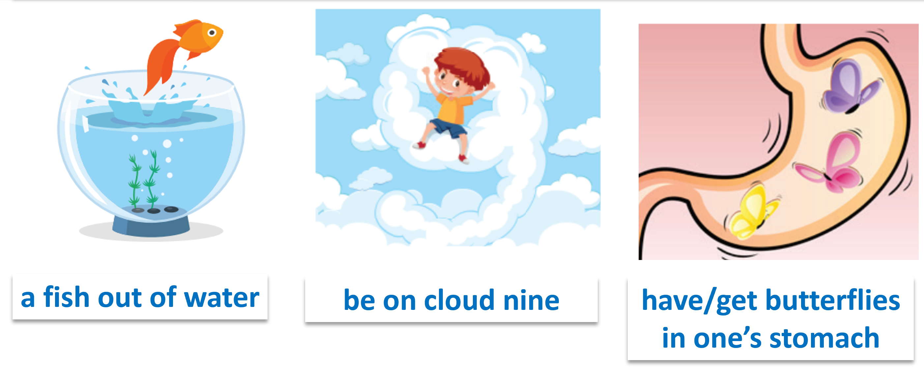
While-listening: Listen to each conversation twice and choose the correct answer (A, B, or C).  - Before listening, have Ss read the questions and look at the pictures to choose the correct answer.  - Play the audio. Have Ss listen and choose the answer.  - Check the answers as a whole class. | - Listen to the instructions.  - Listen to the audio and choose the answer.  Answer Keys  1. A 2. B 3. A 4. C 5. B
Post-listening: in pairs, talk about your feelings using idioms such as ‘a fish out of water’, ‘have butterflies in one’s stomach’, ‘be on cloud nine’, etc.  - Have Ss work in pairs.  - Make a short conversation talking about their feelings using idioms.  - Check around the class and support Ss if necessary.  - Invite some pairs to perform in front of the class. | - Work in pairs and have a short conversation.  - Perform in front of the class.  Sample conversations:  Students’ answers.

2. Reading (15’)
a. Objectives: To improve reading for the specific information.
b. Content: Read and fill in the blanks.
c. Expected outcomes: Ss can read for the specific information.
d. Organization
Teacher’s activities | Students’ activities
Pre-reading:  - Have Ss read the instructions carefully and underline the key information.  - Provide Ss with test-taking skills for the reading section.  1. Read the title or heading first to guess what the text is about. The first sentence of the passage often provides the main topic.  2. Read the entire passage to understand the main ideas and get a sense of where specific types of information might fit best.  3. Identify keywords and themes in the sentences surrounding each blank. These can give clues about what kind of information is missing.  4. Pay attention to pronouns and conjunctions to look for logical flow.  5. Read through all the options and eliminate wrong answers. | - Read the instructions and underline the key information.  - Listen to the test-taking skills and take notes.
While-reading:  - Have Ss read the title and first sentence to get the main topic.  - Elicit Ss’ answer.  - Have Ss read the text to find the main ideas.  - Elicit Ss’ answers.  - Have Ss identify keywords and themes in the sentences surrounding each blank.  - Have Ss read through all options to choose the correct answers.  - Have Ss highlight conjunctions and pronouns to look for logical flow.  - Check around the class.  - Check the answers as a whole class. | - Read the title and first sentence to get the main topic.  - Read the text to find the main ideas.  - Identify keywords and themes in the sentences surrounding each blank.  - Read through all options to choose the correct answers.  Answer Keys:  1. C 2. G 3.D 4.A 5. F
Post-reading:  - Have Ss read the completed passage again.  - Have one student read one paragraph aloud. | - Read the completed passage again aloud.

3. Vocabulary (5’)
a. Objectives: To review vocabulary from unit 1 to unit 3
b. Content: Task a and b
c. Expected outcomes: Ss can use vocabulary in the context.
d. Organization
Teacher’s activities | Students’ activities
a. Match the words with the descriptions. There are two extra words which you do not need to use.  - Have Ss read the words and the descriptions.  - Have Ss match the words with the descriptions.  - Have Ss check their answers with their partner.  - Check the answers as a whole class. | - Read and match the words with the descriptions.  - Check the answers with their partner.  Answer Keys:  1. operate  2. complimentary  3. discreet
b. Fill in the blanks using the words in the box. There are two extra words which you do not need to use.  - Have Ss read the words and the sentences.  - Have Ss fill in the blanks.  - Have Ss check their answers with their partner.  - Invite Ss to give the answers and read the sentences aloud. | - Read and fill in the blanks.  - Check the answers with their partner.  - Give the answers and read the sentences aloud.  Answer Keys:  1. spot  2. confident  3. pick up

C. Consolidation and homework assignments (5’)
- Review and use Vocabulary to make sentences.
- Do the exercises on page 62 - WB
- Prepare for the next lesson (Grammar, Pronunciation, Speaking & Writing on page 38 - SB)
- Play the consolidation games on www.eduhome.com.vn
5. Reflection
a. What I liked most about this lesson today:
…………………………………………………………………………………………
b. What I learned from this lesson today:
…………………………………………………………………………………………
c. What I should improve for this lesson next time:
…………………………………………………………………………………………

