September 4th 2024 | Teacher in charge: Tran Le Vi  Group: Social science
PERIOD 1: INTRODUCTION
Subject: English - Class: 7A1, 7A2, 7A3, 7A4
Allotted time: one period
I. OBJECTIVES:
1. Knowledge:
+ Introducing the content of the textbook, bookmap and the curriculum.
+ Talking about ways of studying and doing the test, Present forms of test
2. Competences:
+ Introducing the content of the textbook, bookmap and the curriculum.
+ Talking about
+ Self-control and self-study competence,Communicative and cooperative competence.
3. Quality/ behavior: To teach Ss the loveof English, the awareness about importance of learning English and educate Ss to have the good attitude to working in groups, individual work, pairwork, cooperative learning and working.
-Educate sts to study harder and to be honest in examinations.
II. TEACHING AIDS AND MATERIALS:
1. Teaching aids: a TV, a laptop computer, pictures, cards, extra boards, Portable multi-function audio device , a loudspeaker, a projector, real objects.
2. Materials: textbooks, workbooks, lesson plan, the teacher’s book, reference books, hoclieu.vn
III. PROCEDURE:
1. ACTIVITY 1: WARM UP & INTRODUCTION ( 4ms)
a. Aims:
- To create a friendliness and atmosphere in the class before the lesson;
- To give T and Ss a chance to introduce themselves;
- To lead into the content of the lesson
b. Content: To have some warm-up activities to create a friendly and relaxed atmostphere to inspire Ss to warm up to the subject and new lesson.
c. Outcome: The content of the textbook ,bookmap and the curriculum.
Ways of studying and doing the test, Present forms of test.
d. Organisation :Teacher’s instructions …
+ Greeting
+ Chatting
- Teacher (T) introduces himself/ herself
- T may introduce some warm-up activities to creat a friendly and relaxed atmostphere to inspire Ss to warm up to the subject and new class…
- Have Ss to introduce themselves.
- T encourages Ss to talk in English as much as possible
+ Lead to the lesson.
* Net work
How do you learn English?

……………………
practice speaking
talk with friends

- T follows and remarks.
- T introduces the lesson.
2. ACTIVITY 2: KNOWLEGDE FORMATION ACTIVITIES/ PRESENTATION / NEW LESSON ( 14ms)
a. Aims:
- To revise the methods of learning English.
- To help the students know the curriculum of the grade 7.
b. Content: methods of learning English.
The curriculum of the grade 7.
c. Outcome: Know how to learn English effectively and get the main parts of the text book and the work books
d. Organisation : Teacher’s instructions..
* Method of studying:
- Train four skills as much as possible
(1) Do the homework.
(2) Do more grammar exercises in grammar books.
(3) Read short stories or newspapers in E.
(4) Write E as much as possible. Write a passage, a web page, an e-mail….
(5) Learn by heart all the new words & texts.
(6) Speak E with friends. Speak E in class, limit Vietnamese .
(7) Use a dictionary for reading and practicing pronunciation.
(8) Practice listening to E tapes.
(9) Watch English TV programs.
(10) Learn to sing E songs.
(11) take part in English speaking club
- Try your best to improve yourself.
- Arrange the timetable at school and at home suitably.
……………….
* Introduce the bookmap
- To help the students know the curriculum of the grade 7.
- To follow and help the students know the knowledge that they get from the units.
3. ACTIVITY 3: PRACTICE ACTIVITIES ( 17ms)
a. Aims:- To make a chance for the students discuss the methods of learning English.
- To help the students know more about forms of test..
b. Content: Discussion .
c. Outcome: Know more about methods of learning English and forms of tests
d. Organisation :Teacher’s instructions.…..
* Discuss ways of learning English
-Gets the students to work in pairs and discuss the following questions:
+ How do you develop your reading/ speaking/ listening/writing?
- Speak English with friends.
- Listen to English tape everyday and English programs on TV.
- Write the passage about personal
- Calls some pairs to present the questions and their answers before the class.
- Follows and gives remarks.
* Forms of test
1. LISTENING:
. Listen and match;
. Listen and number;
. Listen and tick;
. Listen and complete;
…..
2. READING:
. Read and match;
. Read and number;
. Read for the main idea;
. Read for specific details;
……
3. WRITING:
- Complete the sentences with a word or a phrase (pictures can be used);
- Arrange the words to make complete sentences;
- Use the provided words or phrases to write complete sentences;
-…….
4. SPEAKING:
- Introduction;
- Interview;
- Free talk;
- Other speaking tasks.
5. USE OF ENGLISH:
. Multiple choice questions – MCQs;
. Matching;
. Gap filling; …..
- ACTIVITY 4: APPLICATION/ PRODUCTION/ FURTHER PRACTICE ( 8ms)
a. Aims: -To help the students develop their writing skill.
-To make a chance for the students talk about themselves.

b. Content: Writing a short passage about personal information.

Talking about yourself
c. Outcome:Ss know more about their friends, esp new comers .
d. Organisation :Teacher’s instructions
* Writing a short passage about personal information
- Gets the students to work in groups and write a short passage about personal information.
My name is Linh .I’m fourteen ……
- Has the students show their writing on the board .
- Calls the students to give remarks.
- Follows and remarks.
* Talking about yourself.
- Gets the students to work in groups and introduce about their members .
- Calls some to present their speaking before the class.
- Follows and gives remarks.
*WRAP-UP & HOMEWORK ( 2ms)
Summarise the main points of the lesson.
- Asks one or two Ss to tell the class what they have learnt.
- Asks Ss to say aloud some ways of learning English which they remember from the lesson.
* HOMEWORK
- Asks the students to:
+ Prepare for unit 1
+ If there is a projector in the classroom, show the conversation, highlight the key words related to the umit. It would be helpful if T highlights the main content

September 5th 2024 | Teacher in charge: Tran Le Vi  Group: Social science
UNIT 1: HOBBIES
Period 2: LESSON 1:GETTING STARTED
Subject: English - Class: 7A1, 7A2, 7A3, 7A4
Allotted time: one period
I. OBJECTIVES:
* By the end of this lesson, students will be able to:
- use the words related to hobbies and verbs of liking and disliking to talk about different hobbies;
- use the present simple tense;
- talk about likes and dislikes;
1. Knowledge:
- To introduce topic of the lesson My Hobbies. To practice listening and reading.
+ Vocabulary: use the words related to the topic My Hobbies.
+ Grammar: - use the present simple tense;
2. Competence:By the end of the lesson students will be able to know the form and use the present simple tense; talk about the benefits of hobbies correctly. Students can talk about likes and dislikes;
3. Quality/ behavior: To teach Ss the love of English; the love of their hobbies. The awareness about importance of learning English. Ss have the good attitude to working in groups, individual work, pairwork, cooperative learning and working.
II. TEACHING AIDS AND MATERIALS:
1. Teaching aids: a TV, a laptop computer, pictures, cards, extra boards, Portable multi-function audio device , a loudspeaker, a projector, real objects.
2. Materials: textbooks, workbooks, lesson plan, the teacher’s book, reference books, hoclieu.vn
III. PROCEDURE:
1. ACTIVITY 1: WARM UP & INTRODUCTION ( 5ms)
a. Aims:
- To create a friendly and active atmosphere in the class before the lesson;
- To give T and Ss a chance to introduce themselves;
- To lead into the new unit
b. Content: To have some warm-up activities to create a friendly and relaxed atmostphere to inspire Ss to warm up to the subject and new lesson.
c. Outcome: Introducing themselves to make more new friends.
d. Organisation : Teacher’s instructions …
+ Greeting
+ Chatting
- Teacher (T) introduces himself/ herself
- T may introduce some warm-up activities to creat a friendly and relaxed atmostphere to inspire Ss to warm up to the subject and new class…
- Have Ss to introduce themselves.
- T encourages Ss to talk in English as much as possible
+ Lead to the first unit of the new school year.
Before Ss open their books, T asks Ss what they like doing for pleasure in their free time.
- Summarise Ss’ answers and asks them what these activities are called
- Elicit the word ‘hobbies’
- Write the unit title My Hobbies on the board and ask Ss guest what they are going to learn this unit …
- Ask Ss to open their book to page 6 and introduce what they are going to study….
2. ACTIVITY 2: KNOWLEGDE FORMATION ACTIVITIES/ PRESENTATION / NEW LESSON ( 10ms)
a. Aims:
- To provide students with vocabulary;
- To help students be well-prepared for the listening and reading tasks.
b. Content: - Vocabulary pre-teaching
c. Outcome: - Students can identify some new words about hobbies.
d. Organisation : Teacher’s instructions..
T sets the scene / context for the listening and reading.
- Teacher introduces the vocabulary.
- Teacher explains the meaning of the new vocabulary by showing pictures or giving explanations.
* Teach vocabulary:
+ Teacher uses different techniques to teach vocab (situation, realia, translation.)
+ Follows the seven steps of teaching vocab.
1. amazing /əˈmeɪzɪŋ/ (adj): tuyệt vời
It’s amazing. (Nó thật tuyệt đấy. )
2. make it yourself /meɪk ɪt jɔːˈself/ (v.phr): tự làm lấy
Did you make it yourself? (Bạn đã tự làm nó đúng không?)
3. building dollhouses /ˈbɪl.dɪŋ ˈdɒlˌhaʊsiz/ (n.phr): xây nhà búp bê
My hobby is building dollhouses. (Sở thích của tôi là xây nhà búp bê.)
4. cardboard /ˈkɑːdbɔːd/ (n): bìa cứng, các-tông
All you need is some cardboard and glue.(Mọi thứ bạn cần là một ít bìa cứng và hồ dán.)
5. creativity /ˌkriːeɪˈtɪvəti/ (n): sự sáng tạo
Then just use a bit of creativity.(Sau đó chỉ cần tận dụng một ít sáng tạo nữa.)
6. horse-riding /ˈhɔːs raɪdɪŋ/ (n): cưỡi ngựa
I like horse-riding.(Tôi thích cưỡi ngựa.)
7. common /ˈkɒmən/ (adj): phổ biến, thịnh hành
Actually, it’s more common than you think.(Sự thật thì chúng phổ biến hơn bạn nghĩ đấy.)
8. collecting teddy bears /kəˈlektɪŋ ˈted.i /berz/ (n.phr): sưu tầm gấu bông
He likes collecting teddy bears in his free time.(Anh ấy thích sưu tầm gấu bông trong khi rảnh rỗi.)
9. make model /meɪk ˈmɒdl / (v.phr): làm mô hình
The children love making models.(Những đứa trẻ thích thiết kế mô hình.)
10. collecting coins /kəˈlektɪŋ kɔɪnz/ (n.phr): sưu tầm đồng xu
My brother likes collecting coins.(Anh trai tôi thích sưu tầm đồng xu.)
11. gardening /ˈɡɑːdnɪŋ/ (n): việc làm vườn
Gardening is my hobby. (Sở thích của tôi là làm vườn.)
12. learn how to do something /lɜrn haʊ tu du ˈsʌmθɪŋ/ (v.phr): học cách làm việc gì
I want to learn how to ride.(Tôi muốn học cách cưỡi ngựa.)
+ Checks vocabulary.
+ Gets SS to take note
3. ACTIVITY 3: PRACTICE ACTIVITIES ( 20ms)
Task 1: Listen and read.( 4ms)
- Aims: -To set the context for the introductory conversation;
- To introduce the topic of unit, the vocabylary, the sounds, and the grammar points to be learnt.
b. Content: Listen and read the conversation.
c. Outcome: Know more new words. Understand the conversation; topic of the lesson, Vocab, grammar points…
d. Organisation : Teacher’s instructions.…..
- Asks Ss to look at the pictures in the book and answer the questions:
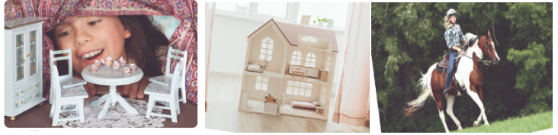
+ What can you see in each picture?
+ What hobby do they have?
- T introduces the two characters : Trang and Ann. Explains they are friends. Quickly write Ss’ answers on the board
- Plays the recording twice for Ss to listen and read along.
- Has Ss underline the words that are related to the topic of the unit while they are listening and reading
- Invites some pairs of Ss to read the conversation aloud
- Now refer to the answers on the board. Confirm the correct answers.
+ A girl with a dollhouse, a dollhouse and a girl riding a horse
+ Trang’s hobby is building dollhouses and Ann’s hobby is horse riding
- Hve Ss say the words in the text that they think are related to the topic My hobbies. Quickly write the words on one part of the board. Comment on Ss’ answers.
Task 2: Read the conversation again and write T (True) or F (False). ( 5ms)
a. Aim: To help Ss understand the conversation.
b. Content: Read the conversation again and write T (True) or F (False).
c. Outcome: Know more new words. Understand the conversation; topic of the lesson, Vocab, grammar points…
d. Organisation : Teacher’s instructions.…..
- Teacher tells Ss to read the conversation again and work independently to find the answers. Remind Ss to underline the information and correct the false statements.
- Ss work independently to find the answers.
- Teacher has Ss compare the answers in pairs before checking with the whole class.
- Teacher checks the answers as a class and gives feedback.
Answer key:
- F (She made it herself.)
- T
- T
- T
5. F (Her lesson starts at 8 a.m.)
Task 3: Write the correct word or phrase from the box under its picture. ( 5ms)
a. Aim: - To introduce some vocabulary items related to hobbies;
b. Content: Understand the conversation;
c. Outcome: SS know more about the topic of the lesson, Vocabularies
d. Organisation : Teacher’s instructions …
- T asks Ss to name the pictures.
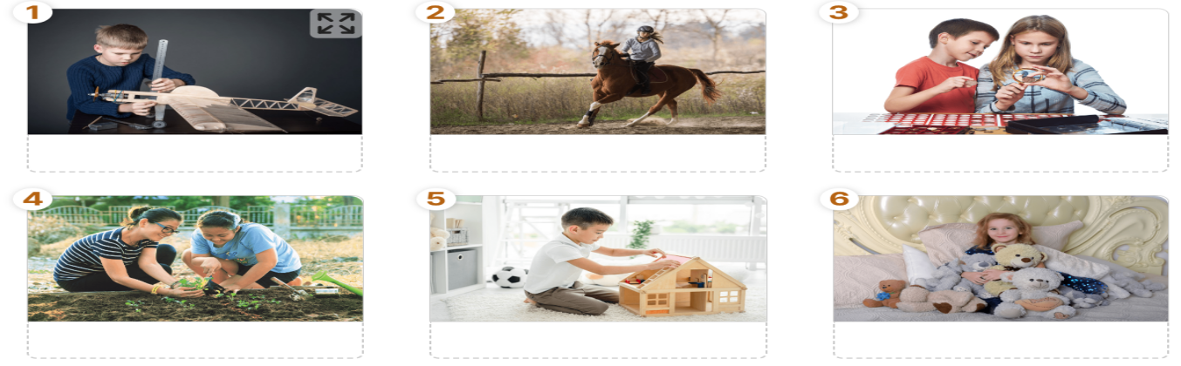
- T has Ss work individually to match the words and phrases in the box with the pictures. Have them compare their answers with a partner. Then ask for Ss’ answers. Quickly write their answers on the board without confirming the correct answers.
- T has Ss listen to the recording, check their answers, and repeat the words / phrases. Ask Ss to look at the answers on the board and say if they are right or wrong. Confirm the correct answers.
- T checks the answers as a class and gives feedback.
Answer keys:
- making models
- riding a horse
- collecting coins
- gardening
- building dollhouses
6. collecting teddy bears
Task 3: Write the hobbies form 3 in the suitable columns. ( 6ms)

a. Aim: To help Ss categorise hobbies
b. Content:To learn some more words indicating hobbies. Filling
c. Outcome: Ss know more some words about hobbies
d. Organisation : Teacher’s instructions ….
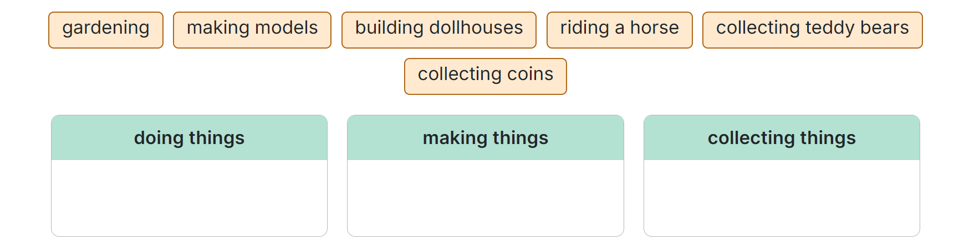- Have Ss work in pairs and complete the table.
- Ss work in pairs and complete the table.
- Teacher allows students to share answers before discussing as a class.
- Write their answers on the board. Have Ss add more words to the table.
Answer key:
+ doing things: riding a horse, gardening (others: travelling, skiing, doing yoga, etc.)
+ making things: making models, building dollhouses (others: painting, making pottery, etc.)
+ collecting things: collecting coins, collecting teddy bears (others: collecting toys, collecting books,etc.)

4. ACTIVITY 4: APPLICATION/ PRODUCTION/ FURTHER PRACTICE ( 8ms)

a. Aim: To help Ss practise using the vocabulary items related to hobbies
b. Content: Talk and find the hobbies
c. Outcome: Ss can name the hobbies. Learn more new words.
d. Organisation : Teacher’s instructions
Find someone who...
Work in groups. Ask your classmates which hobbies they like. Use the question “Do you like...?”. Write the students’ names in the table below. Which hobby is the most popular?
- T lets Ss to move around the class to ask their classmates about their favourite hobbies in 3-5 minutes.
- Has Ss write the results into the table, using the questions ‘Do you like ..?’
- T asks some Ss to report their results. Whoever has the most names wins.
-Teacher can ask students to read aloud the full sentences and correct their pronunciation if needed
*WRAP-UP & HOMEWORK (2ms)
Summarise the main points of the lesson.
- T asks Ss to talk about what they have learnt in the lesson.
- An overview about the topic Hobbies - Vocabulary to talk about hobbies
* HOMEWORK
- Name a list of cheap hobbies, expensive hobbies, easy and difficult hobbies. - Do exercises in the workbook. - Prepare for Lesson 2 - A closer look 1 - Start preparing for the Project of the unit. Teacher randomly puts Ss in groups of 4 or 5 and asks them to choose a popular hobby among teens and think about its benefits, then discuss to choose what to include. They have to find suitable photos or draw pictures then creat a poster about it. Students will show their posters and present their ideas in Lesson 7 – Looking back and Project. (Teacher should check the progress of students’ preparation after each lesson.)

September 8th 2024 | Teacher in charge: Tran Le Vi  Group: Social science
UNIT 1: HOBBIES
Period 3: LESSON 2: A CLOSER LOOK 1
Subject: English - Class: 7A1, 7A2, 7A3, 7A4
Allotted time: one period
I. OBJECTIVES:
1. Knowledge:
To use the words related to the topic Hobbies and pronounce the sounds / ə / and / З:/ correctly
To use common verbs of liking and disliking are: like, love, enjoy, and hate (not like) +V_ing
- Vocabulary:
+ The lexical items related to hobbies
+ Verbs of liking and disliking
- Pronunciation: Correctly pronounce words that contain the sounds /ə/ and /ɜ:/
2. Competence: By the end of the lesson, students will be able to know use common verbs of liking and disliking. Students can say the sentences use the suitable verbs of liking or disliking and the_ing form.
3. Quality/ behavior: To teach Ss the love of English; the love of their hobby. The awareness about importance of learning English. Ss have the good attitude to working in groups, individual work, pairwork, cooperative learning and working.
II. TEACHING AIDS AND MATERIALS:
1. Teaching aids: a TV, a laptop computer, pictures, cards, extra boards, Portable multi-function audio device , a loudspeaker, a projector, real objects.
2. Materials: textbooks, workbooks, lesson plan, the teacher’s book, reference books, hoclieu.vn
III. PROCEDURE:
1. ACTIVITY 1: WARM UP & INTRODUCTION ( 3ms)
a. Aims:
- To create a friendly and atmosphere in the class before the lesson;
- To activate students’ prior knowledge and vocabulary related to the topic.
b. Content: To have some warm-up activities to create a friendly and relaxed atmosphere to inspire Ss to warm up to the subject and new lesson.
c. Outcome: sts know some activities related to the topic HOBBIES
d. Organisation :
Teacher asks sts to play a game “Networks”:
HOBBIES

Reading
- Has sts work in groups writing as many hobbies as possible in 2 minutes. The one which has more is the winner.
- T remarks and gives feedback.
Suggested answer:
- playing board games
- taking photos
- bird-watching
- cycling
- playing the guitar
- gardening
- cooking
- arranging flowers
- skating
- Informs the class of the lesson objectives and leads to the lesson.
- ACTIVITY 2: KNOWLEGDE FORMATION ACTIVITIES/ PRESENTATION / NEW LESSON ( 12ms)
a. Aims:
- To enrich students’ vocabulary and help students have concept and identify the sounds
/ ə / and / З:/.
- To use common verbs of liking and disliking are: like, love, enjoy, and hate (not like) +V_ing
b. Content: some new words and ways to pronounce sounds / ə / and / З:/
verbs of liking and disliking are: like, love, enjoy, and hate (not like) +V_ing
c. Outcome: Know more new words and how to pronounce sounds / ə / and / З:/ correctly
use common verbs of liking and disliking
d. Organisation :
I.Vocabulary:
- providing explanations of the words;
- showing picture illustrating the word.
+ jogging (picture)
+ yoga (picture)
+ coin (picture)
+ making models (real thing)
- Checking understanding of new words, using “what and where”.
- Uses Rub out and Remember to check Ss’ new words
II.Remember:
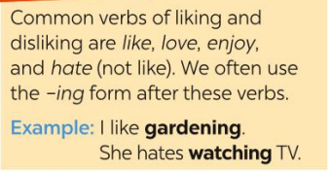
III.Pronunciation:
- Teacher introduces 2 sounds / ə / and / З:/ to students and lets them watch videos about how to pronounce these two sounds. (https://www.youtube.com/watch?v=OPemA_z91xY)
- Teacher asks students to give some words they know containing these sounds.
- Teacher draws students’ attention to the letters containing the sounds and helps them identify the sounds.
Answers:
/ ə /:amazing, yoga, collect, column
/ З:/ : learn, surf, work, thirteen
3. ACTIVITY 3: PRACTICE ACTIVITIES ( 20ms)
Task 1: Complete the word webs below with the words from the box.( 4ms)
a. Aim: To present some action verbs that go with nouns to describe hobbies.
b. Content: Listen and repeat the words.
c. Outcome: Know some common hobbies.
d. Organisation:
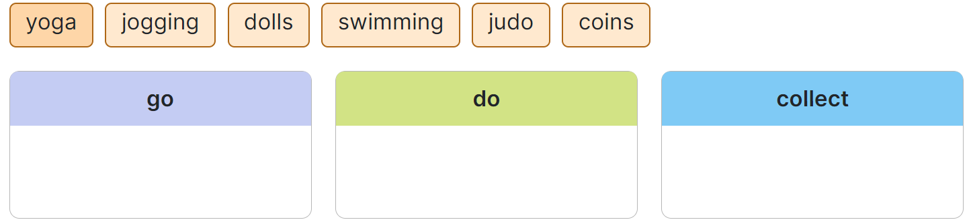
- Teacher has students read the action verbs and match them with suitable words the box. Remind them that a verb can go with more than one word.
- Teacher asks students to work in pairs and quickly do the task.
- Teacher allows students to peer check first.
- Teacher checks and confirms the answers. Then has students add more words that can go with these action verbs.
- Has students read the Remember! box. Asks them to make some examples with the verbs of liking and disliking.
Answer key:
go: jooging, swimming ( others: go camping, go fishing, go cycling, etc.)
do: judo, yoga (others: do karate, do exercise, do sit-ups, etc.)
collect: dolls, coins (others: collect books, collect watches, collect pencils, etc.)
Task 2: Complete the sentences, using the -ing form of the verbs from the box. ( 4ms)
a. Aim: To help students practise the verbs of liking / disliking and action verbs.
b. Content: Complete the sentences, using the-ing form of the verbs from the box.
c. Outcome: Know how to use the verbs of liking and disliking
d. Organisation :
- Teacher reminds students about the form of verbs of liking / disliking.
- Has students do this activity individually. Has students read all the sentences carefully to make sure they understand the sentences.
- Teacher lets them share their answers in pairs. Invites some students to give the answers.
- Teacher writes the correct answers on the board.
Answer key:
1. collecting 2. going 3. playing 4. making 5. doing
Task 3: Look at the picture and say sentence. Use suitable verbs of liking or disliking and the -ing form.( 4ms)
a. Aim:
To give further practice with verbs of liking/ disliking.
b. Content: Look at the pictures and say the sentences. Use the suitable verbs of liking or disliking and –ing form.
c. Outcome: Know how to say the sentences with verbs of liking/ disliking
d. Organisation :
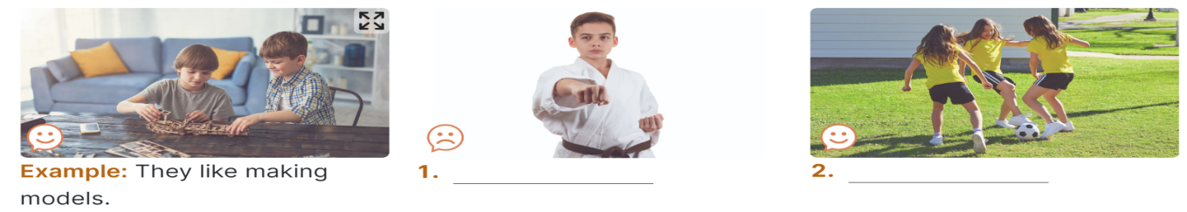
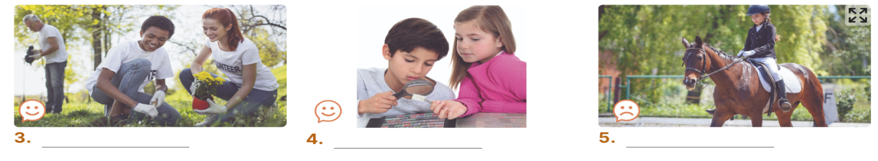
- Teacher has students look at the pictures in this exercise and say what the person / people is / are doing in each picture.
- Asks them what the face in each picture means. (A sad face means ‘not like’ and a happy face means ‘like’.)
- Asks students to look at the example to make sure they understand what to do.
- Teacher asks students to work in pairs to make sentences.
- Teacher invites students to share their answers.
- Confirm the correct answers.
Answer key:
1. He hates / doesn’t like doing judo.
2. They like / love / enjoy playing football.
3. They love / like / enjoy gardening.
4. They enjoy / like / love collecting stamps.
5. She hates / doesn’t like riding a horse / horse riding.
Task 4: Listen and repeat. Pay attention to the sounds / ə / and /ɜ:/ ( 4ms)
- Aims: - To help students identify how to pronounce the sounds /ə/ and /ɜ:/.
- To help students practise pronouncing these sounds in words.
b. Content: Listen and pay attention to the sounds /ə/ and /ɜ:/
c. Outcome: Practice pronouncing these sounds in words
d.Organisation:
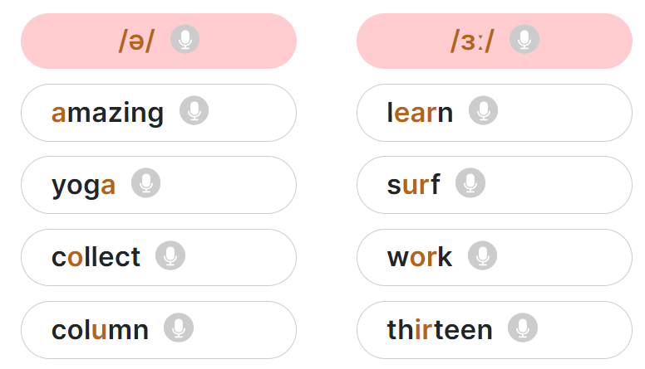
- Teacher has some students read out the words first.
- Teacher plays the recording for them to listen and repeat the words they hear. Asks them to pay close attention to the two sounds. Play the recording as many times as necessary.
- Teacher explains to students the difference between the two sounds if needed. Tells students that /ə/ is the schwa sound while /ɜ:/ sounds like it has a soft /r/ in it.
- Teacher invites some students to say some words they know that include the two sounds.
- Confirms the correct answers.
(Teacher can play the pronunciation guide video of this unit for students to watch and learn).
Task 5: Listen to the sentences and pay attention to the underlined parts. Tick () the appropriate sounds. Practise the sentences. ( 4ms)
a. Aim: To help students pronounce the sounds /ə/ and /ɜ:/ correctly in sentences.
b. Content: Listen and pay attention to the sounds /ə/ and /ɜ:/
c. Outcome: practice pronouncing these sounds in sentences.
d.Organisation :
- Teacher has students quickly read the sentences.
- Teacher plays the recording for students to listen to the sentences. Asks them to pay attention to the underlined parts and tick the appropriate sounds.
- Invites some students to share their answers.
- Confirms the correct ones.
Answer key:
 | /ə/ | /ɜ:/
1. My hobby is collecting dolls. | ✔
2. I go jogging every Thursday. |  | ✔
3. My cousin likes getting up early. |  | ✔
4. My best friend has thirty pens. |  | ✔
5. Nam enjoys playing the violin. | ✔
4. ACTIVITY 4: APPLICATION/ PRODUCTION/ FURTHER PRACTICE ( 8ms)

a.Aim: To allow Ss to apply what they have learnt to play a game and to check Ss’ comprehension and broaden their knowledge

b. Content: game “Who’s faster?”
c. Outcome: Ss can write sentences including 2 features: hobbies and one of the sounds /ə/ and /ɜ:/
d. Organisation :
- Teacher divides students into groups of four, gives each group a piece of paper, asks them to write sentences including 2 features: hobbies and one of the sounds /ə/ and /ɜ:/
(e.g: Nam enjoys playing the violin)
- Teacher asks each group to hand in their paper and checks, the group with more correct sentences will be the winner.
- Teacher invites the winner to read aloud their sentences and give feedback.
*WRAP-UP & HOMEWORK ( 2ms)
Summarise the main points of the lesson.
- Asks one or two Ss to tell the class what they have learnt.
- Asks Ss to say aloud some words they remember from the lesson.
* HOMEWORK
-Do more exercises in workbook.
-Prepare: A closer look 2
September 11th 2024 | Teacher in charge: Tran Le Vi  Group: Social science
UNIT 1: HOBBIES
Period 4: LESSON 3: A CLOSER LOOK 2
Subject: English - Class: 7A1, 7A2, 7A3, 7A4
Allotted time: one period
I. OBJECTIVES:
1. Knowledge:
- Review the knowledge on present simple tense.
2. Competence: By the end of the lesson students will be able to know how to use the present simple.
3. Quality/ behavior: To teach Ss the love of English; the love of their hobby. The awareness about importance of learning English. Ss have the good attitude to working in groups, individual work, pairwork, cooperative learning and working.
II. TEACHING AIDS AND MATERIALS:
- Teacher: Text book, laptop, loudspeaker, projector…
- Students: Text books, studying equipment….
- Method;: T-WC; group works; individual ……
III. PROCEDURE:
1. ACTIVITY 1: WARM UP & INTRODUCTION ( 3ms)
a. Aims:
- To create a friendly and active atmosphere in the class before the lesson;
- To lead into the unit
b.Content: Game: Guessing game
c.Outcome: Enhance Ss’ skills of cooperating with teammates.
d. Organisation : Teacher’s instructions …
- T divides the class into 4 teams.
- T calls on a S from each team to go to the board in turn. That S thinks of a hobby and says the keywords out loud. The other teams try to guess What the hobby is. They will get 1 point for each correct answer. The team with the most points is the winner.
- Teacher and students discuss as a class.
- Teacher asks students to say the words aloud and makes sure they pronounce the words correctly. Teacher can ask for translation to check their understanding.
Example:
A: water, grow, flowers, vegetable.
B: Is it gardening?
A: Yes, it is.
- T draws Ss’ attention to the form of the sentences created in the game and asks them whether they know the target tense.
2. ACTIVITY 2: KNOWLEGDE FORMATION ACTIVITIES/ PRESENTATION / NEW LESSON ( 12ms)
a. Aims: To help Ss know and revise the use of the present simple tense
b. Content: Learn the use of the present simple tense
c. Outcome: Know and understanding the grammar points…
d. Organisation : Teacher’s instructions..
- Cuts and show the following lines from the conversation in Getting Started on the board
Ann: Your house is very nice, Trang
Trang: Thanks! Let’s go upstairs. I’ll show you my room.
Ann: I love your dollhouse. It’s amazing. Did you make it yourself?
Trang: Yes. My hobby is building dollhouses.
Ann: Really? Is it hard to build one?
Trang: Not really. All you need is some cardboard and glue. Then just use a bit of creativity. What do you do in your free time?
Ann: I like horse riding.
- Underlines the present simple structures in these lines
- Asks Ss to look at the sentences in the Remember Box. Remember to introduce all the positive, negative, and question forms of the tense
- Explains to Ss that we use the present simple to talk about actions or events that often happen or are fixed
- Has Ss give some examples. T may give some verbs to make sentences (e.g. like,live,play, walk,etc..)
- Checks and gives feedback.
* Revise grammar:
* With "Tobe"
1.1 positive form: S+ is/am/are ….
1.2 negative form: S+ is/am/are + not ….
1.3 Questions and short answers: Is/Am/Are + S+ … ?
→ Yes, S + is/ am/ are
→ No, S + is/ am/ are + not
* With: Ordinary verbs
1.1 Positive form:
I/You/ We/ They/ Lan and Ba + V(inf)
He/ She/ It/ Lan + V-s/ es
(Những động từ tận cùng bằng: o, ch, sh, s, x, z khi chia với He/She/ It/ Lan ta thêm "es")
Ex: I play soccer after school.
He plays soccer after school.
She goes to school every morning.
1.2 Negative form:
I/You/ We/ They/ Lan and Ba + don't + V(inf)
He/ She/ It/ Lan + doesn't + V(inf)
Ex:
- I don't play soccer after school.
- He doesn't play soccer after school.
1.3 Questions and short answers:
Do + I/You/ We/ They/ Lan and Ba + V(inf)? - Yes, S + do/ No, S + don't
Does + He/ She/ It/ Lan → Yes, S + does / No, S + doesn't
Ex:
Do you read? → Yes, I do / No, I don't
Does she watch TV? → Yes, she does / No, she doesn't.
→ Use:The present simple is used when something often happens or is fixed
+ Gets SS to take note
3. ACTIVITY 3: PRACTICE ACTIVITIES ( 20ms)
Task 1: Match the sentences (1-5) to the correct uses (a-c). ( 4ms)
a. Aim: To help Ss identify and remember the uses of the present simple.
b. Content: Match the sentences (1-5) to the correct uses (a-c)
c. Outcome: Ss can master in using the present simple tense
d. Organisation : Teacher’s instructions.…..
- T asks Ss to do the exercise individually and then check their answers in pairs.
- Has Ss do the exercise individually.
- T invites some Ss to share their answers.
- Confirms the correct answers.
Answer key:
1 – b ,2 – a, 3 – c, 4 – a, 5 - b
Task 2: Complete the sentences. Use the present simple form of the verbs. ( 5ms)
a. Aim: To help Ss practise using verbs in the present simple in sentences and in context.
b. Content: Understand the grammar points; present simple tense..
c. Outcome: SS can master the forms of present simple tense in context
d. Organisation : Teacher’s instructions …
- Has Ss do this exercise individually and then compare their answers with a partner.
- Asks some Ss to write their answers on the board.
- Checks the answers with the whole class. Asks Ss to explain the use of the tense in each sentence. Confirms the correct answers.
Answer key:
1. make 2. does…do 3. have 4. doesn’t lke 5. Does… start
Task 3: Fill in each blank with the correct form of the verb in brackets. ( 5ms)
a. Aim: To give further practice with the present simple.
b. Content: Fill in each blanks with the correct form of the verbs in brackets
c. Outcome: To practise the present simple.
d. Organisation : Teacher’s instructions ….
- Has Ss do this exercise in pairs and then compare the answers with another pairs.
- Asks some Ss to write their answers on the board.
- Checks the answers with the whole class. Asks Ss to explain the use of the tense in each sentence. Confirms the correct answers
Answer key:
1. enjoys 2. spends 3. don’t like/ do not like 4. go 5. begins 6. don’t enjoy/ do not enjoy

Task 4: Write complete sentences, using the given words and phrases. ( 6ms)

a. Aim: To give further practice with the present simple.
b. Content: Write complete sentences, using the given words and phrases. You may have to change the words or add some.
c. Outcome: To practise the present simple by writing complete sentences.
d. Organisation : Teacher’s instructions ….
- Has Ss work in groups to write the sentences. Gives each groups a large-size sheet of paper to write
- Has group cross-check.
- Sticks some sheets on the board. Comments and confirms the correct answers.
Keys:
1.The sun sets in the west every evening.
2. Do Trang and Minh play basketball every day after school?
3. The flight from Ho Chi Minh city doesn’t arrive at 10:30.
4. Our science teacher starts our lessons at 1 p.m on Friday.
5. Do you make a model at the weekend?
4. ACTIVITY 4: APPLICATION/ PRODUCTION/ FURTHER PRACTICE ( 8ms)

a. Aim: To help Ss make sentences with the present simple.
b. Content: Play a game: sentence race.
c. Outcome: Ss can make sentences with some cues
d. Organisation : Teacher’s instructions
- Divides Ss into groups. Assigns a group leader.
- Writes a verb on the board and have Ss make a sentence with the verb, using the present simple form.
- The group leader records his/ her group’s points.
- Invites group leaders to read aloud the sentences.
- Comments and announces the winners.
*WRAP-UP & HOMEWORK ( 2ms)
Summarise the main points of the lesson.
- Ask Ss to summarise the main points.
- Have Ss look at the objectives written on the board at the beginning of the lesson and tick the objectives they can do.
* HOMEWORK
- Do again the exercises they have practised in the classroom
- Do more exercises in workbook.
- Asks Ss to prepare the next lesson: Communication
- Teacher guides and divides some detail tasks.
September 12th 2024 | Teacher in charge: Tran Le Vi  Group: Social science
UNIT 1: HOBBIES
Period 5: LESSON 4: COMMUNICATION
Subject: English - Class: 7A1, 7A2, 7A3, 7A4
Allotted time: one period
I. OBJECTIVES:
* By the end of this lesson, students will be able to:
- use the words related to the topic Hobbies
- talk about benefits of hobbies
1. Knowledge:
+ Vocabulary related to hobbies
+ Talking about likes and dislikes
+ Interviewing friends about their hobbies
2. Competence: By the end of the lesson, students will be able to
+ Talk about their likes and dislikes
+ Apply what they have learnt (vocabulary and grammar) into practice through an interview
3. Quality/ behavior: To teach Ss the love of English; the love of their new school. The awareness about importance of learning English. Ss have the good attitude to working in groups, individual work, pair work, cooperative learning and working.
II. TEACHING AIDS AND MATERIALS:
1. Teaching aids: a TV, a laptop computer, pictures, cards, extra boards, Portable multi-function audio device , a loudspeaker, a projector, real objects.
2. Materials: textbooks, workbooks, lesson plan, the teacher’s book, reference books, hoclieu.vn
III. PROCEDURE:
1. ACTIVITY 1: WARM UP & INTRODUCTION ( 5ms)
a. Aim: To get Ss to brainstorm more about the topic Hobbies
b. Content: GAME: ARRANGE THE FOLLOWING VERBS OF LIKING IN DESCENDING ORDER OF PREFERENCE.
c. Outcome: Get some more knowledge about the topic.
d. Organisation:
- Teacher asks students to work in 2 teams.
- Gives Ss the verbs of liking/ disliking: “ love, adore, detest, like, hate, dislike.”
- Asks Ss to arrange the verbs in the order of preference.
- Which team can write correct answer will be the winner.
- Announces the winner and gives feedback.
Keys:
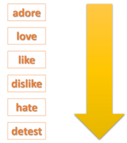
- T asks some Ss to make sentences about themselves, using the verbs of liking / disliking.
- T introduces the objectives of the lesson: learning how to talk about likes / dislikes and about their hobbies.
2. ACTIVITY 2: KNOWLEGDE FORMATION ACTIVITIES/ PRESENTATION / NEW LESSON ( 8ms)
a. Aim:
Introduce some extra vocabulary and sentence structure of talking about likes or dislikes
b. Content: Learn some new words and structures.
c. Outcome: Know more new words and structures
d. Organisation :
- Teacher gives more explanations and writes down the structure of talking about likes and dislikes.
Do you like + N/V-ing?
What about+ V-ing?
To be (not) interested in +N/V-ing.
What do you (not)like /love doing….?
- Asks students to give some more examples related to the structures.
- Invites some Ss to share their answers.
- Checks and comments.
3. ACTIVITY 3: PRACTICE ACTIVITIES ( 22ms)
Task 1: Listen and read the dialogue below. Pay attention to the questions and answers. ( 3ms)
a. Aim: To help Ss practise talking about likes and dislikes.
b. Content: Listen and read the dialogue.
c. Outcome: Know how to make a dialogue about likes and dislikes.
d. Organisation:
- Play the recording for Ss to listen and read the dialogue between Mi and Ann at the same time.
- Ask Ss to pay attention to the questions and answers.
- Have Ss practise the dialogue in pairs.
- Invites some Ss to read the dialogue. Checks Ss’ pronunciation.
Task 2: Ask and answer question about what you like and don’t like doing. ( 5ms)
a. Aim: To help Ss practice asking and answering about likes and dislikes
b. Content: Ask and answer about what you like or don’t like doing.
c. Outcome: SS can communicate with their friends about what they like or don’t like doing
d. Organisation:
- Teacher has students work in pairs.
- T calls on some Ss to give examples.
- Teacher and students discuss the answers.
- Teacher confirms the answers and gives feedback.
Task 3: Answer the questions. Fill in column A with your answer. ( 7ms)
a. Aim: To provide practice with answering about Ss’ hobbies.
b. Content: Answer the questions and fill in the table and interview their friends.
c. Outcome: SS can answer some information about what they like/love doing and get some more information about their friends’ hobbies
d. Organisation:
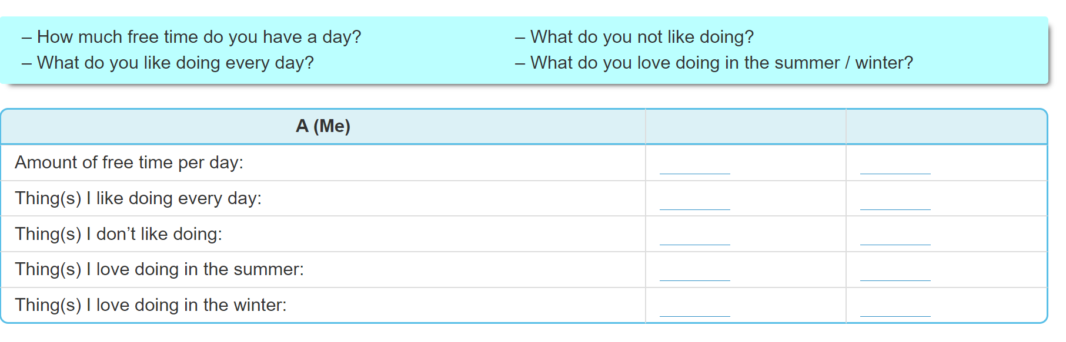
- T asks Ss to work individually and fill in column A.
- Ss work individually to do the task.
- T invites some Ss to share their answers before checking with the whole class.
- T gives feedback and comments.
Task 4: Interview your friend, using the question in 3. Write his/ her answers in column B. ( 7ms)
a. Aim: To let students further practise asking and answering about hobbies.

b. Content: Compare the answer with your friends and present it.
c. Outcome: Students know how to use vocabulary and structure they have learnt to talk about their hobbies.
d. Organisation: 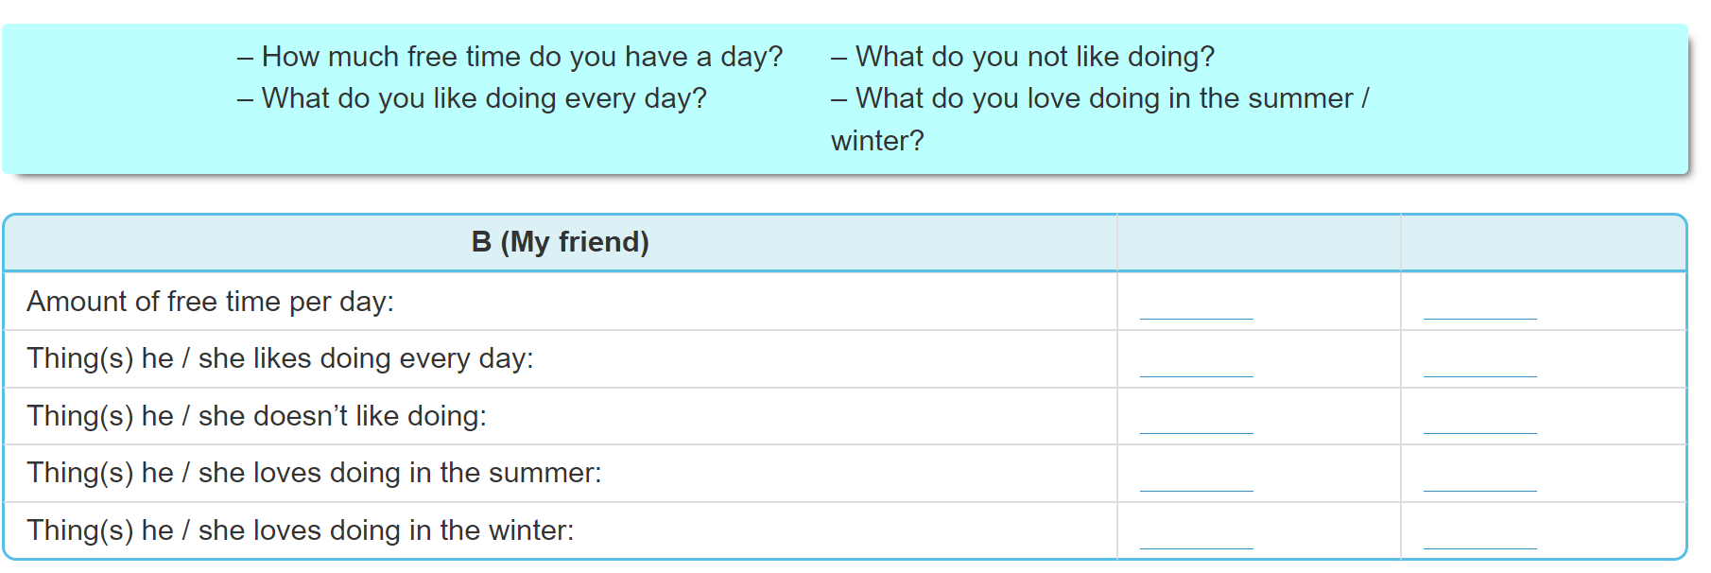
- T asks Ss to take turns being the person who asks the questions. This S has to note down his/ her partner’s answers to report to the class later.
- Has Ss work in pairs to do the task.
- T calls on some Ss to report the answers to the class.
- T and other Ss give comments.
4. ACTIVITY 4: APPLICATION/ PRODUCTION/ FURTHER PRACTICE ( 8ms)
a. Aim: To provide practice with comparing answers and giving a presentation about hobbies.

b. Content: Compare the answer with your friends and present it.
c. Outcome: Students know how to use vocabulary and structure they have learnt to talk about their hobbies.
d. Organisation:
- T asks Ss to read the example to understand how to report the answers. Has them underline the words that can be used to make comparison in the example (but, too). Introduces some other ways to express comparison, such as: both ( we both have one hour of free time every day); more ( I have more free time than her.)
- Has Ss work in pairs again to compare the answers and prepare a short presentation.
- T invites some Ss to present their work.
- T and other Ss give comments.
Example:
I have one hour of free time a day, but my friend Lan has only about 30 minutes. I like listening to music every day, and Lan likes it too. I don’t like exercising, but Lan does.
*WRAP-UP & HOMEWORK ( 2ms)
Summarise the main points of the lesson.
- Asks one or two Ss to tell the class what structure are used to talk about hobbies.
- Asks Ss to talk about their hobbies and their friends’ hobbies.
* HOMEWORK
- Practice the presentation about their hobbies
- Do more exercises in workbook

September 15th 2024 | Teacher in charge: Tran Le Vi  Group: Social science
UNIT 1: HOBBIES
Period 6: LESSON 5: SKILLS 1
Subject: English - Class: 7A1, 7A2, 7A3, 7A4
Allotted time: one period
I. OBJECTIVES:
1. Knowledge:
+To introduce some words relating to some groups of hobbies
+To help Ss train reading for specific information about hobbies.
+ Talk about benefits of hobbies
2. Competence: By the end of the lesson students will be able to know how to talk about benefits of hobbies
3. Quality/ behavior: To teach Ss the love of English; the love of their new school. The awareness about importance of learning English. Ss have the good attitude to working in groups, individual work, pair work, cooperative learning and working.
II. TEACHING AIDS AND MATERIALS:
1. Teaching aids: a TV, a laptop computer, pictures, cards, extra boards, Portable multi-function audio device , a loudspeaker, a projector, real objects.
2. Materials: textbooks, workbooks, lesson plan, the teacher’s book, reference books, hoclieu.vn
III. PROCEDURE:
1. ACTIVITY 1: WARM UP & INTRODUCTION ( 5ms)
a. Aims:
- To create a friendly and atmosphere in the class before the lesson;
- To remind Ss of what they learnt in the previous lessons.
- To lead into the new lesson.
b. Content: describe a picture
c. Outcome: ss can brainstorm some information about gardening
d. Organisation: Teacher’s instructions …
LIST OUT AS MANY HOBBIES AS POSSIBLE
- T introduces the objectives of the lesson and asks Ss to list out as many hobbies as possible within 1 minute.
- Ss work in groups to brainstorm hobbies.
- Which teams can list out more correct answers wins.
- T confirms answers as a class.

Task 1: Work in pairs. Look at the picture and discuss the questions below.
- T has Ss look at the picture in the book or show the picture in the book on a slide.
- Ask Ss who they see in the picture and what they are doing.
- T has Ss work in pairs to discuss the two questions.
- T invites some Ss to share their answers.
- Tell Ss that they are going to read a text about gardening.


2. ACTIVITY 2: KNOWLEGDE FORMATION ACTIVITIES/ PRESENTATION / NEW LESSON ( 8ms)
a. Aim:
- To help Ss get some new materials about the reading texts through the vocabulary they are about to learn in this period.
b. Content: Learn some new words form the reading text.
c. Outcome: Know more new words about groups of hobbies and some words related to gardening. Understanding how to use those vocabularies as well as the main content of the reading text.
d. Organisation :
-Uses some techniques, examples to help Ss guess the words from the context
Underline these words in the text and guess the meanings:
Vocabulary:
- outdoor (adj)
- patient (adj)
- responsibility (n)
- maturity (n)
- valuable (adj)
- Asks sts repeat those words in chorus and then individually.
- Uses Rub out and Remember to check Ss’ understanding of new words.
3. ACTIVITY 3: PRACTICE ACTIVITIES ( 20ms)
Task 2: Read the text about gardening. Match each word in column A with its definition in column B. ( 7ms)
a. Aim: To develop reading skill for general information.
b. Content: Scan the reading text to match the words with their definitions
c. Outcome: Understand the main content of the reading text and have correct matchings.
d. Organisation:
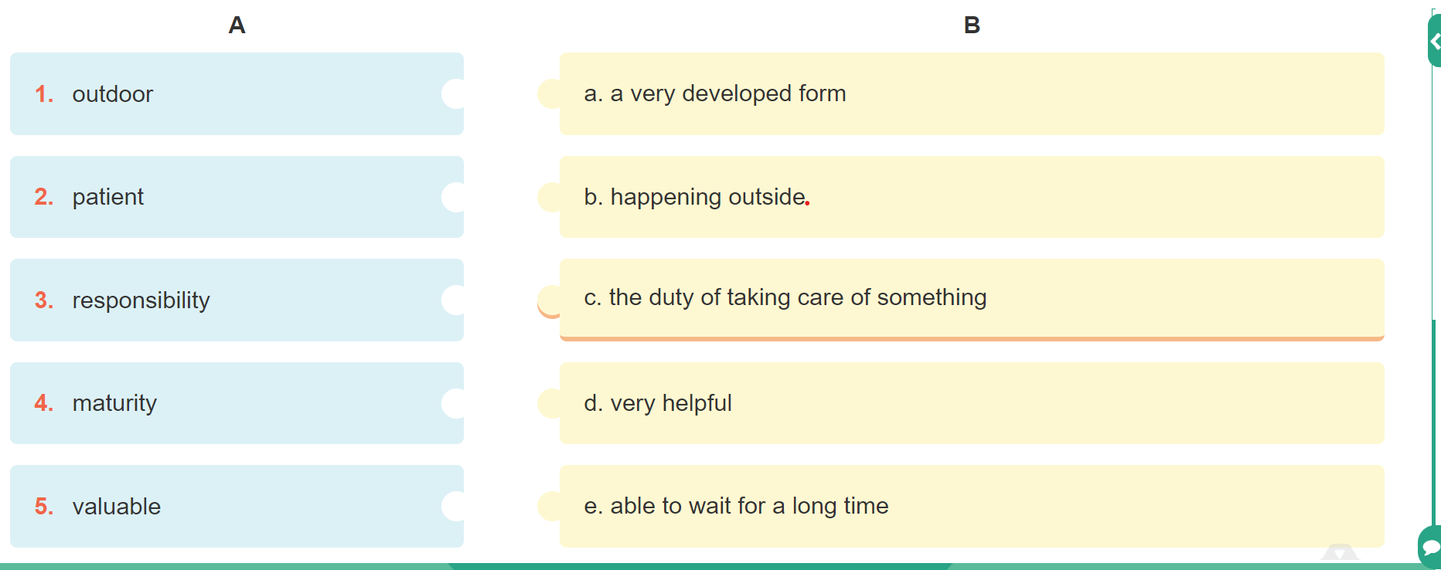
- T tells Ss what they are going to do.
- T asks Ss how to do the exercise. Elicit answers from Ss.
- If needed, T will tell them to follow these steps:
+ Read the words in column A.
+ Locate each word in the text.
+ Read around the word to get the general meaning.
+ Read the definitions in column B, find the suitable meaning to match each word.
- T asks Ss to repeat the steps (they can speak in Vietnamese).
- Ss do the exercise individually and then check answers in pairs.
- T invites some Ss to share their answers and confirms the correct answers.
Answer key:
1. b 2. e 3.c 4.a 5.d
Task 3: Read the text again. Complete each sentence with no more than THREE words.
( 6ms)
a. Aim: To develop reading skill for specific information: scan for gap – filling.
b. Content: Scan the reading text to find out words to complete the sentences.
c. Outcome: SS can get to know more specific information about gardening
d. Organisation: Teacher’s instructions …
- T asks Ss what they are going to do. Has Ss share how to do this exercise.
- T briefly tells them the steps: read the sentences, underline the key words in the sentences, locate the key words in the text and find the words to complete the sentences.
- T asks Ss to repeat the steps (they can speak in Vietnamese).
- T asks Ss to do the exercise individually and then check their answers in pairs.
- T invites some Ss to share their answers. Has them explain their answers.
- Confirms the correct answers.
- T asks Ss to tell the class the benefits of gardening as mentioned in the text.
Key:
1.doing things 2.insects and bugs 3.patient 4. join in 5. an hour
Task 4: Match each hobby with its benefits(s). One hobby may have more than one benefit.
( 7ms)
- Aim: To help Ss know the benefits of each group of hobbies
- b. Content: To learn some more benefits of each group of hobbies
c. Outcome: Ss know more about benefits of hobbies
d. Organisation: Teacher’s instructions ….
- T introduces some structures to talk about the benefits of hobbies:
+ to develop sth
+ to make sb + adj
+ to reduce sth
+ to help sb / sth do sth
- Give some examples.
- Ss work in pairs to match the hobby with its benefit(s). Check as the whole class.
- T asks Ss to name other benefits of these hobbies.
- Invites some Ss to share their answers and comfirm the answers.
* Key :
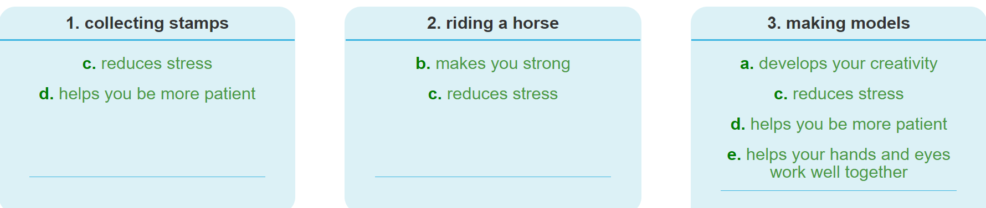
4. ACTIVITY 4: APPLICATION/ PRODUCTION/ FURTHER PRACTICE (10ms)
Task 5: Ask one another the following questions. Then present your partner’ answers to the class.
- Aim: To help Ss use what they have learnt so far to talk about hobbies.

b. Content: Talk about their friend’s hobbies and its benefits

c. Outcome: Ss can present and organise their ideas to talk about their friend’s hobbies and its benefits
d. Organisation: Teacher’s instructions
- Have Ss work in groups to ask and answer the two questions.
- What is your favourite hobby?
- What are its benefits?
- Models the answers to the two questions if needed.
- Has Ss work in groups to ask and answer the two questions.
- Invites some Ss to share their partner’s answers to the questions.
- T allows Ss to give comments for their friends and vote for the most interesting and informative presentation.
- T gives feedback and comments.
Example:
My friend Mi’s favourite hobby is collecting stamps. It helps her be more patient.
*WRAP-UP & HOMEWORK ( 2ms)
Summarise the main points of the lesson.
- Asks one or two Ss to tell the class what they have learnt.
- Asks Ss to say aloud some words they remember from the lesson.
* HOMEWORK
-Learn by heart all the new words.
-Do exercises in the workbook
- Prepare: Skills 2

September 16th 2024 | Teacher in charge: Tran Le Vi  Group: Social science
UNIT 1: HOBBIES
Period 7: LESSON 6: SKILLS 2
Subject: English - Class: 7A1. 7A2. 7A3. 7A4
Allotted time: one period
I. OBJECTIVES:
By the end of this unit, students will be able to:
– use the vocabulary about Hobbies, verbs of liking and disliking;
– listen for specific information about someone’s hobby;
– write a paragraph about your hobby.
1. Knowledge:
+To remind Ss of some words relating to hobbies and verbs of liking and disliking;
2. Competence: By the end of the lesson students will be able to know how
+ to listen for specific information about one’s hobby;
+ to write a paragraph about your hobby.
3. Quality/ behavior: To teach Ss the love of English; the awareness about importance of learning English and encourage Ss to take up a new hobby if they haven’t had one. Help Ss have the good attitude to working in groups, individual work, pair work, cooperative learning and working.
II. TEACHING AIDS AND MATERIALS:
1. Teaching aids: a TV, a laptop computer, pictures, cards, extra boards, Portable multi-function audio device , a loudspeaker, a projector, real objects.
2. Materials: textbooks, workbooks, lesson plan, the teacher’s book, reference books, hoclieu.vn
III. PROCEDURE:
1. ACTIVITY 1: WARM UP & INTRODUCTION ( 5ms)
Task 1: Look at the picture. What hobby is it? Do you think it is a good hobby? Why or why not?
a. Aims:
- To create a friendly and atmosphere in the class before the lesson;
- To remind Ss of what they learnt in the previous lessons.
- To lead into the new lesson.
b. Content: Describe a picture.
c. Outcome: Ss can brainstorm some information about building dollhouses.
d. Organisation: Teacher’s instructions …
- Shows the picture
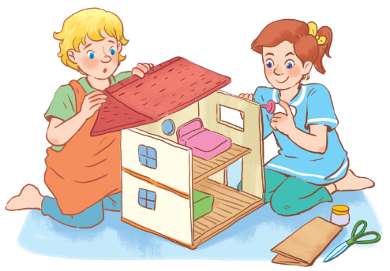
- Teacher asks Ss some questions about the picture:
+ What hobby is it?
+ What do we need for this hobby?
+ Do you think it is a good hobby? Why or Why not?
- Ss work individually to answer the questions.
- T calls Ss to give answers.
- T gets feedback and write on the board.
-Teacher leads to the new lesson.
2. ACTIVITY 2: KNOWLEGDE FORMATION ACTIVITIES/ PRESENTATION / NEW LESSON ( 8ms)
a. Aim: To provide Ss with some vocabulary about hobbies.
b. Content: to supply Ss with some vocabulary about hobbies
c. Outcome: to know how to use some vocabulary about hobbies
d. Organization: Teacher’s instructions.
- Teacher introduces the vocabulary by using a variety of techniques.
1. decorate (v): [visual + explanation] 2. benefit (n): [visual + explanation]


- Asks Ss to read the new words chorally and then individually.
- Checks Ss’ understanding of the words they have just learnt.
- ACTIVITY 3: PRACTICE ACTIVITIES ( 15ms)
Task 2: Listen to an interview about Trangs hobby. Fill in each blank in the mind map with ONE word or number. ( 8ms)
a. Aim: To help Ss develop the skill of listening for specific information about Trang’s hobby.
b. Content: Listen to an interview about Trang’s hobby. Fill in each blank in the mind map with ONE word or number.
c. Outcome:
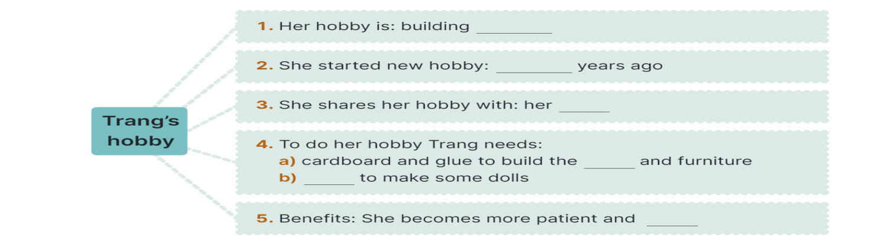
- Tell Ss that they are going to listen to an interview about Trang’s hobby.
- Have Ss read the mindmap.
- T explains the way to listen to Trang’s hobby and asks them to guess the word or number to fill in each blank:
+ What is Trang’s hobby? (name of the hobby)
+ When did she start the hobby?
+ Who shares the hobby with Trang?
+ To do this hobby what does Trang have to?
+ How does she feel about the hobby?
+ Does she intend to continue her hobby in the future?
- Plasy the recording and asks Ss to listen and complete the mind map.
- Ask Ss to work in pairs to compare their answers with each other and with the words/ numbers on the board.
- Plays the recording a second time for pairs to check their answers.
- Confirms the answers.
Key:
1. dollhouses 2. Three/3 3. cousin
4.a/ house b/ cloth 5. Creative
Task 3: What is your hobby? Fill in the blanks below. ( 7ms)
a.Aim: To brainstorm ideas and make an outline for Ss’ writing.
b. Content: Brainstorming. WHAT IS YOUR HOBBY? Fill in the blanks below. (Ex 3, p. 15)
c. Outcome: Giving some ideas about your hobby. Fill in the word web as a way to organize their ideas.
d. Organisation:
- T gives Ss a writing tip:
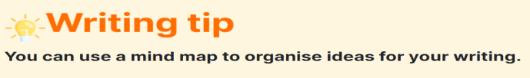
- Tell Ss that they are going to write about his / her hobby.
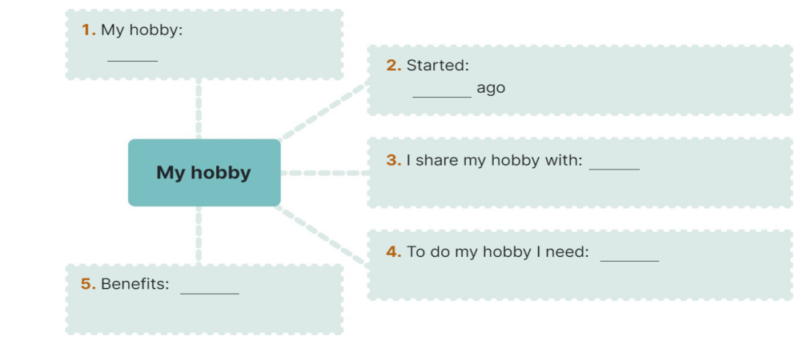
- Ask Ss to use the word web as a way to organize their ideas.
- Model with a S (Ex: Lan)
- Ask Ss to work individually to do Task 3.
- Check the answer.
- Give more comments and feedback.
Suggested answers:
Lan's hobby:
1. Name of the hobby: collecting waste paper
2. Started: 3 years ago
3. Person who shares he hobby with: Nga
4. To do this hobby Nga has to:
a. collect paper after use
b. make flowers, dishes, toys. boxes...
c. use it for drawing if possible
5. Lan's feeling about the hobby: interesting, useful, protect the environment
6. Future: continue the hobby
4. ACTIVITY 4: APPLICATION/ PRODUCTION/ FURTHER PRACTICE ( 13ms)
- Aim: To help Ss practise writing a paragraph about your hobby.
b. Content: Write a paragraph about your hobby.
c. Outcome: Ss can write a paragraph about your hobby well.
d. Organisation: Teacher’s instructions….
- Asks Ss to write a paragraph of about 70 words individually based on the information in their word webs.
- Has Ss listen to the teacher then do the task.
- Asks Ss t do their writing on large sheets of paper and organize a class gallery for students to display their writings on the board. Then students can go around to see their friends’ work, give and receive comments.
- Asks Ss to check the writing.
- Gives comments to the students.
- Ss can exchange and read each other's drafts to give some comments.
If time is limited, T may ask Ss to write the final version at home, and hand them in at the next lesson.
- Asks Ss to write the first draft individually. Next asks Ss to work in pairs doing peer corrections.

*WRAP-UP & HOMEWORK ( 4ms)
Summarise the main points of the lesson.
- T can instruct them to draw a mind map to summarise the main points of the lesson.
- Has Ss look at the objectives written on the board at the beginning of the lesson and tick the objectives they can do.
* HOMEWORK
- Do more exercises in workbook.
- Write about one of your family members’ hobby in about 60 words.
- Prepare: LOOKING BACK + PROJECT

September 17th 2024 | Teacher in charge: Tran Le Vi  Group: Social science
UNIT 1: HOBBIES
Period 8: LESSON 7: LOOKING BACK + PROJECT
Subject: English - Class: 7A1, 7A2, 7A3, 7A4
Allotted time: one period
I. OBJECTIVES:
1. Knowledge:
- Review the vocabulary and grammar of Unit 1
- Apply what they have learnt (vocabulary and grammar) into practice through a project
2. Competence:
By the end of the lesson students will be able to know verbs of liking and disliking to talk about different hobbies as well as develop their presentation skill and critical thinking skill
3. Quality/ behavior: To teach Ss the love of English; help them be more creative when doing the project and develop self-study skills. Besides, Ss have the good attitude to working in groups, individual work, pair work, cooperative learning and working.
II. TEACHING AIDS AND MATERIALS:
1. Teaching aids: a TV, a laptop computer, pictures, cards, extra boards, Portable multi-function audio device , a loudspeaker, a projector, real objects.
2. Materials: textbooks, workbooks, lesson plan, the teacher’s book, reference books, hoclieu.vn
III. PROCEDURE:
1. ACTIVITY 1: WARM UP & INTRODUCTION ( 3ms)
a. Aims:
- To create a friendly and atmosphere in the class before the lesson;
- To lead into the unit
b. Content: To think and guess some hobbies to warm up to the subject and new lesson.
c. Outcome: Remind some hobbies they learnt.
d. Organization:
GAME: GUESSING GAME
- T divides the class into two big groups.
- Ss take turns to think of a hobby for your partner to guess.
- Their partner can ask up to 10 yes / no questions and he / she can only answer with a 'yes’ or 'no’.
- Time allowance: 3 minutes
E.g:1. I have a lot of bottles, dolls or stamps. What is my hobby?
- T asks ss to listen carefully and say aloud the name of the hobby. Who has the quicker and correct answer will get one point. The group with more points is the winner.
- Ss work in groups to do the task.
- Ss give answer.
- T monitors and gives feedback.
2. ACTIVITY 2: KNOWLEGDE FORMATION ACTIVITIES/ PRESENTATION / NEW LESSON ( 6ms)
a. Aim: To revise the vocabulary items, grammars they have learnt in the unit.
b. Content: Some vocabulary about hobbies, grammars, pronunciation.
c. Outcome: use the vocabulary, grammars in the lesson correctly.
d. Organization: Teacher’s instructions.

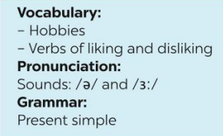

3. ACTIVITY 3: PRACTICE ACTIVITIES ( 14ms)
Task 1: Complete the sentences with appropriate hobbies.( 3ms)
a. Aim: To revise the vocabulary items they have learnt in the unit.
b. Content: Some vocabulary about hobbies.
c. Outcome: remind how to use the vocabulary in the unit.
d. Organization:
- Has Ss do this activity individually then compare their answers with their partners.
- Ss do this activity individually.
- Asks for Ss’ answers or ask one student to write his/her answer on the board.
- Confirms the correct answers.
Key:
1. collecting coins 2. Doing judo 3. Making models
4. gardening 5. Playing football.
Task 2: Write true sentences about you and your family members. ( 3ms)
a. Aim: To help Ss revise the vocabulary items they have learnt in the unit and then apply them in practice.
b. Content: Write sentences about you and your family members’ hobbies.
c. Outcome: Make true sentences about what you and your family members like and dislike.
d. Organization:

- Has Ss do this activity individually then compare their answers with their partners.
- Ss write true sentences about them and their family members.
- Ask for Ss’ answers or ask some Ss to write their answers on the board.
- Teacher and other Ss comment.
Task 3: Use the present simple form of each verb to complete the passage. ( 3ms)
a. Aim: To help Ss revise the present simple.
b. Content: use the present simple tense to complete the passage.
c. Outcome: Know how to apply the present simple tense.
d. Organization: Teacher’s instructions.
- Ask Ss about the uses of the present simple that they have learnt in the unit.
- Ask Ss to do the exercise individually and then exchange their answers with a classmate.
- Call on some Ss to write their answers on the board. Other Ss give comments.
- Confirm the correct answers.
Key: 1. loves 2. Has 3. enjoys 4. Don’t like
5. is 6. Is 7. Go 8. begins
Task 4: Change the following sentences into questions and negative ones. ( 5ms)
a. Aim: To help Ss revise the negative and interrogative form of the present simple tense.
b. Content: Change the sentences into questions and negative ones.
c. Outcome: Identify the structure of questions and negative ones in the present simple tense.
d. Organization:
- Ask Ss to do this exercise in groups of 6 on the group boards.
- Have Ss show their groups’ answers to the class.
- Check Ss’ answers.
Key: 1. (?) Does this river run through your home town?
(-) This river does not run through my home town / This river doesn't run through my home town
2. (?) Does your drawing class start at 8 a.m. every Sunday?
(-) My drawing class doesn't start at 8 a.m. every Sunday / My drawing class does not start at 8 a.m. every Sunday
3. (?) Do they enjoy collecting stamps?
(-) They don't enjoy collecting stamps / They do not enjoy collecting stamps
4. (?) Do you do judo every Tuesday?
(-) I don't do judo every Tuesday / I do not do judo every Tuesday
5. (?) Does your brother love making model cars?
(-) My brother doesn't love making model cars / My brother does not love making model cars.
4. ACTIVITY 4: APPLICATION/ PRODUCTION/ FURTHER PRACTICE ( 20ms)
a. Aim: To help Ss apply what they learnt in this unit to present a project about their hobby.
b. Content: To design a hobby poster and present a project about it.
c. Outcome: Make a presentation about their hobby.
d. Organization:
PROJECT
TASK : Work in groups



REQUIREMENT: Have Ss read the project. Ask them brainstorm some interesting and easy-to-do hobbies. Elicit Ss’ answers. Ss work in groups to choose and discuss about a popular one and create a poster about this hobby. Answer Ss’ questions if there are any. Remember to have Ss present their findings in the next lesson and vote for the best.
ORGANIZATION:
1. Brainstorm some interesting and easy-to-do hobbies.
2. Choose a popular one among teens and discuss its benefits.
3. Create a poster about this hobby. Find suitable photos for it or draw your own pictures.
4. Present the hobby to the class. Try to persuade your classmates to take it up.
5. Prepare a presentation. Remember to assign who will talk about what.
6. Give a presentation to the class an exhibition of posters or video clips sts have made among groups. Vote for the best

FEEDBACK FORM FOR SURVEYS
1. Self-assessment
 | Tick where appropriate | Comments (in English or Vietnamese)
DELIVERY
1. We greeted the audience.
2. We spoke clearly and naturally.
3. We interacted with the audience.
4. We cooperated with my group members when delivering the talk
5. We concluded my part of the talk appropriately.
DESIGN OF THE POSTER / SLIDES/…
1. Our photos/ pictures /drawing/ slides/ videos/ plan were clearly organized .
2. Our content and photos/ drawing/ slides/… were suitable
CONTENT: Our presentation includes the following information:
1. The name of the popular hobby among teens.
2. Suitable photos for it or draw pictures to illustrate the hobby.
3. The benefits of the hobby.
2. Peer assessment
 | Tick where appropriate | Comments (in English or Vietnamese)
DELIVERY
1. The presenters greeted the audience.
2. The presenters spoke clearly and naturally.
3. The presenters interacted with the audience.
4. The presenters cooperated with my group members when delivering the talk
5. The presenters concluded my part of the talk appropriately.
DESIGN OF THE POSTER / SLIDES/…
1. Their photos/ pictures /drawing/ slides/ videos/ plan were clearly organized .
2. Their content and photos/ drawing/ slides/… were suitable
CONTENT: The presentation includes the following information:
1. The name of the popular hobby among teens.
2. Suitable photos for it or draw pictures to illustrate the hobby.
3. The benefits of the hobby.

RULES:
- Make a postcard or a video clip about a hobby
- Each group will send a representative to go to the board to describe their group’s postcard/ video clip in 4 ms.
- After 4 groups have already finished their groups’ presentation, judges will give remarks, assessment and awards

Rubrics for rating:
Part 1: DELIVERY (4pts)
The total score for this part is 4 points
Part 2: DESIGN OF THE POSTER / SLIDES/… (2pts)
The total score for this part is 2 points
Part 3: CONTENT (4pts)
The total score for this part is 4 points

- RESULT FOR THE ASSESSMENT OF STUDENTS’PRODUCTS

Class | Group | Part 1  Delivery | Part 2  Design of the poster/ slides/… | Part 3  Content | Total | Rank
 |  | (4pts) | (2pts) | (4pts) | (10pts)
7A1 | Group 1 | 3,0 | 1,5 | 3,5 | 8,0 | 3
 | Group 2 | 3,5 | 1,5 | 3,5 | 8,5 | 2
 | Group 3 | 4,0 | 1,5 | 3,5 | 9,0 | 1
 | Group 4 | 3,0 | 1,5 | 3,5 | 8,0 | 3
7A2 | Group 1 | 3,0 | 1,5 | 3,5 | 8,0 | 3
 | Group 2 | 4,0 | 1,5 | 3,5 | 9,0 | 1
 | Group 3 | 3,5 | 1,5 | 3,5 | 8,5 | 2
 | Group 4 | 3,0 | 1,5 | 3,5 | 8,0 | 3
7A3 | Group 1 | 3,5 | 1,5 | 3,5 | 8,5 | 2
 | Group 2 | 3,0 | 1,5 | 3,5 | 8,0 | 3
 | Group 3 | 3,0 | 1,5 | 3,5 | 8,0 | 3
 | Group 4 | 4,0 | 1,5 | 3,5 | 9,0 | 1
7A4 | Group 1 | 3,0 | 1,5 | 3,5 | 8,0 | 3
 | Group 2 | 3,0 | 1,5 | 3,5 | 8,0 | 3
 | Group 3 | 4,0 | 1,5 | 3,5 | 9,0 | 1
 | Group 4 | 3,5 | 1,5 | 3,5 | 8,5 | 2

- GROUPS’PRODUCTS
- Make a poster about a hobby

CLASS 7A1
GROUP 1 | GROUP 2
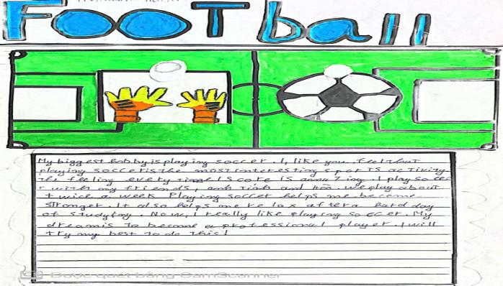 | 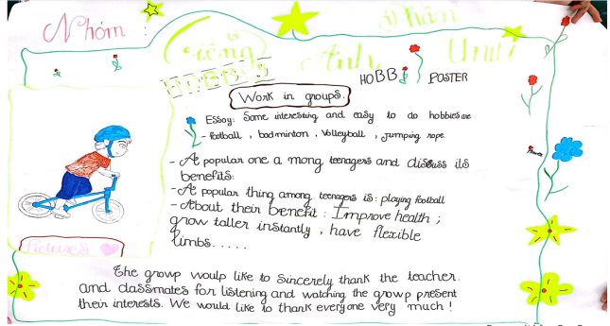
GROUP 3 | GROUP 4
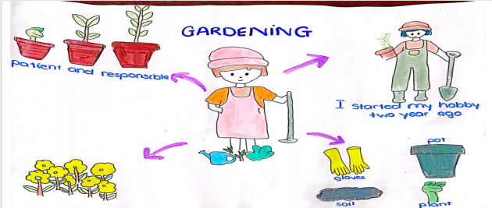 | 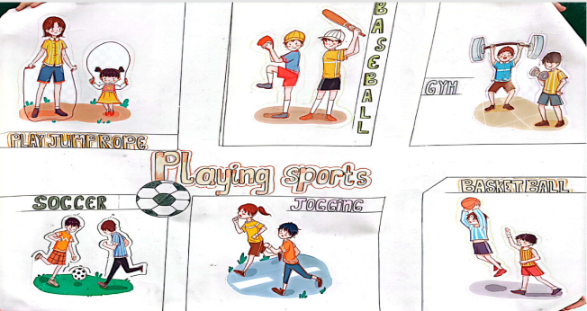
CLASS 7A2
GROUP 1 | GROUP 2
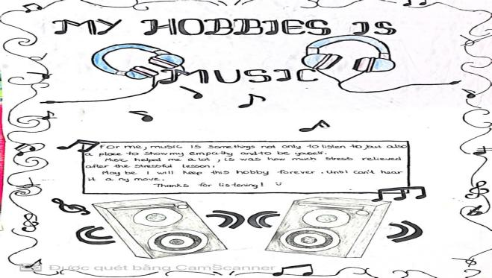 | 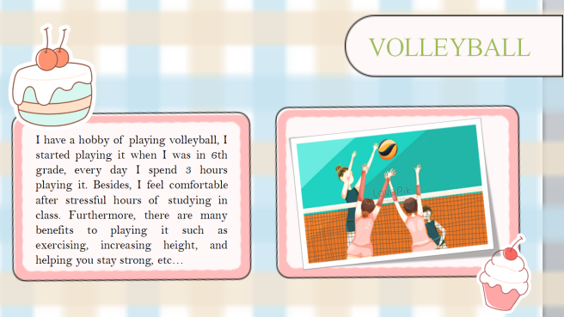
GROUP 3 | GROUP 4
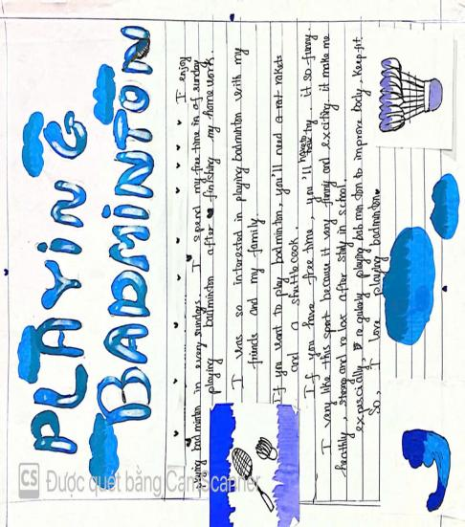 | 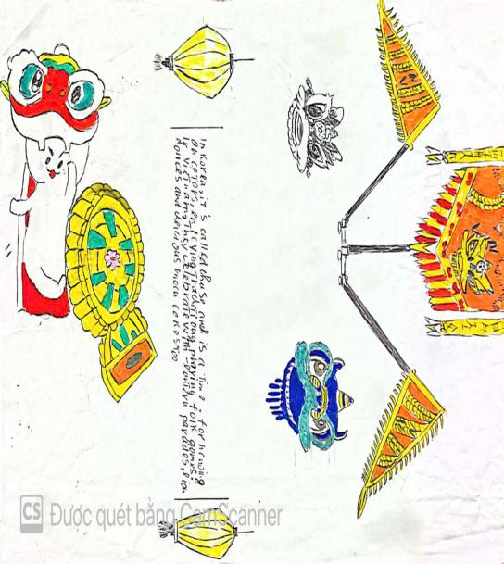
CLASS 7A3
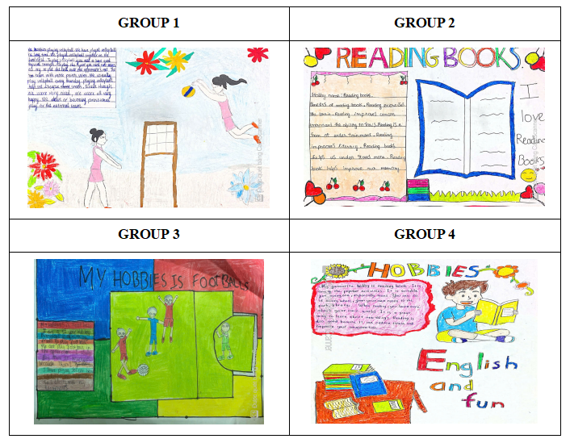
CLASS 7A4
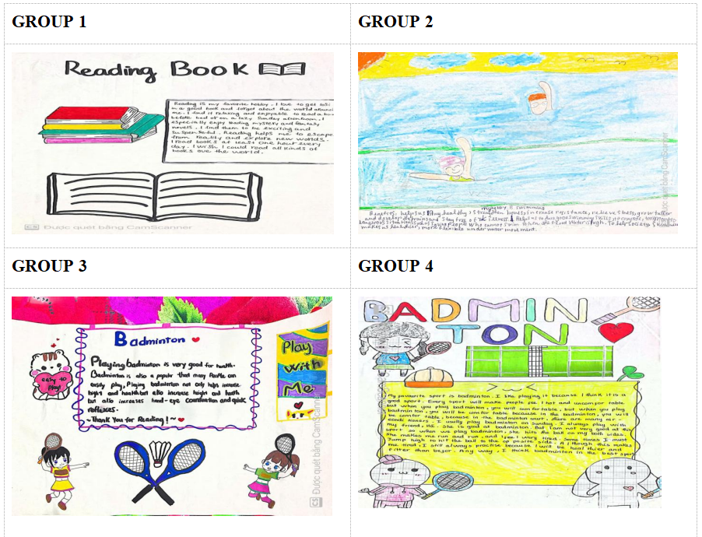

*WRAP-UP & HOMEWORK ( 2ms)
Summarise the main points of the lesson.
- Have Ss summarise what they have learnt in the unit 1. If there is time, T can instruct them to draw a mind map to summarise the main points of the unit
* HOMEWORK
- Do more exercises in workbook.
- Prepare: Unit 2: HEALTHY LIVING (GETTING STARTED)

September 22nd 2024 | Teacher in charge: Tran Le Vi  Group: Social science
UNIT 2: HEALTHY LIVING
Period 9: Lesson 1: GETTING STARTED
Let’s go out!
Subject: English - Class: 7A1, 7A2, 7A3, 7A4
Allotted time: one period
I. OBJECTIVES:
* By the end of this unit, students will be able to:
- use the words about healthy activities and health problems;
- pronounce the sounds /f/ and /v/ correctly;
- recognize and write simple sentences;
- ask for and give health tips;
- read for general and information about acne;
- talk about how to deal with some health problems;
- listen for specific information about some advice about healthy habits;
- write a paragraph of some advice to avoid viruses.
1. Knowledge:
- To introduce topic of the lesson healthy living. To practice listening and reading.
+ Vocabulary: use the words related to the topic healthy living such as healthy activities and health problems..
Pronouncing the sounds /f/ and /v/ correctly;
+ Grammar: simple sentences ;
2. Competence: By the end of the lesson students will be able to develop the vocabulary about the topic; identify and talk about their daily activities and decide if they are good or bad for their health; and know the form and use the present simple tense;
3. Quality/ behavior: To teach Ss the love of English; the value of healthy living. The awareness about importance of learning English. Ss have the good attitude to working in groups, individual work, pairwork, cooperative learning and working.
II. TEACHING AIDS AND MATERIALS:
1. Teaching aids: a TV, a laptop computer, pictures, cards, extra boards, Portable multi-function audio device , a loudspeaker, a projector, real objects.
2. Materials: textbooks, workbooks, lesson plan, the teacher’s book, reference books, hoclieu.vn
III. PROCEDURE:
1. ACTIVITY 1: WARM UP & INTRODUCTION ( 5ms)
a. Aims:
- To create a friendly atmosphere in the class before the lesson;
- To give T and Ss a chance to introduce themselves;
- To lead into the unit
- Content: To have some warm-up activities to create a friendly and relaxed atmostphere
- To set the context for the introduction;
- To lead in basic New words of the lesson.
- Outcome:
-Mastering the vocabulary about healthy living, esp healthy activities and health problems and use some simple sentences.
-Identify and talk about their daily activities and decide if they are good or bad for their health
d. Organisation : Teacher’s instructions …
+ Greeting
+ Game
Brainstorming race (Group work)
Healthy living
Tet

Do

Do/ should | Don’t/ shouldn’t
Eg: play sports  -  - | Eg: use computers too much  -  -
- Students (Ss) play the game in groups
- Asks students to list any activities which they often do or not do to have good health (using the words, activities they learnt last periods or any knowledge they know)
-Leads sts to make simple sentences with those verb phrases and then lead to the lesson
EX: Do: I often play sports with my friends
->T introduces the new lesson: “Today, we start Unit 2: Healthy living – Getting started to develop the vocabulary about the topic; identify and talk about their daily activities and decide if they are good or bad for their health
2. ACTIVITY 2: KNOWLEGDE FORMATION ACTIVITIES/ PRESENTATION / NEW LESSON ( 8ms)
a. Aims:
- To provide students with vocabulary;
- To help students be well-prepared for the listening and reading tasks.
b. Content: - Vocabulary pre-teaching
c. Outcome: - Students can identify some new words about hobbies.
d. Organisation : Teacher’s instructions..
T sets the scene / context for the listening and reading.
- Teacher introduces the vocabulary.
- Teacher explains the meaning of the new vocabulary by showing pictures or giving explanations.
* Teach vocabulary:
+ Teacher uses different techniques to teach vocab (situation, realia, translation.)
+ Follows the seven steps of teaching vocab.
- popular (a): [antonym]
- fresh (a): [definition + picture]

-boat (v): đi bơi thuyền
- outdoor (adj): ngoài trời # indoor (adj)
- sound (v): nghe có vẽ
- bring (v): mang lại, đem đến.
- lunch box (n) hộp cơm trưa
- join (v) [synonym + picture] take part in, participate in

- suncream (n) kem chống nắng
- sunburn (n) da bị sạm vì nắng
(v) bị ăn nắng, cháy nắng
- cycle (v) đạp xe
+ Checks vocabulary.
T: present pictures
STs: read words relating to the pictures.
+ Gets SS to take note
- Calls on some groups of Ss to read the conversation aloud.
3. ACTIVITY 3: PRACTICE ACTIVITIES ( 20ms)
Task 1: Listen and read. ( 6ms)
- Aims: -To set the context for the introductory conversation;
- To introduce the topic of unit, the vocabylary, the sounds, and the grammar points to be learnt.
b. Content: Listen and read the conversation.
c. Outcome: Know more new words. Understand the conversation; topic of the lesson, Vocab, grammar points…
d. Organisation : Teacher’s instructions.…..
- Asks Ss to look at the pictures in the book and answer the questions:
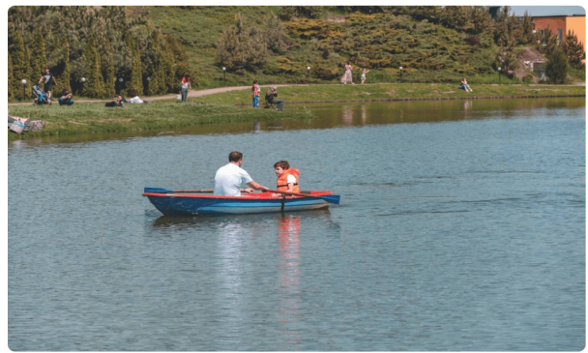
1. Who are they?
2. What might they talk about?
3. What are the people in the picture on the wall doing?
4. Are they healthy activities?
- Encourages Ss to give their answers, but do not confirm whether their answers right or wrong.
Teacher plays the recording, asks students to underline the words related to the topic Healthy living. (Teacher may check the meaning of some words if necessary.)
- Teacher can play the recording more than once.
- Students listen and read.
- Teacher can invite some pairs of students to read aloud.
-Teacher refers to the questions previously asked.
- Confirms the correct answer.
Task 2: Circle the correct answer ( 3ms)
- Aim: To help Ss understand the main idea of the conversation.
- Content: Answer the question by choosing one of three the options.
- Outcome: Know more new words. Understand the conversation; topic of the lesson, Vocab, grammar points…
d. Organisation : Teacher’s instructions.…..
Read the conversation again and answer the question:
What are Mark and Mi talking about ?
- Asks Ss to answer without reading the conversation again
- Has Ss work independently. Tells them to refer back to the conversation if necessary.
- Calls some to answer and explain why they did not choose the other two options
- T and others confirm the correct answer
Key: 1.B
Task 3: Match the word or phrases with the correct pictures. ( 5ms)

Aims:
- To help sts learn some vocabulary from the conversation visually (in pictures) to ensure their understanding of the text;
- To introduce the grammar point of this unit: the present simple.
- Content: write the correct word or phrase from the box under its picture.
- Outcome: SS know more words or phrases about healthy living
- Organisation :
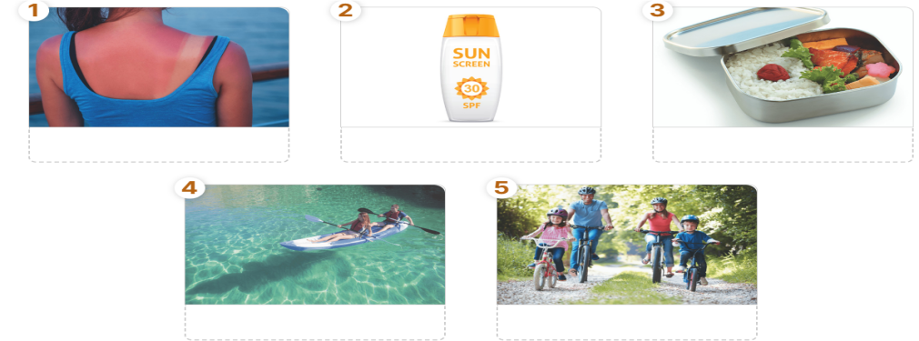
-Teacher asks students to work independently to read the words, look at the pictures and write the correct words / phrase under the pictures
-Teacher allows students to share their answers before discussing as a class.
- Teacher calls some students to check.
- Teacher confirms the right answers and writes on the board.
Answer key:
1. sunburn 2. Suncream 3. lunch box 4. Boating 5. cycling
Task 4: Complete each sentence with a word from the conversation. ( 6ms)
- Aims: To help student develop the vocabulary about the topic and how to use it in one context..
- Content: complete each sentence with a word from the conversation.
- Outcome: Ss can apply words to sentences to make meaningful sentences.
- Organisation :
- Teacher asks students to work independently to fill in each blank with a word from the conversation.
- Ss do exercise 3 individually.
- Teacher asks them to tell where to find the words.
- Teacher checks the answers as a class.
Answer keys:
1. boating 2. Park 3. Countryside 4. Suncream 5. health
4. ACTIVITY 4: APPLICATION/ PRODUCTION/ FURTHER PRACTICE ( 8ms)
a. Aim: To help student identify and talk about their daily activities and decide if they are good or bad for their health.
b. Content: SURVEY: GOOD OR BAD FOR HEALTH.
c. Outcome: Ss can identify and talk about their daily activities and decide if they are good or bad for their health..
d. Organisation :
-Teacher asks students to work in groups of 4 or 6 to take turns to ask and answer about their daily activities, how often they do these activities and discuss if they are good or bad for their health.
- Ss work in groups to ask and answer
- Teacher moves around to observe and offer help when needed.
- By the end of the activity, one student from each group can stand up and report to the class.
Suggested answers:
Daily  activities | How often | Good | Bad
Walking to school | Every day | √
Eating breakfast | Rarely |  | √
Going swimming | Twice a week | √
Sleeping | 12 hours per day |  | √
Doing yoga | Three times a week | √
… | … | … | …
-Teacher checks and gives the correct answers.

*WRAP-UP & HOMEWORK ( 4ms)
Summarise the main points of the lesson.
- Asks one or two Ss to tell the class what they have learnt.
- Asks Ss to say aloud some words they remember from the lesson.
* HOMEWORK
- Read again the conversation on page 18.
- Do more exercises in workbook.
- Prepare the vocabulary for the next lesson: A closer look 1.
- Start preparing for the Project of the unit.
Teacher randomly puts Ss in groups of 4 or 5 and asks them to choose a bad habit that the students in your school often do and think about some tips to change that habit. They have to find suitable photos or draw pictures to create a poster about it. Students will show their posters and present their ideas in Lesson 7 – Looking back and Project. (Teacher should check the progress of students’ preparation after each lesson.)

September 23rd 2024 | Teacher in charge: Tran Le Vi  Group: Social science
UNIT 2: HEALTHY LIVING
Period 10: Lesson 2: A CLOSER LOOK 1
Subject: English - Class: 7A1, 7A2, 7A3, 7A4
Allotted time: one period

I. OBJECTIVES:
1. Knowledge:
+ To introduce visually some nouns related to the topic “Healthy Living”.
+To help Ss use the words/ phrases in specific contexts
+ To help Ss talk about their daily activities and decide if each activity is healthy or unhealthy
+ To help Ss identify the sounds /f/ and /v/ correctly.
a. Vocabulary: - To use the words relating to the topic “Healthy Living” .
- To pronounce the sounds /f/ and /v/ correctly.
b. Grammar: - To use Simple sentences
2. Competence: By the end of the lesson students will be able to use the words/ phrases about healthy activities and health problems, and talk about their daily activities if each activity is healthy or unhealthy
3. Quality/ behavior: To educate Ss the importance of our health, and how to have good health. Ss have the good attitude to working in groups, individual work, pairwork, cooperative learning and working.
II. TEACHING AIDS AND MATERIALS:
1. Teaching aids: a TV, a laptop computer, pictures, cards, extra boards, Portable multi-function audio device , a loudspeaker, a projector, real objects.
2. Materials: textbooks, workbooks, lesson plan, the teacher’s book, reference books, hoclieu.vn
III. PROCEDURE:
1. ACTIVITY 1: WARM UP & INTRODUCTION ( 5ms)
a. Aims:
- To create a friendly and relaxed atmosphere in the class before the lesson;
- To set the context for the introduction;
- To introduce the words about healthy activities and health problems.
b. Content: To have some warm-up activities to create a friendly and relaxed atmostphere to inspire Ss to warm up to the new lesson.
GAME: FACE TO FACE
c. Outcome: Students have a chance to speak English and focus on the topic of the lesson.
d. Organisation: Teacher’s instructions …
GAME: FACE TO FACE:
* Teacher divides class into 2 teams: Cats and Dogs.
- Teacher asks students to think of words or phrases related to “Healthy activities” which they have learnt in the previous lesson or words they may know already.
- Ss have 3 minutes to think of the topic
- Students in each team turn by turn stand up and say 1 word or phrase related to the topic
-In 90 seconds, the team has more right answers will be the winner, and the team repeat the word which is mentioned already or cannot give a word will be the loser.
Suggested answer:
- Going cycling/ swimming
- Walking
- Boating
- Eating breakfast
- Doing yoga/ aerobics
- Playing sports
- ….
2. ACTIVITY 2: KNOWLEGDE FORMATION ACTIVITIES/ PRESENTATION / NEW LESSON ( 12ms)
a. Aims:
+To use the lexical items related to the topic Healthy living
+To use the words about healthy activities and health problems.
+ Pronounce and recognize the sounds /f/ and /v/ in isolation and in context
b. Content: To help sts master the words about healthy activities / health problems, and pronounce the sounds /f/ and /v/ correctly
c. Outcome: Ss can be ready to know the words about healthy activities, health problems and identify the sounds /f/ and /v/ correctly.
d. Organisation : Teacher’s instructions..
- From the part “warm up” , T expresses more words to talk about Health problems and two sounds /f/ and /v/.”
Note:
I.Vocabulary: Health problems
* Teacher introduces the vocabulary by:
+ providing the synonym or antonym of the words
+ providing the pictures of the words
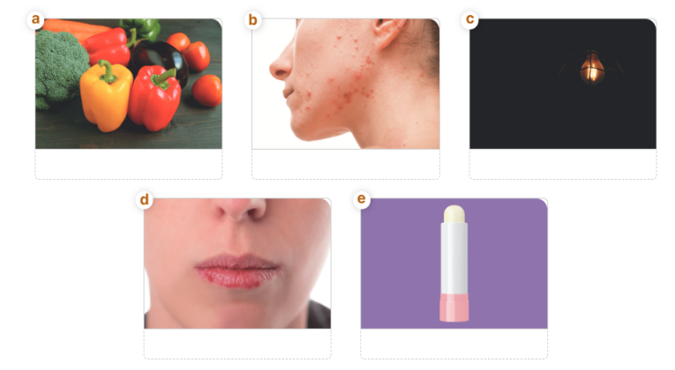
- Teacher have students read the phrases aloud and correct their pronunciation if necessary.
- Teacher asks students for the Vietnamese meanings of these phrases.
1. dim light (n.phr.):not giving or having much light. (ánh sáng lờ mờ)
2. lip balm (n.phr.): a type of cream that is used to keep the lips soft or to help sore lips feel better (son dưỡng môi)
3. chapped lips (n.phr.): chapped skin is sore, rough, and broken, especially because of cold weather (môi nứt nẻ)
4. coloured vegetables (n.phr.):a plant, root, seed, or pod that is used as food, especially in dishes that are not sweet and has colours such as: red, green, etc. (rau có màu sắc)
5. red spots (n.phr.):a small, usually round area of colour that is differently coloured or lighter or darker than the surface around it (đốm đỏ)
- Ss say the words.
- Other Ss correct if the previous answers are incorrect.
- Teacher shows and says the words aloud and asks Ss to repeat them
* Checking techniques:
“Rub out and remember”
II. Pronunciation: /f/ and /v/
- Teacher writes on the board two words “fit” and “vegetables”.
- Then, teacher has students focus on the underlined letters “f” and “v”.
- Ss practice saying the word individually.
-Teacher calls some students to read aloud.
-Teacher corrects if necessary.
-Ss imitate and practice the two sounds together.
-Teacher explains if necessary.
3. ACTIVITY 3: PRACTICE ACTIVITIES ( 18ms)
Task 1: Match the phrases on the left with the correct picture on the right.( 3ms)
a. Aim: To revise the words or phrases they have learnt.
b. Content: To practise the lexical items related to the topic Healthy living
c. Outcome: Know more new words and understand the meaning of the words about healthy activities / health problems.
d. Organisation:
- Teacher asks students to work independently to do matching.
- Ss work individually.
- Teacher has students to check their work with their partner.
- Then, teacher call one student to do matching in front of the class and give correct answer.
Answer keys: 1. C 2. E 3. D 4. A 5. B
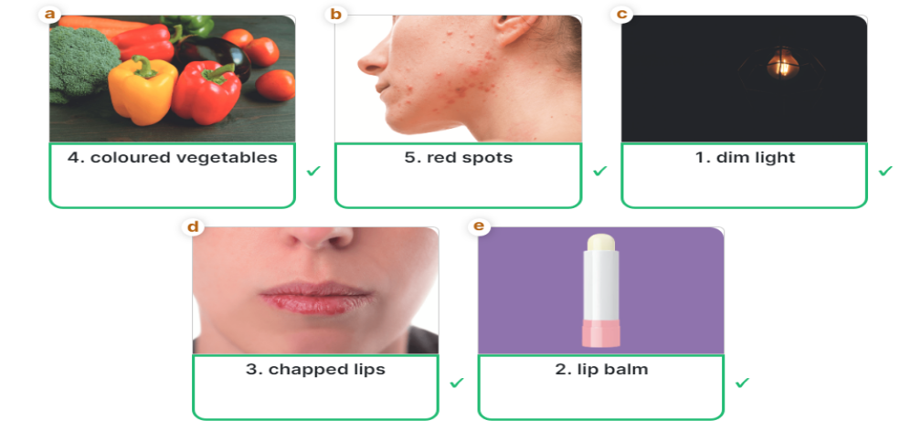
Task 2: Complete the sentences with the correct words and phrases.( 4ms)
a. Aim: To help student use the words/ phrases in specific contexts.
b. Content: To practise the lexical items related to the topic Healthy living
c. Outcome: Know more new words and complete the sentences with the words about healthy activities / health problems
d. Organisation:
- Teacher asks students to read the words and phrases provided aloud and give them their meaning if necessary.
- Teacher asks Ss to work individually.
- Then, teacher calls some students to check and asks them to explain their answers.
- Teacher checks students ‘answers as a class.
Answer key:
1. coloured vegetables 2. Soft drinks 3. Fit 4. skin condition 5. sunburn
Task 3: Discuss and tick () each activity in the table as H (Healthy) or U (Unhealthy).( 4ms)
a. Aim: To help students talk about their daily activities and decide if each activity is healthy or unhealthy.
b. Content: To use the words about healthy activities and health problems
c. Outcome: Ss know more about the topic of the lesson, enrich vocabulary
d. Organisation:
- Teacher asks students to read all the sentences in the table and find out any words are new to them.
- Teacher has students work in group of 4 - 6 to discuss whether each activity is healthy or unhealthy.
- Ss work in groups.
- Teacher calls out some group to give and explain their answers as a class.
- Teacher listens and correct their answers.
Suggested answers:
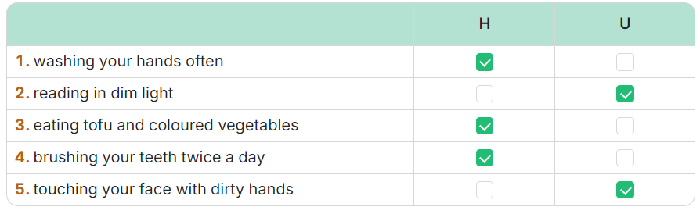
Task 4: Listen and repeat. Pay attention to the sound /f/ and /v/.( 3ms)
- Aims: - To help students identify how to pronounce the sounds /f/ and /v/.
- To help students practise pronouncing these sounds in words.
b. Content: Listen and pay attention to the sounds /f/ and /v/
c. Outcome: Practice pronouncing these sounds in words
d.Organisation:
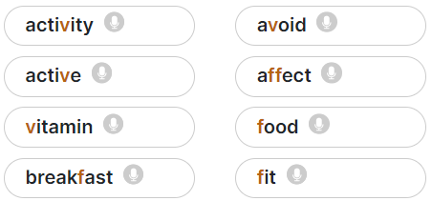
- Teacher has some students read out the words first.
- Teacher plays the recording for them to listen and repeat the words they hear. Asks them to pay close attention to the two sounds. Play the recording as many times as necessary.
- Teacher invites some students to say some words they know that include the two sounds.
- Confirms the correct answers.
(Teacher can play the pronunciation guide video of this unit for students to watch and learn).
Task 5: Listen and repeat. Pay attention to the underlined words. ( 4ms)
a. Aim: To help students pronounce the sounds /f/ and /v/ correctly in sentences.
b. Content: Listen and pay attention to the sounds /f/ and /v/
c. Outcome: practice pronouncing these sounds in sentences.
d.Organisation :
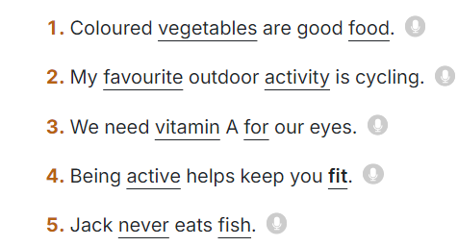
- Teacher has students quickly read the sentences.
- Teacher plays the recording for students to listen to the sentences. Asks them to pay attention to the underlined parts and tick the appropriate sounds.
- Invites some students to read aloud.
- Checks Ss’ pronunciation.
4. ACTIVITY 4: APPLICATION/ PRODUCTION/ FURTHER PRACTICE ( 8ms)
a. Aim: To give Ss much freer practice with their daily activities and decide if each activity is healthy or unhealthy , and to check Ss’ comprehension and broaden their knowledge
b. Content: To make sentences with the words about healthy activities / health problems, and pronounce the sounds /f/ and /v/
c. Outcome: Ss can apply what they have learnt to make real sentences .
d. Organisation : Teacher’s instructions
Using the game : TONGUE TWISTER
1. Victoria fried some fresh fish.
2. Van fried the fish in half a vat of fat.
-Teacher asks students to focus on 2 sentences on the board and try to say it.
- Teacher models, then call some students to read and correct pronunciation if necessary.
- Ss practice saying the sentences.
- Teacher has students try to read the whole sentence as quick as possible without making any mistakes.
- Teacher corrects if necessary.

*WRAP-UP & HOMEWORK ( 2ms)
Summarise the main points of the lesson.
Game: Has some Ss take a card with a health problem or a piece of advice , walk around and try to find the person with the card that matches theirs
Example:
A: I have spots.
B: Oh, I’m sorry. My advice is ‘Wear a hat.’ /Yes! My advice is ‘Wash your face regularly.’
* HOMEWORK:
Asks Ss to do:
- Find 5 more words with the sound /f/ and 5 more words with the sound /v/. Write them down and practice pronouncing the words.
- Do the exercises on page 20 again.
- Do more exercises in the workbook (Exercise B1,2,3,4).
- Prepare the next lesson: Unit 2: A closer look 2

September 24th 2024 | Teacher in charge: Tran Le Vi  Group: Social science
UNIT 2: HEALTHY LIVING
Period 11: Lesson 3: A CLOSER LOOK 2
Subject: English - Class: 7A1, 7A2, 7A3, 7A4
Allotted time: one period
I. OBJECTIVES:
1. Knowledge:
+ To introduce topic of the lesson “ HEALTHY LIVING”.
+ To teach main grammar point : Simple sentences
a. Vocabulary: - To use the words relating to the topic “HEALTHY LIVING”
- To pronounce the sounds /f /, / v / correctly.
b. Grammar: - To recognise and write simple sentences
2. Competence: By the end of the lesson students will be able to learn how to use simple sentences. Students can talk about how to deal with some health problems.
3. Quality/ behavior: To educate Ss the love of English; to known more information about health problems and health tips, their benefits and being aware of the importance of health. Ss have the good attitude to working in groups, individual work, pairwork, cooperative learning and working.
II. TEACHING AIDS AND MATERIALS:
1. Teaching aids: a TV, a laptop computer, pictures, cards, extra boards, Portable multi-function audio device , a loudspeaker, a projector, real objects.
2. Materials: textbooks, workbooks, lesson plan, the teacher’s book, reference books, hoclieu.vn
III. PROCEDURE:
1. ACTIVITY 1: WARM UP & INTRODUCTION ( 5ms)
a. Aims:
- To create a friendly and relaxed atmosphere in the class before the lesson;
- To set the context for the introduction;
- To introduce the grammar points to be learned.
b. Content: To have some warm-up activities to create a friendly and relaxed atmostphere to inspire Ss to warm up to the new lesson.
- To help Ss indentify simple sentences
c. Outcome: Students have a chance to speak English and focus on the topic of the lesson.
d. Organisation: Teacher’s instructions …
GAME: FACE TO FACE:
* Teacher divides class into 2 teams: Cats and Dogs.
- Teacher asks students to think of words or phrases related to “Healthy
activities” which they have learnt in the previous lesson or words they may
know already.
- Ss have 3 minutes to think of the topic
*** Students in each team turn by turn stand up and say 1 word or phrase
related to the topic.
- In 90 seconds, the team has more right answers will be the winner,
and the team repeat the word which is mentioned already or cannot give a
word will be the loser.
Suggested answer:
- Going cycling/ swimming
- Walking
- Boating
- Eating breakfast
- Doing yoga/ aerobics
- Playing sports
- T introduces the new lesson: “Today, we continue Unit 2: “ HEALTHY LIVING” – A closer look 2 to learn more about how to use simple sentences
2. ACTIVITY 2: KNOWLEGDE FORMATION ACTIVITIES/ PRESENTATION / NEW LESSON ( 12ms)
a. Aims:
- To set the context for the introductory;
- To introduce the grammar points to be learned.
- To activate students’ prior knowledge and vocabulary related to the topic, the targeted vocabulary, and its pronunciation.in real context.
b. Content: the two main parts in a simple sentence.
c. Outcome: Ss can understand the conversations , make sentences.
d. Organisation :
VOCABULARY
* Teacher introduces the vocabulary by:
+ providing the synonym or antonym of the words
+ providing the pictures of the words
- Teacher have students read the phrases aloud and correct their pronunciation if necessary.
- Teacher asks students for the Vietnamese meanings of these phrases.
1. dim light (n): [visual + explanation]

2. lip balm (n): [visual + explanation]
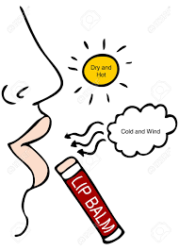
3. chapped lips (n): [visual + explanation]
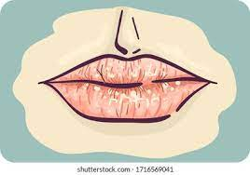
4. coloured vegetables (n): [visual + explanation]

5. red spots (n): [visual + explanation

- Ss say the words.
- Other Ss correct if the previous answers are incorrect.
- Teacher says the words aloud and asks Ss to repeat them
Checking techniques:
“Rub out and remember”
GRAMMAR
- T expresses the subject and the verb of each sentence.
Note: + Some simple sentences have a subject and a verb
Ex: I eat .
+ Some simple sentences also have an object
Ex: I eat a lot of vegetables.
+ Some simple sentences also have an adverb
Ex: I eat a lot of vegetables every day.
-Guides sts to give another example
3. ACTIVITY 3: PRACTICE ACTIVITIES ( 20ms)
Task 1: Tick the simple sentences .( 3ms)
a. Aims:
- To help Ss indentify different parts of a simple sentence.
- To give Ss practice in forming a simple sentence.
b. Content: To understand the situations by using simple sentences better
c. Outcome: Ss know more about the topic of the lesson, enrich vocabulary, and master grammar points.
d. Organisation:
a. Aim: To help students identify the correct form of simple sentences.
b. Content: To understand the situations by using simple sentences better
c. Outcome: Ss know more about the topic of the lesson, enrich vocabulary, and master grammar points.
d. Organisation:
1.The Japanese eat a lot of tofu.
2.She drinks lemonade every morning.
3.I don’t eat fast food, and I don’t drink soft drinks.
4.I am fit.
5.I like fish, but my sister likes meat.
- T guides and gives an example.
- Teacher asks students to do the exercise individually and then compare their answers with a classmate.
- Ss do the task individually.
- Some Ss explain their choices.
- Teacher confirms the correct answers
Suggested answers:1, 2, 4 are simple sentences
Task 2: Underline and write S for the subject and V for the verb in each simple sentence below. ( 3ms)
a. Aim: To help students identify the subject and the verb in a simple sentence.
b. Content: Underline and write S for the subject and V for the verb in each simple sentence below
c. Outcome: Ss know more about the topic of the lesson, enrich vocabulary, and master grammar points.
d. Organisation:
- Teacher has students do this exercise individually by reading each sentence carefully to look for the two main parts.
- Ss do the task individually.
- Ss give and explain their answers.
- Teacher confirms the correct answers.
Suggested answers:

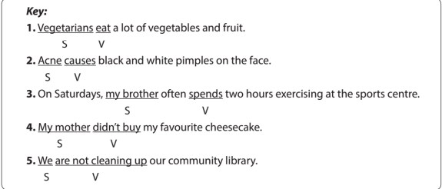

Task 3: Rearrange the words and pharases to make simple sentences. ( 5ms)
a. Aim: To help student identify different parts of a simple sentence and put them in the correct order to form a simple sentence.
b. Content: To rearrange the words and pharases to make simple sentences
c. Outcome: Ss know more about the topic of the lesson, enrich vocabulary, and master grammar points.
d. Organisation:
- Teacher asks Ss to work in pairs.
- Ss work in pairs to do the task.
- Teacher calls on Ss to read aloud the complete sentences.
- Teacher confirms the correct answers
Suggested answers:
1. My sister never drinks soft drinks.
2. Acne aﬀects 80% of young people.
3. He has bread and eggs for breakfast.
4. We don’t eat much fast food.
5. Fruit and vegetables have a lot of vitamins.
Task 4: Write complete sentences from the prompts. You may have to change the words or add some. ( 5ms)
a. Aim: To help student identify different parts of a simple sentence and put them in the correct order to form a simple sentence.
b. Content: To write complete sentences from the prompts.
c. Outcome: Ss complete sentences from the prompts and master grammar points.
d. Organisation:
- Teacher asks Ss to look at the prompts of each sentence and decide the two main parts of the sentence.
- Ss do the task individually.
- Call on some students to read out their answers.
- Teacher confirms the correct answers.
- Choose some typical errors and correct as a whole class without nominating the students’ names.
Suggested answers:
1. Tofu is healthy.
2. Many Vietnamese drink green tea.
3. She does not use suncream.
4. My father does not exercise every morning.
5. Most children have chapped lips and skin in winter.
Task 5: Discuss and write a simple sentence from two given sentences. ( 4ms)
a. Aim: To allow Ss more advanced practice in forming a simple sentence from two separate ones.
b. Content: To discuss and write a simple sentence from two given sentence.
c. Outcome: Ss can write a simple sentence from given sentences and master grammar points.
d. Organisation:
- Teacher asks Ss to work in pairs to read the two separate sentences, discuss and determine the two main parts for the new sentence.
- Ss work in pairs.
- Call on some Ss to write the sentences on the board.
- Teacher corrects the answers.
- Choose some typical errors and correct as a whole class without nominating the students’ names.
Suggested answers:
- We avoid sweetened food and soft drinks.
2. My dad and I love outdoor activities.
3. You should wear a hat and suncream.
4. My mother read and downloaded the health tips.
4. ACTIVITY 4: APPLICATION/ PRODUCTION/ FURTHER PRACTICE ( 6ms)

a. Aim: To give Ss much freer practice with simple sentences in real context and to check Ss’ comprehension and broaden their knowledge
b. Content: To make sentences with words provided using simple sentences
To give advices about healthy activities and health problems.
c. Outcome: Ss can make real sentences .
d. Organisation :
- Teacher asks Ss to give advice about health problems.
- Ss work in group.
- Call on some Ss to write their answers on the board.
- Teacher corrects the answers.
- Choose some typical errors and correct as a whole class without nominating the students’ names.
*WRAP-UP & HOMEWORK ( 2ms)
Summarise the main points of the lesson.
- Teacher asks students to talk about what they have learnt in the lesson.
HOMEWORK:
- Do the exercises on page 21, 22 again, Do more exercises in the workbook.
- Prepare the next lesson: Unit 2: Skills 1

September 29th 2024 | Teacher in charge: Tran Le Vi  Group: Social science
UNIT 2: HEALTHY LIVING
Period 12: Lesson 4: Communication
Subject: English - Class:7A1, 7A2, 7A3, 7A4
Allotted time: one period
I. OBJECTIVES:
1. Knowledge:
+ Vocabulary:
- Revise the words related to healthy activities and health problems;
- Revise the sound /f/, /v/ correctly.
+ Grammar:
- Review grammar such as simple sentences.
+ Skills: Revise how to ask for and give health tips
2. Competence: By the end of the lesson students will be able to develop communication skills, collaborative and supportive in pair work and team work, actively join in class activities. They can revise how to ask for and give health tips. They have learnt so far in terms of language and skills. Students know how to do exercises correctly.
3. Quality/ behavior: Ss will be benevolent and responsible. The awareness about importance of learning English. Having a serious attitude to working in groups, individual work, pairwork, cooperative learning and working.
II. TEACHING AIDS AND MATERIALS:
1. Teaching aids: a TV, a laptop computer, pictures, cards, extra boards, Portable multi-function audio device , a loudspeaker, a projector, real objects.
2. Materials: textbooks, workbooks, lesson plan, the teacher’s book, reference books, hoclieu.vn
III. PROCEDURE:
1. ACTIVITY 1: WARM UP & INTRODUCTION ( 5ms)
a. Aims:
- To create a friendly and atmosphere in the class before the lesson;
- To revise the language they have learnt in Units 1-3;
- To lead into the new lesson.
b. Content: To have some warm-up activities to create a friendly and relaxed atmostphere to inspire Ss to warm up to the subject and new lesson.
c. Outcome: Ss feel excited and focus on the topic of the lesson.
HEALTH PROBLEMS
d. Organisation: Teacher’s instructions …
+ Greeting
+ Play game: BRAINSTORMING
- T divides class into 2 teams and asks them to think of “health problems”.
- Ss have 1 m to think of the words related to the topic or they can discuss with their partners
- Each member from each team turn by turn run to the board and write one word.
- T corrects their answers.
- The team which has more correct words will be the winner
Suggested answers:
Asthma, a backache, a broken leg, a cold, a cough, an earache, a headache, a sore throat, a toothache, sunburn, etc.
=> T leads Ss into the lesson by telling what they are going to learn: “We are going to learn how to give tips for health problems”.
- Open their book and write.
2. ACTIVITY 2: KNOWLEGDE FORMATION ACTIVITIES/ PRESENTATION / NEW LESSON ( 10ms)
a.Aims:
- To help the students review the vocabulary and the pronunciation.
- To enable the students to review the grammar points.
- To introduce two ways to give tips on health problems and to allow Ss some practice.
b.Content: Revise some important items before practising with the tasks.
c.Outcome: Remember the vocabulary, pronunciation of the sound anđ grammar points.
d. Organisation : Teacher’s instructions..
- Lets Ss work in groups to revise about what they have learnt in the old lesson.
1. Vocabulary about healthy activities and health problems;
2. Pronunciation : the sound /f/, /v/ correctly.
- Gets feedback
- Together with the class complete the summary.
+ Gets Ss to take not
3. Grammar:
- Lets Ss work in groups to revise about the grammar points what they have learnt .
  - To give advice/ tips on health problems:
- You should/ shouldn’t … / - You can …
  - The simple sentences
- Gets feedback.
- Together with the class complete the summary
3. ACTIVITY 3: PRACTICE ACTIVITIES ( 20ms)
Task 1: Listen and read the dialogue. ( 4ms)
a.Aim: To help students practice the dialogue.
b.Content: Listen and read the dialogue, practice in pairs.
c.Outcome: Ss can remember and pronounce the words correctly.
d.Organisation:
- Teacher plays the record for SS to listen and read the conversation about health problem.
- Ss listen and practice saying with their partners.
- Teacher calls some pairs to read aloud.
- Teacher corrects pronunciation if necessary.
- Teacher asks Ss to pay attention to the highlighted parts and asks them some questions to elicit the new structure:
- What do these sentences mean?
- When do we use these sentences?
- …
- Ss answer teacher’s questions to find out new structure to give tips for health problems.
- Some students give the new structure to the teacher.
- Teacher corrects and writes on the board:
+ Structure: to give advice:
- You should/ shouldn’t …
- You can …
Task 2: Make similar cobversation. ( 6ms)
a.Aim: To help students practise giving tips on health problems.
b.Content: Making similar conversation by working in pairs.
c.Outcome: Ss can make and present their dialogue in front of the class.
d.Organisation :
-T has Ss look at the situation in Ex 2 to make similar dialogue:
1. I’m tired. 2. I have acne. 3. My hands are chapped.
- Ss work in pairs to make similar dialogue.
- T calls some pairs to present it in front of the class.
- T gives feedback and some comments.
* Suggested answers:
A: I am tired.
B: You can drink some milk.
A: Yes.
B: And you should have a nap.
A: Thank you.
Task 3: Read the passage and choose the correct title for it. ( 4ms)
a. Aim: To provide students with more knowledge about healthy living and help them practice the skill of reading for the main idea.

b.Content: To read the passage and choose the best answer.
c.Outcome: Ss review more some words and can choose the correct answers.
d.Organisation:
- T asks Ss to read the passage independently and choose the correct answer of the main idea.
- Ss so the task individually.
- T calls some Ss to give their answer and explain it.
- T confirms the correct answers.
* Key: A
Task 4: Disucss and make a list for the tips with help the Japanese live long lives. ( 6ms)
a. Aim: To help students identify the main points in a reading and talk about them.

b.Content: Make a list for the healthy living tips.
c.Outcome: Ss remember the tips, the use of some grammar points. Doing the task correctly.
d.Organisation :
-T has Ss work in groups to discuss and takes notes of the tips for a long life that they find in the text.
- Ss work in groups.
- 2-3 groups share their lists.
- T confirms and corrects if necessary.
* Key: (1) They eat a lot of fish and vegetable. (2) They cook fish with little cooking oil.
(3) They also eat a lot of tofu. (4) The Japanese work hard and do a lot of outdoor activities.
4. ACTIVITY 4: APPLICATION/ PRODUCTION/ FURTHER PRACTICE ( 8ms)
a. Aim: To help students practise giving health tips on their own context.
b. Content: Understand the given tips, make more tips.
c. Outcome: Ss can do this task quickly, correctly.
d. Organisation : Teacher’s instructions
- T asks Ss to work in groups of 4- 5.
- Ss work in group of 4- 5 to discuss and come up with some tips for how the Vietnamese can live longer.
- Some groups share ideas with the whole class and other groups listen and add more their ideas.
- T listens and corrects if necessary.
- Teacher and students
- Ss do the task. Work in groups
- Listen carefully- Check the answers
- Copy down
* Suggested answers:
1. avoid overeating 2. do more outdoor activities. 3. drink enough water 4. sleep before 10 p.m
5. eat more nuts. 6. do more exercises. 7. …
*WRAP-UP & HOMEWORK ( 2ms)
Summarise the main points of the lesson.
- Asks Ss what they have learnt so far. Have them recall the important elements.
+ Skills: Revise how to ask for and give health tips
* HOMEWORK
Asks the students to:- Learn by heart all the lesson
- Do more exercises in workbook.
- Prepare: Unit 2 – Skill 1
September 30th 2024 | Teacher in charge: Tran Le Vi  Group: Social science
UNIT 2: HEALTHY LIVING
Period 13: Lesson 5: SKILLS 1
Subject: English - Class: 7A1, 7A2, 7A3, 7A4
Allotted time: one period
I. OBJECTIVES
1. Knowledge
+ Reading: - read for specific information about acne
+ Speaking: - talk about how to deal with some health problems.
+ Vocabulary: use the words related to the topic healthy living such as healthy activities and health problems..
+ Grammar: simple sentences ;
2.Competence:
By the end of the lesson students will be able to develop the vocabulary about the topic; identify and talk about their daily activities and decide if they are good or bad for their health;
3. Quality/ behavior: To teach Ss the love of English; the value of healthy living. The awareness about importance of learning English. Ss have the good attitude to working in groups, individual work, pairwork, cooperative learning and working.
II. TEACHING AIDS:
1. Teaching aids: a TV, a laptop computer, pictures, cards, extra boards, Portable multi-function audio device , a loudspeaker, a projector, real objects.
2. Materials: textbooks, workbooks, lesson plan, the teacher’s book, reference books, hoclieu.vn
III. PROCEDURES
1. ACTIVITY 1: WARM UP & INTRODUCTION ( 4ms)
a. Aims:
- To introduce the topic of reading..
- To set the context for the introduction.
- To know some food and drink.
b. Content:
- To have some warm up activities to create a friendly and relaxed atmostphere.
- To find some food and drink relating to health.
c. Outcome:
- The students can talk about how to deal with some health problems.
d.Organisation:
GAME: HANGMAN
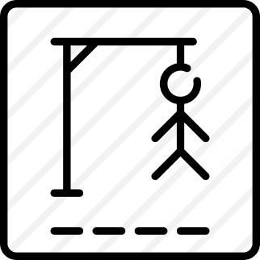

S K I N C O N D I T I O N

* Teacher divides class into 2 teams and asks them to think of the word which has 13 letters in it related the topic “health problems”.
** Ss have 1 min to think of the words related to the topic or they can discuss with their partners.
*** Each member from each team turn by turn guesses the letter in the secret word.
**** Teacher corrects their answers.
- The team which can find or guess the secret first will be the winner.
2. ACTIVITY 2: KNOWLEGDE FORMATION ACTIVITIES/ PRESENTATION / NEW LESSON ( 10ms)
a. Aims: To provide students with some lexical items before reading the text
b. Content: Learn some new words form the reading text.
c. Outcome: Know more new words about groups of a skin condition and some words related to health living.
d.Organisation:
VOCABULARY.
Teacher leads students into the lesson by telling what they are going to learn: “We are going to read a passage about one of the most common “Skin condition” among teenagers.
- Teacher introduces the vocabulary by:
+ Providing the synonym or antonym of the words.
+ Providing the pictures of the words.
+ Providing the definition of the words.
1. disease (n): [explanation]
2. serious (a): [explanation]
3. take care of (phr v): [symnonym]
4. pop (v): [visual + explanation]
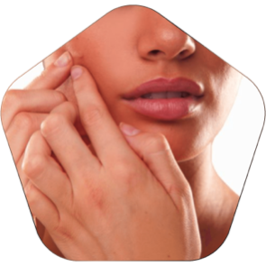

Concept check: Rub out and Remember.
DISCUSSION
Task 1: Read the passage and match the beginnings in A with the endings in B. ( 3ms)
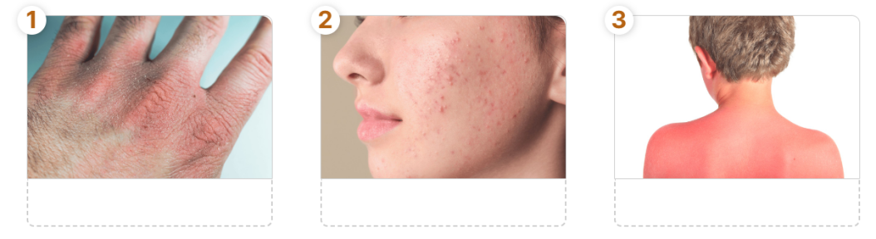
- Teacher asks Ss to work in pairs to look at some pictures in Ex 1 on page 23 to write each word or phrase under the correct picture and discuss with their partners “Which skin condition is the most common among teenagers”.
- Ss work in pairs.
- Teacher calls some Ss to check what they have discussed.
- Teacher corrects.
Answer keys:
1. chapped skin 2. Acne 3. sunburn
3. ACTIVITY 3: PRACTICE ACTIVITIES ( 20ms)
A. READING:
Task 2: Read the passage and match the beginnings in A with the endings in B. ( 4ms)
a. Aim: To help Ss develop their reading skill for specific information (scanning) and help them focus on the problem of acne..
b. Content:- To read the passage and match the beginnings …with the endings…
c. Outcome:- The students can read and understand one of the most common “Skin condition” among teenagers.
d.Organisation:
- Teacher has Ss read the text in detail to do the exercise and asks them how to do this kind of exercise.
- Read the beginnings in A. They all start with ‘acne’ plus the verbs (is, affects, causes).
- Locate the part of the text where they find the information. They all appear right in the first paragraph.
- Read that part and do the matching.
- Ss do the task independently
- Teacher tells Ss to compare their answers in pairs before calling some of them to check.
- Teacher confirms the correct answer and explains if necessary.
Answer key:
1. b 2. d 3. a 4. c
Task 3: Read the passage again and choose the correct answer A, B or C. ( 5ms)
a. Aim: To help Ss further develop their reading skill for specific information (scanning).
b. Content:To read the passage again and choose the correct answer …
c. Outcome:-Sts can develop communication skills
- The students can read and understand one of the most common “Skin condition” among teenagers.
d.Organisation:
- Teacher asks Ss: reading each question, locating where the information appears in the text, reading that part carefully and circling the correct answer.
- Ss do the task independently.
- Teachers has Ss compare their answers in pairs and call some Ss to give their ideas.
- Teacher checks and confirms the correct answers.
Answer key:
1. A 2. C 3. B 4. B 5. A
B. SPEAKING:
Task 4: Read the passage again. Pick the tips which you can easily follow. Share your ideas with your partner. ( 5ms)
a. Aim: To help Ss talk about how they apply the tips in the reading to themselves.
b. Content:To read the passage again and get the tips about the health problems …
c. Outcome:-Sts know the tips about the health problems …
d.Organisation:
- Teacher asks Ss to work in pairs and tells them to focus on the tips for acne in the text to talk about which tip they can easily follow.
- Ss work in pairs. Teacher goes around and listens and gives help if necessary.
- Teacher calls on some Ss to share their answers with the class. If there is a tip they cannot follow, ask them to explain why not.
- Teacher listens and gives comment.
Task 5: Read about the health problems below. Discuss and make note f some tips you can give each person. Then share your ideas with the class. ( 6ms)
a. Aim: To provide Ss an opportunity to practise giving tips for health problems..
b. Content: To share some tips for health problems together…
c. Outcome: -Sts know the tips about the health problems …
d.Organisation:
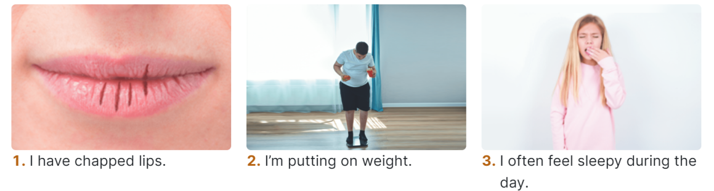
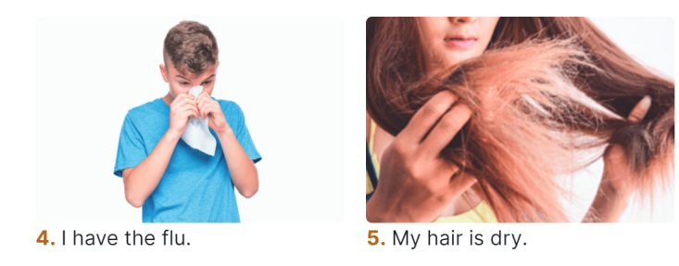
- Teacher has Ss work in groups and asks them to take turns to give tips for each health problem.
- Ss work in groups to do the task. Teacher goes around, listens and gives help if necessary.
- Teacher calls on some groups to share their answers with the class.
- Teacher comments.
Suggested answers:
1. Use some lip balm.
Use coconut oil or body lotion.
2. Eat less fast food, meat, and ice cream.
Eat more fruit and vegetable.
3. Get enough sleep, 7 - 8 hours a day.
Don't go to bed too late.
4. Keep warm and stay in bed.
Drink plenty of water and eat light food.
5. Avoid washing your hair every day.
Take vitamins.
- ACTIVITY 4: APPLICATION/ PRODUCTION/ FURTHER PRACTICE ( 8ms)
a.Aim: To consolidate what students have learnt in the lesson.
b. Content: RETELLING.
c. Outcome: Ss can identify and talk about their daily activities and decide if they are good or bad for their health..
d. Organisation :
- Teacher asks Ss to work in groups and take turn to say 1 sentence which they can remember from the passage they have read about “acne”.
- Ss work in groups.
- Teacher calls some groups to check.
- Teacher corrects if necessary and gives feeback.
*WRAP-UP & HOMEWORK ( 2ms)
Summarise the main points of the lesson.
- Asks one or two Ss to tell the class what they have learnt.
- Asks Ss to say aloud some words they remember from the lesson.
* HOMEWORK
- Read again the passage on page 23.
- Do more exercises in workbook.
- Prepare the vocabulary for the next lesson: Skills 2.

October 1st 2024 | Teacher in charge: Tran Le Vi  Group: Social science
UNIT 2: HEALTHY LIVING
Period 14: Lesson 6: SKILLS 2
Subject: English - Class: 7A1, 7A2, 7A3, 7A4
Allotted time: one period
I. OBJECTIVES:
* By the end of this unit, students will be able to:
1. Knowledge:
+ Listening
- Use the lexical items related to the topic Healthy living
- Listen for specific information about some advice about healthy habits
+ Writing: write some advice to avoid viruses.
2. Competence:
- Develop communication skills
- Be collaborative and supportive in pair work and team work
- Actively join in class activities
3. Quality/ behavior:
- Be benevolent and responsible
II. TEACHING AIDS AND MATERIALS:
1. Teaching aids: a TV, a laptop computer, pictures, cards, extra boards, Portable multi-function audio device , a loudspeaker, a projector, real objects.
2. Materials: textbooks, workbooks, lesson plan, the teacher’s book, reference books, hoclieu.vn
III. PROCEDURE:
1. ACTIVITY 1: WARM UP & INTRODUCTION ( 5ms)
a. Aims:
- To create a friendly and relaxed atmosphere in the class before the lesson;
- To set the context for the introduction.
b. Content: To have some warm-up activities to create a friendly and relaxed atmosphere to inspire Ss to warm up to the new lesson.
c. Outcome: Students have a chance to speak English and focus on the topic of the lesson.
d. Organisation:

Brainstorming race (Group work)
drink a lot of water
Healthy habits

- Students (Ss) play the game in groups
- Ask students to list any vocabularies relating to “heathy habits” in groups.
- Encourage Ss to talk in English and write words related to “heathy habits” in groups as much as possible.
- Ask groups to present their answers on the board and the winner will share their answers.
- Give remarks.
- Lead to the new lesson
- T introduces the new lesson: “Today, we’ll come to Unit 2: Healthy living – Lesson 6: Skills 2 to listen for specific information about some advice about healthy habits and learn how to write some advice to avoid viruses”
2. ACTIVITY 2: KNOWLEGDE FORMATION ACTIVITIES/ PRESENTATION / NEW LESSON ( 7ms)
a. Aims:
- To set the context for the introductory;
- To introduce the topic of the unit, the vocabulary, the sounds, and the grammar points to be learned.
b. Content: Learn some new words.
c. Outcome: Know more new words.
d. Organisation: Teacher’s instructions.
*Teach vocabulary:
+ Teacher uses different techniques to teach vocab (situation, realia, translation.)
+ Follows the seven steps of teaching vocab.
- put on weight (n) [explanation] gain weight
- soft drinks (n) [picture]
- keep fit (v) [translation]
+ Check vocabulary.
+ Get SS to take note
3. ACTIVITY 3: PRACTICE ACTIVITIES ( 23ms)
A. LISTENING:
Task 1: Discuss and tick the habits you think are good for your health. ( 2ms)
a. Aim: To help Ss brainstorm the topic and prepare for the listening text
b.Content: discuss and tick the habits you think are good for your health
c.Outcome: healthy habits
d. Organisation: - Asks Ss to work in pairs to discuss if these sentences are good or bad for their health.
- Ss Work with their partner to do the task.
- Calls on some Ss to answer.
- Gives comments and leads Ss to task 2.
Suggested answers:
Good for health: 2, 3
Task 2: Listen and tick the habits mentioned. ( 5ms)
a.Aim: To help Ss develop their skill of listening for specific information.
b.Content: Listen and tick the habits mentions
c.Outcome: Ss know how to listen for specific information about healthy habits
d.Organisation:
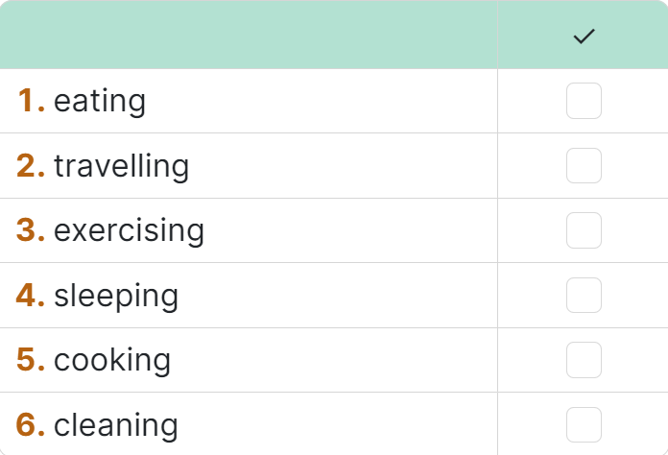
- Has Ss guess if these habits are mentioned in the listening text. If they say yes for a habit, put a tick next to the word. Then, teacher plays the recording once for students to check their guesses.
- Gets Ss to work in pairs to guess then listen to the recording once to check their guess.
- Calls on some pairs to give the answers the have listened.
- Teacher plays the recording again, confirms the correct answers for their predict and stop at places where Ss are having difficulties
Key:
Categories mentioned: 1,2,4,5,7
Audio script – Tracks 12 + 13:
“Healthy habits help us keep fit and avoid disease. Here is some advice. Eat more fruit and vegetable, especially coloured ones like carrots and tomatoes. They provide a lot of vitamins. Eat meat, eggs, and cheese, but not too much. You may put on weight. Drink enough water, but not soft drinks. Be active and exercise every day. Do outdoor activities like cycling, swimming, or playing sports. They keep you fit. Go to bed early and get about 8 hours of sleep daily, so you will not feel tired. Keep your room tidy and clean. Open windows to let in fresh air and sunshine on fine days.”
Task 3: Listen again and answer the questions with no more than three words. ( 4ms)
- Aim: To help Ss further develop their skill of listening for specific information.

b.Content: Listen again and answer the questions with no more than three words.
c.Outcome: Ss know more some healthy habits.
d.Organisation: Teacher’s instructions ….
- Has Ss read the questions and determine what information they need for answering the questions. Remind them answer the questions with no more than THREE words. Then, teacher plays the recording once or twice more for Ss to do the exercise.
- Asks Ss work independently to listen again and determine what information they need. After that, Ss can share their answers in pairs.
- Calls on some pairs to give answers.
- Confirms the correct ones and plays the recording again if needed, stopping at the places where students are having difficulties.
Suggested answers:1. disease 2. (lots of) vitamins 3. 8 / eight hours 4. tidy and clean
B. WRITING
Task 4: Discuss and make notes of the tips from the listening. Then share them with the class. ( 3ms)
a. Aim: To help Ss make simple notes of what they have listened to.
b. Content: Discuss and make notes of the tips and write in full sentences.
c.Outcome: Ss can listen and write the specific information.
d. Organisation: Teacher’s instructions
- Tells Ss to work in groups to discuss and make notes of the tips and write in full sentences.
e.g. Don’t eat too much meat and cheese.
- Asks Ss work in groups. Teacher moves around and offers help if needed.
- Invites some Ss to share their answers.
- Confirms the correct answers.
Task 5: Discuss and brainstorm ideas. ( 5ms)
a. Aim: To help Ss prepare ideas to write a passage.
b. Content: discuss and brainstorm ideas
c. Outcome: ideas about “Covid-19”
d. Organisation: Teacher’s instructions
- Write on the board “Covid-19” and ask Ss to give ideas on what they have known about it and asks them to look at the pictures and explains if needed
- Get Ss to think of it and can discuss with their partners.
- Call on some Ss to raise their ideas.
- Listen and confirm.
Suggested answers: happened in 2019, it caused by virus, many people died of it, …
Task 6: write a passage of about 70 words to give advice on how to avoid viruses. ( 4ms)
a. Aim: To help Ss practise writing a passage to give advice on how to avoid viruses.
b. Content: write a passage of about 70 words to give advice on how to avoid viruses
c.Outcome: a passage of about 70 words to give advice on how to avoid viruses
d. Organisation: Teacher’s instructions
- Tell Ss that they are going to write a passage to give advice on how to avoid viruses
- Have Ss work independently to do the task and try to add more tips if they can.
Teacher goes around and help if necessary.

4. ACTIVITY 4: APPLICATION/ PRODUCTION/ FURTHER PRACTICE ( 8ms)

a.Aim: To peer check, cross check and final check students’ writing.
b. Content: write a passage of about 70 words to give advice on how to avoid viruses
c. Outcome: students’ writing
d. Organisation :
- Ask Ss to share their writing with their partners. Then, call on some Ss to show their writing in front of the class.
- Check ideas, grammar, vocabulary and gives comments.
Suggested answers:
We can do a lot of things to avoid viruses. First, always keep your surroundings clean. Sweep your house, clean your furniture, and change your pillow covers and bedsheets often. Remember to take a bath daily. Wash your hands with soap regularly. Drink a lot of water and eat more fruit and vegetable. Exercise three times a day for at least 15 minutes each time. When you go out, wear a mask and avoid crowds.
*WRAP-UP & HOMEWORK ( 2ms)
Summarise the main points of the lesson.
- Asks one or two Ss to tell the class what they have learnt.
- Asks Ss to say aloud some words they remember from the lesson.
* HOMEWORK
- Rewrite the passage on the notebook.
- Do more exercises in workbook.
- Prepare Looking back and project

October 6th 2024 | Teacher in charge: Tran Le Vi  Group: Social science
UNIT 2: HEALTHY LIVING
Period 15: Lesson 7: Looking back + Project
Subject: English - Class: 7A1, 7A2, 7A3, 7A4
Allotted time: one period
I. OBJECTIVES:
1. Knowledge:
+ Vocabulary:
- Review the vocabulary of Unit 2
- Revise the sound /f/, /v/ correctly.
- Apply what they have learnt into practice through a project.
+ Grammar:
- Review grammar of Unit 2.
+ Skills:
- Practise reading for general and specific information about ance;
- Practise talking about how to deal with some health problems;
- Practise listening for specific information about some advice about healthy habits.
- Practise writing a paragraph of some advice to advoid viuses.
2. Competence: By the end of the lesson students will be able to develop communication skills, collaborative and supportive in pair work and team work, actively join in class activities. They can revise how to ask for and give health tips. They have learnt so far in terms of language and skills. Students know how to do exercises correctly.
3. Quality/ behavior: Ss will be benevolent and responsible. The awareness about importance of learning English. Having a serious attitude to working in groups, individual work, pairwork, cooperative learning and working.
II. TEACHING AIDS AND MATERIALS:
1. Teaching aids: a TV, a laptop computer, pictures, cards, extra boards, Portable multi-function audio device , a loudspeaker, a projector, real objects.
2. Materials: textbooks, workbooks, lesson plan, the teacher’s book, reference books, hoclieu.vn
III. PROCEDURE:
1. ACTIVITY 1: WARM UP & INTRODUCTION ( 3ms)
a. Aims:
- To create a friendly and atmosphere in the class before the lesson;
- To make students curious and motivate students’ learning;
- To revise the skills they have practised in Unit 2; lead into the topic.
b. Content: Having some warm-up activities to create a friendly and relaxed atmostphere to inspire Ss to warm up to the subject and new lesson.
c. Outcome: Having a chance to speak English and focus on the topic of the lesson…
d. Organisation : Teacher’s instructions …
+ Greeting
+ Playing a game
BRAINSTORMING
-T asks Ss to think of what they have learnt already in Unit 2.
- Ss work in pairs to do the task.
- T calls some students to retell.
- T confirms and leads them to do all the exercises in books.
=> Introduces the new lesson “Now, we are going to continue Unit 2: Looking back + Project”
- Open their book and write.
2. ACTIVITY 2: KNOWLEGDE FORMATION ACTIVITIES/ PRESENTATION / NEW LESSON ( 7ms)
a.Aims: - To help students revise the vocabulary items they have learnt in the unit.
- To enhance students’ skills of cooperating with team mates.
b.Content: Revise some important items before practising with the tasks.
c.Outcome: Remember the vocabulary, pronunciation of the sound anđ grammar points.
d. Organisation : Teacher’s instructions..
- Lets Ss work in groups to revise about what they have learnt in the old lesson.
1. Vocabulary about healthy activities and health problems;
2. Pronunciation : the sound /f/, /v/ correctly.
- Gets feedback
- Together with the class complete the summary.
+ Gets Ss to take not
3. Grammar:
- Lets Ss work in groups to revise about the grammar points what they have learnt in the old lesson.
  - To give advice/ tips on health problems:
- You should/ shouldn’t …
- You can …
  - The simple sentences
- Gets feedback.
- Together with the class complete the summary
3. ACTIVITY 3: PRACTICE ACTIVITIES ( 13ms)
Task 1: Complete the sentences with the verbs below.( 3ms)
a.Aim: To help Ss revise the vocabulary items (verbs) they have learnt in the unit.
b.Content: Complete the sentences and give the correct answers. Doing individually. c.Outcome: Ss can do the task correctly
d.Organisation : Teacher’s instructions.…..
-T has Ss work individually read the verbs in the box and see if they still remember their meanings.
- Ss do this activity individually, then compare their answers with their partners.
- T asks for Ss’ answers.
- T confirms the correct ones
* Key:
1. keep 2. affects 3. avoid 4. are 5. exercise
Task 2: Write the words below next to their definitions.( 3ms)
a.Aim: To help Ss revise the vocabulary items (adjectives) they have learnt in the unit.
b.Content: Use the correct words to the definitions.
c.Outcome: Ss can finish the task easily.
d.Organisation : Teacher’s instructions …
-T has Ss work individually read the adjectives in the box and see if they still remember their meanings.
- Ss do this activity individually, then compare their answers with their partners.
- T asks for Ss’ answers.
- T confirms the correct ones.
Answer key:
1. active 2. healthy 3. tidy 4. fit 5. dirty
Task 3: Tick the simple sentences. ( 2ms)
a. Aim: To help Ss revise simple sentences.

b.Content: Read and tick the simple sentences. Working individually.
c.Outcome: Ss can do the task correctly.
d.Organisation : Teacher’s instructions ….
-T asks Ss again What is a simple sentence? and tell them to do Ex 3 in the workbook.
- Ss do the exercise individually and swap with their partners.
- T calls some Ss to check their answer.
- T confirms the correct answer.
* Key:
Answer key: Simple sentences: 2, 3, 5
Task 4: Change the following sentences into simple ones. ( 5ms)
a. Aim: To help Ss revise simple sentences.

b.Content: Read and change into the simple sentences. Working individually.
c.Outcome: Ss can do the task correctly.
d.Organisation : Teacher’s instructions ….
-T asks Ss to write a simple sentence by identifying the main parts of the new sentence.
- Ss work individually to do the task.
-T calls 1 - 2 Ss to write on the board.
-T checks and confirms their answer.
* Key:
1. Both you and your brother are active.
2. Your room looks dark and untidy.
3. The Japanese work hard and exercise regularly.
4. My mother eats a lot of fruit and vegetable.
4. ACTIVITY 4: APPLICATION/ PRODUCTION/ FURTHER PRACTICE ( 20ms)
a. Aims: To help Ss identify a bad habit for healthy living in their school and offer some tips to change that habit.
b. Content: Prepare the posters and present the project.
c. Outcome: Ss can complete this task quickly, correctly.
d. Organisation:
TASK : Work in groups
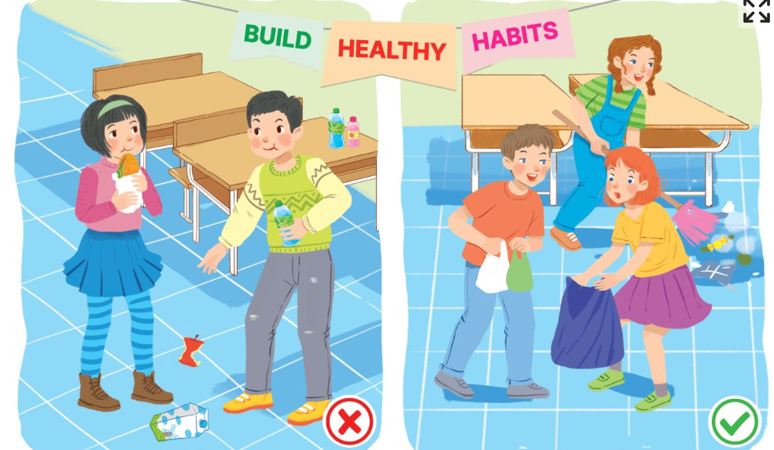

REQUIREMENT: Have Ss read the project. Ask them make a poster about a bad habit that the students in your school often do. Elicit Ss’ answers. Ss work in groups to choose and discuss about a bad habit and create a poster about it then give some tips to change that habit. Answer Ss’ questions if there are any. Remember to have Ss present their findings in the next lesson and vote for the best.

ORGANIZATION:
1. Discuss and find a bad habit and some tips to change it.
2. Find or draw a picture to illustrate your idea.
3. Prepare a presentation. Remember to assign who will talk about what.
4. Give a presentation to the class an exhibition of posters or video clips sts have made among groups. Vote for the best

FEEDBACK FORM FOR SURVEYS
1. Self-assessment
 | Tick where appropriate | Comments (in English or Vietnamese)
DELIVERY
1. We greeted the audience.
2. We spoke clearly and naturally.
3. We interacted with the audience.
4. We cooperated with my group members when delivering the talk
5. We concluded my part of the talk appropriately.
DESIGN OF THE POSTER / SLIDES/…
1. Our photos/ pictures /drawing/ slides/ videos/ plan were clearly organized .
2. Our content and photos/ drawing/ slides/… were suitable
CONTENT: Our presentation includes the following information:
1. The name of the bad habit.
2. Suitable photos for it or draw pictures to illustrate the bad habit.
3. Some tips to change that habit.
2. Peer assessment
 | Tick where appropriate | Comments (in English or Vietnamese)
DELIVERY
1. The presenters greeted the audience.
2. The presenters spoke clearly and naturally.
3. The presenters interacted with the audience.
4. The presenters cooperated with my group members when delivering the talk
5. The presenters concluded my part of the talk appropriately.
DESIGN OF THE POSTER / SLIDES/…
1. Their photos/ pictures /drawing/ slides/ videos/ plan were clearly organized .
2. Their content and photos/ drawing/ slides/… were suitable
CONTENT: The presentation includes the following information:
1. The name of the bad habit.
2. Suitable photos for it or draw pictures to illustrate the bad habit.
3. Some tips to change that habit.

RULES:
- Make a postcard or a video clip about a bad habit.
- Each group will send a representative to go to the board to describe their group’s postcard/ video clip in 4 ms.
- After 4 groups have already finished their groups’ presentation, judges will give remarks, assessment and awards

Rubrics for rating:
Part 1: DELIVERY (4pts)
The total score for this part is 4 points
Part 2: DESIGN OF THE POSTER / SLIDES/… (2pts)
The total score for this part is 2 points
Part 3: CONTENT (4pts)
The total score for this part is 4 points

- RESULT FOR THE ASSESSMENT OF STUDENTS’PRODUCTS

Class | Group | Part 1  Delivery | Part 2  Design of the poster/ slides/… | Part 3  Content | Total | Rank
 |  | (4pts) | (2pts) | (4pts) | (10pts)
7A1 | Group 1 | 3,0 | 1,5 | 3,5 | 8,0 | 3
 | Group 2 | 3,0 | 1,5 | 3,5 | 8,0 | 3
 | Group 3 | 3,5 | 1,5 | 3,5 | 8,5 | 2
 | Group 4 | 4,0 | 1,5 | 3,5 | 9,0 | 1
7A2 | Group 1 | 3,0 | 1,5 | 3,5 | 8,0 | 3
 | Group 2 | 4,0 | 1,5 | 3,5 | 9,0 | 1
 | Group 3 | 3,5 | 1,5 | 3,5 | 8,5 | 2
 | Group 4 | 3,0 | 1,5 | 3,5 | 8,0 | 3
7A3 | Group 1 | 3,5 | 1,5 | 3,5 | 8,5 | 2
 | Group 2 | 3,0 | 1,5 | 3,5 | 8,0 | 3
 | Group 3 | 3,0 | 1,5 | 3,5 | 8,0 | 3
 | Group 4 | 4,0 | 1,5 | 3,5 | 9,0 | 1
7A4 | Group 1 | 4,0 | 1,5 | 3,5 | 9,0 | 1
 | Group 2 | 3,5 | 1,5 | 3,5 | 8,5 | 2
 | Group 3 | 3,0 | 1,5 | 3,5 | 8,0 | 3
 | Group 4 | 3,0 | 1,5 | 3,5 | 8,0 | 3

- GROUPS’PRODUCTS
- Make a poster about a hobby

CLASS 7A1
GROUP 1 | GROUP 2
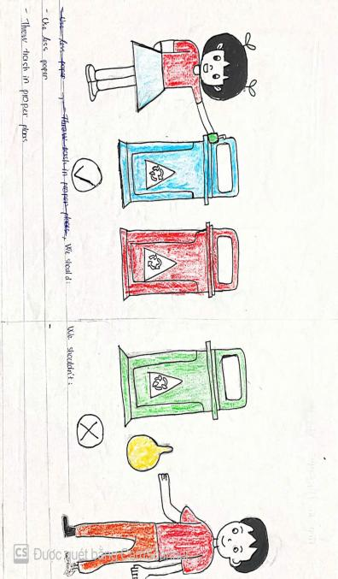 | 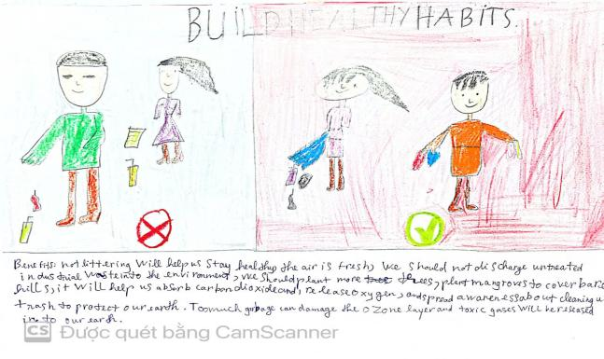
GROUP 3 | GROUP 4
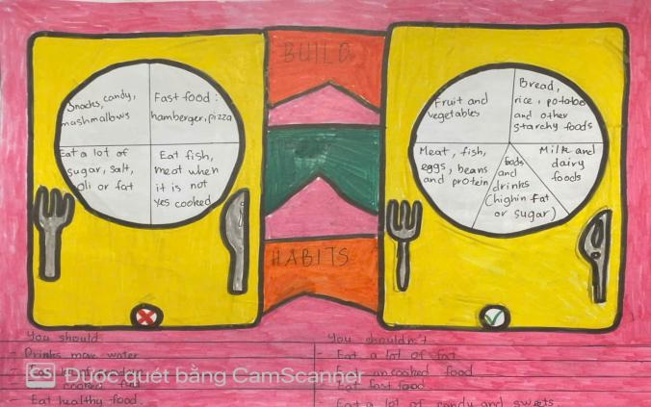 | 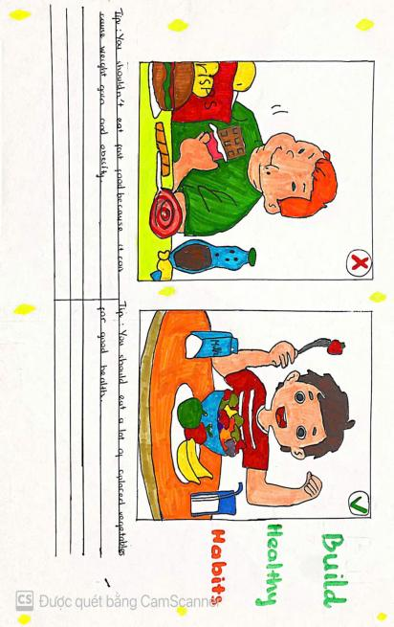

CLASS 7A2
GROUP 1 | GROUP 2
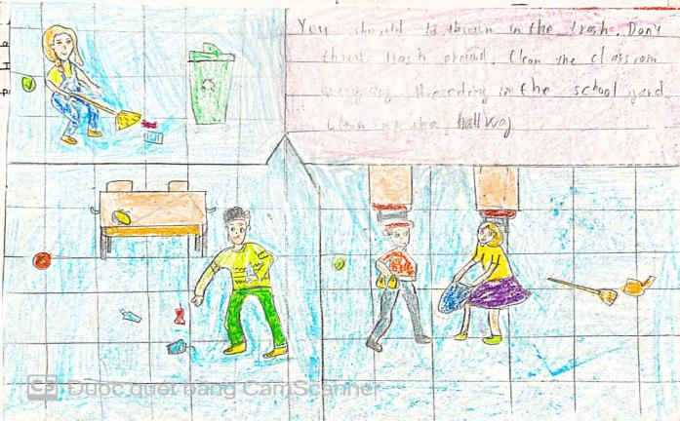 | 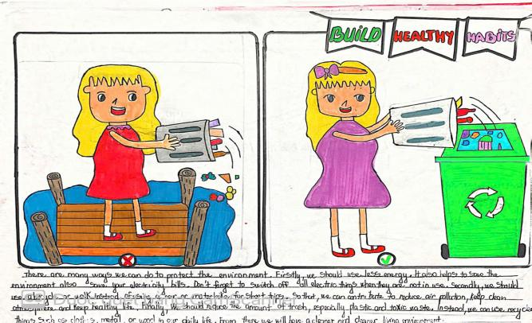
GROUP 3 | GROUP 4
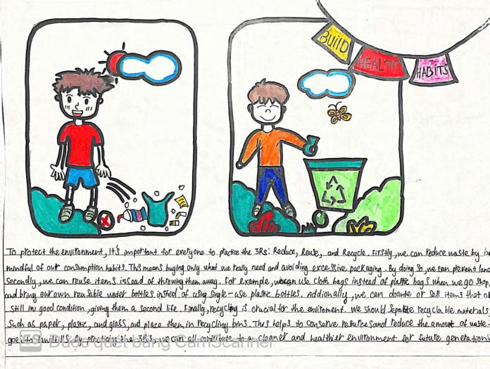 | 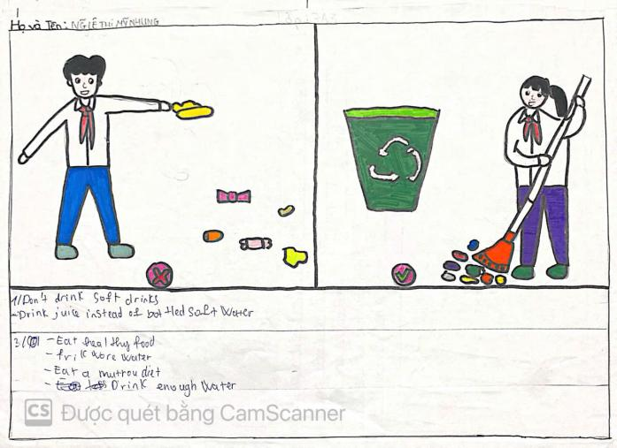

CASS 7A3
GROUP 1 | GROUP 2
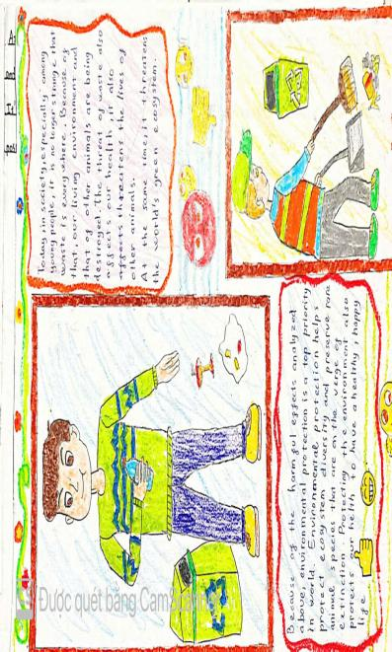 | 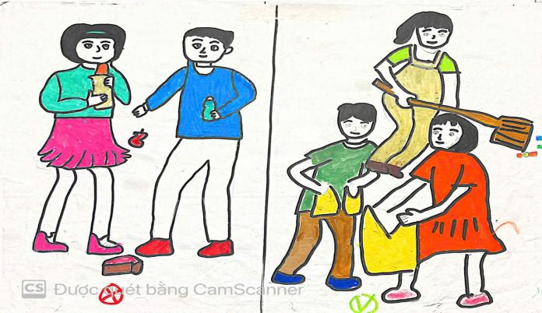
GROUP 3 | GROUP 4
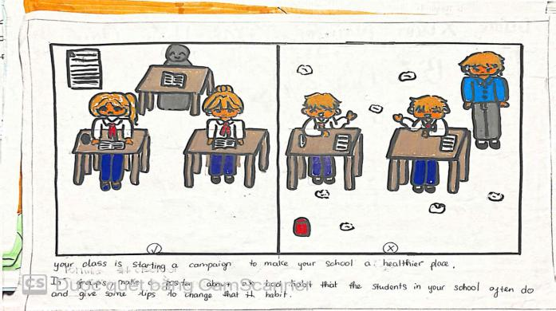 | 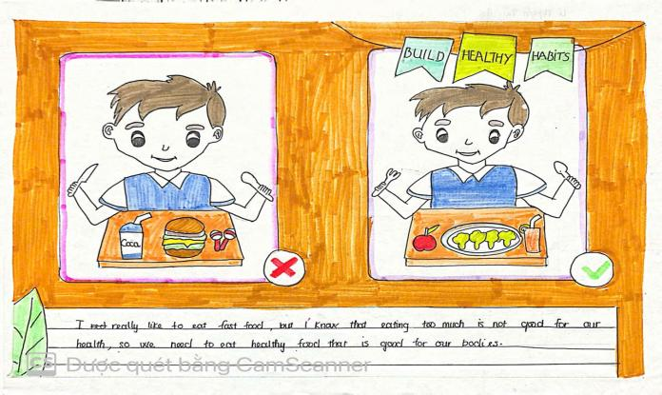

CLASS 7A4
GROUP 1 | GROUP 2
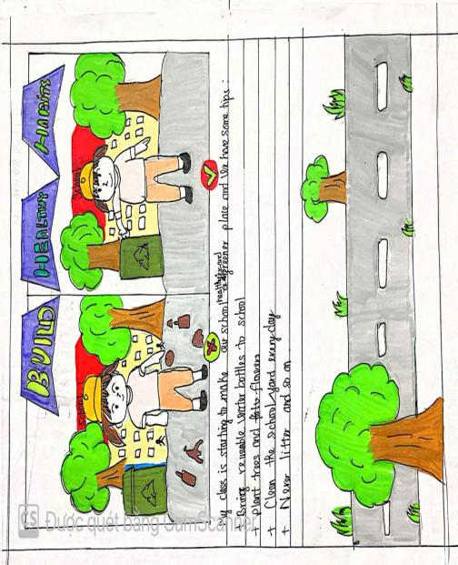 | 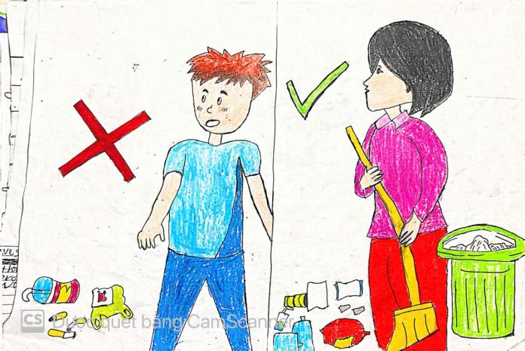
GROUP 3 | GROUP 4
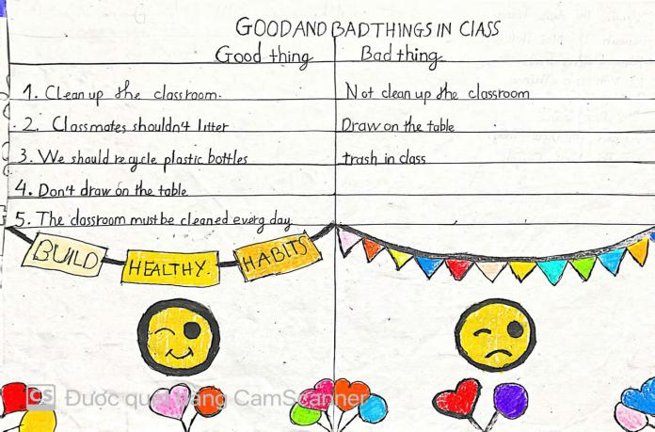 | 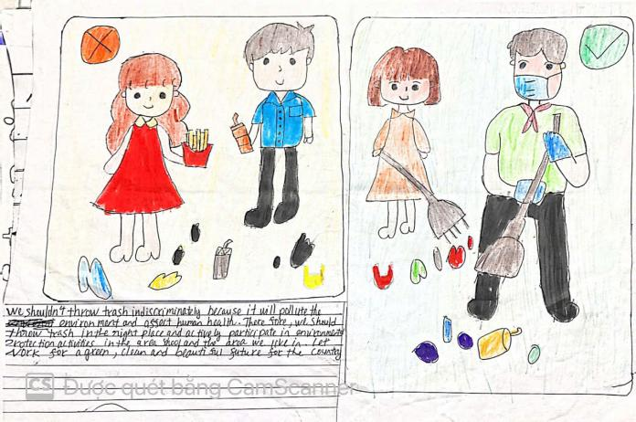

*WRAP-UP & HOMEWORK ( 2ms)
Summarise the main points of the lesson.
- Asks Ss what they have learnt so far. Have them recall the important elements:
+ Words / Phrases: Review the vocabulary of Unit 2
+ Sounds: Revise the sound /f/, /v/ correctly.
+ Grammar: Review grammar of Unit 2.
+ write a paragraph of some advice to avoid viruses.
* HOMEWORK
Asks the students to:
- Learn by heart all the lesson.
- Do more exercises in the workbook.
- Prepare: UNIT3 (getting started)

October 7th 2024 | Teacher in charge: Tran Le Vi  Group: Social science
UNIT 3: COMMUNITY SERVICE
Period 16: Lesson 1: GETTING STARTED
Subject: English - Class: 7A1, 7A2, 7A3, 7A4
Allotted time: one period
I. OBJECTIVES
By the end of this lesson, Ss will be able to :
1. Knowledge
- gain an overview about the topic “Community service”
- learn lexical items related to community activities
2. Competence:
- Develop communication skills and enhance awareness of preserving the culture
- Be collaborative and supportive in pair work and teamwork
- Actively join in class activities
3. Quality/ behavior:
- Develop self-study skills
- Raise students’ awareness of the need to keep their neighbourhood green
II. TEACHING AIDS AND MATERIALS:
1. Teaching aids: a TV, a laptop computer, pictures, cards, extra boards, Portable multi-function audio device , a loudspeaker, a projector, real objects.
2. Materials: textbooks, workbooks, lesson plan, the teacher’s book, reference books, hoclieu.vn
III. PROCEDURE:
1. ACTIVITY 1: WARM UP & INTRODUCTION ( 5ms)
a. Aims:
- To create a friendly and atmosphere in the class before the lesson
- To review students’ knowledge of the past simple tense.
b.Content:
To have some warm-up activities to create a friendly and relaxed atmostphere to inspire Ss to warm up to the subject and new lesson.
-To remind the past simple tense.
c.Outcome: Knowledge about community activities
d. Organisation : Teacher’s instructions …
Picture describing
- Teacher shows the picture and asks students questions:
What can you infer from this picture?

- Students raise hands to answer the questions.
- Teacher and students discuss the questions.
- Teacher accepts all students’ questions and explains the term “Community service” ( work that people do without payment to help other people)
2. ACTIVITY 2: KNOWLEGDE FORMATION ACTIVITIES/ PRESENTATION / NEW LESSON ( 8ms)
a.Aims:
- To provide students with vocabulary.
- To help students well-prepared for the listening and reading tasks.
b.Content: Learn new words relating to the lesson.
c.Outcome:
- Know more new words.
- Understanding the conversation; topic of the lesson, grammar points…
d. Organisation : Teacher’s instructions..
- Teacher draws students’ attention to the picture in the textbook and asks them some questions about it: What are they doing?
- Students raise hands to answer the questions.
- Teacher and students discuss the questions.
- Teacher confirms the answers and indicates that they are doing “community activities”.
VOCABULARY:
- Teacher introduces the vocabulary.
- Teacher introduces the vocabulary by:
+ providing the pictures
+ eliciting the definition of the words
1. community activity (n.phr.)
2. donate (v)
3. nursing home (n.phr.)
4. homeless (adj)
- Teacher do the “Rub out and remember” checking technique.
- Teacher checks students’ pronunciation and gives feedback. Teacher reveals that these four words will appear in the reading text and asks students to open their textbook to discover further.
3. ACTIVITY 3: PRACTICE ACTIVITIES ( 19ms)
Task 1: Listen and read. ( 4ms)
a.Aim: To have students get to know the topic.
b.Content:
- To help students read for specific information about Minh and Tom’s community
- To help students use the vocabulary related to community activities in the right contexts.
activities.
c.Outcome: - Students can further understand the text.
d. Organisation :
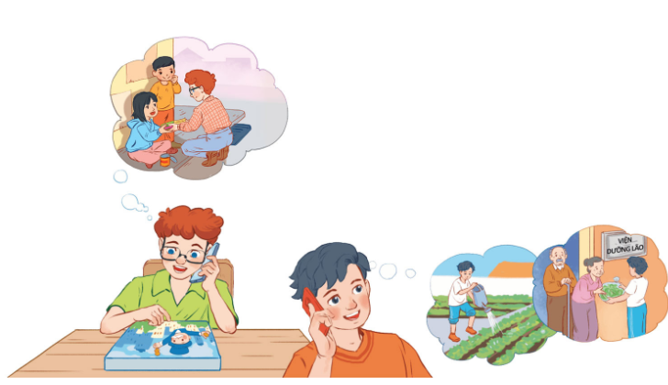
- Teacher can play the recording more than once.
- Students listen and read.
- Teacher can invite some pairs of students to read aloud.
- Teacher check students’ pronunciation ad give feedback.
Task 2: Read the conversation again and tick () the appropriate box. ( 5ms)
a.Aims: To help students read for specific information about Minh and Tom’s community activities.
b.Content:
- To read for specific information about Minh and Tom’s community
- To use the vocabulary related to community activities in the right contexts.
activities.
c.Outcome:
- Students can use phrases related to community activities.
- Students can further understand the text.
d. Organisation :
- Teacher tells students to read the conversation again and work in pairs to find the answers.
- Students can underline the words and phrases about community activities then work together for one or two minutes to check the words / phrases they have underlined.
- Teacher allows students to share their answers before discussing as a class and encourages them to pronounce the words / phrases correctly.
- Teacher checks the answers as a class and gives feedback.
Answer key:
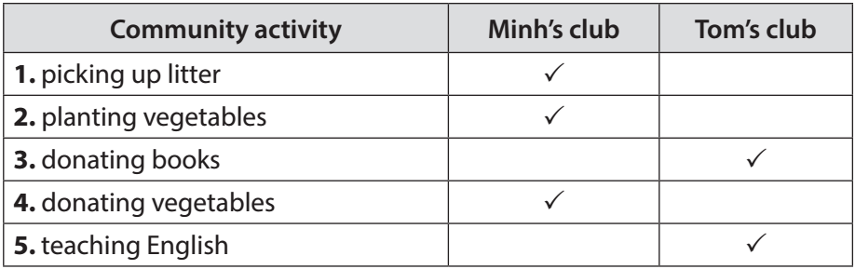
Task 3: Read the conversation again and tick () the appropriate box. ( 5ms)
a.Aims:
- To help students use the phrases related to community activities.
- To help students further understand the text.
b.Content:
Complete the phrases under the pictures with the verb s in the box
c.Outcome:
- Students can use the phrases related to community activities
d. Organisation :
- Teacher asks students to work individually to complete the phrases under the pictures with the given verbs.
- Students work individually to complete the task.
- Teacher allows students to share answers before discussing as a class.
- Teacher asks students to say the phrases aloud and makes sure they pronounce the words and phrases correctly. Teacher can ask for translation to check their understanding.
Answer key:
1. pick up 2. help 3. recycle 4. donate 5. clean
Task 4: Complete the sentences with the correct words or phrases in the box. ( 5ms)
a.Aim:
- To help students use the vocabulary related to community activities in the right contexts.
b.Content:
- Complete the sentences with the correct words or phrases in the box
c.Outcome:
-Students can use the vocabulary related to community activities in the right contexts.
d. Organisation :
- Teacher asks students to work independently to complete each sentence with a word or phrase from the box.
- Students fill in the blanks with the most suitable words / phrases.
- Teacher allows students to share answers before discussing as a class.
- Teacher can ask students to read aloud the full sentences and correct their pronunciation if needed.
Answer key:
1. homeless children 2. litter 3. old people 4. taught 5. planted
4. ACTIVITY 4: APPLICATION/ PRODUCTION/ FURTHER PRACTICE ( 10ms)
Task 5: Vocabulary Ping-pong.
a.Aims:
- To help students review and reuse the learnt vocabulary.
- To create a fun atmosphere in the class.
b.Content:
- Students work in teams and make up sentences with the words which the teams provide……..
c.Outcome:
- Students can make sentences with the words/ phrases related to community activities.
d. Organisation :
- Teacher instructs students to play the Vocabulary Ping-Pong game:
- Ask Ss to think of the topic Community Service.
- One student from team A shouts out a word or phrase related to the topic. Then one student from team B makes a sentence with that word or phrase. Then switch roles.
- The team that cannot give a phrase or make a correct sentence loses and the other team gets a point.
- Students play the game.
- Teacher can go around to help weaker students.
- Teacher stops the game when time is up. The team that makes the most correct sentences wins.
Example:
Team A: Litter
Team B: We often pick up litter in the park. Trees.
Team A: We plan trees in our school every year. Book
*WRAP-UP & HOMEWORK ( 3ms)
Summarise the main points of the lesson.
- Teacher refers to the unit title again then together with students, orally list the community activities students do at school.
- Teacher asks students to say several words or phrases about community activities that they remember from the lesson.
HOMEWORK:
- Think about community activities that students can do (at least 3 activities).
- Project preparation
+ Teacher informs student of the final project of the Unit’s project.
+ Explain the requirements of the project: Think about some environmental problems in your neighbourhood and the solutions to those problems. Students will present their ideas in Lesson 7 – Looking back and Project.
+ Teacher explains to students how they can get the information.
+ Put students into groups and ask them to discuss to assign tasks for each member. Help them set a deadline for each task.
- Prepare: A Closer Look 1

October 8th 2024 | Teacher in charge: Tran Le Vi  Group: Social science
UNIT 3: COMMUNITY SERVICE
Period 17: Lesson 2: A CLOSER LOOK 1
Subject: English - Class:7A1, 7A2, 7A3, 7A4
Allotted time: one period
- OBJECTIVES
By the end of this lesson, Ss will be able to gain:
1. Knowledge
- Vocabulary: Use words related to community activities.
- Pronunciation: Correctly pronounce the sounds: /t/, /d/, /ɪd/ in isolation and in context
2. Competence:
- Develop communication skills and creativity
- Be collaborative and supportive in pair work and teamwork
- Actively join in class activities
3. Quality/ behavior:
- Develop self-study skills
- Raise students’ awareness of the need to keep their neighbourhood green.
II. TEACHING AIDS AND MATERIALS:
1. Teaching aids: a TV, a laptop computer, pictures, cards, extra boards, Portable multi-function audio device , a loudspeaker, a projector, real objects.
2. Materials: textbooks, workbooks, lesson plan, the teacher’s book, reference books, hoclieu.vn
III. PROCEDURE:
1. ACTIVITY 1: WARM UP & INTRODUCTION ( 5ms)
a. Aims:
- To recall students’ vocabulary on community activities.
- To review students’ knowledge of the past simple tense.
b.Content: - To have some warm-up activities to create a friendly and relaxed atmostphere to inspire Ss to warm up to the subject and new lesson.
- To introduce some verbs and verb phrases that are often used to describe community activities.
c.Outcome: Knowledge about community activities
d. Organisation : Teacher’s instructions …
MATCHING GAME:
* Teacher has students play in two groups and explains the game rules.
** Each group will have a list of verbs and nouns. Students match the verbs they have with the correct nouns.
*** Teacher and students discuss the answers. The group with the most correct answers wins.
**** Teacher confirms the answers and gives feedback.
Set of word cards:
recycle | help | plant

trees | vegetables | small children | old people
books | Bottles | cans | homeless children

2. ACTIVITY 2: KNOWLEGDE FORMATION ACTIVITIES/ PRESENTATION / NEW LESSON ( 8ms)
a.Aims:
- To introduce the new words.
- To introduce some verbs and verb phrases that are often used to describe community activities.
b.Content: Learn two ways to give compliments
c.Outcome:Know more new words. Understanding the conversation; topic of the lesson, grammar points…
d. Organisation : Teacher’s instructions..
VOCABULARY:
- Teacher introduces the vocabulary.
- Teacher introduces the vocabulary by:
+ providing the pictures
+ providing the definition of the words.
1. exchange (v)
2. pick up (phr. v)
3. tutor (v)
- Teacher asks students to repeat.
- Teacher rubs out and checks.
3. ACTIVITY 3: PRACTICE ACTIVITIES ( 24ms)
Task 1: Match a verb in A with a word or phrase in B..( 4ms)
a.Aim: To introduce some verbs and verb phrases that are often used to describe community activities.
b.Content: To match a verb with a word or phrase.
c.Outcome: - Knowledge about community activities.
d. Organisation :
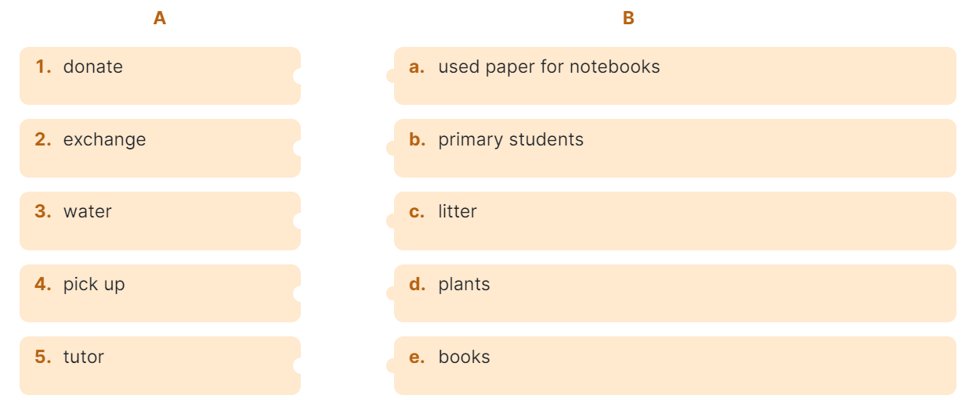
- Teacher has read aloud the verbs in A and words / phrases in B.
- Students work in pairs to match the verbs in A with words / phrases in B.
- Teacher asks them to share their answers in pairs before checking the answers as a class.
- Teacher invites students to take turns to read out their answers and corrects their pronunciation if needed.
Answer key:
1. e 2. a 3. d 4. c 5. b
Task 2: Complete each of the sentences with a suitable word or phrase from the box.( 4ms)
a.Aim: To allow students to use the learnt words / phrases in contexts.
b.Content: To complete the sentences with suitable words or phrases.
c.Outcome: - Ss can practise producing full sentences using the learnt words / phrases.
d. Organisation :
- Teacher asks students to work individually to complete each of the sentences with a suitable word / phrase from the box. All of these words / phrases have been learnt in.
- Students do the task individually.
- Teacher allows students to swap their textbooks to peer check first.
- Teacher confirms the answers and gives feedback, if necessary.
Answer key:
1. litter 2. used paper for notebooks 3. water 4. donate 5. tutor
Task 3: Use the phrases from the box to write full sentences under the correct pictures. ( 5ms)
a.Aim: To have students practise producing full sentences using the learnt words / phrases.
b.Content: To complete the sentences with suitable phrases.
c.Outcome: - Ss can use the phrases correctly.
d. Organisation :
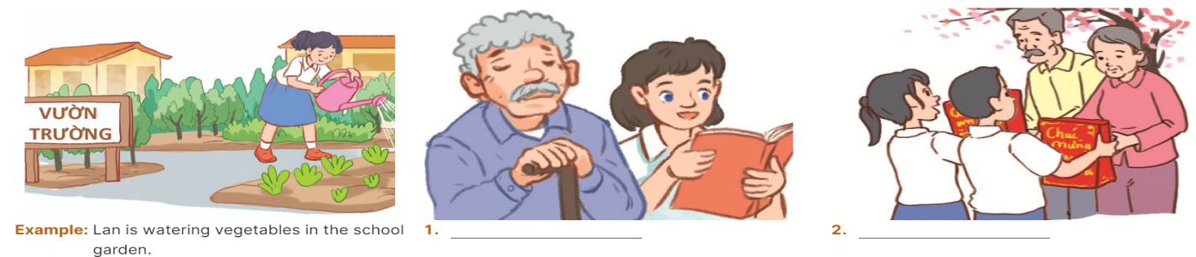
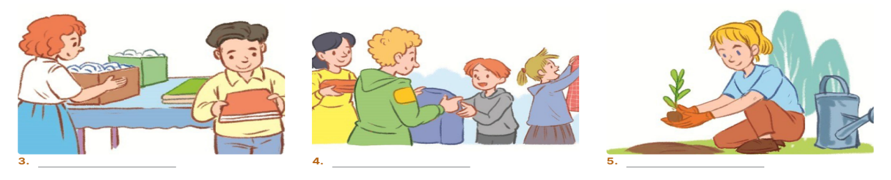
- Teacher asks students to work individually to write full sentences, using the given phrases.
- Students read aloud the six phrases and match with the appropriate pictures.
- Teacher asks students to work in pairs to swap their answers and peer check.
- Teacher checks their answers as a class.
Answer key:
1. She’s reading books to the elderly.
2. They’re giving gifts to old people.
3. They’re exchanging used paper for notebooks.
4. They’re donating clothes to poor children.
5. She’s planting trees in the park.
Task 4: Listen and repeat. Pay attention to the sounds /t/, /d/ and /ɪd/ ( 5ms)
a.Aims: To help students identify how to pronounce the sounds /t/, /d/ and /ɪd/.
- To help students practise pronouncing the sounds in words.
b.Content: Listen and repeat the sounds /t/, /d/ and /ɪd/
c.Outcome: - Ss master the sounds /t/, /d/ and /ɪd/
d. Organisation :
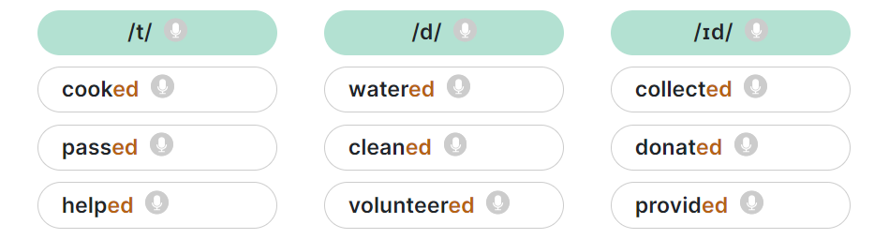
- Teacher has students listen to the recording once first.
- Students listen to the recordings and read out the words.
- Teacher plays the recording for them to listen and repeat each word as a class, then as individuals.
- Teacher check students’ pronunciation if needed.
Task 5: Listen to the sentences and pay attention to the underlined parts. Tick the appropriate sounds. Practise the sentences. ( 6ms)
a.Aims: - To help students practise pronouncing the sounds /t/, /d/ and /ɪd/ in sentences.
- To test students' quick reaction to the targeted sounds.
b. Content:
- To have students practise producing full sentences using the learnt words / phrases.
c. Outcome: -Ss know more about new words in the lessons and pronounce the sounds /t/, /d/ and /ɪd/ in sentences.
d. Organisation :
- Teacher has some students read the sentences first and asks them to pay attention to the underlined parts.
- Teacher plays the recording for Ss to listen then have them tick the appropriate sounds.
- Teacher invites some Ss to share their answers. Confirm the correct ones.
- Teacher plays the recording again and ask students to repeat each sentence after the recording. Teacher confirms the answers.
Answer key:
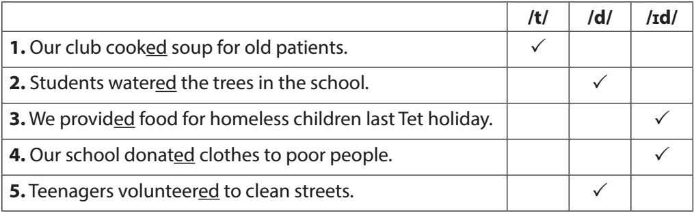
4. ACTIVITY 4: APPLICATION/ PRODUCTION/ FURTHER PRACTICE
( 6ms)
- Aims: - To test students' quick reaction to the targeted sounds.
- To give Ss much freer practice with their daily activities and decide if each activity is healthy or unhealthy , and to check Ss’ comprehension and broaden their knowledge
b. Content:GAME: BROKEN TELEPHONE
c. Outcome: Ss can apply what they have learnt to make real sentences .
d. Organisation :
- Teacher explains the rules:
Teacher divides the class into 2 teams and asks them to stand in 2 lines. The first student from each line will be told some words with the /t/, /d/ and /ɪd/ sounds. Team members have to whisper one by one till the last. The last student from each line runs to the board and write down the words in the correct columns. The faster one with correct answers will be the winner.
- Students play the game.
- Teacher helps students in the game.
- Teacher gives feedback.
Suggested key:
/t/ | /d/ | /ɪd/
picked, booked, helped | tutored, watered, exchanged | donated, planted
*WRAP-UP & HOMEWORK ( 2ms)
Summarise the main points of the lesson.
- Teacher asks students to summarise what they have learnt in the lesson.
- Teacher asks them to list some phrases about community activities they learnt in the lesson.
- Teacher asks them to list some verbs in the past simple, paying attention to their pronunciation.
HOMEWORK:
- Learnt by heart new words and practice the sounds /t/, /d/, /id/
- Do exercises in the workbook
- Prepare: A Closer Look 2

Sua tu dayyyyyyyyyyyyyyyyyyyyyyyyyyy

October 13th 2024 | Teacher in charge: Tran Le Vi  Group: Social science
UNIT 3: COMMUNITY SERVICE
Period 18: Lesson 3: A CLOSER LOOK 2
Subject: English - Class: 7A1, 7A2, 7A3, 7A4
Allotted time: one period
I. OBJECTIVES:
By the end of this lesson, Ss will be able to gain:
1. Knowledge:
- Understand the use of the past simple tense
- Practice using the past simple to talk about past activities
2. Competence:
- Develop communication skills and creativity
- Be collaborative and supportive in pair work and teamwork
- Actively join in class activities
3. Quality/ behavior:
- Develop self-study skills
- Raise students’ awareness of the need to keep their neighbourhood green.
II. TEACHING AIDS AND MATERIALS:
1. Teaching aids: a TV, a laptop computer, pictures, cards, extra boards, Portable multi-function audio device , a loudspeaker, a projector, real objects.
2. Materials: textbooks, workbooks, lesson plan, the teacher’s book, reference books, hoclieu.vn
III. PROCEDURE:
1. ACTIVITY 1: WARM UP & INTRODUCTION (4ms)
a. Aims:
- To create a friendly and atmosphere in the class before the lesson
- To activate students’ prior knowledge related to the targeted grammar: the past simple.
b.Content: To have some warm-up activities to create a friendly and relaxed atmostphere to inspire Ss to warm up to the subject and new lesson.
-To remind the past simple tense.
c.Outcome: Knowledge about community activities
d. Organisation : Teacher’s instructions …
CHATTING
- Teacher asks students some questions:
What did you do last weekend?
What did you watch yesterday?
Who did you meet two days ago?
- Students answer the questions, using the past simple.
- Teacher and students discuss the answers.
- Teacher corrects students answers if needed and confirms the use of the past simple (to talk about completed actions in the past).
2. ACTIVITY 2: KNOWLEGDE FORMATION ACTIVITIES/ PRESENTATION/ NEW LESSON ( 10 ms)
a.Aim: - To review students’ knowledge of the past simple tense.
b.Content: - To raise students’ awareness of the past simple tense and past forms of some verbs.
c.Outcome: Know more about simple past tense
d. Organisation : Teacher’s instructions…
- Teacher asks students to study the Grammar box.
- Teacher draws students’ attention to the meaning and use of the past simple.
- Teacher then asks some more able students to give some more examples.
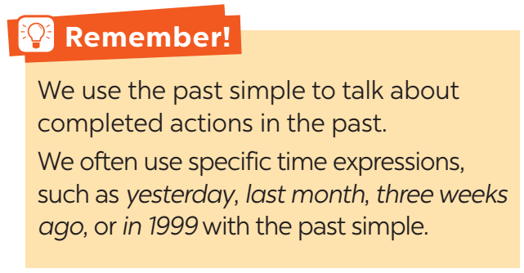
- Teacher and students discuss the answers.
- Teacher confirms the answers and gives feedback.
3. ACTIVITY 3: PRACTICE ACTIVITIES (21ms)
Task 1: Circle the correct answer A,B, or C to complete each sentence. (5ms)
- Aim: - To review students’ knowledge of the past simple tense.
b.Content: - Circle the correct answer A,B, or C to complete each sentence.
c.Outcome: - Students can write full sentences using the correct forms of the verbs.
d. Organisation : Teacher’s instructions…
- Teacher has students work individually.
- Students work individually to to complete the sentences with the past simple form of the given verbs.
- Teacher lets students work in pairs and exchange the answers before checking with the whole class (explain each sentence if necessary).
- Teacher confirms the answers and gives feedback.
Answer key:
1. B 2. C 3. B 4. A 5. C
Task 2: Complete the sentences with the past simple form of the given verbs. (5ms)
- Aim: - To raise students’ awareness of the past simple tense and past forms of some verbs.
b.Content: Complete the sentences with the past simple form of the given verbs.
c.Outcome: - Students can write full sentences using the correct forms of the verbs.
d. Organisation : Teacher’s instructions…
- Teacher has students work individually.
- Students work individually to complete the sentences.
- Teacher lets students work in pairs and exchange the answers before checking with the whole class (explain each sentence if necessary).
- Teacher confirms the answers and gives feedback.
Answer key:
1. took 2. Did … join 3. helped 4. sent 5. volunteered
Task 3: Complete the sentences with the correct forms of the verbs from the box. (5ms)
- Aim: - To help students distinguish between the present simple, present continuous, and past simple in specific context.
b.Content: Complete the sentences with the correct forms of the verbs from the box.
c.Outcome: - Students can write full sentences using the correct forms of the verbs.
d. Organisation : Teacher’s instructions…
- Teacher asks the whole class to read aloud the verbs in the box then has students work individually to complete the sentences with the correct forms of the verbs from the box.
- Students work individually to complete the task.
- Teacher then has them work in pairs, comparing their sentences. Teacher can go around to help students.
- Teacher confirms the answers and gives feedback.
Answer key:
1. cook 2. Did … plant 3. are picking up 4. recycled 5. read
Task 4: Write complete sentences from the prompts. (6ms)
- Aim: - To help Ss write full sentences using the correct forms of the verbs.
b.Content: Complete the sentences with the correct forms of the verbs from the box.
c.Outcome: - Students can write full sentences using the correct forms of the verbs.
d. Organisation : Teacher’s instructions…
- Teacher has students work independently.
- Teacher asks students to do the exercise individually.
- Teacher lets students work in pairs and exchange the answers before checking with the whole class (explain each sentence if necessary).
- Teacher confirms the answers and gives feedback.
Answer key:
1. Last year, our club donated books to children in rural areas.
2. Children sent thank-you cards to us a week ago.
3. I taught two children in grade 2 last summer.
4. Last spring, we helped the elderly in a nursing home.
5. We helped people in flooded areas last year.
4. ACTIVITY 4: APPICATION/ PRODUCTION/ FURTHER PRACTICE ( 8ms)
a.Aim: - To enable students to ask and answer questions related to past activities.
b.Content: - To raise students’ awareness of the past simple tense and past forms of some verbs.
- To help students distinguish between the present simple, present continuous and past simple in specific contexts.
c.Outcome: - Students are aware of some community activities that students in other countries do.
d. Organisation : Teacher’s instructions…
Task 5: The Red Cross in 2016 and 2020.
Work in groups. Tom is from the Red Cross. Look at the fact sheet and ask Tom about his projects in 2016 and 2020.
- Teacher introduces the Red Cross projects and activities in 2016 and 2020 and has students work in pairs for 5 minutes to practise asking and answering questions based on the fact sheet.
- Students use the past simple when they ask and answer questions about the past activities.
- Teacher invites some pairs to make short conversations as an example.
- Teacher corrects any grammar and pronunciation mistakes if necessary.
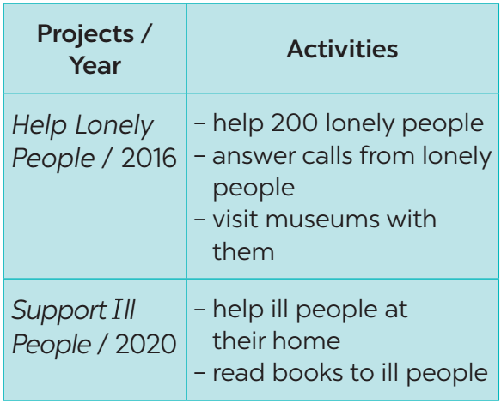
Example:
Tom: I’m from the Red Cross. I worked on the Help Lonely People project in 2016.
Lan: What did you do?
Tom: We helped 200 lonely people…
*WRAP-UP & HOMEWORK (2ms)
- Teacher asks students to summarise what they have learnt in the lesson.
- Teacher has them say out loud the past forms of the verbs they have learnt.
HOMEWORK:
- Learnt by heart new words
- Do exercises in the workbook
- Prepare: Communication

October 14th 2024 | Teacher in charge: Tran Le Vi  Group: Social science
UNIT 3: COMMUNITY SERVICE
Period 19: Lesson 4: Communication + A fifteen-minute progress test
Subject: English - Class: 7A1, 7A2, 7A3, 7A4
Allotted time: one period
I. OBJECTIVES
By the end of this lesson, Ss will be able to:
- know how to give compliments
- discuss and present the benefits of community activities
1. Knowledge:
- Vocabulary: vocabulary on community activities.
- Grammar: structures to give compliments.
2. Competence:
- Develop communication skills and creativity
- Be collaborative and supportive in pair work and teamwork
- Actively join in class activities
3. Quality/ behavior:
- Develop self-study skills
- Raise students’ awareness of the need to keep their neighbourhood green
II. TEACHING AIDS AND MATERIALS:
1. Teaching aids: a TV, a laptop computer, pictures, cards, extra boards, Portable multi-function audio device , a loudspeaker, a projector, real objects.
2. Materials: textbooks, workbooks, lesson plan, the teacher’s book, reference books, hoclieu.vn
III. PROCEDURE:
* TEST 15ms:
I. Complete the following sentence(s) by choosing the best option A, B, C or D.(4ms)
1. My grandfather always ……………. tea every morning.
A. drink B. drinking C. drinks D. to drink
2. I like cartoon, but I don’t …………… them much.
A. watch B. watching C. watches D. to watch
3. Hoa is very creative, and she paints very well. Her hobby is ……………
A. building dollhouses B. painting C. riding D. collecting stamps
4. This river …………….. run through your hometown?
A. isn’t B. don’t C. aren’t D. doesn’t
5. You need some ………………. and glue to build dollhouses.
A. cardboard B. stamps C. pots D. coins
6. A: I don’t want to ……………… sunburn.
B: Wear a hat and use suncream.
A. take B. get C. away D. hide
7. Mai has a lot of doll. She wants to build a ………………… for them.
A. doll B. coin C. model D. dollhouse
8. The weather may affect our …………………..
A. fit B. sunburn C. skin condition D. vitamin
II. Give the correct form of the verb or the word in brackets (3ms)
1. My mum (catch) _____________ the bus to work every morning.
2. We like (read) _____________ books in the living room.
3. We (meet) ____________ Lan tomorrow.
4. _____________ he (visit) ____________ Hoi An last year?
5. I often feel (sleep) _____________ during the day.
6. Children in our village exchange (use)_____________ paper for notebook every school year.
III. Finish each of the following sentences in such a way that it means exactly the same as the one printed before it (2ms)
1. There are four people in my family.
My family ________________________________________________
- My brother doesn’t like listening to music.
→ My brother ______________________________________________________________
IV. Use the provided words/phrases to write a complete sentence. (1m)
1. He/ hard-working / my class/ be/ student/.
->_______________________________________________________________________
KEY:
I. Complete the following sentence(s) by choosing the best option A, B, C or D.(4ms)
1C 2A 3B 4D 5A 6B 7D 8C
II. Give the correct form of the adjectives and verbs in brackets (3ms)
1. catches 2. reading 3. will meet 4. Did; visit 5. sleepy 6. used
III. Finish each of the following sentences in such a way that it means exactly the same as the one printed before it (2ms)
1. My family has four people.
2. My brother hates listening to music.
IV. Use the provided words/phrases to write a complete sentence. (1m)
1. He is a hard-working/ the most hard-working student in my class.
1. ACTIVITY 1: WARM UP & INTRODUCTION (3ms)
a. Aims:
- To create a friendly and atmosphere in the class before the lesson
- To review students’ knowledge of the past simple tense.
b.Content: To have some warm-up activities to create a friendly and relaxed atmostphere to inspire Ss to warm up to the subject and new lesson.
-To remind the past simple tense.
c.Outcome: Knowledge about community activities
d. Organisation : Teacher’s instructions …
+ Greeting
ALPHABET GAME
* Teacher divides the class into 4 groups. Students take turns to use the past simple in a sentence. The first letter of the verbs must follow the sequence of the alphabet.
** Students work in groups to play the game. If a student from a group can’t think of one verb, he/she is out of the game. The next student from other groups continues with the next letter.
*** Teacher goes around to help weaker students.
**** Teacher gives compliments to the group which has the most correct answers.
Example A: He asked me my name.
B: I bought a hat.
C: I came here last month.
2. ACTIVITY 2: KNOWLEGDE FORMATION ACTIVITIES/ PRESENTATION/ NEW LESSON ( 6ms)
a.Aims:
- To introduce ways to give compliments.
- To introduce two ways to give compliments.
b.Content: Learn two ways to give compliments
c.Outcome: Know more new words. Understanding the conversation; topic of the lesson, grammar points…
d. Organisation : Teacher’s instructions..
- Teacher asks students to look at the conversation in GETTING STARTED and check if they find any phrases or clauses that Minh and Tom use to compliment the other for doing something good deeds.
- When students have found the clause “Sounds like great work!”, teacher tells them that they can use this to make compliments. Teacher asks students to think about more ways to give compliments.
- Teacher and students discuss the answers.
- Teacher confirms the answers
EVERYDAY ENGLISH
Task 1: Listen and read the dialouge between Lan and Mark. Pay attention to the highlighted parts. (3ms)
a.Aims: To introduce two ways to give compliments
To help students practise giving compliments
b.Content: Listen and read the conversation.
c.Outcome: Know to give compliments. Understand the lesson, Vocab, grammar points…
d. Organisation : Teacher’s instructions.…..
- Teacher plays the recording for Ss to listen and read the dialogue between Lan and Mark.
- Students pay attention to the highlighted parts.
- Teacher emphasizes the use of the compliments.
- Teacher confirms the answers and gives feedback.
2 ways to give compliments:
- Sounds like great work!
- Wonderful !
Task 2: Work in pairs. Make similar conversations. (3ms)
- Aims: To introduce two ways to give compliments
To help students practise giving compliments
b.Content: Work in pairs. Make similar conversations.
c.Outcome: Know to give compliments. Understand the lesson, Vocab, grammar points…
d. Organisation : Teacher’s instructions.…..
- Teacher has students work in pairs to make similar
- Students work in pairs to make similar dialogues.s, using the contexts given and the sample compliments.
- Teacher asks some pairs to practice the dialogue so that the whole class can give comments.
- Teacher gives feedback as a class
3. ACTIVITY 3: PRACTICE ACTIVITIES (11ms)
Task 3: Read the poster about the volunteer activities for teenagers at Lending Hand. Write the project number (1-3) next to its benefits (A-E) (5ms)
- Aims:. - To help students learn more about some benefits of community activities.
- To help students practise reading for specific ideas.
b.Content:To learn some some benefits of community activities, practisce giving reasons.
c. Outcome: Ss know more some some benefits of community activities and know to give reasons.
d.Organisation : Teacher’s instructions ….
- Teacher has students work in pairs to read the poster and asks them questions like:
+How many projects does Lending Hand offer?
+What activities can you do / join in Projects 1, 2 and 3?
- Students work in pairs to write the number of the projects (1 - 3) next to the benefits (A - E).
- Teacher asks some pairs to to read out their answers.
- Teacher gives feedback and correction (if needed).
Answer key: 1. B, E 2. C, D 3. A
Task 4: Ask and answer which activities in task 3 you want to join. Give reasons. (6ms)
- Aims: - To help students practise asking and answering questions about which activities they want to join and why.
- To help students practisce giving reasons.
b.Content:To learn some some benefits of community activities, practisce giving reasons.
c. Outcome: Ss know more some some benefits of community activities and know to give reasons.
d. Organisation: Teacher’s instructions ….
- Teacher asks students to work in pairs to ask and answer questions about which activities they want to join and why.
- Students work in pairs to do the task. They can use the example in the Student’s book. They should clarify any other benefits they can think of.
- Teacher invites some pairs to role-play, asking and answering questions in front of the class.
- Teacher corrects any grammar or pronunciation mistakes if necessary.
Example:
Minh: Which activity do you want to join?
Lan: I want to join some clean-up activities.
Minh: Why do you want to join these activities?
Lan: Because they make the neighbourhood cleaner.
* Key: 1. b 2. a 3. c 4. d
4. ACTIVITY 4: APPICATION/ PRODUCTION/ FURTHER PRACTICE ( 8ms)
a. Aim: - To help students practise asking and answering questions about which activities they choose to join and the benefits of those activities.
- To help students practise giving reasons.

- To help students practise reporting.
b. Content:
- To help students practise asking and answering questions about which activities they choose to join and the benefits of those activities.
- To help students practise giving reasons.

- To help students practise reporting.
c. Outcome: Ss can practise asking and answering questions about activities and their benefits .
d. Organisation : Teacher’s instructions
Task 5: Work in groups. Discuss which activity each member of your group chooses and the benefit(s) of the activity. Present your group’s answer to the class.
- Teacher lets students work in groups discuss which activity each member of their group chooses and the benefits of each activity.
- Students can give more than one benefit to any activity or any benefits they can think of in addition to those they find in the Student’s book.
- Teacher invites group representatives to report their group’s answers.
- Teacher gives feedback on their reports.
Example:
Mai wants to donate food to street children because this helps feed them. Lan wants to join clean-up activities because these activities make our neighbourhood cleaner…
*WRAP-UP & HOMEWORK (2ms)
Teacher asks students to talk about what they have learnt in the lesson.
* HOMEWORK
- Think about some environmental problems in your neighbourhood and the activities you want to do to solve those problems.
- Do more exercises in workbook.
- Prepare:Skills 1

October 15th 2024 | Teacher in charge: Tran Le Vi  Group: Social science
UNIT 3: COMMUNITY SERVICE
Period 20: Lesson 5: SKILLS 1
Subject: English - Class: 7A1, 7A2, 7A3, 7A4
Allotted time: one period
I. OBJECTIVES:
By the end of this lesson, Ss will be able to:
1. Knowledge:
- Develop reading skill for specific information about community activities at a school
- Develop speaking skill: Talking about the reasons why students join different community activities
2. Competences:
- Develop communication skills and creativity
- Be collaborative and supportive in pair work and teamwork
- Develop presentation skill
- Actively join in class activities
3. Quality/ behavior
- Develop self-study skills
- Raise students’ awareness of the need to keep their neighbourhood green.
II. TEACHING AIDS AND MATERIALS:
1. Teaching aids: a TV, a laptop computer, pictures, cards, extra boards, Portable multi-function audio device , a loudspeaker, a projector, real objects.
2. Materials: textbooks, workbooks, lesson plan, the teacher’s book, reference books, hoclieu.vn
III. PROCEDURE:
1. ACTIVITY 1: WARM UP & INTRODUCTION ( 5ms)
a. Aims:
- To remind students of some community activities.
- To enhance students’ skills of cooperating with team mates.
b.Content:provide recall some new words relating to some community activities
c.Outcome: know what they are going to learn : Reading and talking about New year
in the world .
d. Organisation : Teacher’s instructions …
GAME: WHO IS FASTER?
* Teacher divides the class into 2 teams.
- Each team will have to run in a relay to the board to match the correct description with each picture.
- The team with more correct answers will be the winner.
** Students play the game in team mode.
*** Teacher and students discuss the answers.
**** Teacher confirms the answers and gives feedback.

1. collecting rubbish 2. donating clothes
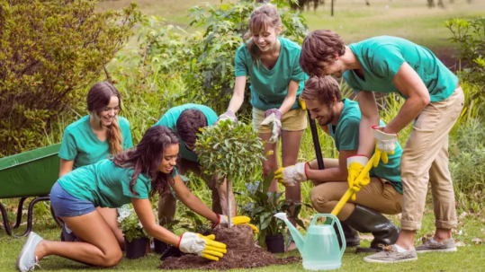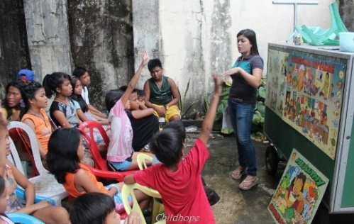
3. planting trees | 4. tutoring homeless children


3. planting trees | 4. tutoring homeless children
2. ACTIVITY 2: KNOWLEGDE FORMATION ACTIVITIES/ PRESENTATION/ NEW LESSON (8ms)
a.Aims: To provide students with some lexical items before reading the text.
- To remind students of some community activities;
- To help Ss brainstorm some more community activities.
b.Content: Read the text and find out new words. Learn some new words .
c.Outcome:Know more new words relating to the text to be read .
d. Organisation : Teacher’s instructions..
Vocabulary
- Teacher introduces the vocabulary.
- Teacher asks students to get the meaning in context and try to make up sentences with of the following words:
1. monthly (adv)
2. proud (adj)
- Teacher and students discuss the answers.
- Teacher confirms student’s answers and checks their pronunciation and gives feedback.
3. ACTIVITY 3: PRACTICE ACTIVITIES (16ms)
Task 1: Circle the activities you would like to do at your school. (4ms)
a.Aims: - To remind students of some community activities;
- To help Ss brainstorm some more community activities.
b.Content: - Circle the activities Ss would like to do at your school
c.Outcome: Understand the meaning of words, Understand more about the text
d. Organisation : Teacher’s instructions.…..
- Teacher has the class read out loud the three activities.
- Students work in pairs to circle the activities they would like to do at their school.
- Students can name some more activities they would like to do at their school if the class is more fluent.
- Teacher accepts all students’ answers.
Task 2: Read the passage and match the higlighted words with their meanings. ( 6ms)
a.Aims: - To improve students’ knowledge of vocabulary related to community activities. - To improve students’ skill of reading for details
b.Content: - Read the passage and match the higlighted words woth their meanings.
c.Outcome: - Understand more about the text
d. Organisation : Teacher’s instructions.…..

- Teacher asks students to work individually to read the passage and find the highlighted words.
- Students read the text and do the task.
- Teacher allows students to share their answers before discussing as a class and encourages them to give evidence.
- Teacher calls some students to give the answer, explain which sentence give them the information.
Answer key:
1. donate 2. exchange 3. monthly 4. proud 5. tutor
Task 3: Read the passage again and tick T (True) or F (False) (6ms)
a.Aim: - To improve students’ skill of reading for details
b.Content: - Read the passage again and tick t (true) or f (false )
c. Outcome: Understand the meaning of words, Understand more about the text
d. Organisation : Teacher’s instructions.…..
- Teacher asks some students to read out loud the sentences in the table.
- Students work individually for some minutes and tick T (True) or F (False).
- Teacher allows students to share their answers before discussing as a class and encourages them to give evidence.
- Teacher calls a student to write his/her answer on the board, then check sentence by sentence with class.
Answer key:
1. T 2. F 3. T 4. F 5. T
4. ACTIVITY 4: APPICATION/ PRODUCTION/ FURTHER PRACTICE ( 12ms)
Task 4: Read about these students. Write the names of the projects you think they should join in the project column. (5ms)
a.Aims: - To enable students to review and reuse the name of some community activities;
- To give students an opportunity to practise explaining their reasons
b. Content: Read about these students. Write the names of the projects you think they should join in the project column.
c. Outcome: Report their groups’answers to the class
d. Organisation : Teacher’s instructions ..
- Teacher asks students work in pairs to read the sentences in the table. Ask some Ss to stand up to answer the
questions: What did you learn about Nick / Ann / Minh / Mark / Tom?
- Students work in pairs to to discuss and decide which student should join which project in the reading.
- Students should give some reasons for their choice.
- Teacher confirms the answers and gives feedback if necessary.
Answer key:
- C 2. A 3. B 4. D 5. E
Task 5: Work in groups. Discuss which project in task 4 you would like to join and why. Report your group’s answers to the class. (7ms)
a.Aim:- To give Ss opportunity to practice explaining reasons.
b. Content: Work in groups. Discuss which project in task 4 you would like to join and why. Report your group’s answers to the class.
c. Outcome: Report their groups’answers to the class
d. Organisation : Teacher’s instructions ..
- Teacher asks students work in pairs to read the sentences in the table. Ask some Ss to stand up to answer the
questions: What did you learn about Nick / Ann / Minh / Mark / Tom?
- Students work in pairs to to discuss and decide which student should join which project in the reading.
- Students should give some reasons for their choice.
- Teacher confirms the answers and gives feedback if necessary.

* Teacher has students work in groups to discuss which project each of them would like to join.
** Students work in groups to discuss which project that each of them would like to join and give reasons.
*** Teacher goes around to help students.
**** After finishing, teacher can call some groups to give presentations in front of the class.
Example: Lan will join the Tutoring project because she is good at maths and English. She also loves children.
*WRAP-UP & HOMEWORK (4ms)
- Asks one or two Ss to tell the class what they have learnt.
- Asks Ss to say aloud some words they remember from the lesson.
* HOMEWORK :
-Learn by heart all new words
-Do exercises in the workbook
- Plan some school activities for next summer holiday.
- Prepare: Skills 2
+ Guides the students how to do the exercises

October 20th 2024 | Teacher in charge: Tran Le Vi  Group: Social science
UNIT 3: COMMUNITY SERVICE
Period 21: Lesson 6: SKILLS 2
Subject: English - Class: 7A1, 7A2, 7A3, 7A4
Allotted time: one period
I. OBJECTIVES:
* By the end of this unit, students will be able to:
1. Knowledge:
- listen for specific information about some community activities and their benefits;.
- write an email about community activities one did last summer.
2. Competence
- Develop communication skills and creativity
- Be collaborative and supportive in pair work and teamwork
- Actively join in class activities
3. Quality/ behavior
- Develop self-study skills
- Raise students’ awareness of the need to keep their neighbourhood green.
II. TEACHING AIDS AND MATERIALS:
1. Teaching aids: a TV, a laptop computer, pictures, cards, extra boards, Portable multi-function audio device , a loudspeaker, a projector, real objects.
2. Materials: textbooks, workbooks, lesson plan, the teacher’s book, reference books, hoclieu.vn
III. PROCEDURE:
1. ACTIVITY 1: WARM UP & INTRODUCTION ( 5ms)
a. Aim: - To lead in the topic of the lesson: school community activities in summer.
b.Content: Know more school activities in summer.
c.Outcome: know what they are going to learn : Listening and about school community activities and do some tasks .
d. Organisation : Teacher’s instructions …
CHATTING & HOMEWORK CHECKING
- Teacher reminds student of the homework of the previous lesson: Plan some school activities for next summer holiday.
- Students raise hands to talk about their plans.
- Teacher asks the whole class to discuss and give feedback on their friends’ plans.
- Teacher chooses some useful and feasible and leads in the topic of the lesson: school activities in summer.
2. ACTIVITY 2: KNOWLEGDE FORMATION ACTIVITIES/ PRESENTATION/ NEW LESSON ( 8ms)
a. Aims: - To help Ss brainstorm key words/ phrases for listening;
- To help Ss practise describing pictures, using vocabulary related to community activities
b.Content: practise describing pictures, using vocabulary related to community activities.
c.Outcome: know some more new words and what they have to do .
d. Organisation : Teacher’s instructions …
WHAT COMMUNITY ACTIVITIES ARE THE CHILDREN DOING IN THE PICTURES? (Ex 1, p. 35)
- Teacher asks students to work in pairs to describe the pictures or discuss what the teenagers are doing in the pictures.
- Students discuss with a partner.
- Teacher elicits as many learnt vocabularies as possible and asks one or two students to re-describe the pictures to the class.
- Teacher gives feedback and tell students that they are going to listen to a talk between Tom and Kate about the community activities they did last summer.
Suggested answer:
a. reading books to the elderly b. picking up litter c. planting trees
3. ACTIVITY 3: PRACTICE ACTIVITIES( 20ms)
Task 1: Listen to Tom and Linda talkinh about their community activities last summer. Circle the correct answers. (4ms)
a.Aim: To draw students’ attention to listening skills: predicting, identifying keywords, and listening for specific details.
b.Content: Listening for general information about things and writing at the same time.
c.Outcome: know general information about things prepare for Tet .
d. Organisation : Teacher’s instructions …
- Teacher asks students to work individually to read through Questions 1 to 4 and underline the key words.
Keywords in the questions:
+ Question 1: Linda, friends, taught
+ Question 2: Linda, friends, elderly
+ Question 3: Tom, friends, picked up
+ Question 4: Tom, friends
Teacher plays the recording.
- Teacher plays the recording once for students to listen and circle the answers.
- Teacher allows student to peer check first, then plays the recording a second time for pairs to check their answers again.
- Teacher confirms the answers and gives feedback.
Answer key:
- C 2. B 3. C 4. A
Task 2: Listen again and fill in each blank with no more than two words. (4ms)
a. Aims: - To continue to improve students’ listening skills: predicting, identifying keywords, and listening for specific details.
- To improve students’ listening comprehension and note taking skills.
b.Content: Listening for specific information about community service activities
c.Outcome: know what is important to each person .
d. Organisation : Teacher’s instructions …
- Asks students to read the conversation and to focus on the key information and underline the keywords to predict the words / phrases they will need to fill in each blank.
- Tells students to think about the part of speech of the words / phrases they will need to use for each blank (e.g. adjective, verb or noun).
- Reminds students of the possible plural and singular forms of nouns
- Reminds students that they should write no more than TWO words for each blank.
- Plays the recording again. Ask students to listen and fill in the blanks.
- Lets students peer-check with a partner.
- Calls some students to give the answers to the class and correct the mistakes where necessary, encourages students to explain their answers, share some tips on finding the information.
Answer key:
1. fun 2. good time 3. skills
Task 3: Read Tom’s email to Nam about his school activities last summer. (5ms)
a. Aims:
- To provide students with a sample of an email.
- To improve students’ reading skills.
- To prepare students for the writing activity.
- Content: Ask and answer to get the information for the email .
- Outcome: Understand clearly about community service activities
d. Organisation : Teacher’s instructions …
- Asks students to work individually to read the email.
- Asks students questions that elicit the format of an email:
+ Who is writing to whom?
+ What is the subject of the third paragraph of the email?
- Asks students to underline the main activities that Tom and his friends did and ask them to underline the words / phrases that show their feelings, and words / phrases that show the benefits of their activities.
- Students work individually as directed.
- Asks students to work in pairs to discuss and peer check the results.
- Gives feedback and confirms the structure of an email as a class.
Task 4: You are Nam. Now write an email of about 70 words to Tom about your school activities last summer. Start your email as shown below. (7ms)
- Aim: - To improve students’ writing skills.
- Content: Write an email of about 70 words to Tom about your school activities last summer.
- Outcome: Writing the email .
d. Organisation : Teacher’s instructions …
- Asks students to work in pairs to list:
- the activities they did and how they feel about doing them;
- the benefits that they got from their community activities last summer.
- Students work in pairs to write on an A1 / A2 size piece of paper.
- Allows students to cross check first.
- Goes around to help (if necessary).
4. ACTIVITY 4: APPICATION/ PRODUCTION/ FURTHER PRACTICE ( 8ms)
a. Aim: - To peer check, cross check and final check students’ writing.
b. Content: Write an email of about 70 words about your school activities last summer
c. Outcome: Students can an email about school activities last summer
d. Organisation : Teacher’s instructions …
CLASS GALLERY
Giving peer-reflection & evaluation
- Asks students to stick their emails onto the board.
- Students can go and see others’ work.
- Students then give comments to each other.
- Gives feedback as a class discussion
*WRAP-UP & HOMEWORK (4ms)
Asks one or two Ss to tell the class what they have learnt.
- Asks Ss to say aloud some words they remember from the lesson.
* HOMEWORK
-Learn by heart all new words
-Do exercises in the workbook
- Write a paragraph about school activities last summer
- Prepare: Looking back +Project

October 21st 2024 | Teacher in charge: Tran Le Vi  Group: Social science
UNIT 3: COMMUNITY SERVICE
Period 22: Lesson 7: Looking back + Project
Subject: English - Class: 7A1, 7A2, 7A3, 7A4
Allotted time: one period

I. OBJECTIVES:
* By the end of this unit, students will be able to:
1. Knowledge:
- Review the vocabulary and grammar of Unit 3
- Apply what they have learnt (vocabulary and grammar) into practice through a project
2. Competence
- Develop communication skills and creativity
- Develop presentation skill
- Develop critical thinking skill
- Be collaborative and supportive in pair work and team work
- Actively join in class activities
3. Quality/ behavior
- Be more creative when doing the project
- Develop self-study skills
- Raise students’ awareness of the need to keep their neighbourhood green.
II. TEACHING AIDS AND MATERIALS:
1. Teaching aids: a TV, a laptop computer, pictures, cards, extra boards, Portable multi-function audio device , a loudspeaker, a projector, real objects. 2. Materials: textbooks, workbooks, lesson plan, the teacher’s book, reference books, hoclieu.vn
III. PROCEDURE:
1. ACTIVITY 1: WARM UP & INTRODUCTION ( 3ms)
a. Aims- To revise the vocabulary related to the topic and lead in the next part of the lesson.
- To enhance students’ skills of cooperating with teammates.
b.Content: Play the game and revise the vocabulary related to the topic
c.Outcome: Use vocabulary related to the topic correctly
d. Organisation : Teacher’s instructions …
GAME: WHO’S FASTER?
- Teacher shows the pictures and asks students to give descriptions to them. Teacher can divide the class into 2 teams and runs the game Who’s faster.
- Members of each team take turns to raise hands to give description for each picture.
- Students discuss their friends’ answers.
- Teacher confirms the answers and gives feedback. The group having more correct answers is the winner.
- Introduces the lesson, and also arouse students’interest
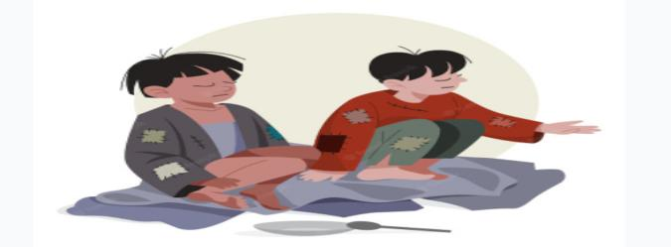 
1. homeless children | 2. the elderly
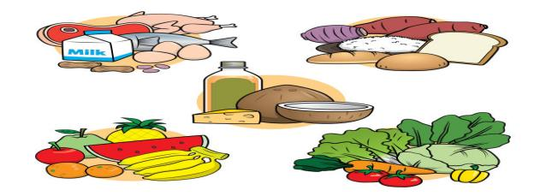 | 
3. food | 4. litter

5. bottles | 6. books
2. ACTIVITY 2: KNOWLEGDE FORMATION ACTIVITIES/ PRESENTATION/ NEW LESSON ( 6ms)
a. Aims: - To help students revise the vocabulary learnt.
- To help students revise the past simple form of some verbs.
b.Content: practise exercises to revise the vocabulary and the past simple form of some verbs learnt.
c.Outcome: Use new words and grammar correctly
d. Organisation : Teacher’s instructions …
Grammar focus
The past simple
Positive | S + V-ed (played)
Negative | S + did not / didn’t V (did not / didn’t play)
Questions and short answers | Did + S + V (play)?  - Yes, S + did.  - No, S + didn’t.

-Reminds ss of The past simple
3. ACTIVITY 3: PRACTICE ACTIVITIES( 14ms)
Task 1: Complete the table with the words and phrases from the box. (3ms)
- Aims:
- To help students revise the vocabulary learnt.
- To help students match the correct verbs with the appropriate nouns / noun phrases to make phrases about community activities.
- Content: Do exercises to revise the vocabulary and the past simple
- Outcome: Use new words and grammar correctly
d. Organisation : Teacher’s instructions …
- Teacher encourages students to complete the task individually.
- Students do the task individually.
- Students exchange their textbooks with their partners.
- Teacher gives feedback as a class discussion.
Answer key:
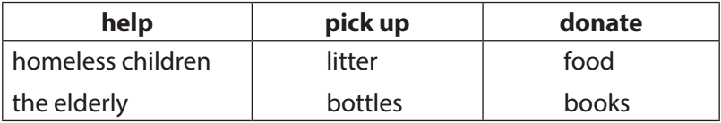
Task 2: Complete each sentence with one phrase from task 1. Remember to use the correct forms of the verbs. (4ms)
- Aims:- To help students use the correct phrases about community activities in the correct contexts.
- To help students revise the vocabulary learnt in the unit.
- Content: Complete each sentence with one phrase from task 1. Remember to use the correct forms of the verbs.
- Outcome: Use new words and grammar correctly
d. Organisation : Teacher’s instructions …

- Teacher asks students to complete the task individually.
- Students do the task individually to put the correct phrases in the blanks.
- Students exchange their textbooks with their partners.
- Teacher gives feedback as a class discussion.
Answer key: 1. donated food 2. picked up bottles
3. helped the elderly 4. donated books 5. helped homeless children
Task 3: Use the correct form of the verbs from the box to complete the passage. (3ms)
- Aim:- To help students revise the past simple form of some verbs.
- Content: Use the correct form of the verbs from the box to complete the passage.
- Outcome: Use grammar correctly
d. Organisation : Teacher’s instructions …
- Teacher encourages students to complete the task individually.
- Students complete the passage using the correct forms of the verbs in the box.
- Students exchange their textbooks with their partners.
- Teacher gives feedback as a class discussion.
Answer key:
- had 2. collected 3. sold 4. donated 5. went
Task 4: Write full sentences about the activities the students did to help their community last year. (4ms)
- Aims:- To help students improve their writing about community activities.
- Content: Complete each sentence with one phrase from task 1. Remember to use the correct forms of the verbs.
- Outcome: Use new words and grammar correctly to write fully sentences
d. Organisation : Teacher’s instructions …
- Teacher asks students to do individually first.
- Students complete the task individually.
- Teacher then asks them to check their answers with a partner before discussing the answers as a class.
- Teacher confirms the answers and corrects students’ pronunciation if necessary.
Answer key:
1. Mi sang and danced for the elderly at a nursing home.
2. Mark and his friends collected books and set up a community library.
3. Lan and Mai grew and donated vegetables to a primary school.
4. Minh and his friends gave food to young patients in a hospital.
5. Tom made and sent postcards to the elderly at Christmas
4. ACTIVITY 4: APPICATION/ PRODUCTION/ FURTHER PRACTICE ( 20ms)
a. Aim: To help Ss apply what they learnt in this unit to present a project about our green neighbourhood.
b. Content: To discuss and present a project about it.
c. Outcome: Make a presentation about our green neighbourhood..
d. Organization:
PROJECT
TASK : Work in groups

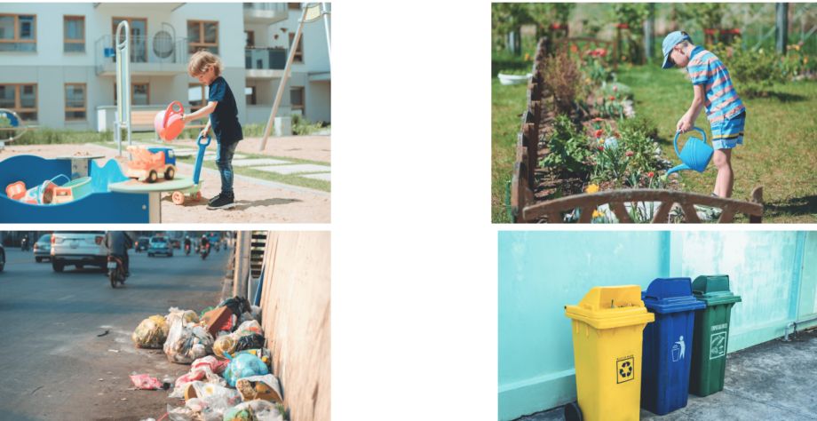
REQUIREMENT: Have Ss read the project. Ask them brainstorm some environmental problems in their neighbourhood. Elicit Ss’ answers. Ss work in groups to discuss and how they are going to solve the problems. Answer Ss’ questions if there are any. Remember to have Ss present their findings in the next lesson and vote for the best.
ORGANIZATION:
- Brainstorm some environmental pronlems in your neighbourhood.
- Discuss the following question :
+ What problems you can find?
+ What do you want to do to solve the problems?
+ How are you going to do them?
- Find suitable photos for it or draw your own pictures.
4. Present the environmental problems to the class. Try to persuade your classmates to take it up.
5. Prepare a presentation. Remember to assign who will talk about what.
6. Give a presentation to the class an exhibition of posters or video clips sts have made among groups. Vote for the best

FEEDBACK FORM FOR SURVEYS
1. Self-assessment
 | Tick where appropriate | Comments (in English or Vietnamese)
DELIVERY
1. We greeted the audience.
2. We spoke clearly and naturally.
3. We interacted with the audience.
4. We cooperated with my group members when delivering the talk
5. We concluded my part of the talk appropriately.
DESIGN OF THE POSTER / SLIDES/…
1. Our photos/ pictures /drawing/ slides/ videos/ plan were clearly organized .
2. Our content and photos/ drawing/ slides/… were suitable
CONTENT: Our presentation includes the following information:
1. The name of the environmental problems.
2. Suitable photos for it or draw pictures to illustrate the environmental problems.
3. How to solve the problems.
2. Peer assessment
 | Tick where appropriate | Comments (in English or Vietnamese)
DELIVERY
1. The presenters greeted the audience.
2. The presenters spoke clearly and naturally.
3. The presenters interacted with the audience.
4. The presenters cooperated with my group members when delivering the talk
5. The presenters concluded my part of the talk appropriately.
DESIGN OF THE POSTER / SLIDES/…
1. Their photos/ pictures /drawing/ slides/ videos/ plan were clearly organized .
2. Their content and photos/ drawing/ slides/… were suitable
CONTENT: The presentation includes the following information:
1. The name of the environmental problems.
2. Suitable photos for it or draw pictures to illustrate the environmental problems.
3. How to solve the problems.

RULES:
- Make a postcard or a video clip about some environental problems.
- Each group will send a representative to go to the board to describe their group’s postcard/ video clip in 4 ms.
- After 4 groups have already finished their groups’ presentation, judges will give remarks, assessment and awards

Rubrics for rating:
Part 1: DELIVERY (4pts)
The total score for this part is 4 points
Part 2: DESIGN OF THE POSTER / SLIDES/… (2pts)
The total score for this part is 2 points
Part 3: CONTENT (4pts)
The total score for this part is 4 points

- RESULT FOR THE ASSESSMENT OF STUDENTS’PRODUCTS

Class | Group | Part 1  Delivery | Part 2  Design of the poster/ slides/… | Part 3  Content | Total | Rank
 |  | (4pts) | (2pts) | (4pts) | (10pts)
7A1 | Group 1 | 3,0 | 1,5 | 3,5 | 8,0 | 3
 | Group 2 | 3,5 | 1,5 | 3,5 | 8,5 | 2
 | Group 3 | 4,0 | 1,5 | 3,5 | 9,0 | 1
 | Group 4 | 3,0 | 1,5 | 3,5 | 8,0 | 3
7A2 | Group 1 | 4,0 | 1,5 | 3,5 | 9,0 | 1
 | Group 2 | 3,0 | 1,5 | 3,5 | 8,0 | 3
 | Group 3 | 3,5 | 1,5 | 3,5 | 8,5 | 2
 | Group 4 | 3,0 | 1,5 | 3,5 | 8,0 | 3
7A3 | Group 1 | 4,0 | 1,5 | 3,5 | 9,0 | 1
 | Group 2 | 3,0 | 1,5 | 3,5 | 8,0 | 3
 | Group 3 | 3,0 | 1,5 | 3,5 | 8,0 | 3
 | Group 4 | 3,5 | 1,5 | 3,5 | 8,5 | 2
7A4 | Group 1 | 4,0 | 1,5 | 3,5 | 9,0 | 1
 | Group 2 | 3,0 | 1,5 | 3,5 | 8,0 | 3
 | Group 3 | 3,0 | 1,5 | 3,5 | 8,0 | 3
 | Group 4 | 3,5 | 1,5 | 3,5 | 8,5 | 2

- GROUPS’PRODUCTS
- Present about some environmental problems.

*WRAP-UP & HOMEWORK (2ms)
Teacher asks students to talk about what they have learnt in the lesson.
* HOMEWORK
- Learn by heart all new words
-Do exercises in the workbook
- Prepare: Review 1 - LANGUAGE

CLASS 7A1

GROUP 1 | GROUP 2
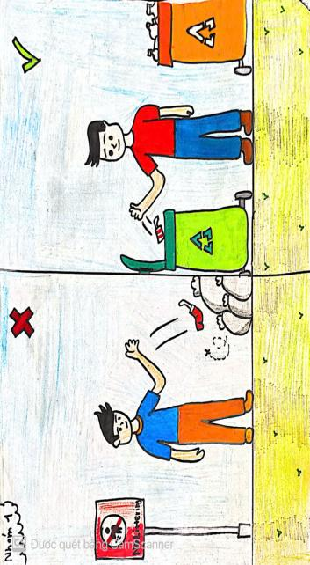 | 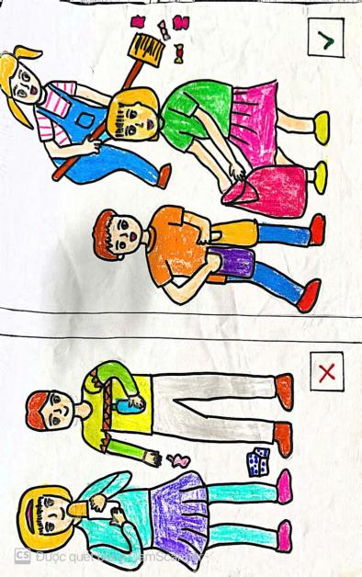
GROUP 3 | GROUP 4
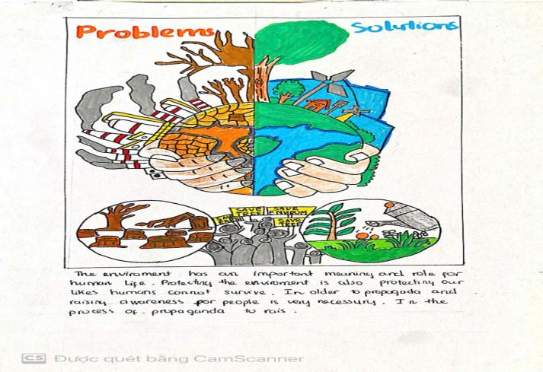 | 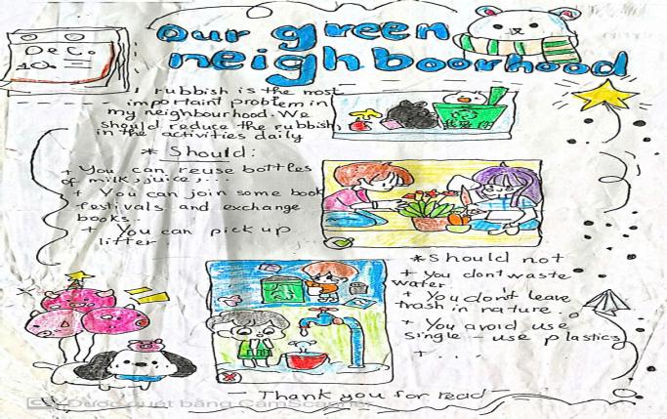

CLASS 7A2

GROUP 1 | GROUP 2
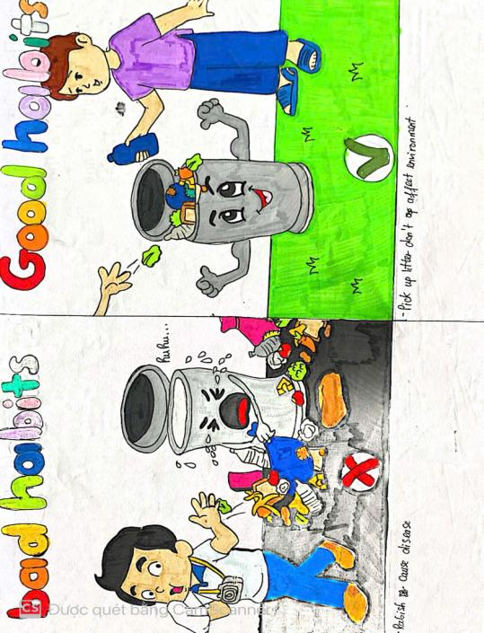 | 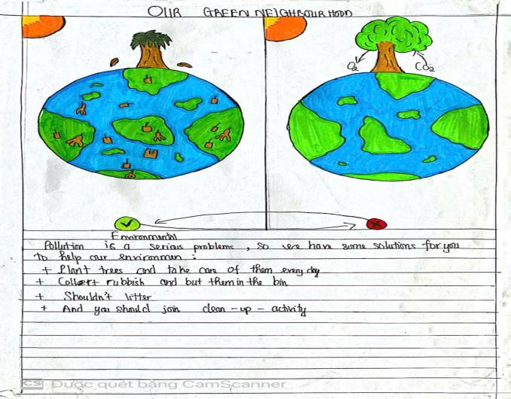
GROUP 3 | GROUP 4
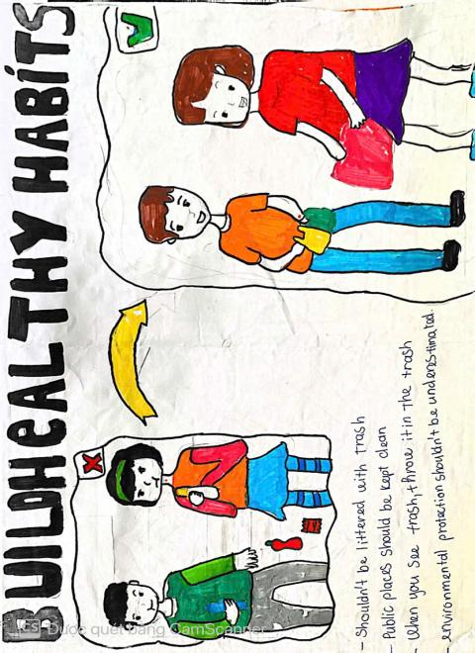 | 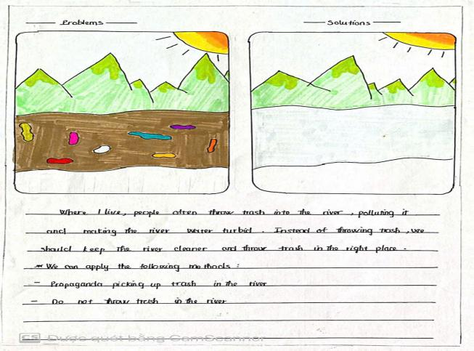

CLASS 7A3

GROUP 1 | GROUP 2
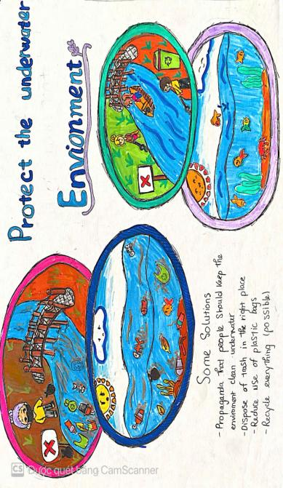 | 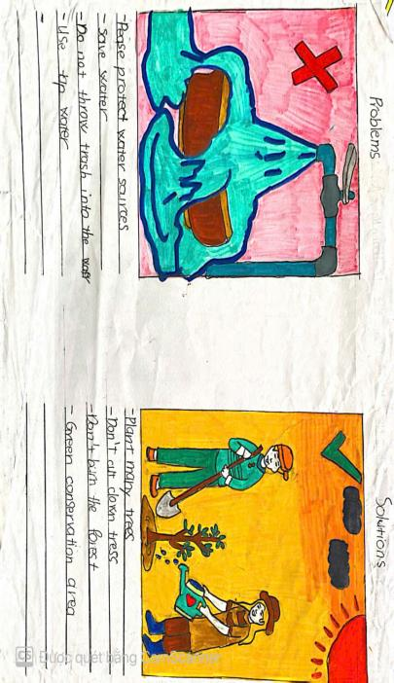
GROUP 3 | GROUP 4
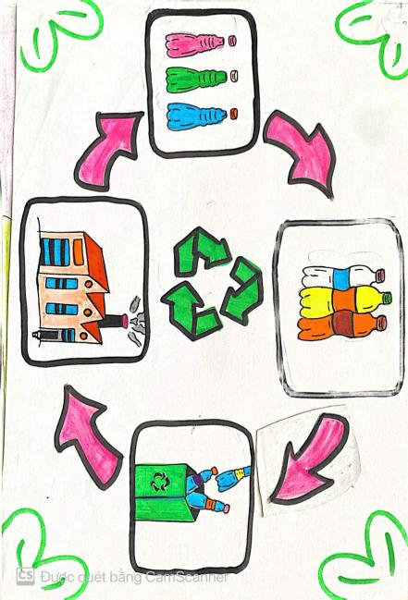 | 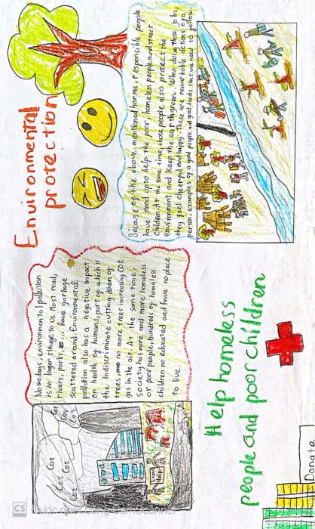

CLASS 7A4

GROUP 1 | GROUP 2
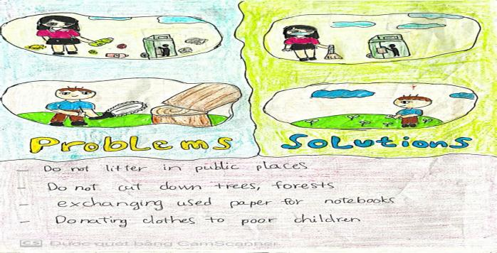 | 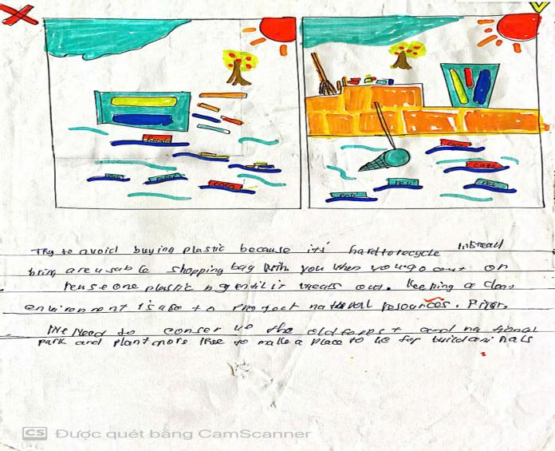
GROUP 3 | GROUP 4
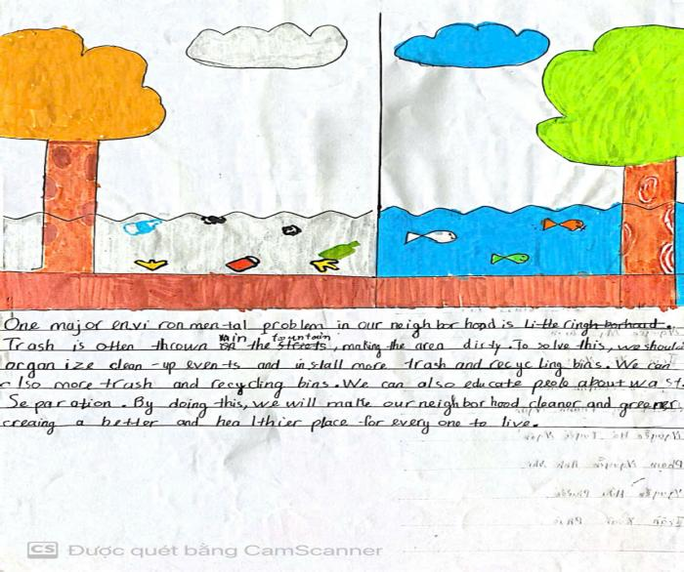 | 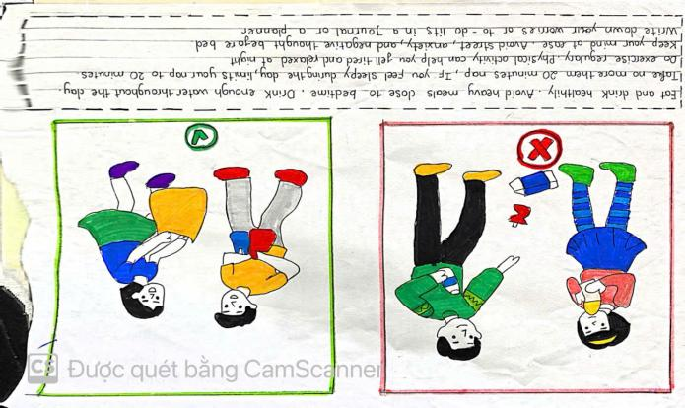

October 22nd 2024 | Teacher in charge: Tran Le Vi  Group: Social science
REVIEW 1 (UNITS 1-2-3)
Period 23: LESSON 1: LANGUAGE
Subject: English - Class: 7A1, 7A2, 7A3, 7A4
Allotted time: one period
I. OBJECTIVES:
* By the end of this lesson, students will be able to:
- Revise the language they have learnt include: pronunciation, vocabulary and grammar they have learnt from unit 1-3 by doing exercises.
1. Knowledge:
+ Vocabulary:
- Revise the words related to hobbies and verbs of liking and disliking; healthy activities and health problems; and words related to community activities;
- Revise the sound/ə/, /ɜ:/, /f/, /v/, /t/, /d/, /ɪd/ correctly in isolation and in context; they have learnt by doing exercises.
+ Grammar:
- Review grammar such as the present simple tense, past simple to talk about past activities;
+ Skills: Revise how to ask for and give health tips; how to give compliments.
2. Competence: By the end of the lesson students will be able to know how to learn Review in right way. They can revise how to ask for and give health tips; how to give compliments. They have learnt so far in terms of language and skills. Students know how to do exercises correctly.
3. Quality/ behavior: Ss are aware of the need to keep their neighbourhood green. The awareness about importance of learning English. Having a serious attitude to working in groups, individual work, pairwork, cooperative learning and working.
- Students are interested in doing exercises and develop self-study skills.
II. TEACHING AIDS AND MATERIALS:
1. Teaching aids: a TV, a laptop computer, pictures, cards, extra boards, Portable multi-function audio device , a loudspeaker, a projector, real objects.
2. Materials: textbooks, workbooks, lesson plan, the teacher’s book, reference books, hoclieu.vn
III. PROCEDURE:
1. ACTIVITY 1: WARM UP & INTRODUCTION (3’)
a. Aims:
- To create a friendly and atmosphere in the class before the lesson;
- To revise the language they have learnt in Units 1-3;
- To lead into the new lesson.
b. Content: To have some warm-up activities to create a friendly and relaxed atmostphere to inspire Ss to warm up to the subject and new lesson.
c. Outcome: Ss feel excited and focus on the topic of the lesson.
d. Organisation: Teacher’s instructions …
+ Greeting
+ Play game: FINDING KEYWORDS
- T shows 3 sets of pictures (taken from Project lessons of Unit 1-2-3) and asks students to find a keyword for each set of pictures.
- Ss raise hands to answer.
- T and Ss discuss the answers.
- T checks the answers as a class.
 |  | 
Set 1: HOBBIES
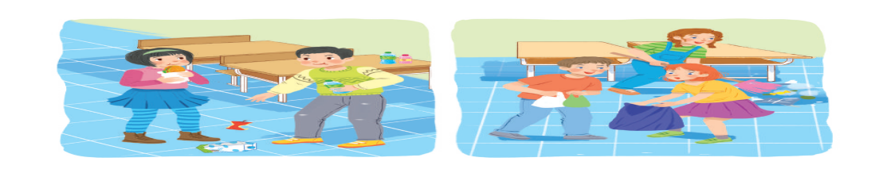
Set 2: HABITS (bad habits, good habits, healthy habits)

 | 
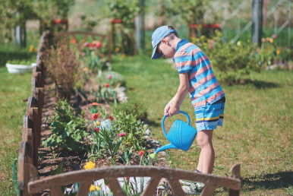 | 
Set 3: COMMUNITY SERVICE
=> Introduces the new lesson “Now, we are going to review the vocabulary as well as the grammar from unit 1 to unit 3”
- Open their book and write.
2. ACTIVITY 2: KNOWLEGDE FORMATION ACTIVITIES/ PRESENTATION/ NEW LESSON (12’)
a.Aims:
- To help the students review the vocabulary and the pronunciation.
- To enable the students to review the grammar points.
b.Content: Revise some important items before practising with the tasks.
c.Outcome: Remember the vocabulary, pronunciation of the sound and grammar points.
d. Organisation : Teacher’s instructions..
- Lets Ss work in groups to revise about what they have learnt in unit 1,2,3
1. Vocabulary about hobbies and verbs of liking and disliking; healthy activities and health problems; and words related to community activities;
2. Pronunciation : the sound/ə/, /ɜ:/, /f/, /v/, /t/, /d/, /ɪd/ correctly in isolation and in context; they have learnt by doing exercises.
- Gets feedback
- Together with the class complete the summary.
+ Gets Ss to take note
3. Grammar:
- Lets Ss work in groups to revise about the grammar points what they have learnt in unit 1,2,3.
1. Present simple tense
2. Past simple to talk about past activities;
- Gets feedback.
- Together with the class complete the summary
3. ACTIVITY 3: PRACTICE ACTIVITIES (20’)
Exercise 1: Circle the word in which the underlined part is pronounced differently. Then listen, check and repeat. (4ms)
a.Aim: To help students review the pronunciation of the sounds learnt in Units 1 - 3.
b.Content: Listen and repeat the words, circle the different sound.
c.Outcome: Ss can remembr and pronounce the words correctly.
d.Organisation : Teacher’s instructions.…..
- T writes the sounds /ə/ and /ɜː/; /t/, /d/ and /ɪd/; /f/ and /v/ on the board.
- T writes one word containing the sound below each of them.
- T asks Ss to read the words aloud.
- Ss do the task by reading aloud each group and circling the odd one out.
- T can invite some pairs of students to read aloud.
- T check Ss’ pronunciation ad give feedback.
- Teacher and students
- Do the task.
- Listen carefully.
- Follow the teacher’s instructions.
- Circle the correct answers.
- Work individually.
- Give the answers.
* Key: 1. A 2. C 3. B 4. A 5. B
Exercise 2: Put the phrases below in the correct columns. (4ms)
a.Aim: To help students revise the phrases showing activities and identify if they benefit oneself or the community.
b.Content: Review the old vocabulary by working individually and doing teamwork.
c.Outcome: Ss can match the adjectives in the box with their opposites correctly.
d.Organisation : Teacher’s instructions …
- T tells Ss to read the phrases carefully and make sure they remember their meanings.
- Ss do this exercise individually by categorising the activities as they do them for their own sake or for the benefit of the community.
- T allows Ss to share their answers before discussing as a class and encourages them to pronounce the words / phrases correctly.
- T checks the answers as a class and gives feedback.
- Teacher and students
- Listen to the instructions clearly.
- Do the task by playing game.
- Give the answers.
- Ss work in pairs
- Copy down them.
* Key:
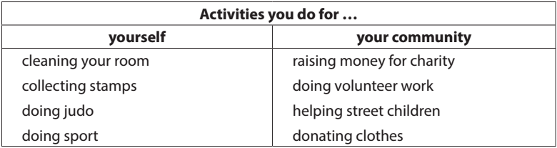
Exercise 3: Complete the sentences with the words and phrases below. (6ms)
a. Aim: To help students revise more words from Units 1 - 3 and use them in context.

b.Content: To review by choosing the words/phrases.
c.Outcome: Ss review more some words and can choose the correct answers.
d.Organisation : Teacher’s instructions ….
- T asks Ss to work individually to complete the sentences with the given words and phrases.
- Ss work individually to complete the task.
- T allows Ss to share answers before discussing as a class.
- T asks Ss to say the sentences aloud and makes sure they pronounce the words and phrases correctly. T can ask for translation to check their understanding.
- Teacher and students
- Ss complete the task. Ss do themselves
- Share their answers.
- Check the answers.
* Key:
1. coloured vegetables 2. mountainous areas 3. hobby
4. chapped lips 5. community 6. taking photos
Exercise 4: Fill in the blanks with the correct tense of the verbs in brackets. (6ms)
a. Aim: To help students revise the use of the present or past simple.

b.Content: Review the grammar points, choose the correct answers.
c.Outcome: Ss remember the form, the use of some grammar points. Doing the task correctly.
d.Organisation : Teacher’s instructions….
- T asks Ss to work independently to fill in the blanks with the correct tense of the verbs in brackets.
- Ss read the sentences first and underline the clues that help them decide if the verbs are used in the present or past simple tense.
- T reminds Ss to use the correct forms of the verbs (positive/ negative statements, or questions) as requested in each sentence then allows them to share answers before discussing as a class.
- T can ask Ss to read aloud the full sentences and correct their pronunciation if necessary.
- Teacher and students
- Ss do the task. Ss do themselves
- Share their answers.
- Give their answers - Check the answers.
* Key:
1. reads 2. Do … do 3. Need 4. could not / couldn’t
5. did not / didn’t volunteer 6. joined
4. ACTIVITY 4: APPICATION/ PRODUCTION/ FURTHER PRACTICE ( 8’)
Exercise 5 : Turn the sentences into negative statements or questions.
a. Aims: To help students practise the present simple and past simple of verbs.
b. Content: Understand the given sentences, turn the sentences into negative or questions.
c. Outcome: Ss can do this task quickly, correctly.
d. Organisation : Teacher’s instructions
- T asks Ss to read the sentences first and underline the verb in each sentence, then look at each verb and note if it is used in the present simple or past simple tense.
- Ss do the task individually.
- T reminds Ss to pay attention to the request of each sentence (change it into a negative statement or a question) then allows them to share answers before discussing as a class.
- T can ask students to read aloud the full sentences and correct their pronunciation if necessary.
- Teacher and students
- Ss do the task. Ss do themselves
- Listen carefully- Check the answers
- Copy down
* Key:
1. She didn’t like exercising.
2. My family doesn’t always spend time doing housework together on Sundays.
3. I didn’t use a lot of suncream during my holiday.
4. Did your community organise a fair to raise money for the homeless last week?
5. Does Tim make beautiful pieces of art from dry leaves and sticks?
*WRAP-UP & HOMEWORK (2’)
- Asks Ss what they have learnt so far. Have them recall the important elements.
+ Words/phrases related to hobbies and verbs of liking and disliking; healthy activities and health problems; and words related to community activities;
- The sound/ə/, /ɜ:/, /f/, /v/, /t/, /d/, /ɪd/ correctly in isolation and in context
+ Grammar: present simple tense, past simple to talk about past activities;
* HOMEWORK
Asks the students to:
- Learn by heart all the lesson
- Do more exercises in workbook.
- Prepare: Review 1 - Skills

October 27th 2024 | Teacher in charge: Tran Le Vi  Group: Social science
REVIEW 1 (UNITS 1-2-3)
Period 24: LESSON 2: SKILLS
Subject: English - Class: 7A1, 7A2, 7A3, 7A4
Allotted time: one period

I. OBJECTIVES:
* By the end of this lesson, students will be able to:
- Revise the skills they have learnt include: reading, listening, speaking and writing they have learnt from unit 1-3 by doing exercises.
1. Knowledge:
+ Vocabulary:
- Revise the words related to hobbies and verbs of liking and disliking; healthy activities and health problems; and words related to community activities;
- Revise the sound/ə/, /ɜ:/, /f/, /v/, /t/, /d/, /ɪd/ correctly in isolation and in context; they have learnt by doing exercises.
+ Grammar:
- Review grammar such as the present simple tense, past simple to talk about past activities;
+ Skills:
- Practise reading for general and specific information about a healthy life
- Practise talking about things related to community service
- Practise listening for specific information about a hobby
- Practise writing complete sentences from the prompts provided
2. Competence: By the end of the lesson students will be able to revise the skills they have learnt in Units 1-3. They know how to practice the skills in right way. Students know how to do exercises correctly.
3. Quality/ behavior: To teach Ss the love of English. Ss have the good attitude to working in groups, individual work, pairwork, cooperative learning and working. Then and now they know how to use the main structures and some main points of grammars in the first semester well and effectively to speak the topic of the units.
- Students are interested in doing exercises and more serious.
II. TEACHING AIDS AND MATERIALS:
1. Teaching aids: a TV, a laptop computer, pictures, cards, extra boards, Portable multi-function audio device , a loudspeaker, a projector, real objects.
2. Materials: textbooks, workbooks, lesson plan, the teacher’s book, reference books, hoclieu.vn
III. PROCEDURE:
1. ACTIVITY 1: WARM UP & INTRODUCTION ( 3’)
a. Aims:
- To create a friendly and atmosphere in the class before the lesson;
- To make students curious and motivate students’ learning;
- To revise the skills they have practised in Units 1-3; lead into the topic.
b. Content: Having some warm-up activities to create a friendly and relaxed atmostphere to inspire Ss to warm up to the subject and new lesson.
c. Outcome: Having a chance to speak English and focus on the topic of the lesson…
d. Organisation : Teacher’s instructions …
+ Greeting
+ Playing a game
NAME THE PICTURES: HOW TO GET A HEALTHY LIFE?
- T shows pictures and asks Ss to discuss the ways to get a healthy life.
- Ss raise hands to answer.
- T and Ss discuss the answers.
- T checks the answers as a class.
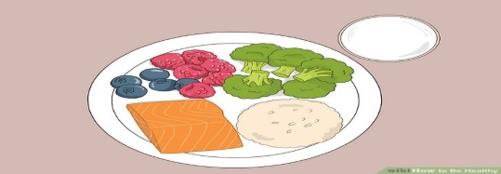 | 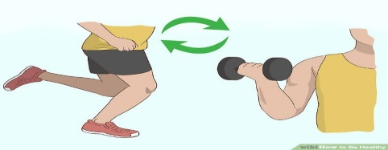
Have a healthy diet | Have a healthy exercise plan
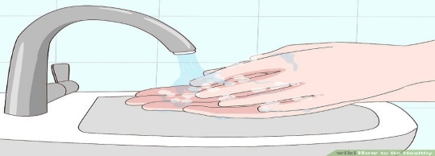 | 
Maintain your personal hygiene | Be happy
=> Introduces the new lesson “Now, we are going to review the skills from unit 1 to 3
- Open their book and write.
2. ACTIVITY 2: KNOWLEGDE FORMATION ACTIVITIES/ PRESENTATION/ NEW LESSON (12’)
a.Aim: To help students how to read the passage for general information.
b.Content: Read the given sentences and do the matching. Doing individually.
c.Outcome: Get some information of the passage by doing the matching.
d. Organisation: Teacher’s instructions…
Read the passage and match the questions (A,B,C) with the paragraphs
- T may guide Ss by asking them to read the questions first and decide where to look for the information to answer the questions.
For example: Question 2 has “love”. It matches the heading “ love others fully”.
- T explain Ss should look for the answer in this paragraph.
- Teacher and students
- Do the task.
- Listen carefully
- Follow the teacher’s instructions.
- Complete the correct answers
- Work individually.
- Give the answers => Gets Ss to take not
* Key: 1-Love other fully 2- Love other fully 3-Laugh more often
4-Enjoy adventures 5-………………….

3. ACTIVITY 3: PRACTICE ACTIVITIES (20’)
Exercise 1: Read the passage and choose the correct answer A, B or C. (6ms)
a.Aims: - To help Ss practise reading for specific information;
- To help Ss to understand more about passages.
b.Content: Read again and choose the correct answers. Doing individually.
c.Outcome: Understand more the content of the passage. Ss can do the task correctly.
d.Organisation : Teacher’s instructions.…..
- T guides Ss by asking them to read the questions first and decide where to look for the information to answer the questions.
- Ss read the text fully and choose the correct answers.
- T asks Ss where they find the answers.
- T confirms the answers as a class.
- Teacher and students
- Do the task.
- Listen carefully
- Follow the teacher’s instructions.
- Circle the correct answers
- Work individually.
- Give the answers
* Key:
1. B 2. C 3. C 4. A 5. A
Exercise 2: Work in pairs. Interview each other, using the question below. Take notes of the answers and then report the results to the class. (7ms)
a.Aim: To help students revise and talk about things related to community service and identify if they benefit oneself or the community.
b.Content: Interview each other. Take notes of the answers and report the result. Working in pairs.
c.Outcome: Ss have more chance to improve speaking skills. They can ask and find out which places their partners want to visit more fluently.
d.Organisation : Teacher’s instructions …
- T asks Ss to work in pairs and take notes of their answers
- Ss work in pairs to exchange their ideas
- T calls on some pairs to report their answers for the class. Each pair may answer just one question to allow room for more pairs.
- Tchecks the answers and add more information if necessary.
- Teacher and students
- Listen to the instructions clearly
- Do the task
- Share the answers - Give the answers.
- Ss work in pairs
Suggested answer:
1. Anybody.
2. Street children, old and sick people, abandoned / street animals, etc.
3. (It can be any tasks like) cooking / shopping for the old / the sick; collecting books / clothes for street children; opening classes to teach street children; adopting a dog / a cat; cleaning the neighbourhood / beach; painting walls at / decorating public places; reading to the people in
hospitals / nursing homes ..
Exercise 3: Listen and complete each sentence with one word. (7ms)
a. Aim: To help students practise listening for specific information.

b.Content: Listen and complete each sentence with one word. Working individually.
c.Outcome: Ss can listen some important information clearly,exactly. Doing the task correctly.
d.Organisation : Teacher’s instructions ….
- T has Ss read the questions first to get an overall idea of what they are going to listen to and decide what information they need to complete the sentences.
- Ss work individually to complete the task.
- T allows Ss to share answers before discussing as a class.
- T asks Ss to say the sentences aloud and makes sure they pronounce the words and phrases correctly. T can ask for translation to check their understanding.
- Teacher and students
- Ss do the task. Ss do themselves
- Share their answers
- Check the answers
* Key:
Answer key:
1. games
2. sandcastles
3. open
4. computer
5. (Any of the following): food, water, compass, sleeping bag, insect cream
Audio script:
Camping can be lots of fun. When we go camping, there is plenty of time for games with friends. If we camp near a beach, we can build sandcastles, go swimming, or play beach volleyball. In other places, we can do other activities like playing football, cycling, bush walking, listening to music or drawing. In the evening, we can have dinner by an open fire. It’s a good time to enjoy the fresh air, tell stories and laugh with friends. While we go camping, there is no television or computer. But don’t worry. You’ll have a great time. Don’t forget to bring important things, like food and water, a sleeping bag, a compass, and some insect cream.

4. ACTIVITY 4: APPICATION/ PRODUCTION/ FURTHER PRACTICE ( 8’)
Exercise 4: Write complete sentences to make a passage describing community activitites.
a. Aims: To help students practise writing complete sentences from the prompts provided.
b. Content: Write complete sentences to make a passage describing community activities
c. Outcome: Ss can complete this task quickly, correctly.
d. Organisation : Teacher’s instructions
- T asks Ss to work individually to make a passage describing community activities.
- Ss read all the six sentences first to help them see the connection among them and decide which tense should be used for each sentence, and which word(s) is / are missing from the sentence.
- T allows Ss to share answers before discussing as a class.
- T can ask Ss to read aloud the full sentences and correct their pronunciation if needed.
- Gets feedback.
- Teacher and students
- Ss do the task. Ss do themselves
- Listen carefully- Check the answers
- Copy down
* Sample answer:
1. We join community activities once a month.
2. Last month we planted (some) trees in the park.
3. We dug some holes to put the young trees in.
4. Then we watered them for two or three weeks.
5. Now the trees are growing very well.
6. They will make the park greener and the air fresher.
*WRAP-UP & HOMEWORK (2’)
Aims: To help students summarize the main points what they have practiced.
- Asks Ss what they have learnt so far. Have them recall the important elements:
+ words/ phrases related to hobbies and verbs of liking and disliking; healthy activities and health problems; and words related to community activities;
+ write a paragraph about community activities…..
* HOMEWORK
Asks the students to:
- Learn by heart all the lesson.
- Do more exercises in the workbook
- Prepare: Unit 4: Getting started

