|  |  |
| --- | --- |
|  |  |

**UNIT 8: TOURISM**

**Period: 67 - Lesson 6: SKILLS 2**

Subject: English - classes: 9

Allotted time: one period

**I. OBJECTIVES**

By the end of this lesson, Ss will be able to:

**1. Knowledge:**

- Listen for specific and general information about a one-day trip to the home of the Brontes - Write a paragraph introducing a half day tour in Hue.

**2. Competence:**

- Develop communication skills and creativity

- Be collaborative and supportive in pair work and teamwork

**3. Quality/ behavior:**

- Actively join in class activities

**II. TEACHING AIDS:**

- Teacher: Text book, laptop, loudspeaker, projector…

- Students: Text books, studying equipment….

- Method: CLT; group works; individual ……

**III. PROCEDURE:**

**1. ACTIVITY 1: WARM UP & INTRODUCTION (5’)**

**a. Aims:**

- To create an active atmosphere in the class before the lesson;

- To lead into the new lesson

**b. Content:**  - Game: UNSCRAMBLED WORDS

**c. Outcome:** - Students can revise some words learnt in previous lessons

**d. Organisation:**

Game: UNSCRAMBLED WORDS

- T divides the class into 2 teams.

- T asks Ss to unscramble words using given hints

- Ss look at the hints to unscramble the words

- Ss write unscrambled words in notebooks

- The group having more correct answers is the winner.

- T corrects students (if needed)

**\*Suggested answer** :

1. ruinous

2. graveyard

3. high street

4. wander

5. cottage

6. accompany

**\*LISTENING**

**2. ACTIVITY 2: KNOWLEGDE FORMATION ACTIVITIES/ PRESENTATION/ NEW LESSON (5’)**

**a. Aims:** - To help students develop their skill of listening for general and specific information about a one-day trip to the home of the Brontes.

**b. Content:** Work in pairs. Discuss if these statements are true.

**c. Outcome:** Ss have a general idea about what they are going to listen.

**d. Organisation:**

**Task 1:** : Work in pairs. Discuss if these statements are true.

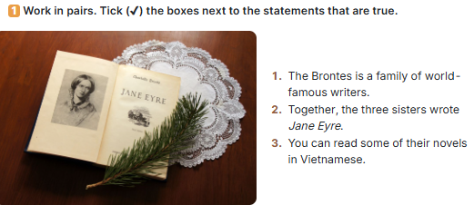

- T has Ss work in pairs.

- T asks Ss to read the statements and discuss if they are true.

- T calls on some pairs to share their answers.

***\** Answer key:**

1. True

3. True

Notes: The Bronte sisters refer to the three sisters from The Brontes in England. They are famous writers: Charlotte Bronte (1816 –1855), Emily Bronte (1818 – 1848), and Anne Bronte (1820 –1849). Their novels Jane Eyre, Wuthering Heights, and The Tenant of Wildfell Hall are worldwide recognised as masterpieces of English literature. These books have been turned into movies. They were first translated into Vietnamese in the 1960s and are still being republished today.

**3. ACTIVITY 3: PRACTICE ACTIVITIES (15’)**

**a. Aim:** - To help Ss develop their skill of listening for specific information

**b. Content**: A tour guide is announcing the schedule for a one-day trip to the home of the Brontes. Listen and complete the missing information

**c. Outcome:** - Ss can listen for specific information to do the learning tasks.

**d. Organisation:**

**Task 2: A tour guide is announcing the schedule for a one-day trip to the home of the Brontes. Listen and complete the missing information. (5’)**

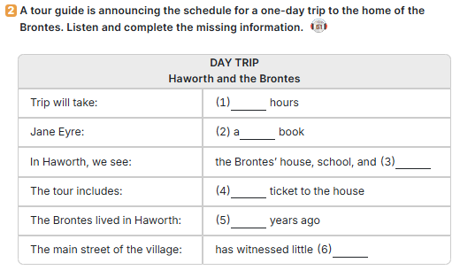

- T has Ss work individually. T has Ss read the table carefully first so that they can have some ideas of what information they need to fill in the blanks.

- T plays the recording for Ss to listen and do 2.

- T invites some Ss to share their answers with the class.

- T confirms the correct answers as a class.

- T plays the recording again if needed. T pauses at places where Ss have difficulties and shows them how to find the answers.

**Answer key:** 1. 9 / nine 2. world-famous 3. graveyard 4. entrance 5. 150 6. Change

**Audio script:** Hello everyone. Welcome to the Brontes tour. My name’s Gillian and I’ll be accompanying you on our nine-hour tour. We’ll drive through the beautiful Yorkshire countryside with its vast green hills and fields. We’ll stop at the villages of Clapham and Wycoller. There you can see the original school and ruinous cottage, which appear in Charlotte’s worldfamous book, Jane Eyre. We’ll then drive on to Haworth, the home of the Brontes. We’ll visit their two-storey house and and the school they set up for the children in the village. The entrance ticket to the house is included in the tour, so you don’t have to pay extra. We will also visit the graveyard where the members of the Brontes rest in peace. After that we have an hour for lunch. There are cafés and restaurants nearby. Our tour continues at one thirty. We’ll wander down the main high street where the Brontes walked 150 years ago. It has hardly changed since then. You’ll see many places that the members of the Bronte sisters used to visit. Next, …

**Task 3: Look at the pictures, listen again and tick (✔) the two which illustrate the ideas of the listening passage (5’)**

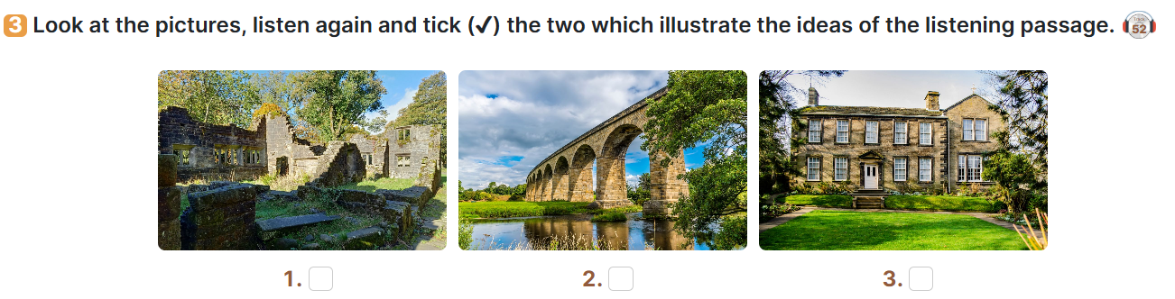

- T has Ss do the task individually.

- T has Ss look at the pictures first and see what they illustrate.

- T plays the recording again for Ss to listen and do the activity.

- T invites some Ss to share their answers with the class.

- T confirms the correct answers as a class.

- T plays the recording again if needed. Pause at places where Ss have difficulties and show them how to find the answers.

**\*Suggested answer**: 1 and 3

Explanation: the listening mentions ‘ruinous cottage’ (the building in Jane Eyre book) and ‘two-storey house’ (The Brontes’ original home). It doesn’t mention any bridge.

**Transition from Listening to Writing**:

- Tell Ss that in the upcoming writing tasks, they are going to write the same thing as in the listening: schedule of a visit.

-Ask Ss to refer to the listening (Activities 1, 2, 3) for any vocabulary, ideas, or structures they may need for their writing.

**\*WRITING**

**4. ACTIVITY 4: APPICATION/ PRODUCTION/ FURTHER PRACTICE (20’)**

**a. Aim:**

- To help students practise writing a paragraph introducing a half day tour in Hue.

**b. Content:**

- Task 4: Work in pairs. Discuss and tick (✔) the thing(s) that the tour guide in the listening passage mentions in her announcement at the beginning of the tour.

- Task 5: Write a paragraph (100 - 120 words) introducing this half day tour in Hue. Use the clues below

**c. Outcome:**

- Students can use learned vocabulary and grammar to write a paragraph introducing a half day tour in Hue.

**d. Organisation:**

**Task 4: Work in pairs. Discuss and tick (✔) the thing(s) that the tour guide in the listening passage mentions in her announcement at the beginning of the tour. (3 mins)**

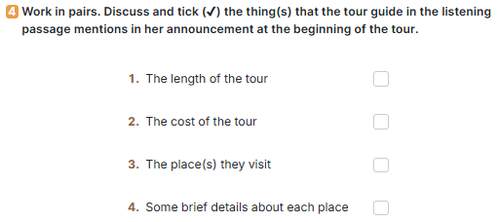

- T has Ss work in pairs. T asks Ss to read the list and tick the thing(s) that the tour guide mentions in the tour schedule.

- T invites some Ss to share their answers with the class.

- T checks the correct answers as a class.

**Answer key: 1, 3, 4**

**Task 5: Write a paragraph (100 - 120 words) introducing this half day tour in Hue. Use the clues below. (17 mins)**

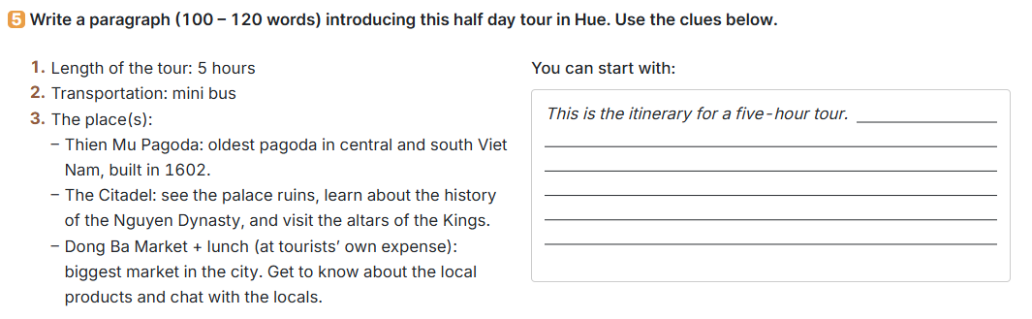

- T has Ss work individually. T allows them to discuss in pairs if needed.

- T asks Ss to read the clues about the tour in Hue.

- T allows them some time to arrange the ideas and write the paragraph. T goes around and offers help if needed.

- T calls on some Ss to read aloud their passage to the class. T comments on them.

***Sample paragraph***: Hi, my name is Nam and I’m going to be with you on a fivehour tour of Hue City. Our first visit is Thien Mu Pagoda. It’s the oldest pagoda in central and south Viet Nam and was built in 1602. Then we drive on to the Citadel, where we can see the palace ruins, learn about the history of the Nguyen Dynasty, and visit the altars of the Kings. The last visit is to Dong Ba Market. It’s the biggest market in the city, where you’ll see local products and chat with the locals. You can have lunch in or around the market before the tour ends

**\*WRAP-UP & HOMEWORK (2’)**

**a. Wrap-up**

- T asks Ss to summarise the main points of the lesson.

**b. Homework**

- Rewrite the paragraph in the notebooks.

- Do exercises in the workbook.

- Prepare: Looking back and project