September 24th, 2024 Teacher in charge: Bui Nguyen Hoang Yen
Group: English – Fine Arts – P.E
UNIT 2: LIFE IN THE COUNTRYSIDE
Period 9: Lesson 1: GETTING STARTED – Last summer holiday
Subject: English - classes: 8A4
Allotted time: one period
I. OBJECTIVES:
1. Knowledge:
- Review the vocabulary and grammar of Unit 1
- Apply what they have learnt (vocabulary and grammar) into practice through a project.
2. Competence:
- Develop communication skills and creativity
- Be collaborative and supportive in pair work and teamwork
- Actively join in class activities
3. Quality/ behavior:
- Love talking about activities in leisure time
II. TEACHING AIDS:
- Teacher: Text book, laptop, loudspeaker, projector…
- Students : Text books, studying equipments….
- Method: T-WC; group works; individual ……
III. PROCEDURE:
1. ACTIVITY 1: WARM UP & INTRODUCTION ( 5ms)
a. Aims:
- To set the context for the introductory dialogue.
- To introduce the topic of the unit.
b. Content:
- Questions & answers about summer activities
- Watching video of summer in the countryside
c. Outcome: - Students know the topic of the unit and are ready for the conversation.
d. Organisation : Teacher’s instructions …
+ Greeting
+ Chatting
- T asks Ss “What did you do last summer?”.
- Ss answer the question individually.
- Teacher shows students a video of summer in the countryside and asks students to guess what the video is about.
- T sets the context for the listening and reading text: Write the title on the board Life in the countryside – Last summer holiday.
- Lead to the new lesson
- Introduce the objectives of the lesson.
2. ACTIVITY 2: KNOWLEGDE FORMATION ACTIVITIES/ PRESENTATION/ NEW LESSON ( 10ms)
a. Aim: - To prepare vocabulary for students to understand the conversation.
b. Content: - Vocabulary pre-teaching.
c. Outcome: - Students know how to use the target vocabulary.
d. Organisation : Teacher’s instructions..
- Teacher explains the meaning of the new vocabulary by pictures.
- Teacher reveals that the words corresponding to the pictures will appear in the reading text and asks students to open their textbook to find these words.
- Teacher introduces the vocabulary.
New words:
1. harvest (v) / /ˈhɑːvɪst/[ explanation : the time of year when the crops are gathered in on a farm, etc.; the act of cutting and gathering crops ]
2. combine harvester (n) /kəmˈbaɪn ˈhɑːvɪstə(r)/ [picture]
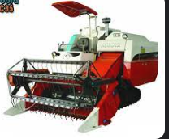

3. herd (v) /hɜːd/[ translation]
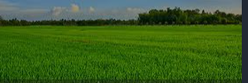
4. paddy fields (n) / ˈpædi fiːld/

- Teacher checks students’ understanding with the “Rub out and remember” technique.
3. ACTIVITY 3: PRACTICE ACTIVITIES (20ms)
Exercise 1: Listen and read.
a. Aim: To help Ss use words and phrases related to farm work in the countryside.
b. Content:
- Task 1: Listen and read.
- Task 2: Read the conversation and choose the correct answer to each question.
- Task 3: Complete the sentences with the words and phrases from the box.
- Task 4: Match the activities (1 - 6) that people living in the countryside often do with the pictures (a - f).
c. Outcome:
- Students understand the conversation and know the vocabulary related to the topic.
d. Organisation : Teacher’s instructions.…..
Task 1. Listen and read.
- Teacher plays the recording and asks students to circle the words learnt in the Presentation stage.
- Teacher can play the recording more than once.
- Students listen and read.
Task 2. Read the conversation again and choose the correct answer to each question.
a. Aim: To help Ss use words and phrases related to farm work in the countryside.
b. Content: Read the conversation again and choose the correct answer to each question.
c. Outcome: Students can write sentences
d. Organisation : Teacher’s instructions.…..
- Teacher asks Ss to read the dialogue in detail to answer the questions.
- Ask them how to do this kind of exercise. Explain the strategies, if necessary (e.g. reading the questions and the options (A, B, C), underlining the key words in the questions and options, locating the key words in the text, and then reading that part and answering the questions).
- Tell them to underline parts of the dialogue that help them to answer. Set a strict time limit to ensure Ss read the text quickly for information.
- Tell them to compare their answers in pairs before sharing them with the class. Ask them to give evidence
to support their answers.
Answer key: 1. A 2. B 3. C 4. A
Exercise 3: Complete the sentences with the words and phrases from the box
a. Aim: To help Ss further understand the text.
b. Content: Complete the sentences with the words and phrases from the box
c. Outcome: Students can use words and phrases relatated to farm work in the countryside
d. Organisation : Teacher’s instructions.…..
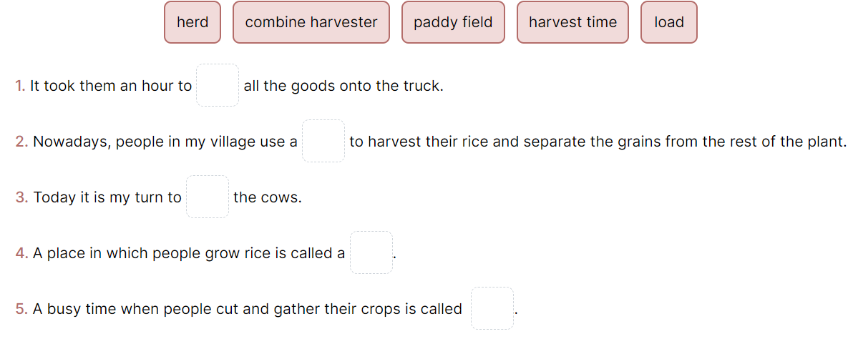
- Teacher tells Ss to read the conversation again, work independently to do the task, and then ask them to share their answers with one or more partners. T can ask for translation of some of the words and phrases in the box to check their understanding.
- T asks 2 students to write their answers on the board.
- Check the answers as a class.
Answer key:
1. load 2. combine harvester 3. herd 4.paddy field 5. harvest time
Exercise 4: Match the activities that people living in the countryside often do with the pictures.
a. Aims:- To introduce some vocabulary items related to activities that rural people often do
b. Content: Match the activities that people living in the countryside often do with the pictures.
c. Outcome: SS know more about the topic of the lesson, Vocabularies
d. Organisation : Teacher’s instructions …
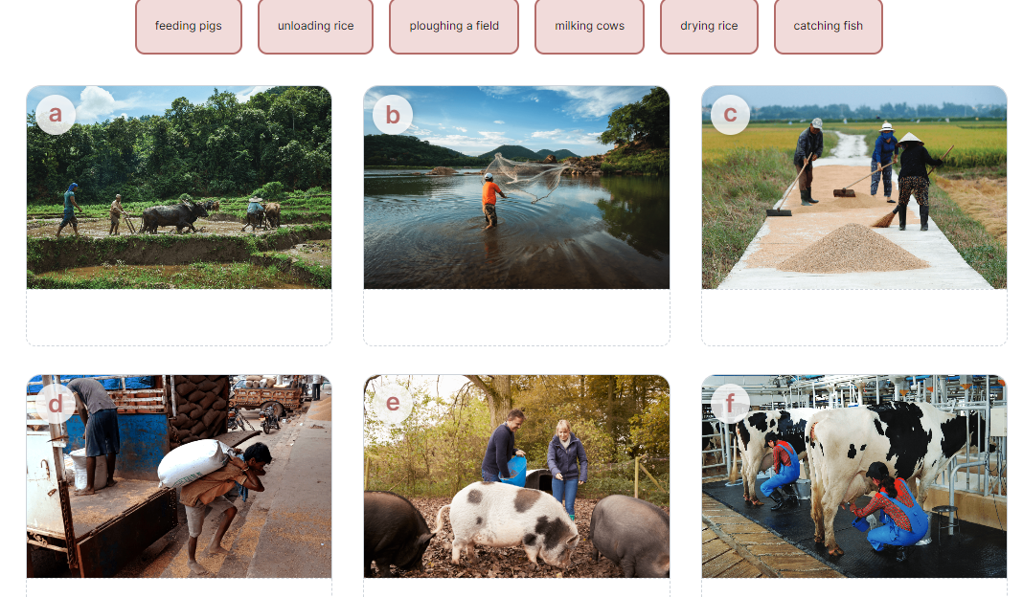
- T has Ss work individually to match the words and phrases in the box with the pictures. Have them compare their answers with their partners. Then ask for Ss’ answers. Quickly write their answers on the board without confirming the correct answers.
- T has Ss listen to the recording, check their answers, and repeat the words / phrases. Ask Ss to look at the answers on the board and say if they are right or wrong. Confirm the correct answers.
- Teacher checks the answers as a class and gives feedback.
Answer key: 1. d 2. a 3. f 4. e 5. b 6. c
4. ACTIVITY 4: APPICATION/ PRODUCTION/ FURTHER PRACTICE ( 8ms)
Task 5. Work in pairs. Ask and answer about the pictures in 4.
a. Aims: - To get students to ask and answer about activities that rural people often do.
b. Content: Work in pairs. Ask and answer about the pictures in 4.
c. Outcome: Students’ conversations
d. Organisation : Teacher’s instructions ….
- Model this activity with a student. Remind Ss that they should only use the phrases and the pictures in 4 to ask and answer about activities that rural people often do.
- Ask Ss to work in pairs. T goes round to help weaker Ss. Then, call on some pairs to practise in front of the class. Comment on their performance.
*WRAP-UP & HOMEWORK (2ms)
- Summarise the main points of the lesson.
- Ask one or two Ss to tell the class what they have learnt.
- Ask Ss to say aloud some words and phrases they remember from the lesson.
* HOMEWORK
- Students’ workbook.
- Prepare : Unit 2 ( A closer look 1)

