LESSON PLAN - Week 35
Subject: English 4 Grade: 4
Lesson Extension activities Number of lessons: 01
Time: From 12/5/2025 to 15/5/2025 Period: 138

A. OBJECTIVES:
By the end of the lesson, Ss will be able to:
1. Knowledge:
- Take part in three fun activities to apply their language knowledge and competences
- Skills: speaking, writing and listening
2. Competences:
- Co-operation: ready to help friends in pair work/ group work.
- Sociability: Talk to each other, say good words to others.
3. Attitude/ Qualities:
- Kindness: Help partners to complete learning tasks.
- Honesty: tell the truth about feelings and emotions
B. TEACHING AIDS:
- Teacher: Teacher’s guide Pages 297, 298; website hoclieu.vn, posters, laptop, pictures, textbook, lesson plan, TV or projector.
- Students: Pupil’s book Page 72, 73, notebooks, workbooks, school things.
C. PROCEDURES:
Time | Teacher’s activities | Students’ activities
5’  30’ | 1.Warm- up  Sing: Head, shoulders, knees and toes  *Aims: to create a friendly and active atmosphere in the class to beginning the lesson.  *Procedure:  - Show the song on the screen.  https://www.youtube.com/watch?v=WX8HmogNyCY  - Ask Ss to listen, sing and dance the song.  - Say “Open your book page 72” and look at “Extension activities”.  2. Practice activities  Activity 1. Look and match  *Aims: Ss will be able to match the animals with their correct homes.  *Procedure:  - Tell Ss the goal of the activity and explain that they should match the animals with their correct homes.  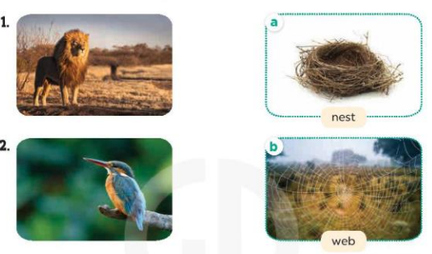  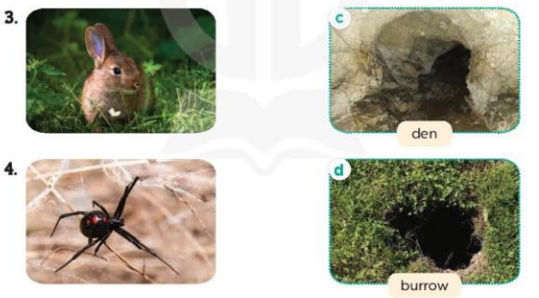  - Elicit the name of the animal in the picture. Then ask them to choose its home.  - Set a time limit for Ss to do the task independently.  - Get Ss to swap their books with a partner and check their answers.  - Have Ss repeat the words nest, web, den, burrow.  Key:1. c 2. a 3. d 4. b  Activity 2. Complete  *Aims: Ss will be able to complete four sentences to introduce the animals and their homes.  *Procedure:  - Tell Ss the goal of the activity and explain that they need to choose the animal homes in 2 to complete the sentences in 3.  -Model number 1: Read the sentence aloud and elicit the answer (den).  - Set a time limit for Ss to do the task independently.  - Get Ss to swap their books with a partner and check their answers before checking as a class.  - Have Ss repeat the completed sentences.  Key: 1. den 2. nest 3. burrow 4. web  Activity 3. Board game. Roll a dice. Listen to a question and answer it. *Aims: Ss will be able to review the target vocabulary and sentence patterns by playing Board games  *Procedure:  - Divide the class into four groups.  - Each group rolls the dice in turn. On their turns, they move their game piece along the path according to the number of spaces by the dice.  - When the groups land on a space, the teacher asks a question.  + The group gives the answer.  + If it is correct, they can stay in the box. + Explain that there are some boxes like back to start, move ahead one space, miss a turn, move ahead three spaces, go back one space.  - The game continues until one or all groups reach the “Finish” space.  - Write the questions on the board. Have pupils sit in groups of three or four and repeat Steps 1-4 to play in groups.  *Consolidation  *Aims: Ss will be able consolidate and wrap up the content of the lesson.  *Procedure:  - T asks ss to answer the following questions:  + What have you learnt from the lesson today?  - T praises some Ss who are hardworking / active/ good…. as well as encourage others to try more.  - Prepare the second term test | - Ss listen  - Ss sing a song  -Ss pay attention  -Ss look at the picture and answer  - - Ss do the task  -Ss swap books and check their answer  -Ss repeat the words nest, web, den, burrow.  -Ss listen  -Ss read and complete the first sentence  -Ss do the task  -Ss swap books and check their answers  -Ss repeat the completed sentences.  - Ss listen and play the game  Questions:  1. What was the weather like yesterday? (It was sunny.)  2. What are these animals? (They’re giraffes.)  3. Back to Start  4. How much is this T-shirt? (It's 50,000 dong.)  5. Move ahead one space  6. What does it say? (It says ʽturn leftʼ.)  7. Miss a turn  8. What are they doing? (They’re singing a song.)  9. Move ahead three spaces  10. Where’s the bakery? (It’s opposite the bookshop.)  11. Go back one space  12. What are these animals doing? (They’re running.)  -Ss answer the questions  -Ss listen and clap their hands  -Ss listen and take note
IV. ADJUSTMENTS (if necessary):
………………………………………………………………………………………….…..……………………………………………………………………………......
……………………………………………………………………………………
……….….…………

